**SCHOOL OF ENGINEERING & TECHNOLOGY**

**COURSE FILE**

**Program**: Electronics and Computer Engineering

**Course Code:** CSE2022

**Course Title:** Web Programming  
Module Semester: 3rd Sem

**Session:** 2024-25

**Index**

|  |  |
| --- | --- |
| **S. No.** | **Topics** |
| **1.** | Course Details: Course-Code; Course Title; Semester/Term/Module; Year |
| **2.** | Vision, Mission of the University |
| **3.** | Graduate Attributes of the BMU Students |
| **4.** | Vision, Mission of the School |
| **5.** | PEOs and POs & PSOs of the Program |
| **6.** | Course Description and its objectives |
| **7.** | Course Outcomes and CO-PO Mapping |
| **8.** | Detailed Session wise Plan & Course Syllabus: (including Course Content with Module-wise teaching hours allocated; Readings, Activities, Teaching Strategy, and Module mapped to COs, Textbook(s), Reference Books, Other learning resources) |
| **9.** | Weekly Timetable |
| **10.** | Registered Students List |
| **11.** | Details of Internal Assessments; weightages, due dates, mapping to CO |
| **12.** | Mid-Semester Question papers with sample solutions |
| **13.** | Sample Evaluated Internal Submissions and Identification of weak students. |
| **14.** | Reflections from the Mid-term semester feedback received, and interventions made to enhance student learning and continuous improvement in teaching and learning strategies. |

|  |  |
| --- | --- |
| **15.** | Interventions made for slow performers and advanced learners, highlighting initiatives taken for student improvements (retest, resubmissions etc.) |
| **16.** | End Semester Question papers with sample solutions |
| **17.** | Details of Marks in all components up to the End Semester including the grades |
| **18.** | Identification of advanced learners and low performers conducted at the end of the semester |
| **19.** | Attendance Report |
| **20.** | CO attainment analysis with the reflection on feedback on course outcomes |
| **21.** | Feedback (class committee or otherwise) and corrective actions (if any) |
| **22.** | Faculty Course Review (if any, like Use of Innovative Pedagogies; Technology; Experiential Learning; Integration with the Vision and Mission of the University; Feedback; Course Outcome attainment for the next run of the course) |
| **23.** | Any other additional information |

# Course Details

* + **Course Code:** CSE2022
  + **Course Title:** Web Programming

## **Module/Semester:** 3rd Sem

* + **Session:** 2024-25

# Vision, Mission of the University

## Vision

BML Munjal University seeks to nurture ethical leaders who are skilled, knowledgeable and have the life skills required for leading their organizations to success. The university shall seek the advancement and dissemination of practically oriented knowledge benchmarked with the best global standards.

## Mission

BML Munjal University aims to be a leading university for the quality and impact of its teaching, research and linkages with major stakeholders. The focus of the university is to find creative solutions to problems through application of knowledge. The university aims to create a talented community of students and faculty who excel in teaching, learning and research, in a creative and stimulating environment. The university will collaborate with other institutions for development of science, technology and arts in the global context.

# Graduate Attributes

* + Acquire and apply practical understanding of discipline knowledge.
  + Demonstrate a sense of ethics and display excellence in both personal and professional life.
  + Exhibit problem solving, critical thinking skills and investigative capability to address real world problems.
  + Manifest leadership qualities and work effectively in teams across globally diverse environments.
  + Be a lifelong learner with an entrepreneurial mindset to innovate in the constantly changing global scenario.
  + Possess a strong sense of inquiry and design innovative solutions for positive societal impact.
  + Be effective communicators and possess an empathetic outlook.

# Vision, Mission of the School

## Vision of School:

To be amongst the leading engineering schools of the country recognized globally for excellence in teaching and research with focus on experiential learning, innovation and entrepreneurship.

## Mission of School:

* Providing high-quality learning experience to our students, preparing them to be global leaders, and contributing to the development of society through research, innovation, and entrepreneurship.
* Creating an inclusive and diverse learning environment that fosters creativity, critical thinking, and ethical values.
* Collaborating with industry, government, and other institutions to address complex societal challenges and promote sustainable development.

# 5. PEOs and POs & PSOs of the Program

# Program Educational Objectives (PEO):

# PEO1: Understand, analyze, design, test and create prototypes for a) Modern electronic circuits & systems; and b) digital & analog systems.

# PEO2: Demonstrate multidisciplinary knowledge to interface and embedded electronics & computer science in a) analyzing, designing, testing and prototyping of engineering solutions; and b) Systems Integration.

# PEO3: Demonstrate capability for creativity, innovation, design thinking and entrepreneurship.

# PEO4: Demonstrate and apply ethical and professional practices in profession and work responsibly towards social welfare, environmental sustainability and Job Creation / enrichment.

# Program Outcomes (PO):

# PO1: Apply the knowledge of mathematics, science, engineering fundamentals, along with Electronics & Computer engineering to the solution of complex engineering problems.

# PO2: Identify, formulate, review research literature, and analyze complex engineering problems reaching substantiated conclusions using domain knowledge of electronics & computer engineering.

# PO3: Design solutions for complex engineering problems and design system components or processes that meet the specified needs with appropriate consideration for the public health & safety, cultural, societal, and environmental considerations.

# PO4: Use research-based knowledge and research methods including design of experiments, analysis and interpretation of data, and synthesis of the information to provide valid conclusions.

# PO5: Select and apply appropriate techniques, resources, and electronics & communication engineering tools to various engineering activities with an understanding of the limitations.

# PO6: Apply reasoning informed by the contextual knowledge to assess societal, health, safety, legal and cultural issues and the consequent responsibilities relevant to the professional engineering practice.

# PO7: Understand the impact of the professional engineering solutions in societal and environmental contexts, and demonstrate the knowledge of, and need for sustainable development.

# PO8: Apply ethical principles and commit to professional ethics and responsibilities and norms of the engineering practice.

# PO9: Function effectively as an individual, and as a member or leader in diverse teams, and in multidisciplinary settings.

# PO10: Communicate effectively on complex engineering activities with the engineering community and with society at large, such as, being able to comprehend and write effective reports and design documentation, make effective presentations, and give and receive clear instructions.

# PO11: Demonstrate knowledge and understanding of the electronics & computer engineering and management principles and apply these to one’s own work, as a member and leader in a team, to manage projects and in multidisciplinary environments.

# PO12: Recognize the need for and have the preparation and ability to engage in independent and life-long learning in the broadest context of technological change.

# Program Specific Outcomes (PSO):

# PSO1: Analyze and create engineering solutions for Inter-disciplinary problems and assess the impact in Global, Economic, Environmental, and Societal context.

# PSO2: Design, develop and test modern electronic systems to derive solutions to real world problems using cutting edge hardware and software tools.

# 6. Course Description and its objectives

This course will cover JavaScript technologies that power a modern full-stack development workflow, including server-side scripting, single-page web applications with MVC structure, package management, and JSON data storage. The students will learn server-side JavaScript with web frameworks such as Node.js making it simple to create and deploy complex, data-driven web applications.

# 7. Course Outcomes and CO-PO Mapping

**Course Outcomes:**

CO1: Apply various core scripting modules to build a server.

CO2: Design single-page applications, create interactive and dynamic websites.

**CO/PO Mapping:**

|  |  |  |  |  |  |  |  |  |  |  |  |  |  |  |
| --- | --- | --- | --- | --- | --- | --- | --- | --- | --- | --- | --- | --- | --- | --- |
| Course Outcomes (CO) | PO1 | PO2 | PO3 | PO4 | PO5 | PO6 | PO7 | PO8 | PO9 | PO10 | PO11 | PO12 | PSO1 | PSO2 |
| CO1 | 1 | 2 | 1 |  | 1 |  |  |  |  |  |  |  | 1 |  |
| CO2 |  |  | 1 | 1 | 2 | 2 | 2 |  |  |  |  |  |  | 2 |

# 8. Detailed Session wise Plan & Course Syllabus

|  |  |  |  |
| --- | --- | --- | --- |
| **Sr. No.** | **Content** | **CO** | **Sessions** |
| 1 | Introduction to CSS, Basic selectors, Formatting, integrating, CSS, In-line Styles, Embedded Style sheets, Imported Style Sheet, Classes | 1 | 4 |
| 2 | JavaScript: Data Types, Primitive Types, Statements, Keywords, Operators, JavaScript Conditional Statements, Function Parameters, Function Return Types, Arrays | 1 | 7 |
| 3 | JavaScript Objects, Window Objects, Document Object, Object Creation, Adding Methods of Objects, JavaScript Loops & Iteration, Adding Properties of Objects, Event Handling, Enumerating Properties, Callbacks, JSON | 1, 2 | 7 |
| 4 | Building scalable Web Apps with Server-Side JavaScript: generating dynamic content on the server using Node.js (creating the HTTP server, handlebars, template engines); storing and retrieving data in MongoDB | 2 | 7 |

# Learning Resources

## **Text Books:**

✓ Flanagan, D. (2020). JavaScript: The Definitive Guide. O'Reilly Media.

✓ DuRocher, D. (2021). HTML & CSS QuickStart Guide: The Simplified Beginners Guide to Developing a Strong Coding Foundation, Building Responsive Websites, and Mastering the Fundamentals of Modern Web Design. ClydeBank Media LLC.

## **Reference Links:**

• https://www.coursera.org/learn/html-css-javascript-for-web-developers

# 9. Weekly Timetable

|  |  |  |  |  |  |
| --- | --- | --- | --- | --- | --- |
| **Time** | **Monday** | **Tuesday** | **Wednesday** | **Thursday** | **Friday** |
| 9:15-10:10 |  |  |  |  |  |
| 10:15-11:10 | Web Programming (CSE2022) |  |  | Web Programming (CSE2022) |  |
| 11:15-12:10 | Web Programming (CSE2022) |  |  |  |  |
| 12:15-13:10 |  |  |  |  |  |
| 13:15-14:10 |  |  |  |  |  |
| 14:15-15:10 |  |  |  |  |  |
| 15:15-16:10 |  |  |  |  |  |
| 16:15-17:10 |  |  |  |  |  |
| 17:15-18:10 |  |  |  |  |  |

# 10. Registered Students List

|  |  |  |
| --- | --- | --- |
| **Sr.No** | **Unique Id.** | **Student Name** |
| 1 | 230768 | Akshat Rawat |
| 2 | 230972 | Arepalli Yagnesh Sri Sai |
| 3 | 240714 | Karan Singh |
| 4 | 230764 | Vivek |
| 5 | 230765 | Samarth Sharma |
| 6 | 230766 | Shubham Patel |
| 7 | 230915 | Harsh Yadav |
| 8 | 230844 | Shruti Negi |
| 9 | 230864 | Karmanya Bhalla |
| 10 | 230872 | Diksha Balodi |
| 11 | 230937 | Ajay Teli |

# 9. Assignment

Could not insert assignment PDF: Unable to get page count.  
I/O Error: Couldn't open file './extractor/1744472187352-549479222-Students Projec detailst.pdf': No such file or directory.

# 11. Internal Assessment Data

|  |  |  |  |  |
| --- | --- | --- | --- | --- |
| **Component** | **Duration** | **Weightage** | **Evaluationweek** | **Remarks** |
| Project Phase Evaluation 1 | Throughout the week starting from 16th September | 30% | Will be held throughout the starting week from 16th September | Focus: Knowledge and application of HTML and CSS fundamentals. Design Layout and Flow of Website (5%), Understanding of HTML Structure (10%), CSS Styling (10%), Accessibility (Consideration of web accessibility standards in design) (5%) |
| Project Phase Evaluation 2 | Throughout the week starting from 4th November | 30% | Will be held throughout the starting week from 4th Novermber | Focus: Integration of HTML, CSS, and JavaScript concepts. Understanding of basic JavaScript syntax and concepts (variables, functions, loops) (10%), Ability to interact with and manipulate the Document Object Model (DOM) using JavaScript (10%), Effective integration of event listeners and handling user interactions (5%), How well HTML, CSS, and JavaScript work together in the project (5%) |
| End Term Evaluation | As per academic calendar/Date-sheet | 40% | As per the academic calendar | Focus: Comprehensive application of HTML, CSS, JavaScript, Node.js, Express.js, and MongoDB. Integration of front-end and back-end technologies, including a clear data flow between client and server. (15%), Correct setup and use of Node.js and Express for creating an HTTP server. Handling routing effectively within the application. (10%), Effective use of template engines, static files to generate content on the server. (5%), Ability to store, retrieve, and manipulate data using MongoDB. Proper use of Mongoose or another ODM for database interactions. (5%), Innovation, complexity, and overall usability of the final project. (5%) |

# 12. Assignment PDF

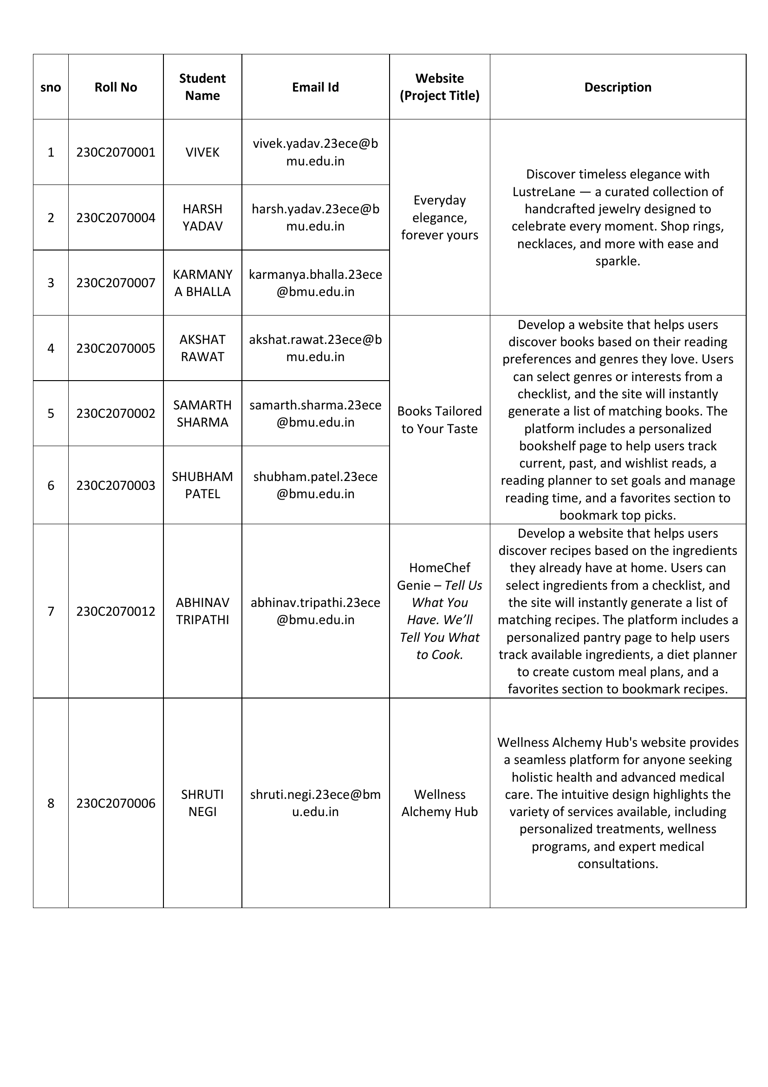

This image is the first page of the embedded PDF.

# 13. Sample Evaluated Internal Submissions and Identification of weak students.

## Learner Categories Summary for Partial Semester

|  |  |
| --- | --- |
| **Learner Category** | **Number of Students** |
| Advanced Learners | 0 |
| Medium Learners | 9 |
| Low Performers | 2 |

## Student Learning Classification for Partial Semester

|  |  |
| --- | --- |
| **Student Name** | **Category** |
| Akshat Rawat | Medium Learner |
| Karan Singh | Medium Learner |
| Vivek | Medium Learner |
| Samarth Sharma | Medium Learner |
| Harsh Yadav | Medium Learner |
| Shruti Negi | Medium Learner |
| Karmanya Bhalla | Medium Learner |
| Diksha Balodi | Medium Learner |
| Ajay Teli | Medium Learner |
| Arepalli Yagnesh Sri Sai | Slow Learner |
| Shubham Patel | Slow Learner |

# 14. Reflections from the Mid-term semester feedback received, and interventions made to enhance the student learning and continuous improvement in teaching and learning strategies.

• Implemented targeted interventions, including additional resources and clarification sessions, based on the identified challenges to enhance the learning experience.

• Encouraged an environment of keeping communication open with students, making sure their opinions help us make teaching and learning better.

# 15. Actions taken for low performers

• Weak students were identified, and they were given extra time to solve their problems.

# 17. Details of Marks in all components up to the End Semester including the grades

|  |  |  |  |  |  |
| --- | --- | --- | --- | --- | --- |
| **Sr.No** | **Unique Id.** | **Student Name** | **Project Evaluation**  **Out of (60)** | **End term examination**  **Out of (40)** | **Grading** |
| 1 | 230768 | Akshat Rawat | 23.0 | 28.75 | C |
| 2 | 230972 | Arepalli Yagnesh Sri Sai | 0.0 | 0.0 | F |
| 3 | 240714 | Karan Singh | 29.0 | 31.5 | B |
| 4 | 230764 | Vivek | 26.0 | 31.5 | C+ |
| 5 | 230765 | Samarth Sharma | 36.0 | 44.75 | A |
| 6 | 230766 | Shubham Patel | 0.0 | 2.75 | F |
| 7 | 230915 | Harsh Yadav | 26.0 | 31.5 | C+ |
| 8 | 230844 | Shruti Negi | 26.0 | 40.25 | B+ |
| 9 | 230864 | Karmanya Bhalla | 33.0 | 40.75 | A |
| 10 | 230872 | Diksha Balodi | 26.0 | 38.25 | B |
| 11 | 230937 | Ajay Teli | 33.0 | 38.75 | B+ |

# 18. Identification of advanced learners and low performers conducted at the end of the semester

## Learner Categories Summary

|  |  |
| --- | --- |
| **Learner Category** | **Number of Students** |
| Advanced Learners | 0 |
| Medium Learners | 9 |
| Slow Learners | 2 |

## Student Learning Classification

|  |  |
| --- | --- |
| **Student Name** | **Category** |
| Akshat Rawat | Medium Learner |
| Karan Singh | Medium Learner |
| Vivek | Medium Learner |
| Samarth Sharma | Medium Learner |
| Harsh Yadav | Medium Learner |
| Shruti Negi | Medium Learner |
| Karmanya Bhalla | Medium Learner |
| Diksha Balodi | Medium Learner |
| Ajay Teli | Medium Learner |
| Arepalli Yagnesh Sri Sai | Slow Learner |
| Shubham Patel | Slow Learner |

# 19. Attendance Report

|  |  |  |  |
| --- | --- | --- | --- |
| **Sr.No** | **Unique Id.** | **Student Name** | **Attendance** |
| 1 | 230768 | Akshat Rawat | 78.72 |
| 2 | 230972 | Arepalli Yagnesh Sri Sai | 76.60 |
| 3 | 240714 | Karan Singh | 92.86 |
| 4 | 230764 | Vivek | 85.42 |
| 5 | 230765 | Samarth Sharma | 89.58 |
| 6 | 230766 | Shubham Patel | 79.17 |
| 7 | 230915 | Harsh Yadav | 87.50 |
| 8 | 230844 | Shruti Negi | 87.50 |
| 9 | 230864 | Karmanya Bhalla | 83.33 |
| 10 | 230872 | Diksha Balodi | 87.50 |
| 11 | 230937 | Ajay Teli | 89.58 |

# 20. CO attainment analysis with the reflection on feedback on course outcomes

## CO Attainment Summary

|  |  |  |
| --- | --- | --- |
| **Course Outcomes** | **CO1** | **CO2** |
| Weights | 52.00% | 48.00% |
| No. of students who scored at the highest attainment level (3) | 0 | 9 |
| Percentage of students who scored at the highest attainment level (3) | 0.00% | 81.82% |
| Attainment Level | 1 | 3 |
| **Overall Course Attainment** | **2.0000** | |

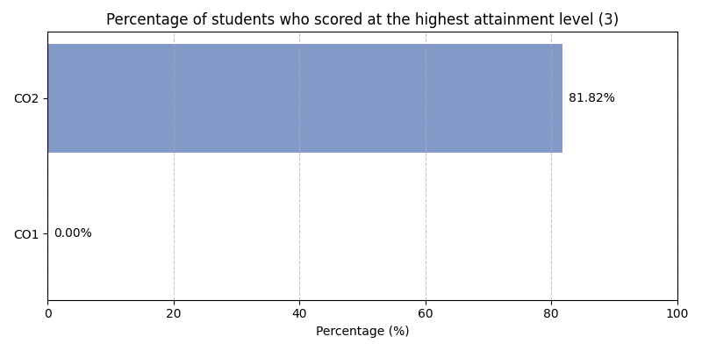

## Program Attainment

|  |  |  |  |  |  |  |  |  |  |  |  |  |  |  |
| --- | --- | --- | --- | --- | --- | --- | --- | --- | --- | --- | --- | --- | --- | --- |
| **Program Outcomes** | **PO1** | **PO2** | **PO3** | **PO4** | **PO5** | **PO6** | **PO7** | **PO8** | **PO9** | **PO10** | **PO11** | **PO12** | **PSO1** | **PSO2** |
| Program Attainment | 1.82 | 1.82 | 2.23 | 2.64 | 2.37 | 2.64 | 2.64 | 0.00 | 0.00 | 0.00 | 0.00 | 0.00 | 1.82 | 2.64 |

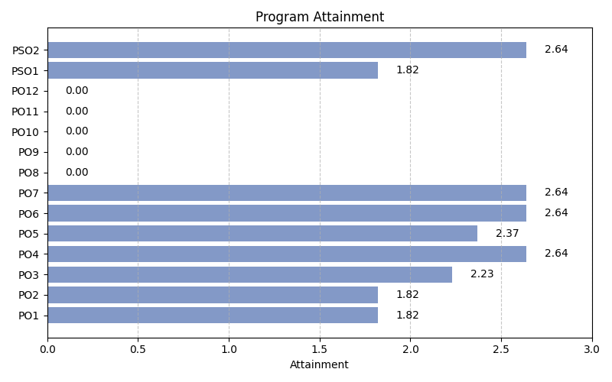

## Student-wise CO Achievement

|  |  |  |
| --- | --- | --- |
| **NAME** | **CO1 Score** | **CO2 Score** |
| Akshat Rawat | 2 | 3 |
| Arepalli Yagnesh Sri Sai | 1 | 1 |
| Karan Singh | 2 | 3 |
| Vivek | 2 | 3 |
| Samarth Sharma | 2 | 3 |
| Shubham Patel | 1 | 1 |
| Harsh Yadav | 2 | 3 |
| Shruti Negi | 2 | 3 |
| Karmanya Bhalla | 2 | 3 |
| Diksha Balodi | 2 | 3 |
| Ajay Teli | 2 | 3 |
| **Average** | **1.82** | **2.64** |

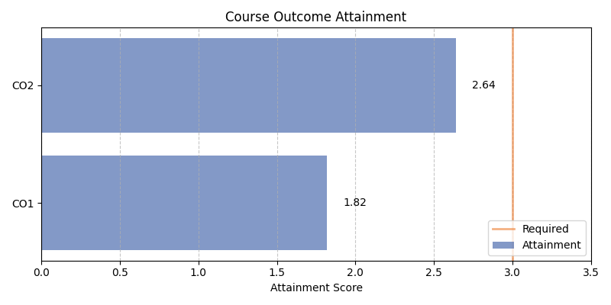

# 21. Feedback (class committee or otherwise) and corrective actions (if any)

**Quantitative Feedback:**

Average Rating: 4.17/5

# 22. Faculty Course Review

The course was designed in such a way that students can relate the theoretical concepts with the practical exercises and can realize how a web page is designed and programmed

✓ The non-graded quiz was conducted at the end of the class to observe the students’ participation in the class. This also helped the students to evaluate themselves with respect to the topics covered in the class.

✓ The students were assigned challenging designing tasks based on the CSS topics discussed in the class.

✓ The students were assigned group projects to work on a particular case study to develop website using HTML, CSS, JavaScript, NodeJS and Templates to provide an aesthetic user experience with appropriate navigation structure.

✓ This course was aimed at enabling the students to design/create website by conducting various activities for remembering, understanding, applying and analyzing level of Bloom’s taxonom