Assignment Description

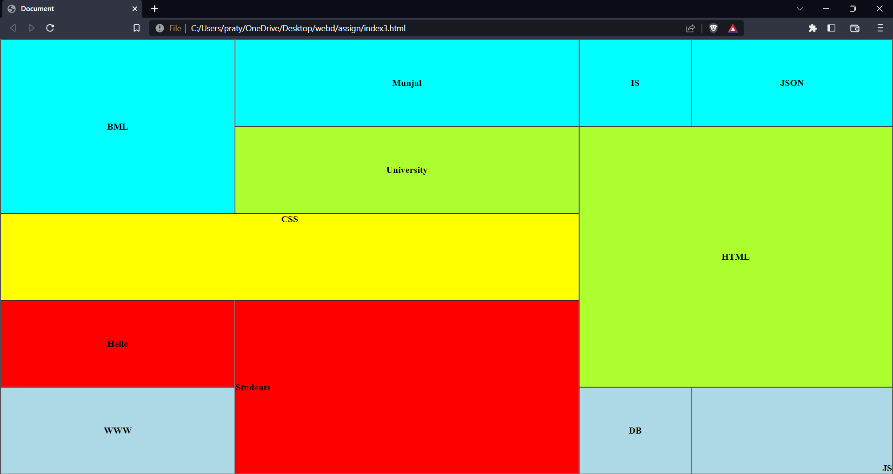

1. Create the above page using html only.
2. Use table, colspan, rowspan, style tags, inline style and align to create the page and align text inside it.

CODE

Html

<!DOCTYPE html>

<html lang="en">

<head>

<meta charset="UTF-8">

<meta http-equiv="X-UA-Compatible" content="IE=edge">

<meta name="viewport" content="width=device-width, initial-scale=1.0">

<title>Document</title>

<style>

.blue{

background-color: aqua;

}

.green{

background-color: greenyellow;

}

.red

{

background-color: red;

}

.yellow{

background-color: yellow;

}

.lb{

background-color: lightblue;

}

table{

width:100vw;

height: 100vh;

font-weight: bold;

}

\*{

padding: 0px;

margin: 0px;

}

</style>

</head>

<body>

<table border="1" cellspacing="0" cellpadding="50">

<tr>

<td rowspan="2" colspan="2" class="blue" align="center">BML</td>

<td colspan="2" class="blue"align="center">Munjal</td>

<td class="blue" align="center">IS</td>

<td class="blue" align="center">JSON</td>

</tr>

<tr>

<td colspan="2" class="green" align="center">University</td>

<td colspan="3" rowspan="3" class="green" align="center">HTML</td>

</tr>

<tr>

<td colspan="4" class="yellow" align="center" valign="top">CSS</td>

</tr>

<tr>

<td colspan="2" class="red" align="center">Hello</td>

<td colspan="2" rowspan="2" class="red">Students</td>

</tr>

<tr>

<td colspan="2" class="lb" align="center">WWW</td>

<td class="lb" align="center">DB</td>

<td class="lb" style="text-align: right;" valign="bottom">JS</td>

</tr>

</table>

</body>

</html>

ScreenShots

