**Challenges and Issues Faced By Local Farmers of Lalitpur**

**District in Supply Chain**

Prashamsha Thapa

Final Research Project

King’s College

Westcliff University

Professor: Anant Tamang

Research Department, King’s College

August 02, 2022

**Declaration**

I hereby declare that the thesis I summited to Kings College Research Committee, titled “Challenges and Issues faced by Local Farmers of Lalitpur District in Supply Chain” is entirely original work I did as a partial requirement for the degree of Master in Business Administration which has not been submitted to any other degree at any other higher educational institution, with the exception of where appropriate acknowledgement have been made.

Prashamsha Thapa

ID No. BN181245

King’s College

# Abstract

This paper exhibits an extensive review on the challenges and issues faced by the various local farmers of Lalitpur district due to unstable supply chain process. The study is entirely base on the information collected from the survey questionnaire of 30 local farmers of Godawari, Chapagaun, Chunikhel, Tikathali and Lubhu who are engaged in agricultural for their income sources and separately interview 5 Local framer, Vegetable market and end customer of Lalitpur Valley. The report is prepared on the base of primary data collection using combined technique. The main purpose of this research is to understand details factors involved in price variation of vegetables from local producer to end consumer along with determining possible solution approach. It present various graphs and charts to illustrate the collected data.

*Keywords:* Local Farmers, Vegetables, Price, Supply Chain, Channel, Market Efficiency, Challenges, Various, Lalitpur

# Chapter 1

# Introduction

## Background of the Research

Agricultural is the art of cultivating soil to produce food and fiber for the welfare of human civilization. It is the foundation of civilization and stable economy of the nation. Since, Nepal is the landlocked country where the majority of population are engaged in agricultural for their livelihood however, only one –third GDP is cover by agricultural where 3,091000 ha of land area has been cultivated for agricultural and 1030000 ha of cultivable land is still not cultivated (Kabita Poudel, Sujan Pokharel, 2019). Though, the agricultural sector has been improved over the last decade, it has still not reach it potential due to which most people in today’s society lack enthusiasm for framing. They are not able to earn adequate amount of profit comparing with the effort and investment required to cultivate the land. Numerous studies in Nepal examine the exploitation of farmers as they didn’t received a fair market share from the product they produce (Deepak Ratna Tuladhar, 2017). Unstable supply chain is one of the major challenges faced by local farmers in commercialized agricultural.

A supply chain is the systematic approach of entire production process and delivering good and services from the initial stage of sourcing raw material to final delivery of output (Stephen A LeMay and Marilyn M. Helms, 2017). Supply chain management is a network between manufacturing processes to end consumption which include various stage of activities. It encompasses everything from the delivery of sources materials from the supplier of manufacturer through to its eventual delivery to the end user (Irina Albastroiu Nastase and Mihai Felea, 2013). Likewise, supply chain has play a vital role in agricultural sector which is highly domain by multiple of channel. In order to create an efficient supply chain, it is necessary to improve all levels of infrastructure, including input delivery, credit, procurement, post-harvest loss reduction, the establishment of cold storage chains, the lunch of processing facilities and marketing strategies and the development of storage facilities and marketing data. However, in agricultural market of Nepal, supply chain practices has create monopolistic situation due to which local farmer are compelled to sale fresh product at low price in market. The high involvement of supply chain has its own pros and corn, nevertheless though it has provided the market place for the local farmer to sale the product in large volume but due to uncoordinated supply chain approach they are unable to earn sufficient income.

In present context of Nepal, in Lalitpur District there are various local farmers who have been involved in agricultural for commercialized market. Among horticulture commodities, most of local farmers engaged in cultivating vegetables for the economy growth. Moreover, due to perishable nature of vegetable, it is highly challenging for the local farmer to keep the product fresh for long period of time. So, at initial phase farmer are slightly interested to collaborate supply chain approach but later on due to unstable supply chain they become demotivated. Supply chain process incorporate multiple channel like first (producer-retailer -consumer), channel second (producer-wholesale-retailer- consumer), channel third (producer-cooperative-retailer- consumer), channel fourth (producer- collector- wholesaler- retailer- consumer) and channel fifth (producer- wholesaler-processor- wholesaler- retailer- consumer) (Hemlal Bhandari, Thaneshwar Bhandari, Krishna Prasad Timsina and Hari Krishna Panta, 2021) which hold big impact on price inflationary cycle that directly affect the local farmer and end consumer. In this study, I will be identifying that how the local farmer are facing problem in supply chain approach.

* 1. **Rationale of the Study**

While pursuing my MBA at King’s, I worked in food and beverage industry named Dining Park Restaurant and Lounge Bar who has been involved in providing hospitality service for two and half years. Food industry provided an indirect sustainable contribution to develop the agricultural sector of the county. This organization is consider to be valuable platform where maximum of the vegetable product are been use to convert into final cuisines. Embracing unique competitive advantage this organization has also started organizing “Organic Farmer’s Mart” every Saturday where local farmer get an opportunity to make direct interaction with end consumer. While, working there as sale executive, I get an opportunity to understand the problem of the unsatisfied local farmers who are not able find right placement in market for their product. Thus, I have seen problem in this component of which has encourage me to execute this research.

This research is conducted in Lalitpur district base on the field survey where half of the population are still depended on cash crop for their economy. Study select five municipality of Lalitpur district Godawari, Chapagau, Chunikehl, Thikathali and Lubhu and the respondent has been randomly selected. Despite of being agricultural county, Nepal is still late back in distributing sufficient vegetable and fruits in the local market. Although, large proportion of population are engaged in farming, the sector contribution to the national GDP seems to be in decreasing ratio. In 2016, agricultural contributed 29.15% of the country’s overall GDP. Additionally, only 27.08% of national GDP was contributed in 2017. The trend is continuously falling and reach up to 24.26% in 2019 (Saugat Khanal and Pramod Gyawali, 2021). There are various crops grown in Nepal by local framers but due to the inappropriate supply chain process both produces and consumer are dealing with their own challenges. In today’s context, consumer are suffering from the problem of “Price hikes in vegetables and fruits but still not able to purchases quality food. Similarly, local framers whose economy is fully depend on agricultural are getting low returns out of their investment and effort (Deepak Ratna Tuladhar, 2017).The acknowledgment of various problem regarding the unsystematic supply chain in local product can help all those local framers as well those people who are planning to get engaged in agribusiness. It will help them to find out the appropriate information for the business plan.

* 1. **Problem Statement**

As stated earlier, there has been done few research which can add valuable insight of various study along with possible solution to improve the Agribusiness in Nepal. More than 66% of population are been engaged in agricultural sector where more commercial- oriented end of framing including in small holding. Though irrigation is a tough work where farmer invest lot of time and energy to produce product however, they are not often appreciated and not able to earn the sufficient income. Similarly, from the perspective of end customer they are also not getting fresh quality product out of their investment. Likewise, Nepal government has been busy importing vegetables and fruits from India due to rupture in Nepal's Agriculture Supply Chain. Fragmentation in the supply chain has been the major issue for Nepal. So, this research is attempt to understand the challenges and issues face by local farmer in supply chain approach while being commercial oriented.

* 1. **Research Objective**

*General Objectives:*

1. To find out the major challenges faced by the local farmers of Lalitpur district in supply chain trend.

*Specific Objectives:*

1. To find out the major challenges faced by the local farmers of Lalitpur district in supply chain trend.
2. To analysis the actual gap between prices of product produce by local farmers and consumption price of end consumer.

**1.5 Research Question**

1. What are major challenges faced by the local farmers to sell their product in market?
2. What are potential solution to address the problem of supply chain local farmers?

**1.6 Limitation of the Research**

1. The limitations on time and money for conducting the research.
2. Since the research emphasis on the Lalitpur District, it may not accurately reflect the challenges and issues face by the local farmer in supply chain throughout the nation.
3. As the study is based on responses, there is a chance respondent’s prejudice and inaccurate information will have an impact on the findings.
4. As I could not find enough articles about the problem face by local farmers in supply chain process of Nepal agricultural sector or Lalitpur District, the articles relates to problem of local farmers while selling product in market of Nepal are used as reference.

**Chapter 2**

**Literature Review**

Agribusiness in Nepal has wide scope however agricultural development has been sluggish and unable to keep the pace with population growth. Observing the recent trend of Nepal, most of the population who used to be farmer yields to find the security in remittance for the livelihood. Although, few researcher and agricultural specialists has conduct their own research and finding but still lack to improve the agricultural sector for the economy growth of the nation. Nevertheless, the major concern in today time of agricultural sector is that those few local farmers who income is fully depend on cultivation are facing challenges in earning sufficient income due to the high involvement of uncoordinated supply chain which has not been the discussed much as matter of problem. So, I examined the following three articles in order to obtain some theoretical understanding of the subject for my research. The first article present the review on analyzing supply chain process of vegetables from Dhading to Kathmandu, the second article talks about potential approach of commercialization of smallholder farming and third one illustrated the significant of Peri-urban Agricultural method which hold an attributes to produce fresh food availability un urban dwellers. These articles are all connected to my research topic in some way.

|  |  |
| --- | --- |
| Improving Supply Chain of Local Products to Markets | |
| Paper Reference | Deepak Ratna Tuladhar. (2017). Improving Supply Chain of Local Products to Markets. *Parliamentary Committee on Agriculture and Water Resource*, 78. Retrieved from https://daayitwa.org/storage/archives/1583127491. |
| Brief | The article on “Improving Supply Chain of Local Products to Markets” is prepared by Deepak Ratna Tuladhar (2017) from Nepal with an aim to understand and study the stakeholders involved in the supply chain of vegetables from Dhading district to Kathmandu. The research paper provided an information about the incredibly difficult condition face by the framer who do not obtain fair price for their product while consumer have always questioned the extreme increase in price of these product. It suggest that effective supply chain management reduce cost an improve productive for the long run sustainability. In order to manage supply chain process this paper suggest to reduce high the involvement of intermediaries and develop good policy and transportation system with the support from government.  The research exhibited descriptive analysis and has applied purposive sampling technique for data collection from the 11 food collective center located in the highway belt of Dhading. Compering the selected localities of Dhadhing Besi, Charaundi, Benighat and Naubise, collection center of Naubise seem to collect 40% of product. The data for this paper were collected through questionnaire survey, focused implications of 61% farmers among which high number of female farmers actively involved in transportation of vegetables from their farm to collection centers. |
| Critical Analysis | The majority of respondents were selected from farmers and traders who hold minimal education background inside the Dhading. Since, this study focused on the supply chain of vegetables from the district of Dhading to Kathmandu which may not reflect the accurate finding of other area and location due to difference in geographical context of market. The study’s conclusions might not accurately reflect the status of other farmers and customer who sources of economy is full depend on agricultural. Similarly, most of the respondents were female farmers and different collection centers has been selected as sources of data collection Therefore, the findings cannot be applied to entire farmers of Dhading, |
| Statement of Relevance | As 61% of the total sample used in this study were farmers and the study was precisely based on Dhadhing district, the major finding of the paper represent the context of female farmers in the location seems to be domain up to certain extent. So, the topic of the article, area of study as well as method used for analyzing and representing the data will be useful for my study too. |

|  |  |
| --- | --- |
| The Commercialization of Smallholder Farming—A Case Study from the Rural Western Middle Hills of Nepal | |
| Paper Reference | Gc, R. K., & Hall, R. P. (2020). The commercialization of smallholder farming—a case study from the rural western middle hills of Nepal. Agriculture, 10(5), 143. |
| Brief | The paper aim to examine various perspectives (from rural farmers to development experts) on the limited commercialization of rural agriculture of Nepal and the potential approaches to promoting agricultural growth and commercialization among small landholder. This study present the importance of sustainable supply chain lead to the sustainable demand and also talk about the impact of remittance on agricultural development. It articulate the concept of commercial pocket approach that establish to mobilize local farmers to produce marketable volume and create community collection center. Development of local market may overcome the uncertainty of sales and maximizes income. Local market can provided an easy access to distribute perishable good promptly in effective price.  This article emphasis on promoting the commercialization of agricultural sector of rural middle hills of Nepal. Most of the farmer in this area have limited experience in selling the commodities in formal market. So, this paper determines appropriates polices to introduce the commercialization of small household farming though technical approach such as adequate access of irrigation, improve production technologies and practices along with determining the opportunity for high value crops. |
| Critical Analysis | As this report is based on commercialization of small household which has mainly focused on finding actual scenario of agricultural status of western middle hill regions that might not cover the large extent scenario. The conclusion of the report present the various potential technical approach and emphasis on promoting high value crops for commercial market. However, it doesn’t reveals about the practicable techniques and particular crops which can be cultivate in every season for commercial business. Though the study present various approaches of commercialization which provided the extensive overview of supply chain. |
| Statement of Relevance | Commercialization of small household farming is consider as the significant component of agricultural development. This report exhibit several approach of commercialization which include, production training and capacity building, access to irrigation system, access to agricultural input, services and market, use technologies, measure risk and promote high value crops. In order to reduce the uncoordinated supply chain, this study suggest to established local managed market facilities that link traders and farmers directly which can add valuable insight for my research topic to large extent. |

|  |  |
| --- | --- |
| Farmer’s Choice and Farmer’s Voice on the Use of Local versus Modern Inputs in Peri-Urban Agriculture in Kathmandu Valley, Nepal | |
| Paper Reference | Sapkota, K. (2009). Farmer’s Choice and Farmer’s Voice on the Use of Local versus Modern Inputs in Peri-Urban Agriculture in Kathmandu Valley, Nepal. Geographical Journal of Nepal, 7, 15-22. |
| Brief | The article, “Farmer’s Choice and Farmer’s Voice on the Use of Local versus Modern Inputs in Peri-Urban Agriculture in Kathmandu Valley, Nepal” aim to explore an extensive review on conflicting information about Peri urban agricultural method from the scientific and local perspective. It identify the significant location for commercialized irrigation system nearby the major market demand centres like Patan and Kathmandu. It emphasized specific on Manahara river basin land for producing varieties of seasonal vegetables for the urban dweller of Kathmandu valley. Madhyapurothimi is renowned as the favorable area around Bhaktapur district for irrigation. Large group of age from 35 to 55 population seem engaged in cultivation as per the survey conduct in the research, The survey was undertaken using source of data collection for preferable cultivation sites.  The paper acknowledge the practices of farmer on local versus or modern inputs on prei - urban agricultural based on information collected from twenty framers of Madhyapurithimi municipality. Observation protocol sheet and in-depth interview with ward chairman, senior citizen and agrovet shopkeeper were undertaken to gain overview about the Peri Urban Agricultural System for the agricultural development in urban area. It further elaborate on the impact of encroaching urban sprawls on production of vegetables. The study also talks about the both merits and demerits in excessive use chemical fertilizers and pesticides lead to the increasing production ratio but has adverse impact on intensified cropping and damage fertile soil. |
| Critical Analysis | Due the lack of education, farmer of Nepal are compelled to adopt traditional practices of irrigation which has create huge impact on national economy. Since, this paper focused on prei urban agricultural system in cities where farmer can have easy access to direct population but due to increasing ratio of urbanization they can’t produce large volume of production in order to commercialized business. Implementation of techniques practices generate quality product however due to low area coverage they might not be able to fulfill the needs and demands of the consumer in right time. |
| Statement of Relevance | Prei urban agricultural approach refers as the cultivation of crops within the available to surrounding of cities for fresh food and reuse of urban waste. Roof top hydroponics is consider to be one of the best techniques of urban agricultural system which has been implemented by few farmers in Nepal for commercialized business. As my research is based on issues of local farmer of Lalitpur valley, the finding of prei urban agricultural system will definitely provide additional value to understand the opportunity to deal with direct market. This study also determine the impact of using local versus modern inputs which would adversely affected on the texture of soil that lead to ultimately result of the production. The information about the Thus, this article is relevant for my paper. |

**Chapter- 3**

**Research Methodology**

**3.1 Area of Study**

Lalitpur District which cover total area of 385 sq.km is selected as the area of this study where 152.96 sq.km land has been use for cultivation respectively (Imagine Lalitpur, 2003). Geographically, this district is divided into three different diversities; urban area, semi- urban area and remote or mountain area which have natural potential to produce organic and fresh vegetables for the overall population of the area. So, the study conducted within local farmers, Entrepreneurs, vegetable market and end consumer of Godawari, Chapagaun, Chunikhel Tikathali and Lubhu who has been involved in agricultural business. Apparently, increasing number of population has cause haphazard urbanization in Lalitpur district however, the local population of this area has understand the importance of cultivated land but due to the low income they are discourage to engaged in agricultural for sustainable growth. One of the major reason of low return is due to the involvement of unstable supply chain. It will help us to find out the challenge faces by local farmers in supply chain. Since, being a local citizen of Lalitpur, I have been observing surrounding of my maternal home Godawari where most of the people embrace agricultural as their occupation; the study within three district Kathmandu, Bhaktapur and Lalitpur, choosing the particular area definitely help me to collect more relevant data.

**Figure** **1**

*The Study Area*

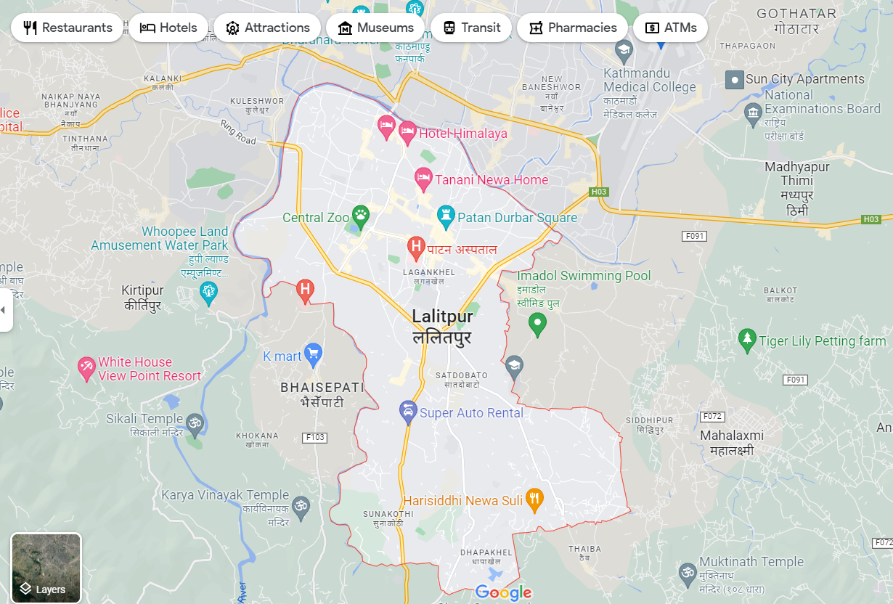

*Note:* Lalitpur District, Google Map, 2021

(<https://www.google.com/maps/place/Lalitpur/@27.6574644,85.2881324,13z/data=!3m1!4b1!4m5!3m4!1s0x39eb19d3cf18ca51:0xd10ec3d53656e18f!8m2!3d27.6587525!4d85.3247183?hl>)

**3.2 Research Design**

In this paper, the exploratory and descriptive research design are combined together for constructive output. Basically, the exploratory research design aim to provide insights and clarity of understanding the problem faced by the researcher for conclusive evidence. It is consider as first step that discover ideas and thought for deeper understanding along with that it is flexible in nature. Likewise, the descriptive research design on the other hand, aim to describe a phenomenon of the situation by addressing main functions and characteristics. Since, descriptive study is based on both qualitative and qualitative data, for this study I will be using survey questionnaires as well as interview question to gather information and data for the investigation of the topic. In this paper, I have tried to understand about the challenges faced by the local farmers of Lalitpur in supply chain approach while delivering the product from production to end consumer. This is why; it resembles the characteristic of descriptive research where survey questionnaire was undertaken for data collection.

**3.3 Data Collection Method**

The techniques for gathering primary data, which were questionnaires, are described in this section.

1. Prime Data: Primary data was collected using survey questionnaires and interview to local farmers, Entrepreneurs, vegetable market of Lalitpur and end consumer. The information from the respondents was gathered though the use of structured questionnaire.
2. Secondary Data: Secondary data was gathered through literary sources, a review of published literature, including journals, papers, published theses and textbooks.

**3.4 Nature and Sources of Data**:

Survey questionnaire and interview was conducted to analysis the data. Primary data has been used for the purpose of this research. Along with that secondary sources like journals, articles, publisher theses and textbooks has been applied in order to gain knowledge and insights about agricultural development and its challenges in context of Nepal.

**3.5 Research Type**

The combined research is employed because it incorporates certain element of descriptive and exploratory research design. Similarly, both qualitative and quantitative data are gathered thorough the use of techniques including questionnaires, interviews and focused group discussion.

**3.6 Sample Size and Design**

As the study was conducted on the issues of local farmer of Lalitpur, the population of the study was 30 local farmers, Entrepreneurs, vegetable market who are being involved in agricultural sector for their income and end consumer experience of purchasing vegetables. 30 samples were selected using convenient sampling for the data collection though survey questionnaire. Likewise, 5 local farmer, Entrepreneurs, vegetable market and end consumer were undertaken for interview.

**Chapter 4**

**Findings and Discussions**

* 1. **Local Farmers (Entrepreneurs/ Vegetable Market and End Consumer)**

The data collected were used to study about the following issues and challenges faced by local farmers in supply chain process. Considering Lalitpur as my hometown, increasing in vegetable price appears to be major problem right now. Similarly, those farmers who are involved in cultivation for commercial purpose are also dealing with own challenges of low return out of their effort and investment. In order to conduct this research, sample survey has been undertaken within the local people from Godawari, Chapagaun, Chunikhel, Tikathali and Lubhu of Lalitpur District. The questionnaire is conducted among the local farmers, Entrepreneurs, vegetable market and end consumer base on location, gender, age and level of education.

***Geographical Location***

Figure 1: The average number of respondent as per Location

From the above figure, we can clearly see that most of the household and farmer from Godawari are engaged in agricultural sector in compare to Chapagaun, Chunikhel, Lubhu and Tikhathali for commercial purpose. Similarly, the figure also present that people from Lubhu area also depend on cultivation for their economy. Likewise, few of the respondent from Tikhathali, Chapagaun and Chunikhel are adopting traditional techniques of cultivation for long run growth. Since, I have chosen Godawari as core area for survey so major involvement of respondent are from this location.

***Gender of Respondent***

Figure 2: Gender of Respondent

The data clearly shows that lager number of female are been working as farmer who has been growing different seasonal vegetable and been able to sales them in market for their living hood. Moreover, number of male has also been involved in agricultural sector however due high influence of remittance in Nepal most of the male population are interested to work in foreign country as labor. While conducting survey, there are few male who has shown interest in find the huge scope in agricultural sector rather than choosing abroad for the opportunity but the graph represent that the ratio of female seem to be highly engaged in farming because due to the excessive land there are forced to the cultivated land.

***Age-group of respondents***

Figure 3: The average age group of respondents

Bases on the data collected, we found that most of the local farmer between age group of 50 to 60 are highly interested and been doing farming. The reason behind high engagement of this age group in agricultural is because they are unemployed, but have excessive land which is only the opportunity to cultivated the land for earning income. Those who are below 30 age group doesn’t have any interest in agricultural. Similarly, the age group of 30-40 belongs to energetic adult group who are highly preferential towards corporate work rather than working as farmer. Likewise, those people whose age is in between 40 to 50 has also been doing cultivation but also been engaged in doing job so the ratio seen to be quite less.

***Average Level of Education***

Figure 4: The average level of Education of local farmer

The graph represent that, majority of farmer from the Lalitpur district who have been cultivating vegetables for commercial business seem to be educated. The figure show that high number of farmer have completed SLC. Since we have conduct survey sample within the Lalitpur District, so most of the local people of these area able to gain basic education facilities. Likewise, there are few number of farmers who have also complete plus 2 and come up with business ideas of vegetable farming for the long run sustainability. Remaining local farmer have attend 7,5,4,2 class and some of them are uneducated too.

***Are you the only member of your family engaged in agricultural? (Average percentage of family engaged in agricultural)***

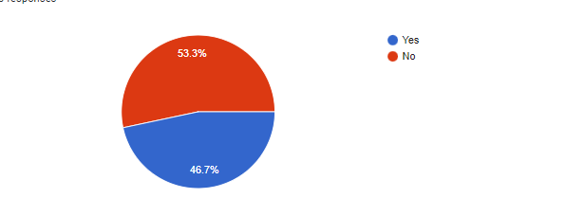

Figure 5: The average percentage of family engaged in agricultural

The data clearly shows that, majority of the population of local farmer family in Lalitpur district are involved in farming. More than 53.3% of the household local people are currently depending on cultivation. However, 46.7% of people consider themselves as one in family who have been working as farmer and rest of the family member depend on job for earning. Therefore, we can’t see huge difference in percentage between Yes and No for answering only the member of family been engaged in agricultural or not.

***Percentage of farmer considering Agricultural as main occupation***

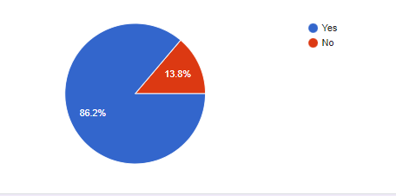

Figure 6: Percentage of farmer considering Agricultural as main occupation

From the collected data, we can see that about 86.2% of local farmers have consider agricultural as the main occupation. Around 13.8% of population are working as an employee in different organization for earning. Therefore, increasing percentage of agricultural clearly shows the great opportunity of agricultural to be the major occupation of the Lalitpur.

***Average types of crops grown by farmers***

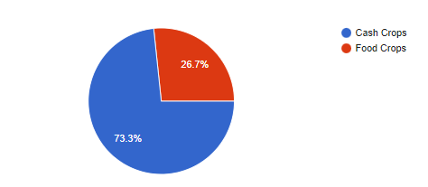

Figure 7: Average types of crops grown by farmers

Above figure illustrated that most of the farmer in Lalitpur are interested to cultivate vegetables for cash crops. We can see that about 73.3% of local farmers are engaged in cash crops whereas only 26.7% of local farmers are growing vegetables for food crops. It show that cash crops has high potential scope in developing agricultural sector.

***Average percentage agree and disagree farmer who prefer to sells vegetables though supply chain process***

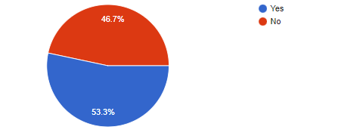

Figure 8: Average percentage agree and disagree farmer who prefer to sells vegetables though supply chain process

As per the chart present above, the majority of local farmers agree to sells there vegetables though supply chain. Around 53.3% of farmers prefer to sales their product through supply chain process. Most of the farmer are unable to find out the right market place so they are more likely to choose channel of supply chain. However, 46.7% farmers simultaneously disagree to sales their goods from supply chain approach due to the low margin. Both farmers have their own valid reason and perception towards the approach of supply chain.

***Opinion of local farmer on profit between Distribution Channel and Direct End Consumer***

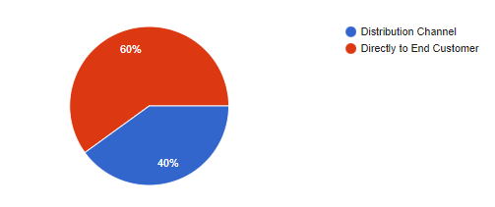

Figure 9: Opinion on profit between Distribution Channel and Direct End Consumer

The figure show that, majority of people consider direct sales to end customer as profitable medium for local farmers. More than 60% of farmers present their opinion to sales the product directly to the end consumer in order to maximize the profitability. They also talk about the availability of fresh organic vegetable in reason price which will add value to both local farmers and customers. While 40% of people are looking forward to sell the product through distribution channel. They believe that selling product to distribution channel will reduce the time and effort of finding appropriated market.

***Average Percentage of annual Income earn by selling vegetables***

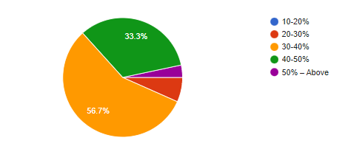

Figure 10: Average percentage of annual income earn by selling vegetables

The data clearly show that the average annual income earn by local farmers of Lalitpur district is around 30-40%. Similarly, the trend of earning goes on decreasing from the ratio of 40-50%, 20-30% and 50% above. Most of the population are able to earn average percentage of income which is much more less in compare to the production cost. So, figure definitely present the low income source in agricultural sector which has been demotivating farmers to do cultivation.

***Method of farming to increase productivity***

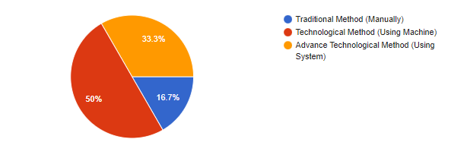

Figure 11; Method of farming to increase productivity

Since Nepal is developing country

per the graph various farmers are still In