ARITHMATIC OPERATIONS 192110441

PROGRAM K.Praveen Kumar

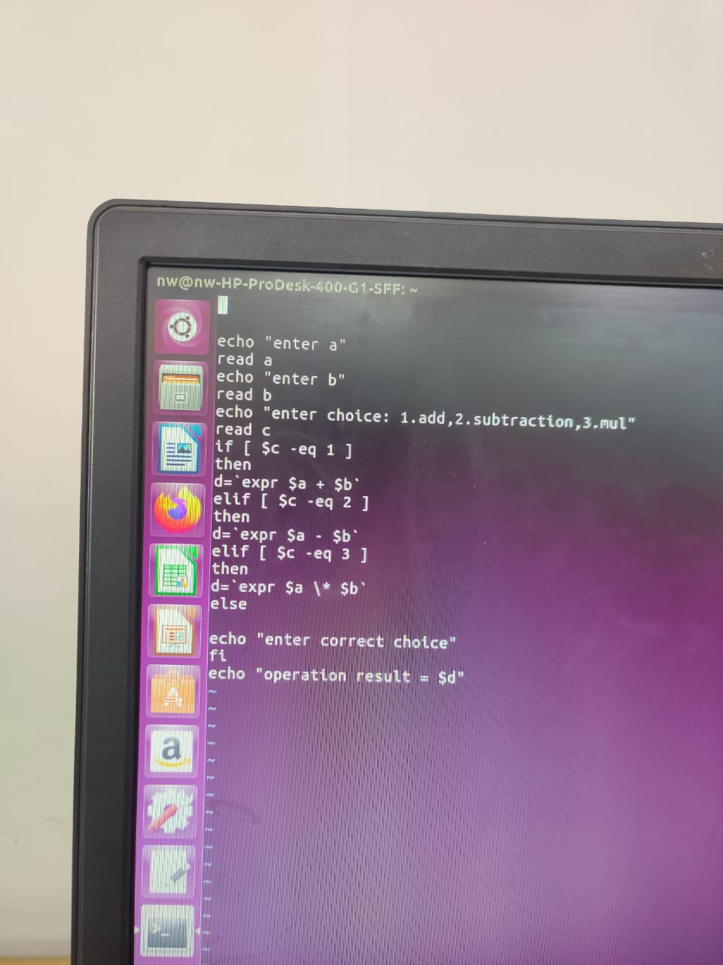

OUTPUT:

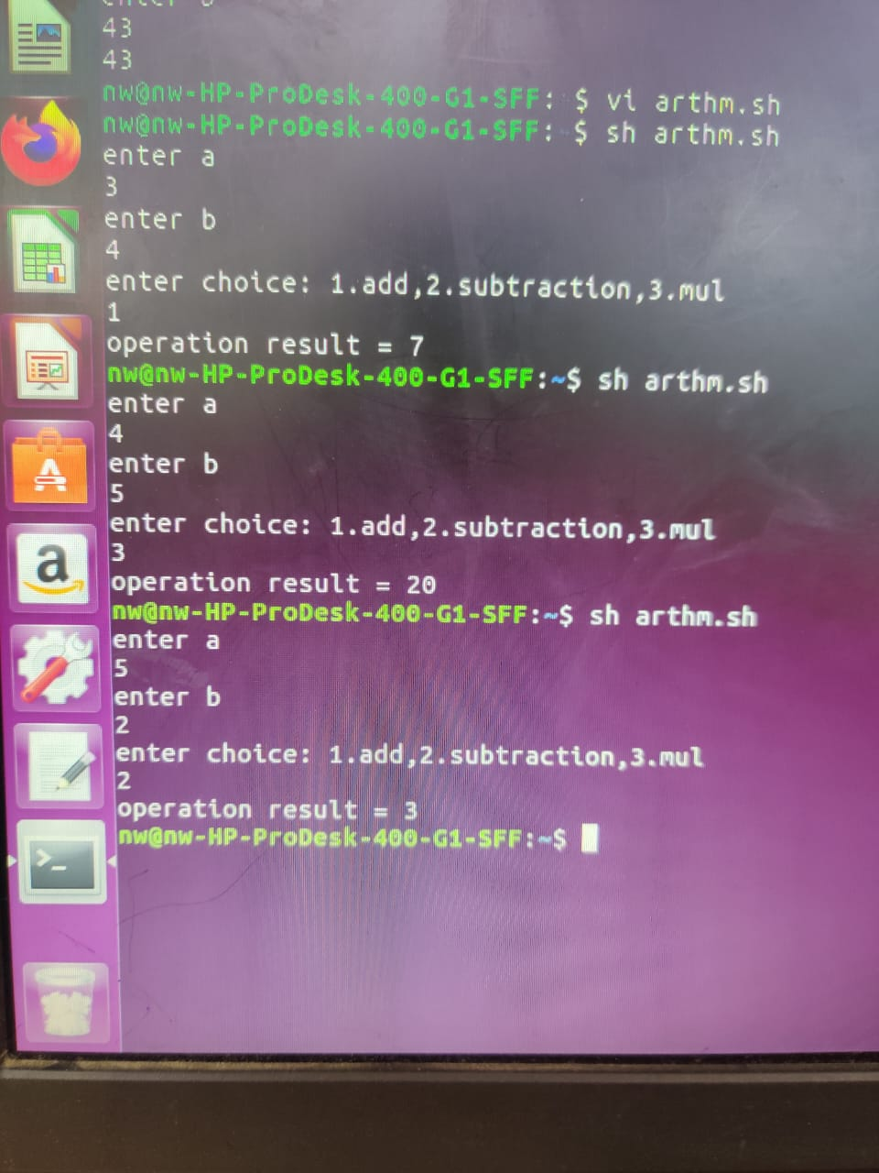

GREATEST OF TWO NUMBERS

PROGRAM

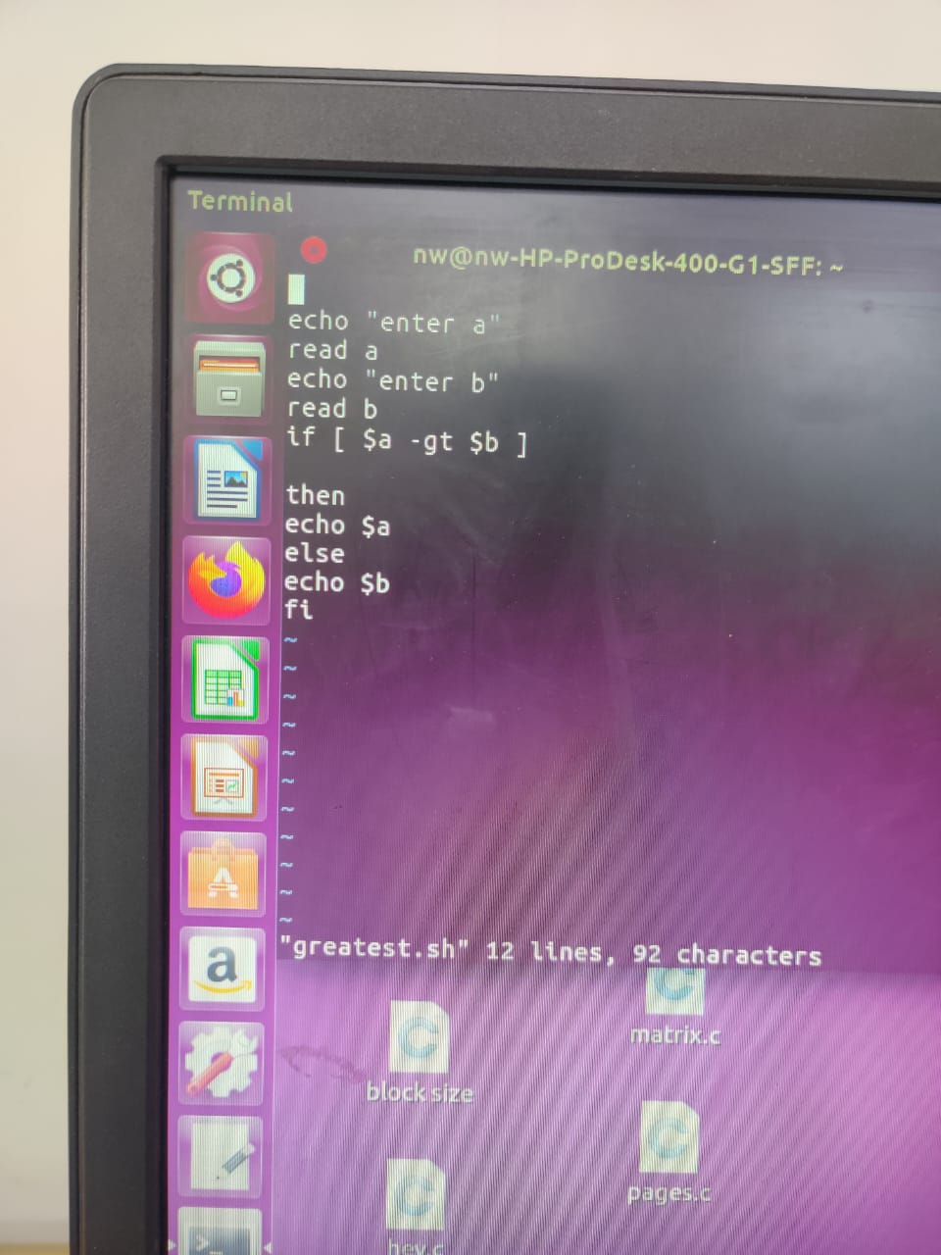

OUTPUT:

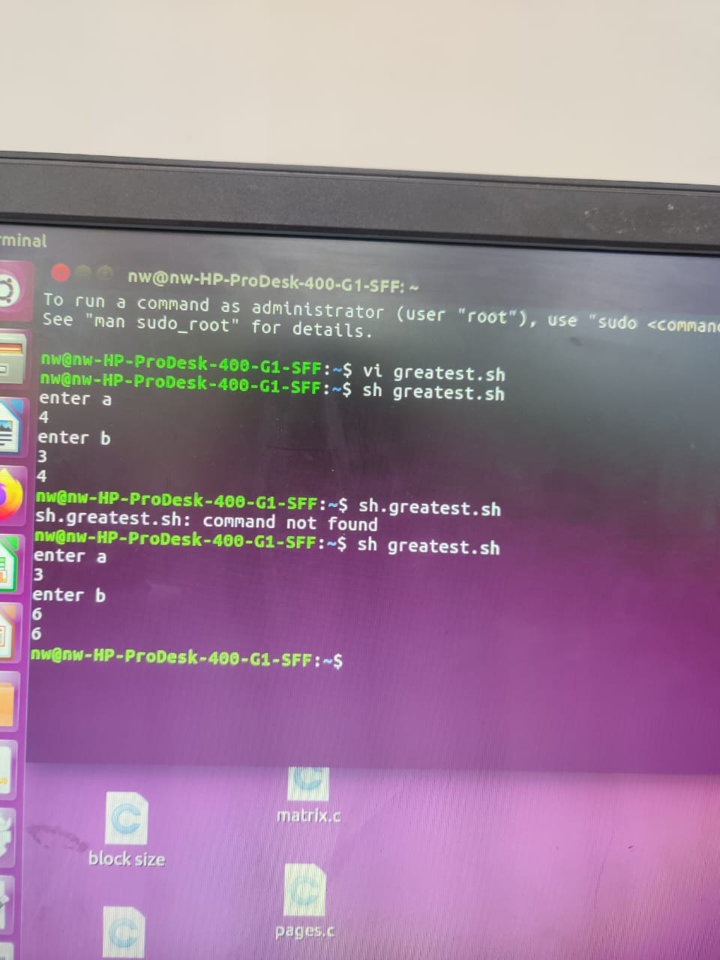

POSITIVE OR NEGATIVE

PROGRAAM

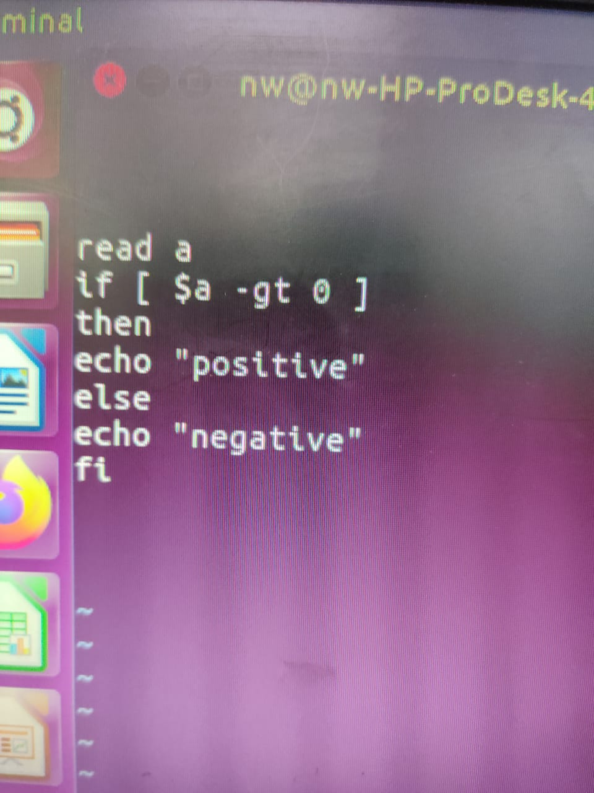  
OUTPUT:

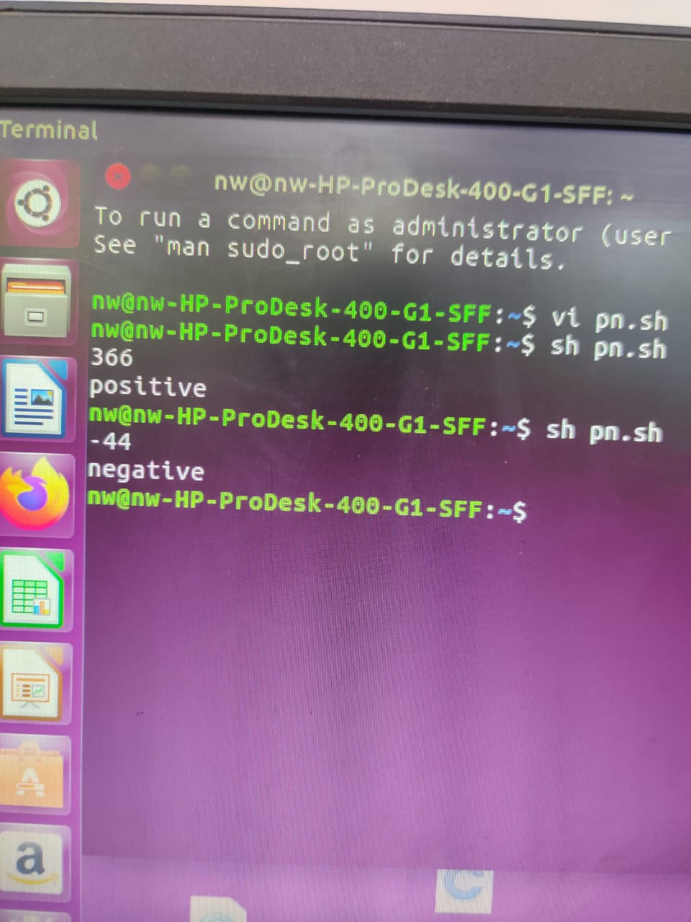

EVEN OR ODD

PROGRAM

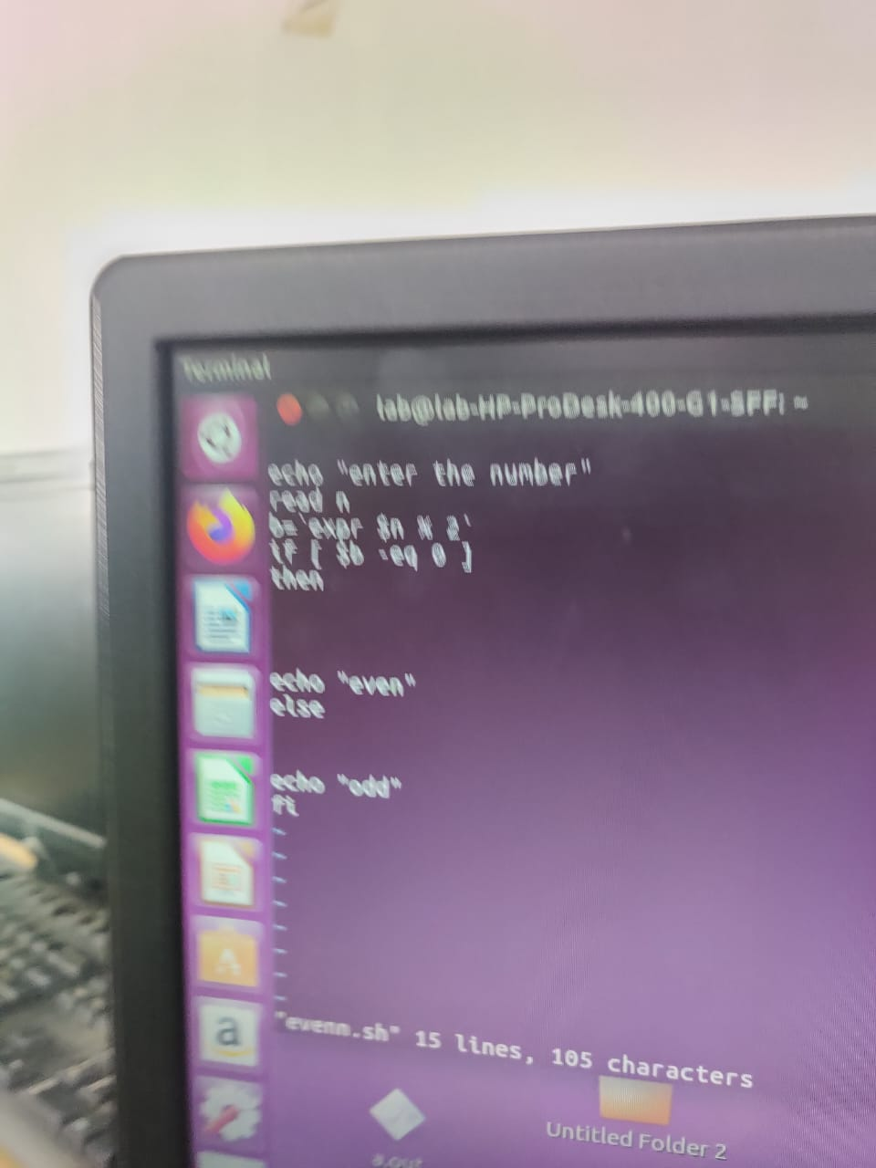

OUTPUT:

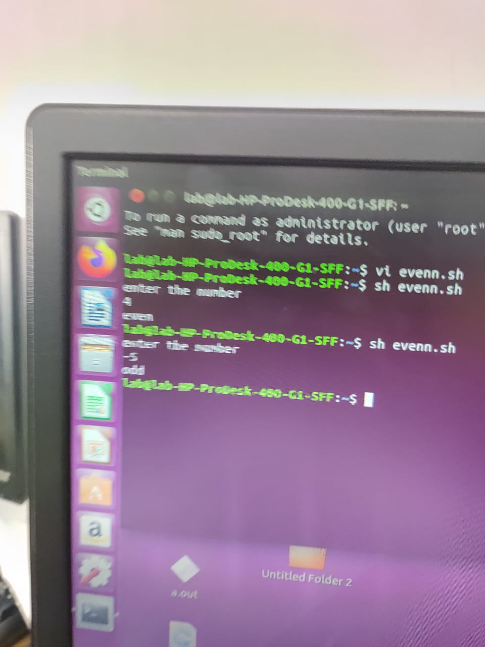

SWAPPING OF TWO NUMBERS

PROGRAM

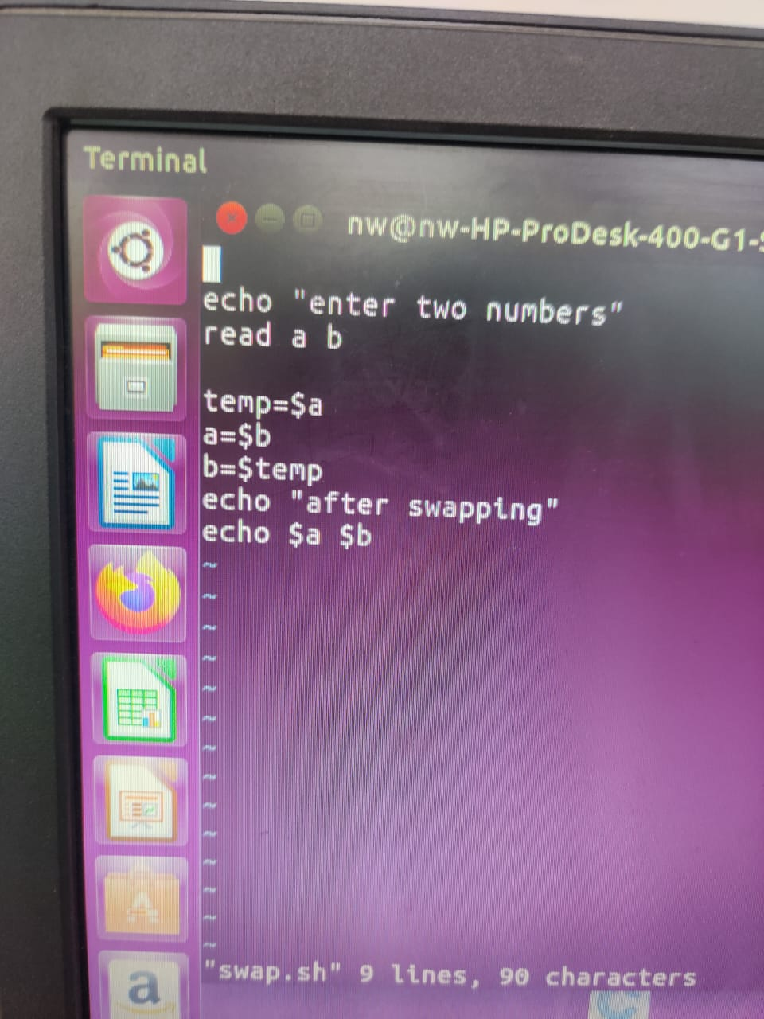

OUTPUT:

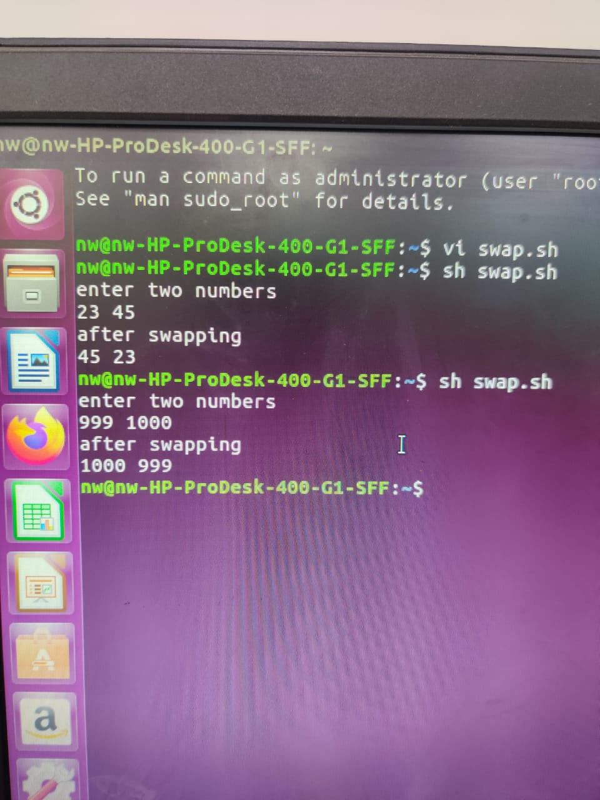

LEAP YEAR OR NOT

PROGRAM

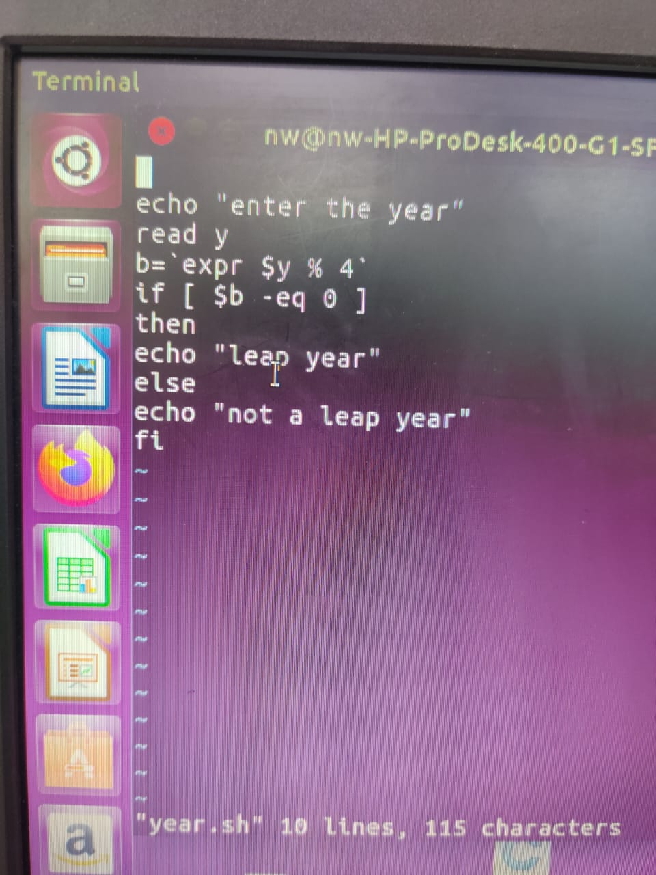

OUTPUT:

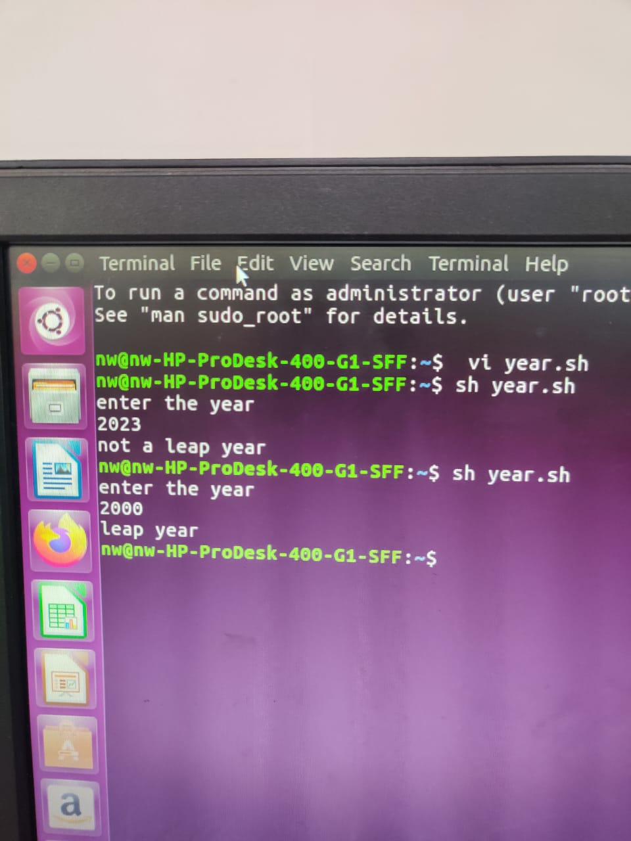

FACTORIAL OF A NUMBER

PROGRAM

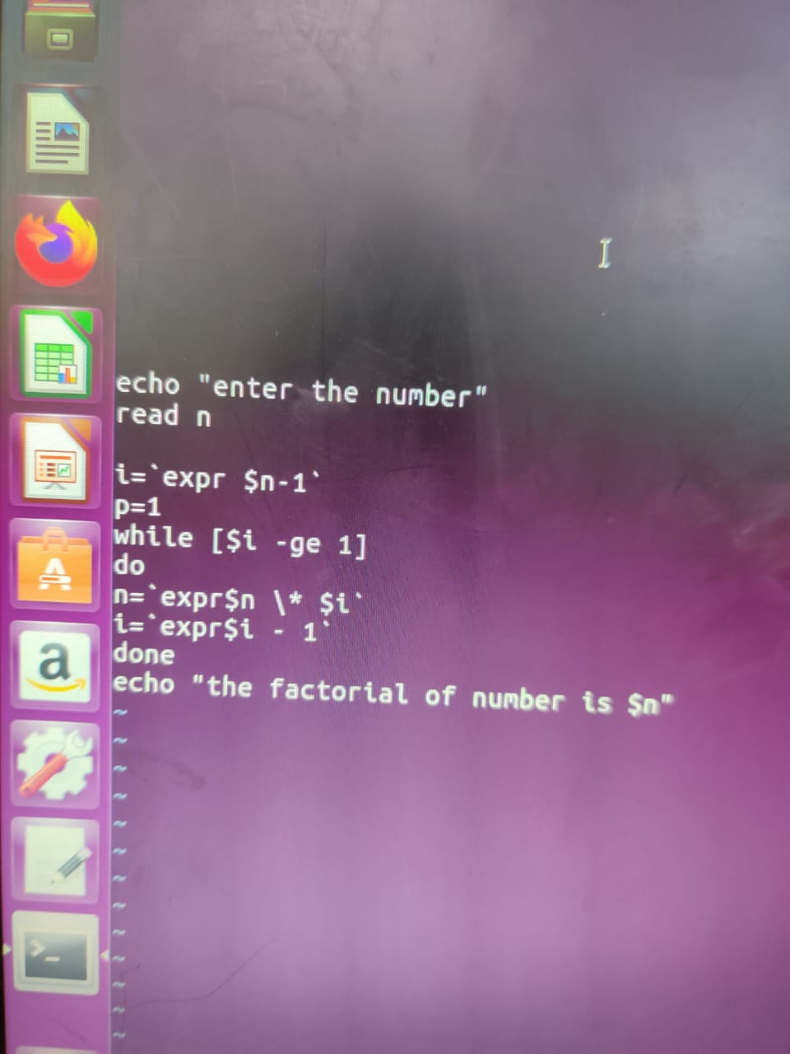

OUTPUT:

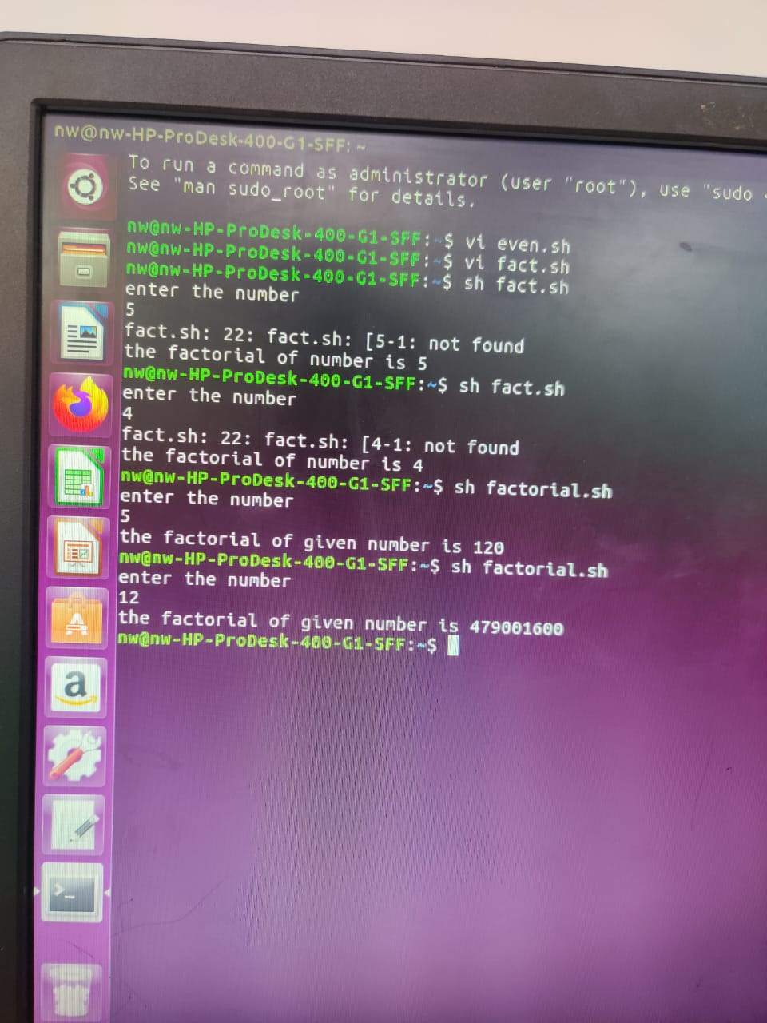

ADDITION PF TWO NUMBERS

PROGRAM

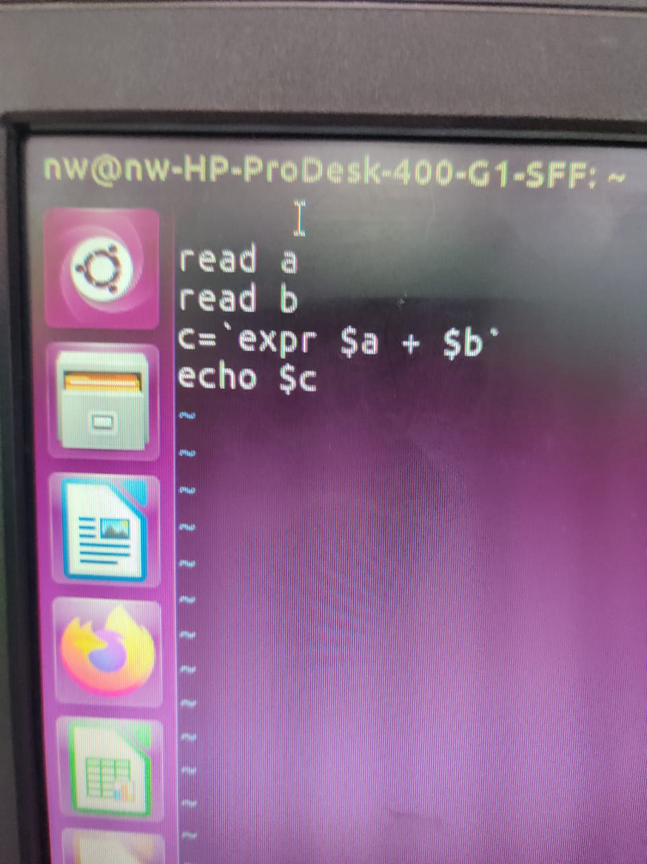

OUTPUT:

