**Navis – Auto Deploy**

Porting of N4 Configuration

Objective

* A generic tool kit to export from Source system and import it in Target system(s).
* All or selective configuration selection.
* Used standard product feature of SNX export and import.
* Same of Different topology to port from one environment to another environment.

Supported Entities

* Code Extension
* Groovy Plugins
* Database Backed Variform
* General Notices
* General References
* Groovy Job
* Event types
* EDI Session
* EDI Message Type
* Extension Trigger

Steps to port the configuration

**Steps 1:** Load the given URL eg. (<http://localhost:5000>), below screen should be visible.

**Home Page**

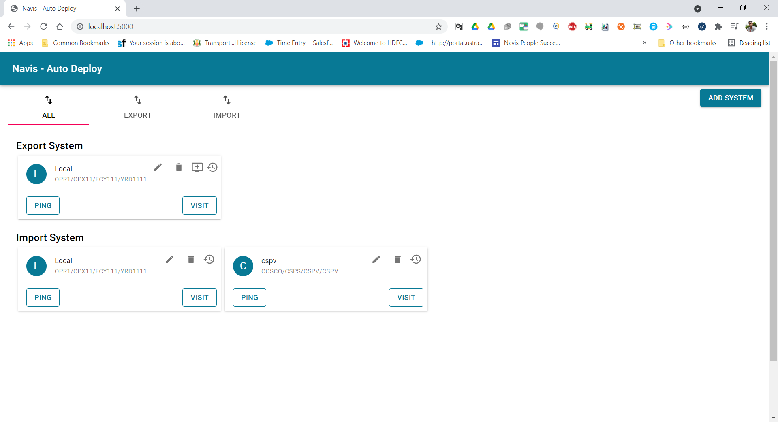

Export and Import system should be visible if it added before.

* **Export Systems:** From where you want to export the entities.
* **Import Systems:** System where you want to import the entities.

Please click on “Add System” button in case you want add new system.

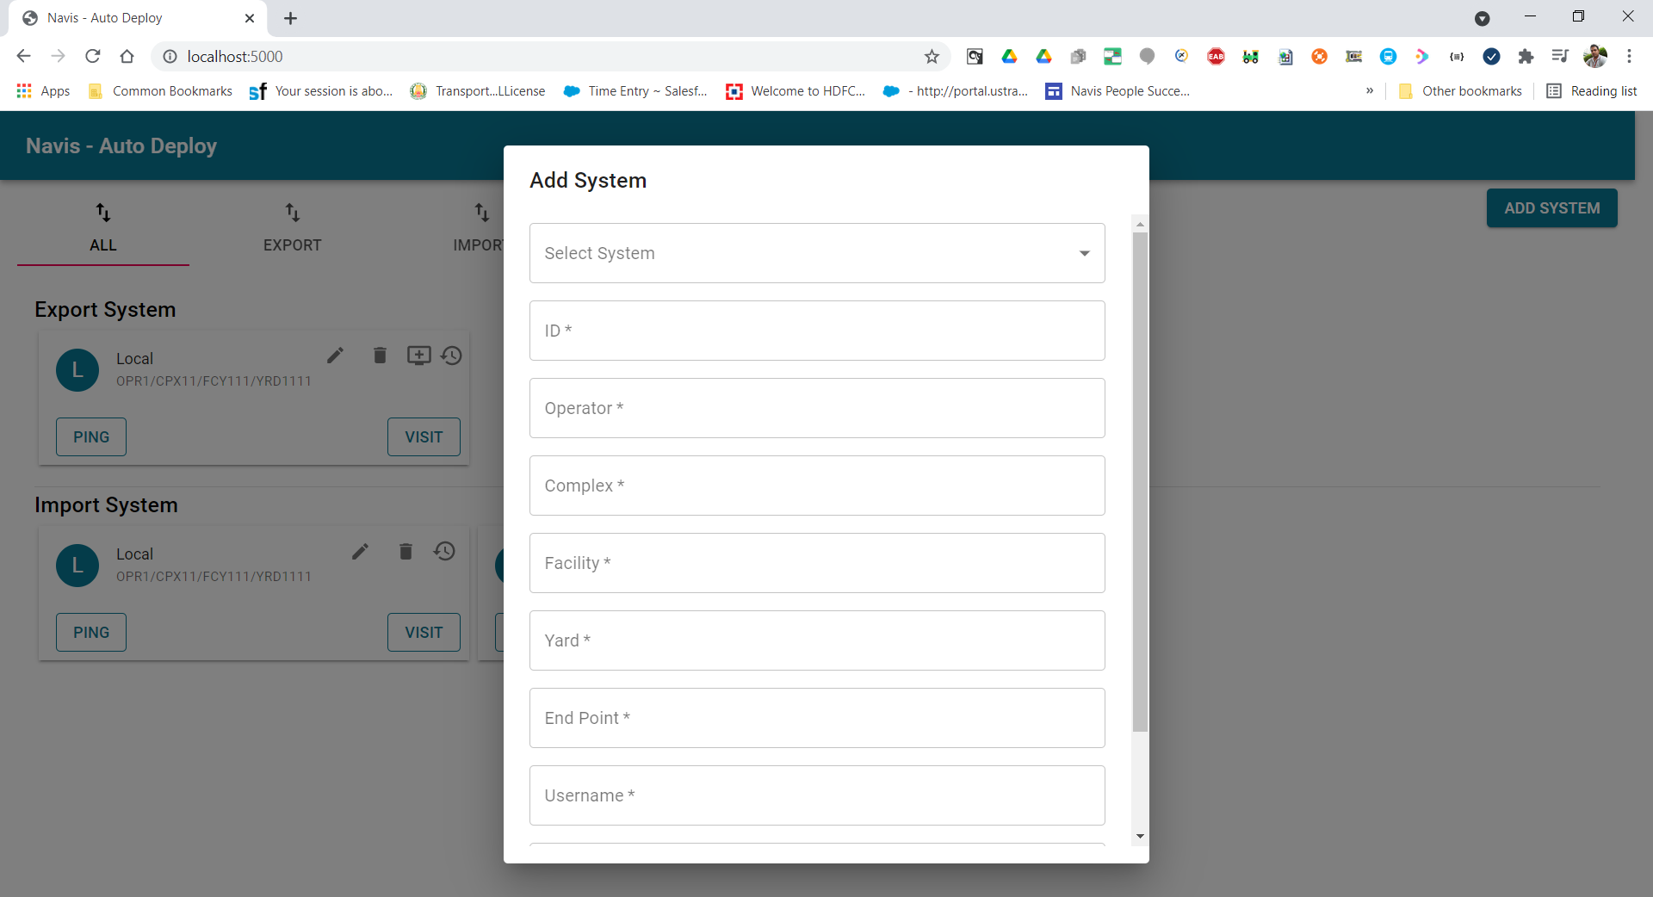

You can use various shortcut to perform the Operation.

1. **Ping:** Click to see N4 is up or not
2. **Visit:** Click to visit the N4.
3. **Pencil:** To Update the N4 details.
4. **Delete:** To delete the N4 System from AD Tool.
5. **Queue:** To see what are the entities are available.
6. **History:** To see the history.

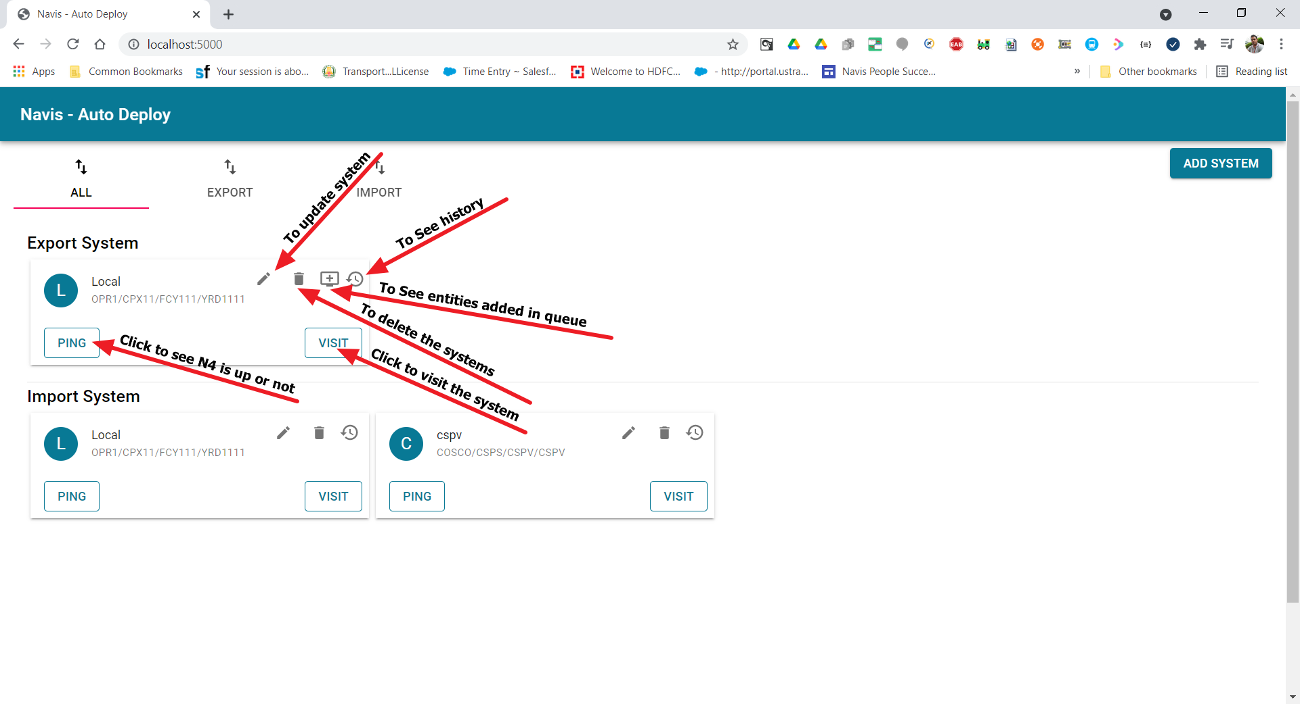

Step 2: Click on “visit” button to visit system.

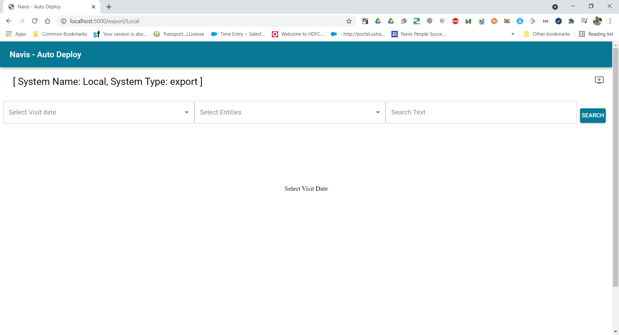

* Select Visit date:

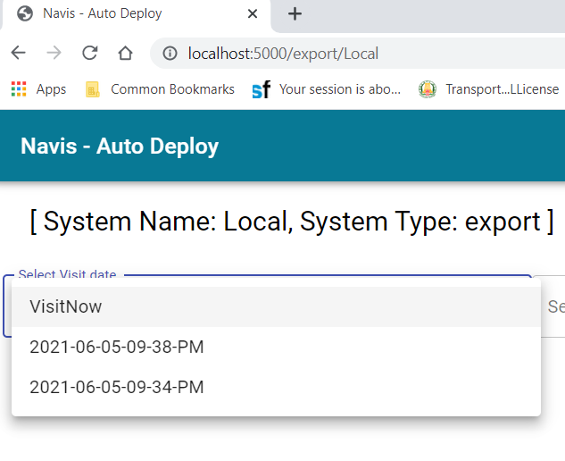

* + Select “VisitNow” if you want to visit now or select visited from the list. List of entities will be displayed from selected system.

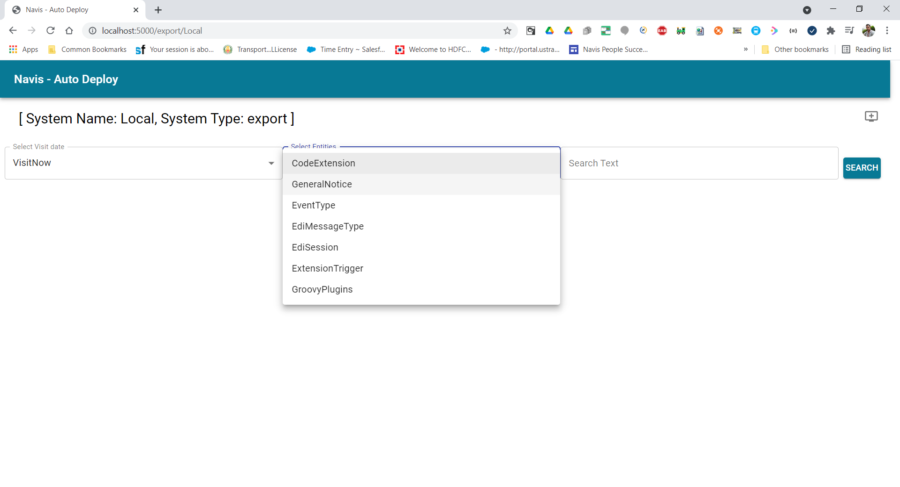

* + Select the entity one by one and select the rows which you want to export from or import to another systems. Eg:
    - Select any number of code extension and click on “Add to Queue” button.

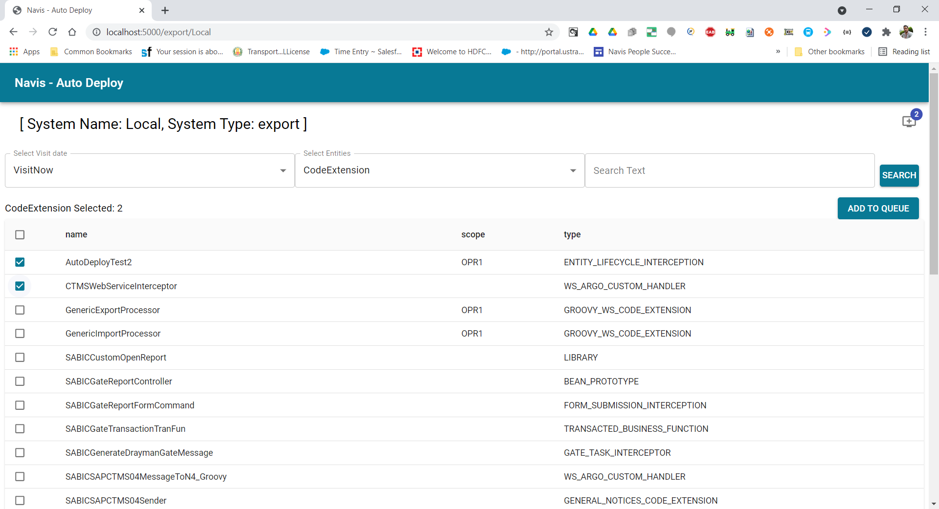

* + - Select any number of General Notice and click on “Add to Queue” button.

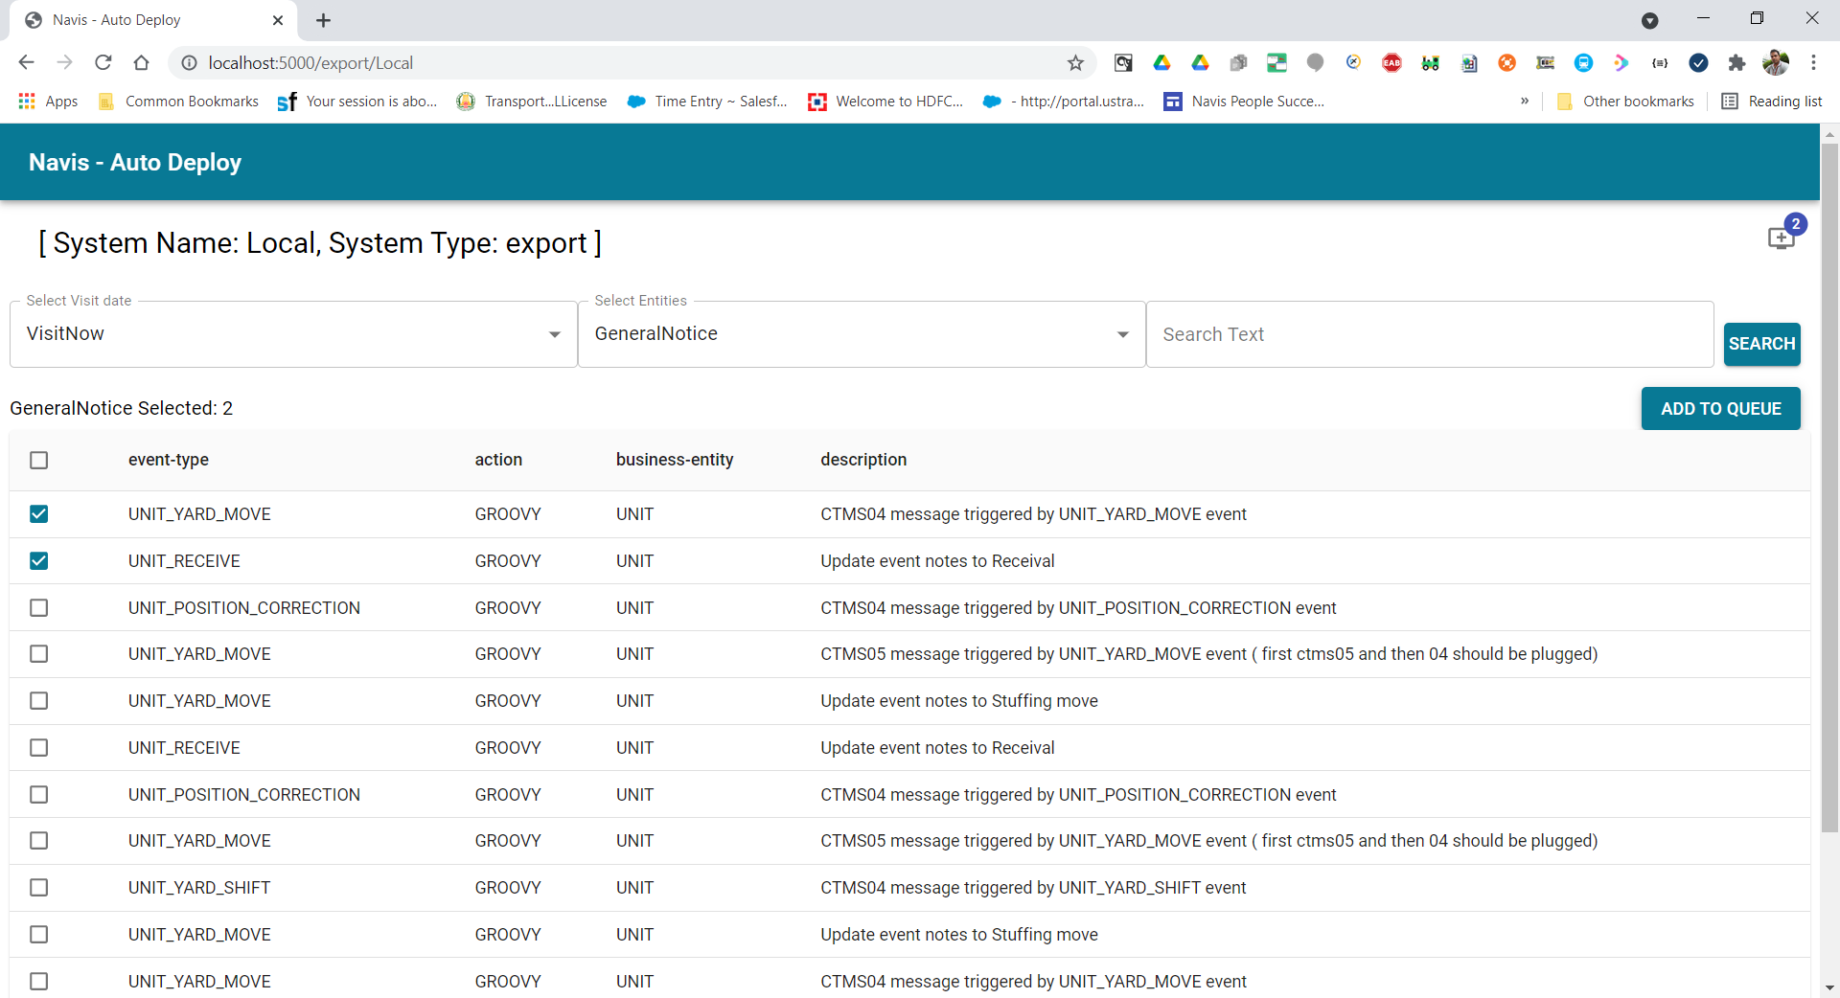

* + - Repeat above steps for any number of time as per your requirement.
    - You can search the item based on wildcard character also. Eg:

Searching the General Notice which is having “YARD” word.

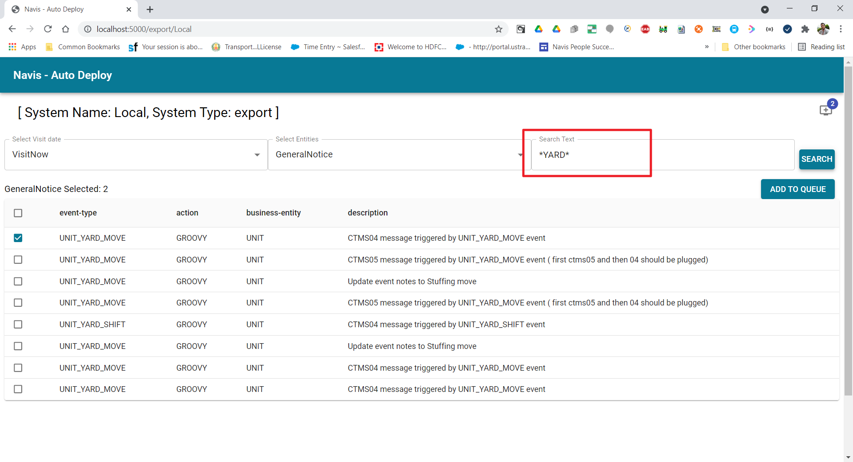

**Step 3:** Click on Queue button to see final Queue, Which will be imported or exported.

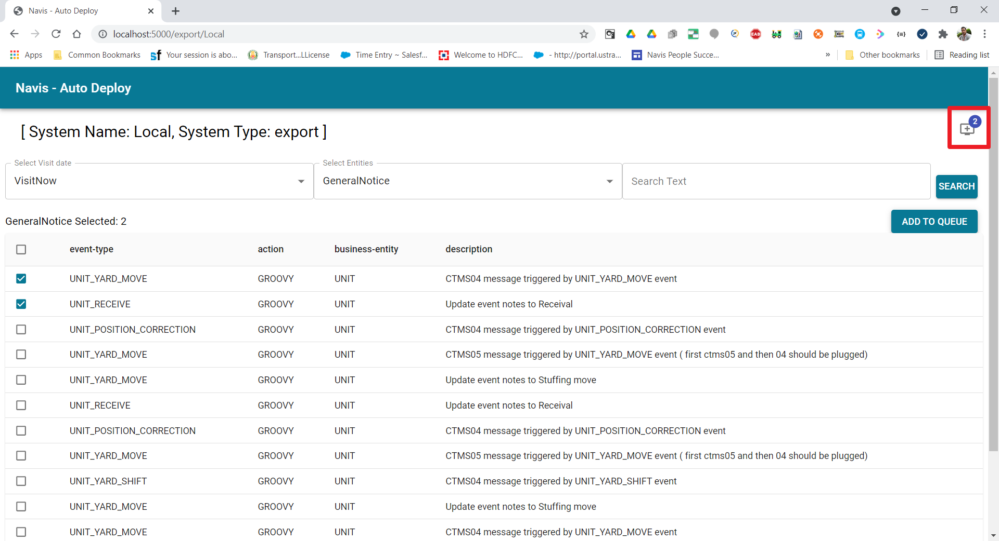

Final Queue

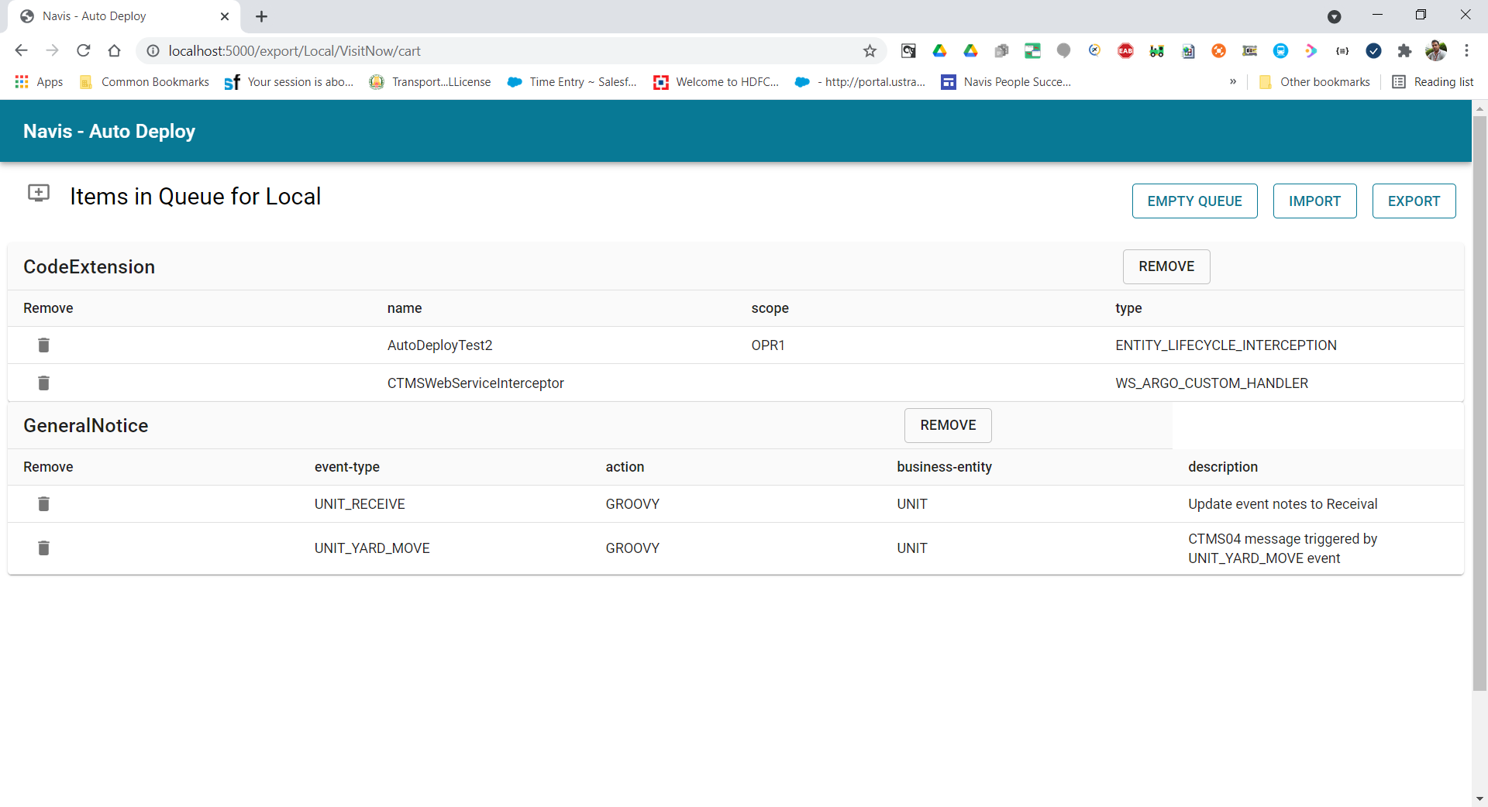

We can do below operation.

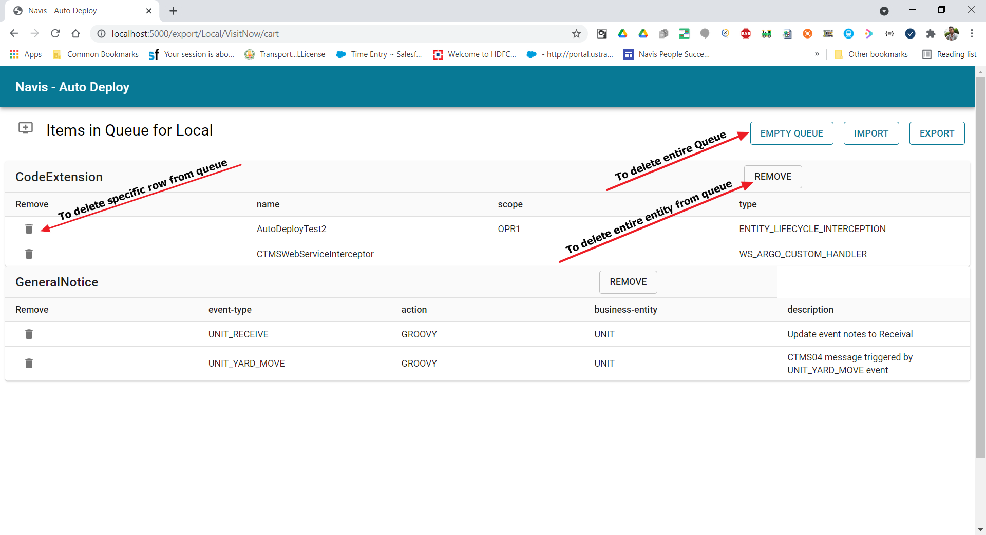

**Step 4:** Click on Export button. SNX will be download to the system.

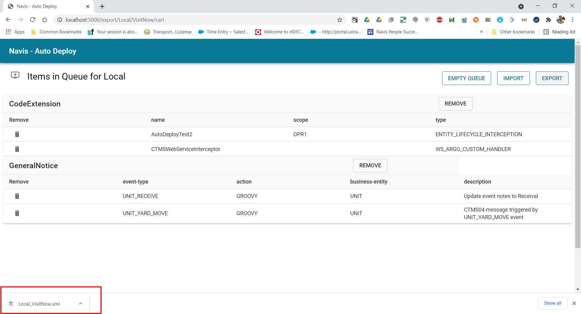

**Sample SNX:** This xml can be used to import to any other system.

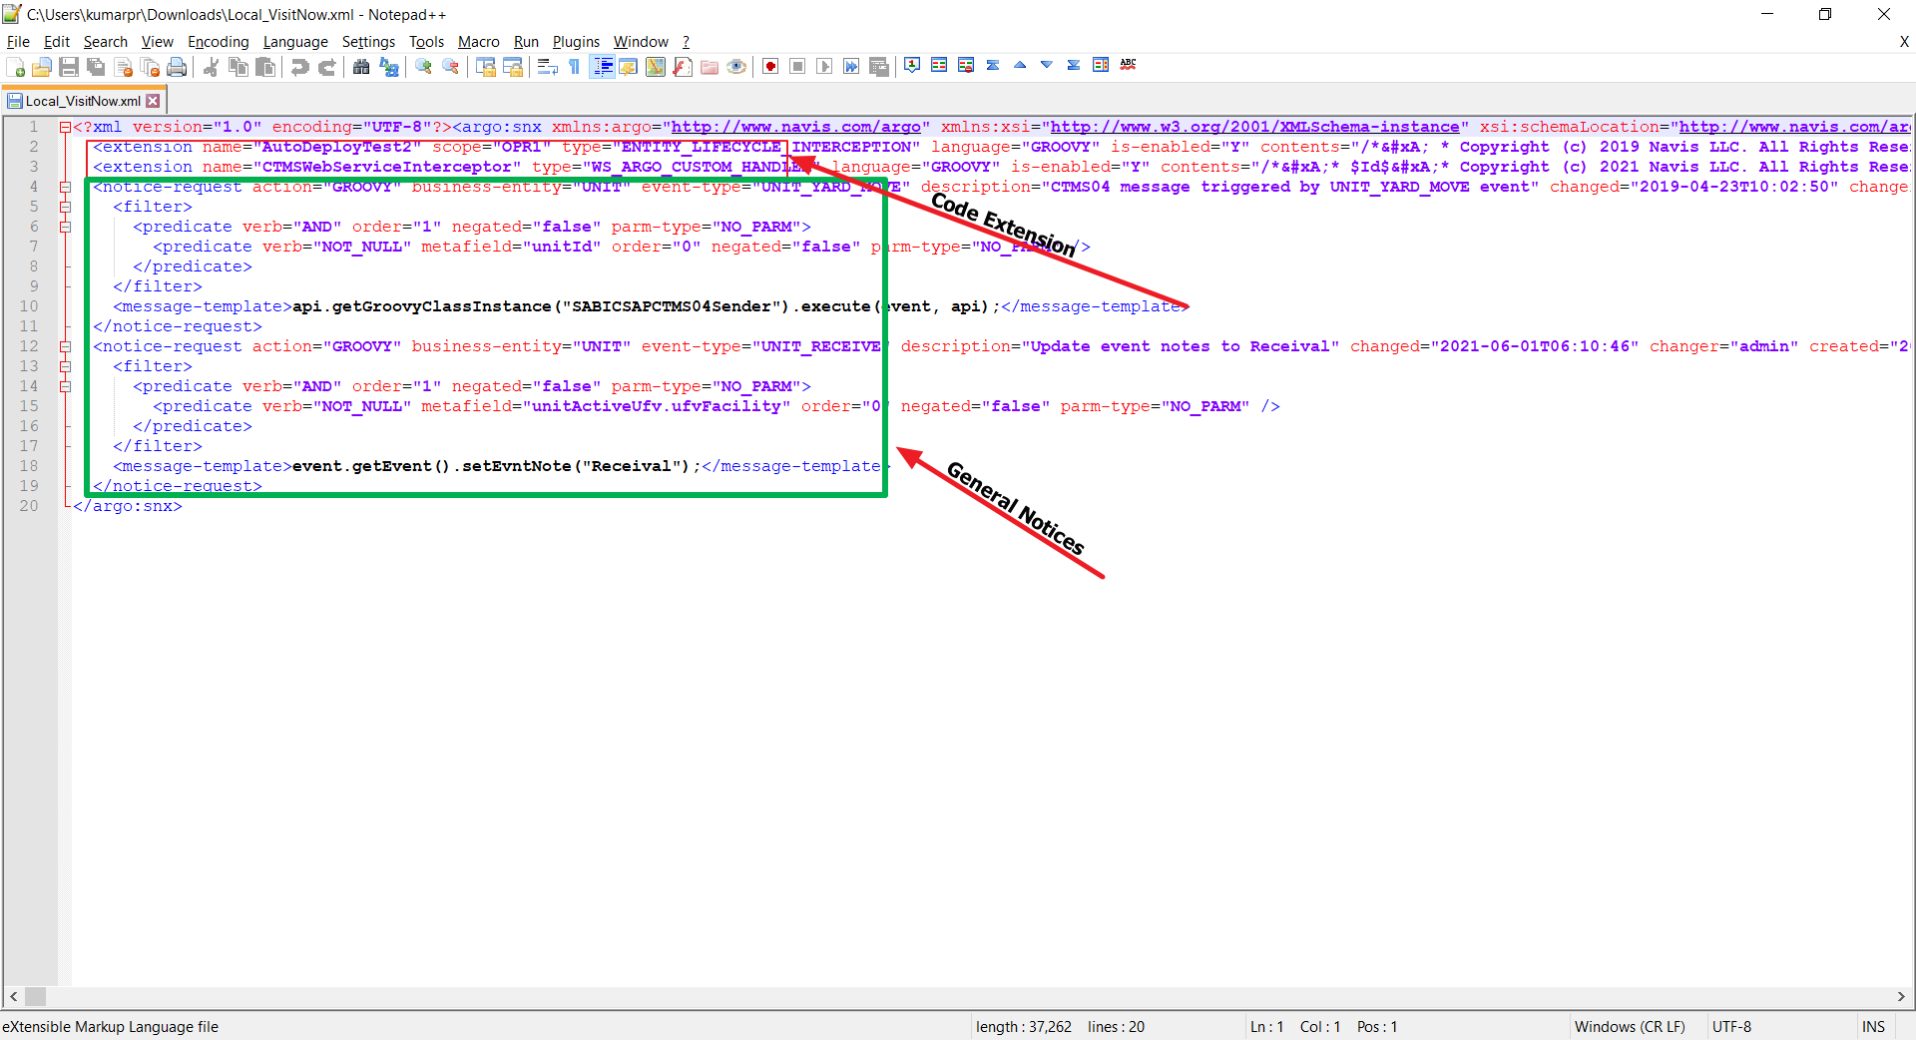

**Stpe 5:** Click on Import button. List of import system will be display please check the checkbox and Click on “CONFIRM IMPORT”.

