SKILL – 1 :-
Repository Initialized
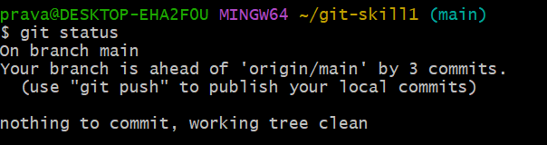
All Branches Created
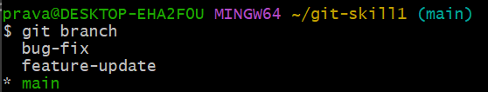
Commit History
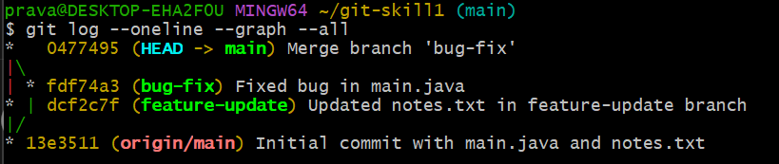
Remote Connection
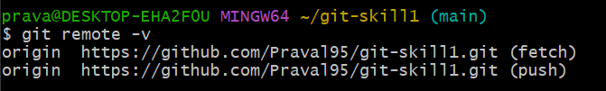
GitHub Repository
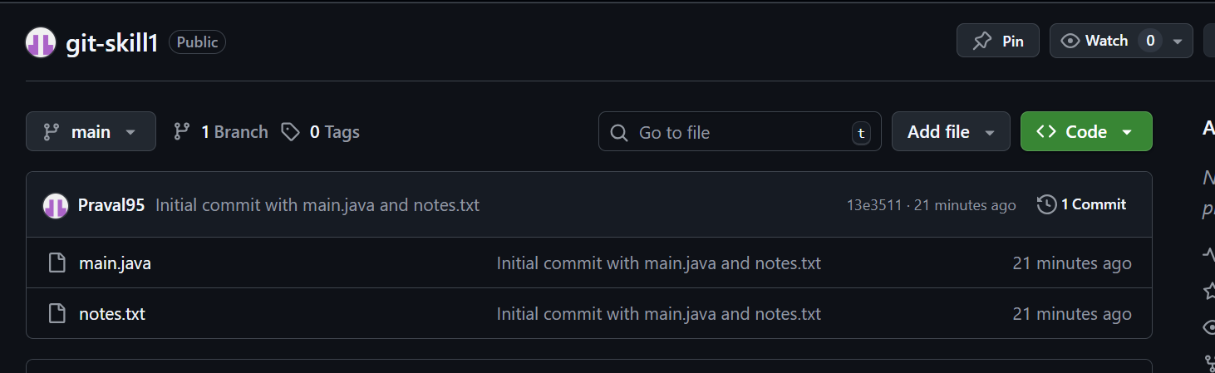
SKILL – 2 :-

