Software Requirements Specification for Pharmacy Management System

Prepared by

|  |  |  |
| --- | --- | --- |
| Praval Pattam | B220057CS | praval_b220057cs@nitc.ac.in |
| Theenesh Potluri | B221121CS | potluri_b221121cs@nitc.ac.in |
| Pranav Sai Sarvepalli | B220055CS | pranav_b220055cs@nitc.ac.in |
|  |  |  |
|  |  |  |

|  |  |
| --- | --- |
| Instructors: | Abdul Nazer K A,  Chandramani Chaudhary |
| Course: | CS3002D  DATABASE MANAGEMENT SYSTEMS |
| Due date: | 30/10/2024 |

Contents

1 Introduction 4

1.1 Document Purpose 4

1.2 Product Scope 4

1.3 Intended Audience and Document Overview 4

1.4 Definitions, Acronyms and Abbreviations 4

1.5 Document Conventions 5

1.6 References and Acknowledgments 5

2 Overall Description 6

2.1 Product Overview 6

2.2 Design and Implementation Constraints 8

2.3 Assumptions and Dependencies 8

3 Specific Requirements 9

3.1 External Interface Requirements 9

3.1.1 User Interfaces 9

3.1.2 Hardware Interfaces 10

3.1.3 Software Interfaces 10

3.2 Functional Requirements 11

3.3 Use Case Model 13

3.3.1 Use Case Diagram 13

3.3.2 Use Cases 14

4 Other Non-functional Requirements 17

4.1 Performance Requirements 17

4.2 Safety and Security Requirements 18

4.3 Software Quality Attributes 18

Revisions

| Version | Primary Author(s) | Description of Version | Date Completed |
| --- | --- | --- | --- |
| 1.0 | Praval Pattam  Theenesh Potluri  Pranav Sai Sarvepalli | SRS document for Pharmacy Management System. | 30/10/2024 |

# Introduction

The **Pharmacy Management System** is a comprehensive database application designed to improve the efficiency, accuracy, and safety of pharmacy operations. This system manages inventory, sales, supplier records, and employee accounts in a pharmaceutical store, streamlining the entire lifecycle of medicines from procurement to sales. By providing separate login access for admins, it ensures secure access and allows admins to manage records.

## Document Purpose

This document provides the Software Requirements Specification (SRS) for the PharmacyManagement System. The main purpose of this system is to establish an organized and efficient method for maintaining a comprehensive database of available medicines and consumables in a pharmacy. It focuses on enhancing accuracy, safety, and operational efficiency in pharmaceutical stores by automating various processes, including inventory management and sales.

## Product Scope

The Pharmacy Management System aims to improve the accuracy and efficiency of inventory management within a pharmacy. By providing a structured system for recording sales, purchases, stock expiry, and supplier details, it enhances daily pharmacy operations. Users can generate reports and manage records related to supplies.

## Intended Audience and Document Overview

This SRS document is intended for developers, project managers, instructors, pharmacy administrators, and other stakeholders involved in the Pharmacy Management System’s development and deployment. It includes a detailed description of system functionalities, interfaces, and requirements, enabling stakeholders to understand how the system operates, the constraints involved, and its specific modules. The document is structured to guide each audience type in the appropriate sections, from general overviews to specific technical details for implementation.

## Definitions, Acronyms and Abbreviations

* **Admin**: Administrator of the pharmacy management system, responsible for managing inventory, and viewing data records.
* **DBMS**: Database Management System, a software tool used to store, retrieve, and manage data in a database. This project uses MySQL as the DBMS.
* **FIFO**: First-In, First-Out, an inventory management method where the oldest stock is sold or used first.
* **GUI**: Graphical User Interface, the visual interface through which users interact with the system.
* **Inventory**: A complete list of medicines and consumables in stock at the pharmacy.
* **MySQL**: A relational database management system used to manage the system’s data.
* **Pharmacy Management System (PMS)**: The software application designed to manage a pharmacy’s inventory, sales, and supplier and employee records.
* **SQL**: Structured Query Language, a programming language used to interact with the database.
* **UI**: User Interface, the space where interactions between humans and the system occur.

## Document Conventions

This document adheres to IEEE standards for Software Requirements Specification (SRS) formatting. The following conventions and standards have been applied:

**Formatting Conventions**

* **Font**: Arial, size 11 for regular text, size 12 for headings.
* **Spacing**: Single-spaced throughout the document.
* **Margins**: 1-inch margins on all sides.
* **Comments**: Italics are used for comments or instructions that are not part of the final document text.
* **Section Titles**: Section and subsection titles follow the IEEE SRS template formatting.

**Naming Conventions**

* **Variables and Tables**: Names for database variables and tables use PascalCase (e.g., MedicineInventory, SupplierRecords).
* **Actors and Roles**: Terms such as “Admin” and “Employee” are capitalized to signify user roles within the system.

## References and Acknowledgments

IEEE standards for Software Requirements Specification (SRS).

# Overall Description

## Product Overview

The Pharmacy Management System (PMS) is a new, self-contained software product designed to enhance the operational efficiency of pharmaceutical stores. It is not a follow-on member of a product family nor a replacement for existing systems, but rather a standalone solution tailored to meet the specific needs of pharmacies. The PMS integrates various functionalities to streamline the management of drugs and consumables, ensuring accurate and timely updates to inventory and sales records.

The PMS operates within the context of a pharmaceutical store, interfacing with external systems to facilitate seamless transactions and inventory updates. It is designed to manage the entire lifecycle of medicines from inventory to sales, including features for report generation, user authentication, and supplier management. The system’s architecture includes modules for user authentication, inventory management, sales and purchase management, report generation, and admin management.

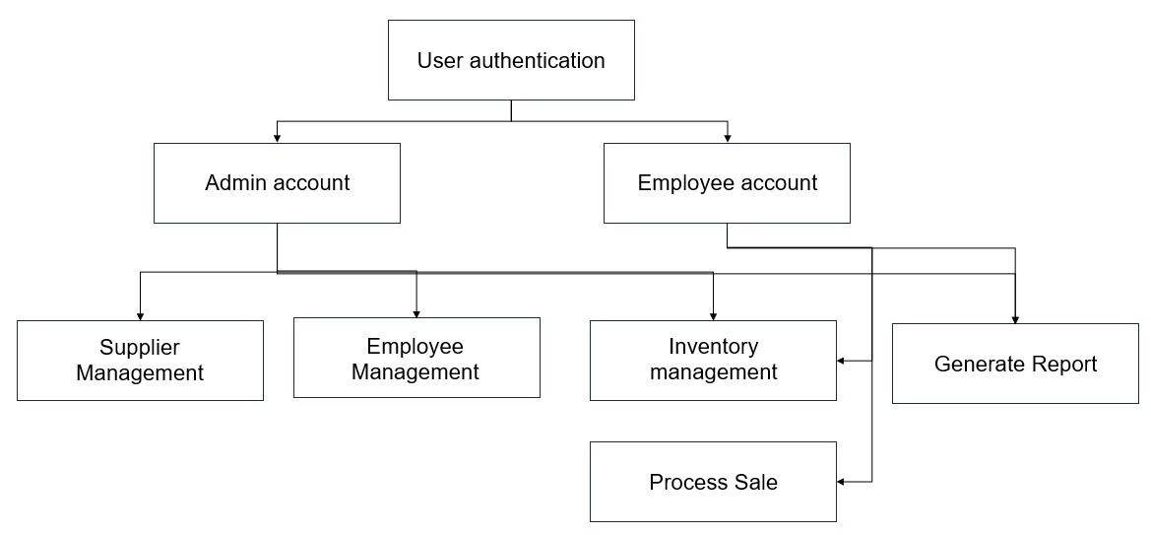

**Product Functionality**

The Pharmacy Management System (PMS) must perform or allow users to perform the following major functions:

* **User Authentication:**
  + Secure login for admins and employees.
  + Unique usernames and passwords for each employee.
* **Inventory Management:**
  + Maintain records of available medicines.
  + Track sales, purchases, stock expiry, and quantities.
  + Update inventory after each transaction.
* **Sales Management:**
  + Facilitate the sale of medicines.
  + Check inventory for stock availability.
  + Generate invoices and maintain sales history.
  + Record customer details and purchase history.
* **Purchase Management:**
  + Purchase medicines from suppliers using their catalogues.
  + Update inventory with new stock.
* **Report Generation:**
  + Generate various reports as per user requirements.
  + Print invoices, bills, and receipts.
* **Admin Management:**
  + Add or remove employees.
  + Manage employee records.
* **Supplier Management.**
  + Supplier Management:
  + Maintain records of supplies from suppliers.
  + Track supplier details and transactions

These functions ensure the system effectively manages the entire lifecycle of medicines from inventory to sales, enhancing the operational efficiency of pharmaceutical stores.

## Design and Implementation Constraints

The development of the Pharmacy Management System (PMS) will be subject to the following constraints:

* Specific Technologies, Tools, and Databases:
  + The system will use MySQL for database management.
  + Python and Flask will be used for backend development.
  + The frontend will be developed using HTML, CSS, and JavaScript.
  + Parallel Operations:
  + The system should support concurrent access by multiple users without performance degradation.
  + Proper synchronization mechanisms must be implemented to handle simultaneoustransactions**.**
* Language Requirements:
  + The primary language for development will be Python.
  + All documentation and user interfaces must be in English.
* Communications Protocols:
  + The system will use HTTPS for secure communication over the internet.
  + Internal communication between modules will use RESTful APIs.
* Security Considerations:
  + User authentication and authorization must be implemented to ensure data security.
  + Sensitive data, such as passwords, must be encrypted.
  + Regular security audits must be conducted to identify and mitigate vulnerabilities.

## Assumptions and Dependencies

No Assumptions made for this SRS.

# Specific Requirements

## External Interface Requirements

### User Interfaces

The user interface for the Pharmacy Management System (PMS) is designed to be intuitive and user-friendly, ensuring that both admins and employees can navigate the system efficiently. Below is a basic description of how users will interact with the system, along with a graphic representation of the main interface.

**Description of User Interaction**

* **Dashboard:**
  + Menus: The dashboard will feature a menu bar with options such as Inventory, Sales, Purchases, Reports, and Admin.
  + Click Navigation: Users can navigate through different sections by clicking the menu items.
* **Inventory Management:**
  + List View: The inventory will be displayed in a list view with details like medicine name, quantity, expiry date, and supplier.
  + Buttons: Options to add, edit, or delete inventory items.
* **Sales and Purchase Management:**
  + Catalog Access: Employees can access supplier catalogs to purchase medicines.
  + Sales Interface: A simple interface to process sales, check stock availability, and generate invoices.
  + History Logs: Access to sales and purchase history for tracking and reporting.
* **Report Generation:**
  + Report Types: Users can select the type of report they need (e.g., sales report, inventory report).
  + Date Range Selection: Options to select the date range for the reports.
  + Generate Button: A button to generate and view the report.
* **Admin Management:**
  + Employee Management: Admins can add or remove employees and manage their details.

### Hardware Interfaces

The Pharmacy Management System (PMS) will interact with various hardware components to ensure smooth operation and data management. Below is a list of the different hardware interfaces and their characteristics:

* **Desktop Computers:**
  + Logical Characteristics: The PMS will run on standard desktop computers used by admins and employees.
  + Physical Characteristics: These computers should have at least 8GB of RAM and 500GB of storage.
* **Printers:**
  + Logical Characteristics: Used to print invoices, bills, receipts, and reports.
  + Physical Characteristics: Standard inkjet or laser printers connected via USB or network.
* **Network Routers and Switches:**
  + Logical Characteristics: Ensure network connectivity for all devices within the pharmacy.
  + Physical Characteristics: Standard networking hardware supporting Ethernet and Wi-Fi connections.
* **External Storage Devices:**
  + Logical Characteristics: Used for data backup and recovery.
  + Physical Characteristics: External hard drives or USB flash drives.

### Software Interfaces

**Web Application Interfaces**

* **Web Application:**
  + Logical Characteristics: The web application allows users, performing functions such as checking inventory, processing sales, and generating reports.
  + Data and Control Interactions:
    - User Authentication: Secure login credentials are used to authenticate users.
    - Inventory Management: Users can view and update inventory details through the app.
    - Sales Processing: This enables users to process sales and generate invoices.
* **Report Generation:** 
  + Users can request and view reports on their mobile devices.

## Functional Requirements

The Pharmacy Management System has the following detailed functional requirements:

* **F1: User Authentication**
  + **Description**: The system shall allow users to log in as either an admin or employee.
  + **Input**: Username and password.
  + **Output**: Access to the relevant system functions based on user role.
  + **Priority**: High
* **F2: Inventory Management**
  + **Description**: The system shall maintain records of all medicines, including name, quantity, expiration date, and supplier information.
  + **Input**: New entries, updates to quantities, and expiration dates.
  + **Output**: Real-time inventory status for all medicines.
  + **Priority**: High
* **F3: Sales Processing**
  + **Description**: The system shall process sales transactions, check for item availability, and update inventory upon completion.
  + **Input**: Selected items, quantity, and payment details.
  + **Output**: Updated inventory and generated invoice.
  + **Priority**: High
* **F4: Report Generation**
  + **Description**: The system shall generate reports, including sales summaries, inventory levels, and supplier records.
  + **Input**: Report type and date range.
  + **Output**: Detailed report in a downloadable format.
  + **Priority**: Medium
* **F5: Supplier Management**
  + **Description**: The system shall maintain a record of suppliers and details of their supplied medicines.
  + **Input**: Supplier name, contact information, and products supplied.
  + **Output**: Up-to-date supplier records.
  + **Priority**: Medium
* **F6: Employee Management**
  + **Description**: Admins shall be able to add, remove, and manage employee records, including assigning usernames and passwords.
  + **Input**: Employee details.
  + **Output**: Updated employee records.
  + **Priority**: High

## Use Case Model

### Use Case Diagram

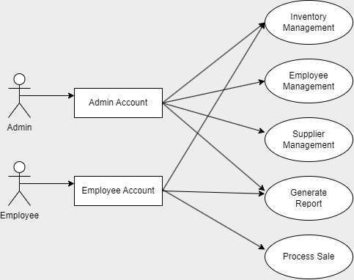

### Use Cases

* **Use Case #1: User Login**
  + **Purpose**: To allow users to securely access the system based on their role (admin or employee).
  + **Requirements Traceability**: F1.
  + **Priority**: High.
  + **Preconditions**: The user must have a valid username and password.
  + **Postconditions**: The user gains access to their respective functions within the system.
  + **Actors**: Admin, Employee.
  + Flow of Events:
    - Basic Flow:
      * User enters username and password.
      * The system verifies credentials.
      * If valid, grants access to the system.
    - Alternative Flow:
      * If credentials are invalid, display an error and prompt for re-entry.
    - Exceptions:
      * Three unsuccessful login attempts result in account lockout.
* **Use Case #2: Inventory Update**
  + **Purpose:** To allow employees and admins to add or modify inventory details.
  + **Requirements Traceability:** F2
  + **Priority:** High.
  + **Preconditions:** User is logged in and authorized to access inventory.
  + **Postconditions:** Inventory details are updated in real-time.
  + **Actors:** Admin, Employee.
  + Flow of Events:
    - Basic Flow:
      * User selects inventory management module.
      * User inputs new stock details or updates existing quantities.
      * System validates and saves changes.
    - Alternative Flow:
      * If inventory input is incomplete, prompt for additional data.
    - Exceptions:
      * System error during save prompts retry.
* **Use Case #3: Process Sale**
  + **Purpose**: To handle the sales transaction process, including inventory checks and invoice generation.
  + **Requirements Traceability**: F3.
  + **Priority**: High.
  + **Preconditions**: User is logged in, and item is available in stock.
  + **Postconditions**: Sale is recorded, and inventory is updated.
  + **Actors**: Employee.
  + Flow of Events:
    - Basic Flow:
      * User selects items for sale and confirms quantity.
      * System verifies item availability.
      * User completes payment details.
      * System updates inventory, generates invoices.
    - Alternative Flow:
      * If an item is out of stock, display “Out of Stock” and prevent transaction.
    - Exceptions:
      * Transaction fails due to system error, prompting retry.
* **Use Case #4: Generate Report**
  + **Purpose**: To provide users with custom reports, such as sales summaries and inventory status.
  + **Requirements Traceability**: F4.
  + **Priority**: Medium
  + **Preconditions**: User is logged in with report generation permissions.
  + **Postconditions**: Report is generated and available for download.
  + **Actors**: Admin, Employee
  + Flow of Events:
    - Basic Flow:
      * User selects report type and date range.
      * System generates reports and provides download link.
    - Alternative Flow:
      * If requested data is unavailable, the system displays a notification.
    - Exceptions:
      * Report generation error prompts a retry.

# Other Non-functional Requirements

## Performance Requirements

The Pharmacy Management System (PMS) must meet specific performance requirements to ensure it operates efficiently under various circumstances. These requirements are based on the information provided and aim to help developers make suitable design choices.

**General Performance Requirements**

* **P1. Response Time:** 
  + The system should respond to user queries and actions within 2 seconds to ensure a smooth user experience.
* **P2. Transaction Processing:** 
  + The system should be capable of processing 100 transactions per second during peak hours.
* **P3. Concurrent Users:** 
  + The system should support up to 500 concurrent users without noticeable performance issues.

**Specific Functional Requirements**

* **P4. Inventory Update:** 
  + Inventory updates (e.g., adding new stock, updating quantities) should be reflected in the system within 1 second of the transaction.
* **P5. Report Generation:** 
  + The system should generate standard reports (e.g., sales reports, inventory reports) within 5 seconds.
* **P6. User Authentication:** 
  + User login and authentication processes should be completed within 3 seconds.

**Real-Time System Requirements**

* **P7. Inventory Alerts:** 
  + Automated alerts for low stock or nearing expiry dates should be triggered within 10 seconds of the condition being met.
* **P8. Sales Processing:** 
  + The system should complete the sales processing, including inventory check and invoice generation, within 5 seconds.

**Resource Utilization**

* **P9. CPU and Memory Usage:** 
  + The system should not use more than 70% of CPU and 60% of memory resources under peak load conditions.

## Safety and Security Requirements

**Safety Requirements**

* **S1. Error Handling and Logging:**
  + The system must implement comprehensive error handling and logging mechanisms to capture and report errors without disrupting user operations.

**Security Requirements**

* **S2. User Authentication:**
  + The system must implement strong user authentication mechanisms, including multi-factor authentication (MFA) for admin accounts.
* **S3. Access Control:**
  + The system must implement role-based access control (RBAC) to restrict access to sensitive functions and data based on user roles (e.g., admin, employee).

## Software Quality Attributes

The Pharmacy Management System (PMS) must meet several quality attributes to ensure it is robust, reliable, and user-friendly. These attributes are crucial for both customers and developers, and they help in maintaining high standards of software quality. Below are the key quality attributes for the PMS:

* **Reliability**
  + The system should have an uptime of 99.9% over a year.
* **Usability**
  + The system should be intuitive and easy to use, with a user satisfaction score of at least 85% in usability tests.
* **Maintainability**
  + The system should allow for easy updates and modifications, with a mean time to repair (MTTR) of less than 2 hours.
* **Security**
  + The system must implement strong security measures, including data encryption and multi-factor authentication (MFA) for admin accounts.
* **Scalability**
  + The system should be able to handle a 50% increase in user load without performance degradation.
* **Interoperability**
  + The system should seamlessly integrate with external systems such as supplier databases and banking systems.