**NOTES:**

1. [**Retailers, Are You Getting the Full Value of Your Dynamic Pricing Strategy? | Bain & Company**](https://www.bain.com/how-we-help/retailers-are-you-getting-the-full-value-of-your-dynamic-pricing-strategy/#:~:text=Though%20the%20term%20dynamic%20pricing%20refers%20to%20a,in%20response%20to%20relevant%20internal%20and%20external%20changes.)

 For decades, retail subsectors, such as the travel and leisure industries, have used dynamic pricing to manage capacity constraints. Now, with new technology, abundant data, and growing acceptance among customers, all retail sectors have the perfect opening to experiment with and capture value by fine-tuning pricing.

**Create a dynamic pricing machine***:*

1. **Primary research**: customer interviews and sample size data. Create a proper **WHO** first.

**Important questions**: *How well do you know your customers? When it comes to dynamic pricing, what would turn them off a purchase? What would they accept? Help identify the questions to ask and then pinpoint the answers to clearly assess the value and risks of your dynamic pricing strategy. Who are your target customers, and in which segments do they fall? What are their purchase occasions? A deep understanding of these facets will inform pricing logic, including which items to bundle (and when).*

1. Work on **WHY, WHERE, WHEN, HOW** now.

* **Goals:** How much should you optimize for price vs. margin? Which customers are you trying to influence and in which ways?
* **Strategy:**Which is the necessary defensive vs. opportunistic offensive moves (such as enhancing your brand perception through product scarcity)?
* **Competitors:** Which competitors should you benchmark or prioritize, and when does it make sense to have the lowest price?
* **Architecture:** How should you cascade the item-level changes to maintain price architecture and prevent cannibalization (e.g., private label strategy)?
* **Omnichannel:** Should online and in-store prices match?
* **Products:** Which products should you dynamically price, and how frequently should you update by tier?
* **Triggers:** Which dynamic pricing prompts (e.g., competitor price, customer demand, supply cost) should you prioritize?
* **Guardrails:** Should you set minimum and maximum prices for a given product?
* **Pricing levers:** Should you change list price, focus on personalized offers, or do a mix of both? How will you integrate these moves with marketing strategy?
* **Data:** What data matters most? How do you ensure your data quality is up to par?
* **Communication:**How should you position pricing changes (and benefits) to customers?

1. Building the **Dynamic Pricing Engine**:

A thoughtfully designed operating model that considers all stakeholders is crucial. Retailers should involve merchants early in the algorithm design to build trust. They also need to look inside the organization to determine **which team will decide pricing** as well as its level of autonomy to move quickly.

**Compensation and incentives of workers** should also be taken into consideration as it gets affected by DP.

1. **Test, Learn and Repeat**:

 Because the technology supporting dynamic pricing solutions is well established, it enables nearly limitless experimentation to fine-tune willingness to pay and other factors. The key is to never stand still: *Persistent experimentation with real data* is essential to shaping and refining your dynamic pricing strategy.

Taking lessons from the market leaders.

**How do they do it?**

1. **Categories by popularity**. This **tiering** determines which items to dynamically price—with priority on those items that customers are most likely to price compare, such as a coffeemaker—as well as how often it updates prices. The company also carefully considers which **competitors to match, choosing to not always be the lowest cost option**.
2. **Get credit for price decreases:** DO show the list price and price decrease percentage. Promotions of discounts!

**To win, you must know the questions to ask, deeply understand your audience, and commit to ongoing refinement.**

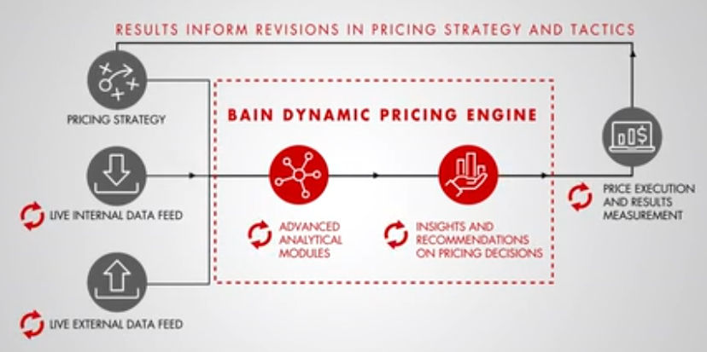

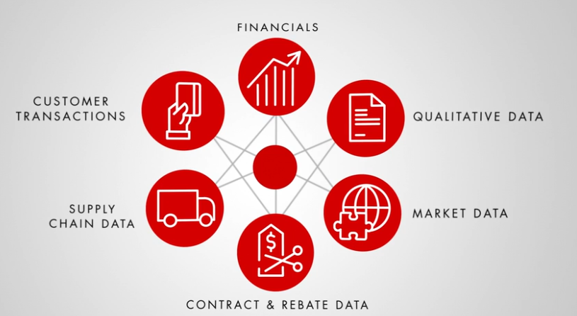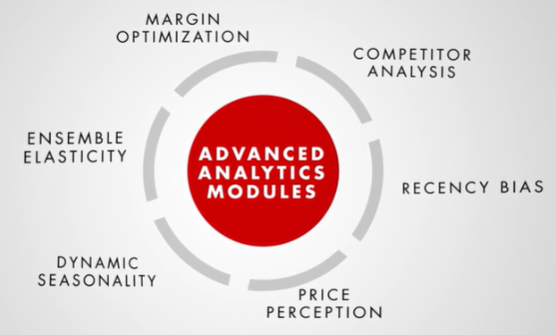

1. [**Dynamic Pricing: The Complete Guide (hubspot.com)**](https://blog.hubspot.com/sales/dynamic-pricing#f)
2. [**Unlock Winning Power of Competitive Pricing Intelligence Software (growbydata.com)**](https://growbydata.com/price-intelligence/#price-intel-bottom-banner)

1. **Understand your Cluster of competitors**.
2. **Match at a Variant Level SKU:** Discover your products competitors are carrying matched at a SKU level.
3. **Powerful Price Intelligence Software**: discovers your competitors **online** and regularly **monitors** their **retail pricing, product availability, shipping, promotional offers, reviews, and ratings** to enable you to make smart informed dynamic pricing decisions.
4. **Monitor price competition** intraday, daily, or weekly from local zip code levels to cities and regions per your need, across platforms like Google Shopping, Amazon, Walmart, Target, and more. This pricing intelligence offers you the power to implement **zonal pricing** and conduct **smart advertising**.
5. Monitor competitor prices for your entire product assortment or your most **competitive products, categories, competitors, channels, locations, and times**. Implement dynamic pricing and repricing strategies based on these product cohorts and business strategies for your price competitiveness.
6. **Competitor Intelligence:**

Get visibility into **your** **product’s competitive landscape**. Discover and monitor your competitors based on **product overlap**s, their **pricing aggressiveness**, and **competitive assortments** with pricing intelligence software.

Analyse **your top competitors’ retail prices, shipping costs, promotions, reviews, and ratings across all channels** with powerful competitor pricing reports. Get monitoring reports on your the top competitors, competitive assortment, dynamic of your top five nearest competitors, competition analytics reports, and more.

1. **Competitive Price Intelligence:**

Analyse and monitor your price competitiveness across channels with Competitive Price Intelligence reports. Compare **your product’s price competitiveness at a SKU** level across competitors.

Analyse the price **of each SKU against your competitors**. Configure shipping and promotional details into your competitive pricing analytics, which are crucial for successful pricing strategies.

Stay cheaper or more expensive than your competitor by a specific amount based on price range. If you are the **only seller in the market**, you are **less immune** to market and **price change volatility**. Many times, a retailer may not be the cheapest and that is okay. As a retailer, you **don’t want to compete** with those who may have made a **pricing error** or are **clearing out old inventory**, at a potential loss. Conversely, you don’t want to go too low on a popular profitable SKU that the market is about to run out.

1. **Automated Repricing Software**:

Build your competitive pricing strategies and rules based on your competitor’s retail base price, shipping price, your market price position, product availability information, and other market intel data points across your sales channels while automatically calculating and updating the optimized price in your online stores, across marketplaces.

1. **Build Smart Product Feeds for Advertising**

Use Competitive Price Intelligence cohorts **like “only seller”, “cheapest product**” etc. to enrich your product feed and automatically export it to paid search advertising channels. Use these labels to create Shopping Ad campaigns and dynamically switch your product to respective campaigns based on your competitive position. **Optimize your bids** based on price competitiveness to **improve your visibility** and conversions across the shopper’s journey.

1. [**Retail dynamic pricing strategy design considering the fluctuations in day-ahead market using integrated demand response - ScienceDirect**](https://www.sciencedirect.com/science/article/abs/pii/S0142061521002234)

**DP model** proposed considering the fluctuation in the day-ahead market from the view of retailers. This model consists of two parts:

1. **the fixed price**, representing the existing price,
2. **the floating price**, which is a real-time reflection of the fluctuating day-ahead price.

Then, a **two-step settlement mode** is adopted for this DP in which the settlement of the **floating price will fall to zero** if the energy expenditure of any specific group is negatively affected.

Further, in a community energy system, an **integrated demand response strategy** for profit maximization of the retailer is proposed to determine the optimal DP, in which the response behaviour of residents is established using the demand price elasticity matrix.

DP can be divided into three types:

* **time-of-use (TOU) pricing,**
* **Critical Peak Pricing (CPP),**
* **real-time pricing (RTP).**

1. **TOU pricing and CPP lack elasticity** with **weak incentive inability**,
2. **RTP** is a type of highly variable price that shows a dynamic relationship between **demand and supply** helping the system operate in an economic and effective way, which is popular in DP studies.

Examples of optimization objectives include:

* **minimizing changes in price signals**
* **the energy cost of residents,**
* **maximizing the profit of retailers,**
* **improving the peak-to-average ratio,**
* **reducing the peak load of the grid.**

The result of the optimal RTP in inducing the desired consumption behaviours of residents was proven based on the developed demand elasticity model.

Zhang says, “There is an opportunity to charge different people different prices even without a capacity restraint or variable demand,” says Zhang. “*But if customers are able to compare prices and figure out what’s going on, it can create a problem*.”

The best way to avoid upsetting your customers, says Zhang, is to create minor differences in the product. “Consumers will accept price variations if they believe the product is different, even if just slightly.”

1. [**The Right Way to Approach Dynamic Pricing (forbes.com)**](https://www.forbes.com/sites/forbestechcouncil/2021/03/17/the-right-way-to-approach-dynamic-pricing/)

From a capitalistic point of view, it makes sense to optimize the profits as much as possible, although it can anger consumers. Still, profit is not the only motivator for using dynamic pricing. Surprisingly, **Uber implemented surge pricing to**[**solve demand-supply issues**](https://www.nytimes.com/2014/01/12/magazine/is-ubers-surge-pricing-an-example-of-high-tech-gouging.html)**on its platform and not just for profit margins**. Uber figured that there is a massive demand for its ride-hailing services on certain occasions, such as early morning office timings. It realized that this revenue loss and poor consumer experience were due to the **lack of available drivers**. Even though the drivers used to be available in the other nearby cities, it was not worth the effort to drive too far for just picking a ride.

Wharton School has shown that **transparency** is the **key to dynamic pricing**. Transparency can enable customers to make informed decisions and plan accordingly. Surprisingly, **many organizations start implementing dynamic pricing by running A/B tests without letting their users figure out they are being experimented upon**. This kind of behaviour can lead to a bad consumer experience and can build mistrust due to a lack of transparency.

Instead, a clear marker with an "info" icon that will open an explanation for the higher prices when clicked on should do the trick. Communication is the other side of the coin along with the transparency in dynamic pricing.

1. [**Dynamic pricing when consumers are strategic: Analysis of posted and contingent pricing schemes - ScienceDirect**](https://www.sciencedirect.com/science/article/abs/pii/S037722170900890X#preview-section-snippets)

A strategic buyer, except in the terminal period, will buy the product only if his or her valuation is above a threshold. Models that ignore strategic behaviour assume that everyone whose valuation is above the given price will buy the product. The threshold depends on the size of the market and the level of scarcity. We use the ratio of the number of units for sale (K) to the number of customers (N) as a measure of the level of scarcity.

In the limit, as the number of price changes approaches infinity posted, and contingent pricing schemes maximize expected revenues. They are revenue-equivalent to a multi-unit auction with reservation prices. This linkage enables us to derive an upper bound for expected revenues. When the number of price changes is restricted, the loss in optimality depends on the level of scarcity (𝐾/𝑁), the distribution of valuations, and the size of the market. If 𝐾/𝑁⩾1 or 𝐾/𝑁 is close to zero, a single price is optimal or nearly optimal, respectively. Also, as 𝑁→∞, no more than one price change is needed to maximize expected revenues, regardless of the ratio K/𝑁.

More generally, we would like to shed light on the following questions:

* 1. What is the loss in revenues if a firm ignores strategic behaviour?
* 2. Because scarcity drives dynamic pricing, what is the relationship between scarcity and the value of dynamic pricing?

1. [**Social Sciences | Free Full-Text | Factors Influencing Consumer Behavior and Prospective Purchase Decisions in a Dynamic Pricing Environment—An Exploratory Factor Analysis Approach (mdpi.com)**](https://www.mdpi.com/2076-0760/7/9/153)

To make the best out of the dynamic pricing strategy, retailers require information about prospective consumers, such as their behaviour, and the strategies of competitors. The internet of things and big data have made it possible for online sellers to use available information for chalking out tailor-made prices for both actual and prospective customers. Several studies have shown that when consumers are dissatisfied with the magnitude and proximity of the price changes, **they resort to spreading negative comments about sellers and engage in behaviours which damage the brand name of sellers**.

1. [**Dynamic Pricing and Risk Analytics Under Competition and Stochastic Reference Price Effects | IEEE Journals & Magazine | IEEE Xplore**](https://ieeexplore.ieee.org/abstract/document/7350137)

The pricing of products and services is an important but difficult area in marketing as it must take into consideration the fluctuating and dynamical effects of the market. In particular, the difficulty arises because firms are often uncertain about the demand for their product. This paper will introduce a new pricing model that considers two stochastic factors that affect demand uncertainty**, competitive pricing, and reference-price effects**. **Competitive pricing provides strategies to set the price of a product based on what the competition is charging. The reference price is what consumers anticipate paying or consider reasonable to pay for a particular good or service. It is an internal price that consumers compare with the observed price**. They are formed through the consumers’ past exposures to the product price, what they paid for similar products and price information such as advertisements. The differences between the reference price and the retail price affect the demand for that product. When the reference price is greater than the retail price, consumers will sense a gain which will lead to increased demand. Conversely, when the reference price is less than the retail price, consumers will sense a loss which will lead to decreased demand.