<https://github.com/PravalikaMedasani/ICP5>

1. import pandas as pd

from sklearn.model_selection import train_test_split

from sklearn.naive_bayes import GaussianNB

from sklearn.metrics import classification_report

#using pandas importing the glass csv file

df = pd.read_csv('glass.csv')

X_train, X_test, Y_train, Y_test = train_test_split(df.drop("Type", axis=1), df["Type"], test_size=0.2)

# train model using the Naive_bayes

model = GaussianNB()

model.fit(X_train, Y_train)

# evaluating the model

score = model.score(X_test, Y_test)

print('Accuracy: %.3f' % score)

# generating the classification report

y_pred = model.predict(X_test)

report = classification_report(y_true=Y_test, y_pred=y_pred)

print(report)

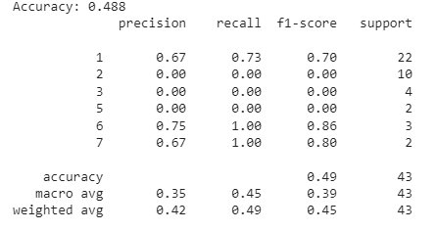

2)

import pandas as pd

from sklearn.model_selection import train_test_split

from sklearn.svm import LinearSVC

from sklearn.metrics import classification_report

# using pandas importing the dataset

df = pd.read_csv('glass.csv')

X_train, X_test, Y_train, Y_test = train_test_split(df.drop("Type", axis=1), df["Type"], test_size=0.2)

# train model using linear support vector machine

model = LinearSVC(dual=False)

model.fit(X_train, Y_train)

# evaluating the model

score = model.score(X_test, Y_test)

print('Accuracy: %.3f' % score)

# generating the classification report

y_pred = model.predict(X_test)

report = classification_report(y_true=Y_test, y_pred=y_pred)

print(report)

