FML ASSIGNMENT 4

pravalika

2022-11-03

##installing and Loading the required libraries

library(factoextra)

## Loading required package: ggplot2

## Welcome! Want to learn more? See two factoextra-related books at https://goo.gl/ve3WBa

library(ggplot2)  
library(dplyr)

##   
## Attaching package: 'dplyr'

## The following objects are masked from 'package:stats':  
##   
## filter, lag

## The following objects are masked from 'package:base':  
##   
## intersect, setdiff, setequal, union

library(cluster)

##Loading the data

Pharmadata <- read.csv("C:/Users/girne/Downloads/Pharmaceuticals.csv")  
View(Pharmadata)  
summary(Pharmadata)

## Symbol Name Market_Cap Beta   
## Length:21 Length:21 Min. : 0.41 Min. :0.1800   
## Class :character Class :character 1st Qu.: 6.30 1st Qu.:0.3500   
## Mode :character Mode :character Median : 48.19 Median :0.4600   
## Mean : 57.65 Mean :0.5257   
## 3rd Qu.: 73.84 3rd Qu.:0.6500   
## Max. :199.47 Max. :1.1100   
## PE_Ratio ROE ROA Asset_Turnover Leverage   
## Min. : 3.60 Min. : 3.9 Min. : 1.40 Min. :0.3 Min. :0.0000   
## 1st Qu.:18.90 1st Qu.:14.9 1st Qu.: 5.70 1st Qu.:0.6 1st Qu.:0.1600   
## Median :21.50 Median :22.6 Median :11.20 Median :0.6 Median :0.3400   
## Mean :25.46 Mean :25.8 Mean :10.51 Mean :0.7 Mean :0.5857   
## 3rd Qu.:27.90 3rd Qu.:31.0 3rd Qu.:15.00 3rd Qu.:0.9 3rd Qu.:0.6000   
## Max. :82.50 Max. :62.9 Max. :20.30 Max. :1.1 Max. :3.5100   
## Rev_Growth Net_Profit_Margin Median_Recommendation Location   
## Min. :-3.17 Min. : 2.6 Length:21 Length:21   
## 1st Qu.: 6.38 1st Qu.:11.2 Class :character Class :character   
## Median : 9.37 Median :16.1 Mode :character Mode :character   
## Mean :13.37 Mean :15.7   
## 3rd Qu.:21.87 3rd Qu.:21.1   
## Max. :34.21 Max. :25.5   
## Exchange   
## Length:21   
## Class :character   
## Mode :character   
##   
##   
##

##Removing the missing data

Pharmadata_NA <- na.omit(Pharmadata)  
View(Pharmadata_NA)

##To cluster the 21 firms, just the quantitative variables (1-9) need be collected.

row.names(Pharmadata_NA) <- Pharmadata_NA[,1]  
Pharmadata1 <- Pharmadata_NA[,3:11]  
head(Pharmadata1)

## Market_Cap Beta PE_Ratio ROE ROA Asset_Turnover Leverage Rev_Growth  
## ABT 68.44 0.32 24.7 26.4 11.8 0.7 0.42 7.54  
## AGN 7.58 0.41 82.5 12.9 5.5 0.9 0.60 9.16  
## AHM 6.30 0.46 20.7 14.9 7.8 0.9 0.27 7.05  
## AZN 67.63 0.52 21.5 27.4 15.4 0.9 0.00 15.00  
## AVE 47.16 0.32 20.1 21.8 7.5 0.6 0.34 26.81  
## BAY 16.90 1.11 27.9 3.9 1.4 0.6 0.00 -3.17  
## Net_Profit_Margin  
## ABT 16.1  
## AGN 5.5  
## AHM 11.2  
## AZN 18.0  
## AVE 12.9  
## BAY 2.6

##Scaling the data to bring the quantity in data and to reduce the distance between them

Pharmascale <- scale(Pharmadata1)  
head(Pharmascale)

## Market_Cap Beta PE_Ratio ROE ROA Asset_Turnover  
## ABT 0.1840960 -0.80125356 -0.04671323 0.04009035 0.2416121 0.0000000  
## AGN -0.8544181 -0.45070513 3.49706911 -0.85483986 -0.9422871 0.9225312  
## AHM -0.8762600 -0.25595600 -0.29195768 -0.72225761 -0.5100700 0.9225312  
## AZN 0.1702742 -0.02225704 -0.24290879 0.10638147 0.9181259 0.9225312  
## AVE -0.1790256 -0.80125356 -0.32874435 -0.26484883 -0.5664461 -0.4612656  
## BAY -0.6953818 2.27578267 0.14948233 -1.45146000 -1.7127612 -0.4612656  
## Leverage Rev_Growth Net_Profit_Margin  
## ABT -0.2120979 -0.5277675 0.06168225  
## AGN 0.0182843 -0.3811391 -1.55366706  
## AHM -0.4040831 -0.5721181 -0.68503583  
## AZN -0.7496565 0.1474473 0.35122600  
## AVE -0.3144900 1.2163867 -0.42597037  
## BAY -0.7496565 -1.4971443 -1.99560225

##Determining the number of clusters using Elbow method and sillhouette Method

fviz_nbclust(Pharmascale, kmeans, method = "wss")

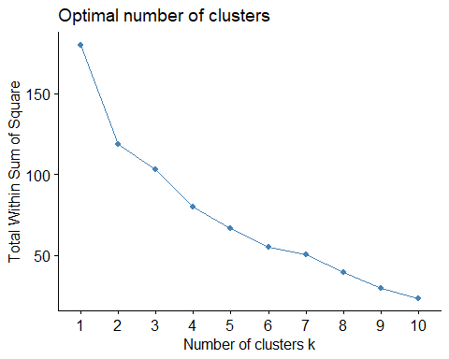

fviz_nbclust(Pharmascale, kmeans, method = "silhouette")

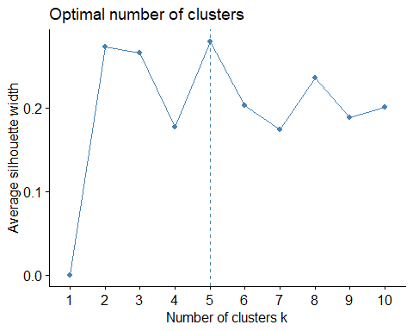

## used Elbow and Silhouette methods to find the optimal number of clusters. As Silhouette analysis is considered better than elbow method, so we are going with the Silhouette method.

set.seed(64060)  
five_clusters <- kmeans(Pharmascale, centers = 5, nstart = 25)  
five_clusters$centers

## Market_Cap Beta PE_Ratio ROE ROA Asset_Turnover  
## 1 -0.87051511 1.3409869 -0.05284434 -0.6184015 -1.1928478 -0.4612656  
## 2 -0.43925134 -0.4701800 2.70002464 -0.8349525 -0.9234951 0.2306328  
## 3 -0.76022489 0.2796041 -0.47742380 -0.7438022 -0.8107428 -1.2684804  
## 4 -0.03142211 -0.4360989 -0.31724852 0.1950459 0.4083915 0.1729746  
## 5 1.69558112 -0.1780563 -0.19845823 1.2349879 1.3503431 1.1531640  
## Leverage Rev_Growth Net_Profit_Margin  
## 1 1.36644699 -0.6912914 -1.320000179  
## 2 -0.14170336 -0.1168459 -1.416514761  
## 3 0.06308085 1.5180158 -0.006893899  
## 4 -0.27449312 -0.7041516 0.556954446  
## 5 -0.46807818 0.4671788 0.591242521

fviz_cluster(five_clusters, data = Pharmascale)

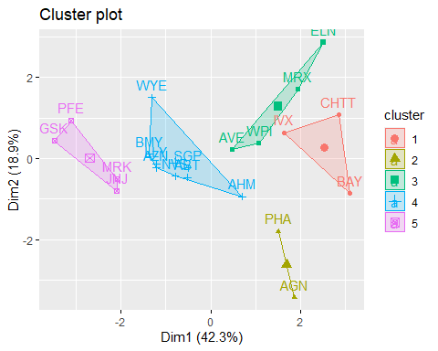

##Using K-Means Cluster Analysis- to Fit the data with 5 clusters

fit <- kmeans(Pharmascale, 5)

Pharma2 <- data.frame(Pharmascale, fit$cluster)  
Pharma2

## Market_Cap Beta PE_Ratio ROE ROA Asset_Turnover  
## ABT 0.1840960 -0.80125356 -0.04671323 0.04009035 0.2416121 0.0000000  
## AGN -0.8544181 -0.45070513 3.49706911 -0.85483986 -0.9422871 0.9225312  
## AHM -0.8762600 -0.25595600 -0.29195768 -0.72225761 -0.5100700 0.9225312  
## AZN 0.1702742 -0.02225704 -0.24290879 0.10638147 0.9181259 0.9225312  
## AVE -0.1790256 -0.80125356 -0.32874435 -0.26484883 -0.5664461 -0.4612656  
## BAY -0.6953818 2.27578267 0.14948233 -1.45146000 -1.7127612 -0.4612656  
## BMY -0.1078688 -0.10015669 -0.70887325 0.59693581 0.8617498 0.9225312  
## CHTT -0.9767669 1.26308721 0.03299122 -0.11237924 -1.1677918 -0.4612656  
## ELN -0.9704532 2.15893320 -1.34037772 -0.70899938 -1.0174553 -1.8450624  
## LLY 0.2762415 -1.34655112 0.14948233 0.34502953 0.5610770 -0.4612656  
## GSK 1.0999201 -0.68440408 -0.45749769 2.45971647 1.8389364 1.3837968  
## IVX -0.9393967 0.48409069 -0.34100657 -0.29136529 -0.6979905 -0.4612656  
## JNJ 1.9841758 -0.25595600 0.18013789 0.18593083 1.0872544 0.9225312  
## MRX -0.9632863 0.87358895 0.19240011 -0.96753478 -0.9610792 -1.8450624  
## MRK 1.2782387 -0.25595600 -0.40231769 0.98142435 0.8429577 1.8450624  
## NVS 0.6654710 -1.30760129 -0.23677768 -0.52338423 0.1288598 -0.9225312  
## PFE 2.4199899 0.48409069 -0.11415545 1.31287998 1.6322239 0.4612656  
## PHA -0.0240846 -0.48965495 1.90298017 -0.81506519 -0.9047030 -0.4612656  
## SGP -0.4018812 -0.06120687 -0.40231769 -0.21181593 0.5234929 0.4612656  
## WPI -0.9281345 -1.11285216 -0.43297324 -1.03382590 -0.6979905 -0.9225312  
## WYE -0.1614497 0.40619104 -0.75792214 1.92938746 0.5422849 -0.4612656  
## Leverage Rev_Growth Net_Profit_Margin fit.cluster  
## ABT -0.21209793 -0.52776752 0.06168225 5  
## AGN 0.01828430 -0.38113909 -1.55366706 4  
## AHM -0.40408312 -0.57211809 -0.68503583 2  
## AZN -0.74965647 0.14744734 0.35122600 5  
## AVE -0.31449003 1.21638667 -0.42597037 2  
## BAY -0.74965647 -1.49714434 -1.99560225 4  
## BMY -0.02011273 -0.96584257 0.74744375 5  
## CHTT 3.74279705 -0.63276071 -1.24888417 3  
## ELN 0.61983791 1.88617085 -0.36501379 3  
## LLY -0.07130879 -0.64814764 1.17413980 5  
## GSK -0.31449003 0.76926048 0.82363947 1  
## IVX 1.10620040 0.05603085 -0.71551412 3  
## JNJ -0.62166634 -0.36213170 0.33598685 1  
## MRX 0.44065173 1.53860717 0.85411776 3  
## MRK -0.39128411 0.36014907 -0.24310064 1  
## NVS -0.67286239 -1.45369888 1.02174835 5  
## PFE -0.54487226 1.10143723 1.44844440 1  
## PHA -0.30169102 0.14744734 -1.27936246 4  
## SGP -0.74965647 -0.43544591 0.29026942 5  
## WPI -0.49367621 1.43089863 -0.09070919 2  
## WYE 0.68383297 -1.17763919 1.49416183 5

##view of the cluster plot AND Installing and calling library cluster

clusplot(Pharmascale, fit$cluster, color = TRUE, shade = TRUE, labels = 2, lines =0)

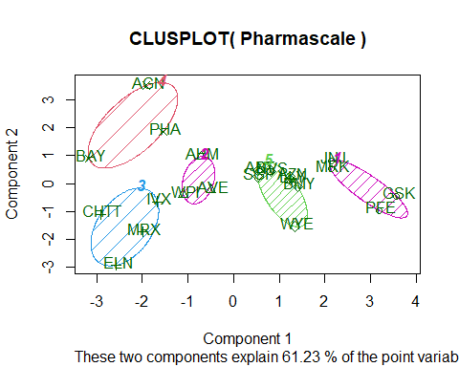

##2): Interpret the clusters with respect to the numerical variables used in forming the clusters.

By observing the mean values of all quantitative variables for each cluster

aggregate(Pharmascale, by = list(fit$cluster), FUN=mean)

## Group.1 Market_Cap Beta PE_Ratio ROE ROA  
## 1 1 1.69558112 -0.1780563 -0.1984582 1.2349879 1.3503431  
## 2 2 -0.66114002 -0.7233539 -0.3512251 -0.6736441 -0.5915022  
## 3 3 -0.96247577 1.1949250 -0.3639982 -0.5200697 -0.9610792  
## 4 4 -0.52462814 0.4451409 1.8498439 -1.0404550 -1.1865838  
## 5 5 0.08926902 -0.4618336 -0.3208615 0.3260892 0.5396003  
## Asset_Turnover Leverage Rev_Growth Net_Profit_Margin  
## 1 1.153164e+00 -0.4680782 0.4671788 0.5912425  
## 2 -1.537552e-01 -0.4040831 0.6917224 -0.4005718  
## 3 -1.153164e+00 1.4773718 0.7120120 -0.3688236  
## 4 1.480297e-16 -0.3443544 -0.5769454 -1.6095439  
## 5 6.589509e-02 -0.2559803 -0.7230135 0.7343816

Cluster_1 - JNJ, MRK, GSK, PFE - They have the highest market cap and the the companies are managing their operations by financing their operations fairly well (leverage below 0.47)

Cluster_2 - AHM, AVE, WPI - They have lowest asset turnover, lowest beta meaning the company stocks are performing lower than the current market performance index.

Cluster_3 - IVX, MRX, ELN, CHTT - Cluster 3 has highest Beta, Leverage and lowest Market_Cap, ROE, ROA, Leverage, Rev_Growth, Net_Profit_Margin.

Cluster_4 - AGN, PHA, BAY - These have the highest price to earning ratio making them less lucrative. Their Return on equity is also in below 1 proving that investment in these stocks will not be as fruitful as other stocks.

Cluster_5 - ABT, NVS, AZN, LLY, BMY, WYE, SGP - They have highest asset turnover, lowest revenue growth, and highest net profit margin.

##3): Is there a pattern in the clusters with respect to the numerical variables (10 to 12)? (those not used in forming the clusters)

We have manually filter each cluster to identify the patterns with respect to media recommendations, location and exchange.

For cluster 1: The stocks are moderate in nature meaning, they are neither weak stocks nor stocks with good returns in the recent past.

For cluster 2: The stocks are diversified in terms of their location. Their fundamentals are technically good and media recommendations are highly positive

For cluster 3: Their leverage ratio is high, they are moderately recommended because of their financial stability

For cluster 4: hese are the stocks that needs to be held as per the media recommendations since they will eventually turn into good stocks

For Cluster 5: The cluster has stocks that are recommended to be held for longer time since they have high net profit margin.

##4):Provide an appropriate name for each cluster using any or all of the variables in the dataset.

Cluster 1: Growth Cluster - Since these are stable stocks Cluster 2: Multi bagger cluster - Through their beta is low, market recommendations are very positive Cluster 3: Fundamental Cluster - Stocks with good stability in terms of their finances and other fundamentals Cluster 4: Hold cluster - These are the stocks they have decent numbers. Cluster 5: Long term Cluster - High net profit margin means good business and hence the stocks are highly recommended to be held in the portofolio