AI RESUME ANALYZER
& JOB RECOMMENDATION SYSTEM

MAJOR PROJECT REPORT

Submitted by
M.Pravalika
Batch
July AI

2. ABSTRACT
This project presents an AI Resume Analyzer and Job Recommendation System designed to analyze a student's resume and suggest suitable job roles. The application allows a user to upload a resume in PDF, DOCX or TXT format. The uploaded resume is processed to extract text, clean the text and identify skills using a predefined skill dictionary.
The extracted skills are compared with the requirements of available job roles. The system combines direct skill matching with TF-IDF and cosine similarity to calculate a match percentage for each role. It also identifies missing skills and generates a personalized learning roadmap based on the missing skills from the recommended roles.
The complete application is implemented in Python using Streamlit. Pandas is used for CSV data processing and scikit-learn is used for TF-IDF and cosine similarity. The system also provides a downloadable text report containing the detected skills, recommended roles, missing skills and learning roadmap.

3. INTRODUCTION
Students and fresh graduates often have several technical skills but may not know which job roles match their current profile. Comparing a resume manually with many job descriptions can also take time. A resume analyzer can reduce this manual effort by extracting relevant information from the resume and comparing it with predefined job roles.
In this project, the resume is treated as the main input. The system extracts the text, preprocesses it and searches for skills from a predefined skill dictionary. The detected skills are then compared with the skills required for different job roles. TF-IDF and cosine similarity are used as a text-based similarity component along with direct skill matching.
The project is intended as a practical student-level AI/ML application. It does not depend on a large language model or external API. The main objective is to demonstrate a complete workflow from resume processing to job recommendation and skill-gap analysis.

4. PROBLEM STATEMENT
Students may find it difficult to identify suitable entry-level job roles from a resume containing multiple technical skills. Manual comparison of a resume with different job requirements is time-consuming and may not clearly show which skills are missing.
The problem addressed by this project is to develop a simple application that can analyze a resume, identify its skills, compare the profile with available job roles, provide a match percentage, show missing skills and suggest a learning roadmap.

5. OBJECTIVES
- Accept resumes in PDF, DOCX and TXT formats.
- Extract text from an uploaded resume.
- Clean and preprocess the extracted text.
- Detect relevant technical and soft skills using a skill dictionary.
- Compare the detected skills with predefined job-role requirements.
- Calculate job match percentages using skill matching and TF-IDF similarity.
- Display matched and missing skills for recommended roles.
- Generate a learning roadmap from the missing skills.
- Provide a downloadable analysis report.
- Build the complete application using a simple Streamlit interface.

6. TECHNOLOGIES USED
Technology | Purpose
Python | Main programming language
Streamlit | User interface and application framework
Pandas | Reading and processing CSV datasets
Scikit-learn | TF-IDF vectorization and cosine similarity
PyPDF | Text extraction from PDF resumes
python-docx | Text extraction from DOCX resumes
CSV | Storage of job-role and skill-dictionary data

7. SYSTEM ARCHITECTURE
The system follows a simple processing pipeline. The user uploads a resume through the Streamlit interface. The resume parser extracts its text, after which the text cleaner preprocesses it. The skill extractor checks the cleaned text against the skill dictionary. The detected skills and resume text are then used by the job matcher to compare the profile with the job-role dataset. Finally, missing skills are passed to the roadmap generator and the results are displayed through Streamlit.
Main flow:
Resume Upload → Text Extraction → Text Cleaning → Skill Extraction → Job Role Matching → Match Score → Missing Skills → Learning Roadmap → Results → Download Report
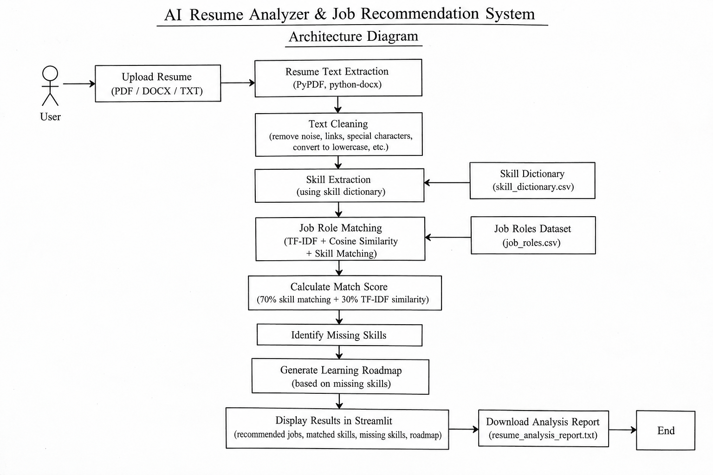
Figure 1: System Architecture

8. METHODOLOGY / WORKFLOW

8.1 Resume Upload and Text Extraction
The application provides a Streamlit file uploader that accepts PDF, DOCX and TXT files. For PDF files, PyPDF is used to read the document. For DOCX files, python-docx is used. TXT files are read as normal text. The uploaded file is temporarily stored before processing.

8.2 Text Cleaning
The extracted text is converted to lowercase and cleaned using regular expressions. Email addresses, URLs, unwanted special characters and extra spaces are removed so that later matching is more consistent.

8.3 Skill Extraction
The cleaned resume text is compared with the skills stored in skill_dictionary.csv. Regular expressions are used to identify complete skill terms. The detected skills are then displayed in the Streamlit application.

8.4 Job Role Matching
The detected resume skills are compared with the skills required by each job role in job_roles.csv. The matching skills form the matched-skill set, while required skills that are not present in the resume are treated as missing skills.

8.5 Match Score Calculation
The project combines direct skill matching and TF-IDF text similarity. The final score gives 70 percent weight to skill matching and 30 percent weight to TF-IDF similarity. The results are sorted from the highest match percentage to the lowest.

8.6 Missing Skill Identification
For each job role, the system identifies the required skills that were not detected in the resume. These missing skills are displayed along with the corresponding job recommendation.

8.7 Learning Roadmap
The roadmap generator considers the missing skills from the top three recommended job roles. Skills that occur across multiple recommended roles receive higher priority. The current roadmap displays up to ten skills with a reason for each skill.

8.8 Report Generation
After the analysis is completed, the application creates a text report containing the detected skills, recommended job roles, match percentages, matched skills, missing skills and learning roadmap. The report can be downloaded from the Streamlit interface.

9. IMPLEMENTATION
File / Component | Function
app.py | Streamlit interface, file upload, display of results and report download
resume_parser.py | PDF, DOCX and TXT resume text extraction
text_cleaner.py | Resume text preprocessing and cleaning
skill_extractor.py | Skill detection using the skill dictionary
job_matcher.py | Skill matching, TF-IDF similarity and final match score
roadmap_generator.py | Learning roadmap generation from missing skills
data/job_roles.csv | Job roles, required skills and descriptions
data/skill_dictionary.csv | List of skills used for extraction

9.1 Job Matching Formula
The final job match score is calculated as:
Final Score = (Skill Percentage × 0.70) + (TF-IDF Similarity Percentage × 0.30)
Skill Percentage is calculated as the number of matched required skills divided by the total number of required skills for that job role, multiplied by 100.

10. TESTING & RESULTS
The application was tested using a sample AIML fresher resume. The resume contains programming, database, web, machine learning and AI-related skills. The main end-to-end PDF workflow was successfully demonstrated in Streamlit.
S.No | Test | Observed Result | Status
1 | Application launch | Application opened successfully | Pass
2 | PDF resume upload | Sample AIML resume uploaded successfully | Pass
3 | Resume processing | Resume was processed and analysis results were generated | Pass
4 | Skill detection | Multiple resume skills were detected and displayed | Pass
5 | Job recommendation | Recommended job roles and match percentages were displayed | Pass
6 | Match score | Scores were displayed for the recommended roles | Pass
7 | Matched / missing skills | Matched and missing skills were displayed | Pass
8 | Learning roadmap | PyTorch, Scikit-learn and TensorFlow were shown in the roadmap | Pass
9 | Report option | Download Analysis Report button was displayed | Pending verification

10.1 Sample Output
For the sample AIML resume, the application displayed the following top recommendations:
Job Role | Match | Matched Skills | Missing Skills
Machine Learning Engineer | 70.47% | Git, Machine Learning, NumPy, Pandas, Python, SQL | Scikit-learn
NLP Engineer | 63.98% | Artificial Intelligence, Deep Learning, Machine Learning, NLP, Python | PyTorch
AI Engineer | 59.48% | Artificial Intelligence, Deep Learning, Machine Learning, Python | PyTorch, TensorFlow
Python Developer | 57.69% | Git, Python, REST API, SQL | Flask
Data Scientist | 57.27% | Machine Learning, NumPy, Pandas, Python, SQL | Scikit-learn, Statistics
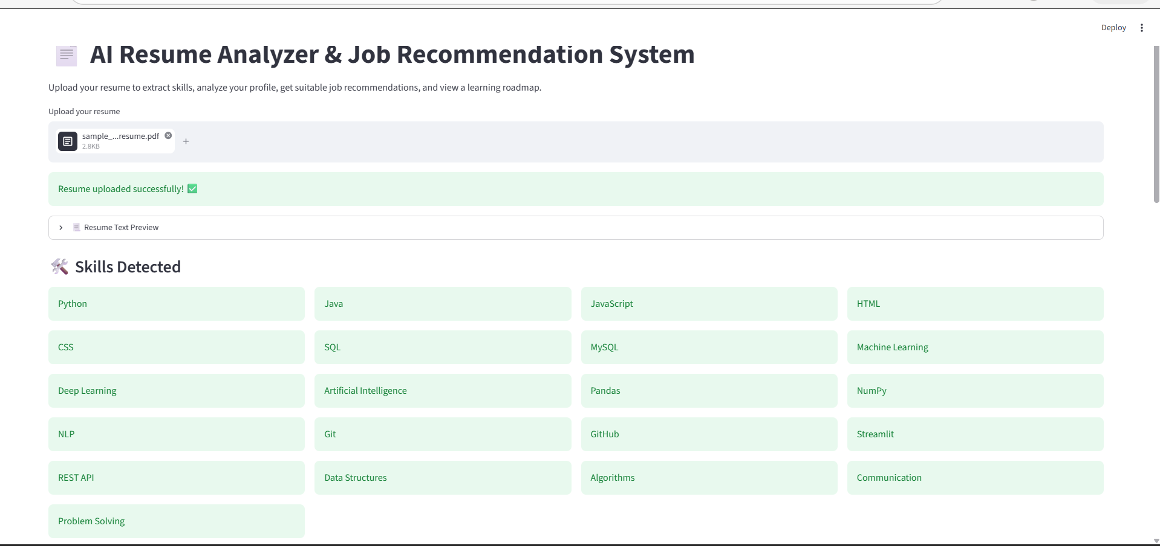
Figure 2: Resume upload and detected skills
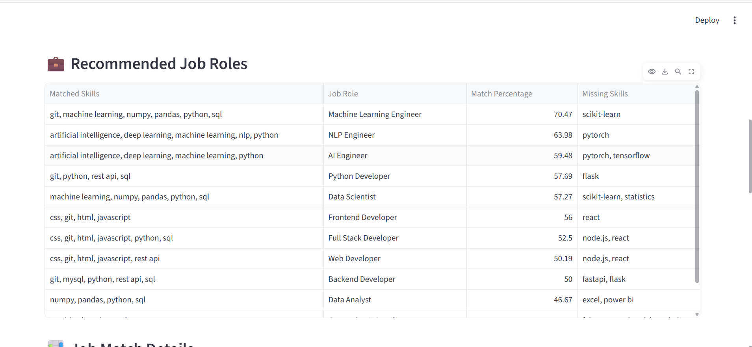
Figure 3: Recommended job roles and match percentages
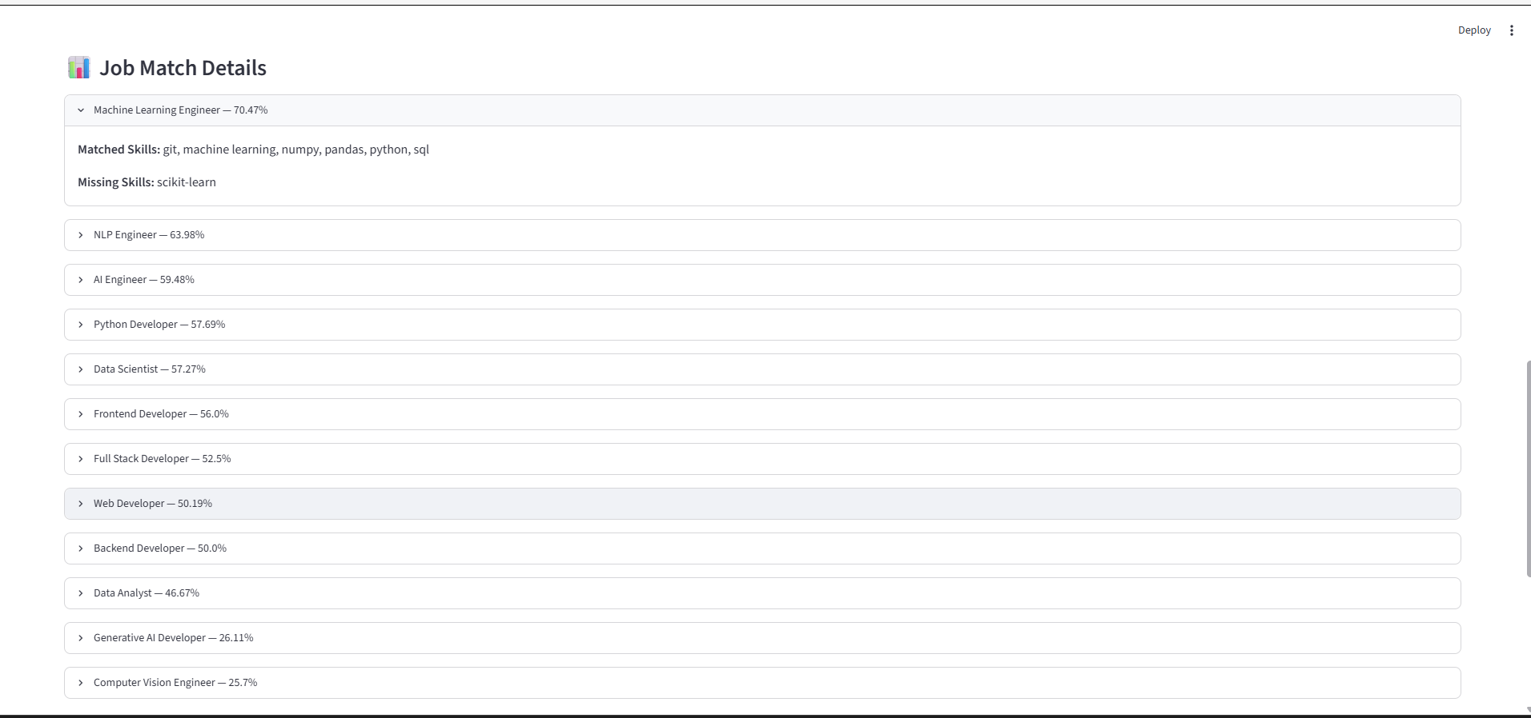
Figure 4: Job match details
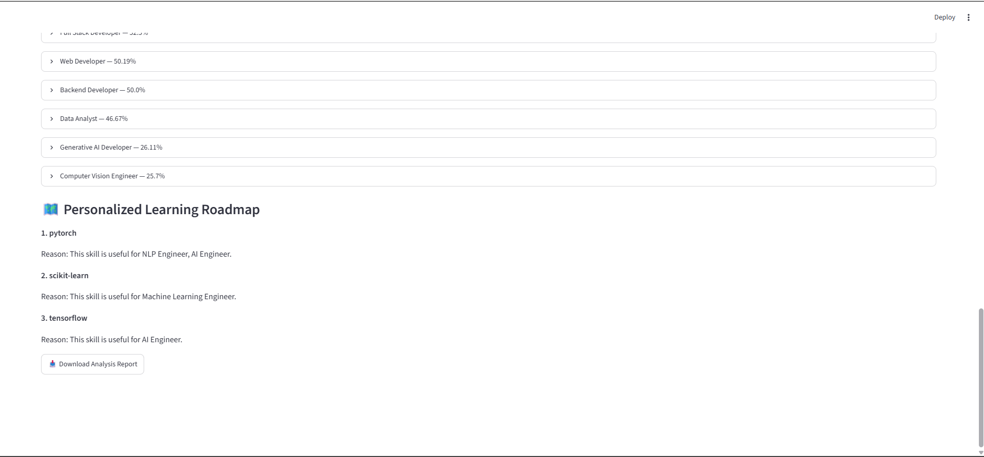
Figure 5: Learning roadmap and report download

11. ADVANTAGES
- Reduces the manual effort required to compare a resume with different job roles.
- Supports PDF, DOCX and TXT resumes.
- Uses both direct skill matching and text similarity.
- Shows the skills already matched to a job role.
- Identifies missing skills for each recommended role.
- Provides a simple learning roadmap based on the skill gap.
- Does not require an external LLM API or API key.
- Provides a downloadable analysis report.
- Uses a simple Streamlit interface suitable for student use.

12. LIMITATIONS
- The current job-role dataset contains a limited number of predefined roles.
- Skill extraction depends on the skills present in the skill dictionary.
- The system mainly detects explicitly mentioned skills rather than understanding every possible skill context.
- The recommendations depend on the quality and coverage of the job-role dataset.
- The current roadmap is based on missing skills from the top recommended roles rather than a full personalized career plan.
- The current implementation uses CSV files rather than a database.
- The system does not use an LLM to interpret complex resume information.

13. FUTURE SCOPE
- Expand the job-role dataset with more entry-level and industry-specific roles.
- Improve skill extraction using NLP-based entity recognition.
- Support additional resume formats and scanned resumes using OCR.
- Add more detailed resume section analysis such as education, projects and experience.
- Improve ranking by considering experience level, location and other job requirements.
- Provide links or learning resources for the missing skills.
- Store user analysis history using a database.
- Deploy the application so that it can be accessed online.

14. CONCLUSION
The AI Resume Analyzer and Job Recommendation System demonstrates a practical application of text processing and machine learning techniques for resume analysis. The system accepts a resume, extracts and cleans its text, detects skills and compares the profile with predefined job roles.
The combination of direct skill matching with TF-IDF and cosine similarity provides a simple way to calculate job match percentages. The system also shows missing skills and generates a learning roadmap, making the output more useful than a simple job recommendation list.
The working Streamlit application successfully demonstrated the main PDF resume analysis pipeline using the sample AIML resume. The project provides a complete student-level implementation that can be further improved by expanding the datasets, improving skill extraction and adding additional resume analysis features.

15. REFERENCES
- Python documentation – Python programming language.
- Streamlit documentation – Streamlit application framework.
- scikit-learn documentation – TF-IDF vectorization and cosine similarity.
- PyPDF documentation – PDF text extraction.
- python-docx documentation – DOCX document processing.

