US Unemployment rate analysis

## Dataset:

Below are the datasets:

US unemployment dataset

:<https://www.kaggle.com/datasets/aniruddhasshirahatti/us-unemployment-dataset-2010-2020> Unemployment analysis : <https://www.kaggle.com/datasets/pantanjali/unemployment-dataset>

### Features with their descriptions:

1. **Unemployment Analysis with respect to Education:** For this feature, we are considering data related to education, i.e., the unemployment rate for individuals who have completed primary school, high school, an associate degree, and a professional degree
2. **Unemployment Analysis with respect to Ethnicity:** For this feature we are considering data that is related to ethnicity ie., white, black, Asian and Hispanic passed outs for each year.
3. **Unemployment Analysis with respect to Gender:** For this feature we are considering data related to individuals based on their gender (Male, Female).
4. **Unemployment analysis of United States from 2010 to 2021:** For this feature we are considering data from 2010 to 2021 for United states only.
5. **Average highest and lowest unemployment countries:** Considered data after 2010 and plotted interactive graphs.
6. **Best unemployment rate development countries:** This feature shows the countries with best development using their unemployment rate.

# Unemployment Analysis with respect to education

Performed statistical analysis and visualized mean and standard deviation for each parameter

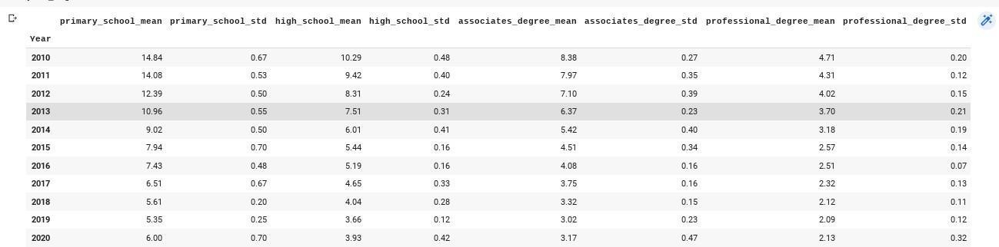

Visual representation:

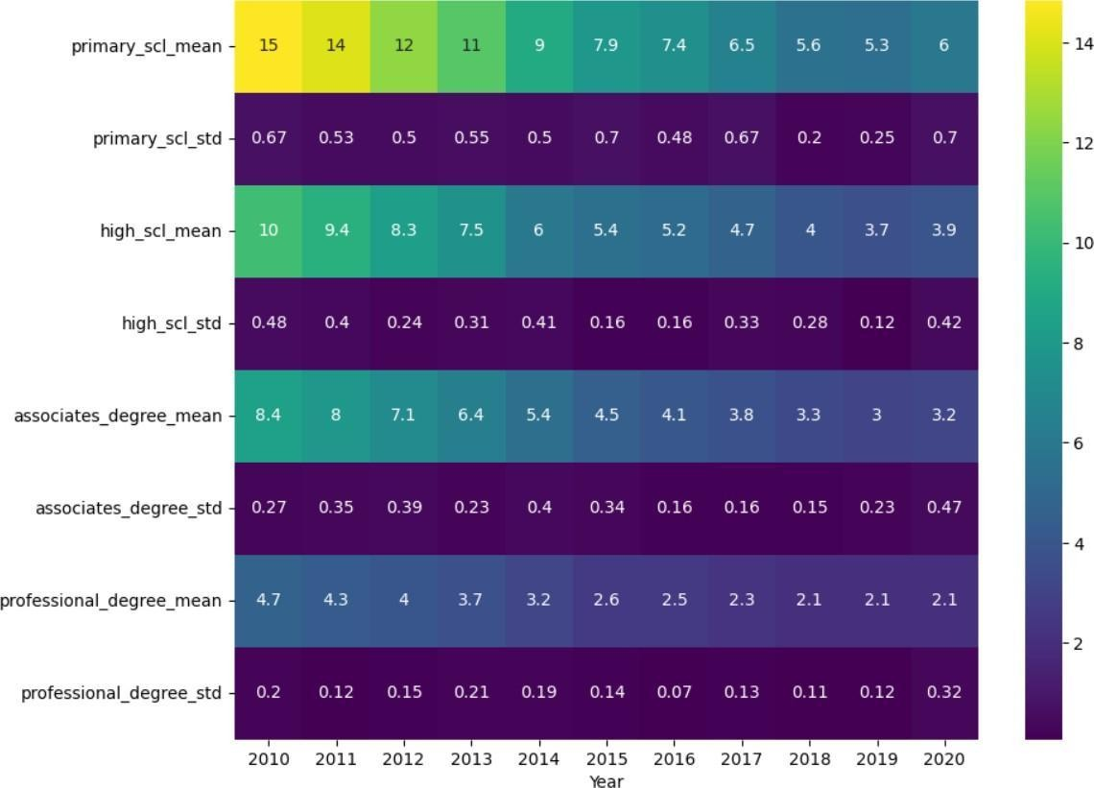

The below graph shows the unemployment rate of the high school(histogram):

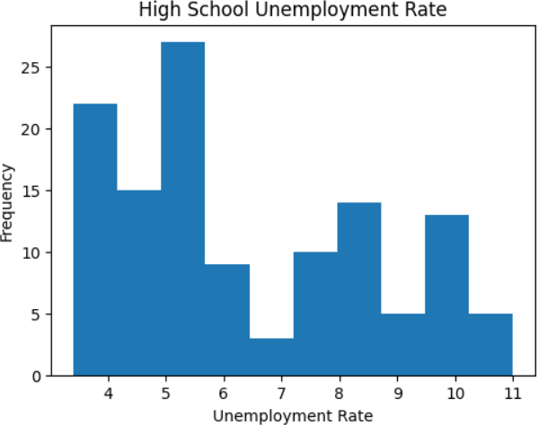

The below graph shows the unemployment rate of the Primary school:

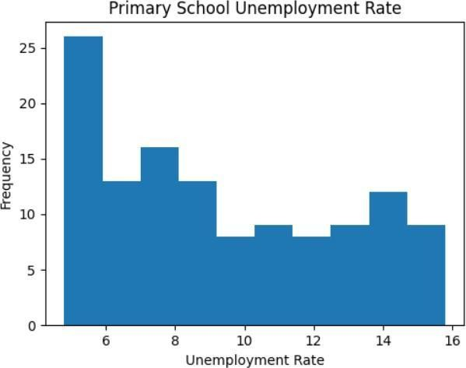

The below graph shows the unemployment rate of the Professional Degree

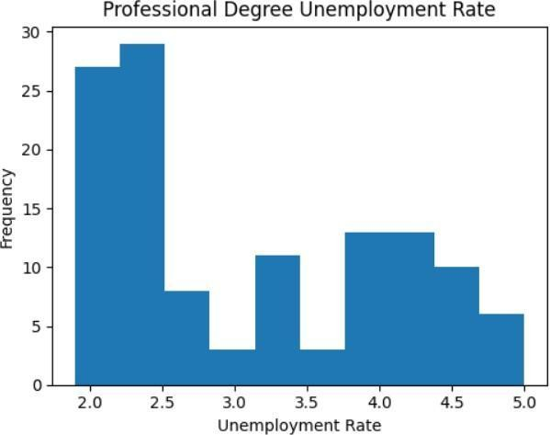

The below graph shows the unemployment rate of the Associate Degree:

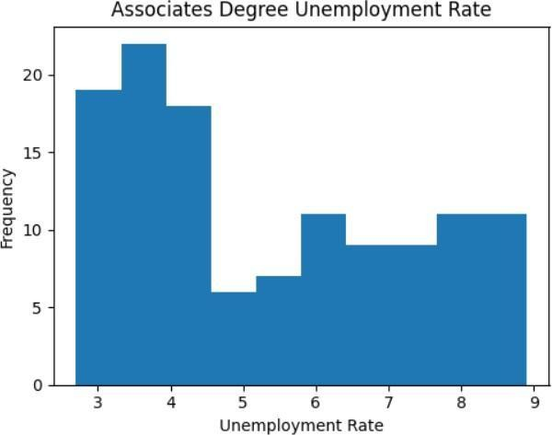

# Unemployment Analysis with respect to ethnicity:

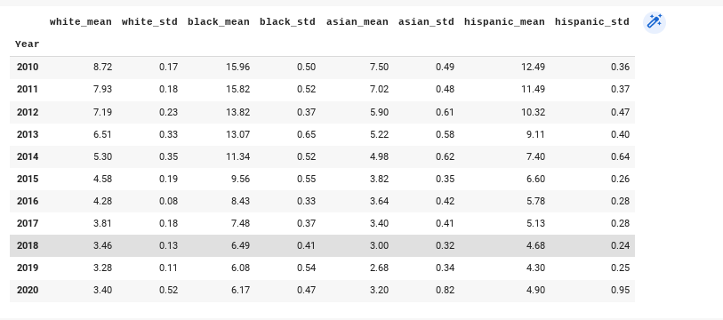

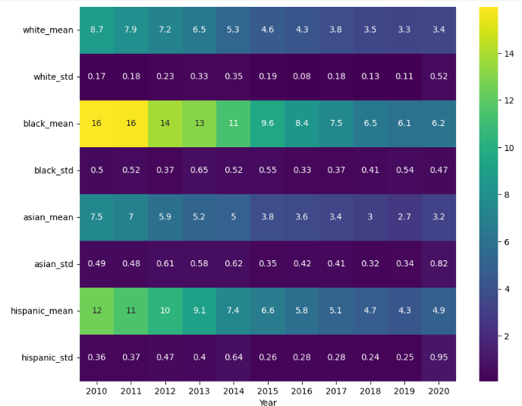

The below histogram shows the unemployment rate of White’s from 2010 to 2020, we can see the gradual decrease in the unemployment rate till 2019 and there is drastic increase in year 2020.

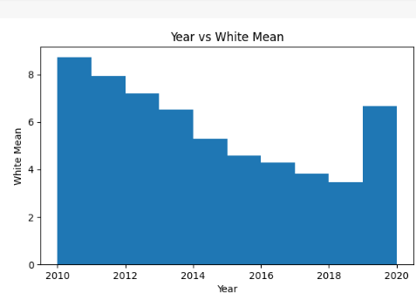

The below histogram shows the unemployment rate of Black’s from 2010 to 2020, we can see that there is not much change in the unemployment rate in years 2010, 2011 and gradual decrease in the unemployment rate from 2012 to 2019 and there is drastic increase in year 2020.

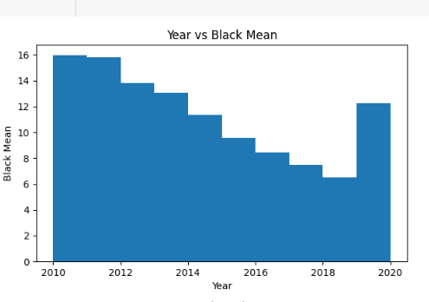

The below histogram shows the unemployment rate of Asian’s from 2010 to 2020, we can see the gradual decrease in the unemployment rate till 2019 and there is drastic increase in year 2020.

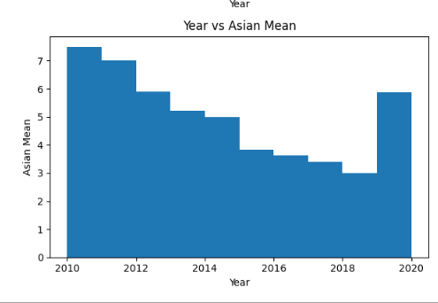

The below histogram shows the unemployment rate of Hispanics from 2010 to 2020, we can see the gradual decrease in the unemployment rate till 2019 and there is drastic increase in year 2020.

Below is

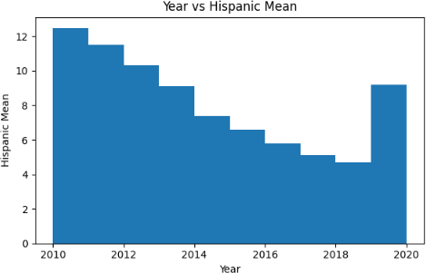

# Unemployment Analysis with respect to Gender

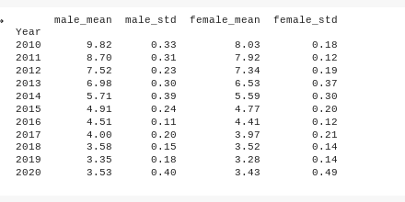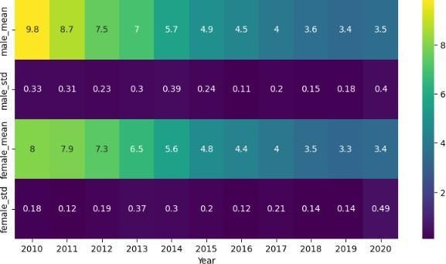

The below is the bar graph representing the male unemployment rate by year with x-axis as years from 2010 to 2020 and y-axis as unemployment rate. Here, we can see that the the unemployment rate is high in year 2010 and gragually drecreases to the year 2019 and there is slight increase in unemployment in year 2020 which is same as 2018.

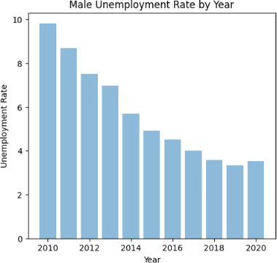

The below is the bar graph representing the female unemployment rate by year with x-axis as years from 2010 to 2020 and y-axis as unemployment rate. Here, we can see that the the unemployment rate is high in year 2010 and 2011 and gragually drecreases to the year 2019 and there is slight increase in unemployment in year 2020 which is same as 2018.

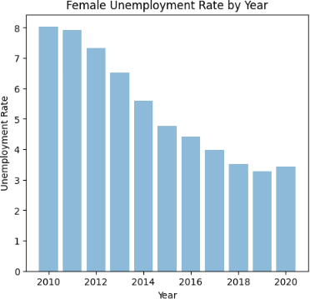

Below is the histogram representation of unemployment rate of Gender. We can observe that the male unemployment rate is much higher than the female.

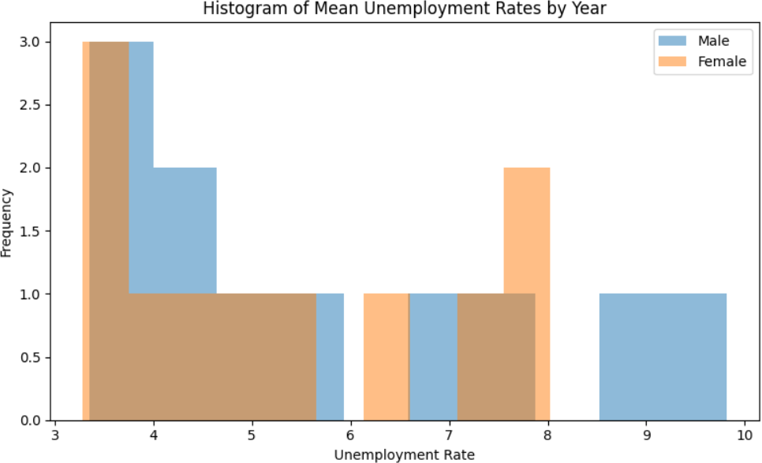

## Unemployment analysis of United States from 2010 to 2021

**Mean of unemployment rate of United States:**



**Standard Deviation of unemployment rate of United States:**



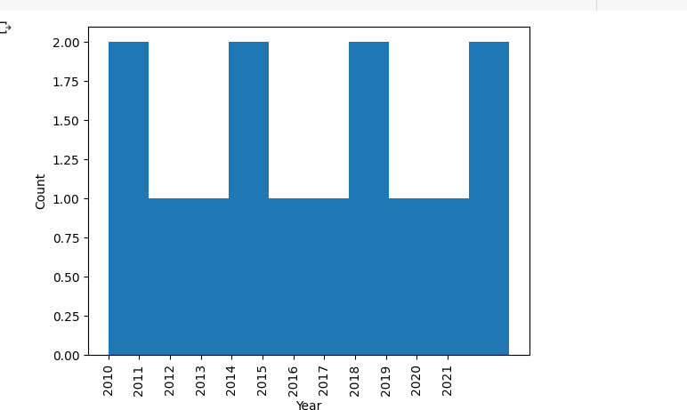**Below is the histogram of the unemployment rate of the United States from years 2010 to 2021:**

## Average highest and lowest unemployment countries:

The below graph explains the average lowest unemployment rate. This is an interactive graph which gives unemployment of the country when hovered on it.

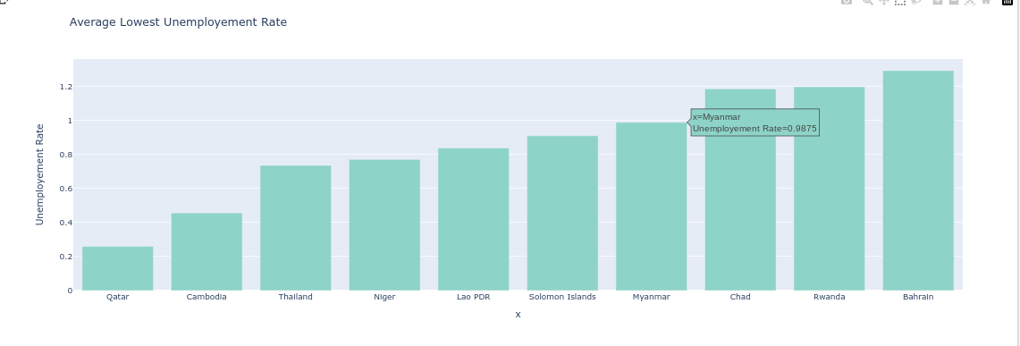

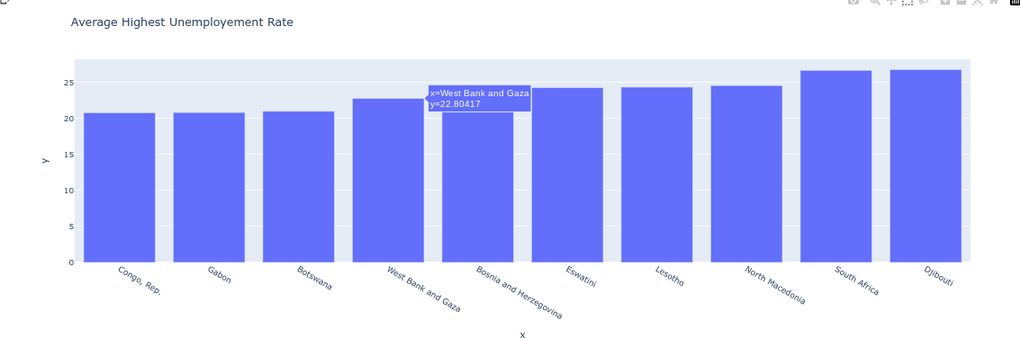The below graph explains the highest unemployment rate. This is also an interactive graph.

## Best unemployment rate development countries

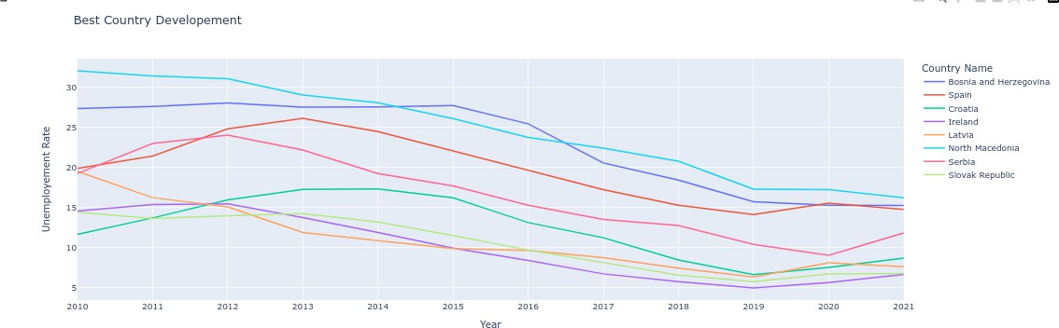The below graph gives clear visualization about the countries with best development in terms of employment.

# Unemployment comparison between 3 features for US Unemployment dataset:(first 3 features)

For connection between features, here we have considered parameters with highest unemployment rate from each feature. Unemployment rate is highest for primary school passed outs for education, black people passed outs for ethnicity and Men for Gender. Following is simple bar graph showing their unemployment rate.

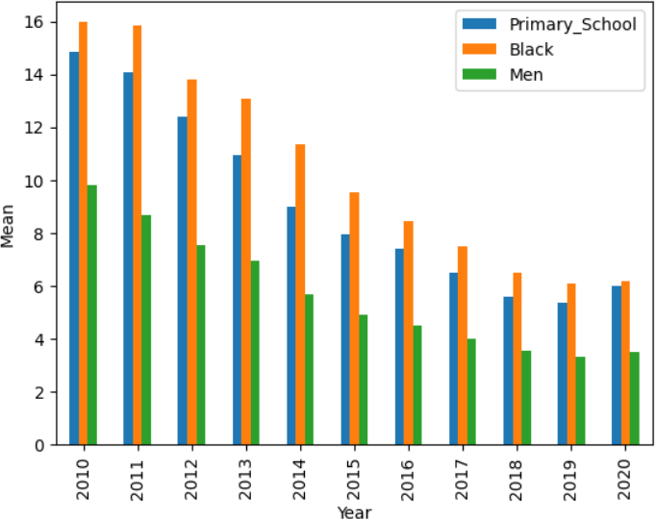

However further analysis is required for detailed explanation of Unemployment dataset, which will be delivered in future submissions.

## Unemployment comparison (4,5,6 features)

The below graph shows the countries unemployment for the selected year of the slider.

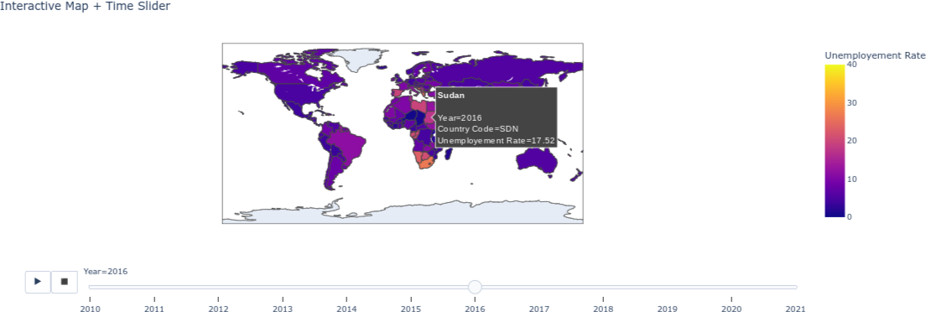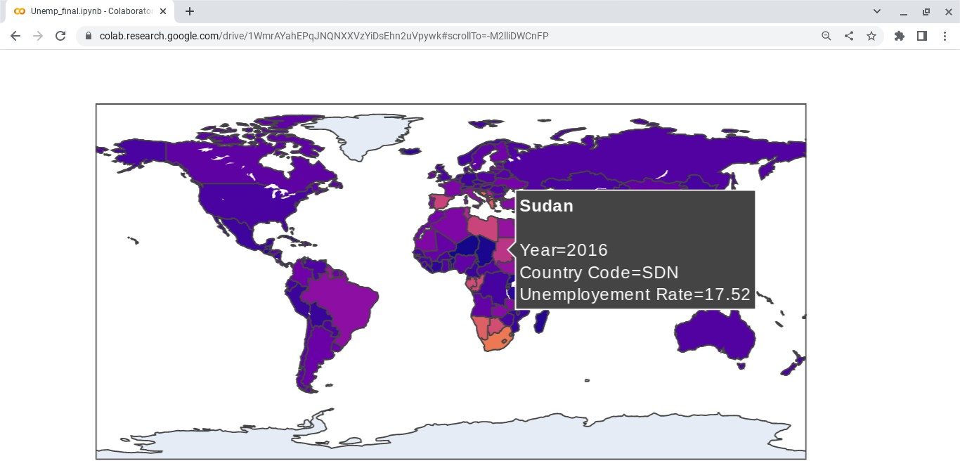

### CONCLUSION:

Using Us unemployment dataset and Unemployment dataset gave us more clarity on the patterns of unemployment rate in recent years.