Distributed Collaborative Filtering Recommendation Engine using PySpark ALS

A Term project report submitted



by

Vaddi. Pravallika Nadagani. Navya Lakshmi
323103282106 323103282063
Panduri. Harshini Parupalli. Sowjanya
323103282074 323103282076

Department of Computer Science and Engineering (AI & ML)
Gayatri Vidya Parishad College of Engineering for Women
(Affiliated to Andhra Pradesh University, Visakhapatnam)
2023-27

Gayatri Vidya Parishad College of Engineering for Women
Department of Computer Science and Engineering (AI &ML)



CERTIFICATE

This is to certify that the term project report titled “Distributed Collaborative Filtering Recommendation Engine using PySpark ALS” is a bonafide work of following III B.Tech IInd Semester students in the Department of Computer Science and Engineering (AI&ML), Gayatri Vidya Parishad College of Engineering for Women affiliated to ANDHRA UNIVERSITY, Visakhapatnam during the academic year 2025-26.

V. Pravallika (3CSM2) N. Navya Lakshmi (3CSM2)
P. Harshini (3CSM2) P. Sowjanya (3CSM2)

Project Coordinator
Dr. K. Purushotam Naidu
Associate Professor, Dept of CSE(AI&ML)
GVP College of Engineering for Women
Visakhapatnam, AP, INDIA

ACKNOWLEDGEMENT

The satisfaction that accompanies the successful completion of any task would be incomplete without the mention of people who made it possible and whose constant guidance and encouragement crown all the efforts with success.
We feel elated to extend our sincere gratitude to our mentor Dr. K. Purushotam Naidu, Mrs. Kanika Soni Assistant Professor of Computer Science and Engineering (AI&ML) for encouragement all the way during analysis of the project. His annotations, insinuations and criticisms are the key behind the successful completion of the thesis and for providing us all the required facilities.
We express our deep sense of gratitude and thanks to Dr. D.K Bebartha, Professor and Head of the Department of Computer Science and Engineering (AI&ML) for his guidance and for expressing his valuable and grateful opinions in the project for its development and for providing lab sessions and extra hours to complete the project.
We would like to take this opportunity to express our profound sense of gratitude to Vice Principal, Dr. G. Sudheer for allowing us to utilize the college resources thereby facilitating the successful completion of our project. We are also thankful to both teaching and non-teaching faculty of the Department of Computer Science and Engineering (AI&ML) for giving valuable suggestions for our project.
We would like to take the opportunity to express our profound sense of gratitude to the revered Principal, Dr. R. K. Goswami for all the help and support towards the successful completion of our project.

Contents

ABSTRACT 1
1. INTRODUCTION 2
2. TECHNOLOGIES USED 5
2.1. Python Programming Language 5
2.2. Apache Spark 5
2.3. PySpark 5
2.4. Alternating Least Squares (ALS) Algorithm 6
2.5. MovieLens Dataset 6
2.6. Data Preprocessing Techniques 6
2.7. Machine Learning Evaluation Metrics 6
2.8. Flask (Optional for Deployment) 7
2.9. Development Environment and Tools 7
2.10. Distributed Computing Concept 7
3. METHODOLOGY 8
4. SOURCE CODES 12
4.1. Train_model.py 12
4.2. data_preprocessing.py 13
5. OUTPUT SCREENS 15
6. CONCLUSION 16
7. REFERENCES 17

ABSTRACT

The Movie Recommendation System developed in this project presents an efficient and scalable solution for providing personalized movie suggestions by leveraging big data processing and machine learning techniques. The system is built using Apache Spark and its Python API PySpark, enabling distributed data processing for handling large-scale datasets such as the MovieLens Dataset. The core of the system is based on the Collaborative Filtering approach, implemented using the Alternating Least Squares (ALS) algorithm, which learns user preferences and item characteristics to predict ratings for unseen movies. The data preprocessing phase involves transforming raw text data into structured formats, followed by splitting the dataset into training and testing sets to ensure proper model evaluation. The performance of the model is assessed using Root Mean Square Error (RMSE), which measures the difference between predicted and actual ratings. In addition to backend processing, an interactive frontend interface is developed using Streamlit, allowing users to input specific user IDs and receive top movie recommendations, search movies by ID or name to view overall ratings and user reviews, and explore top-rated movies within the dataset. The system is designed to be user-friendly, efficient, and adaptable, addressing practical challenges such as handling large datasets, optimizing performance, and ensuring smooth integration between backend and frontend components. Overall, this project demonstrates the practical application of machine learning and big data technologies in building intelligent recommendation systems, which are widely used in modern digital platforms such as streaming services and e-commerce websites to enhance user experience and decision-making.

INTRODUCTION

Distributed Recommendation System using ALS and PySpark
In the modern digital era, the exponential growth of data has transformed the way users interact with online platforms. From streaming services to e-commerce websites, users are constantly exposed to vast amounts of content. While this abundance of information provides more choices, it also creates a challenge known as information overload, where users find it difficult to identify relevant and personalized content. To address this problem, Recommendation Systems have emerged as an essential component of intelligent applications, helping users discover items that match their preferences efficiently.
A Recommendation System is a type of information filtering system that predicts the interests or preferences of users and suggests relevant items accordingly. These systems are widely used in platforms such as movie streaming services, online shopping websites, music applications, and social media. Among these, Movie Recommendation Systems are particularly significant as they enhance user experience by suggesting movies tailored to individual tastes, thereby increasing user engagement and satisfaction.
Recommendation systems are broadly classified into three categories: content-based filtering, collaborative filtering, and hybrid methods. Content-based filtering recommends items based on their attributes and user preferences, such as genres, actors, or keywords. Collaborative filtering, on the other hand, relies on the behavior and interactions of users, such as ratings and viewing history, to make recommendations. Hybrid systems combine both approaches to improve accuracy and overcome individual limitations. In this project, a collaborative filtering approach is adopted due to its effectiveness in capturing user behavior patterns and scalability for large datasets.
The implementation of recommendation systems becomes more complex when dealing with large-scale data. Traditional data processing techniques often fail to handle massive datasets efficiently due to limitations in memory and computational power. To overcome these challenges, Big Data technologies such as Apache Spark have gained popularity. PySpark, the Python interface for Apache Spark, enables distributed data processing and provides efficient tools for handling large datasets. It allows parallel computation across multiple nodes, making it highly suitable for building scalable machine learning applications.
In this project, PySpark is used for data preprocessing, transformation, and model training. The dataset used consists of three main components: ratings, movies, and tags. The ratings dataset contains user–movie interactions in the form of ratings, which serve as the primary input for the recommendation model. The movies dataset includes details such as movie titles and genres, while the tags dataset provides additional contextual information generated by users. These datasets are processed and converted into structured formats using PySpark DataFrames, ensuring efficient handling and compatibility with machine learning algorithms.
The core algorithm used in this system is the Alternating Least Squares (ALS) algorithm, a widely used technique for collaborative filtering. ALS works by decomposing the user–item interaction matrix into two lower-dimensional matrices representing user features and item features. These latent factors capture hidden patterns in user preferences and movie characteristics. By learning these patterns, the model can predict unknown ratings and recommend movies that users are likely to enjoy. ALS is particularly effective for large datasets as it supports parallel computation and handles sparse data efficiently.
To evaluate the performance of the recommendation model, the dataset is divided into training and testing sets. The model is trained on the training data and tested on unseen data to measure its prediction accuracy. The evaluation metric used in this project is Root Mean Square Error (RMSE), which measures the difference between predicted ratings and actual ratings. A lower RMSE value indicates better model performance and higher prediction accuracy.
In addition to backend processing and model development, providing an intuitive and interactive user interface is essential for enhancing user experience. Therefore, this project integrates a frontend application using Streamlit, a popular Python framework for building data-driven web applications. The Streamlit interface allows users to interact with the recommendation system in real time without requiring technical knowledge.
The application provides multiple functionalities to improve usability and accessibility. Users can enter one or more user IDs to receive personalized movie recommendations generated by the ALS model. The system displays the top recommended movies along with predicted ratings, helping users quickly identify relevant content. Additionally, users can search for movies using either movie ID or movie name to view detailed information, including overall average ratings and individual user reviews. This feature provides transparency and helps users make informed decisions. The application also includes a section that displays the top-rated movies based on aggregated ratings, allowing users to explore popular and highly rated content.
The frontend design is enhanced using custom styling techniques, including light-themed color schemes and improved visual elements, to create an appealing and user-friendly interface. This integration of backend processing, machine learning, and frontend visualization demonstrates a complete end-to-end system for movie recommendation.
The significance of this project lies in its ability to combine big data processing, machine learning algorithms, and interactive visualization into a single application. It showcases how modern technologies can be leveraged to build scalable and efficient recommendation systems that cater to user preferences. Such systems are widely used in real-world applications and play a crucial role in improving user engagement, retention, and satisfaction.
Furthermore, this project provides a strong foundation for future enhancements. Advanced techniques such as hybrid recommendation models, deep learning-based approaches, and real-time data processing can be incorporated to improve accuracy and performance. The system can also be deployed on cloud platforms to handle larger datasets and support real-world applications. Additional features such as personalized dashboards, recommendation explanations, and integration with external APIs can further enhance the system’s capabilities.
In conclusion, the Movie Recommendation System developed in this project demonstrates an effective approach to solving the problem of information overload by providing personalized suggestions to users. By leveraging PySpark for large-scale data processing, ALS for collaborative filtering, and Streamlit for user interaction, the system achieves a balance between performance, scalability, and usability. This project highlights the practical implementation of recommendation systems and their importance in today’s data-driven world.
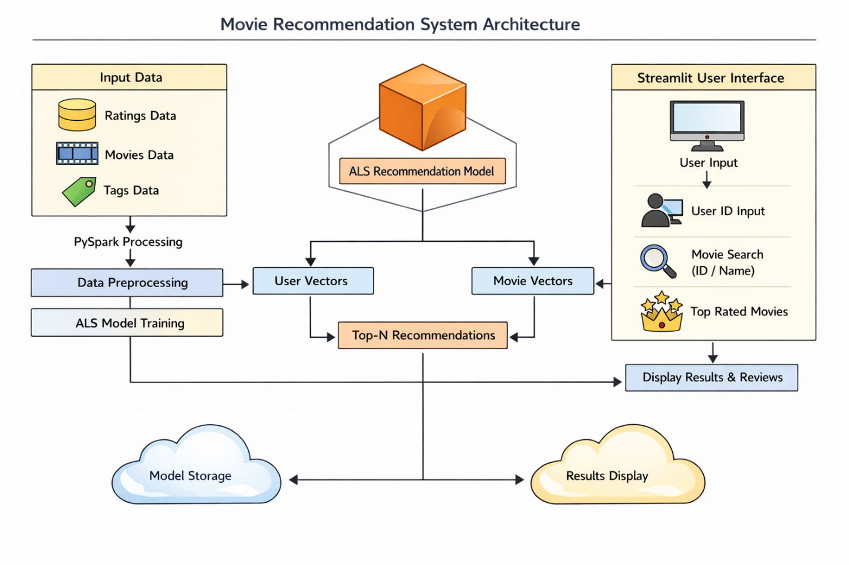
Fig 1 Architecture

TECHNOLOGIES USED

The Movie Recommendation System is developed using a combination of modern big data, machine learning, and web technologies. These technologies work together to handle large-scale data processing, model training, and interactive user interface development.

2.1. Apache Spark (PySpark)
Apache Spark is a powerful distributed computing framework used for big data processing. In this project, PySpark (Python API for Spark) is used to efficiently process large datasets such as ratings, movies, and tags.
Spark provides in-memory computation, which makes it significantly faster than traditional data processing frameworks. It allows parallel processing of data across multiple nodes, making it highly scalable and suitable for recommendation systems.
Key uses in the project:
- Reading large datasets (ratings.dat, movies.dat, tags.dat)
- Data preprocessing and transformation
- Handling structured data using DataFrames
- Performing distributed computations efficiently
PySpark also integrates seamlessly with machine learning libraries, making it an ideal choice for building recommendation systems.

2.2. Spark MLlib (ALS Algorithm)
Spark MLlib is the machine learning library provided by Apache Spark. In this project, the Alternating Least Squares (ALS) algorithm is used for collaborative filtering.
ALS is specifically designed for recommendation systems and works by factorizing the user-item interaction matrix into two lower-dimensional matrices:
- User feature matrix
- Item (movie) feature matrix
These matrices help predict missing ratings and generate recommendations.
Key features of ALS:
- Handles large-scale data efficiently
- Supports implicit and explicit feedback
- Works well with sparse datasets
- Provides fast and scalable model training
In this project, ALS is used to:
- Train the recommendation model
- Predict user ratings for unseen movies
- Generate top-N movie recommendations

2.3. Python Programming Language
Python is the primary programming language used in this project due to its simplicity, readability, and extensive support for data science and machine learning libraries.
Advantages of Python:
- Easy to learn and use
- Rich ecosystem of libraries
- Strong community support
- Seamless integration with PySpark
Python is used for:
- Writing data preprocessing scripts
- Training machine learning models
- Building backend logic
- Integrating with Streamlit for frontend

2.4. Streamlit (Frontend UI)
Streamlit is a lightweight Python framework used to build interactive web applications quickly. It is used in this project to create a user-friendly interface for the recommendation system.
Features of Streamlit:
- Simple and fast UI development
- Real-time interaction
- No need for HTML/CSS/JavaScript (basic usage)
- Easy integration with Python code
Functionalities implemented using Streamlit:
- Input user IDs to get recommendations
- Search movies by ID or name
- Display movie reviews and ratings
- Show top-rated movies
- Visual display using progress bars
Custom styling using CSS is also applied to enhance the appearance of the application.

2.5. Hadoop (WinUtils for Windows Support)
Although Hadoop is not directly used for storage or distributed computing in this project, certain components like winutils.exe are required for running Spark on Windows systems.
Purpose:
- Provides compatibility for file system operations
- Enables Spark to run smoothly on Windows
Without proper Hadoop configuration, errors like HADOOP_HOME not set may occur. Hence, minimal Hadoop setup is necessary.

2.6. Dataset (MovieLens Dataset)
The project uses a dataset similar to the MovieLens dataset, which contains:
- User ratings for movies
- Movie details (title, genres)
- User-generated tags
Dataset structure:
- ratings.dat → userId, movieId, rating
- movies.dat → movieId, title, genres
- tags.dat → userId, movieId, tag
This dataset is widely used for building recommendation systems and provides a realistic scenario for collaborative filtering.

2.7. Data Processing Techniques
Several data processing techniques are used to prepare the data for model training:
- Data Cleaning: Removing unnecessary columns and handling missing values
- Data Transformation: Converting raw text data into structured format
- Type Casting: Converting string values into integers and floats
- Feature Selection: Selecting relevant columns like userId, movieId, rating
These steps ensure that the data is suitable for machine learning algorithms.

2.8. Model Evaluation (RMSE)
The performance of the recommendation model is evaluated using Root Mean Square Error (RMSE).
RMSE measures the difference between predicted ratings and actual ratings. A lower RMSE value indicates better model performance.
Formula:
- RMSE = √(Σ(predicted − actual)² / n)
In this project:
- Predictions are generated using the ALS model
- RMSE is calculated using Spark’s RegressionEvaluator

2.9. Visualization Components
Basic visualization techniques are used in the Streamlit interface:
- Progress bars for rating display
- Text-based structured output
- Interactive input fields
These components enhance user experience and make the system more intuitive.

2.10. File System & Project Structure
The project follows a modular structure:
- data/ → contains datasets
- src/ → contains preprocessing and model training code
- app.py → main frontend application
This structure improves:
- Code readability
- Maintainability
- Scalability

METHODOLOGY

The Movie Recommendation System is developed using a structured approach that includes environment setup, data processing, model training, and frontend development. The methodology ensures smooth implementation from start to end.

Step 1: Environment Setup
The first step involves setting up the required software and libraries.
Tools Installed:
- Python (latest version)
- Apache Spark (PySpark)
- Java (JDK required for Spark)
- Streamlit (for frontend)
Installation Steps:
- Install Python and verify using:
python --version
- Install required Python libraries:
pip install pyspark streamlit
- Install Java (JDK) and set environment variables:
  - JAVA_HOME
  - Add Java to system PATH
- (For Windows) Setup Hadoop:
  - Download winutils.exe
  - Set HADOOP_HOME environment variable
  - Add %HADOOP_HOME%\bin to PATH
This setup ensures Spark runs without errors.

Step 2: Project Structure Creation
A clean project structure is created to organize files properly.
This structure separates:
- Data
- Backend logic
- Frontend interface
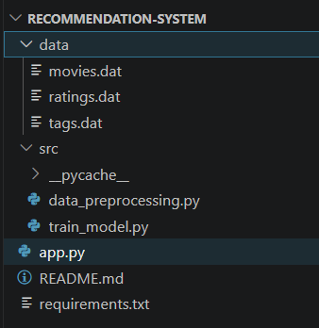

Step 3: Data Collection
The dataset consists of three files:
- ratings.dat
  - Contains user ratings for movies
  - Format: userId::movieId::rating::timestamp
- movies.dat
  - Contains movie details
  - Format: movieId::title::genres
- tags.dat
  - Contains user-generated tags
These datasets are stored inside the data/ folder.

Step 4: Data Preprocessing
Raw data is converted into structured format using PySpark.
Key Operations:
- Splitting text data using ::
- Converting data types (string → int/float)
- Selecting required columns
This step ensures the data is clean and ready for model training.

Step 5: Data Splitting
The dataset is divided into:
- Training data (80%)
- Testing data (20%)
train_data, test_data = ratings.randomSplit([0.8, 0.2])
Purpose:
- Train the model on one portion
- Evaluate performance on unseen data

Step 6: Model Building (ALS Algorithm)
The recommendation system uses the ALS (Alternating Least Squares) algorithm.
Model Configuration:
als = ALS(
userCol="userId",
itemCol="movieId",
ratingCol="rating",
coldStartStrategy="drop",
nonnegative=True
)
Training:
model = als.fit(train_data)
ALS learns:
- User preferences
- Movie characteristics

Step 7: Prediction Generation
The trained model is used to predict ratings:
predictions = model.transform(test_data)
These predictions help evaluate how well the model performs.

Step 8: Model Evaluation
The model is evaluated using RMSE (Root Mean Square Error).
Lower RMSE indicates better accuracy.

Step 9: Generating Recommendations
Top-N recommendations are generated using:
model.recommendForUserSubset(users, 5)
Steps:
- Select users
- Generate top 5 movies
- Retrieve movie titles
- Format output
Output format:
userId: [
{movie:Movie Name, rating: 4.5},
{movie: Movie Name, rating: 4.2}
]

Step 10: Handling User Input
The system allows dynamic user input:
user_list = list(map(int, input().split(",")))
This enables:
- Custom user selection
- Real-time recommendations

Step 11: Frontend Development (Streamlit)
A web interface is built using Streamlit.
Features Implemented:
1. User Recommendation
- Input: User IDs
- Output: Top 5 movie recommendations
2. Movie Review Section
- Search by:
  - Movie ID
  - Movie Name
- Displays:
  - Overall rating
  - User reviews
3. Top Rated Movies
- Displays highest-rated movies in dataset

Step 12: UI Design & Styling
Custom CSS is applied to improve appearance:
- Light background colors
- Styled buttons
- Enhanced readability

Step 13: Performance Optimization
- Used caching (@st.cache_resource) to avoid recomputation
- Limited data display for faster UI response
- Efficient filtering using Spark

Step 14: Error Handling
Common issues handled:
- Missing Hadoop setup
- Duplicate Streamlit keys
- Undefined variables
- Data filtering errors
Proper fixes ensure smooth execution.

Step 15: Deployment & Execution
Run Backend:
python -m src.train_model
Run Frontend:
streamlit run app.py
The application opens in a browser where users can interact with the system.

SOURCE CODES

4.1. Train_model.py
from pyspark.ml.recommendation import ALS
from pyspark.ml.evaluation import RegressionEvaluator
from src.data_preprocessing import load_all_data
def train():
# Load data
ratings, movies, tags, spark = load_all_data()
# Split data
train_data, test_data = ratings.randomSplit([0.8, 0.2])
# ALS Model
als = ALS(
userCol="userId",
itemCol="movieId",
ratingCol="rating",
coldStartStrategy="drop",
nonnegative=True
)
# Train model
model = als.fit(train_data)
# Predictions
predictions = model.transform(test_data)
# Evaluation
evaluator = RegressionEvaluator(
metricName="rmse",
labelCol="rating",
predictionCol="prediction"
)
rmse = evaluator.evaluate(predictions)
print("RMSE:", rmse)
# Generate recommendations
print("Available sample users selected from dataset.")
print("Enter comma-separated user IDs:")
user_list = list(map(int, input().split(",")))
users = ratings.where(ratings.userId.isin(user_list)).select("userId").distinct()
recommendations = model.recommendForUserSubset(users, 5)

print("\nTop 5 Recommendations for given users:\n")
# Collect results
recs = recommendations.collect()
for row in recs:
user_id = row["userId"]
rec_list = row["recommendations"]
# Get movie IDs
movie_ids = [r["movieId"] for r in rec_list]
# Fetch movie titles
movie_data = movies.filter(movies.movieId.isin(movie_ids)) \
.select("movieId", "title") \
.collect()
movie_dict = {m.movieId: m.title for m in movie_data}
# Format output
formatted = [
{
"movie": movie_dict.get(r["movieId"], "Unknown"),
"rating": float(r["rating"])
}
for r in rec_list
]
print(f"{user_id}: [")
for item in formatted:
print(f" {{movie: {item['movie']}, rating: {item['rating']}}},")
print("]\n")
spark.stop()
if __name__ == "__main__":
train()

4.2. data_preprocessing.py
from pyspark.sql import SparkSession
from pyspark.sql.functions import split, col
def load_all_data():
spark = SparkSession.builder \
.appName("Movie Recommendation System") \
.getOrCreate()

# Load raw data
ratings = spark.read.text("data/ratings.dat")
movies = spark.read.text("data/movies.dat")
tags = spark.read.text("data/tags.dat")

# Parse ratings.dat → userId::movieId::rating::timestamp
ratings = ratings.withColumn("value", split(col("value"), "::")) \
.select(
col("value")[0].cast("int").alias("userId"),
col("value")[1].cast("int").alias("movieId"),
col("value")[2].cast("float").alias("rating"),
col("value")[3].alias("timestamp")
)

# Parse movies.dat → movieId::title::genres
movies = movies.withColumn("value", split(col("value"), "::")) \
.select(
col("value")[0].cast("int").alias("movieId"),
col("value")[1].alias("title"),
col("value")[2].alias("genres")
)

# Parse tags.dat → userId::movieId::tag::timestamp
tags = tags.withColumn("value", split(col("value"), "::")) \
.select(
col("value")[0].cast("int").alias("userId"),
col("value")[1].cast("int").alias("movieId"),
col("value")[2].alias("tag"),
col("value")[3].alias("timestamp")
)
return ratings, movies, tags, spark

4.3. app.py
import streamlit as st
from pyspark.ml.recommendation import ALSModel
from pyspark.sql import SparkSession
from pyspark.sql.functions import split, col, avg

st.markdown("""
<style>
.stApp {
background: linear-gradient(to right, #fffaf0, #fdf6e3);
color: black;
}

/* All text */
html, body, [class*="css"] {
color: black !important;
}

/* Sidebar */
section[data-testid="stSidebar"] {
background-color: #fff0d6;
color: black;
}

/* Buttons */
.stButton>button {
background-color: #ffb347;
color: black;
border-radius: 8px;
}

div[data-baseweb="input"] input {
background-color: #ffe5b4 !important; /* light orange */
color: black !important;
border-radius: 6px;
}

/* Text area */
textarea {
background-color: #ffe5b4 !important;
color: black !important;
}

/* Radio label (Select Input Type) */
div[data-testid="stRadio"] label {
color: black !important;
}

/* Radio options (Movie ID, Movie Name) */
div[data-testid="stRadio"] div {
color: black !important;
}

/* Labels */
label {
color: black !important;
}
</style>
""", unsafe_allow_html=True)

# -----------------------------
# Load Spark + Data
# -----------------------------
@st.cache_resource
def load_data():
spark = SparkSession.builder \
.appName("Movie Recommendation UI") \
.getOrCreate()

ratings = spark.read.text("data/ratings.dat")
movies = spark.read.text("data/movies.dat")
tags = spark.read.text("data/tags.dat")

# Parse ratings
ratings = ratings.withColumn("value", split(col("value"), "::")) \
.select(
col("value")[0].cast("int").alias("userId"),
col("value")[1].cast("int").alias("movieId"),
col("value")[2].cast("float").alias("rating"),
)

# Parse movies
movies = movies.withColumn("value", split(col("value"), "::")) \
.select(
col("value")[0].cast("int").alias("movieId"),
col("value")[1].alias("title"),
col("value")[2].alias("genres")
)

# Parse tags
tags = tags.withColumn("value", split(col("value"), "::")) \
.select(
col("value")[0].cast("int").alias("userId"),
col("value")[1].cast("int").alias("movieId"),
col("value")[2].alias("tag")
)

return spark, ratings, movies, tags

# -----------------------------
# Train / Load Model
# -----------------------------
@st.cache_resource
def train_model(_ratings):
from pyspark.ml.recommendation import ALS

model = ALS(
userCol="userId",
itemCol="movieId",
ratingCol="rating",
coldStartStrategy="drop"
).fit(_ratings)

return model

# -----------------------------
# UI START
# -----------------------------
st.title("🎬 Movie Recommendation System")

spark, ratings, movies, tags = load_data()
model = train_model(ratings)

# -----------------------------
# 1️⃣ USER RECOMMENDATION
# -----------------------------
st.header("👤Get Recommendations by User ID")

user_input = st.text_input("Enter User IDs (comma separated)", "1,2")

if st.button("Get Recommendations", key="rec_button"):
user_list = [int(x.strip()) for x in user_input.split(",")]

users = ratings.where(ratings.userId.isin(user_list)).select("userId").distinct()
recs = model.recommendForUserSubset(users, 5).collect()

for row in recs:
user_id = row["userId"]
rec_list = row["recommendations"]

movie_ids = [r["movieId"] for r in rec_list]
movie_data = movies.filter(movies.movieId.isin(movie_ids)).collect()
movie_dict = {m.movieId: m.title for m in movie_data}

st.subheader(f"User {user_id}")

for r in rec_list:
pred_rating = min(float(r["rating"]), 5.0) # scale fix

st.write(f"🎥 {movie_dict.get(r['movieId'])} ⭐ {round(pred_rating,2)}")
st.progress(pred_rating / 5)

# -----------------------------
# 2️⃣ MOVIE REVIEWS
# -----------------------------
st.header("🎥 Get Movie Reviews")

option = st.radio("Select Input Type", ["Movie ID", "Movie Name"])

if option == "Movie ID":
movie_id = st.number_input("Enter Movie ID", min_value=1, step=1)

if st.button("Show Reviews (ID)", key="movie_id_btn"):
movie_name = movies.filter(movies.movieId == movie_id).collect()

if movie_name:
st.subheader(movie_name[0]["title"])

# ✅ overall rating
avg_rating = ratings.filter(ratings.movieId == movie_id) \
.agg(avg("rating").alias("avg_rating")) \
.collect()[0]["avg_rating"]

st.write(f"Overall Rating: ⭐ {round(avg_rating,2)}")
st.progress(min(avg_rating / 5, 1.0))

# individual reviews
reviews = ratings.filter(ratings.movieId == movie_id).limit(20).collect()

st.write("### User Reviews:")
for r in reviews:
st.write(f"User {r['userId']} ➝ ⭐ {r['rating']}")
else:
st.write("Movie not found")

else:
movie_name_input = st.text_input("Enter Movie Name")

if st.button("Show Reviews (Name)", key="movie_name_btn"):
movie_match = movies.filter(movies.title.contains(movie_name_input)).collect()

if movie_match:
movie_id = movie_match[0]["movieId"]
st.subheader(movie_match[0]["title"])

# ✅ overall rating
avg_rating = ratings.filter(ratings.movieId == movie_id) \
.agg(avg("rating").alias("avg_rating")) \
.collect()[0]["avg_rating"]

st.write(f"Overall Rating: ⭐ {round(avg_rating,2)}")
st.progress(min(avg_rating / 5, 1.0))

# reviews
reviews = ratings.filter(ratings.movieId == movie_id).limit(20).collect()

st.write("### User Reviews:")
for r in reviews:
st.write(f"User {r['userId']} ➝ ⭐ {r['rating']}")
else:
st.write("Movie not found")

# -----------------------------
# 3️⃣ TOP RATED MOVIES
# -----------------------------
st.header("💥 Top Rated Movies")

if st.button("Show Top Movies", key="top_movies_btn"):
top_movies = ratings.groupBy("movieId") \
.agg(avg("rating").alias("avg_rating")) \
.orderBy(col("avg_rating").desc()) \
.limit(10)

result = top_movies.join(movies, "movieId").collect()

for r in result:
st.write(f"🎬 {r['title']} ⭐ {round(r['avg_rating'],2)}")
st.progress(min(r['avg_rating'] / 5, 1.0))

OUTPUT SCREENS

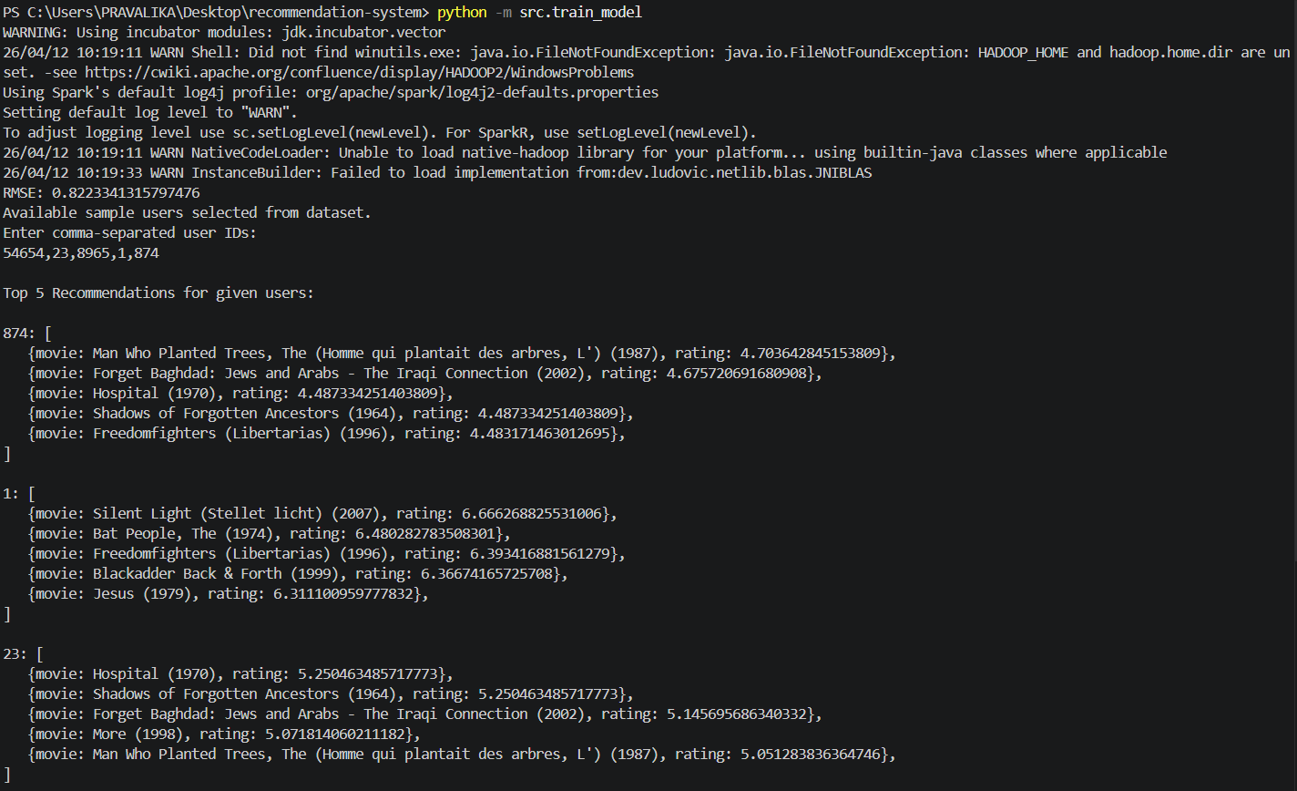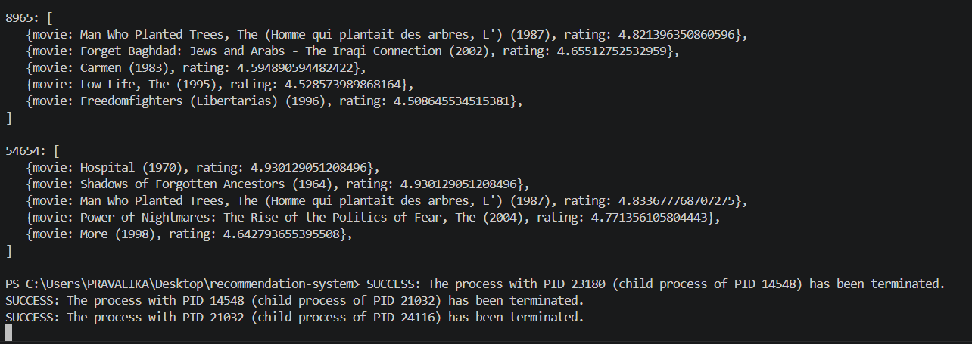
Fig 2 Screenshot of the recommendation
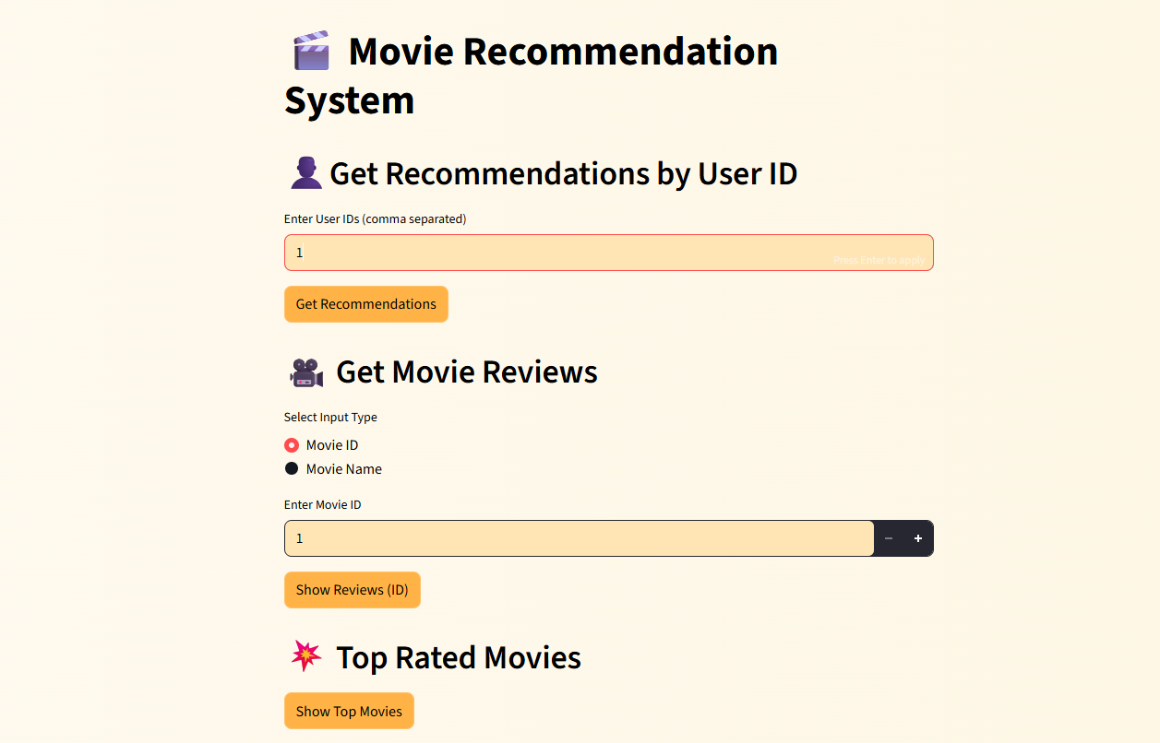
Fig 5.2 web page before giving any input
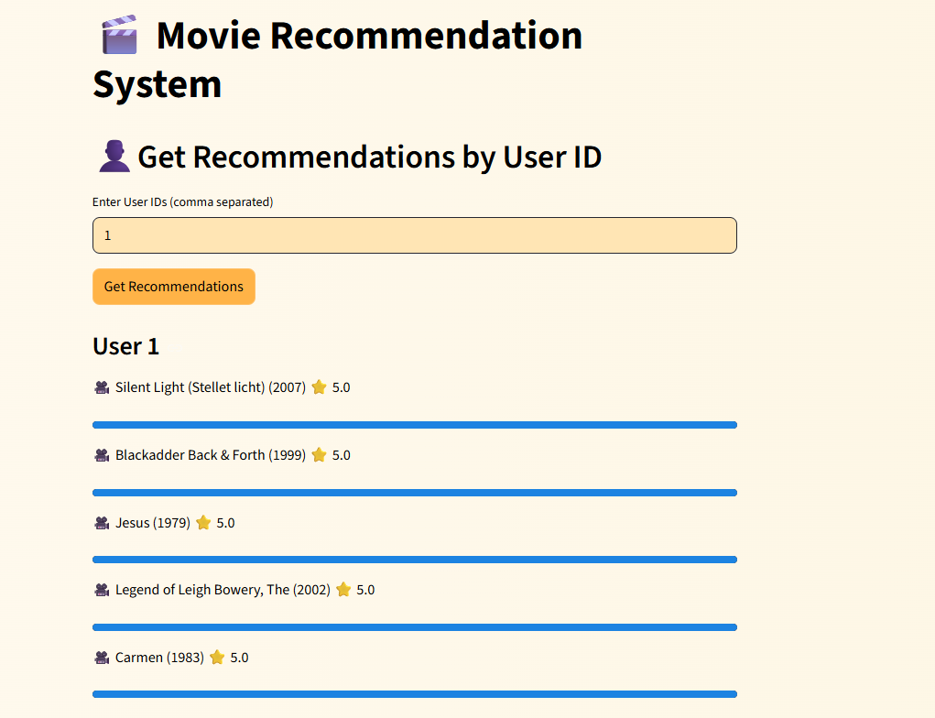
Fig 5.3 getting movie recommendations by previously watched movies of the user
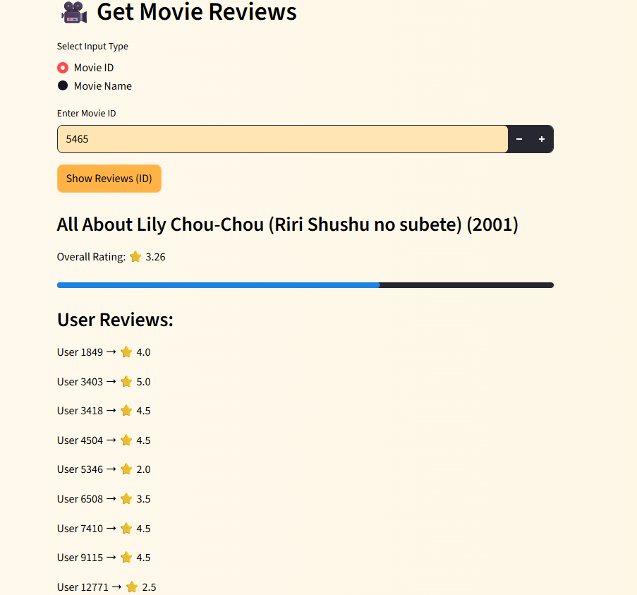
Fig 5.4 getting review of the movie by entering movie id
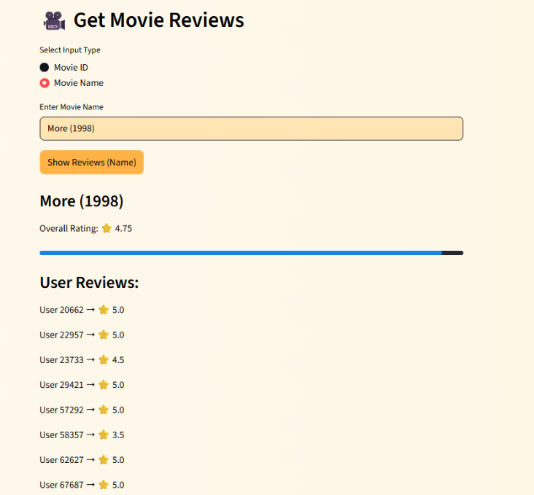
Fig 5.5 getting review of the movie by entering movie name
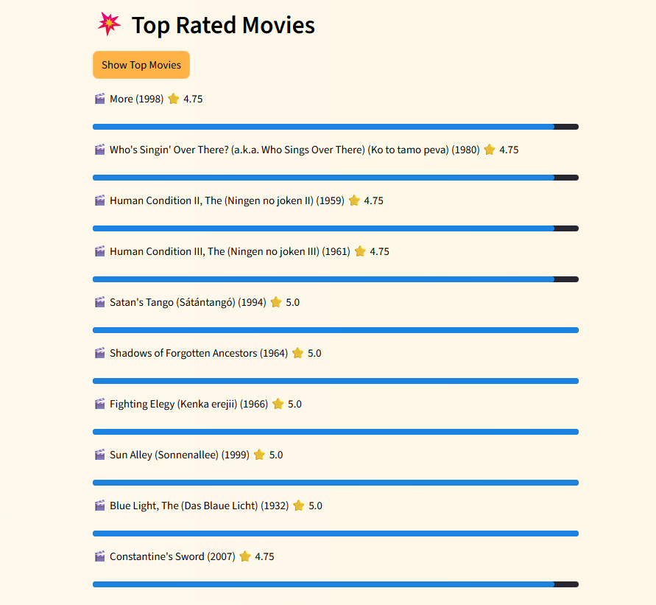
Fig 5.6 top rated movies

CONCLUSION

The Movie Recommendation System developed in this project demonstrates an effective application of big data processing and machine learning techniques to solve real-world problems. By leveraging PySpark and the Alternating Least Squares (ALS) algorithm, the system is capable of analyzing large-scale user–movie interaction data and generating personalized recommendations efficiently.
The project successfully integrates multiple components, including data preprocessing, model training, evaluation, and a user-friendly frontend interface using Streamlit. The use of distributed computing through Apache Spark ensures scalability and high performance, making the system suitable for handling large datasets. The ALS model, being a collaborative filtering technique, effectively captures user preferences and predicts ratings for unseen movies, thereby improving recommendation accuracy.
The system provides three main functionalities: generating top movie recommendations for specific users, displaying detailed movie reviews and overall ratings, and identifying top-rated movies in the dataset. These features enhance user experience by offering both personalized and general insights into movie preferences. Additionally, the interactive Streamlit interface allows users to easily input data and visualize results in an intuitive manner.
During the development process, several practical challenges such as environment configuration, handling Spark dependencies, and optimizing performance were addressed. These challenges contributed to a deeper understanding of real-world system implementation and debugging in big data environments.
Overall, this project highlights the importance of combining data engineering, machine learning, and frontend technologies to build a complete end-to-end application. The system can be further enhanced by incorporating advanced techniques such as content-based filtering, deep learning models, and real-time recommendation updates. It can also be extended to other domains like e-commerce, music, and online streaming platforms.
In conclusion, the Movie Recommendation System is a scalable, efficient, and practical solution that demonstrates how modern technologies can be used to deliver personalized user experiences and improve decision-making in digital platforms.

REFERENCES

- Apache Spark Documentation – https://spark.apache.org/docs/latest/
- PySpark Guide – https://spark.apache.org/docs/latest/api/python/
- Streamlit Documentation – https://docs.streamlit.io/
- MovieLens Dataset – https://grouplens.org/datasets/movielens/
- Collaborative Filtering Research Papers & Online Tutorials

