PRAVALLIKA BOLLU

DSCI 5360

**DATA VISUALIZATION ON COVID-19 CASES**

**INTRODUCTION:**

Data Visualization is a graphical view of the information and data. In this, we use graphs, tables, charts, etc., to represent the data. The primary purpose of this visualization is to clean the raw data, analyze the data and visualize it. We prefer the visualization than the other representations because it is easy to anyone to understand the data by graphical view and also, they give accurate results. The visualizations are mostly used for the business purposes because they help in understanding for the end users. Data visualization enables to look into analytical reports for the data which are hard to grasp. Here We take the help of dashboards and story boards to represent the visualizations on a high level.

In this project, the data I have collected is covid-19 cases, to visualize how people across the world are affected and people in different states of U.S.A are affected. I have shown the graphical representations of total case, total tests conducted and how many recovered, how many are affected and led to death. As this is still trending and affecting the whole world a lot so I have chosen this dataset which might be helpful to understand in a better way. The data source is collected from worldometer website. The fields included in this data set are countries, new cases, total cases, total deaths, new deaths, total recovered, active cases, serious cases, total tests.

**ANALYSIS:**

In this project, I have used different visualizations to represent the covid-19 cases worldwide and in different states of U.S.A. We need to clean the data before visualizing it. So, I have used the filters to neglect the null data in representing the global cases and global tests. The visualizations used are bar charts, line chart, choropleth maps.

BAR CHARTS:

I have used the bar charts to represent the recovered cases in all the countries and for the death cases world-wide. There is one more visualization tab which analyses the top 10 countries with more death cases.

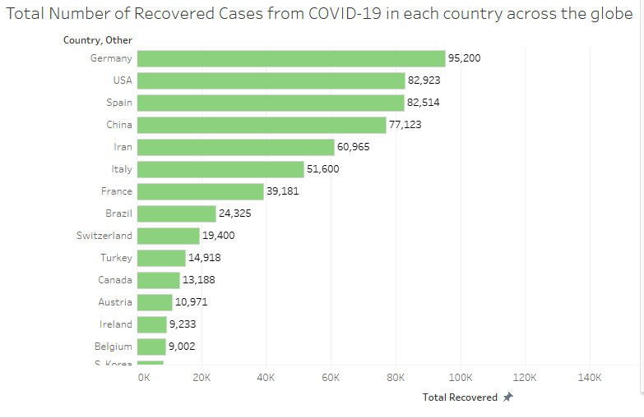

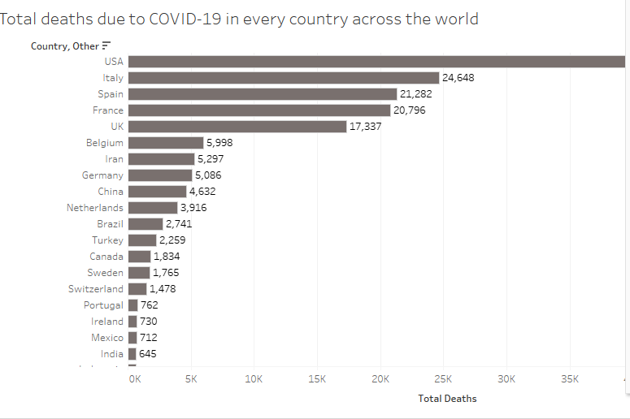

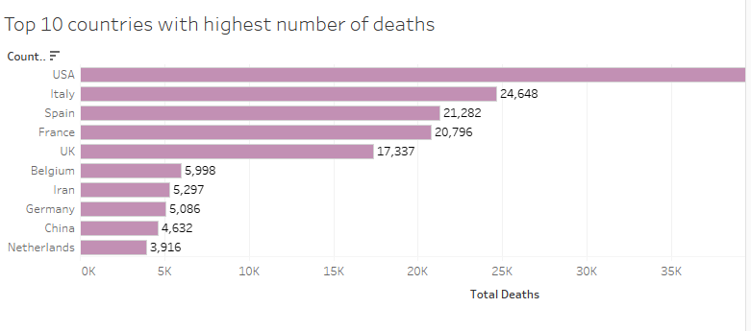

LINE CHARTS:

The line chart is used to represent the day to day increasing cases. For more information, if we hover over the visualization we can see the number of corona cases on a particular day.

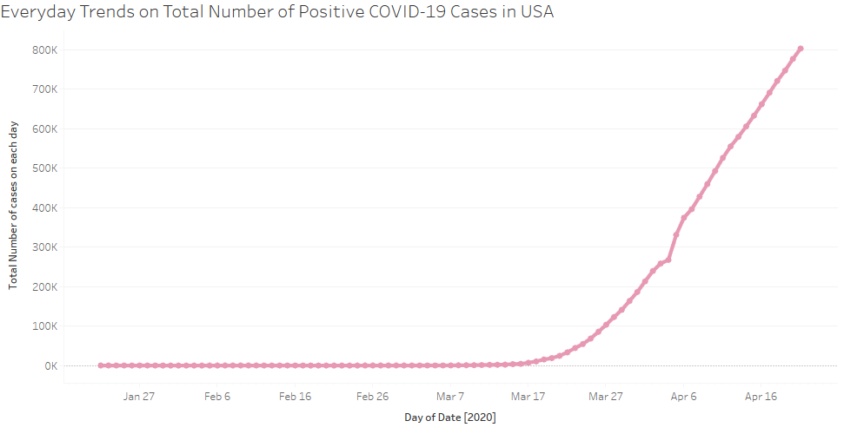

CHOROPLETH MAPS:

Choropleth maps are used to represent the complete geographical view by using the latitudes and longitudes. Here we have represented the global cases and global tests performed. I have used color for the visualization to easily demonstrate the countries with danger.

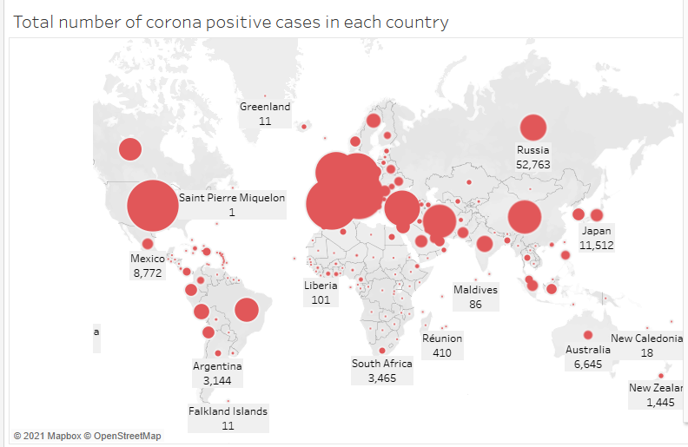

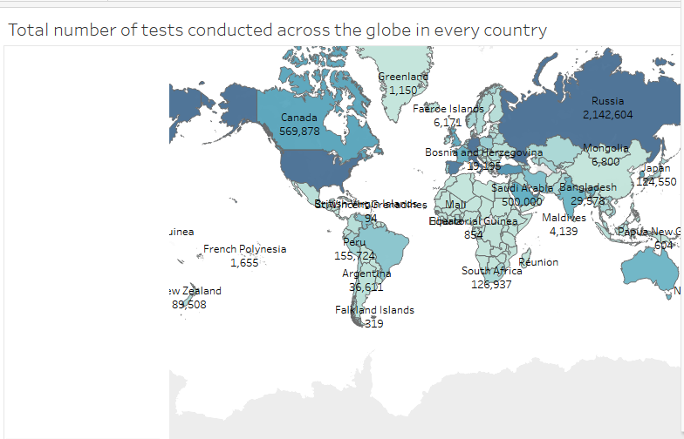

**DASHBOARD:**

Dashboard is used to represent one or more visualizations on a same page. So, by viewing all the visualizations in a single sheet we can compare the data between them and analyze it so easily. It is better way to represent the overall output. Here, I have taken the world wise cases and tests conducted over all the countries and the recovered cases and death cases for the dashboard representation.

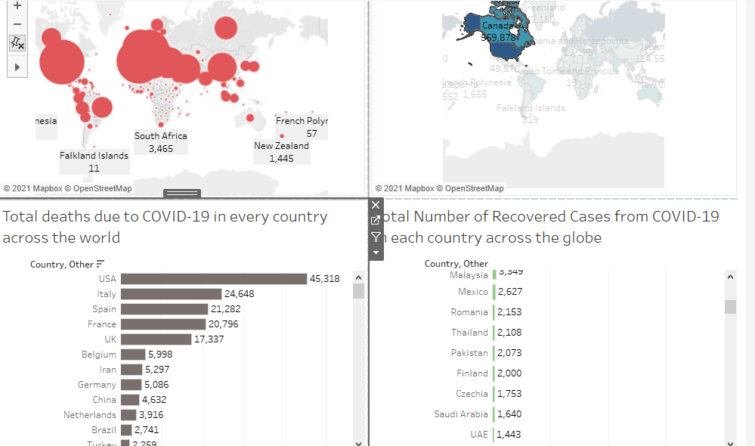

**STORY:**

In story we can have series of visualizations to narrate them or relate them each other. In this I have used the both dashboards and trends in the story.

**BUSINESS IMPLICATIONS:**

As we all know that Covid-19 has impacted the whole world a lot. It had bought a tremendous decrease in people’s heath and business. Apart of this pandemic, people are looking for the true information as the wrong information leads to unwanted pressures and disturbances in everyone’s life. The first priority should be the health of every individual so to overcome this problem, more health centers are increased and now vaccines are given based on the ages. As the older ones are highly at risk due to less resistance power, so they are given the priority. People are highly recommended to maintain the social distance and use the face masks mandatorily. It is suggested to avoid social gatherings to reduce the spread of the cases. Due to this pandemic, all the educational institutions are closed and the classes are performed virtually. Even though, the virtual classes are not highly encouraged as they don’t perform the students progress in their education.

Due to this, the business of small scale and medium scale are impacted a lot. There is no income for the average and below average people, so the government is trying its best to recover from this situation. Its been a year this pandemic had started, but at the end of the first phase the second phase has started and it is highly impacting the people now. The different vaccines are implemented all over the world, mostly every one is ready to take the vaccine as the individual health matters and also, they are at affordable prices. In a recent survey, more than 400 US based companies’ 40 percent of the employees are more likely to get vaccinated. The sectors in costumer spending including the wellness sector 1.5 trillion-dollar market is growing at 5 to 10% every year.

**CONCLUSION:**

Overall covid-19 has impacted the whole world a lot but by visualizations we can observe that few countries like Germany, United states, Spain, China, Iran have more recovered cases as well as death cases too. The United states tops the list in having the death cases and second in recovering them. Now, as per the latest information India is having a lot of cases daily and defeating the United states in having the covid-19 cases. On the other side, there is a good point that vaccines are successful and are used. And also, the small and medium companies are recovering day by day.