# **INFO 5707 - Data Modelling for Information Professionals**

## Hospital Management System - Project Design Phase

**Team Name:** ELM

**Team Members:**

1. Ravi Varma Kumar Bevara (Team Coordinator)
2. Venakata Avinash Mallampati
3. Pravallika Bollu
4. Lakshmi Swetha Sreegiriraju

**Objectives of Database:**

Clinical Assistance plays a major role in this contemporary world. With the increase in the number of hospitals, it’s hard to keep track of information related to them in tact. As hospitals are trying to provide the best facilities to the patients suffering from various types of illness, this design of database will help them to maintain the records of patients, doctors profile, billing data. The main objective of this database is to store, review, and retrieve the information about the doctors, patients, departments, labs, building(blocks), medication information and billing information. One can use this database to make an appointment for a particular doctor, and the administrator can manage the doctors, patients and appointments. Etc. It will help to manage the business of medium scale hospitals in a large populated city.

**Scope of Database:**

The scope of this database is to handle all difficult tasks such as managing all the data related to patient visits to a physician and scheduling lab work for the patients. A well-designed hospital management workflow entails a slew of critical decisions that must be made as efficiently and quickly as possible. It is difficult to execute it nowadays without a separate hospital administration system. In this project, we’ve designed a database which is patient-centric, which is more effectively managing the functions of a hospital administration.

**User’s Requirements:**

1. Registration of patients and assigning them an unique ID.
2. Assign each patient to a doctor, nurse and assign a ward.
3. Doctors need to be notified about the patient data to study the complete case.
4. Generate reports of every patient and maintain a record.
5. Discharge a patient and update the ward availability list.
6. Administrators can manage the building data by updating the locations.
7. Billing staff will maintain the record of the patient's insurance and other records.
8. Updating the Departments according to the new illnesses treated.
9. Appointments by patients for a consultation.
10. Maintain the status of operation theatres, ICU’s incase of emergency.
11. Keep Track of Ambulance intact to the emergency cases.
12. This Database stores all historical patient data, historical employee data.
13. We store demographic data of patients and employees as well.

**Choice of DBMS:**

As a team, we decided to use MySQL database for implementing this schema. We propose to use **phpMyAdmin**, an open source relational database management tool. According to the constraints, we came up with entities like Patient, Doctor, Department, Billing, Labs, Staff etc.

**Business Rules:**

1. Every patient that comes to the hospital for a consultation with a doctor is put into the database as a new patient.
2. Patients can book appointments, track them,and view the reports.
3. Feedback can be given by a patient to a hospital employee.
4. A Doctor will look at one patient at a time and consults many patients throughout the day.
5. Each patient can check in with more than one appointment.
6. Billing information related to patient visit can have transaction type, insurance split, attendant charge, consultant charge.
7. Departments can be of various types such as emergency, pediatric, etc.
8. Patients visiting a physician are not always provided with an attendant or nurse.
9. This system also maintains an audit of patient in and out times.
10. A report is generated for every service a doctor provides to the patient.
11. The system should allow them to save many patient addresses provided by them in all the visits.
12. Patients can be billed for several services on one visit to the physician such as pharmacy, lab work etc.
13. Patients are not always admitted into the hospital.

**Entity Relationship Diagram (crow-foot notation):**

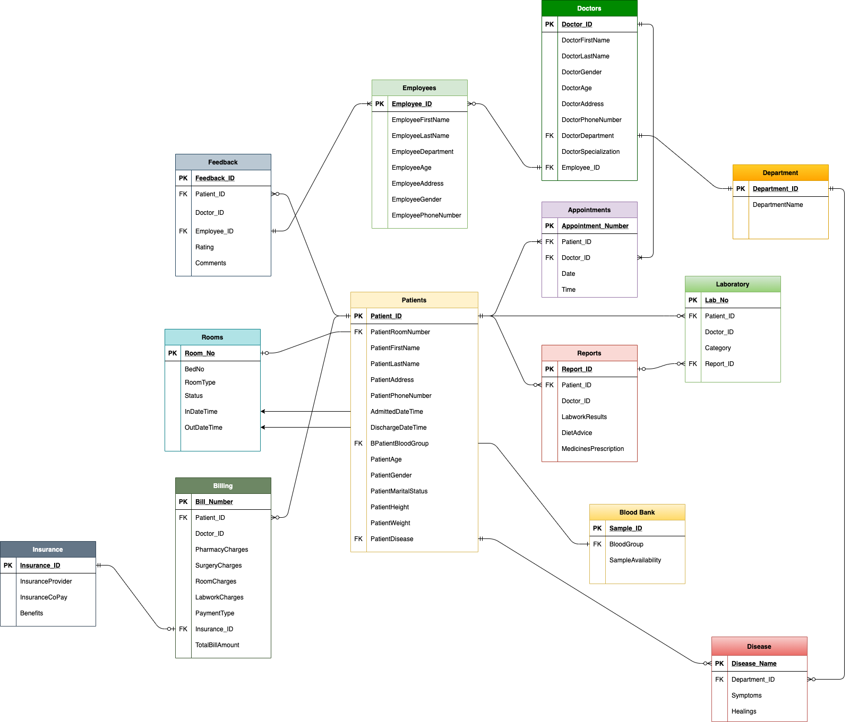

**Data Dictionary:**

Attached Excel file