Assignment-02

10 Points

Please follow the below instructions to complete the assignment.

1. Open Xcode from the Launchpad, click on "File," and choose "New Project."
2. Select the iOS template, click on the "App" application, and then click on the "Next" button.
3. Enter the project name as "**LastName_Assignment02,"** set "nwmsu" as the organization identifier, choose "Storyboard" for the interface, and select "Swift" as the programming language.
4. Click on "Next" and choose the location for storing the app.
5. In the app's general settings, set the project format to be compatible with Xcode 14.0, and in the "Minimum Deployment" section, select 15.0.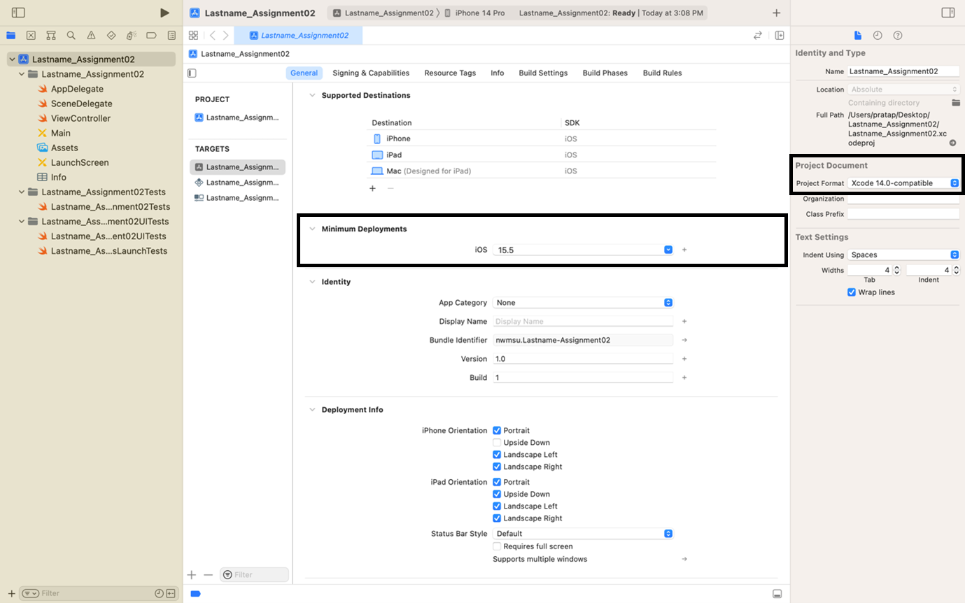
6. From the project navigator click on “Main”. An empty mobile screen will be loaded where we need to add the required fields.
7. We need to add 3 labels by dragging them from the library and name them **Name**, **Bill Amount** and **Tip (%)** respectively as shown below. Also drag 2 filled buttons and name them **Submit** and **Reset.**

1. When the submit button is clicked, we should display the Name, Bill Amount, Calculated Tip Amount, and Total Bill Amount (Bill Amount + Calculated Tip Amount). Please Check sample output screenshots at the bottom.
2. To display these details, we need to drag and drop 4 labels from the library and make sure that these are empty initially.

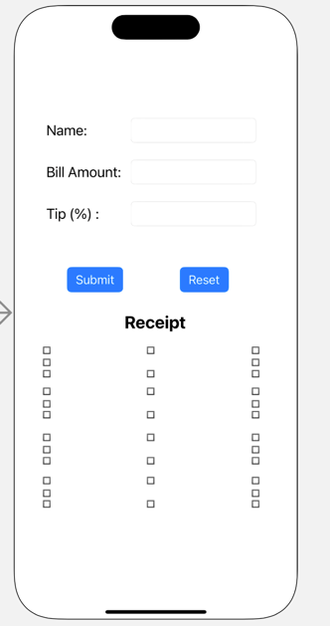

1. On clicking the reset button, we need to clear the text entered into the text fields and also reset the display labels.
2. Now that the UI of the app is complete, we need to establish connections to the ViewController.
3. Next, we will create outlets for the Name, Bill Amount, and Tip (%) as UITextField objects, naming them as `**nameOutlet**`, `**billAmountOutlet**`, and `**tipPercentageOutlet**`. We will also create outlets for labels representing Name, Bill Amount, Tip Amount, and Total Amount as UILabel objects in the view controller, naming them as `**nameLabel**`, `**billAmountLabel**`, `**tipAmountLabel**`, and `**totalAmountLabel**`, respectively. To do this, ctrl+click on an object and drag it to the view controller, selecting the action as an outlet in the popup menu as specified.
4. To add the submit and reset actions, we need to ctrl+click on the submit button and drag it to the view controller. In the pop-up menu, select the connection as an action, type as UIButton, and name it as `**SubmitBTN**`. Follow the same procedure for the reset button, naming it `**ResetBTN**`.
5. In the `**SubmitBTN**` function of the view controller, write code to display the name and bill amount by reading the values from the text fields. Next, calculate the tip amount in dollars ($) and the total bill amount (Bill Amount + Calculated Tip Amount). Finally, round both values to two decimal places.

[**Hint: Tip Amount in $ = (Bill Amount * Tip Percentage Value) / 100]**

1. In the `**ResetBTN**` function, write code to erase all the details entered and also the

details displayed.

17. Set the application background and font styles according to your preference.

**Sample Output:**

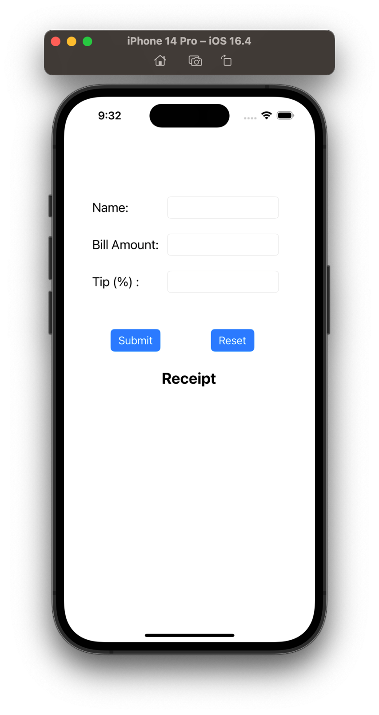

**Click of the Submit button:**

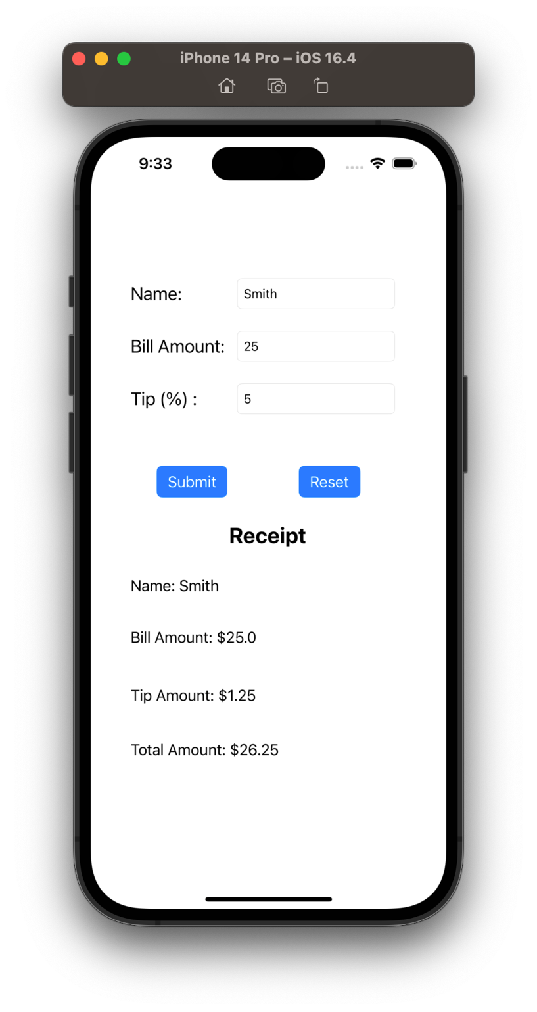

**Click of the Reset button:**

