Task 1:
class Solution {
public int maxSubArray(int[] nums) {
int currentSum = nums[0];
int maxSum = nums[0];

for (int i = 1; i < nums.length; i++) {
currentSum = Math.max(nums[i], currentSum + nums[i]);
maxSum = Math.max(maxSum, currentSum);
}

return maxSum;
}
}
Output:
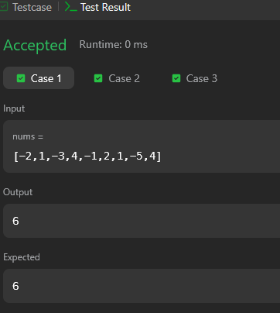
Task 2:
import java.util.*;

public class Main {
public static void main(String[] args) {
Scanner sc = new Scanner(System.in);
int t = sc.nextInt();

while (t-- > 0) {
String s = sc.next();

int n = s.length();

String left, right;

if (n % 2 == 0) {
left = s.substring(0, n / 2);
right = s.substring(n / 2);
} else {
left = s.substring(0, n / 2);
right = s.substring(n / 2 + 1);
}

if (isLapindrome(left, right)) {
System.out.println("YES");
} else {
System.out.println("NO");
}
}

sc.close();
}

public static boolean isLapindrome(String left, String right) {
int[] freq = new int[26];

for (int i = 0; i < left.length(); i++) {
freq[left.charAt(i) - 'a']++;
}

for (int i = 0; i < right.length(); i++) {
freq[right.charAt(i) - 'a']--;
}

for (int i = 0; i < 26; i++) {
if (freq[i] != 0) {
return false;
}
}

return true;
}
}
Output :
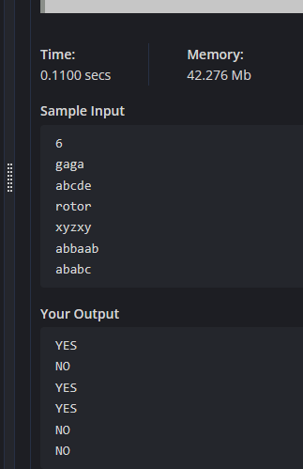
Task 3:
import java.util.*;

public class Main {
public static void main(String[] args) {
Scanner sc = new Scanner(System.in);
int t = sc.nextInt();

while (t-- > 0) {
int n = sc.nextInt();
int[] arr = new int[n];

for (int i = 0; i < n; i++) {
arr[i] = sc.nextInt();
}

// Maximum Subarray (Kadane)
int currentSum = arr[0];
int maxSubarray = arr[0];

for (int i = 1; i < n; i++) {
currentSum = Math.max(arr[i], currentSum + arr[i]);
maxSubarray = Math.max(maxSubarray, currentSum);
}

// Maximum Subsequence
int maxSubsequence = 0;
int maxElement = arr[0];

for (int num : arr) {
if (num > 0) {
maxSubsequence += num;
}
if (num > maxElement) {
maxElement = num;
}
}

// If no positive numbers
if (maxSubsequence == 0) {
maxSubsequence = maxElement;
}

System.out.println(maxSubarray + " " + maxSubsequence);
}

sc.close();
}
}
Output :
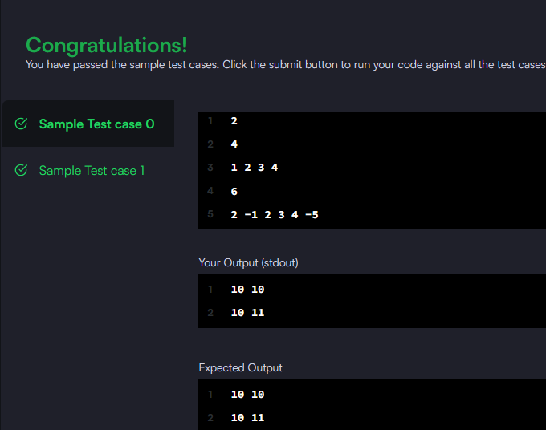
Task 4:
class Solution {
public int maxSubarraySumCircular(int[] nums) {
int totalSum = 0;

int maxSum = nums[0];
int curMax = 0;

int minSum = nums[0];
int curMin = 0;

for (int num : nums) {
// For max subarray (Kadane)
curMax = Math.max(num, curMax + num);
maxSum = Math.max(maxSum, curMax);

// For min subarray
curMin = Math.min(num, curMin + num);
minSum = Math.min(minSum, curMin);

totalSum += num;
}

// If all numbers are negative
if (maxSum < 0) return maxSum;

// Otherwise return the best of:
// 1. normal max subarray
// 2. circular subarray (total - min subarray)
return Math.max(maxSum, totalSum - minSum);
}
}
Output :
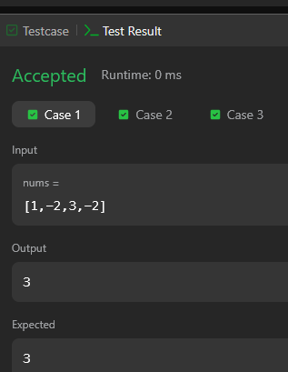
Task 5:
class Solution {
public int myAtoi(String s) {
int i = 0, n = s.length();

// Step 1: Skip leading spaces
while (i < n && s.charAt(i) == ' ') {
i++;
}

// Step 2: Check sign
int sign = 1;
if (i < n && (s.charAt(i) == '+' || s.charAt(i) == '-')) {
sign = (s.charAt(i) == '-') ? -1 : 1;
i++;
}

// Step 3: Convert digits
long result = 0;

while (i < n && Character.isDigit(s.charAt(i))) {
int digit = s.charAt(i) - '0';
result = result * 10 + digit;

// Step 4: Handle overflow early
if (sign == 1 && result > Integer.MAX_VALUE) {
return Integer.MAX_VALUE;
}
if (sign == -1 && -result < Integer.MIN_VALUE) {
return Integer.MIN_VALUE;
}

i++;
}

return (int)(result * sign);
}
}
Output :
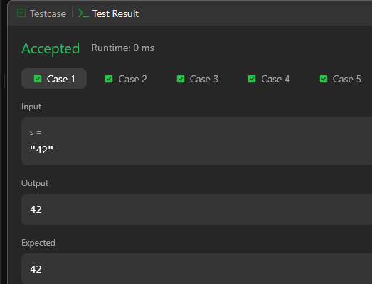
Task 6:
class Solution {
public void moveZeroes(int[] nums) {
int j = 0; // position for next non-zero

for (int i = 0; i < nums.length; i++) {
if (nums[i] != 0) {
// swap nums[i] and nums[j]
int temp = nums[i];
nums[i] = nums[j];
nums[j] = temp;
j++;
}
}
}
}
Output :
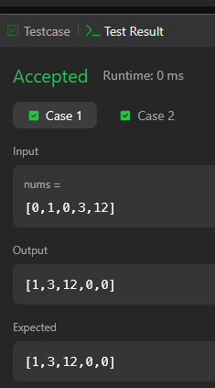
Task 7:
import java.util.*;

class Solution {

public static int diagonalDifference(int[][] arr) {
int n = arr.length;
int primarySum = 0;
int secondarySum = 0;

for (int i = 0; i < n; i++) {
primarySum += arr[i][i];
secondarySum += arr[i][n - 1 - i];
}

return Math.abs(primarySum - secondarySum);
}

public static void main(String[] args) {
Scanner sc = new Scanner(System.in);

int n = sc.nextInt();
int[][] arr = new int[n][n];

// Read matrix input
for (int i = 0; i < n; i++) {
for (int j = 0; j < n; j++) {
arr[i][j] = sc.nextInt();
}
}

int result = diagonalDifference(arr);
System.out.println(result);

sc.close();
}
}
Output :
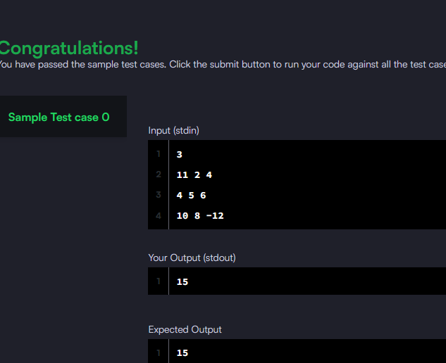
Task 8:
import java.util.*;

class Solution {
public List<String> findAndReplacePattern(String[] words, String pattern) {
List<String> result = new ArrayList<>();

for (String word : words) {
if (matches(word, pattern)) {
result.add(word);
}
}

return result;
}

private boolean matches(String word, String pattern) {
Map<Character, Character> map = new HashMap<>();
Map<Character, Character> reverseMap = new HashMap<>();

for (int i = 0; i < word.length(); i++) {
char w = word.charAt(i);
char p = pattern.charAt(i);

// Forward mapping check
if (map.containsKey(p)) {
if (map.get(p) != w) return false;
} else {
map.put(p, w);
}

// Reverse mapping check
if (reverseMap.containsKey(w)) {
if (reverseMap.get(w) != p) return false;
} else {
reverseMap.put(w, p);
}
}

return true;
}
}
Output :
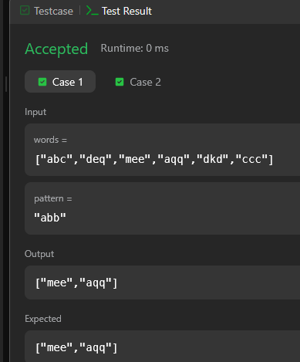
Task 9:
import java.util.*;

class Solution {
public List<String> stringMatching(String[] words) {
List<String> result = new ArrayList<>();

for (int i = 0; i < words.length; i++) {
for (int j = 0; j < words.length; j++) {
if (i != j && words[j].contains(words[i])) {
result.add(words[i]);
break; // no need to check further
}
}
}

return result;
}
}
Output :
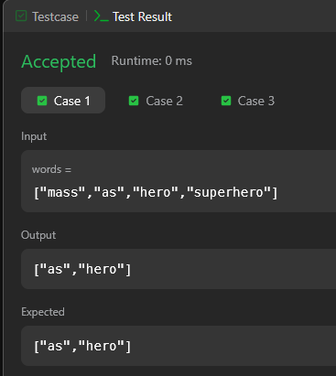
Task 10:
import java.util.*;

class GFG {

// Function to find all occurrences of pattern in text
public static List<Integer> searchPattern(String text, String pattern) {
List<Integer> result = new ArrayList<>();

int n = text.length();
int m = pattern.length();

for (int i = 0; i <= n - m; i++) {
int j;

for (j = 0; j < m; j++) {
if (text.charAt(i + j) != pattern.charAt(j)) {
break;
}
}

if (j == m) {
result.add(i);
}
}

return result;
}

public static void main(String[] args) {
Scanner sc = new Scanner(System.in);

// Safely read input
if (!sc.hasNext()) return;
String text = sc.next();

if (!sc.hasNext()) return;
String pattern = sc.next();

List<Integer> result = searchPattern(text, pattern);

// Print result
for (int idx : result) {
System.out.print(idx + " ");
}

sc.close();
}
}
Output :
