

School of Computing
Department of Computer Science and Engineering ACADEMIC YEAR: 2025-26
(WINTER SEMESTER)

LAB RECORD

10211CS224 - Full Stack Application Development

NAME : S.PRAVALLIKA
VTU.NO : VTU25243
REG.NO : 23UECS0510 BRANCH : CSE YEAR/SEM : 3/6th
SLOT : E2

10211CS224 - Full Stack Application Development
TABLE OF CONTENTS

Task No | Date | Experiment Title
1. | 05-01-2026 | Student Registration System with Database Storage and Retrieval
2. | 22-01-2026 | Data Retrieval, Sorting, and Filtering Dashboard
3. | 29-01-2026 | Login System with Input Validation and Authentication
4. | 02-02-2026 | Order Management Using SQL Joins and Subqueries
5. | 05-02-2026 | Transaction-Based Payment Simulation Using COMMIT and ROLLBACK
6. | 09-02-2026 | Automated Logging Using Database Triggers and Views
7. | 12-02-2026 | Interactive Web Form Using JavaScript Events and Functions
8. | 16-02-2026 | Employee Management Using Spring Core and Dependency Injection
9. | 19-02-2026 | Spring MVC Application Using Annotation-Based Configuration
10. | 23-02-2026 | Student CRUD Operations Using Spring Boot and JPA
11. | 26-02-2026 | Data Access Using Spring Data JPA with Sorting and Pagination
12. | 02-03-2026 | RESTful API for Product Management Using Spring Boot
13. | 05-03-2026 | Exception Handling and Validation in RESTful Applications
14. | 09-03-2026 | Microservices Architecture with Service Decomposition
15. | 16-03-2026 | Service Registry and Discovery Using Eureka
16. | 28-03-2026 | API Gateway with Load Balancing for Microservices
17. | 30-03-2026 | Inter-Service Communication Using REST APIs
18. | 02-04-2026 | Unit Testing for Microservices Applications
19. | 06-04-2026 | Version Control Using Git and Remote Repositories
20. | 08-04-2026 | Git Branching, Merging, and Conflict Resolution
21. | 13-04-2026 | CI/CD Pipeline for Automated Build and Deployment
22. | 16-04-2026 | Cloud Service Providers Comparison and Pricing Models
23. | 20-04-2026 | Prompt Engineering for Code Generation Using Generative AI
24. | 27-04-2026 | Cloud-Based Application Using Vibe Coding and Generative AI
25. | 30-04-2026 | Use Cases

Task-1: Student Registration & Data Storage System

AIM: To develop a Student Registration System that allows users to enter, store, and manage student details efficiently using a web interface and a MySQL database.

ALGORITHM:
Step 1: Start
Step 2: Open the web application (index page)
Step 3: Display home page with option to go to registration page Step 4: User navigates to the registration form
Step 5: User enters student details (like name, ID, course, etc.) Step 6: Validate input fields
- Check if fields are empty
- Ensure correct data format
Step 7: Submit the form data to the server Step 8: Server receives the data using Node.js
Step 9: Establish connection with MySQL database
- If connection fails → display error
- Else → proceed
Step 10: Insert student data into database table Step 11: Confirm successful storage of data Step 12: Display success message to user
Step 13: Allow user to view/manage stored data (if implemented) Step 14: Stop

PROGRAM: INDEX.HTML:
<!DOCTYPE html>

<html>
<head>
<title>Student Portal</title>
<link rel="stylesheet" href="style.css">
</head>
<body>
<div class="home-container">
<h1>Welcome to Student Portal</h1>
<p>Register and manage student information easily.</p>
<a href="registration.html" class="start-btn">Go to Registration</a>
</div>
</body>
</html>

REGISTRATION.HTML:
<!DOCTYPE html>
<html>
<head>
<title>Student Registration</title>
<link rel="stylesheet" href="style.css">
</head>
<body>
<div class="container">
<h1>Student Registration</h1>
<button onclick="goHome()" class="home-btn">Home</button>
<form id="studentForm">
<label>Name</label>

<input type="text" id="name" placeholder="Enter your name" required>
<label>Email</label>
<input type="email" id="email" placeholder="Enter your email" required>
<label>Date of Birth</label>
<input type="date" id="dob" required>
<label>Department</label>
<select id="department" required>
<option value="">Select Department</option>
<option>CSE</option>
<option>IT</option>
<option>ECE</option>
<option>MECH</option>
</select>
<label>Phone</label>
<input type="text" id="phone" placeholder="Enter phone number" required>
<button type="submit">Register</button>
</form>
</div>
<script src="script.js"></script>
</body>
</html>

STYLE.CSS:
body{
font-family: 'Segoe UI', sans-serif;
background: linear-gradient(135deg,#0f2027,#203a43,#2c5364); height:100vh;

display:flex;
justify-content:center; align-items:center; margin:0;
}
.container{ width:420px; padding:35px;
background:rgba(255,255,255,0.08); border-radius:18px;
backdrop-filter: blur(10px);
box-shadow:0 10px 35px rgba(0,0,0,0.6);
}
h1{
text-align:center; color:white;
margin-bottom:25px;
}
h2{
text-align:center; color:white; margin-top:30px;
}
form{ display:flex;
flex-direction:column;

}
label{ color:#ddd; font-size:14px;
margin-bottom:5px; margin-top:10px;
}
input,select{ width:100%; padding:12px; border:none; border-radius:8px;
background:#27496d; color:white;
font-size:14px; outline:none; margin-bottom:5px;
}
input:focus,select:focus{
box-shadow:0 0 8px #00eaff; background:#2c5d8a;
}
button{
margin-top:15px; padding:12px; border:none;

border-radius:10px;
background:linear-gradient(45deg,#ff4b2b,#ff416c); color:white;
font-size:16px; font-weight:bold; cursor:pointer; transition:0.3s;
}
button:hover{ transform:scale(1.05);
box-shadow:0 0 15px #ff416c;
}
#studentList{ margin-top:15px; text-align:center; color:white;
font-size:15px;
}
.home-container{ text-align:center; color:white;
background:rgba(255,255,255,0.08); padding:50px;
border-radius:20px; backdrop-filter: blur(10px);
box-shadow:0 10px 35px rgba(0,0,0,0.6);

width:420px;
}
.home-container h1{ font-size:32px; margin-bottom:15px;
}
.home-container p{ margin-bottom:30px; color:#ddd;
}
.start-btn{
text-decoration:none; padding:12px 25px; border-radius:10px;
background:linear-gradient(45deg,#ff4b2b,#ff416c); color:white;
font-weight:bold; transition:0.3s;
}
.start-btn:hover{ transform:scale(1.05);
box-shadow:0 0 15px #ff416c;
}

SCRIPT.JS:
const form = document.getElementById("studentForm")

form.addEventListener("submit", async (e) => { e.preventDefault()
const student = {
name: document.getElementById("name").value, email: document.getElementById("email").value, dob: document.getElementById("dob").value,
department: document.getElementById("department").value, phone: document.getElementById("phone").value
}
try{
const res = await fetch("http://localhost:3000/addStudent",{ method:"POST",
headers:{
"Content-Type":"application/json"
},
body:JSON.stringify(student)
})
const data = await res.text() alert(data)
// clear form form.reset()
}catch(error){ console.log("Error:",error)
}
})
function goHome(){

window.location.href="index.html"
}

SERVER.JS:
const express = require("express") const cors = require("cors")
const path = require("path") const db = require("./db") const app = express() app.use(cors()) app.use(express.json())
// Serve static files (HTML, CSS, JS) app.use(express.static( dirname))
// Redirect root link to index.html app.get("/", (req, res) => {
res.sendFile(path.join( dirname, "index.html"))
})
// Insert student data app.post("/addStudent", (req, res) => {
const {name,email,dob,department,phone} = req.body
const sql = "INSERT INTO students(name,email,dob,department,phone) VALUES (?,?,?,?,?)" db.query(sql,[name,email,dob,department,phone],(err,result)=>{
if(err){ res.send(err)
}else{
res.send("Student Added Successfully")

}
})

})
// Get student data app.get("/students",(req,res)=>{
db.query("SELECT * FROM students",(err,result)=>{ if(err){
res.send(err)
}else{ res.json(result)
}
})

})
// Start server app.listen(3000,()=>{
console.log("Server running at: http://localhost:3000")
})

DB.JS:
const mysql = require("mysql") const db = mysql.createConnection({ host: "localhost",
user: "root", password: "fahi",

database: "studentdb"
})
db.connect((err)=>{ if(err){
console.log("Database Error:", err)
}else{
console.log("MySQL Connected Successfully")
}
})
module.exports = db

OUTPUTS:
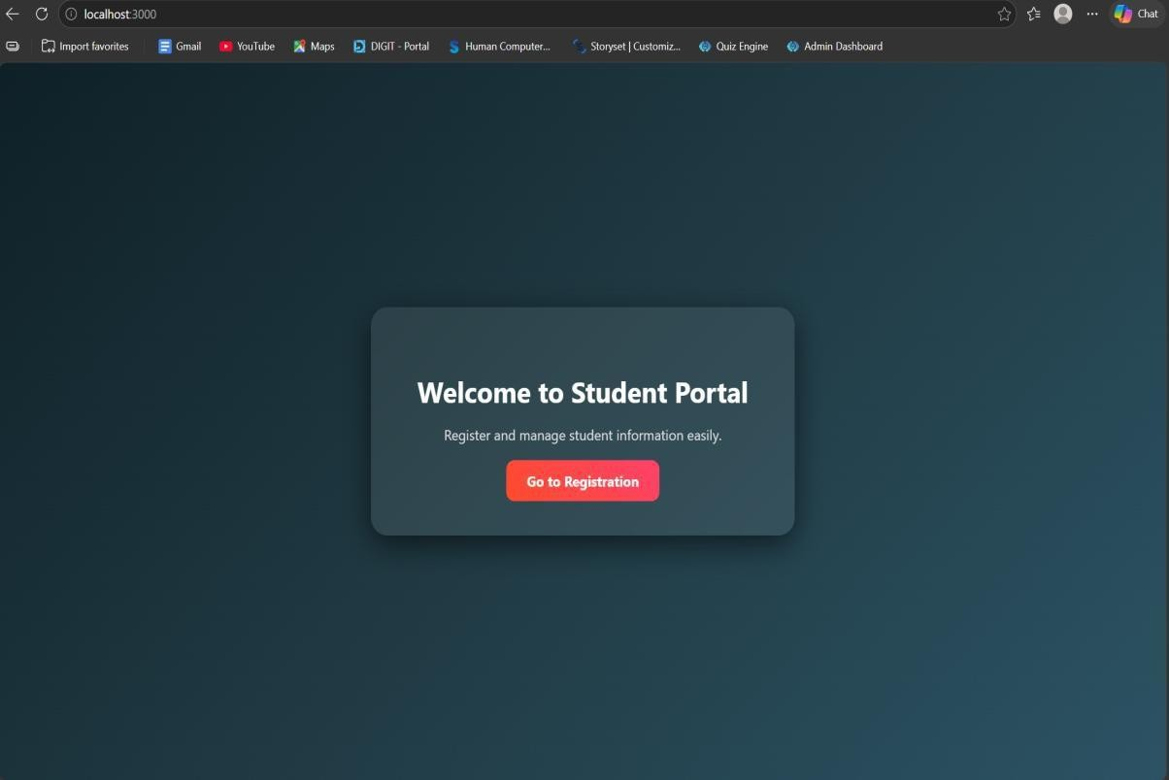

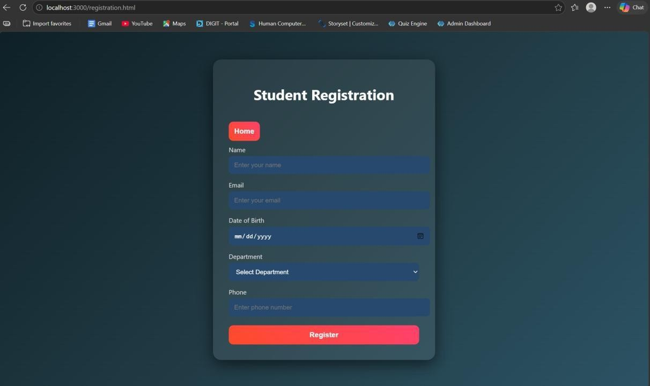

RESULT: The student registration system was successfully developed to store and manage student data using a web interface and MySQL database.

TASK2: Data Retrieval & Sorting Dashboard
AIM: To develop a web-based dashboard that allows users to store, retrieve, and display student data efficiently from a database, and present it in a structured format for easy access and management.

ALGORITHM:
- Start the application
- Initialize the server using Express framework
- Establish database connection using MySQL
- Load frontend pages (HTML, CSS, JS) in browser
➤ Data Insertion Process:
- User enters student details (Name, Email, DOB, Department, Phone)
- Send data to backend using POST request (/addStudent)
- Execute SQL query to insert data into database
- Display success message after insertion
➤ Data Retrieval Process:
- Send GET request to server (/students)
- Fetch all student records from database
- Convert data into JSON format
- Display data dynamically in dashboard table.
- Arrange data in structured format (table/grid)
- Allow better readability and management
- Stop. PROGRAM: INDEX.HTML:
<!DOCTYPE html>
<html>

<head>
<title>Student Portal</title>
<link rel="stylesheet" href="style.css">
</head>
<body>
<div class="home-container">
<h1>Welcome to Student Portal</h1>
<p>Register and manage student information easily.</p>
<a href="registration.html" class="start-btn">Go to Registration</a>
<a href="dashboard.html" class="start-btn">View Dashboard</a>
</div>
</body>
</html>

REGISTRATION.HTML:
<!DOCTYPE html>
<html>
<head>
<title>Student Registration</title>
<link rel="stylesheet" href="style.css">
</head>
<body>
<div class="container">
<h1>Student Registration</h1>
<button onclick="goHome()" class="home-btn">Home</button>
<form id="studentForm">

<label>Name</label>
<input type="text" id="name" placeholder="Enter your name" required>
<label>Email</label>
<input type="email" id="email" placeholder="Enter your email" required>
<label>Date of Birth</label>
<input type="date" id="dob" required>
<label>Department</label>
<select id="department" required>
<option value="">Select Department</option>
<option>CSE</option>
<option>IT</option>
<option>ECE</option>
<option>MECH</option>
</select>
<label>Phone</label>
<input type="text" id="phone" placeholder="Enter phone number" required>
<button type="submit">Register</button>
</form>
</div>
<script src="script.js"></script>
</body>
</html>

DASHBOARD.HTML:
<!DOCTYPE html>
<html>

<head>
<title>Student Dashboard</title>
<link rel="stylesheet" href="dashboard.css">
</head>
<body>
<div class="container">
<button onclick="goHome()" class="home-btn">Home</button>
<h1>Student Dashboard</h1>
<div class="controls">
<select id="sortSelect">
<option value="">Sort By</option>
<option value="name">Name</option>
<option value="dob">Date of Birth</option>
</select>
<select id="departmentFilter">
<option value="">Filter by Department</option>
<option value="CSE">CSE</option>
<option value="IT">IT</option>
<option value="ECE">ECE</option>
<option value="MECH">MECH</option>
</select>
<button onclick="loadStudents()">Apply</button>
</div>
<table>
<thead>
<tr>

<th>ID</th>
<th>Name</th>
<th>Email</th>
<th>DOB</th>
<th>Department</th>
<th>Phone</th>
</tr>
</thead>
<tbody id="studentTable"></tbody>
</table>
<h2>Department Count</h2>
<div id="deptCount"></div>
</div>
<script src="dashboard.js"></script>
<script>
function goHome(){ window.location.href = "index.html"
}
</script>
</body>
</html>

STYLE.CSS:
body{
font-family: 'Segoe UI', sans-serif;
background: linear-gradient(135deg,#0f2027,#203a43,#2c5364);

height:100vh; display:flex;
justify-content:center; align-items:center; margin:0;
}

.container{ width:420px; padding:35px;
background:rgba(255,255,255,0.08); border-radius:18px;
backdrop-filter: blur(10px);
box-shadow:0 10px 35px rgba(0,0,0,0.6);
}

h1{
text-align:center; color:white;
margin-bottom:25px;
}

h2{
text-align:center; color:white; margin-top:30px;

}

form{ display:flex;
flex-direction:column;
}

label{ color:#ddd; font-size:14px;
margin-bottom:5px; margin-top:10px;
}

input,select{ width:100%; padding:12px; border:none; border-radius:8px;
background:#27496d; color:white;
font-size:14px; outline:none; margin-bottom:5px;
}

input:focus,select:focus{
box-shadow:0 0 8px #00eaff; background:#2c5d8a;
}

button{
margin-top:15px; padding:12px; border:none; border-radius:10px;
background:linear-gradient(45deg,#ff4b2b,#ff416c); color:white;
font-size:16px; font-weight:bold; cursor:pointer; transition:0.3s;
}

button:hover{ transform:scale(1.05);
box-shadow:0 0 15px #ff416c;
}

#studentList{ margin-top:15px; text-align:center;

color:white; font-size:15px;
}
.home-container{ text-align:center; color:white;
background:rgba(255,255,255,0.08); padding:50px;
border-radius:20px; backdrop-filter: blur(10px);
box-shadow:0 10px 35px rgba(0,0,0,0.6); width:420px;
}

.home-container h1{ font-size:32px; margin-bottom:15px;
}

.home-container p{ margin-bottom:30px; color:#ddd;
}

.start-btn{
text-decoration:none;

padding:12px 25px; border-radius:10px;
background:linear-gradient(45deg,#ff4b2b,#ff416c); color:white;
font-weight:bold; transition:0.3s;
}

.start-btn:hover{ transform:scale(1.05);
box-shadow:0 0 15px #ff416c;
}

DASHBOARD.CSS:
body{
font-family:Segoe UI;
background:linear-gradient(135deg,#0f2027,#203a43,#2c5364); margin:0;
padding:0; display:flex;
justify-content:center;
}

.container{ width:900px; margin-top:40px;

background:rgba(255,255,255,0.08); padding:30px;
border-radius:15px; backdrop-filter:blur(10px); color:white;
}

h1{
text-align:center; margin-bottom:20px;
}

.controls{ display:flex; gap:10px;
margin-bottom:20px;
}

select,button{ padding:10px; border:none; border-radius:6px;
}

button{ background:#ff416c;

color:white; cursor:pointer;
}

table{ width:100%;
border-collapse:collapse; background:rgba(255,255,255,0.1);
}

th,td{ padding:10px; text-align:center;
}

th{ background:#1f4068;
}

tr:nth-child(even){ background:rgba(255,255,255,0.05);
}

#deptCount{ margin-top:15px; font-size:16px;

}
.home-btn{ padding:8px 16px; border:none; border-radius:6px; background:#00c6ff; color:white; cursor:pointer;
margin-bottom:10px;
}

SCRIPT.JS:
const form = document.getElementById("studentForm") form.addEventListener("submit", async (e) => { e.preventDefault()
const student = {
name: document.getElementById("name").value, email: document.getElementById("email").value, dob: document.getElementById("dob").value,
department: document.getElementById("department").value, phone: document.getElementById("phone").value
}
try{
const res = await fetch("http://localhost:3000/addStudent",{ method:"POST",
headers:{

"Content-Type":"application/json"
},
body:JSON.stringify(student)
})
const data = await res.text() alert(data)
// clear form form.reset()
}catch(error){ console.log("Error:",error)
}
})
function goHome(){ window.location.href="index.html"
}

SERVER.JS:
const express = require("express") const cors = require("cors")
const path = require("path") const db = require("./db") const app = express() app.use(cors()) app.use(express.json())
// Serve static files (HTML, CSS, JS) app.use(express.static( dirname))

// Redirect root link to index.html app.get("/", (req, res) => {
res.sendFile(path.join( dirname, "index.html"))
})
// Insert student data app.post("/addStudent", (req, res) => {
const {name,email,dob,department,phone} = req.body
const sql = "INSERT INTO students(name,email,dob,department,phone) VALUES (?,?,?,?,?)" db.query(sql,[name,email,dob,department,phone],(err,result)=>{
if(err){ res.send(err)
}else{
res.send("Student Added Successfully")
}
})

})
// Get student data app.get("/students",(req,res)=>{
db.query("SELECT * FROM students",(err,result)=>{ if(err){
res.send(err)
}else{ res.json(result)
}
})

})
// Start server app.listen(3000,()=>{
console.log("Server running at: http://localhost:3000")
})

DB.JS:
const mysql = require("mysql") const db = mysql.createConnection({ host: "localhost",
user: "root", password: "fahi", database: "studentdb"
})
db.connect((err)=>{ if(err){
console.log("Database Error:", err)
}else{
console.log("MySQL Connected Successfully")
}
})
module.exports = db

OUTPUTS:
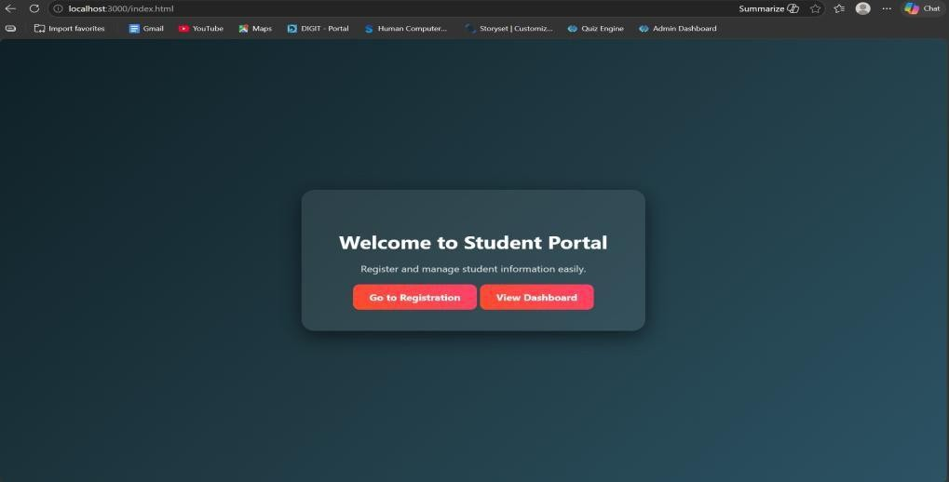
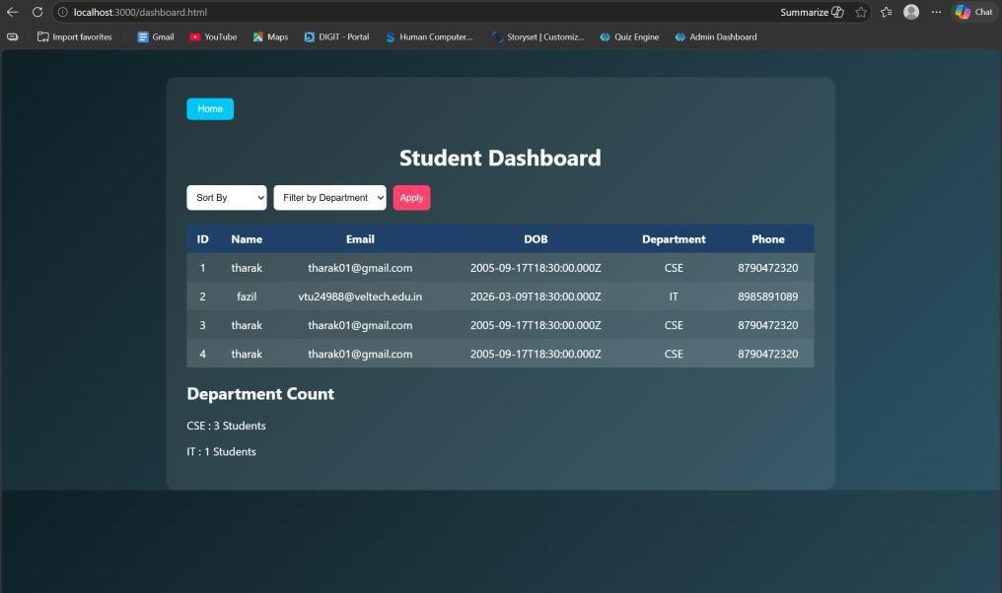

RESULT: The system successfully stores, retrieves, and displays student data efficiently through a user-friendly dashboard.

TASK3: : Login System with Validation

AIM: To develop a secure login system that validates user credentials (username and password) and allows access only to authorized users.

ALGORITHM:
- Start the application
- Display login form (Username & Password fields)
- User enters login credentials
- Perform input validation:
  - Check if fields are empty
  - Validate email format (if applicable)
  - Ensure password meets required criteria
- Send login data to backend server
- Server receives request and processes input
- Compare entered credentials with database records
- If credentials match:
  - Grant access and redirect to dashboard
- Else:
  - Display error message (“Invalid Username/Password”)
- End process

PROGRAM: INDEX.HTML:
<!DOCTYPE html>
<html>

<head>
<title>Student Portal</title>
<link rel="stylesheet" href="style.css">
</head>
<body>
<div class="home-container">
<h1>Welcome to Student Portal</h1>
<p>Register and manage student information easily.</p>
<a href="registration.html" class="start-btn">Go to Registration</a>
<a href="dashboard.html" class="start-btn">View Dashboard</a>
</div>
</body>
</html>

DASHBOARD.HTML:
<!DOCTYPE html>
<html>
<head>
<title>Student Dashboard</title>
<link rel="stylesheet" href="dashboard.css">
</head>
<body>
<div class="container">
<button onclick="goHome()" class="home-btn">Home</button>
<h1>Student Dashboard</h1>
<div class="controls">

<select id="sortSelect">
<option value="">Sort By</option>
<option value="name">Name</option>
<option value="dob">Date of Birth</option>
</select>
<select id="departmentFilter">
<option value="">Filter by Department</option>
<option value="CSE">CSE</option>
<option value="IT">IT</option>
<option value="ECE">ECE</option>
<option value="MECH">MECH</option>
</select>
<button onclick="loadStudents()">Apply</button>
</div>
<table>
<thead>
<tr>
<th>ID</th>
<th>Name</th>
<th>Email</th>
<th>DOB</th>
<th>Department</th>
<th>Phone</th>
</tr>
</thead>
<tbody id="studentTable"></tbody>

</table>
<h2>Department Count</h2>
<div id="deptCount"></div>
</div>
<script src="dashboard.js"></script>
<script>
function goHome(){ window.location.href = "index.html"
}
</script>
</body>
</html>

LOGIN.HTML:
<!DOCTYPE html>
<html>
<head>
<title>Login</title>
<link rel="stylesheet" href="login.css">
</head>
<body>
<div class="login-container">
<h1>Login</h1>
<form id="loginForm">
<label>Username</label>
<input type="text" id="username">

<label>Password</label>
<input type="password" id="password">
<p id="errorMsg"></p>
<button type="submit">Login</button>
</form>
</div>
<script src="login.js"></script>
</body>
</html>

REGISTRATION.HTML:
<!DOCTYPE html>
<html>
<head>
<title>Student Registration</title>
<link rel="stylesheet" href="style.css">
</head>
<body>
<div class="container">
<h1>Student Registration</h1>
<button onclick="goHome()" class="home-btn">Home</button>
<form id="studentForm">
<label>Name</label>
<input type="text" id="name" placeholder="Enter your name" required>
<label>Email</label>
<input type="email" id="email" placeholder="Enter your email" required>

<label>Date of Birth</label>
<input type="date" id="dob" required>
<label>Department</label>
<select id="department" required>
<option value="">Select Department</option>
<option>CSE</option>
<option>IT</option>
<option>ECE</option>
<option>MECH</option>
</select>
<label>Phone</label>
<input type="text" id="phone" placeholder="Enter phone number" required>
<button type="submit">Register</button>
</form>
</div>
<script src="script.js"></script>
</body>
</html>

STYLE.CSS:
body{
font-family: 'Segoe UI', sans-serif;
background: linear-gradient(135deg,#0f2027,#203a43,#2c5364); height:100vh;
display:flex;
justify-content:center;

align-items:center; margin:0;
}

.container{ width:420px; padding:35px;
background:rgba(255,255,255,0.08); border-radius:18px;
backdrop-filter: blur(10px);
box-shadow:0 10px 35px rgba(0,0,0,0.6);
}

h1{
text-align:center; color:white;
margin-bottom:25px;
}

h2{
text-align:center; color:white; margin-top:30px;
}

form{

display:flex;
flex-direction:column;
}

label{ color:#ddd; font-size:14px;
margin-bottom:5px; margin-top:10px;
}

input,select{ width:100%; padding:12px; border:none; border-radius:8px;
background:#27496d; color:white;
font-size:14px; outline:none; margin-bottom:5px;
}

input:focus,select:focus{
box-shadow:0 0 8px #00eaff; background:#2c5d8a;

}

button{
margin-top:15px; padding:12px; border:none; border-radius:10px;
background:linear-gradient(45deg,#ff4b2b,#ff416c); color:white;
font-size:16px; font-weight:bold; cursor:pointer; transition:0.3s;
}

button:hover{ transform:scale(1.05);
box-shadow:0 0 15px #ff416c;
}

#studentList{ margin-top:15px; text-align:center; color:white;
font-size:15px;
}

.home-container{ text-align:center; color:white;
background:rgba(255,255,255,0.08); padding:50px;
border-radius:20px; backdrop-filter: blur(10px);
box-shadow:0 10px 35px rgba(0,0,0,0.6); width:420px;
}

.home-container h1{ font-size:32px; margin-bottom:15px;
}

.home-container p{ margin-bottom:30px; color:#ddd;
}

.start-btn{
text-decoration:none; padding:12px 25px; border-radius:10px;
background:linear-gradient(45deg,#ff4b2b,#ff416c);

color:white;
font-weight:bold; transition:0.3s;
}

.start-btn:hover{ transform:scale(1.05);
box-shadow:0 0 15px #ff416c;
}

SERVER.JS:
const express = require("express") const cors = require("cors")
const path = require("path") const db = require("./db") const app = express() app.use(cors()) app.use(express.json())
app.use(express.urlencoded({ extended: true }))
// Disable default index.html loading app.use(express.static( dirname, { index: false }))
// ==========================
// OPEN LOGIN PAGE FIRST
// ==========================
app.get("/", (req, res) => { res.sendFile(path.join( dirname, "login.html"))

})
// ==========================
// LOGIN SYSTEM
// ==========================
app.post("/login",(req,res)=>{
const {username,password} = req.body
const sql = "SELECT * FROM users WHERE username=? AND password=?" db.query(sql,[username,password],(err,result)=>{
if(err){ res.send("error") return
}
if(result.length > 0){ res.send("success")
}else{ res.send("fail")
}
})
})
// ==========================
// STUDENT REGISTRATION
// ==========================
app.post("/addStudent",(req,res)=>{
const {name,email,dob,department,phone} = req.body
const sql = "INSERT INTO students(name,email,dob,department,phone) VALUES (?,?,?,?,?)" db.query(sql,[name,email,dob,department,phone],(err,result)=>{

if(err){ res.send(err)
}else{
res.send("Student Added Successfully")
}

})

})
// ==========================
// GET STUDENTS (Dashboard)
// ==========================

app.get("/students",(req,res)=>{

db.query("SELECT * FROM students",(err,result)=>{

if(err){ res.send(err)
}else{ res.json(result)
}

})

})

// ==========================
// START SERVER
// ==========================
app.listen(3000,()=>{
console.log("Server running at: http://localhost:3000")
})

OUTPUTS:
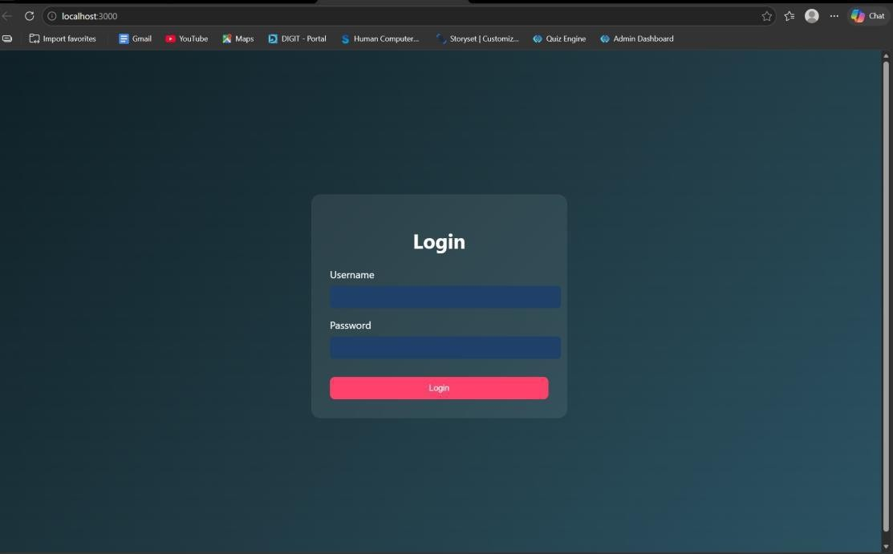

RESULT: The system successfully validates user credentials and grants access only to authorized users while preventing invalid logins.

TASK4: Order Management using Joins

AIM: To design and implement an order management system using SQL joins and subqueries to efficiently retrieve and analyze customer, product, and order data.

ALGORITHM:
- Start the process
- Create database tables:
  - Customers (CustomerID, Name, etc.)
  - Products (ProductID, ProductName, Price)
  - Orders (OrderID, CustomerID, ProductID, Quantity, TotalAmount)
- Insert sample data into all tables
➤ Data Retrieval using Joins:
- Use SQL JOIN queries to combine data from Customers, Orders, and Products
- Display customer order history with details (Name, Product, Quantity, Total Amount)
➤ Subquery for Analysis:
- Use subquery to find the highest value order
- Use subquery with GROUP BY to find the most active customer (maximum number of orders)
➤ Sorting:
- Apply ORDER BY clause to sort results (e.g., highest order value first)
- Display results in structured format (table/UI with CSS if frontend used)
- Stop

PROGRAM:
INDEX.HTML:
<!DOCTYPE html>
<html>
<head>
<title>Login</title>
<link rel="stylesheet" href="style.css">
</head>
<body>
<div class="login">
<h2>Admin Login</h2>
<input type="text" id="username" placeholder="Username">
<input type="password" id="password" placeholder="Password">
<button onclick="login()">Login</button>
</div>
<script src="script.js"></script>
</body>
</html>

ADMINDASHBOARD.HTML:

<!DOCTYPE html>
<html>
<head>
<title>Order Dashboard</title>
<link rel="stylesheet" href="style.css">

</head>
<body>
<!-- NAVBAR -->
<div class="navbar">
<h2>Order Management</h2>
<a href="index.html">
<button class="logout-btn">Logout</button>
</a>
</div>
<h1>Order Management Dashboard</h1>
<!-- CARDS SECTION -->
<div class="grid">
<!-- Add Customer -->
<div class="card">
<h3>Add Customer</h3>
<input id="cname" placeholder="Customer Name">
<input id="cemail" placeholder="Email">
<button onclick="addCustomer()">Add Customer</button>
</div>
<!-- Add Product -->
<div class="card">
<h3>Add Product</h3>
<input id="pname" placeholder="Product Name">
<input id="pprice" placeholder="Price">
<button onclick="addProduct()">Add Product</button>
</div>

<!-- Place Order -->
<div class="card">
<h3>Place Order</h3>
<select id="customerSelect">
<option value="">Select Customer</option>
</select>
<select id="productSelect">
<option value="">Select Product</option>
</select>
<input id="qty" placeholder="Quantity">
<button onclick="placeOrder()">Place Order</button>
</div>
</div>
<!-- ACTION BUTTONS -->
<div class="actions">
<button onclick="loadOrders()">Order History</button>
<button onclick="highestOrder()">Highest Order</button>
<button onclick="activeCustomer()">Most Active Customer</button>
</div>
<!-- RESULT AREA -->
<div id="result"></div>
<script src="script.js"></script>
</body>
</html>

STYLE.CSS:

*{ margin:0; padding:0;
box-sizing:border-box;
font-family: 'Segoe UI', Tahoma, Geneva, Verdana, sans-serif;
}

body{
background: linear-gradient(135deg,#5f6caf,#9a6bff); min-height:100vh;
display:flex;
flex-direction:column; align-items:center;
}

/* LOGIN PAGE */

.login{ width:350px; padding:40px; margin-top:120px; background:white; border-radius:15px;
box-shadow:0 10px 25px rgba(0,0,0,0.2); text-align:center;
}

.login h2{
margin-bottom:20px; color:#333;
}

.login input{ width:100%; padding:12px; margin:10px 0; border:1px solid #ccc; border-radius:8px; outline:none;
}

.login button{ width:100%; padding:12px; border:none; background:#5f6caf; color:white;
font-weight:bold; border-radius:8px; cursor:pointer; transition:0.3s;
}

.login button:hover{ background:#7c4dff;
}

/* DASHBOARD TITLE */

h1{
margin-top:30px; margin-bottom:25px; color:white;
}

/* CARD GRID */

.grid{ display:flex; gap:25px;
flex-wrap:wrap; justify-content:center; margin-bottom:20px;
}

/* CARDS */

.card{

width:260px; padding:22px; border-radius:15px;
box-shadow:0 8px 20px rgba(0,0,0,0.2); text-align:center;
transition:0.3s; color:white;
}

/* Different card colors */

.card:nth-child(1){
background:linear-gradient(135deg,#ff7a18,#ffb347);
}

.card:nth-child(2){
background:linear-gradient(135deg,#00c6ff,#0072ff);
}

.card:nth-child(3){
background:linear-gradient(135deg,#43e97b,#38f9d7); color:#222;
}

.card:hover{ transform:translateY(-6px);

}

.card h3{
margin-bottom:10px;
}

/* INPUTS */

.card input{ width:90%; padding:10px; margin:6px; border-radius:6px; border:none;
}

/* CARD BUTTON */

.card button{ padding:10px 15px; border:none; background:white; color:#333;
border-radius:6px; cursor:pointer; font-weight:bold;

transition:0.3s;
}

.card button:hover{ background:#f1f1f1;
}

/* ACTION BUTTONS */

button{ margin:10px; padding:12px 18px; border:none; border-radius:6px; background:#ffffff; color:#333;
font-weight:bold; cursor:pointer; transition:0.3s;
}

button:hover{ background:#eaeaea;
}

/* TABLE */

table{ width:85%; margin:auto; margin-top:30px;
border-collapse:collapse; background:white; border-radius:12px; overflow:hidden;
box-shadow:0 5px 15px rgba(0,0,0,0.2);
}

th{ background:#5f6caf; color:white; padding:14px;
font-size:18px;
}

td{ padding:12px; text-align:center;
border-bottom:1px solid #ddd; color:#222;
font-weight:500;
}

tr:nth-child(even){ background:#f7f7f7;
}

tr:hover{ background:#eef1ff;
}

/* RESULT TEXT */

#result{
margin-top:20px; color:white;
font-size:18px; text-align:center;
}
/* NAVBAR */

.navbar{

width:100%; display:flex;
justify-content:space-between; align-items:center; padding:15px 40px;

background:#2c2f5c; color:white;
box-shadow:0 4px 10px rgba(0,0,0,0.2);

}

.navbar h2{
font-weight:600;
}

.logout-btn{

background:#ff5252; color:white; border:none; padding:10px 16px; border-radius:6px; cursor:pointer;
font-weight:bold;

}

.logout-btn:hover{

background:#ff1744;

}
.actions{

display:flex;
justify-content:center; gap:20px;
margin-top:30px; flex-wrap:wrap;

}
.actions button{ padding:12px 20px; font-size:16px; border:none; border-radius:8px; background:#5f6caf; color:white; cursor:pointer; transition:0.3s;
}
.actions button:hover{ background:#7c4dff; transform:scale(1.05);

}

SCRIPT.JS:
// LOGIN FUNCTION

function login(){

const username=document.getElementById("username").value const password=document.getElementById("password").value

fetch("/login",{

method:"POST",
headers:{"Content-Type":"application/json"},

body:JSON.stringify({username,password})

})

.then(res=>res.json())

.then(data=>{

if(data.success){

window.location="admindashboard.html"
}else{
alert("Invalid login")

}
})

}
// ADD CUSTOMER

function addCustomer(){

fetch("/add-customer",{

method:"POST",
headers:{"Content-Type":"application/json"},

body:JSON.stringify({

name:document.getElementById("cname").value, email:document.getElementById("cemail").value

})

})

.then(res=>res.text())
.then(alert)

}

// ADD PRODUCT

function addProduct(){

fetch("/add-product",{

method:"POST",
headers:{"Content-Type":"application/json"},

body:JSON.stringify({

product:document.getElementById("pname").value, price:document.getElementById("pprice").value

})

})

.then(res=>res.text())
.then(alert)

}

// LOAD CUSTOMERS INTO DROPDOWN

async function loadCustomers(){

const res = await fetch("/customers") const data = await res.json()

let select=document.getElementById("customerSelect")

if(!select) return

select.innerHTML='<option value="">Select Customer</option>'

data.forEach(c=>{

select.innerHTML+=`<option value="${c.id}">${c.name}</option>`

})

}

// LOAD PRODUCTS INTO DROPDOWN

async function loadProducts(){

const res = await fetch("/products")

const data = await res.json()

let select=document.getElementById("productSelect")

if(!select) return

select.innerHTML='<option value="">Select Product</option>'

data.forEach(p=>{

select.innerHTML+=`<option value="${p.id}">${p.product_name}</option>`

})

}

// PLACE ORDER

function placeOrder(){

fetch("/place-order",{

method:"POST",
headers:{"Content-Type":"application/json"},

body:JSON.stringify({

customer_id:document.getElementById("customerSelect").value, product_id:document.getElementById("productSelect").value, quantity:document.getElementById("qty").value

})

})

.then(res=>res.text())
.then(alert)

}

// ORDER HISTORY (JOIN)

async function loadOrders(){

const res=await fetch("/orders") const data=await res.json()

let html="<table><tr><th>Customer</th><th>Product</th><th>Price</th><th>Qty</th><th>Total<
/th></tr>"

data.forEach(o=>{

html+=`

<tr>

<td>${o.name}</td>
<td>${o.product_name}</td>
<td>${o.price}</td>
<td>${o.quantity}</td>
<td>${o.total}</td>

</tr>

`

})

html+="</table>"

document.getElementById("result").innerHTML=html

}

// HIGHEST ORDER (SUBQUERY)

async function highestOrder(){

const res=await fetch("/highest-order") const data=await res.json()

document.getElementById("result").innerHTML=

`<h2>Highest Order</h2>

${data[0].name} - ₹${data[0].total}`

}

// MOST ACTIVE CUSTOMER

async function activeCustomer(){

const res=await fetch("/active-customer") const data=await res.json()

document.getElementById("result").innerHTML=

`<h2>Most Active Customer</h2>

${data[0].name} (${data[0].total_orders} orders)`

}

// AUTO LOAD DROPDOWNS WHEN PAGE LOADS

window.onload=function(){

loadCustomers() loadProducts()

}

SERVER.JS:
const express=require("express") const db=require("./db")

const app=express()

app.use(express.json()) app.use(express.static( dirname))

// LOGIN

app.post("/login",(req,res)=>{

const {username,password}=req.body

const sql="SELECT * FROM users WHERE username=? AND password=?"

db.query(sql,[username,password],(err,result)=>{

if(err) throw err

if(result.length>0){ res.json({success:true})
}else{ res.json({success:false})
}

})

})

// ADD CUSTOMER

app.post("/add-customer",(req,res)=>{

const {name,email}=req.body

const sql="INSERT INTO customers(name,email) VALUES(?,?)"

db.query(sql,[name,email],(err)=>{

if(err) throw err

res.send("Customer Added Successfully")

})

})

// ADD PRODUCT

app.post("/add-product",(req,res)=>{

const {product,price}=req.body

const sql="INSERT INTO products(product_name,price) VALUES(?,?)"

db.query(sql,[product,price],(err)=>{

if(err) throw err

res.send("Product Added Successfully")

})

})

// GET CUSTOMERS (for dropdown)

app.get("/customers",(req,res)=>{

const sql="SELECT * FROM customers"

db.query(sql,(err,result)=>{

if(err) throw err

res.json(result)

})

})

// GET PRODUCTS (for dropdown)

app.get("/products",(req,res)=>{

const sql="SELECT * FROM products"

db.query(sql,(err,result)=>{

if(err) throw err

res.json(result)

})

})

// PLACE ORDER

app.post("/place-order",(req,res)=>{

const {customer_id,product_id,quantity}=req.body

const sql="INSERT INTO orders(customer_id,product_id,quantity) VALUES(?,?,?)"

db.query(sql,[customer_id,product_id,quantity],(err)=>{

if(err) throw err

res.send("Order Placed Successfully")

})

})
// ORDER HISTORY (JOIN)

app.get("/orders",(req,res)=>{

const sql=`

SELECT customers.name, products.product_name, products.price, orders.quantity,
(products.price * orders.quantity) AS total

FROM orders

JOIN customers
ON orders.customer_id = customers.id

JOIN products
ON orders.product_id = products.id

ORDER BY orders.order_date DESC

`

db.query(sql,(err,result)=>{

if(err) throw err

res.json(result)

})

})

// HIGHEST VALUE ORDER (SUBQUERY)

app.get("/highest-order",(req,res)=>{

const sql=`

SELECT customers.name,
(products.price * orders.quantity) AS total

FROM orders

JOIN customers
ON orders.customer_id = customers.id

JOIN products
ON orders.product_id = products.id

WHERE (products.price * orders.quantity) =

(
SELECT MAX(products.price * orders.quantity) FROM orders
JOIN products
ON orders.product_id = products.id
)

`

db.query(sql,(err,result)=>{

if(err) throw err

res.json(result)

})

})

// MOST ACTIVE CUSTOMER

app.get("/active-customer",(req,res)=>{

const sql=`

SELECT customers.name, COUNT(orders.id) AS total_orders

FROM customers

JOIN orders
ON customers.id = orders.customer_id

GROUP BY customers.id

ORDER BY total_orders DESC

LIMIT 1

`

db.query(sql,(err,result)=>{

if(err) throw err

res.json(result)

})

})

// START SERVER

app.listen(3000,()=>{

console.log("Server running at http://localhost:3000")

})

OUTPUTS:
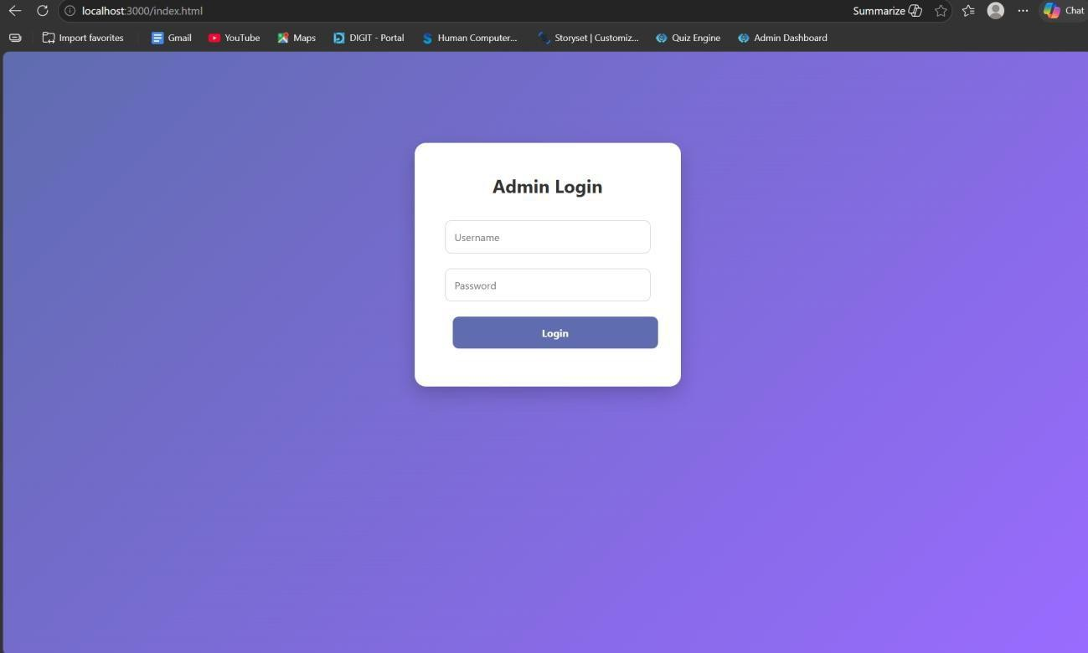

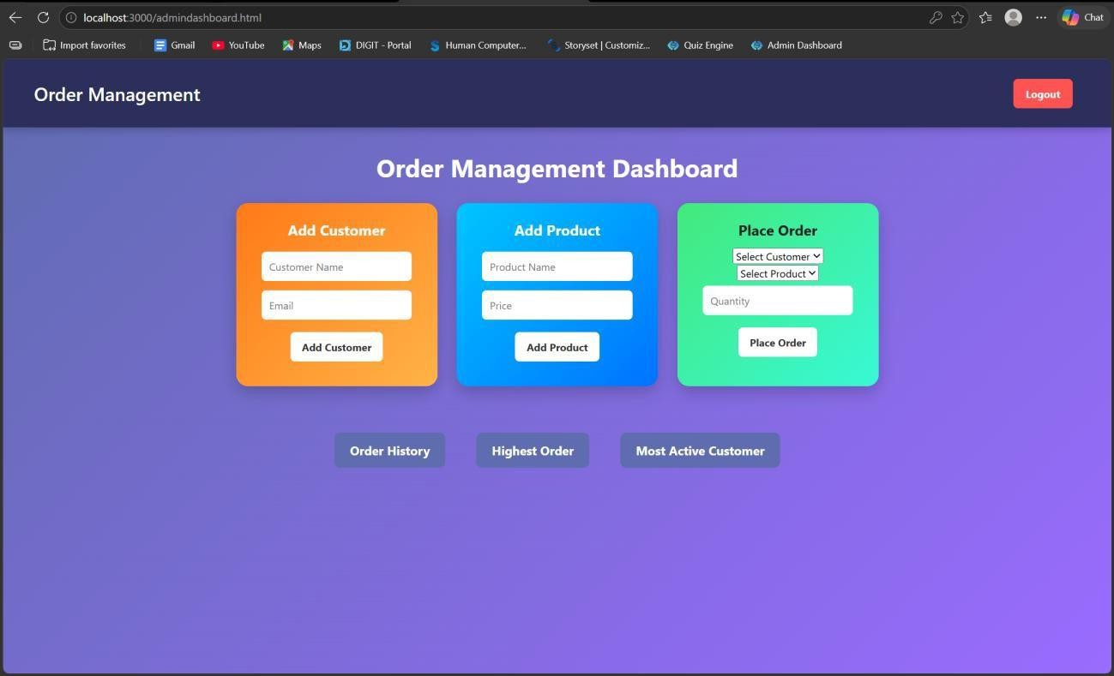

RESULT: The system successfully retrieves and analyzes customer order data using joins and subqueries, displaying meaningful insights like highest order value and most active customer.

TASK5: Transaction-Based Payment Simulation

AIM: To simulate an online payment system using database transactions that ensures safe and reliable fund transfer between user and merchant accounts using COMMIT and ROLLBACK operations.

ALGORITHM:
- Start the process
- Create database tables:
  - User Account (UserID, Balance)
  - Merchant Account (MerchantID, Balance)
- Insert initial balance values for user and merchant
➤ Transaction Process:
- Begin transaction (START TRANSACTION)
- Deduct amount from user account
- Add amount to merchant account
➤ Validation:
- Check if user has sufficient balance
  - If yes → proceed
  - If no → go to rollback
➤ Commit / Rollback:
- If all operations are successful → COMMIT transaction
- If any error occurs → ROLLBACK transaction
- Display transaction status (Success / Failed)
- Stop

PROGRAM:
INDEX.HTML:
<!DOCTYPE html>
<html>
<head>
<title>Payment Simulation</title>
<link rel="stylesheet" href="style.css">
</head>
<body>
<div class="container">
<h2>Online Payment</h2>
<select id="user" onchange="updateBalances()"></select>
<select id="merchant" onchange="updateBalances()"></select>
<input type="number" id="amount" placeholder="Enter amount">
<button onclick="pay()">Pay</button>
<h3 id="userBalance"></h3>
<h3 id="merchantBalance"></h3>
<p id="result"></p>
</div>
<script src="script.js"></script>
</body>
</html>

STYLE.CSS:
body{
font-family: Arial;

background: linear-gradient(135deg,#dfe9f3,#ffffff); display:flex;
justify-content:center; align-items:center; height:100vh;
}

.container{ background:white; padding:30px; border-radius:15px;
box-shadow:0 10px 25px rgba(0,0,0,0.2); text-align:center;
width:400px;
}

select, input{ padding:10px; margin:10px; width:90%; border-radius:5px;
border:1px solid #ccc;
}

button{ padding:10px;

width:95%; background:green; color:white; border:none; border-radius:5px; cursor:pointer; font-size:16px;
}

button:hover{ background:darkgreen;
}

h3{ margin:5px; color:#333;
}

SCRIPT.JS:
let usersData = []
let merchantsData = [] function loadData(){ fetch("/balances")
.then(res=>res.json())
.then(data=>{ usersData = data.users

merchantsData = data.merchants
let userSelect = document.getElementById("user")
let merchantSelect = document.getElementById("merchant") userSelect.innerHTML=""
merchantSelect.innerHTML=""
// fill users usersData.forEach(u=>{
userSelect.innerHTML += `<option value="${u.id}">${u.name}</option>`
})
window.onload = loadData
// fill merchants merchantsData.forEach(m=>{
merchantSelect.innerHTML += `<option value="${m.id}">${m.name}</option>`
})
// show initial balances updateBalances()
})
}
function updateBalances(){
let userId = document.getElementById("user").value
let merchantId = document.getElementById("merchant").value let user = usersData.find(u=>u.id == userId)
let merchant = merchantsData.find(m=>m.id == merchantId) document.getElementById("userBalance").innerText = "User Balance: ₹" + user.balance document.getElementById("merchantBalance").innerText =

"Shop Balance: ₹" + merchant.balance
}
function pay(){
let userId = document.getElementById("user").value
let merchantId = document.getElementById("merchant").value let amount = document.getElementById("amount").value fetch("/pay",{
method:"POST", headers:{
"Content-Type":"application/json"
},
body:JSON.stringify({ userId:userId, merchantId:merchantId, amount:amount
})
})
.then(res=>res.json())
.then(data=>{
document.getElementById("result").innerText = data.message loadData()
})
}
window.onload = loadData

SERVER.JS:
const express = require("express") const db = require("./db")
const app = express() app.use(express.json()) app.use(express.static( dirname))
app.get("/", (req, res) => {
res.sendFile( dirname + "/index.html")
})
app.post("/pay", (req, res) => {
const { userId, merchantId, amount } = req.body const amt = parseInt(amount)
if (!amt || amt <= 0) {
return res.json({ message: "Enter valid amount" })
}
db.beginTransaction(err => {
if (err) return res.status(500).send("Transaction error")
// 1. Get user balance
db.query("SELECT balance FROM users WHERE id=?", [userId], (err, result) => { if (err || result.length === 0) {
return db.rollback(() => res.send("User not found"))
}
let balance = result[0].balance if (balance < amt) {
return db.rollback(() => {
res.json({ message: "Insufficient Balance" })

})
}

// 2. Deduct from user db.query(
"UPDATE users SET balance = balance - ? WHERE id=?", [amt, userId],
(err) => {

if (err) {
return db.rollback(() => res.send("Deduction failed"))
}

// 3. Add to merchant db.query(
"UPDATE merchants SET balance = balance + ? WHERE id=?", [amt, merchantId],
(err) => {

if (err) {
return db.rollback(() => res.send("Merchant update failed"))
}
// 4. Commit db.commit(err => {

if (err) {

return db.rollback(() => res.send("Commit failed"))
}

res.json({ message: "Payment Successful " })
})
}
)
}
)
})
})
})
app.get("/balances", (req, res) => {

db.query("SELECT * FROM users", (err, users) => {

if (err) return res.send("Error fetching users")

db.query("SELECT * FROM merchants", (err, merchants) => {

if (err) return res.send("Error fetching merchants")

res.json({ users: users,
merchants: merchants
})

})
})
})
app.listen(3000, () => {
console.log("Server running on http://localhost:3000")
})

OUTPUTS:
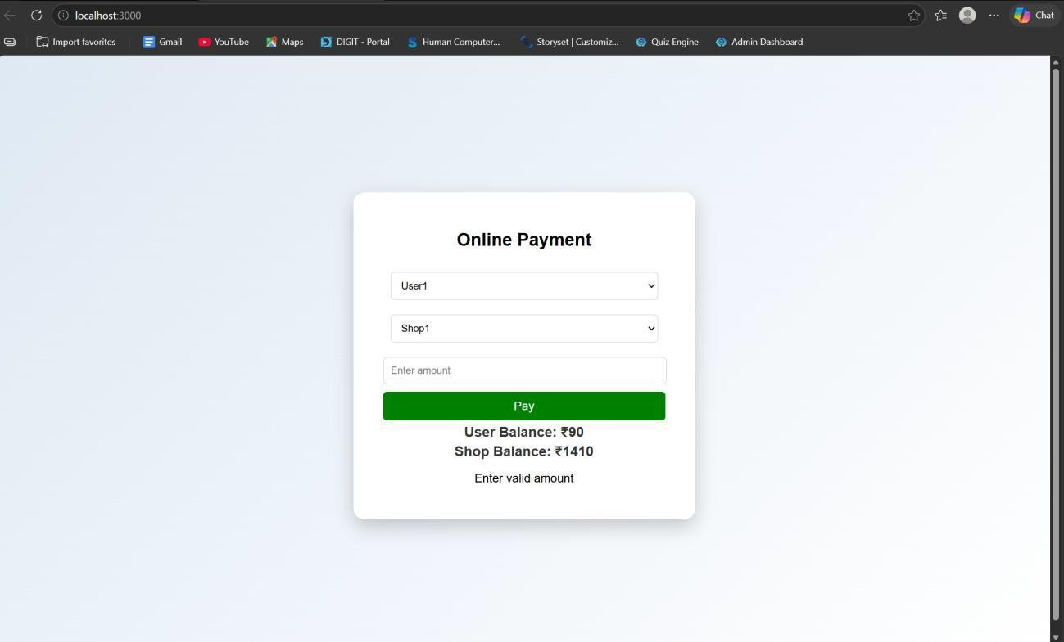
RESULT: The system successfully performs secure payment transactions by updating balances accurately using COMMIT on success and ROLLBACK on failure.

TASK6: Automated Logging using Triggers & Views
AIM: To develop a web-based application for automated logging of database activities using MySQL triggers and views, integrated with a Node.js backend and frontend interface, in order to track INSERT and UPDATE operations and generate daily activity reports.

ALGORITHM:
- Start the program
- Create database and required tables
- Create triggers for INSERT and UPDATE operations
- Store actions in log table automatically
- Create a view for daily activity report
- Develop backend using Node.js and Express
- Connect backend with MySQL database
- Create APIs for add, update, logs, and report
- Design frontend using HTML, CSS, and JavaScript
- Run the application and display results
- Stop the program

PROGRAM:
INDEX.HTML:
<!DOCTYPE html>
<html>
<head>
<title>Employee Audit System</title>
<link rel="stylesheet" href="style.css">
</head>
<body>

<h2>Employee Management</h2>
<div class="form">
<input type="number" id="emp_id" placeholder="Employee ID">
<input type="text" id="name" placeholder="Name">
<input type="number" id="salary" placeholder="Salary">
<button onclick="addEmployee()">Add</button>
</div>
<div class="form">
<input type="number" id="update_id" placeholder="Employee ID">
<input type="number" id="new_salary" placeholder="New Salary">
<button onclick="updateEmployee()">Update</button>
</div>
<button onclick="loadLogs()">View Logs</button>
<button onclick="loadReport()">View Daily Report</button>
<h3>Output</h3>
<pre id="output"></pre>
<script src="script.js"></script>
</body>
</html>

STYLE.CSS:
body {
font-family: Arial; text-align: center; background: #f4f4f4;
}

.form {
margin: 15px;
}
input {
padding: 8px; margin: 5px;
}
button {
padding: 8px 15px; background: blue; color: white; border: none; cursor: pointer;
}
button:hover { background: darkblue;
}
pre {
background: white; padding: 10px; width: 60%; margin: auto;
text-align: left;
}

SCRIPT.JS:
const BASE_URL = "http://localhost:3000";

// Add Employee function addEmployee() {
const data = {
emp_id: document.getElementById("emp_id").value, name: document.getElementById("name").value, salary: document.getElementById("salary").value
};
fetch(`${BASE_URL}/add`, { method: "POST",
headers: { "Content-Type": "application/json" }, body: JSON.stringify(data)
})
.then(res => res.text())
.then(data => alert(data));
}
// Update Employee function updateEmployee() {
const id = document.getElementById("update_id").value; const salary = document.getElementById("new_salary").value;

fetch(`${BASE_URL}/update/${id}`, { method: "PUT",
headers: { "Content-Type": "application/json" }, body: JSON.stringify({ salary })
})
.then(res => res.text())

.then(data => alert(data));
}
// Load Logs function loadLogs() {
fetch(`${BASE_URL}/logs`)
.then(res => res.json())
.then(data => { document.getElementById("output").innerText =
JSON.stringify(data, null, 2);
});
}
// Load Report function loadReport() {
fetch(`${BASE_URL}/report`)
.then(res => res.json())
.then(data => { document.getElementById("output").innerText =
JSON.stringify(data, null, 2);
});
}

DB.JS:
const mysql = require('mysql2'); const db = mysql.createConnection({
host: 'localhost', user: 'root', password: 'fahi',

database: 'audit_db'
});
db.connect((err) => { if (err) {
console.error('DB Connection Failed:', err);
} else {
console.log('Connected to MySQL');
}
});
module.exports = db;

OUTPUTS:
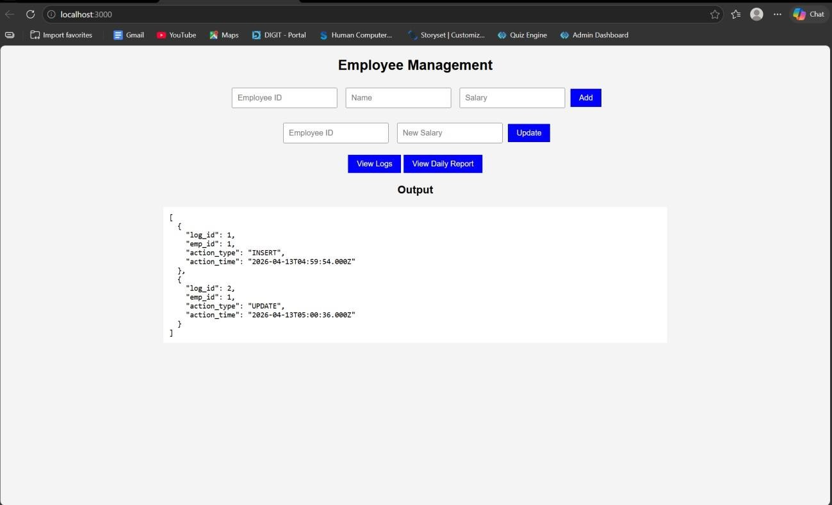

RESULT: The system successfully logs all INSERT and UPDATE operations automatically using triggers and displays daily activity reports through a web interface.

TASK7: Interactive Web Form with Events & Functions

AIM: To develop an interactive web-based feedback form with real-time validation, UI effects, and backend data storage using HTML, CSS, JavaScript, and Node.js.

ALGORITHM:
- Start the program
- Create project files (HTML, CSS, JS, server.js, db.js)
- Design feedback form with input fields (name, email, message)
- Apply CSS styling for layout and visual effects
- Define reusable validation functions in JavaScript
- Capture user input using DOM elements
- Apply keyup event for real-time validation
- Add hover effect to highlight input fields
- Implement double-click event on submit button
- Validate all fields before submission
- Send data to server using fetch API (POST request)
- Store data in database module and display success message

PROGRAM:
INDEX.HTML:
<!DOCTYPE html>
<html lang="en">
<head>
<title>Feedback Form</title>
<link rel="stylesheet" href="style.css">
</head>

<body>
<div class="container">
<h2> Customer Feedback</h2>
<form id="feedbackForm">
<input type="text" id="name" placeholder="Your Name" required>
<span class="error" id="nameError"></span>
<input type="email" id="email" placeholder="Your Email" required>
<span class="error" id="emailError"></span>
<textarea id="message" placeholder="Your Feedback" required></textarea>
<span class="error" id="msgError"></span>
<button type="button" id="submitBtn">Submit</button>
</form>
<p id="successMsg"></p>
</div>
<script src="script.js"></script>
</body>
</html>

STYLE.CSS:
body {
font-family: 'Segoe UI', sans-serif;
background: linear-gradient(135deg, #1f1c2c, #928dab); display: flex;
justify-content: center; align-items: center; height: 100vh;
color: white;

}
.container {
background: rgba(255, 255, 255, 0.1); padding: 25px;
border-radius: 15px; backdrop-filter: blur(10px); width: 320px;
box-shadow: 0 10px 25px rgba(0,0,0,0.3);
}
h2 {
text-align: center;
}
input, textarea { width: 100%; padding: 10px; margin: 8px 0; border-radius: 8px; border: none; outline: none; transition: 0.3s;
}
input:hover, textarea:hover { transform: scale(1.05);
box-shadow: 0 0 8px #00f7ff;
}
button {

width: 100%; padding: 10px; background: #00c6ff; border: none; border-radius: 10px; color: white;
font-weight: bold; cursor: pointer;
}
button:hover { background: #0072ff;
}
.error {
color: #ff6b6b; font-size: 12px;
}
#successMsg {
text-align: center; margin-top: 10px; color: #00ffae;
}

SCRIPT.JS:
const nameInput = document.getElementById("name"); const emailInput = document.getElementById("email");
const messageInput = document.getElementById("message"); const submitBtn = document.getElementById("submitBtn");

function validateName() {
if (nameInput.value.length < 3) { document.getElementById("nameError").innerText = "Min 3 characters"; return false;
}
document.getElementById("nameError").innerText = ""; return true;
}
function validateEmail() {
let pattern = /^[^ ]+@[^ ]+\.[a-z]{2,3}$/; if (!emailInput.value.match(pattern)) {
document.getElementById("emailError").innerText = "Invalid email"; return false;
}
document.getElementById("emailError").innerText = ""; return true;
}
function validateMessage() {
if (messageInput.value.length < 5) { document.getElementById("msgError").innerText = "Too short"; return false;
}
document.getElementById("msgError").innerText = ""; return true;
}
nameInput.addEventListener("keyup", validateName);

emailInput.addEventListener("keyup", validateEmail); messageInput.addEventListener("keyup", validateMessage); submitBtn.addEventListener("dblclick", () => {
if (validateName() && validateEmail() && validateMessage()) { sendData();
} else {
alert("Fix errors before submitting!");
}
});
function sendData() { fetch("http://localhost:3000/submit", {
method: "POST", headers: {
"Content-Type": "application/json"
},
body: JSON.stringify({ name: nameInput.value, email: emailInput.value,
message: messageInput.value
})
})
.then(res => res.json())
.then(data => {
document.getElementById("successMsg").innerText = " Feedback Submitted!";
});
}

SERVER.JS:
const express = require("express"); const cors = require("cors");
const bodyParser = require("body-parser"); const path = require("path");
const db = require("./db"); const app = express(); app.use(cors()); app.use(bodyParser.json());
app.use(express.static( dirname));
app.get("/", (req, res) => {
res.sendFile(path.join( dirname, "index.html"));
});
app.post("/submit", (req, res) => {
const { name, email, message } = req.body; db.saveFeedback({ name, email, message }); res.json({ status: "success" });
});
app.listen(3000, () => {
console.log("Server running on http://localhost:3000");
});

DB.JS:
let feedbacks = [];
function saveFeedback(data) { feedbacks.push(data); console.log("Saved:", data);

}
module.exports = { saveFeedback
};

OUTPUT:
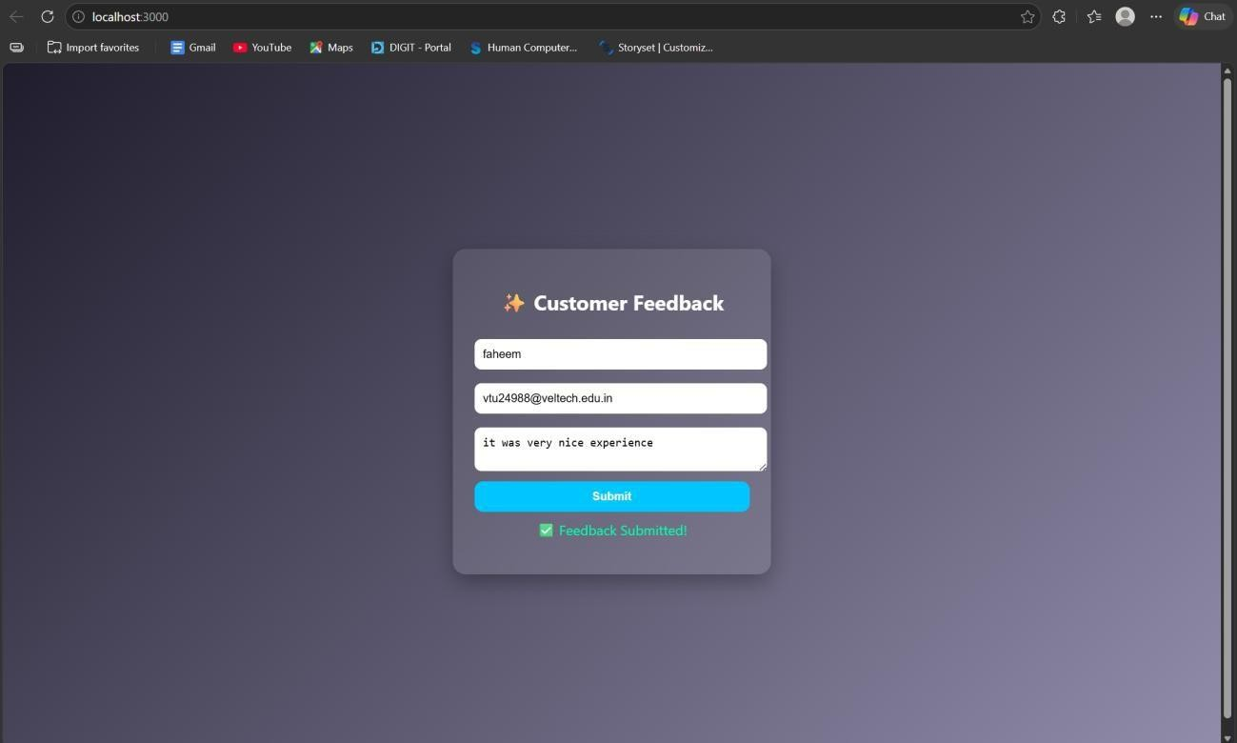

RESULT: The interactive feedback form was successfully implemented with real-time validation, enhanced UI effects, and backend data handling.

TASK8: Employee Management

AIM: To develop a simple Employee Management system using HTML, CSS, JavaScript, and Node.js for adding and displaying employee data.

ALGORITHM:
- Start the program
- Create project files (HTML, CSS, JS, server.js, db.js)
- Design the user interface with input fields (name, role)
- Apply CSS styling for layout and centering
- Capture user input using JavaScript
- Create function to add employee data
- Send data to server using fetch API (POST request)
- Create backend using Node.js and Express
- Receive and store employee data in memory (db.js)
- Create API to fetch all employee records (GET request)
- Display employee list dynamically on the webpage
- Stop the program

PROGRAM:
INDEX.HTML:
<!DOCTYPE html>
<html>
<head>
<title>Employee Management</title>
<link rel="stylesheet" href="style.css">
</head>

<body>
<div class="container">
<h2>Employee Management</h2>
<input id="name" placeholder="Name">
<input id="role" placeholder="Role">
<button onclick="addEmployee()">Add</button>
<ul id="list"></ul>
</div>
<script src="script.js"></script>
</body>
</html>

STYLE.CSS:
body {
font-family: Arial; background: #1e1e2f; color: white;
display: flex;
justify-content: center; align-items: center; height: 100vh;
margin: 0;
}
.container {
text-align: center;
}

input {
padding: 10px; margin: 5px; border-radius: 5px; border: none;
}
button { padding: 10px;
background: #00c6ff; border: none; border-radius: 5px; cursor: pointer;
}

SCRIPT.JS:
function addEmployee() {
const name = document.getElementById("name").value; const role = document.getElementById("role").value; fetch("http://localhost:3000/add", {
method: "POST", headers: {
"Content-Type": "application/json"
},
body: JSON.stringify({ name, role })
})
.then(res => res.json())

.then(() => loadEmployees());
}
function loadEmployees() { fetch("http://localhost:3000/all")
.then(res => res.json())
.then(data => {
let list = document.getElementById("list"); list.innerHTML = "";

data.forEach(emp => {
let li = document.createElement("li"); li.innerText = emp.name + " - " + emp.role; list.appendChild(li);
});
});
}
loadEmployees();

SERVER.JS:
const express = require("express"); const cors = require("cors");
const path = require("path"); const db = require("./db"); const app = express(); app.use(cors()); app.use(express.json());
app.use(express.static( dirname));

app.get("/", (req, res) => {
res.sendFile(path.join( dirname, "index.html"));
});
app.post("/add", (req, res) => { db.addEmployee(req.body); res.json({ msg: "Added" });
});
app.get("/all", (req, res) => { res.json(db.getEmployees());
});
app.listen(3000, () => {
console.log("• Server running at: http://localhost:3000");
});

DB.JS:
let employees = [];
function addEmployee(emp) { employees.push(emp);
}
function getEmployees() { return employees;
}
module.exports = { addEmployee, getEmployees };

OUTPUT:
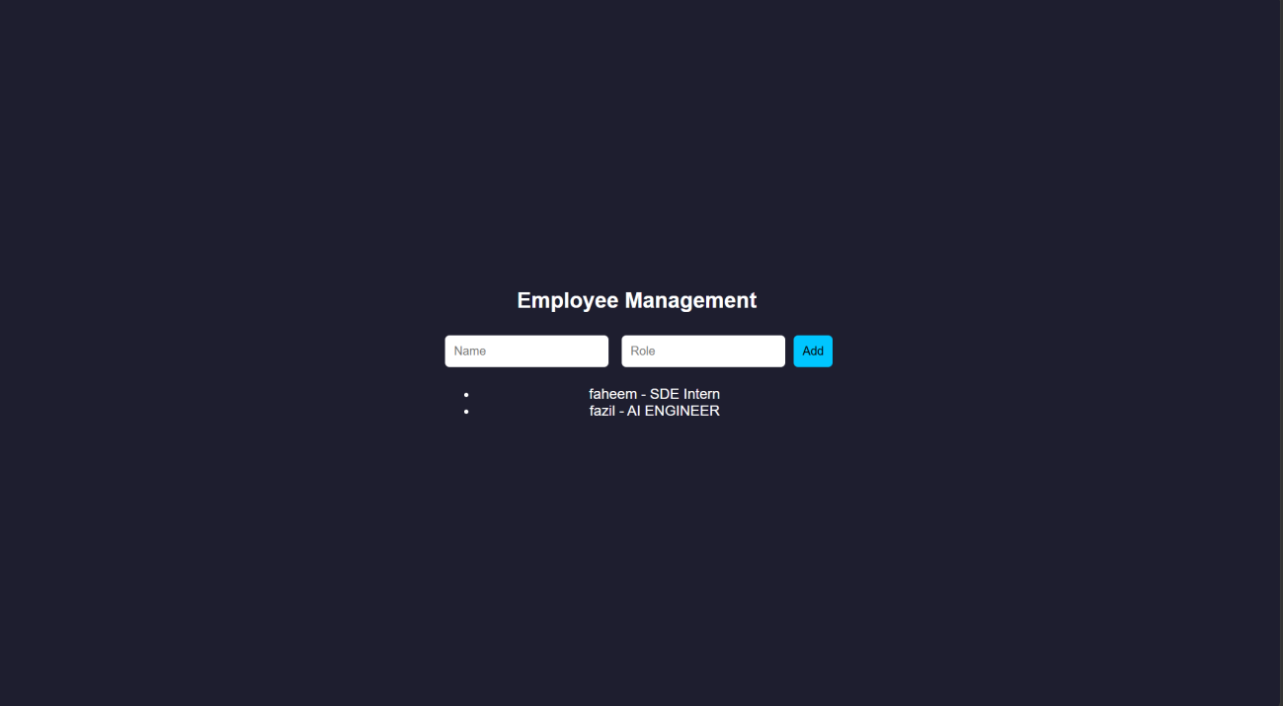

RESULT: The Employee Management system was successfully implemented with a user- friendly interface and dynamic data handling using Node.js backend.

TASK9: Employee MVC APP

AIM: To develop a basic MVC-based Employee application using HTML, CSS, JavaScript, and Node.js to handle user requests and display employee details.

ALGORITHM:
- Start the program
- Create project files (HTML, CSS, JS, server.js, db.js)
- Design UI form to accept employee details
- Apply CSS styling for better user interface
- Capture user input using JavaScript
- Send request to server using fetch API
- Create controller logic in server.js
- Define routes to handle requests (/add, /all)
- Store employee data in memory using db.js
- Retrieve employee data from database module
- Send response back to frontend (view)
- Display employee details dynamically and stop

PROGRAM:
INDEX.HTML:
<!DOCTYPE html>
<html>
<head>
<title>Employee MVC</title>
<link rel="stylesheet" href="style.css">
</head>
<body>

<div class="container">
<h2>Employee Details</h2>
<input id="name" placeholder="Name">
<input id="role" placeholder="Role">
<button onclick="addEmployee()">Add</button>
<ul id="list"></ul>
</div>
<script src="script.js"></script>
</body>
</html>

STYLE.CSS:
* {
margin: 0;
padding: 0;
box-sizing: border-box;
}
body {
font-family: 'Segoe UI', sans-serif;
background: linear-gradient(135deg, #1f1c2c, #928dab); height: 100vh;

display: flex;
justify-content: center; align-items: center;

color: white;

}
.container {
background: rgba(255, 255, 255, 0.1); padding: 30px;
border-radius: 15px; backdrop-filter: blur(10px); width: 320px;
text-align: center;

box-shadow: 0 10px 25px rgba(0,0,0,0.4);
}
h2 {
margin-bottom: 15px;
}
input {
width: 100%; padding: 10px; margin: 8px 0;

border: none; border-radius: 8px; outline: none;

transition: 0.3s;
}
input:hover,

input:focus {
transform: scale(1.05);
box-shadow: 0 0 8px #00f7ff;
}
button {
width: 100%; padding: 10px; margin-top: 10px;

background: #00c6ff; border: none; border-radius: 10px;

color: white;
font-weight: bold; cursor: pointer;

transition: 0.3s;
}
button:hover { background: #0072ff; transform: scale(1.05);
}
ul {
list-style: none; margin-top: 15px;

}
li {
background: rgba(255,255,255,0.15); padding: 8px;
margin: 5px 0; border-radius: 6px;

transition: 0.3s;
}
li:hover {
background: rgba(255,255,255,0.3);
}

SCRIPT.JS:
function addEmployee() {
const name = document.getElementById("name").value; const role = document.getElementById("role").value; fetch("/add", {
method: "POST",
headers: { "Content-Type": "application/json" }, body: JSON.stringify({ name, role })
})
.then(() => loadEmployees());
}
function loadEmployees() { fetch("/all")
.then(res => res.json())

.then(data => {
let list = document.getElementById("list"); list.innerHTML = "";
data.forEach(emp => {
let li = document.createElement("li"); li.innerText = emp.name + " - " + emp.role; list.appendChild(li);
});
});
}
loadEmployees();

SERVER.JS:
const express = require("express"); const cors = require("cors");
const path = require("path"); const db = require("./db"); const app = express(); app.use(cors()); app.use(express.json());
app.use(express.static( dirname));
app.post("/add", (req, res) => { db.addEmployee(req.body); res.json({ msg: "Employee Added" });
});
app.get("/all", (req, res) => { res.json(db.getEmployees());

});
app.listen(3000, () => { console.log("http://localhost:3000");
});

DB.JS:
let employees = [];
function addEmployee(emp) { employees.push(emp);
}
function getEmployees() { return employees;
}
module.exports = { addEmployee, getEmployees };

OUTPUT:
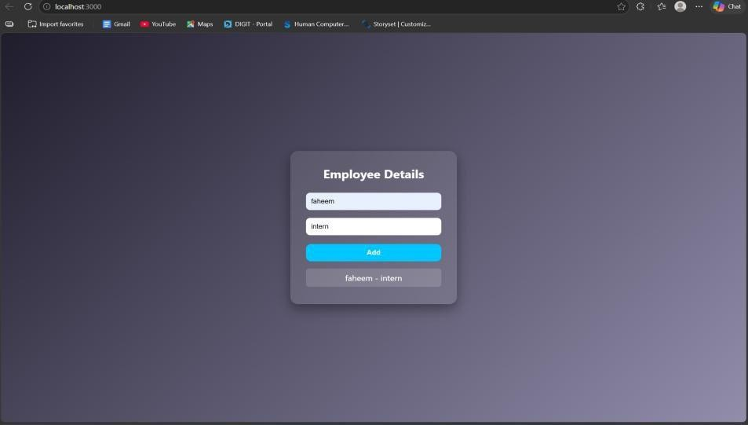
RESULT: The MVC-based Employee application was successfully implemented using Node.js, where user requests were processed and employee details were displayed dynamically.

TASK10: Student Crud App
AIM: To develop a Student CRUD application using HTML, CSS, JavaScript, and Node.js to perform create, read, update, and delete operations.

ALGORITHM:
- Start the program
- Create project files (HTML, CSS, JS, server.js, db.js)
- Design UI for student input (id, name, course)
- Apply CSS for styling and layout
- Capture user input using JavaScript
- Send data to server using fetch API
- Create backend using Node.js and Express
- Implement Create operation (POST request)
- Implement Read operation (GET request)
- Implement Update operation (PUT request)
- Implement Delete operation (DELETE request)
- Display updated student data dynamically and stop

PROGRAM:
INDEX.HTML:
<!DOCTYPE html>
<html>
<head>
<title>Student CRUD</title>
<link rel="stylesheet" href="style.css">
</head>
<body>
<div class="container">

<h2>Student CRUD</h2>
<input id="id" placeholder="ID">
<input id="name" placeholder="Name">
<input id="course" placeholder="Course">
<button onclick="addStudent()">Add</button>
<button onclick="updateStudent()">Update</button>
<ul id="list"></ul>
</div>
<script src="script.js"></script>
</body>
</html>

STYLE.CSS:
body {
font-family: 'Segoe UI';
background: linear-gradient(135deg,#1f1c2c,#928dab); height: 100vh;
display:flex;
justify-content:center; align-items:center; color:white;
}
.container {
background: rgba(255,255,255,0.1); padding:20px;
border-radius:10px; text-align:center;

}
input {
display:block; margin:8px auto; padding:8px;
}
button { margin:5px; padding:8px;
background:#00c6ff; border:none; color:white;
}

SCRIPT.JS:
function addStudent() { let data = getInput(); fetch("/add", {
method: "POST",
headers: {"Content-Type":"application/json"}, body: JSON.stringify(data)
}).then(loadStudents);
}
function loadStudents() { fetch("/all")
.then(res => res.json())
.then(data => {

let list = document.getElementById("list"); list.innerHTML = "";
data.forEach(s => {
let li = document.createElement("li"); li.innerHTML = `
${s.id} - ${s.name} (${s.course})
<button onclick="deleteStudent(${s.id})"> </button>
`; list.appendChild(li);
});
});
}
function updateStudent() { let data = getInput(); fetch("/update", {
method: "PUT",
headers: {"Content-Type":"application/json"}, body: JSON.stringify(data)
}).then(loadStudents);
}
function deleteStudent(id) { fetch(`/delete/${id}`, { method: "DELETE" })
.then(loadStudents);
}
function getInput() { return {

id: document.getElementById("id").value,
name: document.getElementById("name").value, course: document.getElementById("course").value
};
}
loadStudents();

SERVER.JS:
const express = require("express"); const cors = require("cors");
const db = require("./db"); const app = express(); app.use(cors()); app.use(express.json());
app.use(express.static( dirname));
// CREATE
app.post("/add", (req, res) => { db.add(req.body); res.json({msg:"Added"});
});
// READ
app.get("/all", (req, res) => {
res.json(db.getAll());
});
// UPDATE
app.put("/update", (req, res) => { db.update(req.body);

res.json({msg:"Updated"});
});
// DELETE
app.delete("/delete/:id", (req, res) => { db.remove(req.params.id); res.json({msg:"Deleted"});
});
app.listen(3000, () => console.log("http://localhost:3000"));

DB.JS:
let students = []; function add(s) {
students.push(s);
}
function getAll() { return students;
}
function update(updated) { students = students.map(s =>
s.id == updated.id ? updated : s
);
}
function remove(id) {
students = students.filter(s => s.id != id);
}
module.exports = { add, getAll, update, remove };

OUTPUT:
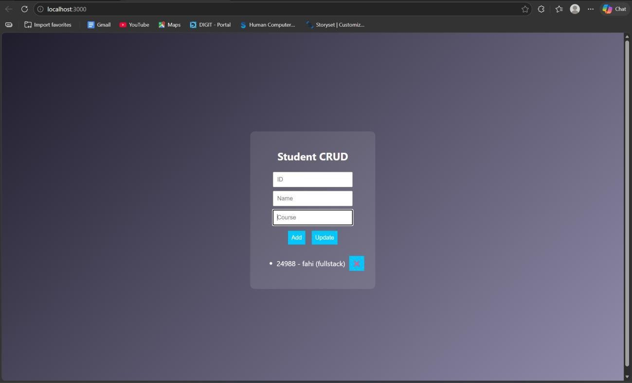
RESULT: The Student CRUD application was successfully implemented with full create, read, update, and delete operations using Node.js and a dynamic web interface.

TASK11: Student Data Layer

AIM: To implement a data access layer for managing student records with filtering, sorting, and pagination using HTML, CSS, JavaScript, and Node.js.

ALGORITHM:
- Start the program
- Create project files (HTML, CSS, JS, server.js, db.js)
- Design UI for student details (id, name, age, department)
- Apply CSS styling for layout and UI
- Capture input using JavaScript
- Send data to backend using fetch API
- Create Node.js server using Express
- Store student data in memory (db.js)
- Implement filtering (by department/age)
- Implement sorting (by name/age)
- Implement pagination (limit & page number)
- Display filtered, sorted, paginated data

PROGRAM:
INDEX.HTML:
<!DOCTYPE html>
<html>
<head>
<title>Student Data Layer</title>
<link rel="stylesheet" href="style.css">
</head>
<body>

<div class="container">
<h2>Student Data</h2>
<input id="name" placeholder="Name">
<input id="age" placeholder="Age">
<input id="dept" placeholder="Department">
<button onclick="addStudent()">Add</button>
<hr>
<input id="filterDept" placeholder="Filter Dept">
<input id="sortBy" placeholder="Sort (name/age)">
<input id="page" placeholder="Page No">
<button onclick="loadStudents()">Search</button>
<ul id="list"></ul>
</div>
<script src="script.js"></script>
</body>
</html>

STYLE.CSS:
body {
font-family: Arial; background: #1e1e2f; color: white; display:flex;
justify-content:center; align-items:center; height:100vh;
}

.container {
text-align:center;
}
input {
display:block; margin:5px; padding:8px;

} SCRIPT.JS:
function addStudent() { const data = {
name: val("name"),
age: val("age"),
dept: val("dept")
};
fetch("/add", { method: "POST",
headers: {"Content-Type":"application/json"}, body: JSON.stringify(data)
}).then(loadStudents);
}
function loadStudents() {
const dept = val("filterDept"); const sort = val("sortBy"); const page = val("page");

fetch(`/students?dept=${dept}&sort=${sort}&page=${page}`)
.then(res => res.json())
.then(data => {
let list = document.getElementById("list"); list.innerHTML = "";
data.forEach(s => {
let li = document.createElement("li"); li.innerText = `${s.name} (${s.age}) - ${s.dept}`; list.appendChild(li);
});
});
}
function val(id){
return document.getElementById(id).value;
}
loadStudents();

SERVER.JS:
const express = require("express"); const cors = require("cors");
const db = require("./db"); const app = express(); app.use(cors()); app.use(express.json());
app.use(express.static( dirname));
// Add student app.post("/add", (req, res) => {

db.add(req.body); res.json({msg:"Added"});
});
// Filter + Sort + Pagination app.get("/students", (req, res) => {
let { dept, sort, page } = req.query; let data = db.getAll();
// FILTER
if (dept) {
data = data.filter(s => s.dept === dept);
}
// SORT
if (sort === "name") { data.sort((a,b)=>a.name.localeCompare(b.name));
} else if (sort === "age") { data.sort((a,b)=>a.age - b.age);
}
// PAGINATION
let limit = 3;
page = parseInt(page) || 1; let start = (page - 1) * limit;
let paginated = data.slice(start, start + limit); res.json(paginated);
});
app.listen(3000, () => console.log("http://localhost:3000"));

DB.JS:
let students = []; function add(s) {
students.push(s);
}
function getAll() { return students;
}
module.exports = { add, getAll };

OUTPUT:
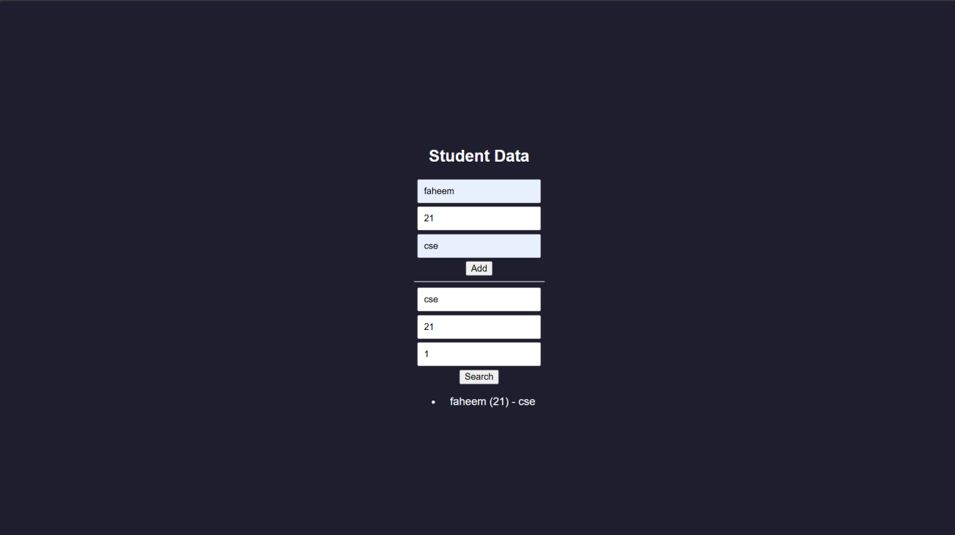

RESULT: The data access layer was successfully implemented with filtering, sorting, and pagination using Node.js and dynamic frontend interaction.

TASK12: Product Api
AIM: To design and develop a RESTful API for Product Management using Node.js that supports GET, POST, PUT, and DELETE operations with JSON responses.

ALGORITHM:
- Start the program
- Create project files (server.js, db.js, HTML, CSS, JS)
- Design product structure (id, name, price)
- Create Node.js server using Express
- Enable JSON parsing using middleware
- Implement POST method to add products
- Implement GET method to fetch all products
- Implement PUT method to update product details
- Implement DELETE method to remove a product
- Store product data in memory using db.js
- Send JSON responses for all API requests
- Test APIs using browser or REST client

PROGRAM: INDEX.HTML:
<!DOCTYPE html>
<html>
<head>
<title>Product API</title>
</head>
<body>
<h2>Product API Test</h2>
<input id="id" placeholder="ID">

<input id="name" placeholder="Name">
<input id="price" placeholder="Price">
<button onclick="add()">Add</button>
<button onclick="get()">Get All</button>
<ul id="list"></ul>
<script src="script.js"></script>
</body>
</html>

STYLE.CSS:
/* Reset */
* {
margin: 0;
padding: 0;
box-sizing: border-box;
}
/* Background */ body {
font-family: 'Segoe UI', sans-serif;
background: linear-gradient(135deg, #141e30, #243b55); height: 100vh;
display: flex;
justify-content: center; align-items: center; color: white;
}
/* Container */

.container {
background: rgba(255, 255, 255, 0.1); padding: 25px;
border-radius: 15px; backdrop-filter: blur(10px);

width: 350px; text-align: center;
box-shadow: 0 10px 25px rgba(0,0,0,0.4);
}
/* Heading */ h2 {
margin-bottom: 15px;
}
/* Inputs */ input {
width: 100%; padding: 10px; margin: 8px 0; border: none; border-radius: 8px; outline: none; transition: 0.3s;
}
/* Hover + focus effect */ input:hover,

input:focus {
transform: scale(1.05);
box-shadow: 0 0 8px #00f7ff;
}
/* Buttons */ button {
width: 100%; padding: 10px; margin-top: 8px; background: #00c6ff; border: none; border-radius: 10px; color: white;
font-weight: bold; cursor: pointer; transition: 0.3s;
}
/* Button hover */ button:hover {
background: #0072ff; transform: scale(1.05);
}
/* Product List */ ul {
list-style: none; margin-top: 15px;

}
/* List items */ li {
background: rgba(255,255,255,0.15); padding: 10px;
margin: 6px 0; border-radius: 8px; display: flex;
justify-content: space-between; align-items: center;
transition: 0.3s;
}
/* Hover effect */ li:hover {
background: rgba(255,255,255,0.3);
}
/* Optional delete button inside list */ li button {
width: auto; padding: 5px 8px; font-size: 12px; background: #ff4b5c;
}
li button:hover { background: #ff1e38;
}

SCRIPT.JS:
function add() { fetch("/products", {
method: "POST",
headers: {"Content-Type":"application/json"}, body: JSON.stringify(getData())
}).then(get);
}
function get() { fetch("/products")
.then(res => res.json())
.then(data => {
let list = document.getElementById("list"); list.innerHTML = "";
data.forEach(p => {
let li = document.createElement("li"); li.innerText = `${p.id} - ${p.name} - ₹${p.price}`; list.appendChild(li);
});
});
}
function getData() { return {
id: document.getElementById("id").value,
name: document.getElementById("name").value, price: document.getElementById("price").value

};
}

SERVER.JS:
const express = require("express"); const cors = require("cors");
const db = require("./db"); const app = express(); app.use(cors()); app.use(express.json());
// GET all products app.get("/products", (req, res) => {
res.json(db.getAll());
});
// POST add product app.post("/products", (req, res) => {
db.add(req.body);
res.json({ message: "Product added" });
});
// PUT update product app.put("/products/:id", (req, res) => {
db.update(req.params.id, req.body); res.json({ message: "Product updated" });
});
// DELETE product app.delete("/products/:id", (req, res) => {

db.remove(req.params.id);
res.json({ message: "Product deleted" });
});
// Server start app.listen(3000, () => {
console.log("• API running at http://localhost:3000/products");
});

DB.JS:
let products = []; function getAll() {
return products;
}
function add(p) { products.push(p);
}
function update(id, newData) { products = products.map(p =>
p.id == id ? { ...p, ...newData } : p
);
}
function remove(id) {
products = products.filter(p => p.id != id);
}
module.exports = { getAll, add, update, remove };

OUTPUT:
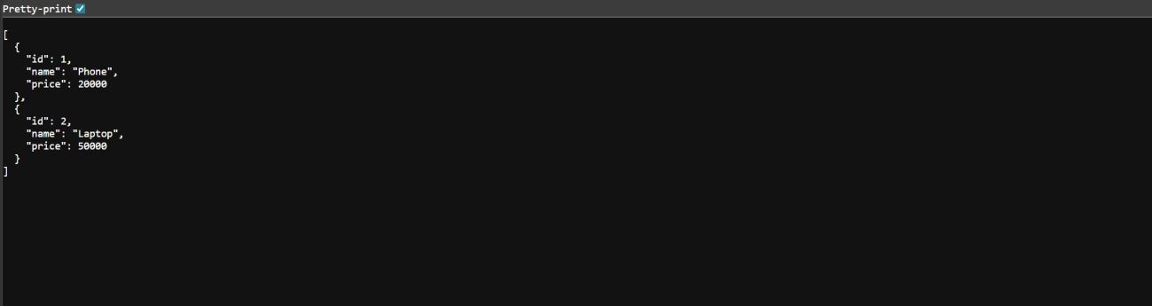

RESULT: The RESTful API for Product Management was successfully implemented with GET, POST, PUT, and DELETE methods returning JSON responses.

TASK13: PRODUCT-API
AIM: To design and develop a RESTful API for Product Management using Node.js that supports GET, POST, PUT, and DELETE operations with JSON responses.

ALGORITHM:
- Start the program
- Create project files (server.js, db.js, HTML, CSS, JS)
- Design product structure (id, name, price)
- Create Node.js server using Express
- Enable JSON parsing using middleware
- Implement POST method to add products
- Implement GET method to fetch all products
- Implement PUT method to update product details
- Implement DELETE method to remove a product
- Store product data in memory using db.js
- Send JSON responses for all API requests
- Test APIs using browser or REST client

PROGRAM: INDEX.HTML:
<!DOCTYPE html>
<html>
<head>
<title>Product API</title>
</head>
<body>
<h2>Product API Test</h2>
<input id="id" placeholder="ID">

<input id="name" placeholder="Name">
<input id="price" placeholder="Price">
<button onclick="add()">Add</button>
<button onclick="get()">Get All</button>
<ul id="list"></ul>
<script src="script.js"></script>
</body>
</html>

STYLE.CSS:
/* Reset */
* {
margin: 0;
padding: 0;
box-sizing: border-box;
}
/* Background */ body {
font-family: 'Segoe UI', sans-serif;
background: linear-gradient(135deg, #141e30, #243b55); height: 100vh;
display: flex;
justify-content: center; align-items: center; color: white;
}
/* Container */

.container {
background: rgba(255, 255, 255, 0.1); padding: 25px;
border-radius: 15px; backdrop-filter: blur(10px);

width: 350px; text-align: center;
box-shadow: 0 10px 25px rgba(0,0,0,0.4);
}
/* Heading */ h2 {
margin-bottom: 15px;
}
/* Inputs */ input {
width: 100%; padding: 10px; margin: 8px 0; border: none; border-radius: 8px; outline: none; transition: 0.3s;
}
/* Hover + focus effect */ input:hover,

input:focus {
transform: scale(1.05);
box-shadow: 0 0 8px #00f7ff;
}
/* Buttons */ button {
width: 100%; padding: 10px; margin-top: 8px; background: #00c6ff; border: none; border-radius: 10px; color: white;
font-weight: bold; cursor: pointer; transition: 0.3s;
}
/* Button hover */ button:hover {
background: #0072ff; transform: scale(1.05);
}
/* Product List */ ul {
list-style: none; margin-top: 15px;

}
/* List items */ li {
background: rgba(255,255,255,0.15); padding: 10px;
margin: 6px 0; border-radius: 8px; display: flex;
justify-content: space-between; align-items: center;
transition: 0.3s;
}
/* Hover effect */ li:hover {
background: rgba(255,255,255,0.3);
}
/* Optional delete button inside list */ li button {
width: auto; padding: 5px 8px; font-size: 12px; background: #ff4b5c;
}
li button:hover { background: #ff1e38;
}

SCRIPT.JS:
function add() { fetch("/products", {
method: "POST",
headers: {"Content-Type":"application/json"}, body: JSON.stringify(getData())
}).then(get);
}
function get() { fetch("/products")
.then(res => res.json())
.then(data => {
let list = document.getElementById("list"); list.innerHTML = "";
data.forEach(p => {
let li = document.createElement("li"); li.innerText = `${p.id} - ${p.name} - ₹${p.price}`; list.appendChild(li);
});
});
}
function getData() { return {
id: document.getElementById("id").value,
name: document.getElementById("name").value, price: document.getElementById("price").value

};
}

SERVER.JS:
const express = require("express"); const cors = require("cors");
const db = require("./db"); const app = express(); app.use(cors()); app.use(express.json());
// GET all products app.get("/products", (req, res) => {
res.json(db.getAll());
});
// POST add product app.post("/products", (req, res) => {
db.add(req.body);
res.json({ message: "Product added" });
});
// PUT update product app.put("/products/:id", (req, res) => {
db.update(req.params.id, req.body); res.json({ message: "Product updated" });
});
// DELETE product app.delete("/products/:id", (req, res) => {

db.remove(req.params.id);
res.json({ message: "Product deleted" });
});
// Server start app.listen(3000, () => {
console.log("• API running at http://localhost:3000/products");
});

DB.JS:
let products = []; function getAll() {
return products;
}
function add(p) { products.push(p);
}
function update(id, newData) { products = products.map(p =>
p.id == id ? { ...p, ...newData } : p
);
}
function remove(id) {
products = products.filter(p => p.id != id);
}
module.exports = { getAll, add, update, remove };

OUTPUT:
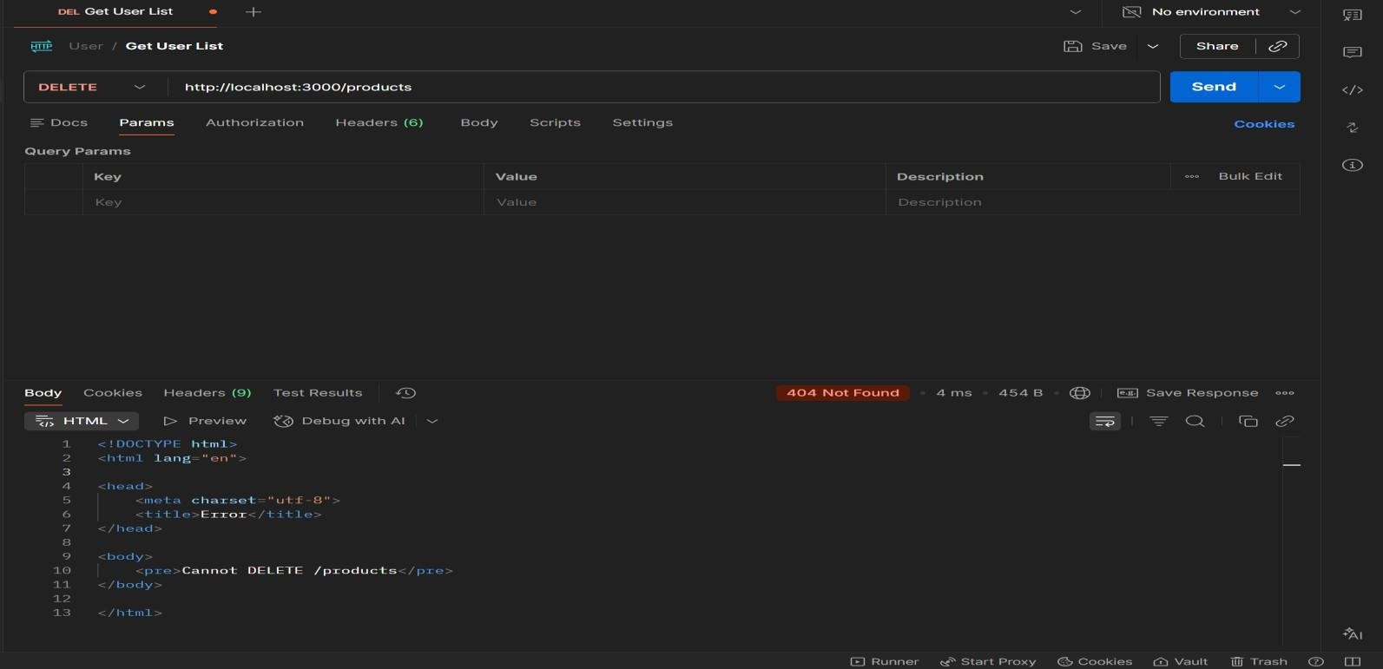

RESULT: The RESTful API for Product Management was successfully implemented with GET, POST, PUT, and DELETE methods returning JSON responses.

TASK14: MICROSERVICES APP
AIM: To design a simple microservices-based system by splitting a monolithic application into independent services with loose coupling and single responsibility.

ALGORITHM:
- Start the program
- Identify modules in monolithic system
- Split system into independent services
- Create separate folders for each service
- Implement Service 1 (Product Service)
- Implement Service 2 (Order Service)
- Use separate databases (db.js) for each service
- Assign different ports for each service
- Enable communication via REST APIs
- Keep services loosely coupled
- Deploy and run services independently
- Access services and verify functionality

PROGRAM:
INDEX.HTML:
<!DOCTYPE html>
<html>
<head>
<title>Microservices App</title>
<link rel="stylesheet" href="style.css">
</head>
<body>
<div class="container">

<h2>Microservices Demo</h2>
<input id="pname" placeholder="Product Name">
<button onclick="addProduct()">Add Product</button>
<input id="order" placeholder="Order Item">
<button onclick="addOrder()">Place Order</button>
</div>
<script src="script.js"></script>
</body>
</html>

STYLE.CSS:
body {
font-family: Arial; background: #1e1e2f; color: white; display:flex;
justify-content:center; align-items:center; height:100vh;
}
.container {
text-align:center;
}
input {
margin: 5px; padding: 8px;
}

button { padding: 8px; margin: 5px;
background: #00c6ff; border: none;
}

SCRIPT.JS:
function addProduct() { fetch("http://localhost:3001/products", {
method: "POST",
headers: { "Content-Type": "application/json" }, body: JSON.stringify({ name: val("pname") })
});
}
function addOrder() { fetch("http://localhost:3002/orders", {
method: "POST",
headers: { "Content-Type": "application/json" }, body: JSON.stringify({ item: val("order") })
});
}
function val(id) {
return document.getElementById(id).value;
}

SERVER.JS:
const express = require("express");

const cors = require("cors"); const db = require("./db"); const app = express(); app.use(cors()); app.use(express.json());
// GET products app.get("/products", (req, res) => {
res.json(db.getAll());
});
// ADD product app.post("/products", (req, res) => {
db.add(req.body);
res.json({ msg: "Product added" });
});
app.listen(3001, () => {
console.log("Product Service running at http://localhost:3001");
});

DB.JS:
let products = []; function add(p) {
products.push(p);
}
function getAll() { return products;
}
module.exports = { add, getAll };

OUTPUT:
- GET : http://localhost:3001/products
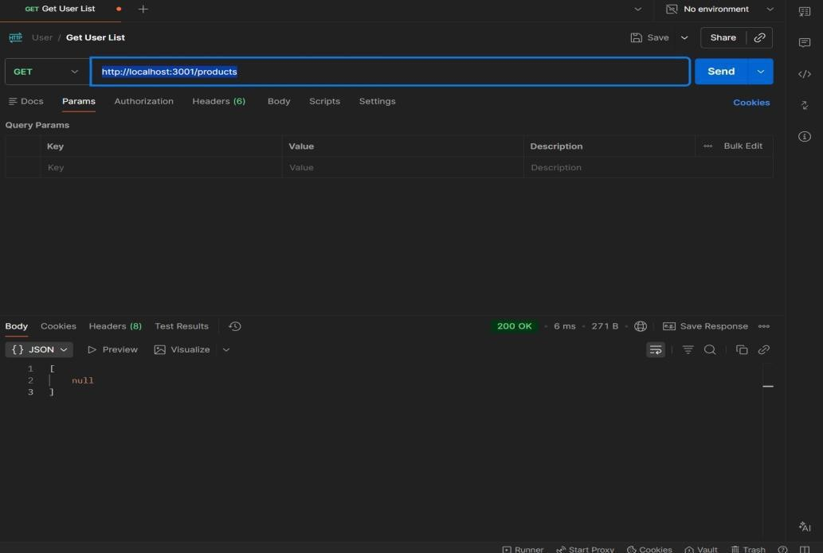
- POST: http://localhost:3001/products
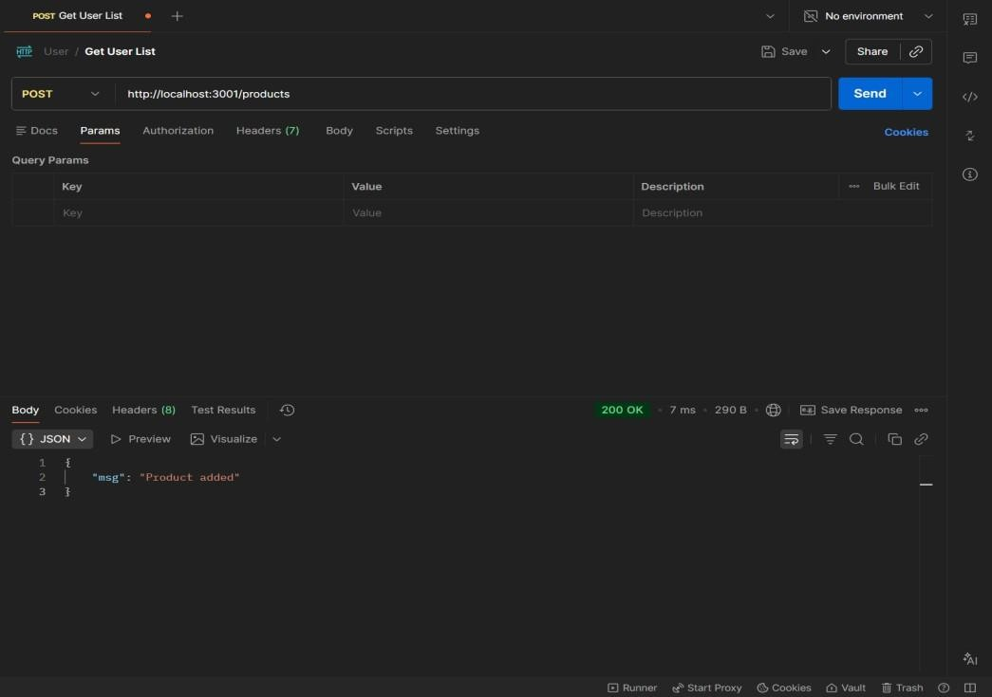
RESULTS: The application was successfully divided into independent microservices with separate responsibilities and communication via REST APIs

TASK15: Service Registry App

Aim: To implement service registry and discovery using Node.js by dynamically registering and discovering microservices without hard-coded URLs.

ALGORITHM:
- Start the program
- Create a registry server
- Store service name and URL in memory
- Start Product Service
- Register Product Service to registry
- Start Order Service
- Register Order Service to registry
- Maintain service list in registry
- Client requests service from registry
- Fetch service URL dynamically
- Call the discovered service API
- Stop the program

PROGRAM:
SERVER.JS:
const express = require("express"); const app = express(); app.use(express.json());
let services = {}; app.post("/register", (req, res) => {
const { name, url } = req.body; services[name] = url;

console.log(`${name} registered at ${url}`); res.json({ msg: "Registered" });
});
app.get("/service/:name", (req, res) => { const service = services[req.params.name]; if (!service) {
return res.status(404).json({ error: "Service not found" }) res.json({ url: service });
});
app.listen(4000, () => {
console.log("Registry running at http://localhost:4000");
});

OUTPUT

RESULT: The microservices-based system was successfully implemented with service registry and discovery, enabling dynamic communication between independent services without hard- coded URLs.

TASK16: API GATEWAY API

AIM: To configure an API Gateway that routes client requests to microservices and performs basic load balancing across multiple service instances.

ALGORITHM:
- Start the program
- Create API Gateway server
- Define routes for microservices
- Create multiple instances of a service
- Store service URLs in an array
- Implement round-robin load balancing
- Receive client request at gateway
- Select service instance dynamically
- Forward request to selected instance
- Get response from service
- Send response back to client
- Stop the program

PROGRAM:
SERVER.JS:
const express = require("express"); const axios = require("axios"); const app = express();
const services = [ "http://localhost:3001", "http://localhost:3002"
];

let index = 0;
app.get("/products", async (req, res) => { try {
const service = services[index]; index = (index + 1) % services.length;
const response = await axios.get(service + "/products"); res.json(response.data);

} catch (err) {
res.status(500).json({ error: "Service unavailable" });
}
});
app.listen(5000, () => {
console.log("API Gateway → http://localhost:5000/products");
});

OUTPUT:
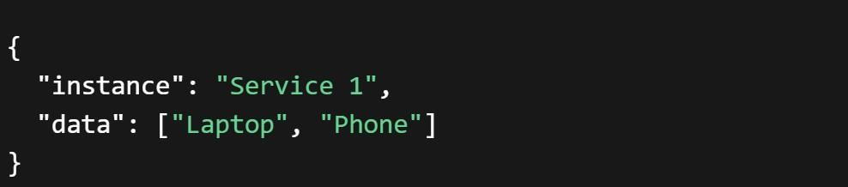
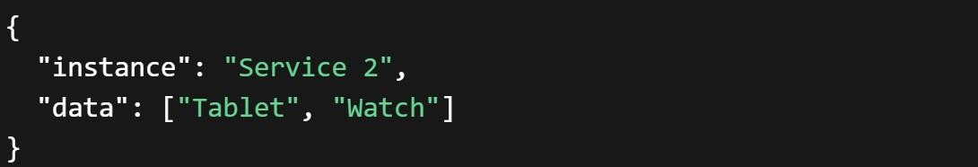

RESULT: The API Gateway was successfully implemented to route requests and distribute load across multiple service instances using round-robin load balancing.

TASK17: Inter Service App
AIM: To enable inter-service communication where one microservice consumes another service’s REST API and handles responses and failures gracefully.

ALGORITHM:
- Start the program
- Create Product Service (provider)
- Create Order Service (consumer)
- Implement REST API in Product Service
- Store product data in memory
- Implement Order Service API
- Use axios/fetch to call Product Service
- Receive response from Product Service
- Process and store order data
- Handle errors using try-catch
- Send proper success/error response
- Stop the program

FOLDER STRUCTURE:
inter-service-app/
│
├── product-service/
│ └── server.js
│
├── order-service/
│ └── server.js

PROGRAM:
PRODUCT-SERVICE:SERVER.JS:
const express = require("express"); const app = express();
let products = [
{ id: 1, name: "Laptop" },
{ id: 2, name: "Phone" }
];
app.get("/products", (req, res) => { res.json(products);
});
app.listen(3001, () => {
console.log("Product Service → http://localhost:3001/products");
});

ORDER-SERVICE:SERVER.JS:
const express = require("express"); const axios = require("axios"); const app = express(); app.use(express.json());
let orders = [];
app.post("/orders", async (req, res) => { try {
const response = await axios.get("http://localhost:3001/products"); const products = response.data;
const order = { id: Date.now(),

products: products
};
orders.push(order); res.json({
message: "Order created successfully", order: order
});
} catch (error) { res.status(500).json({
error: "Failed to fetch products from Product Service"
});
}
});
app.get("/orders", (req, res) => { res.json(orders);
});
app.listen(3002, () => {
console.log("Order Service → http://localhost:3002/orders");
});

OUTPUT:
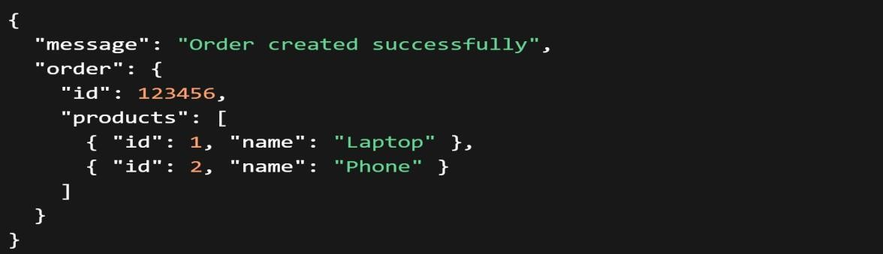

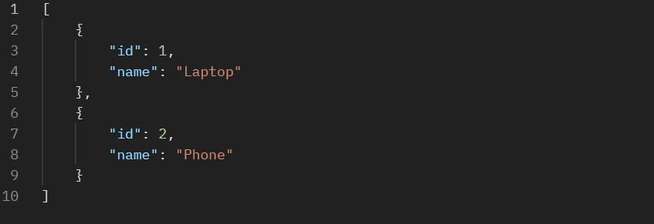

RESULT: Inter-service communication was successfully implemented using REST APIs, with proper handling of responses and failures between microservices.

TASK18: Microservice Test
AIM: To write unit test cases for microservices to validate service logic, REST APIs, and data handling using a testing framework.

ALGORITHM:
- Start the program
- Install testing framework (Jest, Supertest)
- Configure test script in package.json
- Create test folder/files
- Import service modules
- Write test cases for service logic
- Write test cases for REST APIs
- Mock external dependencies if needed
- Execute test cases using Jest
- Verify expected outputs
- Handle edge cases and errors
- Stop the program

PROGRAM:

app.js:
const express = require("express"); const app = express(); app.use(express.json());
let products = [];
// API
app.get("/products", (req, res) => { res.json(products);
});

app.post("/products", (req, res) => { products.push(req.body); res.json({ msg: "Product added" });
});
module.exports = app;

SERVER.JS:
const app = require("./app"); app.listen(3001, () => {
console.log("Product Service running");
});

Product.Test.js:
const request = require("supertest");
const app = require("../product-service/app"); describe("Product API Tests", () => {
test("GET /products should return empty array", async () => { const res = await request(app).get("/products"); expect(res.statusCode).toBe(200); expect(res.body).toEqual([]);
});
test("POST /products should add product", async () => { const res = await request(app)
.post("/products")
.send({ name: "Laptop" }); expect(res.statusCode).toBe(200); expect(res.body.msg).toBe("Product added");
});
test("GET /products should return data", async () => {

const res = await request(app).get("/products"); expect(res.body.length).toBeGreaterThan(0);
});
});

OUTPUT:
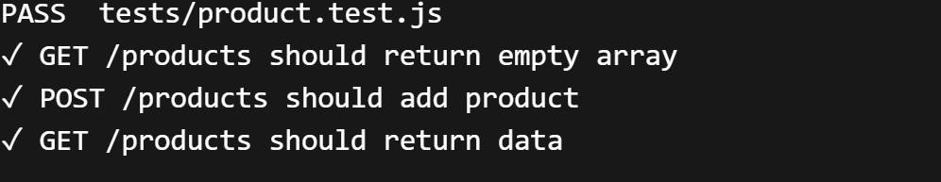
RESULT: Unit test cases were successfully implemented to validate microservice logic, REST APIs, and data handling, ensuring application reliability.

TASK19: Mini Git System
AIM: To design a simple Git-like web application that tracks file changes, stores versions, and displays commit history using HTML, CSS, JavaScript, and Node.js.

ALGORITHM:
- Start the program
- Create project files (HTML, CSS, JS, server.js, db.js)
- Design UI for entering file content
- Capture user input using JavaScript
- Send data to server using fetch API
- Store versions in database (array)
- Assign version number to each commit
- Save commit message and timestamp
- Create API to fetch commit history
- Display commit history in UI
- Allow viewing previous versions
- Stop the program

PROGRAM:
INDEX.HTML:
<!DOCTYPE html>
<html>
<head>
<title>Mini Git System</title>
<link rel="stylesheet" href="style.css">
</head>
<body>
<div class="container">

<h2>Mini Git System</h2>
<textarea id="content" placeholder="Write your code..."></textarea>
<input id="message" placeholder="Commit message">
<button onclick="commit()">Commit</button>
<h3>Commit History</h3>
<ul id="history"></ul>
</div>
<script src="script.js"></script>
</body>
</html>

STYLE.CSS:
body {
font-family: Arial; background: #1e1e2f; color: white; display:flex;
justify-content:center; align-items:center; height:100vh;
}
.container { width: 400px;
text-align: center;
}
textarea { width: 100%;

height: 80px; margin: 5px;
}
input, button { margin: 5px; padding: 8px;
}
li {
background: #333; margin: 5px; padding: 5px;
}

SCRIPT.JS:
function commit() {
const content = document.getElementById("content").value; const message = document.getElementById("message").value; fetch("/commit", {
method: "POST",
headers: {"Content-Type":"application/json"}, body: JSON.stringify({ content, message })
}).then(loadHistory);
}
function loadHistory() { fetch("/history")
.then(res => res.json())
.then(data => {

let list = document.getElementById("history"); list.innerHTML = "";
data.forEach(c => {
let li = document.createElement("li"); li.innerText = `v${c.version}: ${c.message}`; list.appendChild(li);
});
});
}
loadHistory();

SERVER.JS:
const express = require("express"); const db = require("./db");
const app = express(); app.use(express.json()); app.use(express.static( dirname));
app.post("/commit", (req, res) => { db.save(req.body);
res.json({ msg: "Committed" });
});
app.get("/history", (req, res) => { res.json(db.getAll());
});
app.listen(3000, () => { console.log("http://localhost:3000");
});

DB.JS:
let commits = []; let version = 1;
function save(data) { commits.push({
version: version++, message: data.message, content: data.content, time: new Date()
});
}
function getAll() { return commits;
}
module.exports = { save, getAll };

OUTPUT:
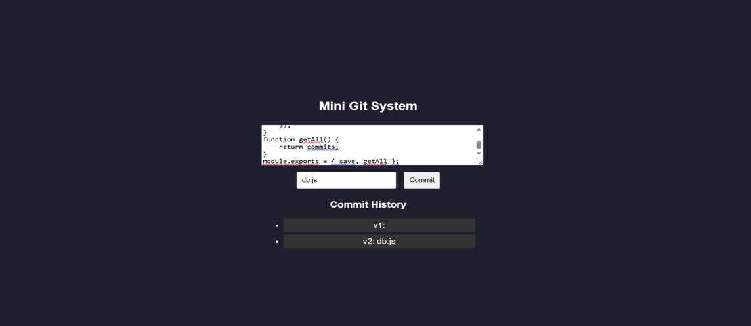
RESULT: A mini Git-like system was successfully developed to track versions, store commits, and display history through a web interface.

TASK20: Mini Git Branch App
Aim: To develop a Git-like application that supports branching, merging, rebasing, and conflict resolution using a web interface.

ALGORITHM:
- Start the program
- Create project files (HTML, CSS, JS, server.js, db.js)
- Store branches and commits in memory
- Create default branch (main)
- Add feature to create new branch
- Commit changes to selected branch
- Implement merge logic
- Detect conflicts (same file modified)
- Show conflict message
- Resolve conflicts manually
- Implement rebase logic
- Display branch history and stop

PROGRAM:
INDEX.HTML:
<!DOCTYPE html>
<html>
<head>
<title>Mini Git Branching</title>
<link rel="stylesheet" href="style.css">
</head>
<body>
<div class="container">

<h2>Mini Git Branching</h2>
<input id="branchName" placeholder="New Branch Name">
<button onclick="createBranch()">Create Branch</button>
<input id="message" placeholder="Commit Message">
<button onclick="commit()">Commit</button>
<button onclick="merge()">Merge</button>
<button onclick="rebase()">Rebase</button>
<h3>Branches</h3>
<ul id="branches"></ul>
<h3>History</h3>
<ul id="history"></ul>
</div>
<script src="script.js"></script>
</body>
</html>

STYLE.CSS:
body {
font-family: Arial; background: #1e1e2f; color: white; display:flex;
justify-content:center; align-items:center; height:100vh;
}
.container {

text-align:center;
}
input, button { margin: 5px; padding: 8px;
}
li {
background: #333; margin: 5px; padding: 5px;
}

SCRIPT.JS:
function createBranch() {
const name = document.getElementById("branchName").value; fetch("/branch", {
method: "POST",
headers: {"Content-Type":"application/json"}, body: JSON.stringify({ name })
}).then(load);
}
function commit() {
const message = document.getElementById("message").value; fetch("/commit", {
method: "POST",
headers: {"Content-Type":"application/json"}, body: JSON.stringify({ message })

}).then(load);
}
function merge() {
fetch("/merge", { method: "POST" })
.then(res => res.json())
.then(alert)
.then(load);
}
function rebase() {
fetch("/rebase", { method: "POST" })
.then(load);
}
function load() { fetch("/data")
.then(res => res.json())
.then(data => {
let b = document.getElementById("branches"); let h = document.getElementById("history"); b.innerHTML = "";
h.innerHTML = ""; data.branches.forEach(br => {
let li = document.createElement("li"); li.innerText = br;
b.appendChild(li);
});
data.history.forEach(c => {

let li = document.createElement("li"); li.innerText = c;
h.appendChild(li);
});
});
}
load();

SERVER.JS:
const express = require("express"); const db = require("./db");
const app = express(); app.use(express.json()); app.use(express.static( dirname));
app.post("/branch", (req, res) => { db.createBranch(req.body.name); res.json({ msg: "Branch created" });
});
app.post("/commit", (req, res) => { db.commit(req.body.message); res.json({ msg: "Committed" });
});
app.post("/merge", (req, res) => { const result = db.merge(); res.json({ msg: result });
});
app.post("/rebase", (req, res) => {

db.rebase();
res.json({ msg: "Rebased" });
});
app.get("/data", (req, res) => {
res.json(db.getData());
});
app.listen(3000, () => console.log("http://localhost:3000"));

DB.JS:
let branches = ["main"]; let current = "main"; let commits = {
main: []
};
function createBranch(name) { branches.push(name);
commits[name] = [...commits[current]];
}
function commit(msg) { commits[current].push(msg);
}
function merge() {
let mainCommits = commits["main"];
let featureCommits = commits[current];
if (mainCommits.length && featureCommits.length) { return "Merge Conflict Detected!";
}

commits["main"] = [...mainCommits, ...featureCommits]; return "Merged Successfully";
}
function rebase() {
commits[current] = [...commits["main"], ...commits[current]];
}
function getData() { return {
branches,
history: commits[current]
};
}
module.exports = { createBranch, commit, merge, rebase, getData };

OUTPUT:
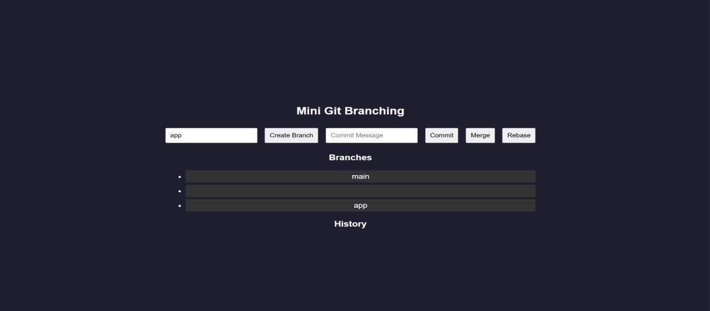

RESULT: A Git-like branching application was successfully developed to simulate branching, merging, rebasing, and conflict resolution through a web interface.

TASK21: Mini Cicd App
AIM: To develop a CI/CD pipeline simulation application that automates build, test, and deployment steps through a web interface.

ALGORITHM:
- Start the program
- Create project files (HTML, CSS, JS, server.js, db.js)
- Design UI for pipeline trigger
- Capture user action (Run Pipeline)
- Send request to backend
- Simulate code checkout step
- Simulate build process
- Simulate test execution
- Simulate deployment step
- Store pipeline logs
- Display pipeline status in UI
- Stop the program

PROGRAM:
INDEX.HTML:
<!DOCTYPE html>
<html>
<head>
<title>Mini CI/CD Pipeline</title>
<link rel="stylesheet" href="style.css">
</head>
<body>
<div class="container">

<h2>CI/CD Pipeline Simulator</h2>
<button onclick="runPipeline()">Run Pipeline</button>
<h3>Pipeline Logs</h3>
<ul id="logs"></ul>
</div>
<script src="script.js"></script>
</body>
</html>

STYLE.CSS:
body {
font-family: Arial; background: #1e1e2f; color: white; display:flex;
justify-content:center; align-items:center; height:100vh;
}
.container {
text-align:center; width: 400px;
}
button { padding: 10px; margin: 10px;
background: #00c6ff;

border: none; color: white; cursor: pointer;
}
li {
background: #333; margin: 5px; padding: 5px;
}

SCRIPT.JS:
function runPipeline() { fetch("/run", { method: "POST" })
.then(() => loadLogs());
}
function loadLogs() { fetch("/logs")
.then(res => res.json())
.then(data => {
let list = document.getElementById("logs"); list.innerHTML = "";
data.forEach(log => {
let li = document.createElement("li"); li.innerText = log;
list.appendChild(li);
});
});

}
loadLogs();

SERVER.JS:
const express = require("express"); const db = require("./db");
const app = express(); app.use(express.json()); app.use(express.static( dirname));
app.post("/run", async (req, res) => { await db.runPipeline();
res.json({ msg: "Pipeline executed" });
});
app.get("/logs", (req, res) => {
res.json(db.getLogs());
});
app.listen(3000, () => { console.log("http://localhost:3000");
});

DB.JS:
let logs = [];
async function runPipeline() { logs = [];
logs.push(" Code Checkout..."); await delay();
logs.push(" Build Started..."); await delay();

logs.push(" Running Tests..."); await delay();
logs.push(" Tests Passed"); await delay();
logs.push("• Deploying Application..."); await delay();
logs.push(" Deployment Successful!");
}
function getLogs() { return logs;
}
function delay() {
return new Promise(resolve => setTimeout(resolve, 1000));
}
module.exports = { runPipeline, getLogs };

OUTPUT:
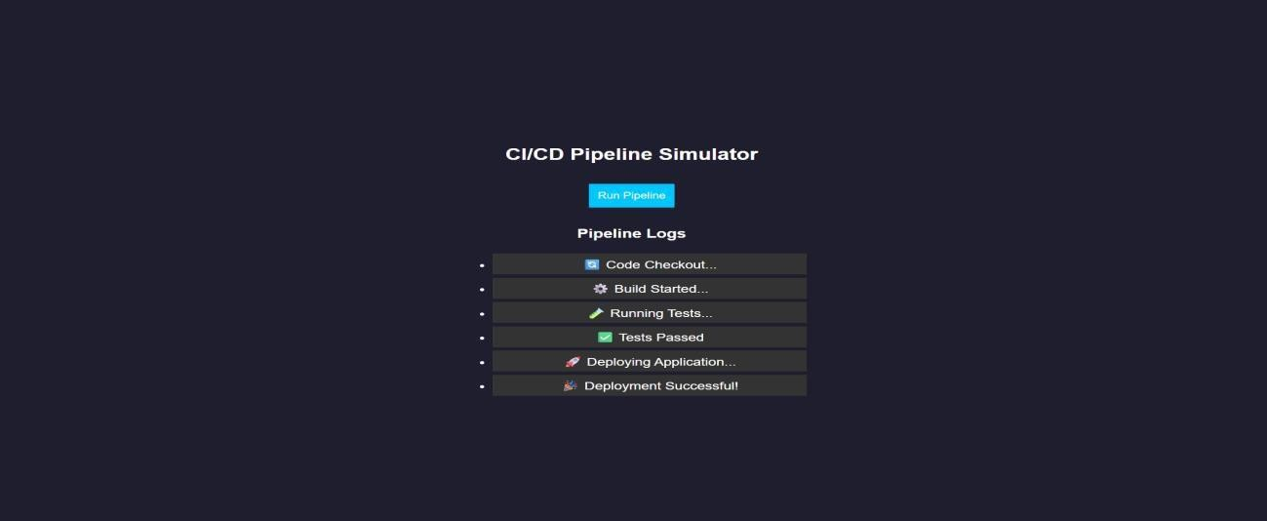
RESULT: A CI/CD pipeline simulation application was successfully developed to automate and visualize build, test, and deployment processes.

TASK22: Cloud App
AIM: To develop a cloud comparison application that displays and compares services and pricing models of AWS, GCP, and Azure

ALGORITHM:
- Start the program
- Create project files (HTML, CSS, JS, server.js, db.js)
- Design user interface with dropdown for cloud providers
- Initialize cloud service data (AWS, GCP, Azure) in database module
- Capture selected provider using JavaScript
- Send request to server to fetch service details
- Display compute, storage, database, and networking services
- Accept user input for compute hours and storage usage
- Send input data to server for cost calculation
- Calculate cost based on pay-as-you-use pricing model
- Display total cost dynamically on UI
- Stop the program

PROGRAM:
INDEX.HTML:
<!DOCTYPE html>
<html>
<head>
<title>Cloud Comparison</title>
<link rel="stylesheet" href="style.css">
</head>
<body>
<div class="container">

<h2>Cloud Service Comparison</h2>
<select id="provider" onchange="loadData()">
<option value="aws">AWS</option>
<option value="gcp">GCP</option>
<option value="azure">Azure</option>
</select>
<h3>Services</h3>
<ul id="services"></ul>
<h3>Pricing Calculator</h3>
<input id="hours" placeholder="Compute Hours">
<input id="storage" placeholder="Storage (GB)">
<button onclick="calculate()">Calculate Cost</button>
<h3 id="result"></h3>
</div>
<script src="script.js"></script>
</body>
</html>

STYLE.CSS:
body {
font-family: Arial; background: #1e1e2f; color: white; display:flex;
justify-content:center; align-items:center; height:100vh;

}
.container {
text-align:center; width: 350px;
}
input, select, button { margin: 5px; padding: 8px;
}
li {
background: #333; margin: 5px; padding: 5px;
}

SCRIPT.JS:
function loadData() {
const provider = document.getElementById("provider").value; fetch(`/services/${provider}`)
.then(res => res.json())
.then(data => {
let list = document.getElementById("services"); list.innerHTML = ""; Object.entries(data).forEach(([key, value]) => {
let li = document.createElement("li"); li.innerText = `${key}: ${value}`; list.appendChild(li);

});
});
}
function calculate() {
const provider = document.getElementById("provider").value; const hours = document.getElementById("hours").value; const storage = document.getElementById("storage").value; fetch("/cost", {
method: "POST",
headers: {"Content-Type":"application/json"}, body: JSON.stringify({ provider, hours, storage })
})
.then(res => res.json())
.then(data => {
document.getElementById("result").innerText = "Cost: $" + data.cost;
});
}
loadData();

SERVER.JS:
const express = require("express"); const db = require("./db");
const app = express(); app.use(express.json()); app.use(express.static( dirname));
app.get("/services/:provider", (req, res) => { res.json(db.getServices(req.params.provider));

});
app.post("/cost", (req, res) => {
const { provider, hours, storage } = req.body;
const cost = db.calculate(provider, hours, storage); res.json({ cost });
});
app.listen(3000, () => { console.log("http://localhost:3000");
});

DB.JS:
const services = { aws: {
Compute: "EC2", Storage: "S3", Database: "RDS", Network: "VPC"
},
gcp: {
Compute: "Compute Engine", Storage: "Cloud Storage", Database: "Cloud SQL", Network: "VPC"
},
azure: {
Compute: "Virtual Machines", Storage: "Blob Storage",

Database: "SQL Database", Network: "VNet"
}
};
const pricing = {
aws: { compute: 0.1, storage: 0.02 }, gcp: { compute: 0.09, storage: 0.025 }, azure: { compute: 0.11, storage: 0.018 }
};
function getServices(provider) { return services[provider];
}
function calculate(provider, hours, storage) { const p = pricing[provider];
return (hours * p.compute + storage * p.storage).toFixed(2);
}
module.exports = { getServices, calculate };

OUTPUT:
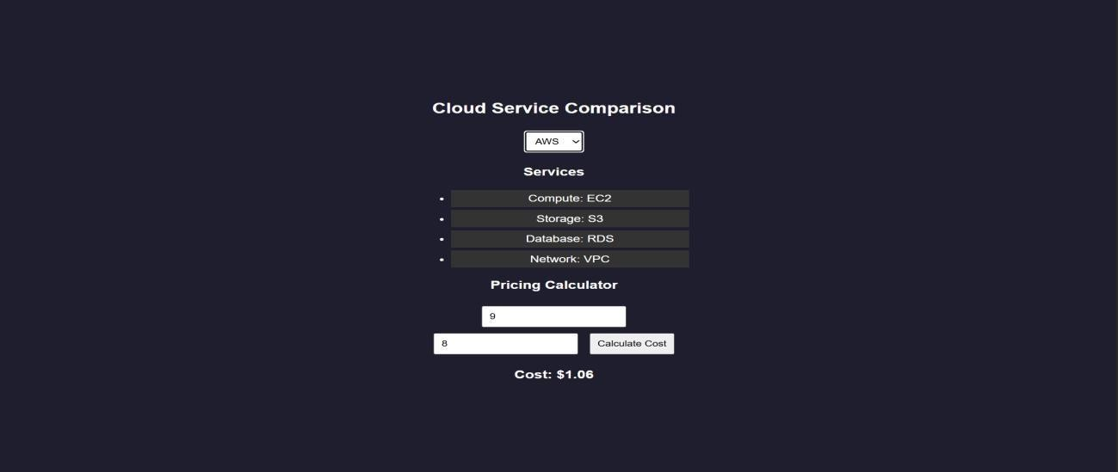

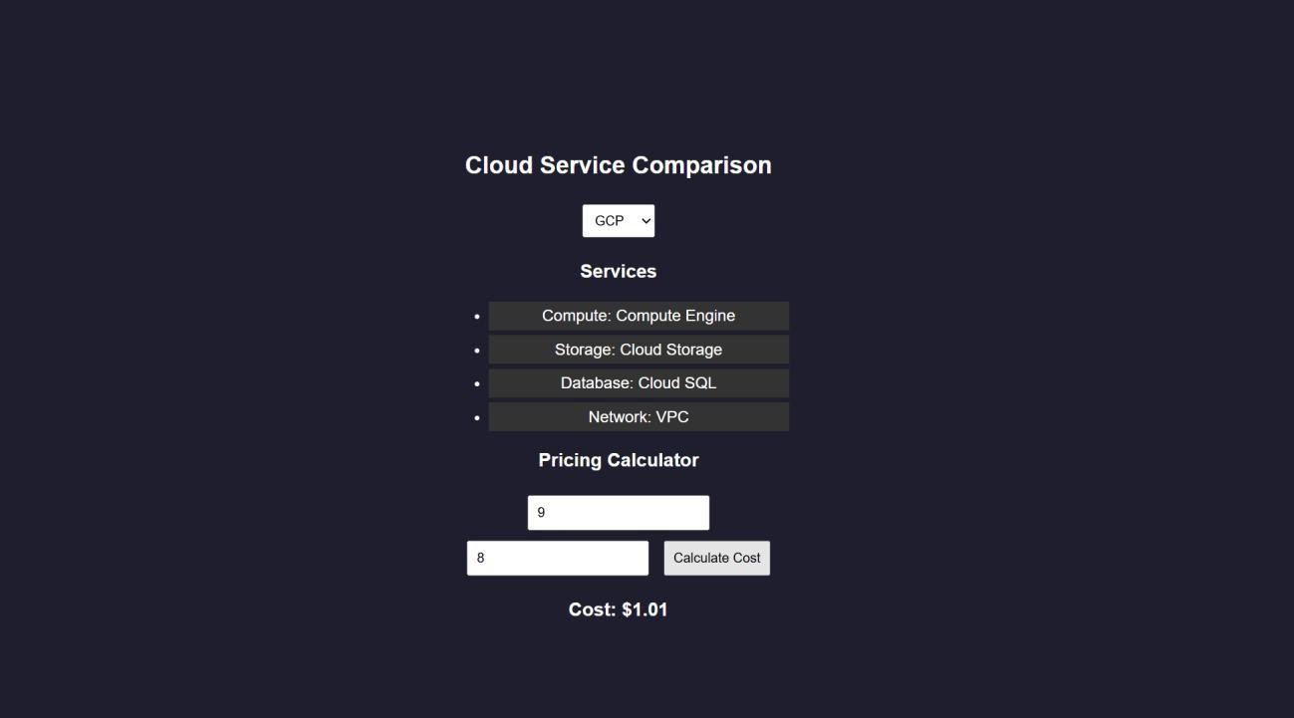
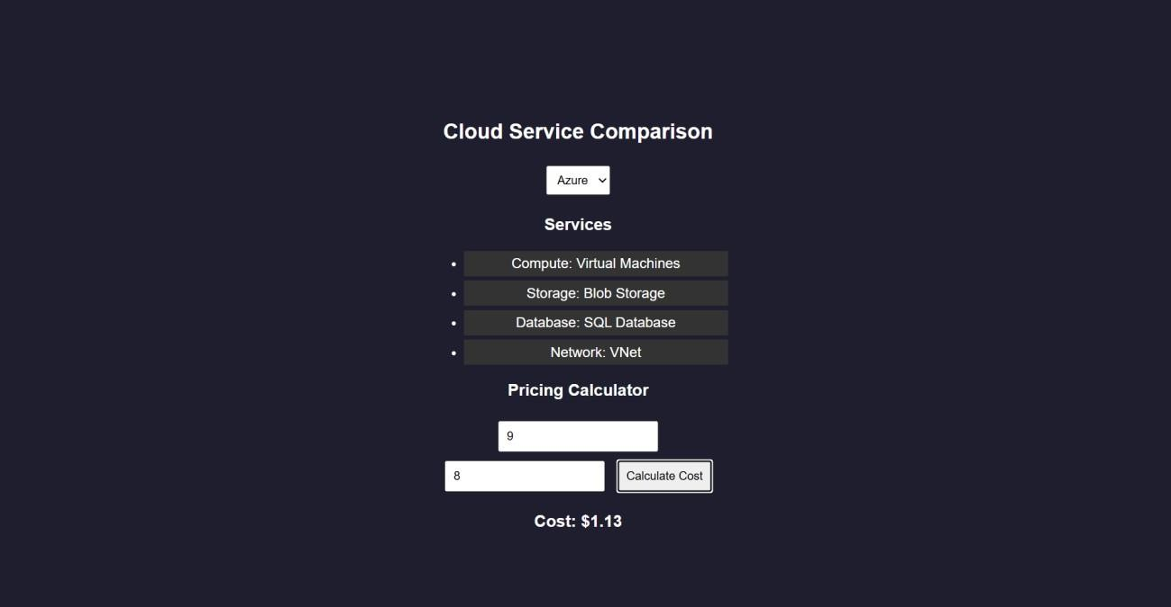
RESULTS: A cloud comparison application was successfully developed to display services and simulate pay-as-you-use pricing across AWS, GCP, and Azure.

TASK23: AI PROMPT APP

AIM: To develop an application that demonstrates prompt engineering by generating and evaluating code or cloud configurations based on user input.

ALGORITHM:
- Start the program
- Create project files (HTML, CSS, JS, server.js, db.js)
- Design UI with input field for user prompt
- Capture user prompt using JavaScript
- Send prompt to server using fetch API
- Receive prompt data in backend (server.js)
- Process prompt using predefined logic (db.js)
- Generate output (code / cloud config / response)
- Evaluate output quality and assign score
- Send generated output and score to frontend
- Display output and score on UI
- Stop the program

PROGRAM:
INDEX.HTML:
<!DOCTYPE html>
<html>
<head>
<title>AI Prompt App</title>
<link rel="stylesheet" href="style.css">
</head>
<body>

<div class="container">
<h2>Prompt Engineering Tool</h2>
<textarea id="prompt" placeholder="Enter your prompt..."></textarea>
<button onclick="generate()">Generate Output</button>
<h3>Generated Output</h3>
<pre id="output"></pre>
<h3>Quality Score</h3>
<p id="score"></p>
</div>
<script src="script.js"></script>
</body>
</html>

STYLE.CSS:
body {
font-family: Arial; background: #202038; color: white; display:flex;
justify-content:center; align-items:center; height:100vh;
}
.container { width: 400px;
text-align: center;
}

textarea { width: 100%; height: 100px; margin: 5px;
}
button { padding: 10px; margin: 10px;
background: #00c6ff; border: none;
color: white;
}
pre {
background: #333; padding: 10px;
}

SCRIPT.JS:
function generate() {
const prompt = document.getElementById("prompt").value; fetch("/generate", {
method: "POST",
headers: {"Content-Type":"application/json"}, body: JSON.stringify({ prompt })
})
.then(res => res.json())
.then(data => {

document.getElementById("output").innerText = data.output; document.getElementById("score").innerText = data.score + "/10";
});
}

SERVER.JS:
const express = require("express"); const db = require("./db");

const app = express();

// Middleware app.use(express.json());
app.use(express.static( dirname)); // serve HTML

// Home route (optional but useful) app.get("/", (req, res) => {
res.sendFile( dirname + "/index.html");
});
// Generate output app.post("/generate", (req, res) => {
const result = db.processPrompt(req.body.prompt); res.json(result);
});
// START SERVER WITH LINK
app.listen(3000, () => {
console.log("• Server running at:");

console.log(" http://localhost:3000");
});

DB.JS:
function processPrompt(prompt) { let output = "";
let score = 5;
if (prompt.toLowerCase().includes("code")) { output = `function greet() {
console.log("Hello from AI!");
}`;
score = 9;
}
else if (prompt.toLowerCase().includes("cloud")) { output = `AWS EC2 Config:
- Instance: t2.micro
- Region: us-east-1`; score = 8;
}
else {
output = "Basic AI response generated."; score = 5;
}

return { output, score };
}
module.exports = { processPrompt };

OUTPUT:
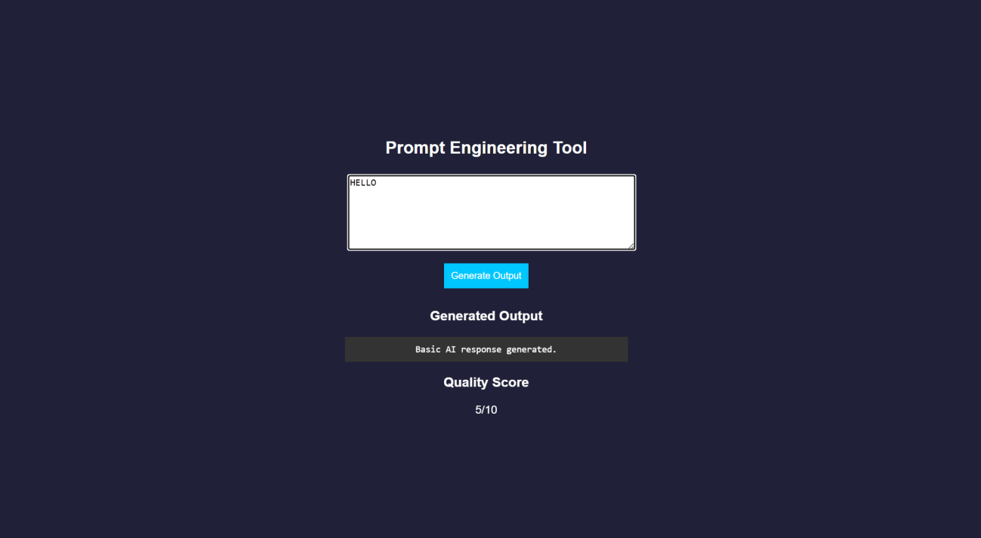
RESULT: A prompt engineering application was successfully developed to generate and evaluate AI-based outputs for code and cloud configurations.

TASK24: Vibe Cloud App
AIM: To develop an application that uses iterative prompt engineering to generate and evaluate REST APIs, cloud deployment steps, and security configurations.

ALGORITHM:
- Start the program
- Create project files (HTML, CSS, JS, server.js, db.js)
- Design UI to accept user prompts
- Capture prompt input using JavaScript
- Send prompt to backend using fetch API
- Receive prompt in server and forward to processing module
- Store prompt in history for version tracking
- Analyze prompt type (REST API / Cloud / Security)
- Generate corresponding output based on prompt
- Evaluate output quality and assign score
- Return output and score to frontend and display results
- Stop the program

PROGRAM:
INDEX.HTML:
<!DOCTYPE html>
<html>
<head>
<title>Vibe Coding App</title>
<link rel="stylesheet" href="style.css">
</head>
<body>
<div class="container">
<h2>Vibe Coding Cloud Generator</h2>

<textarea id="prompt" placeholder="Enter prompt..."></textarea>
<button onclick="generate()">Generate</button>
<h3>Output</h3>
<pre id="output"></pre>
<h3>Score</h3>
<p id="score"></p>
<h3>Prompt Versions</h3>
<ul id="history"></ul>
</div>
<script src="script.js"></script>
</body>
</html>

STYLE.CSS:
body {
font-family: Arial; background: #b98bdb; color: white; display:flex;
justify-content:center; align-items:center; height:100vh;
}
.container { width: 400px;
text-align: center;
}

textarea { width: 100%; height: 100px;
}
button { padding: 10px; margin: 10px;
background: #00c6ff; border: none;
}
pre {
background: #333; padding: 10px;
}
li {
background: #444; margin: 5px; padding: 5px;
}

SCRIPT.JS:
function generate() {
const prompt = document.getElementById("prompt").value; fetch("/generate", {
method: "POST",
headers: {"Content-Type":"application/json"},

body: JSON.stringify({ prompt })
})
.then(res => res.json())
.then(data => {
document.getElementById("output").innerText = data.output; document.getElementById("score").innerText = data.score + "/10"; loadHistory();
});
}
function loadHistory() { fetch("/history")
.then(res => res.json())
.then(data => {
let list = document.getElementById("history"); list.innerHTML = "";
data.forEach((p, i) => {
let li = document.createElement("li"); li.innerText = `v${i+1}: ${p.prompt}`; list.appendChild(li);
});
});
}
loadHistory();

SERVER.JS:
const express = require("express"); const db = require("./db");

const app = express(); app.use(express.json()); app.use(express.static( dirname));
app.post("/generate", (req, res) => {
const result = db.process(req.body.prompt); res.json(result);
});
app.get("/history", (req, res) => { res.json(db.getHistory());
});
app.listen(3000, () => {
console.log("• http://localhost:3000");
});

DB.JS:
let history = [];
function process(prompt) { let output = "";
let score = 5; history.push({ prompt });
if (prompt.includes("REST")) {
output = `app.get('/api', (req,res)=>res.send('API running'));`; score = 7;
}
else if (prompt.includes("cloud")) { output = `Deploy using AWS EC2:
- Launch instance

- Install Node.js
- Run app`;
score = 8;
}
else if (prompt.includes("security")) {
output = `Use HTTPS, JWT authentication, and firewall rules`; score = 9;
}
score += Math.min(history.length, 2); return { output, score };
}
function getHistory() { return history;
}
module.exports = { process, getHistory };

OUTPUT:
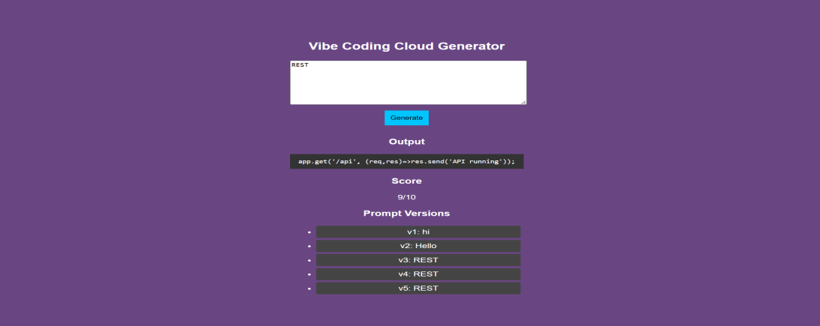
RESULT: A Vibe Coding application was successfully developed to generate and refine cloud- based features using iterative prompt engineering.

