- Create a database.
CREATE DATABASE fullstack;
USE fullstack;
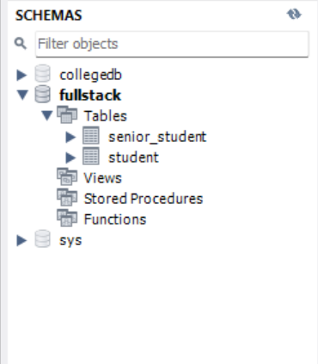

- Create at least two tables:
Table 1: Student (VTU Number, Name, Email, Phone, Department)
CREATE TABLE Student (
VTU_Number VARCHAR(20) PRIMARY KEY,
Name VARCHAR(100),
Email VARCHAR(100),
Phone VARCHAR(15),
Department VARCHAR(50)
);
Table 2: Course (Course Code, Course Name, Faculty Id, Student ID, Faculty Email)
CREATE TABLE Course (
Course_Code VARCHAR(10) PRIMARY KEY,
Course_Name VARCHAR(100),
Faculty_Id INT,
Student_ID VARCHAR(20),
Faculty_Email VARCHAR(100),
FOREIGN KEY (Student_ID) REFERENCES Student(VTU_Number)
);
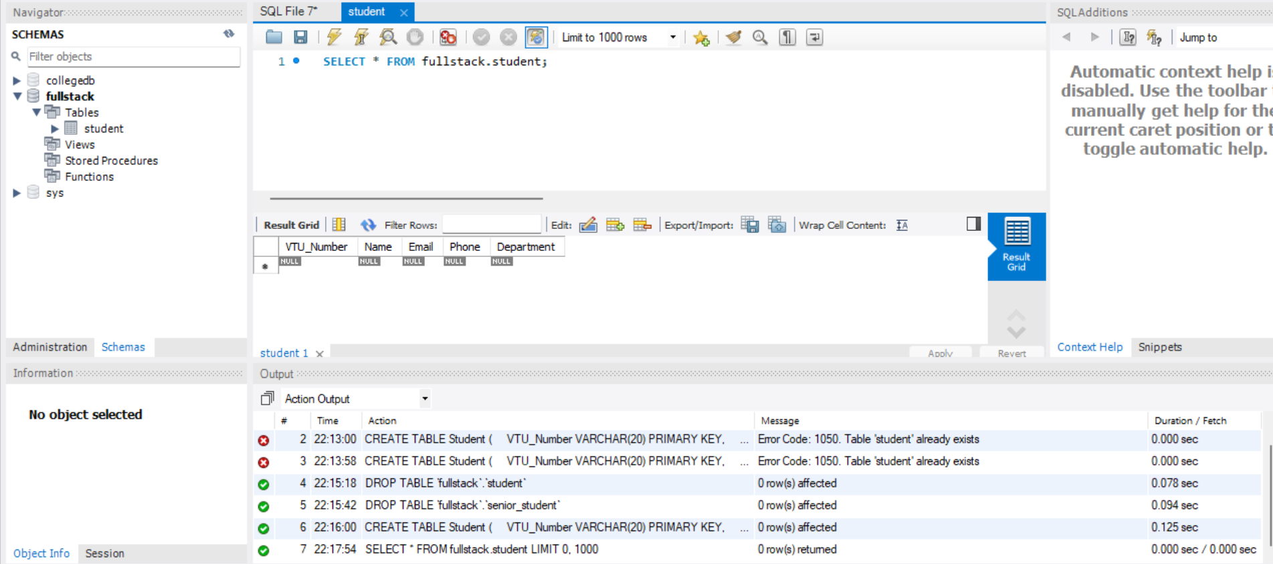
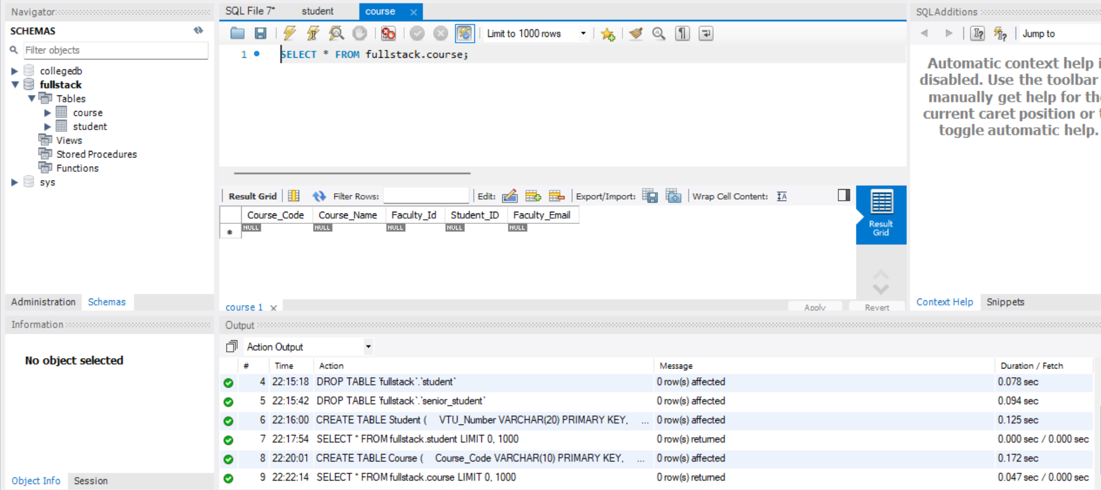
- Insert minimum 5 records into each table.
Inserting into Student Table
INSERT INTO Student VALUES
('1MS23CS001', 'Arjun Kumar', 'arjun@mail.com', '9845011223', 'CSE'),
('1MS23CS002', 'Sneha Rao', 'sneha@mail.com', '9845022334', 'IT'),
('1MS23CS003', 'Rahul Nair', 'rahul@mail.com', '9845033445', 'CSE'),
('1MS23CS004', 'Priya Das', 'priya@mail.com', '9845044556', 'ECE'),
('1MS23CS005', 'Amit Singh', 'amit@mail.com', '9845055667', 'IT');
Inserting into Course Table
INSERT INTO Course VALUES
('CS101', 'Database Management', 101, '1MS23CS001', 'prof_smith@vtu.edu'),
('IS202', 'Data Structures', 102, '1MS23CS002', 'prof_jones@vtu.edu'),
('CS103', 'Operating Systems', 101, '1MS23CS003', 'prof_smith@vtu.edu'),
('EC301', 'Digital Electronics', 103, '1MS23CS004', 'prof_kumar@vtu.edu'),
('IS204', 'Web Programming', 104, '1MS23CS005', 'prof_leila@vtu.edu');

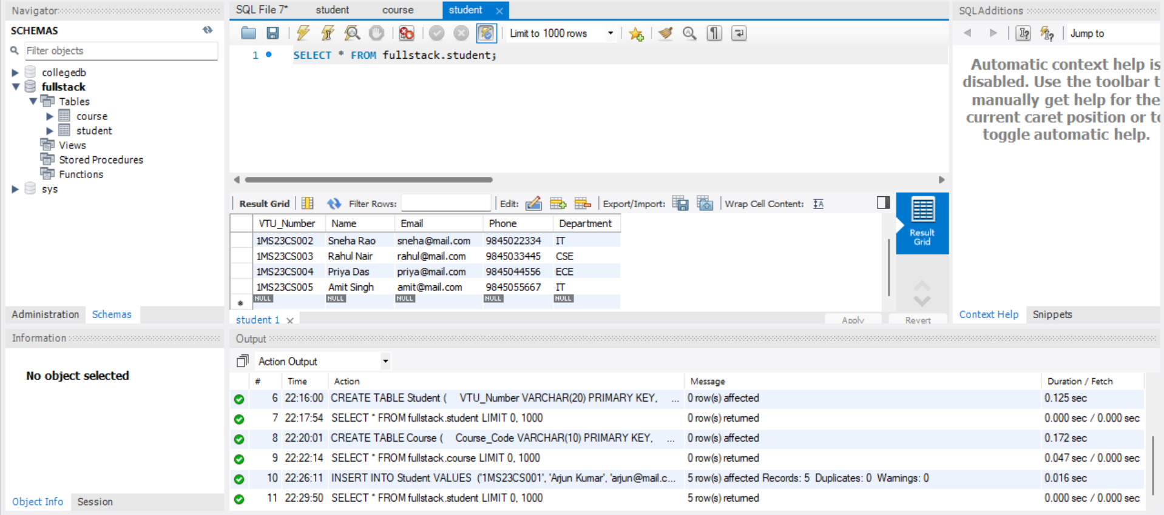
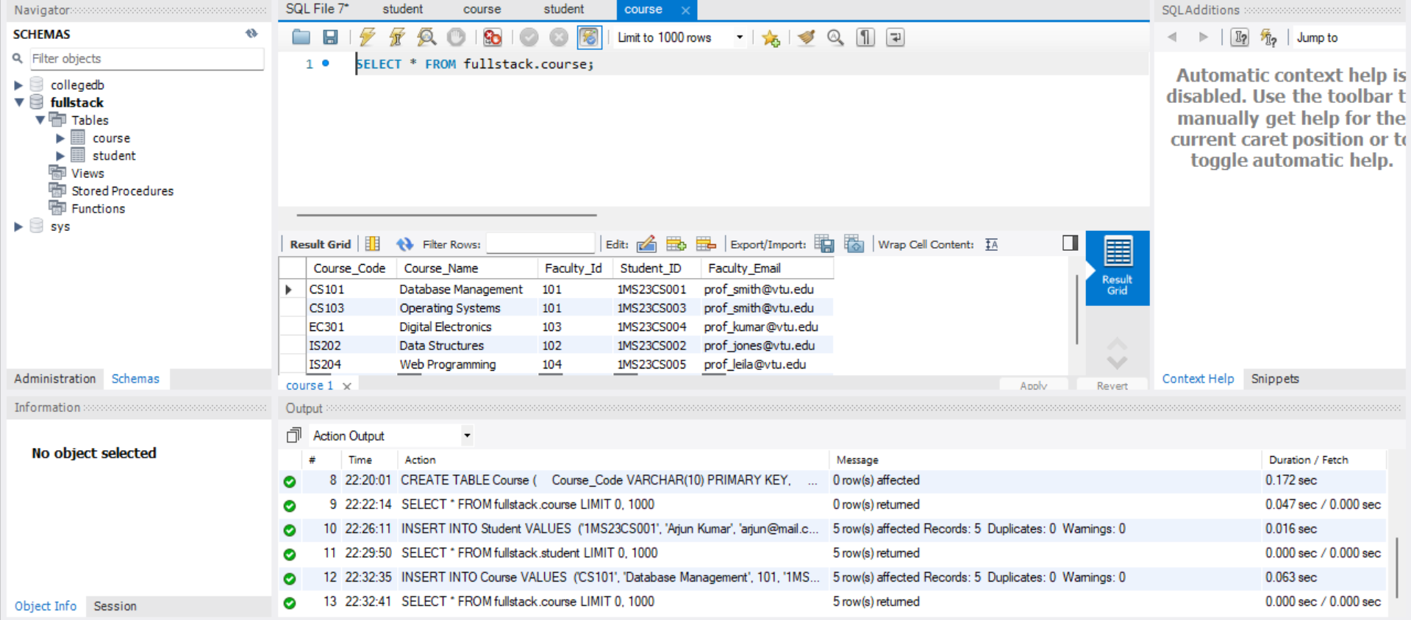

- Select records using different CLAUSE.
WHERE clause:
SELECT * FROM Student WHERE Department = 'CSE';
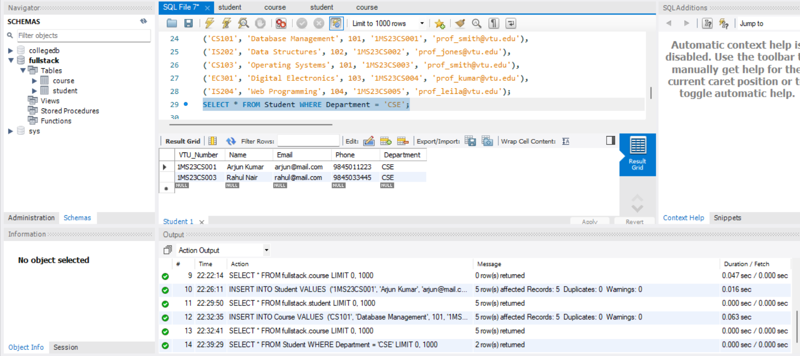
ORDER BY Clause (Sorting):
SELECT * FROM Course ORDER BY Course_Name ASC;
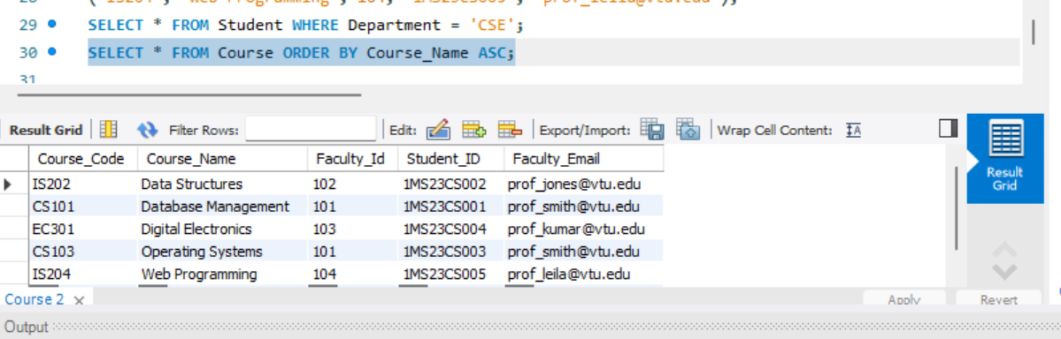
LIKE Clause (Pattern Matching):
SELECT Name, Email FROM Student WHERE Email LIKE '%@mail.com';
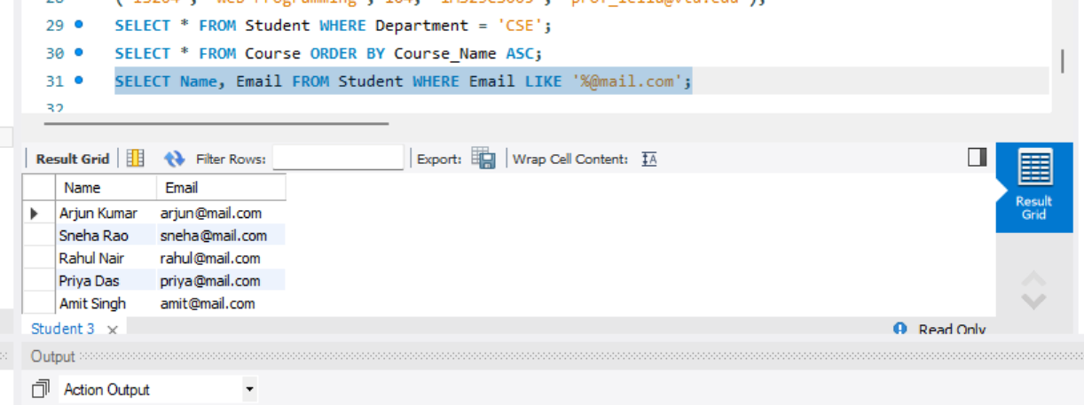
LIMIT Clause (Restricting Results):
SELECT * FROM Student LIMIT 3;
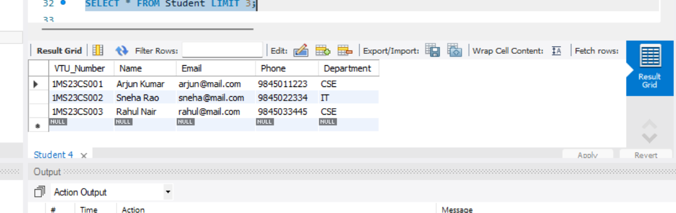

GROUP BY & HAVING Clause (Aggregating):
SELECT Department, COUNT(*) as Total_Students
FROM Student
GROUP BY Department
HAVING COUNT(*) > 1;
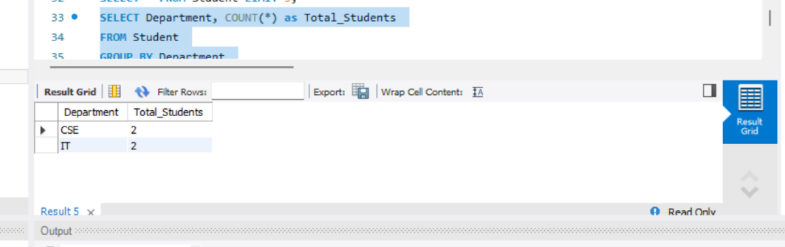
Session 3:
- Write SELECT queries to display all records.
Display all students
SELECT * FROM Student;
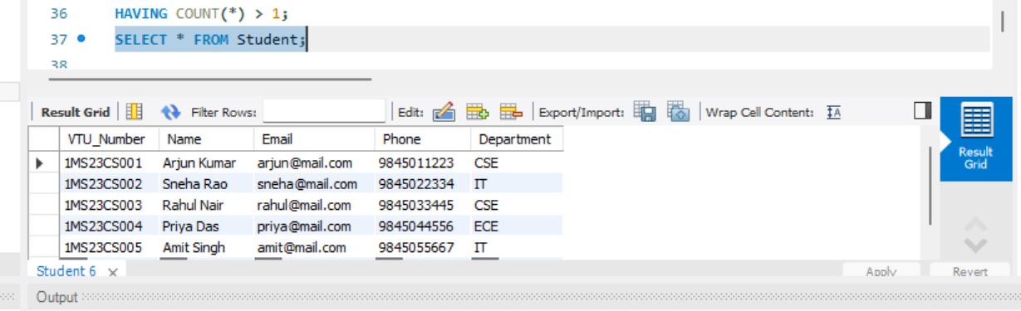
Display all courses
SELECT * FROM Course;
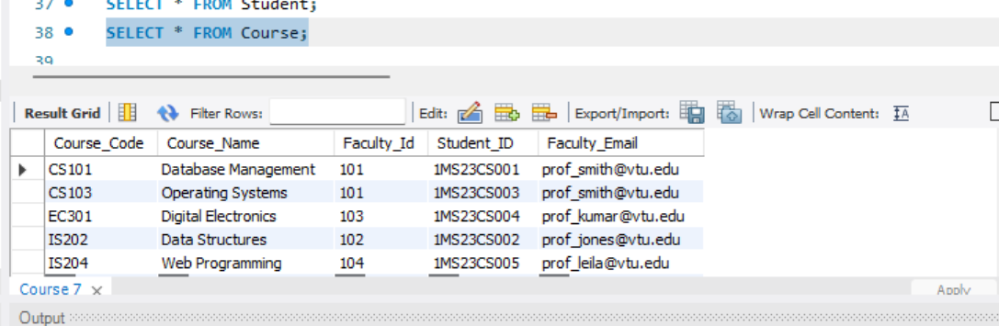
- Write queries using aggregate functions.
Count total number of students
SELECT COUNT(*) AS Total_Students FROM Student;
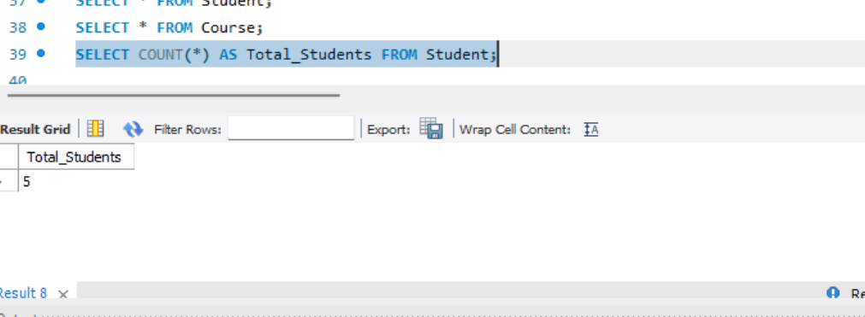
Count unique departments
SELECT COUNT(DISTINCT Department) AS Department_Count FROM Student;
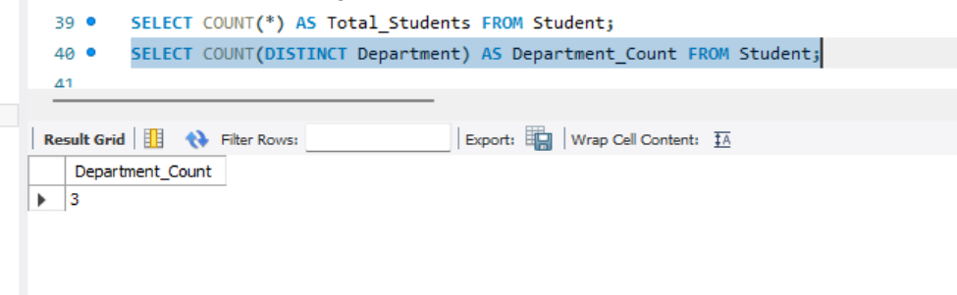
Find the highest Faculty ID assigned
SELECT MAX(Faculty_Id) AS Highest_Faculty_ID FROM Course;
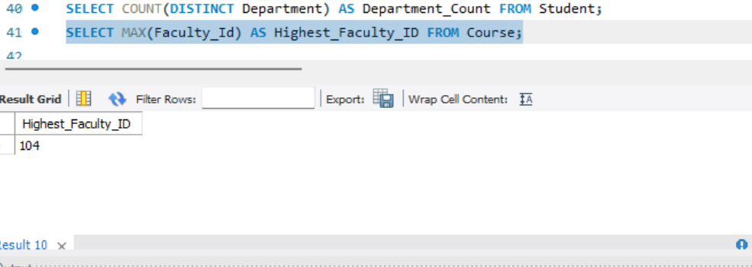
- Sort data and display based in ascending/descending order of the VTU number.
Sort - Ascending order (Default)
SELECT * FROM Student
ORDER BY VTU_Number ASC;
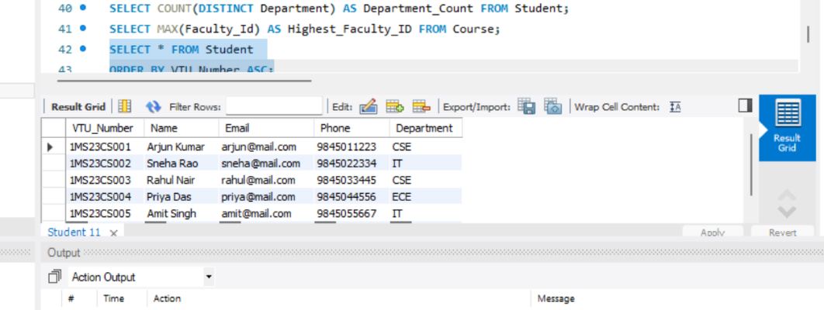
Sort - in Descending order
SELECT * FROM Student
ORDER BY VTU_Number DESC;
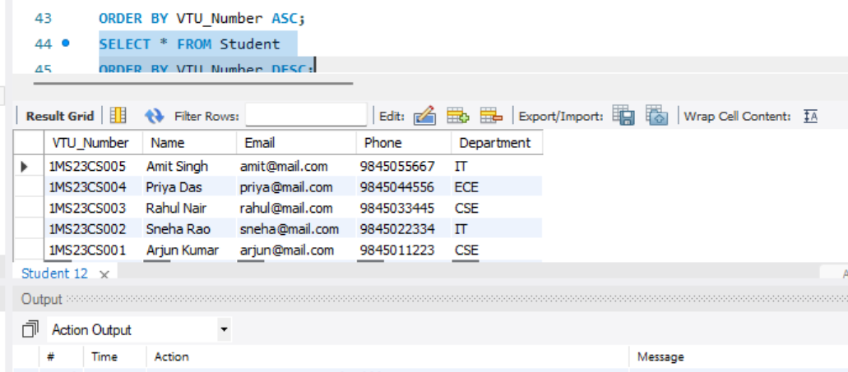
- Display student records belonging to a particular department.
SELECT * FROM Student
WHERE Department = 'CSE';
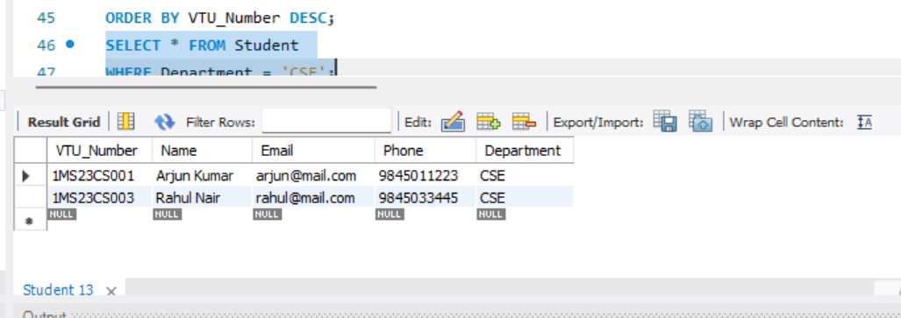
Inner Join:
SELECT
s.VTU_Number,
s.Name AS Student_Name,
c.Course_Name,
c.Faculty_Id,
c.Faculty_Email
FROM Student s
INNER JOIN Course c ON s.VTU_Number = c.Student_ID;
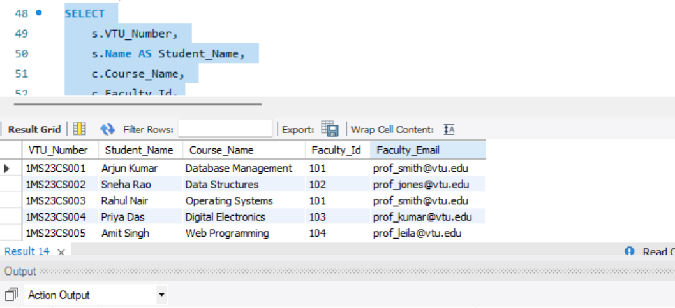
Left Join:
SELECT
s.VTU_Number,
s.Name,
c.Course_Name
FROM Student s
LEFT JOIN Course c ON s.VTU_Number = c.Student_ID;
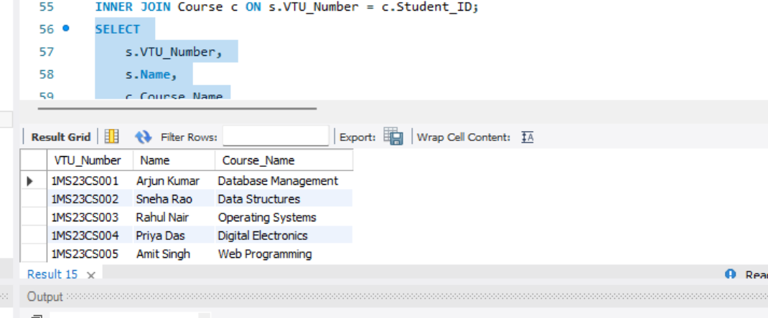
Right Join:
SELECT
s.Name,
c.Course_Code,
c.Course_Name
FROM Student s
RIGHT JOIN Course c ON s.VTU_Number = c.Student_ID;
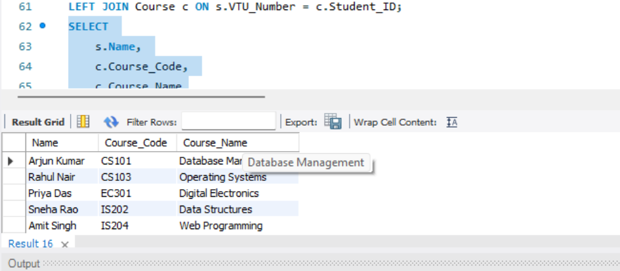
FULL JOIN (Full Outer Join):
SELECT s.Name, c.Course_Name FROM Student s
LEFT JOIN Course c ON s.VTU_Number = c.Student_ID
UNION
SELECT s.Name, c.Course_Name FROM Student s
RIGHT JOIN Course c ON s.VTU_Number = c.Student_ID;
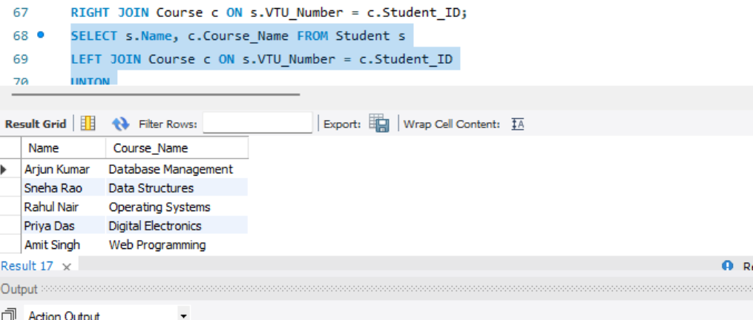
Cross Join(Cartesian Product):
SELECT s.Name, c.Course_Name
FROM Student s
CROSS JOIN Course c;
