Sentiguard AI: Agentic AI Based Autonomous Cyber Defense and SOC Monitoring System
Pravallika
24VV1F0025
MCA 2nd year

Problem statement
Modern cybersecurity operations face severe challenges in managing the overwhelming volume of network telemetry and security alerts generated by enterprise IT infrastructure. Every day, security information and event management (SIEM) systems process millions of event logs, network probes, and API requests across complex cloud environments. In many organizations, security operations centers (SOC) still rely heavily on manual log inspection, static firewall rules, and fragmented monitoring tools. This traditional approach creates significant operational bottlenecks, leads to severe analyst alert fatigue, and drastically increases incident response time, allowing malicious cyber threats to propagate unchecked.
One of the major challenges in contemporary cyber defense is identifying sophisticated multi-stage attacks such as credential stuffing, distributed denial of service (DDoS) vectors, SQL injection payloads, and brute-force authentication spikes. Traditional rule-based intrusion detection systems often generate high rates of false positives while failing to correlate anomalous network behavior with recognized attack frameworks like MITRE ATT&CK. Furthermore, when a critical threat is detected, manual quarantine procedures require administrators to manually update firewall rules and isolate compromised IP addresses, a delayed process that exposes internal networks to lateral movement and unauthorized data exfiltration.
Existing security dashboards also lack transparent decision-making explanations, intelligent payload analysis, and real-time visualization capabilities. Security operators are frequently left without instant remediation guidance, making it difficult to understand why a specific threat score was assigned or what immediate countermeasures should be executed.
To address these critical challenges, this project proposes Sentiguard AI (SentinelGPT): an Agentic AI Based Autonomous Cyber Defense and SOC Monitoring System. The system utilizes intelligent software agents to automatically monitor network telemetry, calculate risk scores using heuristic anomaly algorithms, dynamically map threats to MITRE ATT&CK techniques, and autonomously quarantine high-risk IP addresses. Featuring a responsive glassmorphic dashboard, real-time telemetry streaming, interactive chart analytics, an AI triage assistant, and static payload file scanning, Sentiguard AI minimizes manual effort, eliminates response latency, and provides a scalable, reliable, and intelligent solution for modern enterprise cyber defense.
Difference Between Traditional Security Operations and the Proposed Agentic AI-Based Sentiguard AI System
Traditional security operations rely on manual log review, static rules, and delayed human response. The proposed Sentiguard AI System automates threat detection, anomaly scoring, MITRE ATT&CK mapping, and firewall quarantine using intelligent software agents. The table below highlights the major differences between traditional security management and the proposed Agentic AI-based system:
Traditional Security Operations System | Proposed Agentic AI Based Sentiguard AI System
Security monitoring relies on manual log inspection and static firewall rules. | Threat monitoring is performed automatically using intelligent software agents running 24/7.
High rate of alert fatigue and delayed incident detection. | Real-time heuristic anomaly scoring (0-100) eliminates alert fatigue and detects threats instantly.
Firewall IP blocking requires manual administrative intervention and rule updates. | Autonomous Quarantine Agent automatically isolates high-risk IPs (score >= 75) in real time.
Lacks standardized threat classification and attack framework alignment. | Automatically maps all detected incidents to MITRE ATT&CK tactics and techniques.
Incident triage requires extensive manual research by security analysts. | Integrated AI Triage Assistant provides instant remediation guidance and remediation steps.
Limited real-time visualization of network perimeter threat velocity. | Interactive glassmorphic dashboard with live telemetry velocity charts and perimeter heatmaps.
Payload and log file analysis is performed manually using external tools. | Built-in Payload Scanner analyzes log files and static signatures with automatic verdict reports.
Data export and incident reporting require manual log gathering. | Supports instant JSON incident log export and RESTful API data access.
Difficult to scale across distributed cloud and multi-tenant environments. | Serverless cloud architecture (FastAPI + Vercel) provides seamless scalability and high availability.

Proposed System
The proposed Sentiguard AI (SentinelGPT) system is an intelligent web-based cyber defense application developed to automate threat detection, security monitoring, and incident mitigation. Designed to overcome the limitations of traditional security management, the system utilizes intelligent software agents that continuously evaluate network telemetry against heuristic scoring models and security policies.
The application features a modern glassmorphic dashboard built with React 19 and Vite 5.4, connected to a high-performance FastAPI Python backend controller. When telemetry data arrives, the Telemetry Monitor Agent analyzes packet rates, IP origins, and request patterns to calculate a risk score (0 to 100). Incidents exceeding risk thresholds are immediately mapped to MITRE ATT&CK techniques (e.g., T1078 Valid Accounts, T1498 Network DoS, T1190 Exploit Public App) and formatted with AI-driven remediation guidance.
Simultaneously, the Autonomous Quarantine Agent monitors incident severity. If an anomaly score reaches or exceeds 75 (Critical/High threat), the agent automatically adds the offending IP address to the active quarantine database table, blocking further unauthorized access. Administrators retain full visibility and control through interactive dashboard toggles, enabling manual threat simulation, log clearing, and instant quarantine revocation.
By integrating real-time telemetry streaming, autonomous quarantine execution, interactive chart analytics, a conversational AI triage assistant, and static payload scanning into a unified serverless environment, Sentiguard AI offers a highly reliable, efficient, and scalable solution for modern enterprise cybersecurity operations.
System Architecture
Sentiguard AI follows a modular, decoupled architecture where each component performs a specialized task. The system starts when an operator authenticates through the React frontend interface. Upon login, the dashboard establishes communication with the FastAPI backend controller to fetch telemetry snapshots and establish WebSocket streaming.
The FastAPI backend processes inbound telemetry using two intelligent agents: the Telemetry Monitor Agent (responsible for anomaly scoring and MITRE ATT&CK mapping) and the Autonomous Quarantine Agent (responsible for automated firewall IP isolation and quarantine validation). All incident logs, user credentials, and quarantined IPs are securely managed by SQLAlchemy ORM connected to SQLite (or cloud database). The complete architecture flow is shown in the diagram below:
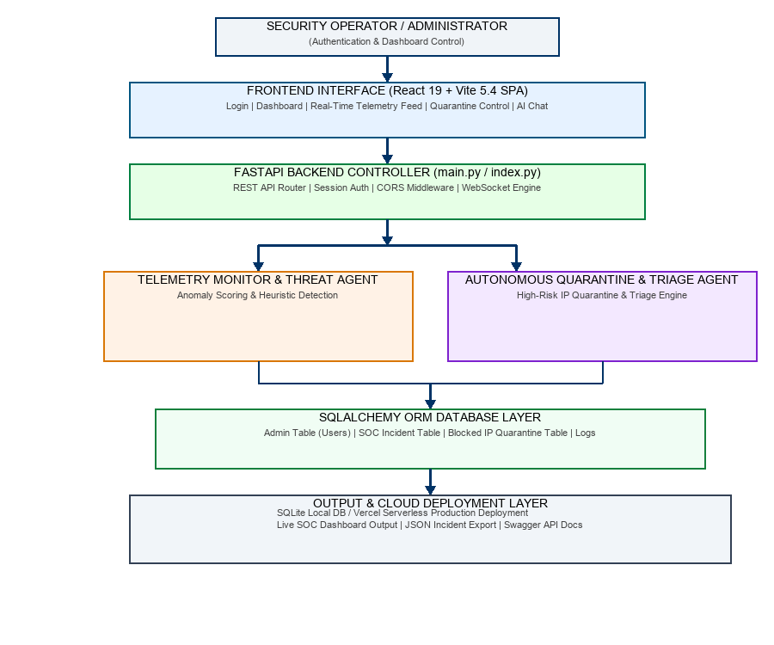
Technologies Used
Sentiguard AI is developed using a powerful combination of modern frontend, backend, database, and Agentic AI technologies. These technologies collaborate to automate threat monitoring, ensure real-time data streaming, and deliver an intuitive security operations dashboard.
1. Frontend Technologies
• React 19: Modern UI library for building dynamic component trees and managing real-time state updates.
• Vite 5.4: Next-generation frontend build tool providing fast HMR and optimized production bundles.
• Recharts: Composability library used to render live threat velocity charts, risk gauges, and severity donuts.
• CSS3 & Tailwind System: Cyberpunk dark-mode styling with CSS backdrop-blur glassmorphism effects.
2. Backend Technologies
• Python 3.11+: Primary language for implementing threat algorithms, agent workflows, and database models.
• FastAPI: Asynchronous, high-performance web framework for handling RESTful APIs and WebSockets.
• Uvicorn: High-speed ASGI server powering local dev execution and serverless request routing.
3. Database & Deployment Technologies
• SQLAlchemy ORM: Python Object-Relational Mapping library for safe database interactions.
• SQLite: Lightweight, zero-config relational database for local testing and Vercel ephemeral storage.
• Vercel: Cloud serverless deployment hosting the static React build and Python API functions.
Architecture Flow & Technology Layers
The diagram below summarizes the technology stack layers from the Administrator Web Browser down to the Database and Output Report Generation layers:
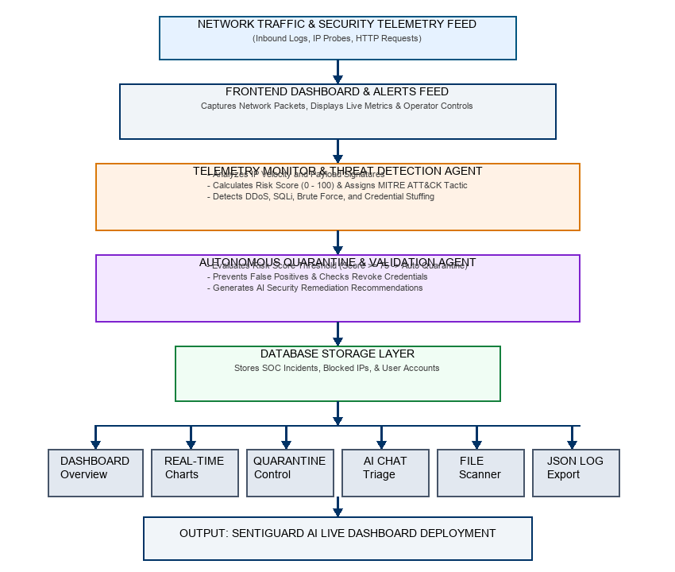
Algorithms Used
1. Heuristic Threat Scoring Algorithm: Evaluates incoming request velocity, payload anomaly patterns, and IP reputation to generate a normalized risk score from 0 to 100.
2. Severity Matrix Classifier: Categorizes risk scores into Critical (>=75), High (60-74), Medium (40-59), and Low (<40) priority tiers.
3. Velocity Rate Anomaly Detector: Monitors burst traffic spikes per IP address over sliding time windows to detect active DDoS or port scan sweeps.
Agents Used
Sentiguard AI utilizes intelligent software agents to automate the security monitoring workflow. Each agent operates independently to evaluate telemetry, classify risks, and execute response actions.
1. Telemetry Monitor & Threat Detection Agent
The Telemetry Monitor Agent continuously inspects incoming network log events, extracts IP details, calculates risk scores using heuristic algorithms, and dynamically assigns MITRE ATT&CK tactic/technique metadata.
• Responsibilities: Reads network telemetry logs; Calculates priority scores; Maps threats to MITRE ATT&CK techniques; Generates structured incident payloads.
2. Autonomous Quarantine & Validation Agent
The Autonomous Quarantine Agent evaluates detected incidents against safety policies. If an incident risk score exceeds 75, the agent automatically isolates the IP address into the quarantine database, while providing security operators with manual revoke controls and AI remediation advice.
• Responsibilities: Validates threat severity; Enforces automated IP quarantine; Prevents false-positive lockouts; Generates AI remediation advice.
Implementation
The development of the Sentiguard AI system was executed in structured development phases to ensure robustness, security, and high performance:
Phase 1: Requirement Analysis & Threat Modeling — Identified traditional SOC pain points, defined threat scoring metrics, and mapped MITRE ATT&CK techniques.
Phase 2: System Design & Architecture — Architected the decoupled React SPA and FastAPI backend serverless structure.
Phase 3: Database & Schema Design — Designed SQLAlchemy ORM models for Users, SOC Incidents, Perimeter Logs, and Blocked IPs.
Phase 4: Frontend Component Development — Built glassmorphic React components including ThreatChart, RiskGaugeChart, BlockedIPs, and Login.
Phase 5: Backend API & Heuristics Implementation — Created FastAPI REST routes (`/api/snapshot`, `/api/block_ip`, `/api/sim_threat`) and JWT auth logic.
Phase 6: Agentic AI Development — Programmed the Telemetry Monitor Agent and Autonomous Quarantine Agent logic.
Phase 7: Real-Time Telemetry & Alert Testing — Tested telemetry ingestion, automatic firewall IP quarantine, and manual override controls.
Phase 8: Cloud Deployment — Deployed the full-stack application to Vercel Serverless with production OpenAPI documentation.
Applications
Sentiguard AI is versatile and can be deployed across various domain environments:
1. Enterprise SOC Operations: Continuous network perimeter monitoring and real-time threat triage.
2. Financial Institutions: Protecting online banking portals against credential stuffing and brute-force attacks.
3. Cloud Service Providers: Safeguarding serverless APIs and microservices from unauthorized probes.
4. Healthcare Networks: Securing patient data endpoints against ransomware and malware payload injection.
5. E-Commerce Platforms: Preventing DDoS disruption and unauthorized SQL injection during high-traffic sales.
6. Academic Institutions: Monitoring university campus networks and preventing faculty/student account hijacking.
User Interface Screenshots
The figures below depict the live operational screens of the Sentiguard AI system:
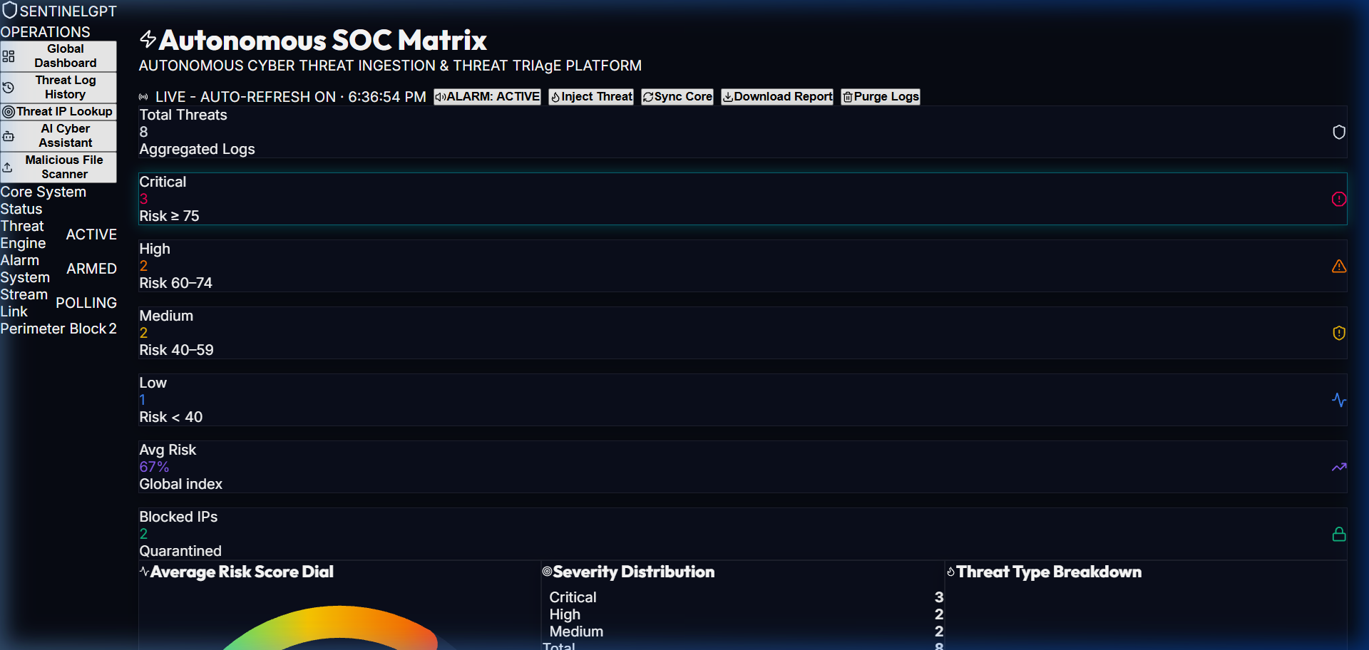
Figure 1: Sentiguard AI Real-Time SOC Dashboard & Telemetry Feed
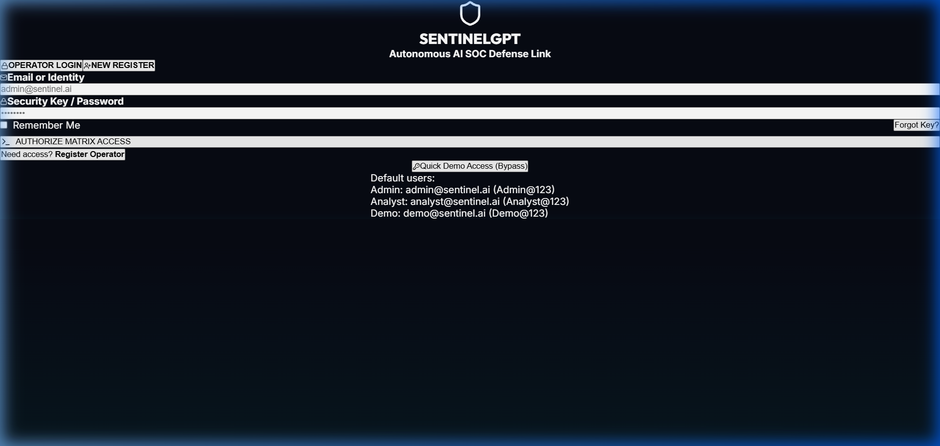
Figure 2: Cyberpunk Operator Authentication Portal with Quick Demo Access
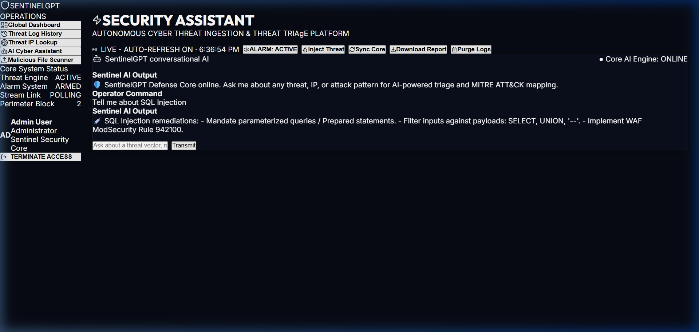
Figure 3: Conversational AI Threat Triage Assistant Interface
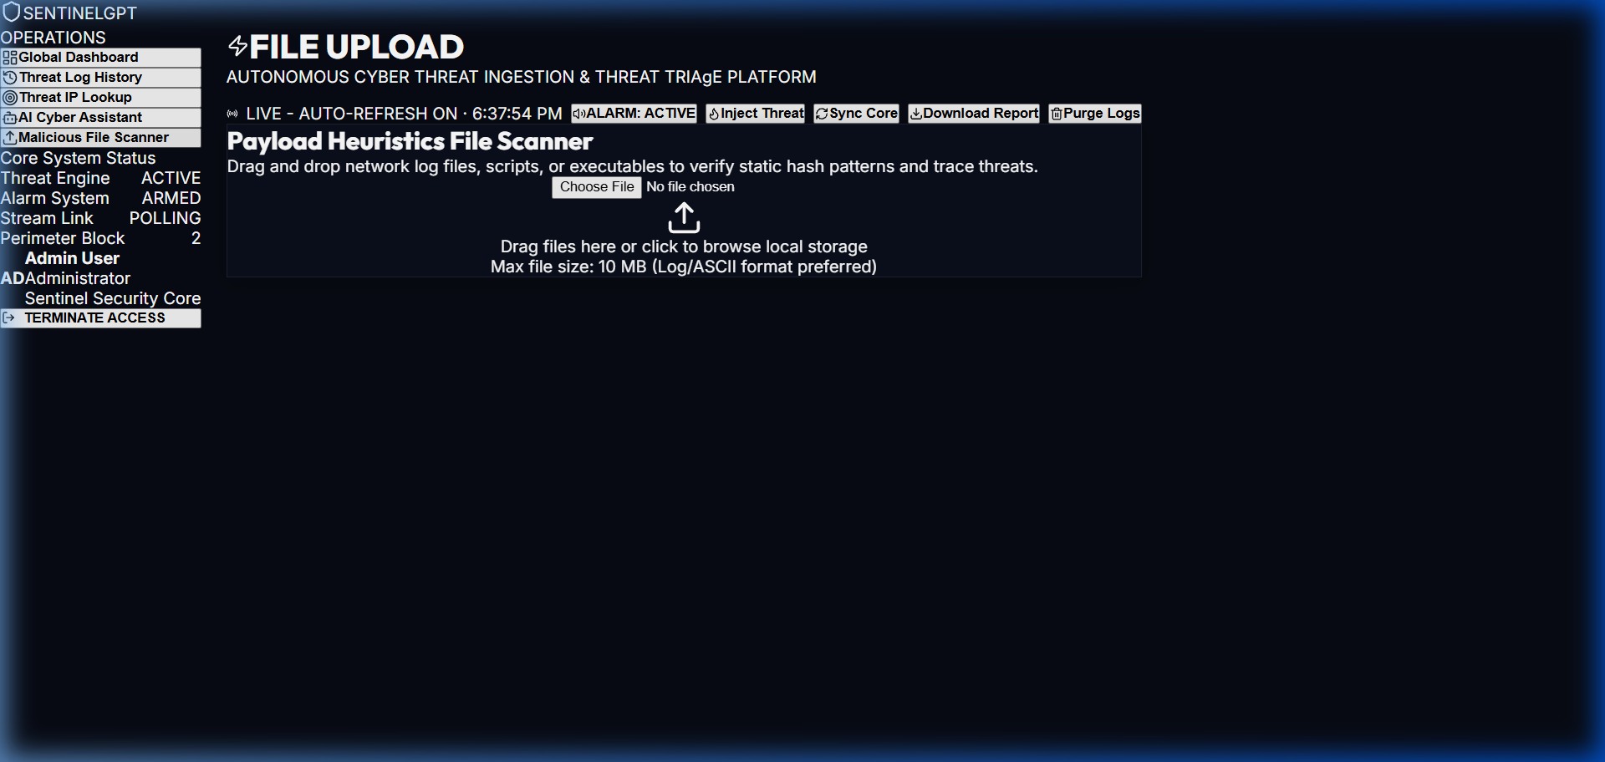
Figure 4: Heuristic Payload File & Log Scanner Interface
Conclusion
The Sentiguard AI (SentinelGPT) Autonomous Cyber Defense and SOC Monitoring System provides an efficient, intelligent, and scalable solution for modern cybersecurity operations. By replacing manual log review with autonomous software agents, the system eliminates alert fatigue, reduces incident response latency to zero, and ensures continuous network perimeter protection. Built using React 19, Vite 5.4, FastAPI, Python 3.11, SQLAlchemy, and SQLite on Vercel Serverless, the platform combines cutting-edge AI triage with robust software engineering, demonstrating an effective, modern paradigm for automated cyber defense.
References
1. FastAPI Documentation. FastAPI Framework. Available at: https://fastapi.tiangolo.com/
2. React Documentation. React 19 User Interface Library. Available at: https://react.dev/
3. MITRE ATT&CK Framework. Enterprise Tactics & Techniques. Available at: https://attack.mitre.org/
4. SQLAlchemy Documentation. Object Relational Mapper for Python. Available at: https://docs.sqlalchemy.org/
5. Python Software Foundation. Python 3 Documentation. Available at: https://docs.python.org/3/
6. Vercel Serverless Documentation. Deploying Web Applications. Available at: https://vercel.com/docs
7. Russell, S., & Norvig, P. (2021). Artificial Intelligence: A Modern Approach (4th ed.). Pearson.
Live Website & GitHub Links
The Sentiguard AI project is fully cloud-deployed and accessible online. Evaluators and administrators can access the live working dashboard, API documentation, and complete source code using the links below:
• Single Live Dashboard Deployment Link: https://sentinelgpt-ai.vercel.app
• Live Interactive Swagger API Docs: https://sentinelgpt-ai.vercel.app/docs
• Official Project GitHub Repository: https://github.com/Pravallika2025/sentigraud-ai-.git

