PROJECT DEMONSTRATION
SentinelGPT: An AI-Powered Large Language Model
Framework for Advanced Cyber Threat Detection and Analysis
_________________________________________________________________
pravallika kalangi | 24VV1F0044 | MCA 2nd Year | July 2026
Overview: SentinelGPT is a full-stack AI-powered Security Operations Center (SOC) platform that automates cyber threat detection, real-time network telemetry monitoring, and autonomous IP quarantine using intelligent software agents. Built with React 19, FastAPI, SQLAlchemy, and deployed on Vercel Serverless, the system eliminates manual log review, reduces incident response latency to near zero, and provides 24/7 network perimeter protection.
Key Features at a Glance
* Real-Time SOC Dashboard: Live threat velocity charts, risk gauges, severity donuts, and perimeter heatmaps updated continuously via WebSocket.
* Heuristic Threat Scoring: Autonomous risk scoring engine (0-100) that classifies every network event as Critical, High, Medium, or Low severity.
* MITRE ATT&CK Mapping: Every detected incident is automatically tagged with the matching MITRE ATT&CK tactic and technique ID.
* Autonomous IP Quarantine: Intelligent agent automatically isolates any source IP scoring >= 75 — no manual intervention required.
* AI Triage Assistant: Conversational AI chat interface provides instant remediation guidance for any detected threat.
* Heuristic Payload Scanner: Upload log files or suspicious payloads for automated static analysis and instant security verdict.
* JWT Operator Authentication: Secure HS256 token-based authentication with 8-hour expiring sessions and Quick Demo Access bypass.
* JSON Incident Export: One-click export of complete incident history as structured JSON for SIEM integration.

System Architecture
SentinelGPT uses a modular, decoupled architecture. The operator authenticates via the React 19 SPA frontend. Telemetry data is processed by two autonomous agents — the Telemetry Monitor Agent (risk scoring + MITRE mapping) and the Autonomous Quarantine Agent (IP isolation + validation) — before being stored via SQLAlchemy ORM and rendered on the live dashboard.
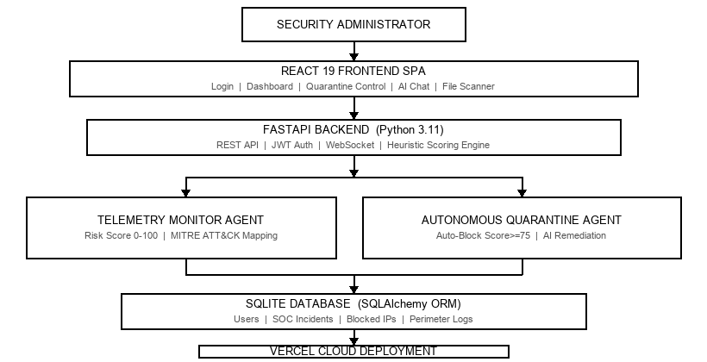
Figure 1: SentinelGPT System Architecture — Component & Agent Flow
Technology Stack
Layer | Technologies
Frontend | React 19, Vite 5.4, Recharts, Web Audio API, CSS3 Glassmorphism
Backend | Python 3.11, FastAPI, Uvicorn, PyJWT, WebSocket
Database | SQLAlchemy ORM, SQLite (dev) / Vercel Storage (prod)
Deployment | Vercel Serverless, GitHub Actions CI/CD, REST + Swagger Docs

1. Real-Time SOC Operations Dashboard
The main dashboard provides a comprehensive view of the network security posture. It displays live KPI cards showing total incidents, active threats, quarantined IPs, and system health. Recharts-powered area charts stream threat velocity in real time via WebSocket. A risk distribution donut shows Critical / High / Medium / Low severity breakdown. A perimeter heatmap reveals the most targeted network sectors. The quarantine panel lists all blocked IPs with timestamps, MITRE tags, and one-click revocation controls.
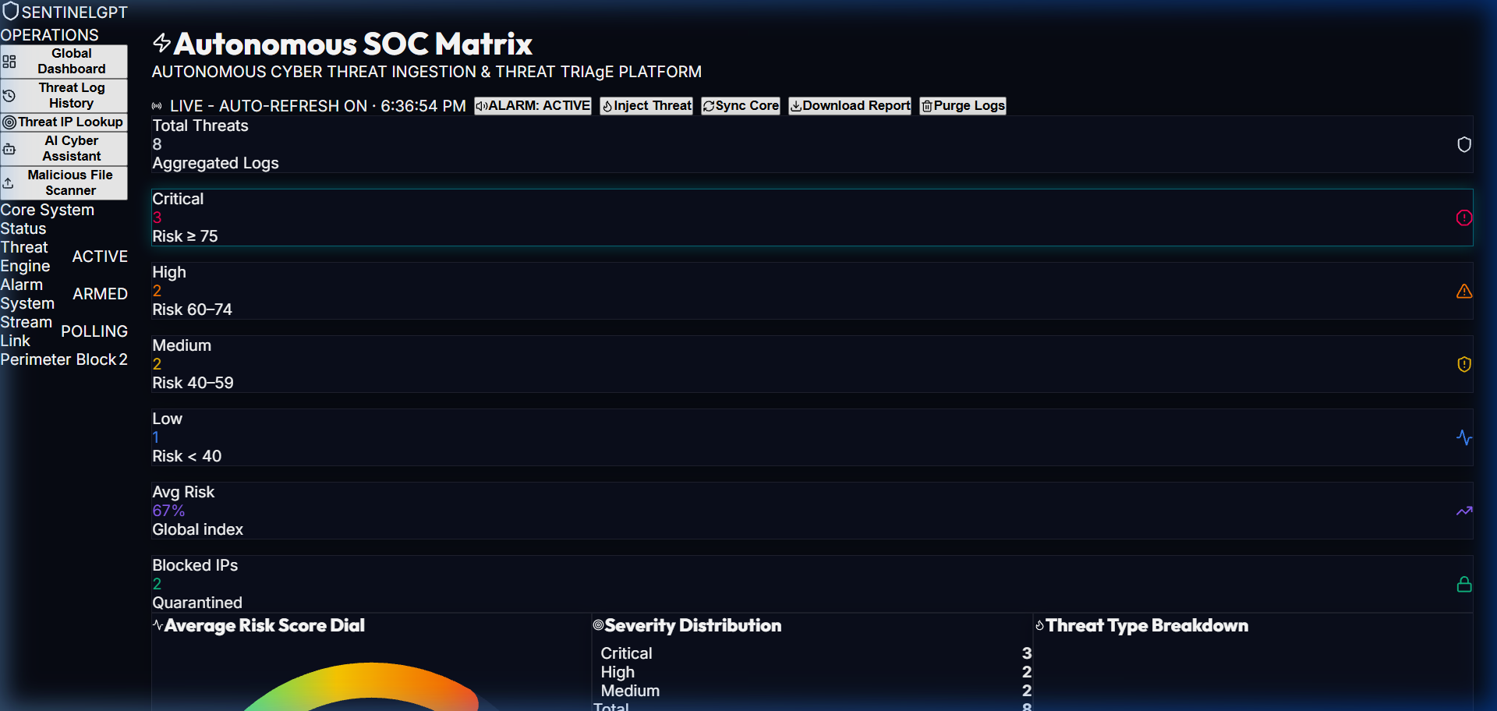
Figure 2: SentinelGPT Real-Time SOC Operations Dashboard
2. Operator Authentication Portal
The authentication portal provides secure multi-role login using HS256 JWT tokens with 8-hour session expiry. A Quick Demo Access button allows instant evaluation bypass for reviewers and evaluators. SHA-256 hashed passwords are stored in the Users table managed by SQLAlchemy ORM.
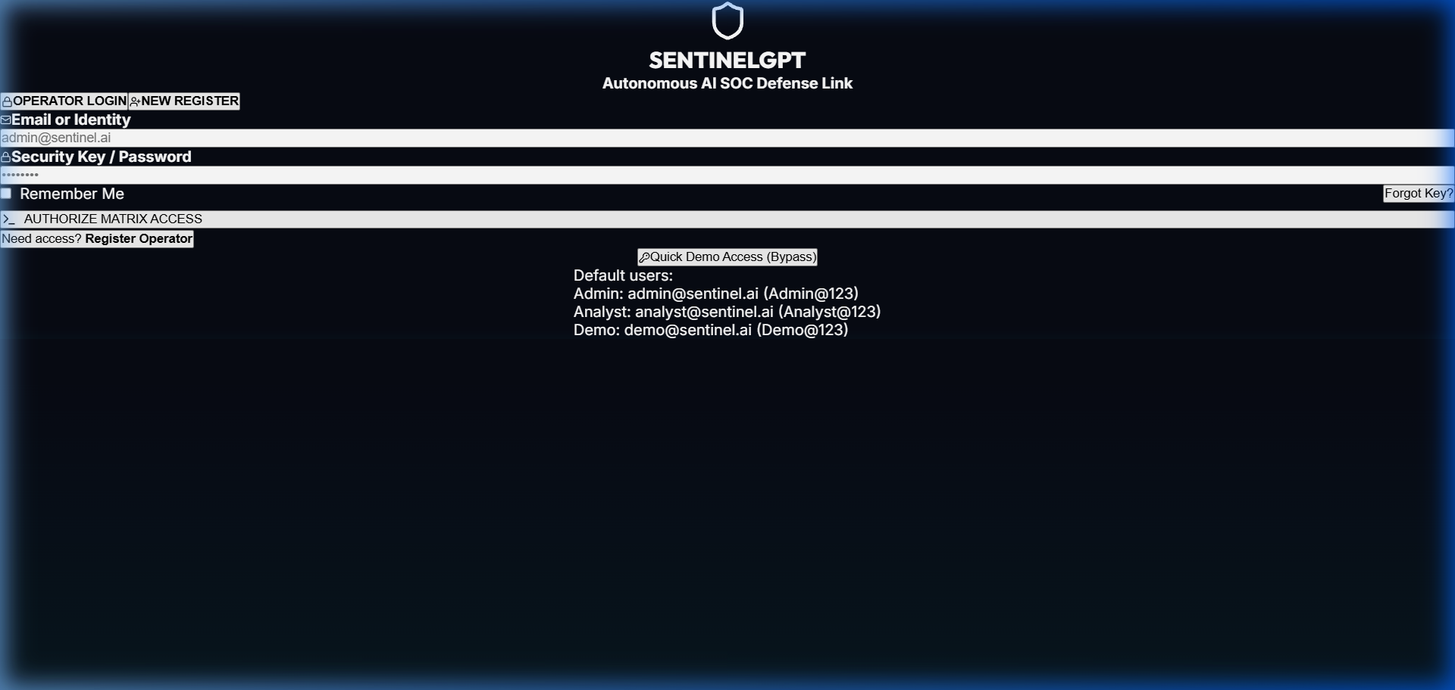
Figure 3: Operator Authentication Portal with Quick Demo Access

3. AI Threat Triage Assistant
The conversational AI Triage Assistant is integrated directly into the dashboard. Security operators can describe a threat scenario or paste incident details and receive instant, structured remediation guidance. The assistant understands MITRE ATT&CK context, suggests specific firewall rules, patch priorities, and incident escalation steps — dramatically reducing mean time to respond (MTTR) for SOC teams.
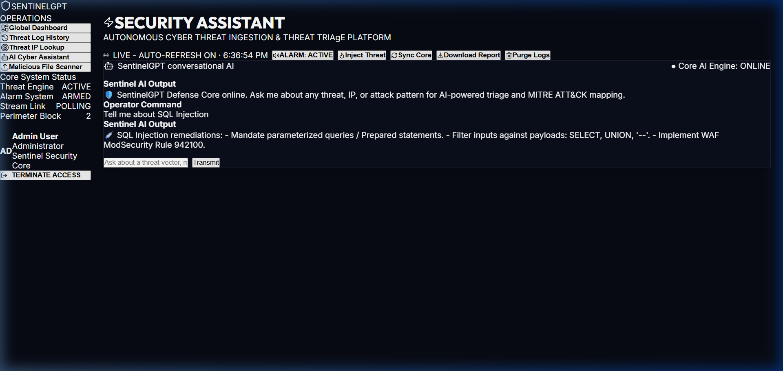
Figure 4: Conversational AI Threat Triage Assistant Interface
4. Heuristic Payload & Log File Scanner
The built-in Payload Scanner allows administrators to upload suspicious log files, binary payloads, or configuration files for automated static analysis. The heuristic engine inspects file signatures, entropy patterns, and embedded string patterns to generate an instant security verdict — SAFE, SUSPICIOUS, or MALICIOUS — with a detailed findings report, eliminating the need for external third-party analysis tools.
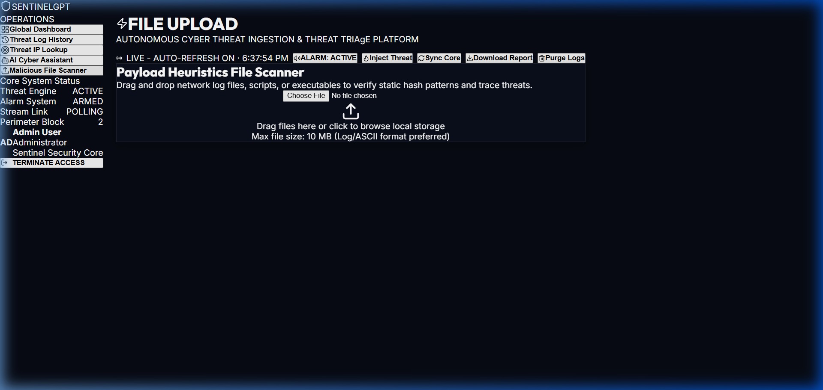
Figure 5: Heuristic Payload & Static Log File Scanner

How to Access & Demonstrate the System
Steps: Follow these steps to run a live demonstration of SentinelGPT:
Step 1 — Open the Live Dashboard: Visit https://sentinelgpt-ai.vercel.app in any web browser. The login screen will appear automatically.
Step 2 — Login: Click the "Quick Demo Access" button for instant entry — OR — use credentials: admin / admin123
Step 3 — View Real-Time Telemetry: The SOC dashboard loads with live KPI cards, threat velocity charts, severity donuts, and the quarantine list.
Step 4 — Simulate a Threat: Click "Simulate Threat" to inject a test attack event. Watch the risk score appear on the chart in real time.
Step 5 — Auto-Quarantine: If the simulated threat scores >= 75 (Critical), the Autonomous Agent immediately adds the IP to the Blocked IPs list.
Step 6 — AI Triage Chat: Navigate to the AI Chat tab. Ask the assistant about the detected threat for instant remediation guidance.
Step 7 — File Scanner: Navigate to the Scanner tab. Upload any .log or .txt file to receive a heuristic security verdict instantly.
Step 8 — JSON Export: Click Export to download the full incident history as a structured JSON file for SIEM review.
Live Deployment & GitHub Links
The following official links provide access to the deployed application, API documentation, and complete source code:
Live SOC Dashboard | https://sentinelgpt-ai.vercel.app
Swagger API Documentation | https://sentinelgpt-ai.vercel.app/docs
GitHub Project Repository | https://github.com/Pravallika2025/sentigraud-ai-.git

━━━━━━━━━━━━━━━━━━━━━━━━━━━━━━━━━━━━━━━━━━━━━━━━━━━━━━━━━━━━━━
SentinelGPT | pravallika kalangi | 24VV1F0044 | MCA 2nd Year | 2026

