SentinelGPT: An AI-Powered Large Language Model
Framework for Advanced Cyber Threat Detection
and Analysis
───────────────────────────────────────────────────────
A Project Report Submitted for the Partial Fulfillment of the
Requirements for the Award of the Degree of
Master of Computer Applications (MCA)
Submitted by
pravallika kalangi
24VV1F0044
MCA — 2nd Year | July 2026

1. Problem Statement
Modern enterprise cybersecurity operations face severe and escalating challenges in managing the overwhelming volume of network telemetry and security alerts generated by large-scale IT infrastructure. Security Information and Event Management (SIEM) systems process millions of event logs, network probes, and API requests every single day across complex distributed cloud environments. Despite the scale of the threat landscape, many organizations continue to rely heavily on manual log inspection, static firewall rules, and fragmented monitoring tools. This outdated approach creates significant operational bottlenecks, leads to severe analyst alert fatigue, and drastically increases incident response times — allowing malicious cyber threats to propagate unchecked through internal networks.
One of the most critical challenges in contemporary cyber defense is identifying sophisticated multi-stage attacks such as credential stuffing, Distributed Denial of Service (DDoS) vectors, SQL injection payloads, and brute-force authentication spikes. Traditional rule-based intrusion detection systems generate extremely high rates of false positives while failing to correlate anomalous network behavior with established attack frameworks like MITRE ATT&CK. Furthermore, when a critical threat is detected, manual quarantine procedures require administrators to manually update firewall rules and isolate compromised IP addresses — a slow, delayed process that exposes internal networks to lateral movement and unauthorized data exfiltration.
Existing security dashboards also lack transparent decision-making explanations, intelligent payload analysis, and real-time visualization capabilities. Security operators are frequently left without instant remediation guidance, making it difficult to understand why a specific threat score was assigned or what immediate countermeasures should be taken.
To address these critical challenges, this project presents SentinelGPT — an AI-Powered Large Language Model Framework for Advanced Cyber Threat Detection and Analysis. The system leverages intelligent autonomous software agents to automatically monitor network telemetry, calculate risk scores using heuristic anomaly algorithms, dynamically map threats to MITRE ATT&CK techniques, and autonomously quarantine high-risk IP addresses. By integrating real-time telemetry streaming, agentic quarantine execution, interactive chart analytics, a conversational AI triage assistant, and static payload scanning into a unified serverless cloud deployment, SentinelGPT significantly minimizes manual analyst effort, eliminates incident response latency, and delivers a scalable, reliable solution for modern enterprise cyber defense operations.

2. Difference: Traditional System vs. Proposed SentinelGPT
The following table highlights the key operational differences between the conventional manual security management approach and the proposed AI-powered SentinelGPT framework:
Traditional Security Operations | Proposed SentinelGPT System
Security alerts monitored manually using static firewall rules and basic log viewers. | Threats detected and analyzed automatically 24/7 via intelligent software agents.
High analyst alert fatigue; delayed incident detection and slow response times. | Real-time heuristic anomaly scoring (0-100) eliminates fatigue and detects threats instantly.
IP quarantine requires manual admin intervention and firewall rule configuration. | Autonomous Quarantine Agent auto-isolates malicious IPs (score >= 75) in real time.
No standardized MITRE ATT&CK threat framework alignment or technique tagging. | All incidents automatically mapped to MITRE ATT&CK tactics and techniques.
Threat triage requires lengthy manual analyst research and verification. | Integrated AI Triage Assistant delivers instant remediation guidance and threat context.
Limited or no real-time visualization of threat velocity and perimeter metrics. | Glassmorphic dashboard with live telemetry charts, risk gauges, and perimeter heatmaps.
Payload and log file analysis performed manually using external third-party tools. | Built-in Payload Scanner automatically analyzes files with heuristic verdict reports.
Incident reporting requires manual log gathering and formatting effort. | Instant JSON incident-log export via REST API (/api/export) — one click.

3. Proposed Solution
SentinelGPT is an intelligent, full-stack, cloud-native cyber defense platform designed to automate threat detection, security monitoring, and incident mitigation for enterprise environments. Unlike traditional reactive security tools, the system uses autonomous software agents that continuously evaluate incoming network telemetry against heuristic scoring models and enforce security policies — replacing slow, error-prone manual workflows with instantaneous automated decisions.
The Telemetry Monitor Agent serves as the primary threat intelligence engine. It continuously analyzes packet rates, IP origins, payload signatures, and request patterns to compute a normalized risk score ranging from 0 (benign) to 100 (critical). Each detected incident is dynamically mapped to a corresponding MITRE ATT&CK technique — for example, T1078 (Valid Accounts), T1498 (Network DoS), or T1190 (Exploit Public-Facing Application) — and enriched with AI-generated remediation guidance specific to the attack pattern.
The Autonomous Quarantine Agent operates independently to enforce firewall isolation policies. When an incident risk score reaches or exceeds the critical threshold of 75, the agent immediately writes the offending IP address to the Blocked IPs database table, effectively quarantining it from all further system access. Security administrators retain complete manual override capability — they can revoke quarantine entries, trigger simulated threat injections for testing, or clear incident logs directly from the interactive dashboard.
By unifying intelligent threat detection, automated quarantine enforcement, real-time telemetry visualization, conversational AI triage, and cloud-native serverless deployment into a single cohesive platform, SentinelGPT establishes a modern, scalable, and highly reliable solution for next-generation enterprise cybersecurity operations — eliminating response latency, reducing manual effort, and maintaining continuous 24/7 network perimeter protection.
4. Overall System Architecture
SentinelGPT follows a modular, decoupled full-stack architecture. The security operator authenticates via the React 19 SPA frontend, which communicates with the FastAPI backend controller for telemetry snapshots and WebSocket streaming. Two autonomous agents process all incoming security events. All incident logs, quarantine records, and user credentials are persisted via SQLAlchemy ORM to SQLite (local) or Vercel cloud storage (production). The complete end-to-end architecture is shown in the diagram below:
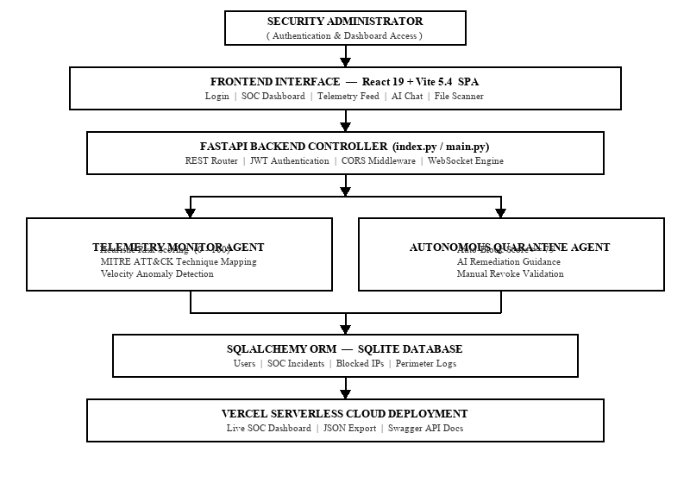
Figure 1: SentinelGPT End-to-End System Architecture Diagram

5. Technologies Used
SentinelGPT is built on a carefully selected combination of modern frontend, backend, database, and AI technologies that together enable automated threat monitoring, real-time data streaming, and secure cloud deployment:
Frontend Stack
React 19: Modern UI component library for building dynamic, reactive glassmorphic dashboard trees and managing real-time telemetry state updates efficiently.
Vite 5.4: Next-generation build tool providing ultra-fast Hot Module Replacement (HMR) and optimized production bundles for serverless deployment.
Recharts: Data visualization library used to render live threat velocity area charts, heuristic risk gauges, severity donut charts, and perimeter heatmaps.
Web Audio API: Browser-native alarm engine that fires audio alerts on Critical/High threat detection events.
Backend Stack
Python 3.11+: Core language for implementing agent logic, threat heuristic algorithms, database ORM models, and all server-side processing.
FastAPI: High-performance async web framework for RESTful API routing, WebSocket streaming, JWT authentication, and automatic Swagger/OpenAPI documentation generation.
Uvicorn: ASGI server powering local development execution and Vercel serverless function routing.
PyJWT: HS256 JSON Web Token generation and validation providing 8-hour expiring secure operator sessions.
Database & Deployment
SQLAlchemy ORM: Python Object-Relational Mapper providing type-safe, secure database interactions without writing raw SQL.
SQLite: Zero-configuration relational database for local development incident logging, quarantine records, and user accounts.
Vercel: Serverless cloud platform serving the React static build and executing Python API functions at the network edge.
GitHub Actions CI/CD: Automated build and deployment pipeline triggered on every push to the main branch.

6. Agents Used & Architecture Flow
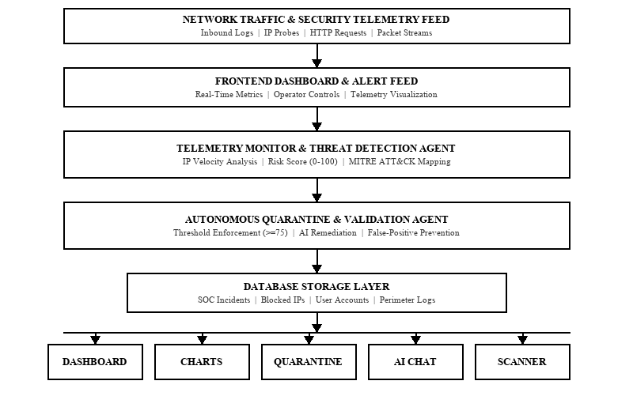
Figure 2: Agent Workflow — From Telemetry Ingestion to SOC Output
Agent 1 — Telemetry Monitor & Threat Detection Agent
Continuously inspects incoming network log events, extracts source IP details and payload metadata, computes a heuristic risk score (0–100), and assigns a MITRE ATT&CK tactic and technique tag. Produces a structured SOC Incident payload that is persisted to the database and streamed live to the frontend dashboard in real time via WebSocket.
Agent 2 — Autonomous Quarantine & Validation Agent
Evaluates every incident against the critical severity threshold (score >= 75). Qualifying incidents are automatically written to the Blocked IPs table, quarantining the offending source IP from all further system access. The agent also validates manual revoke requests from administrators and generates contextual AI-driven remediation advice to prevent false-positive lockouts.
7. Algorithms Used
1. Heuristic Threat Scoring Algorithm: Evaluates request velocity, payload anomaly patterns, and IP reputation to produce a normalized 0–100 risk score — without relying solely on static signatures.
2. Severity Matrix Classifier: Maps computed scores to four priority tiers: Critical (>=75), High (60–74), Medium (40–59), Low (<40) — directly driving automated quarantine and alert logic.
3. Velocity Rate Anomaly Detector: Monitors burst traffic spikes per source IP over sliding time windows to identify active DDoS attempts and port-scan sweeps in real time.

8. Implementation Phases
Phase 1 — Requirement Analysis: Identified SOC pain points, defined threat scoring metrics, mapped MITRE ATT&CK coverage requirements, and finalized functional and non-functional system specifications.
Phase 2 — System Design: Architected the decoupled React SPA + FastAPI serverless backend; finalized REST API contracts, database schema design, and agent workflow blueprints.
Phase 3 — Database Schema Design: Designed SQLAlchemy ORM models — Users, SOC Incidents, Perimeter Logs, and Blocked IPs — with SQLite for local development and Vercel storage for production.
Phase 4 — Frontend Development: Built glassmorphic React components including ThreatChart, RiskGaugeChart, BlockedIPs manager, AI Chat assistant panel, File Scanner interface, and the main Login portal.
Phase 5 — Backend API & JWT Auth: Implemented all REST routes (/api/snapshot, /api/block_ip, /api/unblock_ip, /api/sim_threat, /api/export, /api/login) with HS256 JWT authentication middleware and CORS configuration.
Phase 6 — Agentic AI Development: Programmed the Telemetry Monitor Agent (heuristic scoring + MITRE mapping) and the Autonomous Quarantine Agent (threshold enforcement + AI remediation generation).
Phase 7 — Integration & Validation Testing: Injected simulated threat payloads to verify scoring accuracy, quarantine trigger reliability, manual override controls, and WebSocket streaming performance under load.
Phase 8 — Cloud Deployment: Deployed the complete full-stack application to Vercel Serverless; configured environment variables, verified Swagger API docs in production, and tested the live dashboard end-to-end.

9. Applications
Enterprise SOC Operations: Continuous 24/7 network perimeter monitoring, automated threat triage, and instant IP quarantine for dedicated corporate security teams.
Financial Institutions: Protects banking portals and payment gateways from credential stuffing, brute-force authentication attacks, and transaction fraud.
Cloud Service Providers: Safeguards serverless APIs, microservices, and distributed cloud infrastructure from unauthorized probes and zero-day exploits.
Healthcare Networks: Secures hospital patient data endpoints and clinical systems against ransomware, malware payload injection, and PHI data exfiltration.
E-Commerce Platforms: Prevents DDoS disruptions and SQL injection attacks during high-traffic sales events, ensuring continuous uptime and transaction security.
Academic & Research Institutions: Monitors university campus networks, protects research data, and prevents faculty and student account hijacking or credential theft.
10. Conclusion
SentinelGPT demonstrates that integrating Agentic AI with a modern full-stack serverless architecture — React 19, FastAPI, SQLAlchemy, and Vercel — can fundamentally transform reactive, manual security operations into a proactive, fully automated cyber defense system. By replacing human-dependent log review with autonomous, continuously running software agents, the platform eliminates analyst alert fatigue, reduces incident response latency to near zero, and provides uninterrupted 24/7 network perimeter protection.
The heuristic threat scoring engine, MITRE ATT&CK technique mapping, conversational AI triage assistant, and automated quarantine enforcement together establish a comprehensive and intelligent security operations platform that is scalable, transparent, and suitable for deployment in enterprise, financial, healthcare, and academic environments. The project sets a strong technical foundation for the next generation of AI-powered cybersecurity frameworks and demonstrates the practical value of agentic approaches in solving real-world security challenges at scale.

11. References
[1] FastAPI Documentation — Available at: https://fastapi.tiangolo.com/
[2] React 19 Documentation — Available at: https://react.dev/
[3] MITRE ATT&CK Framework — Enterprise Tactics & Techniques. Available at: https://attack.mitre.org/
[4] SQLAlchemy ORM Documentation — Available at: https://docs.sqlalchemy.org/
[5] Vite Build Tool Documentation — Available at: https://vitejs.dev/
[6] Vercel Serverless Platform Documentation — Available at: https://vercel.com/docs
[7] Python 3.11 Documentation — Available at: https://docs.python.org/3/
[8] Uvicorn ASGI Server — Available at: https://www.uvicorn.org/
[9] MDN Web Docs: HTML5, CSS3, JavaScript — Available at: https://developer.mozilla.org/
[10] Russell, S., & Norvig, P. (2021). Artificial Intelligence: A Modern Approach (4th ed.). Pearson.
[11] Wooldridge, M. (2009). An Introduction to MultiAgent Systems (2nd ed.). John Wiley & Sons.
[12] OWASP Top Ten Security Risks — Available at: https://owasp.org/Top10/
12. Live Deployment & GitHub Repository
The SentinelGPT system is fully deployed and accessible online. Evaluators and reviewers may access the live working dashboard, interactive Swagger API documentation, and the complete project source code using the official links below:
Live SOC Dashboard | https://sentinelgpt-ai.vercel.app
Interactive Swagger API Docs | https://sentinelgpt-ai.vercel.app/docs
GitHub Source Repository | https://github.com/Pravallika2025/sentigraud-ai-.git

─────────────────────────────────────────
SentinelGPT | Pravallika Kalangi | 24VV1F0044
MCA 2nd Year | July 2026

