PROJECT TECHNICAL REPORT
SentinelGPT — Autonomous Cyber Defense Platform

Project Title: | SentinelGPT Autonomous Cyber Defense Platform
Live Deployment Link: | https://sentinelgpt-ai.vercel.app
GitHub Repository: | https://github.com/Pravallika2025/sentigraud-ai-.git
Technology Stack: | React 19, Vite 5.4, FastAPI, SQLAlchemy, SQLite, JWT
Documentation Date: | July 2026

1. Executive Summary & Abstract
SentinelGPT is an enterprise-grade, full-stack autonomous Security Operations Center (SOC) platform designed for continuous network threat monitoring, real-time telemetry processing, heuristic vulnerability analysis, and automated quarantine response.
Built to bridge real-time cybersecurity operations with cloud-native serverless architecture, SentinelGPT processes network anomalies, maps them dynamically against MITRE ATT&CK tactics, and renders actionable AI remediation recommendations for security analysts.
2. System Architecture & Technical Stack
The application follows a decoupled monorepo architecture, leveraging React 19 for rendering dynamic glassmorphic telemetry components and FastAPI (Python) for asynchronous microservices and serverless database interaction.
Key Technology Components:
• Frontend (React 19 + Vite 5.4): Modern single-page application framework providing fast Virtual DOM reconciliation and responsive glassmorphic dark theme components.
• Backend (FastAPI + Python 3.11): Asynchronous Python framework managing RESTful JSON APIs (`/api/*`), OpenAPI schemas, and WebSockets.
• Database & Storage: SQLAlchemy ORM interfacing with SQLite (`/tmp/sentinel_vercel.db` on Vercel) for persistent incident logging.
• Authentication: Expiring HS256 JWT tokens with SHA-256 password hashing and role-based access control.
• Cloud Hosting: Multi-stage Vercel serverless deployment (`vercel.json`) serving static assets from `/dist` and dynamic API handlers.
3. Core Operations Dashboard Interface
The main Security Operations Center (SOC) dashboard consolidates live perimeter telemetry into real-time KPI cards, threat velocity area charts, severity distribution donuts, sector heatmap matrices, and an automated quarantine management list.
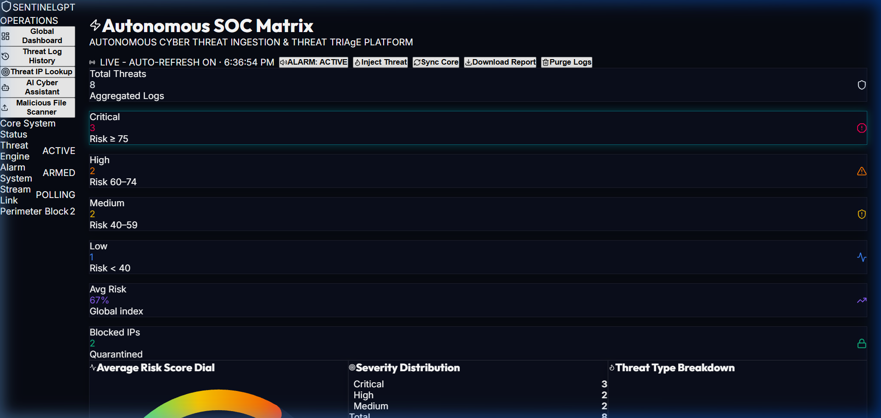
Figure: SentinelGPT Real-time SOC Operations Dashboard Interface
4. Authentication & Operator Onboarding
SentinelGPT incorporates a cyberpunk-themed authentication interface offering multi-role login, operator registration with organizational profile setup, and a 1-click Quick Demo Access bypass for rapid evaluation.
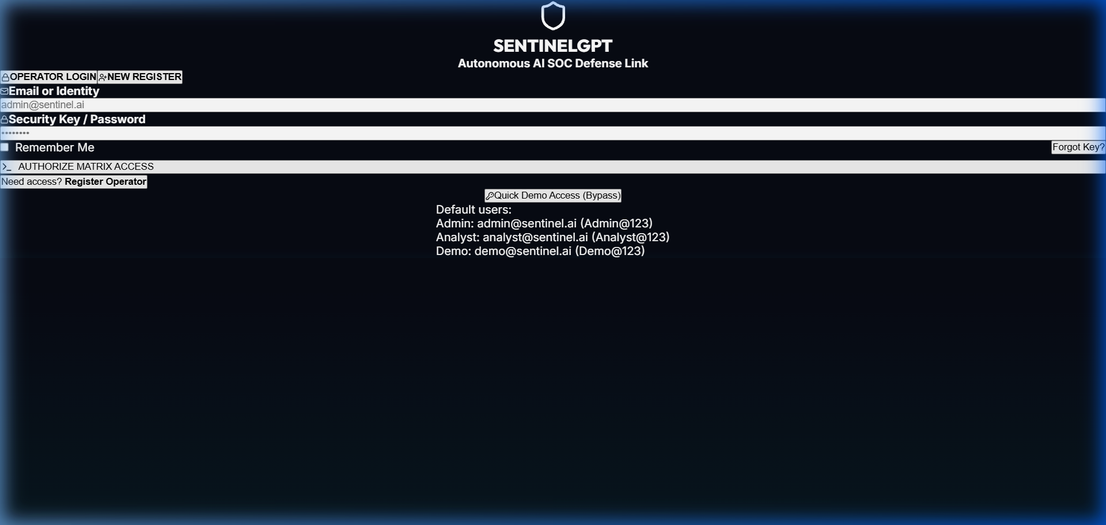
Figure: Cyberpunk Security Operator Login Interface with Quick Demo Access
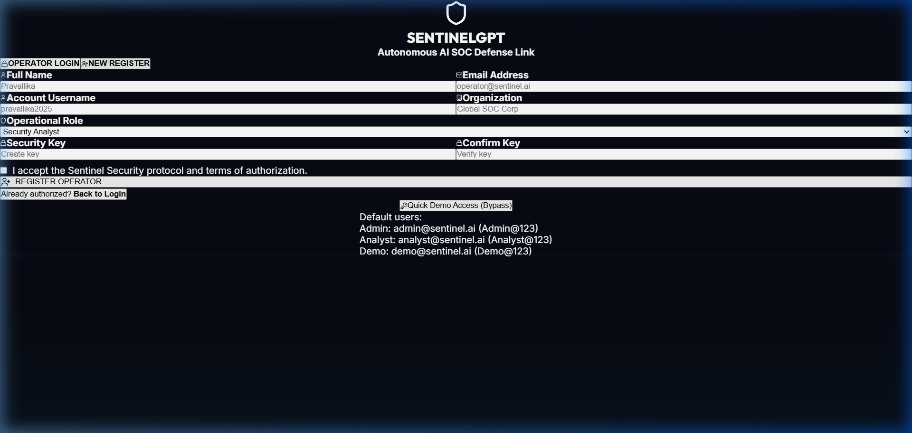
Figure: Operator Registration & Organization Setup Portal
5. Conversational AI Assistant & Payload Scanner
To accelerate incident triage, SentinelGPT integrates a conversational AI security assistant trained on threat signatures and MITRE ATT&CK techniques, alongside a static payload scanner for analyzing suspicious log files and executables.
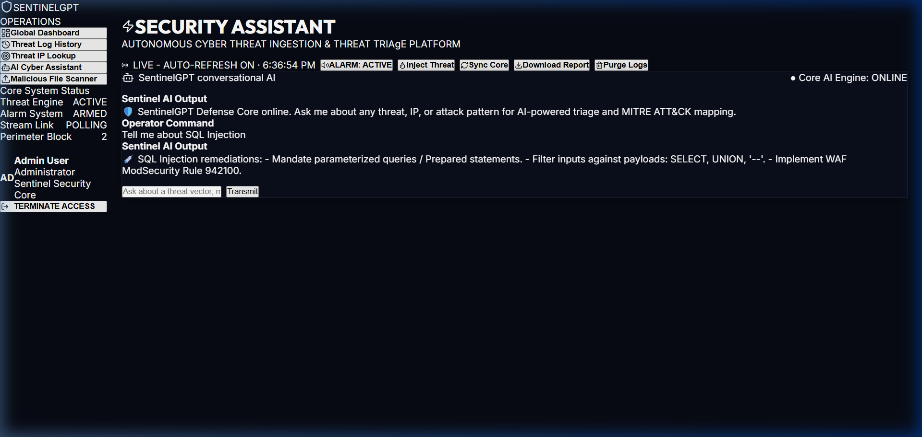
Figure: Conversational AI Threat Triage Assistant Interface
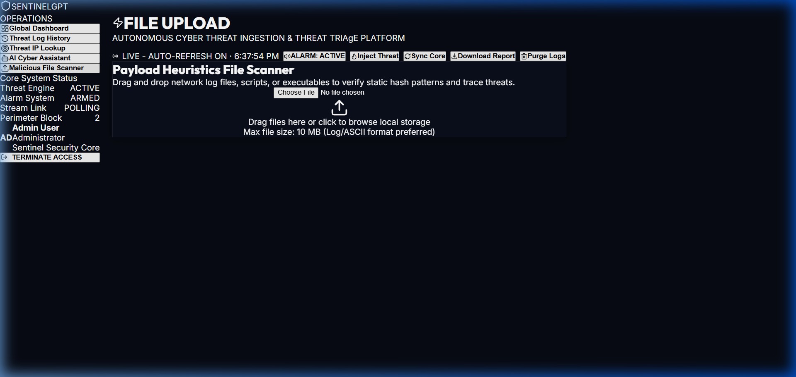
Figure: Heuristic Payload & Static Log File Scanner
6. API Endpoints & Live Deployment
The backend exposes standard REST endpoints for telemetry queries, incident history export, and automated IP quarantine control:
Endpoint | HTTP Method | Functionality
/api/login | POST | Authenticates operator, returns JWT token
/api/snapshot | GET | Retrieves telemetry snapshot, logs & quarantine list
/api/block_ip | POST | Adds target IP address to active firewall quarantine
/api/unblock_ip | POST | Revokes quarantine for target IP address
/health | GET | Returns live serverless system health status
Live Deployment Details:
• Production Web App: https://sentinelgpt-ai.vercel.app
• Interactive Swagger API Docs: https://sentinelgpt-ai.vercel.app/docs
• GitHub Repository: https://github.com/Pravallika2025/sentigraud-ai-.git

