WEEK 2 | LOGISTICS DATA ANALYST INTERNSHIP
Data Collection,
Cleaning, and
Preprocessing
A documented Python workflow using the DataCo SMART Supply Chain dataset

Report details | Information
Prepared by | Pravallika Gurubhagavatula
Programme | Logistics Data Analyst Intern
Task | Week 2: Data Collection, Cleaning, and Preprocessing for Logistics Analysis
Dataset | DataCo SMART Supply Chain for Big Data Analysis
Report date | 15 October 2026

Practical focus
This report documents the actual preprocessing run, explains the decisions made, presents the numerical evidence, and identifies limitations that matter before downstream logistics analysis.

Executive Summary
This task used a public supply-chain transaction dataset to simulate a logistics data collection and preprocessing workflow. The main CSV was read from the local project folder, profiled with pandas, cleaned using documented column and validity rules, reviewed for statistical outliers, and transformed into a separate Min-Max-scaled feature file. The original raw file was preserved.
Measure | Verified result
Source records | 180,519 rows × 53 columns
Local source file size | 95,910,149 bytes
Exact duplicate rows | 0
Columns removed | 8 (missingness, irrelevance, or privacy/data minimisation)
Records removed by cleaning rules | 0
Final cleaned dataset | 180,519 rows × 46 columns
Missing cells in retained cleaned dataset | 0
Numerical features normalized | 8; observed scaled range 0.0–1.0
Outlier handling | IQR flags recorded for investigation; no outlier rows deleted

Main conclusions
- The four fields containing missing values accounted for all 336,209 missing cells in the source file. They were excluded from the task-specific cleaned table; no imputation was performed.
- No fully duplicated records, missing required-field rows, negative shipping durations, non-positive item quantities, negative prices, or shipping-before-order-date records were flagged by the checks implemented.
- The IQR rule flagged 35,701 schedule-variance values (19.78%) and 18,942 order-profit values (10.49%). These were retained because statistical outliers are not necessarily errors.
- All eight selected numeric feature columns were scaled to the 0–1 range. The scaled file is a preprocessing demonstration, not a trained predictive model.
Scope note: the work is a reproducible preprocessing exercise based on an existing public dataset. It is not a live production data-ingestion system, and no predictive model was trained as part of this task.

1. Task Objective and Data Collection Simulation
The objective was to prepare logistics data for reliable downstream analysis by identifying data-quality problems, choosing appropriate treatments, documenting the process in Python, and reflecting on the effect of data quality on business decisions.

1.1 Public dataset selection
The project uses the DataCo SMART Supply Chain for Big Data Analysis dataset released by Constante, Silva, and Pereira on Mendeley Data. The repository describes structured transaction data covering supply chain activity such as provisioning, production, sales, and commercial distribution, alongside a separate clickstream file and a variable-description file [1].
The local file used in this task was DataCoSupplyChainDataset.csv. PowerShell reported a file length of 95,910,149 bytes. The CSV was loaded with encoding="latin-1", which allowed the file to be read without an encoding exception. The dataset was downloaded in advance and placed in data/raw/; no API connection, scheduled extract, or live logistics-system integration was implemented.

1.2 Fields relevant to logistics
The source contained order identifiers, delivery status, shipping mode, market and region, scheduled and actual shipping days, sales/order-item amounts, order dates and shipping dates, customer and product fields, and other transaction attributes. The Week 2 workflow focused on fields needed to inspect shipment duration and schedule variance while removing direct customer identifiers that were not required.

1.3 Reproducible folder structure
LogisticsAnalytics_Week1/
├── data/
│ ├── raw/DataCoSupplyChainDataset.csv # unchanged source
│ └── processed/ # generated output tables
├── outputs/charts/ # quality and preprocessing figures
└── src/
├── week2_data_preprocessing.py # profiling + cleaning + scaling
└── week2_create_report_visuals.py # report charts

The preprocessing script writes separate output files so the input dataset remains unchanged. Generated full-size cleaned and normalized CSVs are local working outputs and should not be committed to GitHub if their size is unnecessary.

2. Initial Data-Quality Assessment
The first audit identified 180,519 records and 53 columns. A full-row duplicate check returned zero. Missing values were concentrated in four columns, and the sum of those missing cells equalled the total missing-cell count reported for the source file.
Column | Missing count | Missing % | Initial interpretation
Product Description | 180,519 | 100.0000% | No observed non-missing values
Order Zipcode | 155,679 | 86.2397% | Most values unavailable
Customer Lname | 8 | 0.0044% | Direct identifier, not required
Customer Zipcode | 3 | 0.0017% | Fine-grained location field, not required

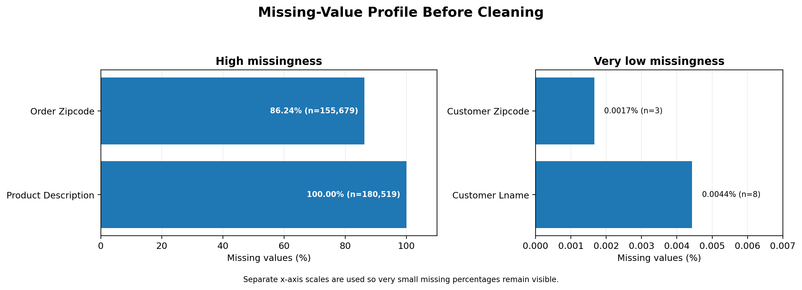
Figure 1. Missing-value profile before cleaning. Separate scales are used so very small percentages remain visible.
The counts sum to 336,209 missing cells: 180,519 + 155,679 + 8 + 3 = 336,209. The low missingness percentages for the last name and customer ZIP fields round to 0.00% at two decimal places; the more precise values are shown in the figure and table.

2.1 Why profile before cleaning?
Profiling before modifying a dataset prevents accidental loss of evidence. In pandas, isna().sum() counts missing entries by column and duplicated().sum() counts exact duplicate rows. These checks help distinguish column-level missingness from incomplete records. Pandas documentation describes multiple missing-value sentinels and the use of dropna() and fillna() for different handling choices [2].

3. Cleaning Methodology and Decisions
The cleaning rules were based on analytical relevance, missingness, privacy/data minimisation, and basic validity checks. The purpose was not to make the table look smaller at any cost; it was to retain complete fields needed for this particular analysis without discarding valid shipment records.
Issue / field | Evidence | Treatment | Reason
Product Description | 100% missing; unusable for this analysis | Drop column | No information can be recovered from this column as supplied.
Order Zipcode | 86.24% missing; not used in market/mode analysis | Drop column | High missingness and low relevance to the selected analysis.
Customer Email | No missing values; direct identifier | Drop column | Not needed for KPI/preprocessing task; data minimisation.
Customer Password | No missing values; credential-like field | Drop column | Sensitive field; must not be used or redistributed for analysis.
Customer Fname / Customer Lname | Direct personal identifiers; last name has 8 missing values | Drop both columns | Not required for logistics cleaning objective.
Customer Street / Customer Zipcode | Detailed personal location fields; 3 ZIP values missing | Drop both columns | Not needed for the selected analysis; avoids unnecessary location identifiers.
Exact duplicate rows | 0 found | No removal | Repeated order identifiers can represent multiple legitimate line items.
Required analytical fields | 0 rows missing at least one required field | No row removal | No missing value required dropping an observation.
Negative shipping duration | 0 rows flagged | No row removal | No impossible negative actual/scheduled shipping-day values were found.

3.1 Type standardisation and feature engineering
Date fields (order date (DateOrders) and shipping date (DateOrders)) were converted using pandas datetime parsing. Numeric columns used for shipment duration, price, sales and profit were converted to numeric types with invalid parses configured to become missing values, so they could be identified in the quality checks. Selected categorical fields were cast to string type, trimmed of surrounding whitespace and empty strings were converted to missing values.
One derived feature was created: Shipping Delay Days = Days for shipping (real) - Days for shipment (scheduled). It retains the sign of schedule variance: negative values indicate shipment earlier than the scheduled duration, zero indicates equal duration, and positive values indicate shipment duration beyond schedule. This feature is useful for analysis, but because it directly incorporates actual and scheduled shipping duration, it should not automatically be treated as an independent predictor of a status that is itself based on delivery timing.

3.2 Why no mean/median imputation was applied
The missing values were located only in fields that were removed for this task. After those exclusions, the retained table had zero missing cells, and no rows had missing values in required analytical fields. Therefore, filling a mean, median or mode would have changed no required field and was not necessary for the observed data. For another dataset—or if a required numeric field became incomplete—median imputation may be an option, but it should be justified from the field distribution and fitted on training data only when building a model.
# Missing-value profile
missing_count = df.isna().sum()
missing_pct = (missing_count / len(df)) * 100

# Exact duplicate check (do not deduplicate by Order Id alone)
duplicate_rows = int(df.duplicated().sum())
if duplicate_rows:
df = df.drop_duplicates()

# Remove task-irrelevant / sensitive fields
columns_to_drop = [
"Product Description", "Order Zipcode", "Customer Email",
"Customer Password", "Customer Fname", "Customer Lname",
"Customer Street", "Customer Zipcode"
]
df = df.drop(columns=columns_to_drop, errors="ignore")

# Schedule variance
df["Shipping Delay Days"] = (
df["Days for shipping (real)"]
- df["Days for shipment (scheduled)"]
)

4. Outlier Detection Using the IQR Rule
The interquartile range (IQR) was used as a distribution-based flagging method. For each numeric field, Q1 and Q3 were calculated; the IQR is Q3 minus Q1. Potential outliers are observations below Q1 − 1.5 × IQR or above Q3 + 1.5 × IQR. NIST describes these inner fences as a standard box-plot method for identifying potential outliers, while cautioning that outliers must be investigated rather than automatically discarded [3].
q1 = series.quantile(0.25)
q3 = series.quantile(0.75)
iqr = q3 - q1
lower_fence = q1 - 1.5 * iqr
upper_fence = q3 + 1.5 * iqr
flagged = (series < lower_fence) | (series > upper_fence)
outlier_count = int(flagged.sum())
outlier_percent = 100 * flagged.mean()

Numeric field | Q1 | Q3 | Lower fence | Upper fence | Flagged n | Flagged %
Days for shipping (real) | 2.00 | 5.00 | -2.50 | 9.50 | 0 | 0.00%
Days for shipment (scheduled) | 2.00 | 4.00 | -1.00 | 7.00 | 0 | 0.00%
Shipping Delay Days | 0.00 | 1.00 | -1.50 | 2.50 | 35,701 | 19.78%
Order Item Quantity | 1.00 | 3.00 | -2.00 | 6.00 | 0 | 0.00%
Order Item Product Price | 50.00 | 199.99 | -174.99 | 424.98 | 2,048 | 1.13%
Order Item Total | 104.38 | 247.40 | -110.15 | 461.93 | 1,943 | 1.08%
Sales | 119.98 | 299.95 | -149.98 | 569.91 | 488 | 0.27%
Order Profit Per Order | 7.00 | 64.80 | -79.70 | 151.50 | 18,942 | 10.49%

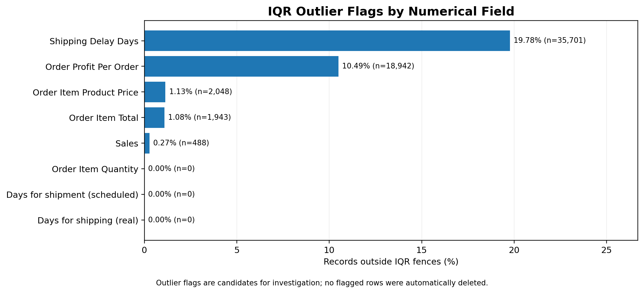
Figure 2. Percentage and count of observations outside the IQR fences for each numeric field.

4.1 Interpretation
Shipping Delay Days has Q1 = 0, Q3 = 1 and IQR = 1, so its fences are −1.5 and +2.5 days. Because the observed delay values are integer-valued, −2, +3 and +4 fall outside those fences. The observed counts were 21,666 at −2 days, 7,052 at +3 days and 6,983 at +4 days, totalling 35,701 (19.78%).
The other large flagged group was Order Profit Per Order: 18,942 records (10.49%) lay outside its fences of approximately −79.70 to +151.50. Price, item-total and sales fields had smaller flag rates of 1.13%, 1.08% and 0.27%, respectively. No outliers were flagged by the 1.5 × IQR rule for actual shipping days, scheduled shipping days or item quantity.
These results identify candidates for review, not data errors. A long shipping delay may be an operational problem worth retaining; unusual profit can be a genuine high- or low-margin transaction. The report pipeline records the flags but does not winsorise, cap or remove them. Any later correction would require business validation and a documented rule.

5. Schedule-Variance Distribution and Consistency Check
The distribution of Shipping Delay Days contains seven integer values, from −2 through +4. The most frequent value was +1 day (60,647 records), followed by 0 days (33,753) and +2 days (28,718).
Delay (days) | Records | Share of all rows | Interpretation
-2 | 21,666 | 12.00% | Earlier than schedule
-1 | 21,700 | 12.02% | Earlier than schedule
0 | 33,753 | 18.70% | Equal to schedule
+1 | 60,647 | 33.60% | Longer than scheduled duration
+2 | 28,718 | 15.91% | Longer than scheduled duration
+3 | 7,052 | 3.91% | Longer than scheduled duration
+4 | 6,983 | 3.87% | Longer than scheduled duration

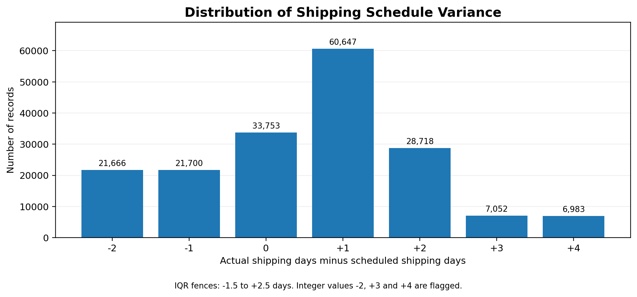
Figure 3. Record counts for each observed difference between actual and scheduled shipping days.

5.1 Relationship to delivery status
Schedule variance | Within-row delivery-status distribution
-2 | Advance shipping 96.3%; Shipping canceled 3.7%
-1 | Advance shipping 95.5%; Shipping canceled 4.5%
0 | Shipping on time 95.4%; Shipping canceled 4.6%
+1 | Late delivery 95.6%; Shipping canceled 4.4%
+2 | Late delivery 95.9%; Shipping canceled 4.1%
+3 | Late delivery 96.0%; Shipping canceled 4.0%
+4 | Late delivery 95.9%; Shipping canceled 4.1%

The close alignment between schedule variance and delivery status is an internal consistency check, not independent causal evidence. The variables encode closely related timing information. For future modelling, using actual shipping duration or the derived difference to predict a status that is determined from the same outcome can create target leakage, depending on when those fields become available. Predictors must be restricted to information available at the intended prediction time.

6. Numerical Normalization
Min-Max normalization transforms each selected feature to the range 0–1 using x_scaled = (x − x_min) / (x_max − x_min). It preserves the ordering of values within a feature while making their numerical ranges comparable. The scikit-learn documentation describes the same formula for MinMaxScaler and notes that scaling does not remove the influence of outliers [4].
# Demonstration used for the separate Week 2 normalized output
numeric_for_scaling = df[numeric_columns].apply(pd.to_numeric, errors="coerce")
minimum = numeric_for_scaling.min()
maximum = numeric_for_scaling.max()
span = maximum - minimum
safe_span = span.mask(span.eq(0), 1)
normalized = (numeric_for_scaling - minimum) / safe_span
normalized = normalized.where(span.ne(0), 0)
normalized.to_csv("week2_normalized_features.csv", index=False)

Feature | Original minimum | Original maximum | Observed normalized range
Days for shipping (real) | 0.00 | 6.00 | 0.000–1.000
Days for shipment (scheduled) | 0.00 | 4.00 | 0.000–1.000
Shipping Delay Days | -2.00 | 4.00 | 0.000–1.000
Order Item Quantity | 1.00 | 5.00 | 0.000–1.000
Order Item Product Price | 9.99 | 1,999.99 | 0.000–1.000
Order Item Total | 7.49 | 1,939.99 | 0.000–1.000
Sales | 9.99 | 1,999.99 | 0.000–1.000
Order Item Profit Ratio | -2.75 | 0.50 | 0.000–1.000

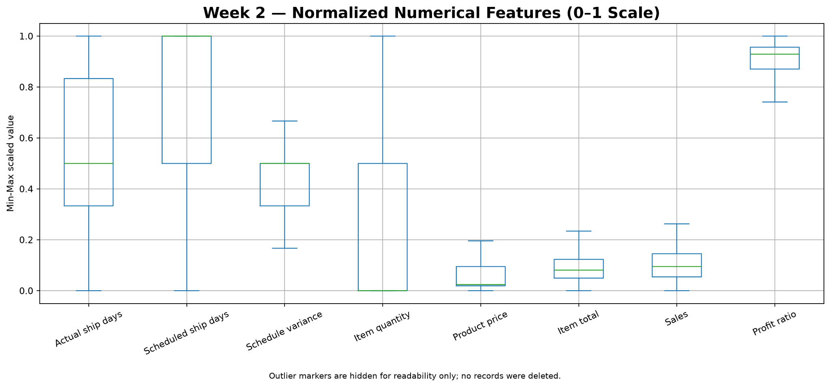
Figure 4. Box plots of the eight Min-Max-normalized numeric features. Fliers are hidden in this visual for legibility; the normalized output itself retains the values.

6.1 Important limitation for later machine learning
In this Week 2 demonstration, the min and max were calculated from all 180,519 rows to produce an exploratory normalized file. This is acceptable as an illustration of the transformation, but it must not be reused unchanged as the evaluation setup for a predictive model. For future modelling, split the data first, fit the scaler on training records only, and transform validation/test records using those training-set parameters. Scikit-learn identifies fitting preprocessing on the full dataset as a form of leakage that can bias evaluation [5].

7. Post-Cleaning Validation
The cleaned data and normalized output were checked after the pipeline finished. All the checks below were run locally against the generated CSV files.
Validation check | Observed result | Status
Cleaned dataset shape | 180,519 × 46 | Pass
Missing cells in cleaned data | 0 | Pass
Exact duplicate rows in cleaned data | 0 | Pass
Delay formula mismatches | 0 | Pass
Negative actual shipping days | 0 | Pass
Negative scheduled shipping days | 0 | Pass
Normalized output shape | 180,519 × 8 | Pass
Cleaned vs normalized row counts | Match | Pass
Missing normalized values | 0 | Pass
Overall normalized minimum / maximum | 0.000000 / 1.000000 | Pass
All normalized values within [0,1] | True | Pass

7.1 Data transformations recap
The final cleaned dataset has 46 columns: 53 initial columns − 8 removed columns + 1 engineered schedule-variance column = 46. Because no required-field rows failed the row-level checks, the record count remained 180,519. This is important: the reduction in missing cells came from excluding columns—not from imputing all source missing values or dropping shipment records.

8. Reproduction and Code Documentation
The project separates data processing from visualisation. week2_data_preprocessing.py creates the profiles, cleaning-decision log, quality flags, IQR summary, normalized file and validation-ready outputs. week2_create_report_visuals.py reads those generated files and creates report charts; it does not modify the raw or cleaned dataset.

8.1 Essential pandas checks
from pathlib import Path
import pandas as pd

ROOT = Path(__file__).resolve().parents[1]
RAW_FILE = ROOT / "data" / "raw" / "DataCoSupplyChainDataset.csv"
df = pd.read_csv(RAW_FILE, encoding="latin-1", low_memory=False)

print("Shape:", df.shape)
print("Exact duplicate rows:", int(df.duplicated().sum()))
missing = df.isna().sum().sort_values(ascending=False)
print(missing[missing > 0])

8.2 Type validation and derived feature
for col in ["order date (DateOrders)", "shipping date (DateOrders)"]:
df[col] = pd.to_datetime(df[col], errors="coerce")

for col in ["Days for shipping (real)", "Days for shipment (scheduled)"]:
df[col] = pd.to_numeric(df[col], errors="coerce")

df["Shipping Delay Days"] = (
df["Days for shipping (real)"]
- df["Days for shipment (scheduled)"]
)

8.3 Handling missingness in a different case
No imputation was required for the retained fields in this dataset. If a required numeric feature were missing in a future dataset, median imputation could be tested as one candidate approach after assessing the missingness mechanism and distribution. In a predictive pipeline, imputation statistics must be estimated from training data only.
# Future example only; median imputation was NOT applied to this dataset
from sklearn.impute import SimpleImputer
from sklearn.preprocessing import MinMaxScaler
from sklearn.pipeline import make_pipeline

preprocess = make_pipeline(
SimpleImputer(strategy="median"), MinMaxScaler()
)
# Fit on training data only; transform validation/test data.

8.4 Re-run commands
# Run from the LogisticsAnalytics_Week1 project root
python .\src\week2_data_preprocessing.py
python .\src\week2_create_report_visuals.py

# Local outputs of the pipeline are stored in:
# data/processed/week2_*.csv
# outputs/charts/WEEK2_REPORT_*.png

9. Reflection: Why Data Quality Matters in Logistics
Data quality has a direct effect on how a logistics team interprets performance. If shipment dates are parsed incorrectly, schedule variance can be miscalculated. If repeated line-item rows are mistaken for duplicated orders, valid transactions could be removed. If customer identifiers are retained unnecessarily, the dataset exposes more personal information than the analysis needs. If valid extreme delays are removed automatically, the analysis may understate the operational problems that a manager needs to investigate.
The preprocessing run showed why each check must be interpreted in context. The dataset contained a high number of missing cells, but those cells were concentrated in four fields, including one with no values at all and one with 86.24% missingness. The other four columns removed were excluded for relevance or privacy rather than missingness. No shipment rows needed to be dropped under the required-field or negative-duration rules. The IQR results were preserved as flags to support review, and normalization was stored separately so business-scale values remained available in the cleaned file.

9.1 How the results support decisions
- Data engineers can use the cleaning-decision log to reproduce exactly which fields were removed and why.
- Logistics analysts can use schedule-variance counts to prioritise investigation of unusually early or late shipments rather than treating all outliers as errors.
- Business stakeholders can distinguish a measurement problem from a genuine exception that may affect service levels or costs.
- Model developers can start from a retained dataset with validated types and a separate scaled feature file, while still applying training-only fit procedures before model evaluation.
- Privacy-aware reporting avoids carrying customer email, password, names, street and ZIP-code fields into a task where they add no value.

Conclusion
This task completed a traceable preprocessing workflow on 180,519 logistics records. The workflow profiled the public data source, quantified missingness, removed eight non-essential or sensitive columns, standardized data types, engineered schedule variance, checked validity conditions, flagged IQR outliers without deleting them, normalized eight numeric features, and verified that the retained cleaned data had no missing cells or exact duplicate rows. All validation checks reported in this document passed.
The main limitation is that the dataset was prepared for a simulated analytical exercise rather than a live logistics integration, and the normalized values were generated before any train/test modelling split. Future work should retain the same transparent cleaning log, investigate flagged cases with business context, and fit all learned preprocessing steps only on training data when predictive modelling begins.

References
[1] Constante, F., Silva, F., & Pereira, A. (2019). DataCo SMART SUPPLY CHAIN FOR BIG DATA ANALYSIS (Version 5). Mendeley Data. https://doi.org/10.17632/8gx2fvg2k6.5
[2] pandas development team. Working with missing data. pandas documentation. https://pandas.pydata.org/docs/user_guide/missing_data.html
[3] NIST/SEMATECH. Detection of Outliers; and Box Plot. Engineering Statistics Handbook. https://www.itl.nist.gov/div898/handbook/eda/section3/eda35h.htm and https://www.itl.nist.gov/div898/handbook/eda/section3/boxplot.htm
[4] scikit-learn developers. MinMaxScaler. https://scikit-learn.org/stable/modules/generated/sklearn.preprocessing.MinMaxScaler.html
[5] scikit-learn developers. Common pitfalls and recommended practices: data leakage and inconsistent preprocessing. https://scikit-learn.org/stable/common_pitfalls.html
Dataset citation/licence note: the Mendeley record identifies the dataset as CC BY 4.0. The source is credited here and in the report; the raw CSV is not embedded in the deliverable.

