LOGISTICS DATA ANALYTICS
Advanced Data Analysis and Visualization
WEEK 3 PROJECT REPORT

A reproducible exploratory analysis of a hypothetical logistics operation

Prepared by: Pravallika Gurubhagatavula
Programme: Logistics Data Analyst Intern
Organisation: YuvaIntern
Analysis period represented: January–December 2025
Dataset: 5,000 synthetic shipment records

IMPORTANT DATA NOTE
All shipment records and results in this report are synthetic and were generated for an educational assignment. They do not represent a real company or actual logistics operations.

Executive Summary
This project explores a hypothetical logistics operation using a reproducible dataset of 5,000 synthetic shipments and 16 variables. The analysis examines delivery outcomes, service-mode performance, regional differences, monthly and quarterly patterns, transportation costs, numerical distributions and correlations.
The dataset contains no missing cells, exact duplicate rows or duplicate shipment identifiers. The late-delivery indicator was independently checked against the documented rule: a shipment is late when actual delivery time exceeds promised delivery time.
The simulated late-delivery rate is 27.76%. Express has the highest late rate at 40.65%, even though it has the shortest mean actual delivery time. The East region has the highest regional late rate at 35.69%. The Q4 late rate is 37.36%, compared with 24.56% for January–September.
Mean transportation cost is INR 933.03 per shipment, while the median is INR 836.09. The difference indicates a right-skewed cost distribution.
These results demonstrate how exploratory analysis can help identify operational segments that deserve further investigation. Because the dataset is synthetic and some relationships are embedded in its generation formulas, the findings are illustrative rather than evidence about real logistics operations.

Key Results at a Glance
Measure | Result | Unit
Shipments analysed | 5,000 | shipments
Late shipments | 1,388 | shipments
Late-delivery rate | 27.76 | %
Mean actual delivery time | 1.67 | days
Mean transportation cost | INR 933.03 | per shipment
Mean schedule variance | -0.165 | days

Report Contents
- 1. Project Background and Objectives
- 2. Dataset Design and Simulation Assumptions
- 3. Analytical Methodology and Validation
- 4. Key Performance Indicators
- 5. Exploratory Data Analysis
- 6. Visual Analysis and Interpretation
- 7. Operational Insights and Recommendations
- 8. Limitations and Responsible Interpretation
- 9. Conclusion
- Appendix A. Python Code Illustrations
- Appendix B. Dataset Dictionary
- Appendix C. Reproducibility and Project Files

1. Project Background and Objectives
Logistics operations involve decisions about delivery promises, service modes, geographic coverage, shipment handling and transportation expenditure. Exploratory data analysis helps transform shipment-level records into summaries that can guide operational questions.

1.1 Business Scenario
The hypothetical organisation in this project manages shipments across five simulated regions using Economy, Standard and Express service modes. Each shipment has a distance, weight, volume, dispatch delay, disruption index, handling time, promised delivery duration, actual delivery duration and transportation cost.

1.2 Project Objectives
1. Generate a documented and reproducible hypothetical logistics dataset.
2. Validate dataset structure, identifiers, missing values and delivery calculations.
3. Summarise central tendency, spread, skewness and percentile behaviour.
4. Compare delivery performance across service modes and regions.
5. Explore monthly and quarterly patterns in shipment volume and late deliveries.
6. Examine relationships between distance, weight, delivery duration and cost.
7. Create visualisations that communicate operational patterns clearly.
8. Develop cautious, evidence-based recommendations for further operational investigation.

2. Dataset Design and Simulation Assumptions
The dataset was generated locally using Python and a fixed random seed. A fixed seed makes the simulation reproducible: repeated execution with the same script and environment produces the same generated records.

2.1 Dataset Profile
Dataset characteristic | Value
Records | 5,000
Variables | 16
Unique shipment identifiers | 5,000
Date coverage | 2025-01-01 to 2025-12-31
Regions | 5
Shipping modes | 3
Missing cells | 0
Exact duplicate rows | 0

2.2 Variable Groups
The 16 variables can be grouped into shipment identification and context, operational inputs, delivery performance and transportation cost.
- Shipment context: shipment_id, order_date, region and shipping_mode.
- Shipment attributes: distance_km, shipment_weight_kg and shipment_volume_m3.
- Operational factors: dispatch_delay_hours, disruption_index and handling_time_hours.
- Delivery measures: promised_delivery_days, actual_delivery_days, schedule_variance_days and late_delivery.
- Cost measures: fuel_surcharge_inr and transportation_cost_inr.

2.3 Simulation Assumptions
Distance, weight and volume were generated from bounded distributions. Promised delivery time was based partly on distance and service-mode assumptions. Actual delivery time included simulated operational delays, handling, disruption, regional and peak-period adjustments, and random variation. Transportation cost was generated from distance, shipment attributes, service-mode factors and a fuel surcharge component.
The simulation notes are retained in data/processed/week3_simulation_assumptions.txt. They should be treated as part of the analytical evidence because they describe how the dataset was constructed.

3. Analytical Methodology and Validation

3.1 Analysis Workflow
1. Generate the hypothetical dataset using a fixed random seed.
2. Load the CSV using pandas and inspect dimensions, data types and sample records.
3. Check missing values, duplicates, unique identifiers and invalid values.
4. Reconcile schedule variance with actual delivery time minus promised delivery time.
5. Validate the late-delivery indicator against the documented positive-variance rule.
6. Calculate descriptive statistics and grouped performance summaries.
7. Calculate Pearson and Spearman correlations for numerical variables.
8. Create charts and export analysis tables for reporting.
9. Interpret findings while keeping simulation limitations explicit.

3.2 Data Validation Results
Validation check | Observed result
Total records | 5,000
Total columns | 16
Missing cells | 0
Exact duplicate rows | 0
Duplicate shipment IDs | 0
Invalid dates | 0
Late-flag mismatches | 0
Maximum schedule variance reconciliation difference | 0.000
Negative distances | 0
Negative transportation costs | 0

The maximum reconciliation difference between the stored schedule variance and the recalculated value is effectively zero, allowing for floating-point precision. No invalid dates, negative distances or negative transportation costs were identified.

3.3 Delivery Outcome Definition
Schedule variance is calculated as actual delivery days minus promised delivery days. A negative value means the shipment arrived early; zero means it arrived exactly on schedule; a positive value means it arrived late.
schedule_variance_days = actual_delivery_days - promised_delivery_days
late_delivery = 1 if schedule_variance_days > 0 else 0

This definition matters because early shipments must not be counted as on-time shipments, and exactly-on-schedule shipments are a separate outcome.

4. Key Performance Indicators
The following indicators provide a consistent framework for evaluating the simulated operation.

4.1 Overall KPI Results
Metric | Value | Unit
Total shipments | 5,000 | shipments
Late shipments | 1,388 | shipments
Early shipments | 3,570 | shipments
Exactly on-schedule shipments | 42 | shipments
Late shipment rate | 27.760 | %
Early shipment rate | 71.400 | %
Exactly on-schedule rate | 0.840 | %
Mean actual delivery time | 1.668 | days
Median actual delivery time | 1.520 | days
Mean promised delivery time | 1.834 | days
Mean schedule variance | -0.165 | days
Mean transportation cost | 933.030 | INR
Median transportation cost | 836.085 | INR
Mean shipment distance | 737.584 | km
Mean cost per kilometre | 1.474 | INR/km

The mean schedule variance is approximately -0.165 days. Since schedule variance equals actual minus promised delivery duration, a negative mean indicates that the average shipment in this simulation arrived before its promised duration. It does not mean that every shipment was early: 1,388 shipments were classified late.

4.2 Cost Efficiency: Two Complementary Measures
Two different cost-per-kilometre measures are reported. The mean shipment-level ratio is the arithmetic average of each shipment's transportation cost divided by its distance. The weighted aggregate ratio divides total transportation cost by total shipment distance. They answer different questions and should not be treated as interchangeable.
Cost-efficiency measure | Value (INR/km)
Mean shipment-level cost per kilometre | 1.474
Total cost divided by total distance | 1.265

5. Exploratory Data Analysis

5.1 Central Tendency, Dispersion and Shape
Mean and median are used together because a mean can be influenced by unusually large observations. Standard deviation and quartiles describe spread, while skewness provides an indication of asymmetry.
Variable | Mean | Median | Standard Deviation | Q1 | Q3 | Maximum | Skewness
Distance (km) | 737.584 | 623.530 | 443.492 | 414.217 | 943.768 | 2,000 | 1.155
Weight (kg) | 47.086 | 34.700 | 43.533 | 20.605 | 58.263 | 525.890 | 3.213
Volume (m3) | 0.287 | 0.245 | 0.188 | 0.168 | 0.349 | 2.305 | 2.727
Dispatch delay (hours) | 4.035 | 3.355 | 2.884 | 1.940 | 5.332 | 20 | 1.459
Disruption index | 0.283 | 0.262 | 0.160 | 0.157 | 0.385 | 0.881 | 0.637
Handling time (hours) | 2.508 | 2.420 | 0.876 | 1.940 | 2.950 | 9.380 | 1.404
Promised delivery (days) | 1.833 | 1.660 | 0.721 | 1.320 | 2.160 | 4.730 | 1.398
Actual delivery (days) | 1.668 | 1.520 | 0.746 | 1.150 | 2.010 | 5.060 | 1.159
Schedule variance (days) | -0.165 | -0.180 | 0.298 | -0.370 | 0.030 | 0.920 | 0.159
Fuel surcharge (INR) | 121.906 | 107.490 | 62.831 | 76.050 | 153.030 | 505.620 | 1.120
Transport cost (INR) | 933.030 | 836.085 | 430.285 | 624.335 | 1,135.973 | 4,314.610 | 1.389

The distribution of shipment weight, volume, distance, actual delivery time and transportation cost is positively skewed to varying degrees. In particular, shipment weight has a skewness of 3.213 and volume has a skewness of 2.727. For these variables, the median and upper percentiles provide useful context alongside the mean.

5.2 Service-Mode Comparison
Service mode | Shipments | Late | Late rate (%) | Mean actual (days) | Mean promise (days) | Mean cost (INR)
Economy | 1,267 | 229 | 18.074 | 2.024 | 2.293 | 816.008
Express | 1,252 | 509 | 40.655 | 1.351 | 1.407 | 1,112.031
Standard | 2,481 | 650 | 26.199 | 1.646 | 1.814 | 902.461

Express has the shortest mean actual delivery time (1.351 days), but also the highest late rate (40.65%). Its mean promised delivery duration is 1.407 days, shorter than the corresponding values for Standard and Economy. This suggests that the delivery promise is an important part of service performance: a service can be faster in absolute time while still missing its tighter promise more often.

5.3 Regional Comparison
Region | Shipments | Late | Late rate (%) | Mean actual (days) | Mean cost (INR)
Central | 772 | 242 | 31.347 | 1.712 | 944.445
East | 975 | 348 | 35.692 | 1.738 | 953.911
North | 1,096 | 236 | 21.533 | 1.612 | 898.003
South | 1,043 | 297 | 28.476 | 1.674 | 946.853
West | 1,114 | 265 | 23.788 | 1.626 | 928.363

East has the highest simulated late rate (35.69%), followed by Central (31.35%). North has the lowest late rate (21.53%). The difference between East and North is approximately 14.16 percentage points. In an actual operation, this pattern would justify investigation of routes, carrier performance, dispatch processes and regional operating conditions.

5.4 Monthly and Quarterly Patterns
Month | Shipments | Late | Late rate (%) | Mean actual (days) | Mean cost (INR)
2025-01 | 406 | 100 | 24.631 | 1.662 | 937.573
2025-02 | 372 | 102 | 27.419 | 1.705 | 959.337
2025-03 | 457 | 125 | 27.352 | 1.672 | 929.075
2025-04 | 401 | 95 | 23.691 | 1.653 | 966.405
2025-05 | 415 | 103 | 24.819 | 1.637 | 929.172
2025-06 | 418 | 84 | 20.096 | 1.642 | 937.039
2025-07 | 436 | 104 | 23.853 | 1.598 | 930.675
2025-08 | 420 | 93 | 22.143 | 1.560 | 908.402
2025-09 | 425 | 115 | 27.059 | 1.600 | 910.582
2025-10 | 417 | 142 | 34.053 | 1.777 | 932.351
2025-11 | 407 | 154 | 37.838 | 1.771 | 932.323
2025-12 | 426 | 171 | 40.141 | 1.751 | 928.809

Quarterly comparison
Quarter | Shipments | Late | Late rate (%) | Mean actual (days) | Mean cost (INR)
2025Q1 | 1,235 | 327 | 26.478 | 1.678 | 940.984
2025Q2 | 1,234 | 282 | 22.853 | 1.644 | 943.936
2025Q3 | 1,281 | 312 | 24.356 | 1.586 | 916.706
2025Q4 | 1,250 | 467 | 37.360 | 1.766 | 931.135

The Q4 late rate is 37.36%, compared with 24.56% for January–September. The difference is 12.80 percentage points. The simulation assumptions explicitly include a small October–December peak-period pressure adjustment. Therefore, this pattern demonstrates how the simulated peak-period factor appears in the output; it must not be presented as independently discovered real-world seasonality.

5.5 Outlier Review
Variable | Flagged records | Flagged (%) | Lower IQR fence | Upper IQR fence
distance_km | 240 | 4.800 | -380.108 | 1,738.092
shipment_weight_kg | 317 | 6.340 | -35.881 | 114.749
shipment_volume_m3 | 242 | 4.840 | -0.104 | 0.621
dispatch_delay_hours | 199 | 3.980 | -3.149 | 10.421
disruption_index | 41 | 0.820 | -0.184 | 0.726
handling_time_hours | 127 | 2.540 | 0.425 | 4.465
promised_delivery_days | 227 | 4.540 | 0.060 | 3.420
actual_delivery_days | 200 | 4 | -0.140 | 3.300
schedule_variance_days | 39 | 0.780 | -0.970 | 0.630
fuel_surcharge_inr | 197 | 3.940 | -39.420 | 268.500
transportation_cost_inr | 162 | 3.240 | -143.121 | 1,903.429

The interquartile range method flags observations outside Q1 − 1.5 × IQR or Q3 + 1.5 × IQR. A flagged observation is not automatically an error. For example, a large shipment or high-cost long-distance shipment may be valid. The analysis therefore retains the records and treats the flags as prompts for business review rather than deletion instructions.

5.6 Correlation Analysis
Variable 1 | Variable 2 | Pearson r | Spearman rho
fuel_surcharge_inr | transportation_cost_inr | 0.935 | 0.941
shipment_weight_kg | shipment_volume_m3 | 0.922 | 0.812
promised_delivery_days | actual_delivery_days | 0.918 | 0.862
distance_km | fuel_surcharge_inr | 0.911 | 0.898
distance_km | promised_delivery_days | 0.878 | 0.878
distance_km | actual_delivery_days | 0.843 | 0.811
distance_km | transportation_cost_inr | 0.806 | 0.811
promised_delivery_days | fuel_surcharge_inr | 0.793 | 0.789
actual_delivery_days | fuel_surcharge_inr | 0.772 | 0.743
shipment_weight_kg | handling_time_hours | 0.758 | 0.593
shipment_volume_m3 | handling_time_hours | 0.723 | 0.545
actual_delivery_days | transportation_cost_inr | 0.600 | 0.607

Pearson correlation measures linear association, while Spearman correlation measures monotonic association using ranked values. Spearman is useful when variables are skewed or when the relationship may not be well represented by a straight line. Neither measure establishes causality.
The strongest displayed association is between fuel surcharge and total transportation cost (Spearman rho = 0.941). Distance and fuel surcharge also show a strong association (rho = 0.898). These results are consistent with the simulation's cost-generation structure, which explicitly uses distance and a fuel-surcharge component.

6. Visual Analysis and Interpretation
The visualisations were selected to match the analytical question. Bar charts compare categories, a line chart displays change over time, scatter plots examine relationships between two numerical measures, a histogram displays a distribution, a heatmap summarises correlations, and a box plot compares distributions across groups.
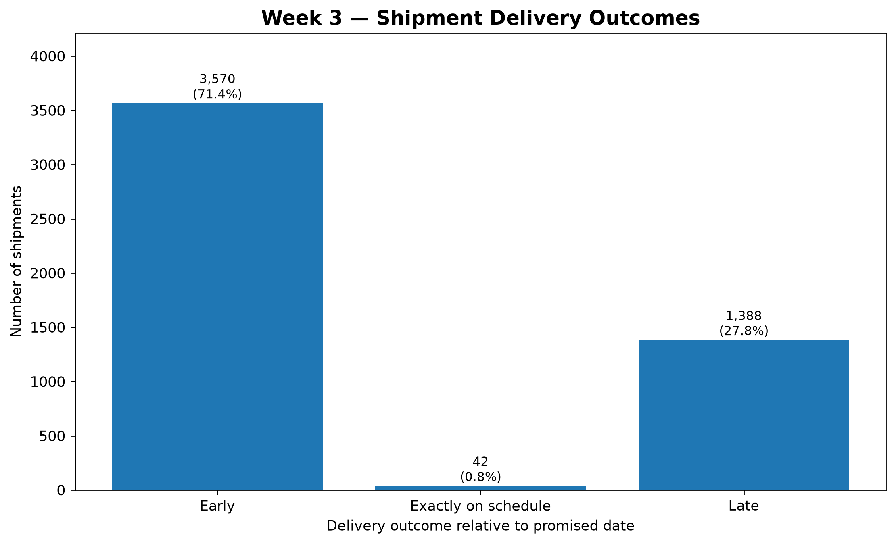
Figure 1. Shipment delivery outcomes
Chart choice: A bar chart is suitable for comparing shipment counts across three discrete delivery-outcome categories.
Interpretation: The chart separates shipments delivered early, exactly on schedule and late. It shows 71.40% early deliveries, 0.84% exactly on schedule and 27.76% late deliveries. This provides an overall view of service performance against promised dates.
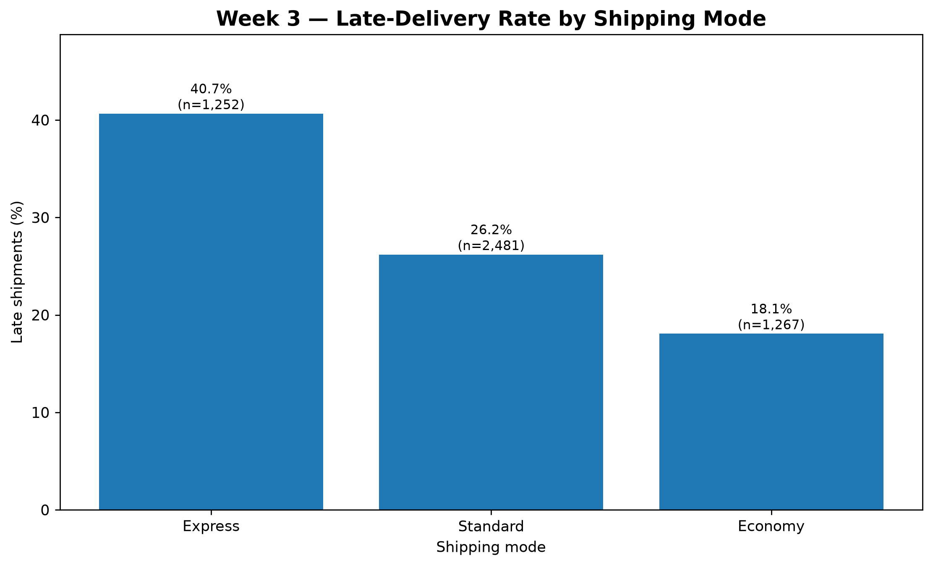
Figure 2. Late-delivery rate by shipping mode
Chart choice: A bar chart makes late-delivery percentages directly comparable across the three service modes. Sample sizes are included for context.
Interpretation: Express has the highest observed late rate (40.65%), followed by Standard (26.20%) and Economy (18.07%). The service-mode comparison should be interpreted alongside promised delivery windows and actual delivery durations.
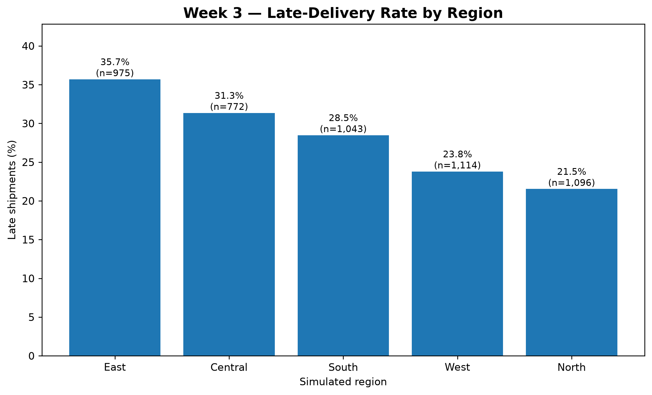
Figure 3. Late-delivery rate by simulated region
Chart choice: A bar chart provides a clear ranking of regional late-delivery rates on a common percentage scale.
Interpretation: East records the highest late rate (35.69%), while North records the lowest (21.53%). This identifies regions that would merit closer investigation in a real operation.
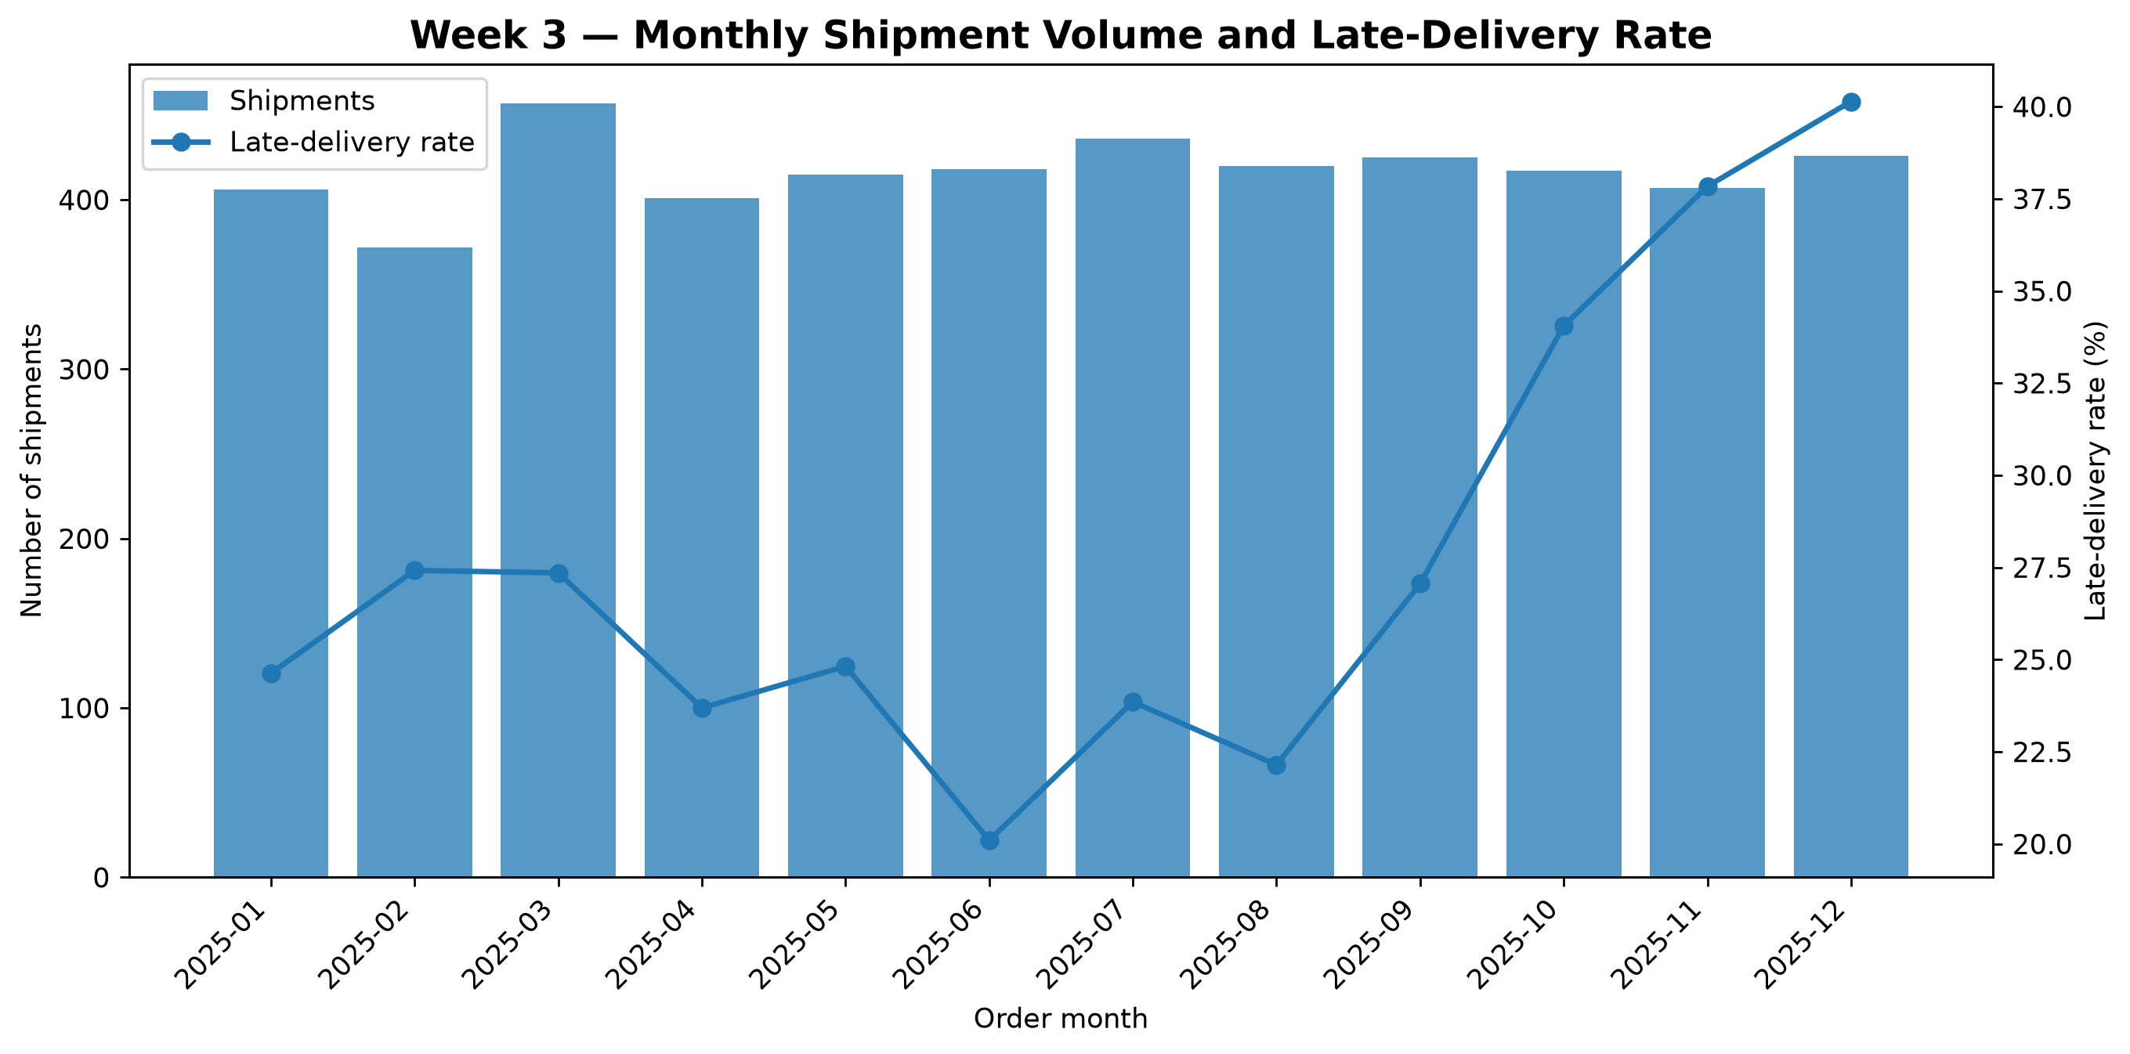
Figure 4. Monthly shipment volume and late-delivery rate
Chart choice: A combination chart uses bars for monthly shipment volume and a line for late-delivery rate, allowing two different time-based measures to be examined together using separate axes.
Interpretation: The combined chart compares shipment volume with the monthly late-delivery rate. The late rate rises in the final quarter, reaching 40.14% in December. The two axes represent different measures and should be read independently.
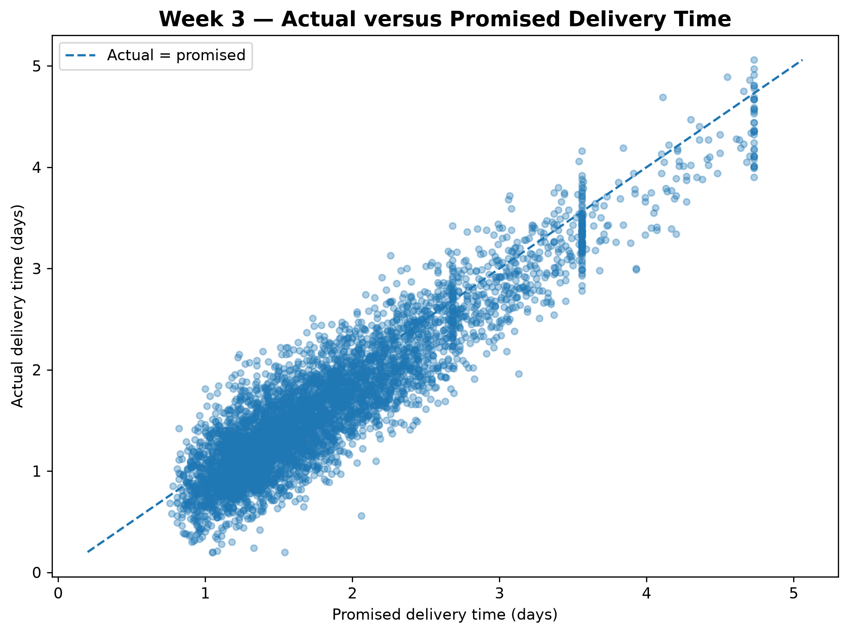
Figure 5. Actual versus promised delivery time
Chart choice: A scatter plot is appropriate for two continuous variables. The equality line helps distinguish early and late deliveries.
Interpretation: Each point represents a simulated shipment. The diagonal reference line represents actual delivery time equal to promised delivery time. Points above the line indicate late deliveries; points below the line indicate early deliveries.
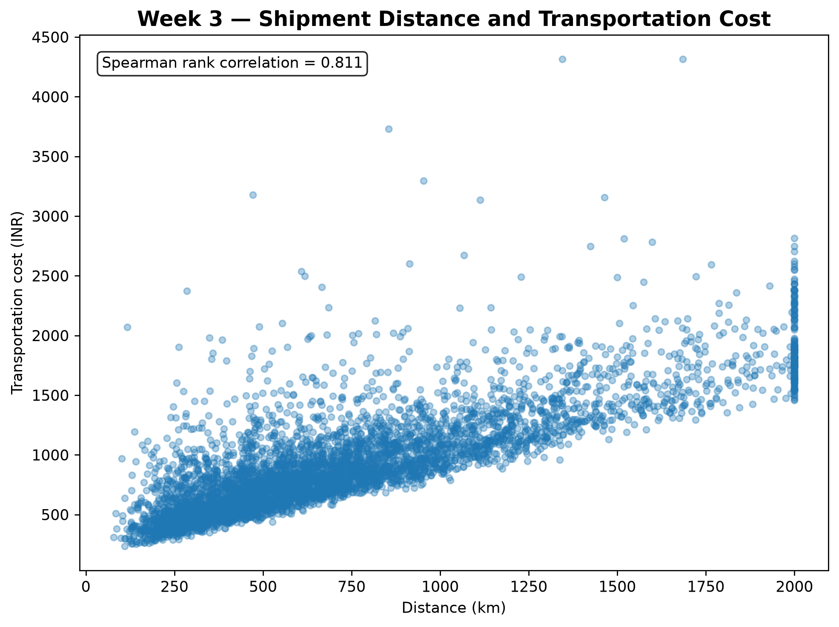
Figure 6. Shipment distance and transportation cost
Chart choice: A scatter plot shows the relationship between two numerical variables and helps reveal patterns, spread and unusual observations.
Interpretation: The scatter plot shows a strong positive monotonic association between distance and transportation cost (Spearman rho = 0.811). Longer simulated journeys generally have higher transportation costs. This association is partly built into the simulation formula.
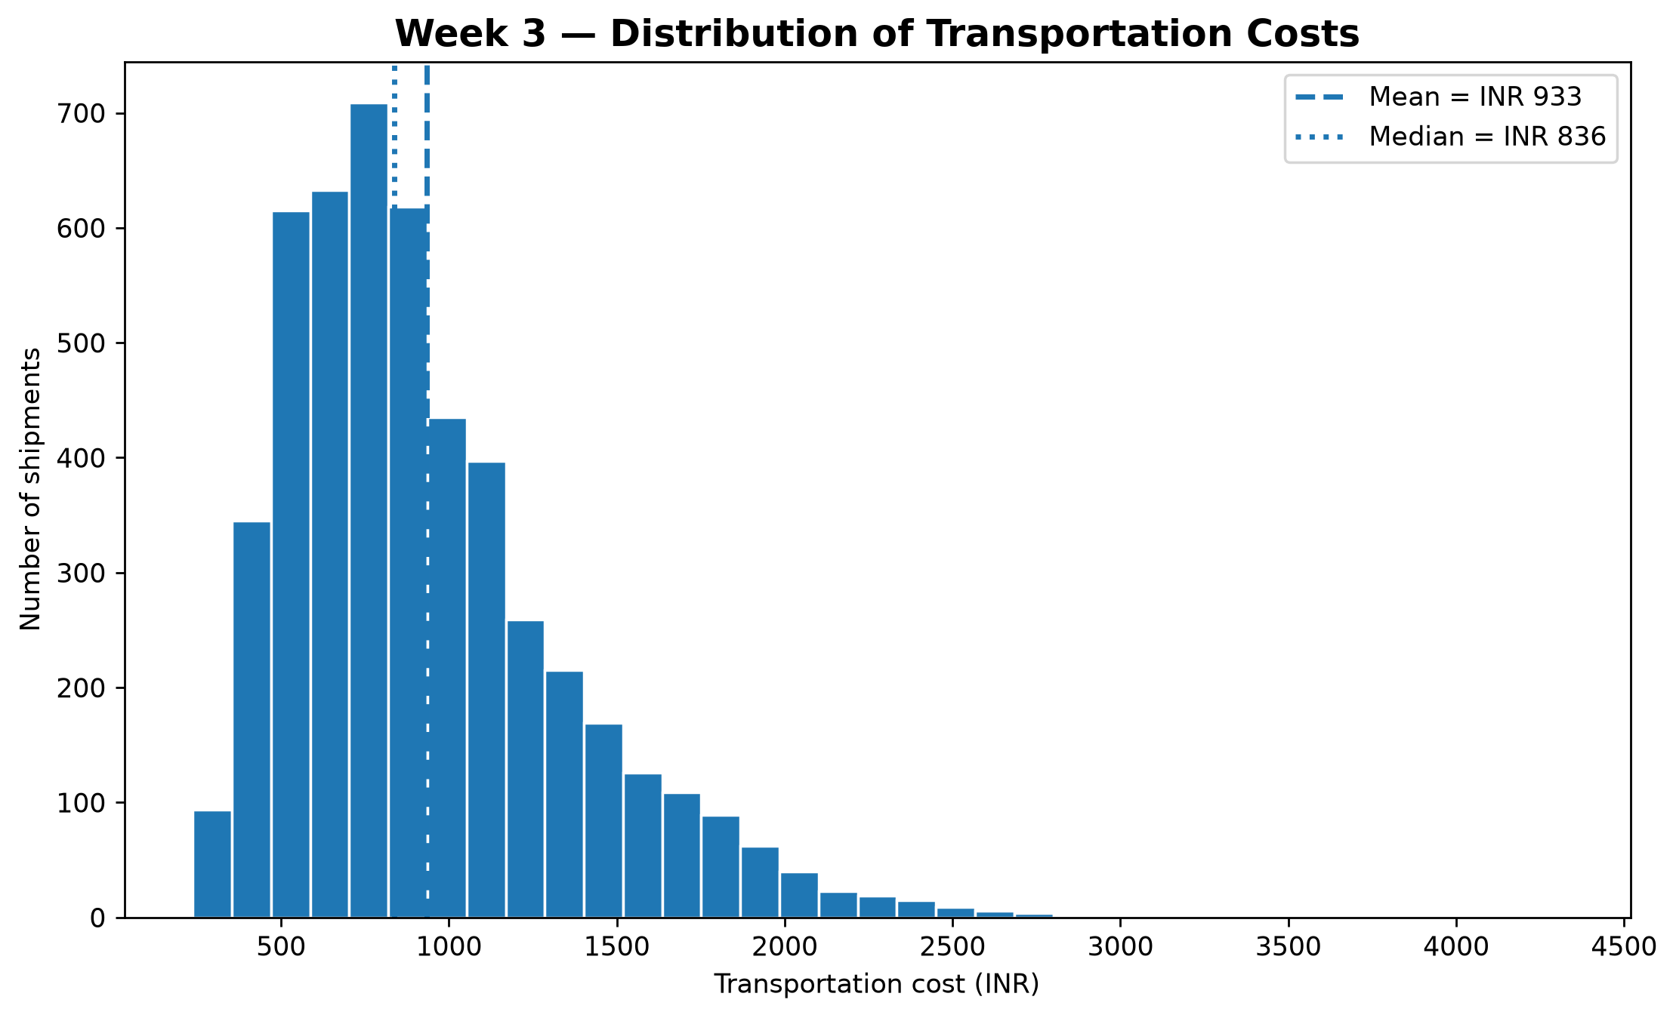
Figure 7. Distribution of transportation costs
Chart choice: A histogram shows the shape, concentration and skewness of the transportation-cost distribution. Mean and median markers aid comparison.
Interpretation: The distribution is right-skewed: most shipments fall in the lower-to-middle cost range, while a smaller number of shipments have substantially higher costs. The mean (INR 933.03) exceeds the median (approximately INR 836.09), reflecting the influence of higher-cost shipments.
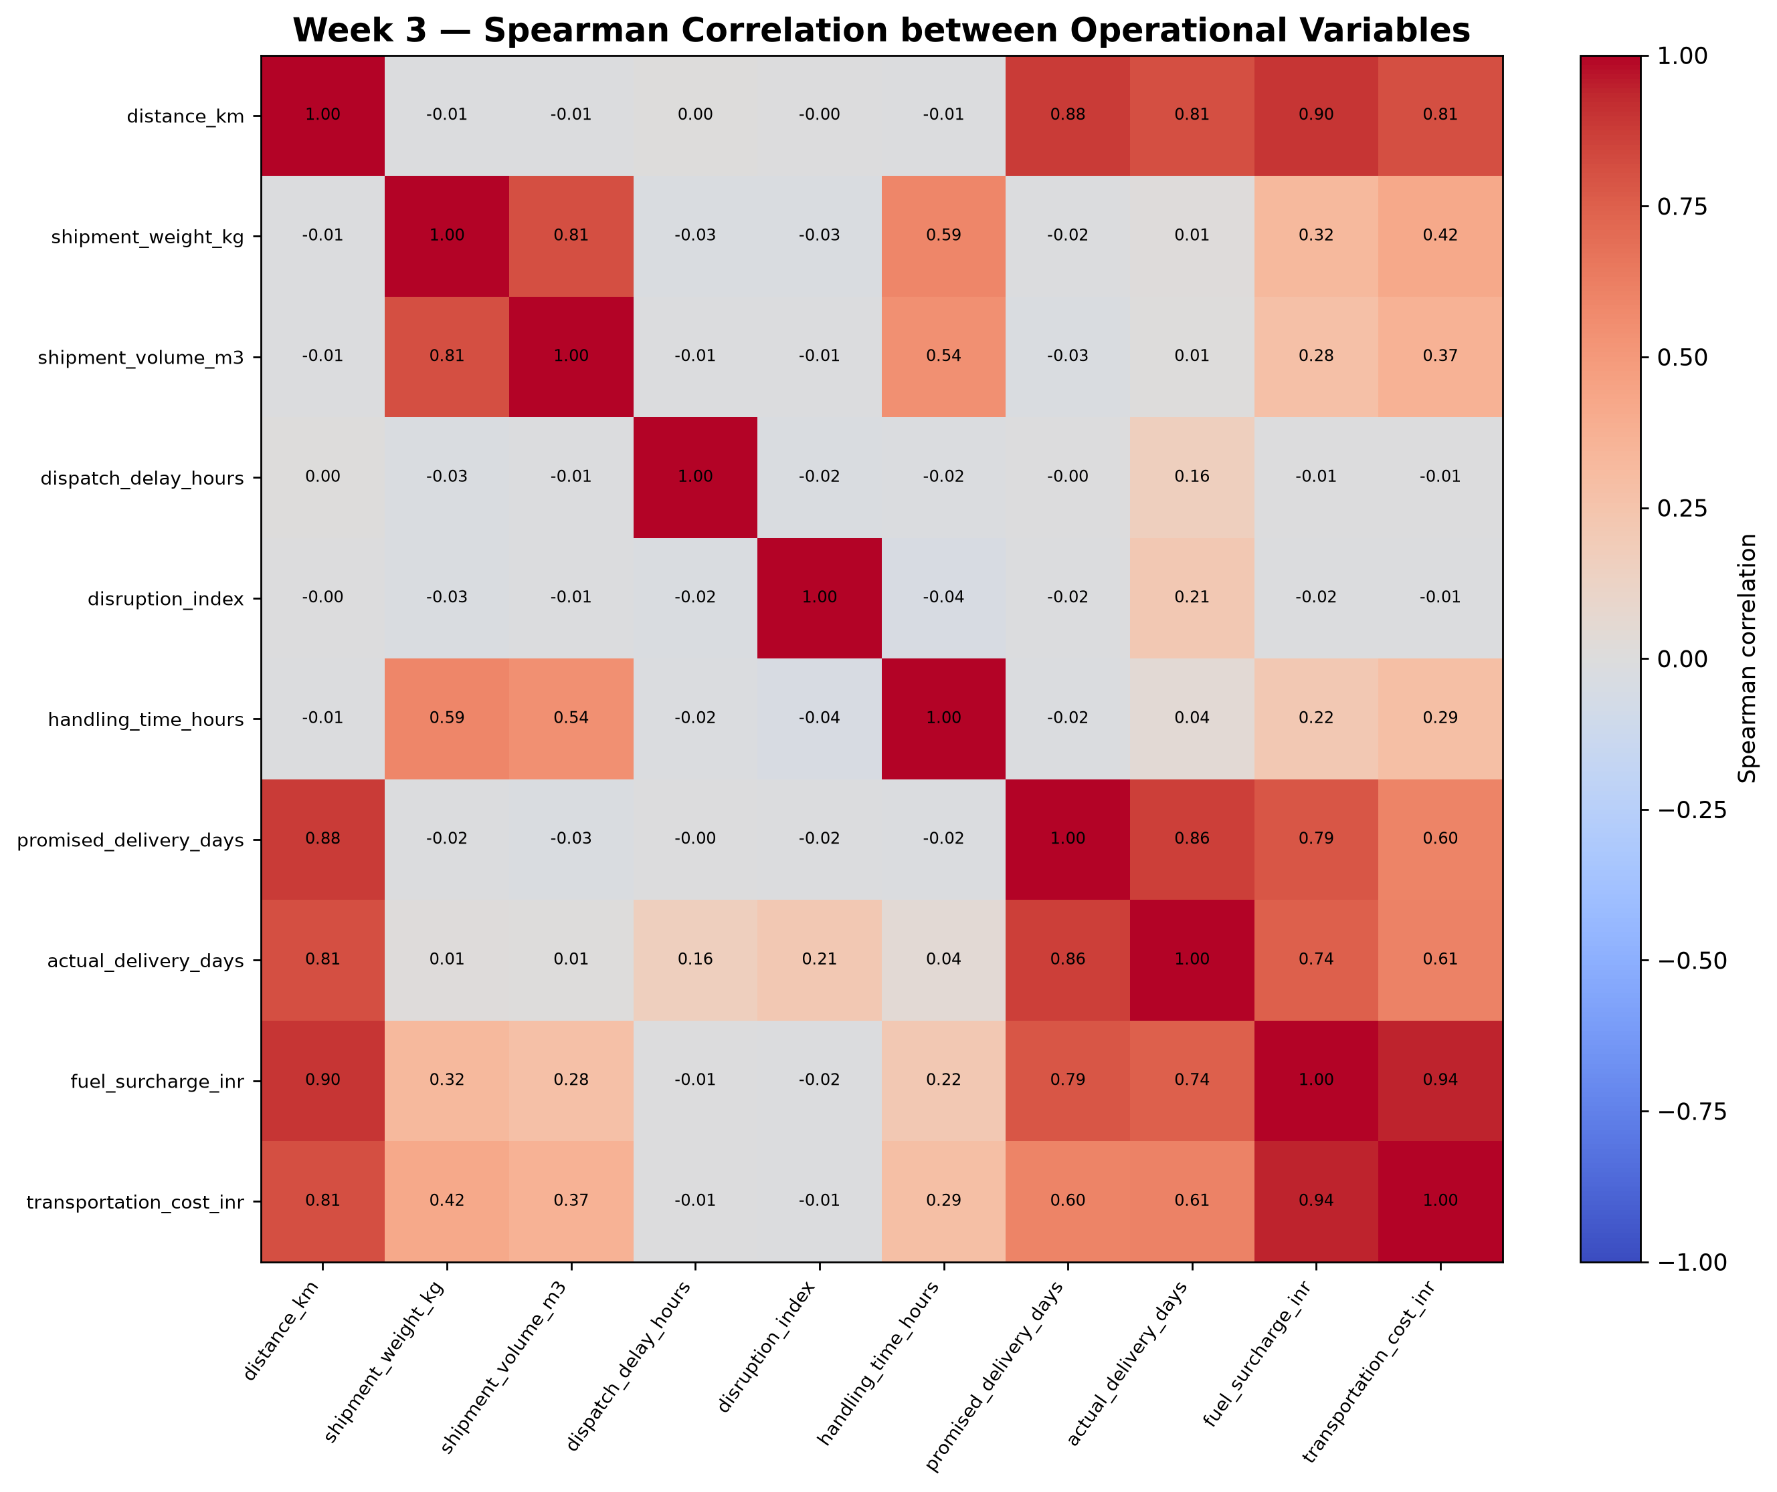
Figure 8. Spearman correlation heatmap
Chart choice: A heatmap presents the correlation matrix compactly, allowing the direction and strength of multiple numerical relationships to be compared.
Interpretation: The heatmap summarises monotonic relationships among numerical operational variables. Notable associations include fuel surcharge with total transportation cost (rho = 0.941), distance with fuel surcharge (rho = 0.898), and promised with actual delivery time (rho = 0.862). These are associations, not proof of causation.
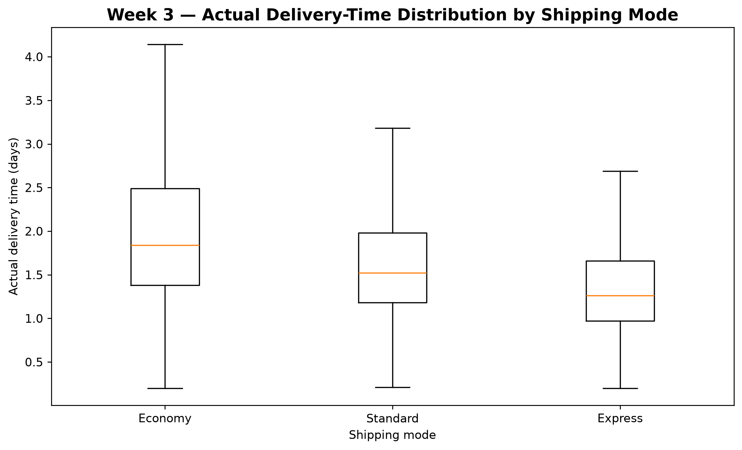
Figure 9. Actual delivery-time distribution by shipping mode
Chart choice: A box plot compares the median, interquartile range and spread of delivery times across multiple categorical groups.
Interpretation: The box plot compares the median, interquartile range and spread of actual delivery times across the three service modes. Express has the lowest median delivery time, while Economy has the highest. This complements the late-rate comparison.

7. Operational Insights and Recommendations

7.1 Priority Findings
- Service-mode performance requires a promise-aware comparison. Express is fastest on average but has the highest late rate. Review whether the promised Express delivery windows are realistic for the simulated operating conditions.
- The East region has the highest late rate. In a real setting, review route-level performance, dispatch cut-off times, carrier hand-offs and local disruption records.
- The Q4 late rate is notably higher than the January–September rate. Since the simulation intentionally includes a peak-period adjustment, the result is a useful demonstration of peak-period analysis, not independent evidence of a seasonal effect.
- Transportation cost is strongly associated with distance and fuel surcharge in the simulation. Cost-control analysis should therefore distinguish distance-driven cost from other cost components.
- The cost distribution is right-skewed. Reporting both mean and median avoids allowing a small number of high-cost shipments to obscure the typical shipment.

7.2 Recommended Follow-up Analyses
1. Break regional results down by individual routes, carriers and shipment service levels.
2. Compare late rates with sample sizes and confidence intervals before prioritising real interventions.
3. Separate the effects of distance, shipment weight, volume and fuel surcharge in a cost model.
4. Investigate high-cost records using shipment-level details rather than deleting statistical outliers.
5. For peak planning, compare multiple years of actual operational data and account for changes in shipment mix.
6. In future predictive work, use only features that would genuinely be available at the time a prediction is made.

7.3 Potential Management Actions
Area | Evidence | Recommended action | Monitoring KPI
Express service | 40.65% late rate; mean delivery 1.351 days against a 1.407-day promise. | Review route-level performance, dispatch cut-off times and the feasibility of Express delivery promises. | Late-delivery rate; 90th-percentile schedule variance.
East region | 35.69% late rate, compared with 21.53% in North. | Investigate individual routes, carrier hand-offs, dispatch delays and disruption records. | Regional late rate; route-level delivery performance.
Q4 operations | 37.36% late rate versus 24.56% in January–September. | Review capacity, staffing and shipment planning for peak-period demand. | Monthly late rate; shipment volume; backlog.
Transportation costs | Spearman correlation of 0.941 between fuel surcharge and total transportation cost. | Break down cost components and review high-cost shipments by distance, weight and service mode. | Weighted cost per km; median shipment cost.
High-cost shipments | Mean cost INR 933.03 exceeds median cost INR 836.09. | Examine high-percentile shipments to distinguish valid exceptional costs from possible inefficiencies. | 90th-percentile cost; cost per shipment.

These actions are proposed investigations rather than proven solutions. The findings originate from synthetic records. Any intervention should first be evaluated using actual shipment data and a suitable before-and-after comparison.

8. Limitations and Responsible Interpretation
- The dataset is synthetic. It does not describe real customers, carriers, shipments, routes or markets.
- Some relationships are embedded in the data-generation formulas. Correlations may therefore reflect the simulation design.
- The peak-period adjustment is an explicit simulation assumption, so the Q4 pattern is not independent evidence of real seasonality.
- The service modes and regions are hypothetical categories rather than validated operational geographies.
- The analysis is descriptive and exploratory. It does not estimate causal effects.
- Results from this dataset should not be used to set real delivery promises, carrier contracts or transportation budgets.
- Further work with timestamped operational records, carrier identifiers, route data, actual fuel prices and external disruption data would be needed for real-world validation.
These limitations do not invalidate the educational exercise. They define the scope in which its methods and findings can be interpreted responsibly.

9. Conclusion
This project completed an end-to-end exploratory analysis of a hypothetical logistics dataset containing 5,000 simulated shipments. The workflow included dataset generation, structural validation, KPI calculation, descriptive statistics, grouped comparisons, time-based analysis, outlier review, correlation analysis and visual communication.
The most important simulated patterns were the elevated late-delivery rate for Express, the higher late rate in the East region and the Q4 increase in late deliveries. The cost analysis showed a right-skewed distribution and a strong monotonic association between distance and transportation cost.
The project demonstrates how Python-based exploratory analysis can convert shipment-level data into structured operational evidence. The next stage should build on these findings with predictive modelling and optimisation, while preserving a clear distinction between simulation results and real-world evidence.

Appendix A. Python Code Illustrations
The following excerpts illustrate the main analytical operations used in the project. The complete executable implementations are maintained in the src folder.

A.1 Load and inspect the simulated dataset
import pandas as pd

df = pd.read_csv("data/processed/week3_simulated_logistics.csv")
print(df.shape)
print(df.dtypes)
print(df.isna().sum().sum())

A.2 Recalculate schedule variance and delivery outcome
df["schedule_variance_days"] = (
df["actual_delivery_days"] - df["promised_delivery_days"]
)

df["late_delivery"] = (
df["schedule_variance_days"] > 0
).astype(int)

A.3 Summarise performance by shipping mode
mode_summary = df.groupby("shipping_mode").agg(
shipments=("shipment_id", "count"),
late_rate=("late_delivery", "mean"),
mean_delivery_days=("actual_delivery_days", "mean"),
mean_cost=("transportation_cost_inr", "mean")
).reset_index()

mode_summary["late_rate_pct"] = mode_summary["late_rate"] * 100

A.4 Calculate descriptive statistics and correlations
numeric = df.select_dtypes(include="number")
descriptive = numeric.describe().T

pearson = numeric.corr(method="pearson")
spearman = numeric.corr(method="spearman")

A.5 Generate a visual comparison
import matplotlib.pyplot as plt

mode_late = (
df.groupby("shipping_mode")["late_delivery"].mean() * 100
)

ax = mode_late.sort_values(ascending=False).plot(
kind="bar", figsize=(8, 5), title="Late rate by shipping mode"
)
ax.set_ylabel("Late shipments (%)")
ax.set_xlabel("Shipping mode")
plt.tight_layout()
plt.savefig("outputs/charts/example_mode_comparison.png", dpi=200)
plt.close()

The examples are concise excerpts for explanation. The full project scripts contain the complete generation, validation, tabulation and charting workflows.

Appendix B. Dataset Dictionary
Variable | Definition | Type / unit
shipment_id | Unique synthetic shipment identifier | Identifier
order_date | Synthetic order date between 2025-01-01 and 2025-12-31 | Date
region | Synthetic operating region: North, South, East, West or Central | Categorical
shipping_mode | Synthetic service mode: Economy, Standard or Express | Categorical
distance_km | Simulated shipment distance in kilometres | Numerical; km
shipment_weight_kg | Simulated shipment weight in kilograms | Numerical; kg
shipment_volume_m3 | Simulated shipment volume in cubic metres | Numerical; m3
dispatch_delay_hours | Simulated elapsed dispatch delay in hours | Numerical; hours
disruption_index | Synthetic disruption intensity between 0 and 1 | Index; unitless
handling_time_hours | Simulated warehouse/handling time in hours | Numerical; hours
promised_delivery_days | Simulated promised delivery duration in days | Numerical; days
actual_delivery_days | Simulated actual delivery duration in days | Numerical; days
schedule_variance_days | Actual delivery days minus promised delivery days | Derived; days
late_delivery | 1 when schedule variance is positive; otherwise 0 | Binary target
fuel_surcharge_inr | Simulated fuel surcharge component in INR | Numerical; INR
transportation_cost_inr | Simulated total transportation cost in INR, including fuel surcharge | Numerical; INR

Appendix C. Reproducibility and Project Files
The project is organised so that dataset generation, exploratory analysis, deep-dive analysis and report preparation can be run separately.

C.1 Execution commands
python src/week3_generate_dataset.py
python src/week3_eda_analysis.py
python src/week3_deep_dive_analysis.py
python src/week3_create_report.py

C.2 Important project files
Project file | Purpose
src/week3_generate_dataset.py | Creates the reproducible synthetic shipment dataset.
src/week3_eda_analysis.py | Performs exploratory analysis and creates the nine charts.
src/week3_deep_dive_analysis.py | Produces additional service, region, quarter, peak-period and cost summaries.
src/week3_create_report.py | Builds this Word report from saved outputs.
data/processed/week3_simulated_logistics.csv | The synthetic shipment-level dataset.
data/processed/week3_simulation_assumptions.txt | Simulation assumptions and interpretation limitations.
data/processed/week3_dataset_dictionary.csv | Variable definitions and units.
outputs/charts/WEEK3_*.png | The nine generated report visualisations.

The synthetic dataset and report outputs are reproducible using the saved scripts and documented assumptions. Generated data should remain clearly labelled as synthetic.

