LOGISTICS DATA ANALYTICS
Strategic Planning and Data Exploration
YuvaIntern - Logistics Data Analyst Internship | Week 1

Prepared by | Pravallika Gurubhagavatula
Internship | Logistics Data Analyst Intern
Organization | YuvaIntern
Dataset | DataCo SMART Supply Chain for Big Data Analysis

Submission date: 02 October 2026

Contents
1. Introduction
2. Business Scenario
3. Problem Statement
4. Project Objectives
5. Background and Literature Research
6. Dataset Description and Data Quality
7. Logistics KPI Framework
8. Data Science Methodologies
9. Exploratory Findings
10. Strategic Analytical Roadmap
11. Python Code Illustrations
12. Expected Outcomes
13. Business Impact and Decision Use
14. Limitations and Risk Controls
15. Conclusion
16. References

1. Introduction
Logistics operations generate data at multiple stages, including order placement, shipment scheduling, transportation, customer delivery, and financial settlement. A logistics data analyst converts these records into measurable service indicators, identifies operational patterns, and creates a foundation for predictive decision-making.
This Week 1 project simulates the strategic planning stage of a logistics analytics engagement. The focus is delivery performance: understanding where delays are observed, defining the right KPIs, checking data quality, and designing a roadmap that can later support predictive modeling and operational optimization.

2. Business Scenario
Scenario: an omnichannel retail and distribution organization manages a large international order network. Management wants to improve delivery reliability without relying only on retrospective reporting. The analytics team is therefore asked to build a structured delivery-performance program that begins with KPI monitoring and exploratory analysis and progresses to delay prediction and decision support.
The proposed analytical solution should answer four practical questions:
- How frequently are shipments recorded as late, on schedule, early, or canceled?
- How does observed late-delivery performance differ across shipping modes and markets?
- Which operational variables should be used for a future predictive model?
- How can predicted risk be converted into an operational action such as expediting, prioritization, or route/capacity review?

3. Problem Statement
The core problem is to transform historical shipment and order data into a reliable framework for monitoring and predicting delivery performance. A major analytical challenge is that operational datasets may contain variables recorded after the outcome is already known. Such variables can create data leakage and produce unrealistic model performance. The project therefore treats data availability at prediction time as a design requirement, not an afterthought.

4. Project Objectives
1. Define a realistic logistics analytics scenario centered on delivery performance.
2. Establish a KPI framework covering timeliness, schedule variance, cancellations, and order value.
3. Inspect the public DataCo SMART Supply Chain dataset and prepare a clean analytical layer.
4. Use exploratory analysis to identify meaningful patterns across shipping mode, market, customer segment, and region.
5. Explain suitable data science methods such as regression, classification, clustering, and optimization.
6. Design a feasible Python-based analytical roadmap from data collection through decision support.

5. Background and Literature Research
The selected DataCo SMART Supply Chain dataset is publicly hosted on Mendeley Data. The dataset description states that it covers supply-chain activities such as provisioning, production, sales, and commercial distribution and includes a structured transaction file, a variable-description file, and a clickstream file. The Mendeley record lists a Creative Commons Attribution 4.0 license. (Constante, Silva, & Pereira, 2019).
A 2025 systematic literature review on direct delivery-delay prediction reports that machine learning has substantial potential in this area. The review also notes that many studies frame the problem as on-time versus delayed classification, while predicting the actual delay magnitude can provide greater practical value. It further reports that combining enterprise resource planning data with logistics and other relevant data classes can improve prediction performance, and highlights the value of decision-support systems that translate predictions into recommended actions. (Müller et al., 2025).
A 2026 empirical study using the same DataCo dataset examined sales forecasting, delivery-risk classification, and customer segmentation. Importantly for this project, the study explicitly removed data-leakage variables before estimating realistic predictive performance. This supports the project design choice to separate outcome variables from features that would only become known after delivery status is established. (Katangoori, 2026).
Research implication for this project: the roadmap should not stop at producing a high-scoring model. It should also document prediction timing, feature availability, validation design, and the path from prediction to an operational decision.

6. Dataset Description and Data Quality
Dataset selected: DataCo SMART Supply Chain for Big Data Analysis. The local analysis identified 180,519 rows and 53 columns in the main CSV file. The fields cover shipment timing, delivery status, shipping mode, customers, geography, products, orders, and financial measures.
Area | Key finding | Treatment / implication
Dataset size | 180,519 rows; 53 columns | Sufficient for descriptive analysis and a future ML baseline
Missing values | Product Description: 100%; Order Zipcode: 86.24%; Customer Lname: 8; Customer Zipcode: 3 | Dropped non-essential / highly incomplete fields for the analytical layer
Duplicates | 0 duplicate rows observed | No duplicate-removal step required for the current file
Important analytical fields | Shipping days, delivery status, shipping mode, market, order value fields available without missing values | Suitable for KPI and EDA stages
Target leakage risk | Delivery Status and Late_delivery_risk describe the outcome or are tightly linked to it | Exclude from predictive features when predicting delivery risk
The analysis layer removes Product Description and Order Zipcode because they are not required for the Week 1 delivery-performance questions and have very high missingness. Customer names, email, password, and address-related fields are also not required for the analytical objective and should not be exposed in downstream dashboards or models.

7. Logistics KPI Framework
The KPI framework is designed to distinguish late delivery from other outcomes and to avoid misleading denominators. In particular, the project uses an on-schedule/early rate rather than calling only the "Shipping on time" category the on-time rate.
KPI | Definition | Observed value | Interpretation
Late Delivery Rate | Late records / all records | 54.83% | Baseline measure of records labeled late
On-Schedule / Early Rate | (Advance + On-time) / non-cancelled records | 42.71% | Share of completed records that were not late
Average Actual Shipping Time | Mean of actual shipping days | 3.50 days | Observed time taken to ship
Average Schedule Variance | Actual days - scheduled days | +0.57 days | Positive value indicates actual time exceeded schedule on average
Cancellation Rate | Canceled records / all records | 4.30% | Share of records marked as canceled
Average Order Value | Order-level sum of line-item totals, then averaged by Order Id | $502.71 | True order-level value; avoids line-item averaging bias
KPI calculation note: average order value is computed after grouping line items by Order Id. This is important because multiple rows can represent items within the same customer order.

8. Data Science Methodologies
Method | Purpose | Example variables | Planned use
Descriptive analytics | Summarize current performance | Delivery Status, Shipping Mode, Market | Baseline KPI reporting
Exploratory Data Analysis | Detect patterns and relationships | Actual vs scheduled days, region, segment | Identify areas needing deeper investigation
Classification | Predict whether a future shipment will be late | Historical order and shipment-planning features | Early warning / risk flag
Regression | Predict delay duration or schedule variance | Scheduled days, mode, route/geography, order characteristics | Estimate how much delay may occur
Clustering | Segment similar customers or operational profiles | Order behavior, value, frequency, geography | Targeted service or operational strategy
Optimization | Choose actions subject to constraints | Capacity, service level, cost, shipment mode | Scenario planning and action recommendations
Decision support / dashboarding | Translate analytics into decisions | Predicted risk + KPI context | Operational alerts, monitoring, and review

8.1 Predictive modeling design principle
The first predictive problem will be defined at the point when a business decision can still be changed. Features that are only known after delivery status is determined should not be used. For example, Delivery Status and Late_delivery_risk should not be included as predictors of the same delivery outcome. This avoids data leakage and makes model evaluation more representative of deployment conditions.

9. Exploratory Findings
The current EDA stage produced three report-ready charts. These are descriptive findings from the local dataset and should not be interpreted as proof that one factor causes late delivery.
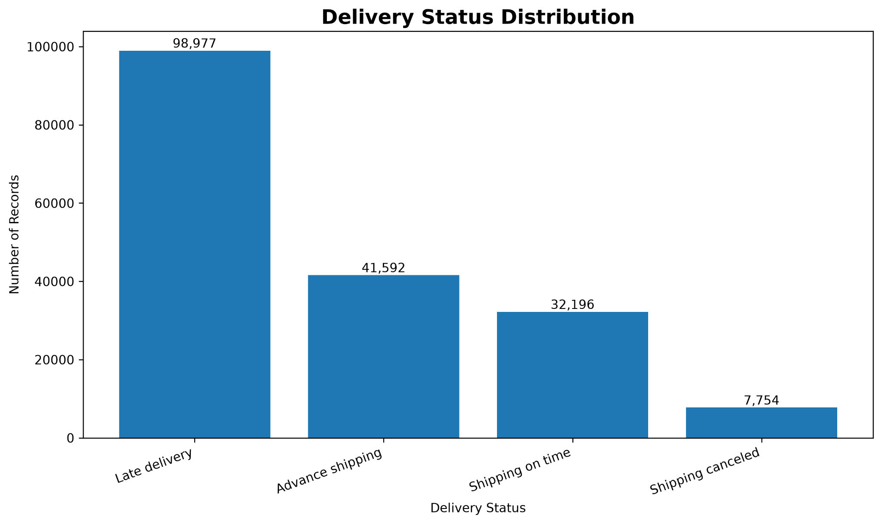
Figure 1. Delivery status distribution in the analyzed dataset.
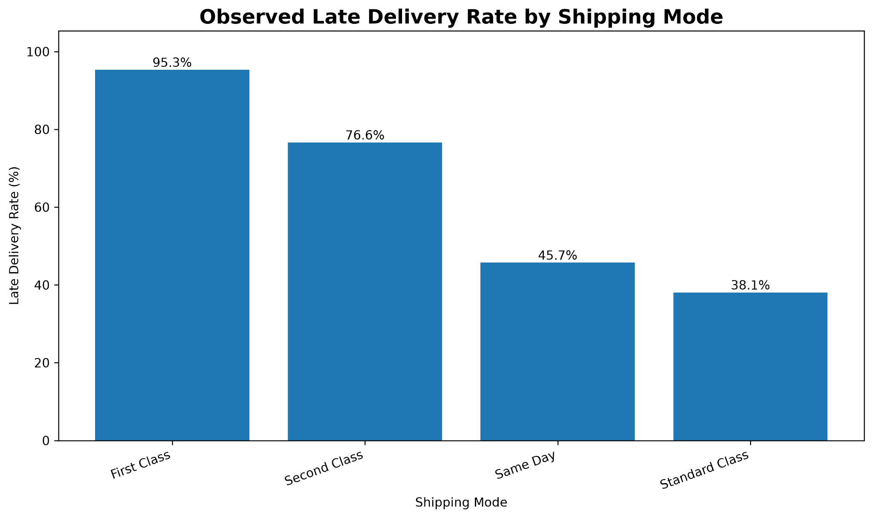
Figure 2. Observed late-delivery rate by shipping mode.
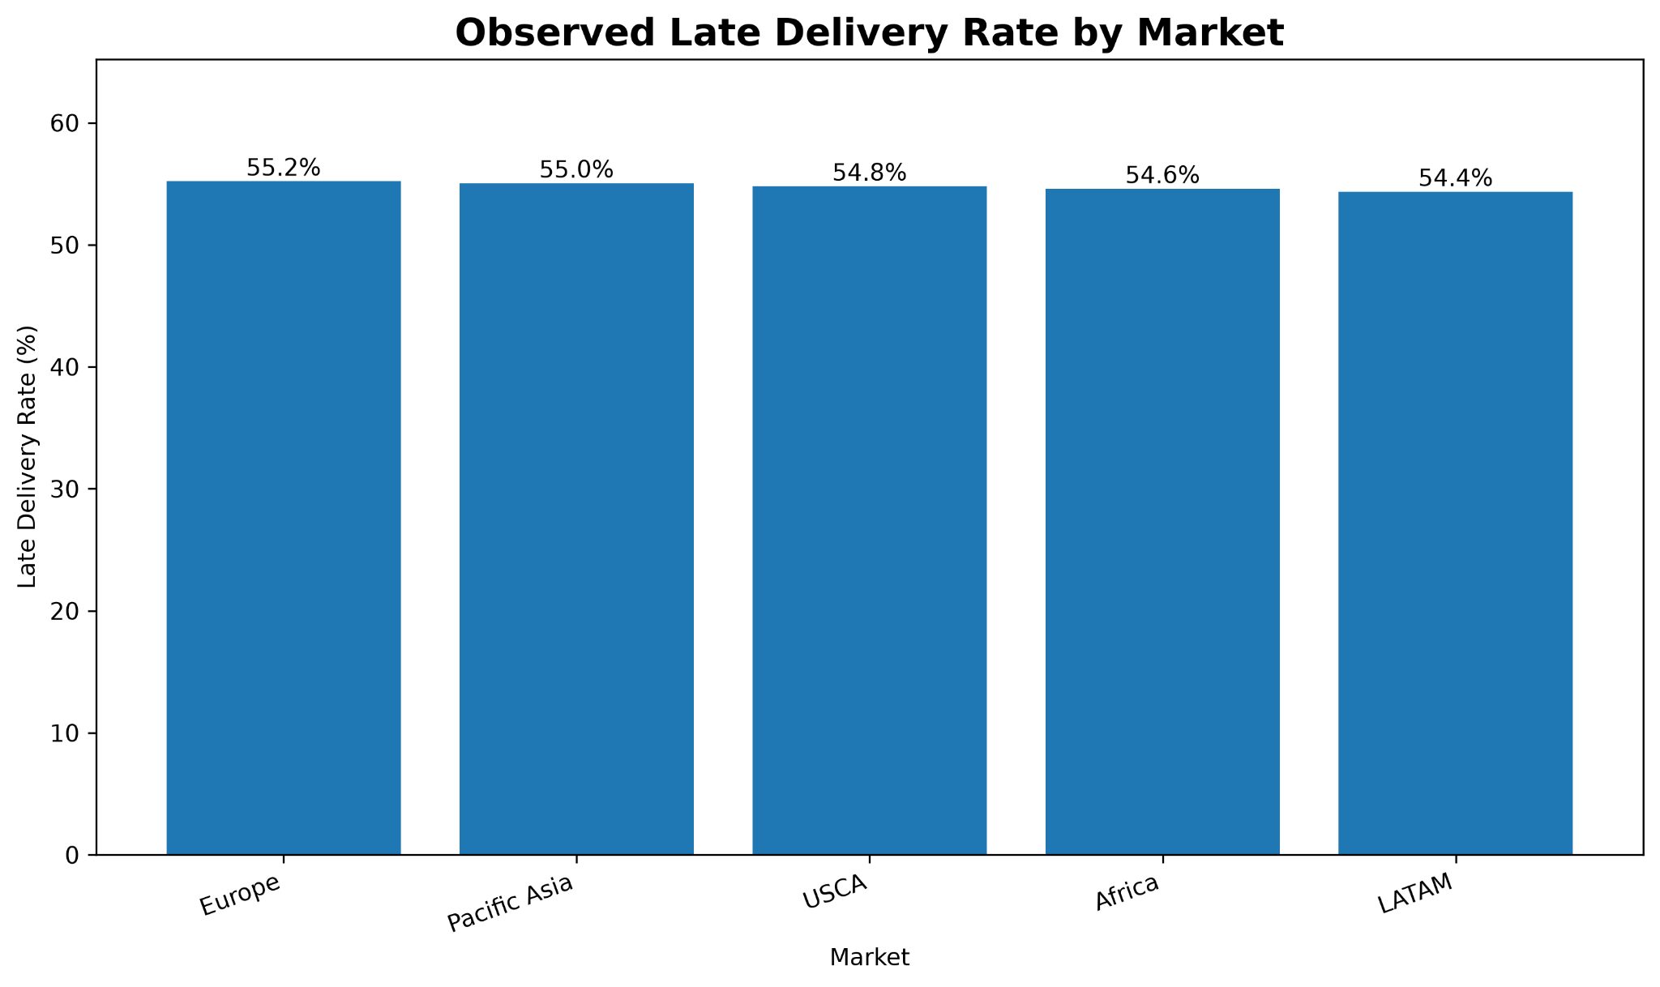
Figure 3. Observed late-delivery rate by market.

9.1 Key observations
- Late delivery is the largest status category: 98,977 of 180,519 records are labeled Late delivery.
- Advance shipping accounts for 41,592 records, while 32,196 are labeled Shipping on time and 7,754 are Shipping canceled.
- The observed late-delivery rate varies substantially by shipping mode: First Class 95.3%, Second Class 76.6%, Same Day 45.7%, and Standard Class 38.1%. These are associations in the historical data, not causal estimates.
- Market-level late-delivery rates are relatively close to one another, ranging from 54.4% in LATAM to 55.2% in Europe in this dataset.
- Customer-segment differences are also small compared with shipping-mode differences, suggesting that the first deeper investigation should focus on operational features and interactions rather than assuming customer segment is the dominant driver.

10. Strategic Analytical Roadmap
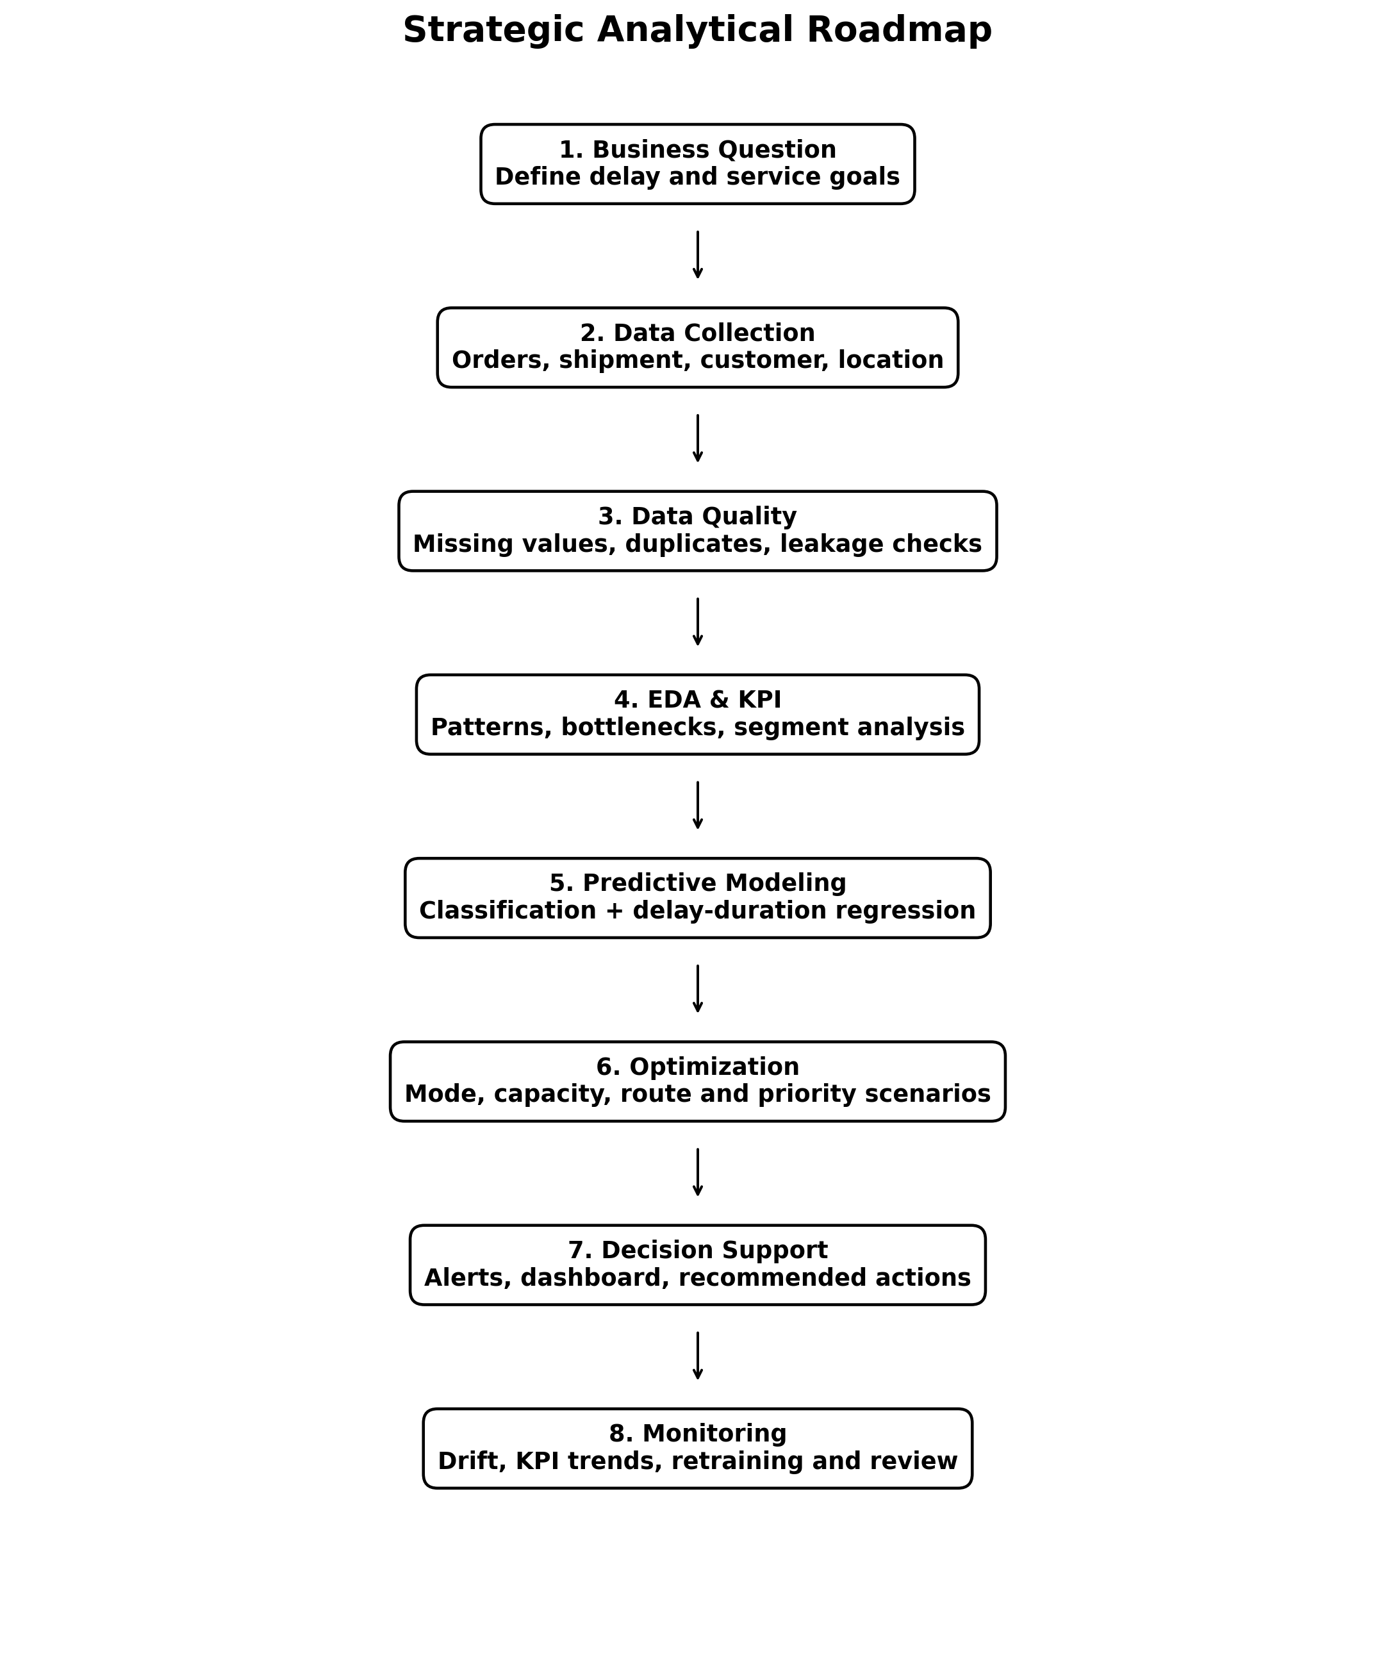
Figure 4. End-to-end roadmap from business question to monitored decision support.
Phase | Activities | Outputs | Decision value
1. Define | Business question, target, prediction time | Scope + KPI definitions | Align analytics with operations
2. Collect | Orders, shipment history, route/location, capacity inputs | Data inventory | Know what is available before action
3. Clean | Missing values, duplicates, date parsing, leakage review | Model-ready analytical layer | Improve trust and reproducibility
4. Explore | Distribution, trends, segment comparisons, bottleneck analysis | EDA report | Locate patterns worth investigating
5. Predict | Baseline classification + regression; time-aware validation | Risk and delay-duration models | Create early warnings
6. Optimize | Scenario testing for mode/capacity/priority decisions | What-if recommendations | Connect predictions to actions
7. Deploy | Dashboard, alerts, documentation, user workflow | Decision-support layer | Make analysis usable by teams
8. Monitor | KPI drift, feature drift, model performance, retraining triggers | Monitoring report | Sustain model usefulness

11. Python Code Illustrations
The Week 1 implementation uses Python with pandas and matplotlib. The following excerpts illustrate the planned workflow. The full working scripts are maintained in the project src/ directory.

11.1 Data preparation and feature engineering
import pandas as pd
df = pd.read_csv("data/raw/DataCoSupplyChainDataset.csv", encoding="latin-1")
# Keep the fields required for the Week 1 analytical objective
df = df.drop(columns=["Product Description", "Order Zipcode"], errors="ignore")
df["Shipping Delay Days"] = (
df["Days for shipping (real)"]
- df["Days for shipment (scheduled)"]
)
df["Is Delayed"] = (df["Delivery Status"] == "Late delivery").astype(int)

11.2 KPI calculation
total = len(df)
late = (df["Delivery Status"] == "Late delivery").sum()
cancelled = (df["Delivery Status"] == "Shipping canceled").sum()
completed = total - cancelled
advance = (df["Delivery Status"] == "Advance shipping").sum()
on_time = (df["Delivery Status"] == "Shipping on time").sum()
late_rate = late / total * 100
on_schedule_or_early = (advance + on_time) / completed * 100
avg_actual_days = df["Days for shipping (real)"].mean()
avg_variance = df["Shipping Delay Days"].mean()
cancellation_rate = cancelled / total * 100
order_values = df.groupby("Order Id")["Order Item Total"].sum()
avg_order_value = order_values.mean()

11.3 Predictive-modeling pseudocode
1. Define prediction timestamp and target = future late delivery / delay duration.
2. Remove leakage variables that reveal the target after the prediction point.
3. Split data using time-aware validation when dates support it.
4. Encode categorical variables and scale only when required by the model.
5. Train baseline logistic / tree classifier and regression model.
6. Evaluate with precision, recall, F1, ROC-AUC (classification) and MAE/RMSE (regression).
7. Inspect feature importance and error cases.
8. Convert high-risk predictions into operational recommendations.

12. Expected Outcomes
- A trusted KPI layer for delivery performance monitoring.
- A cleaned analytical dataset with documented transformations and data-quality checks.
- Clear descriptive evidence about shipment-mode, market, and regional differences.
- A predictive baseline for identifying potentially late shipments before the delivery outcome is known.
- A regression-based estimate of expected delay duration, supporting more precise prioritization.
- Operational segmentation that groups similar customers or shipment profiles for targeted service decisions.
- A decision-support view that combines predicted risk with business context rather than presenting model scores alone.

13. Business Impact and Decision Use
Analytical output | Potential decision | Business use
Late-risk alert | Review or prioritize high-risk orders | Earlier intervention before customer impact
Predicted delay duration | Estimate severity and urgency | Allocate limited expediting capacity
Shipping-mode analysis | Investigate mode/service-level mismatches | Support service design and scheduling review
Market/region dashboard | Identify persistent geographic patterns | Focus operational investigation where evidence is strongest
Customer segmentation | Tailor service policies to groups | Prioritize high-value or high-sensitivity segments
Optimization scenarios | Compare cost, capacity, and service outcomes | Support structured what-if planning
The analytical objective is not simply to maximize model accuracy. The final system should improve the timing and quality of logistics decisions while making the assumptions, data limitations, and uncertainty visible to users.

14. Limitations and Risk Controls
- This is a public historical dataset and does not represent a live company data environment; conclusions should therefore be treated as analytical findings for the dataset, not universal operational truths.
- The current Week 1 analysis is descriptive. Observed differences do not establish causation.
- The dataset contains fields that can leak the delivery outcome. Leakage screening must occur before any predictive model is trained.
- Some geographic groups have smaller sample sizes than others, so extreme percentages should be interpreted with sample size context.
- A deployment-quality model would require data available at prediction time, time-aware validation, monitoring, and periodic recalibration.

15. Conclusion
This Week 1 project establishes a practical strategic foundation for logistics data analytics. The DataCo SMART Supply Chain dataset provides sufficient breadth for KPI definition, exploratory analysis, predictive-model planning, and future optimization work. The first analysis shows that delivery performance should be examined carefully by operational dimensions, especially shipping mode, while market-level differences appear comparatively narrow in the current data.
The next analytical stage should move from descriptive evidence to predictive and decision-oriented analysis: define the prediction point, enforce leakage controls, build classification and delay-duration regression baselines, and then connect those predictions to optimization scenarios and a decision-support dashboard. This sequence provides a clear path from raw logistics data to an operationally meaningful analytical product.

16. References
1. Constante, F., Silva, F., & Pereira, A. (2019). DataCo SMART SUPPLY CHAIN FOR BIG DATA ANALYSIS. Mendeley Data, Version 5. DOI: 10.17632/8gx2fvg2k6.5. URL: https://data.mendeley.com/datasets/8gx2fvg2k6/5
2. Müller, N., Burggräf, P., Steinberg, F., Sauer, C. R., & Schütz, M. (2025). An analytical review of predictive methods for delivery delays in supply chains. Supply Chain Analytics, 11, 100130. DOI: 10.1016/j.sca.2025.100130. URL: https://doi.org/10.1016/j.sca.2025.100130
3. Katangoori, A. (2026). An empirical analysis of data-driven supply chain optimization in retail and logistics. Supply Chain Analytics, 14, 100206. DOI: 10.1016/j.sca.2026.100206. URL: https://doi.org/10.1016/j.sca.2026.100206

