NAME : D Naga Pravallika devi

EMAIL : 208x1a4213@khitguntur.ac.in

PHONE : 7386866925

ROLL NO.: 208x1a4213

COLLEGE : Kallam Haranadhareddy Institute of

Technology

HTML CODE: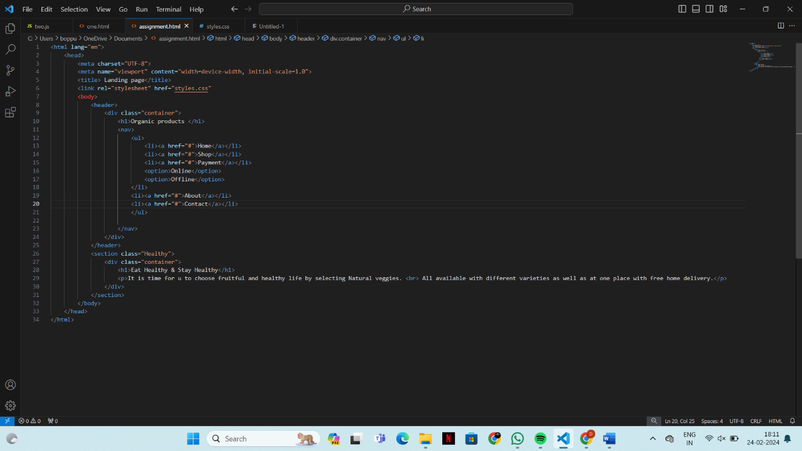

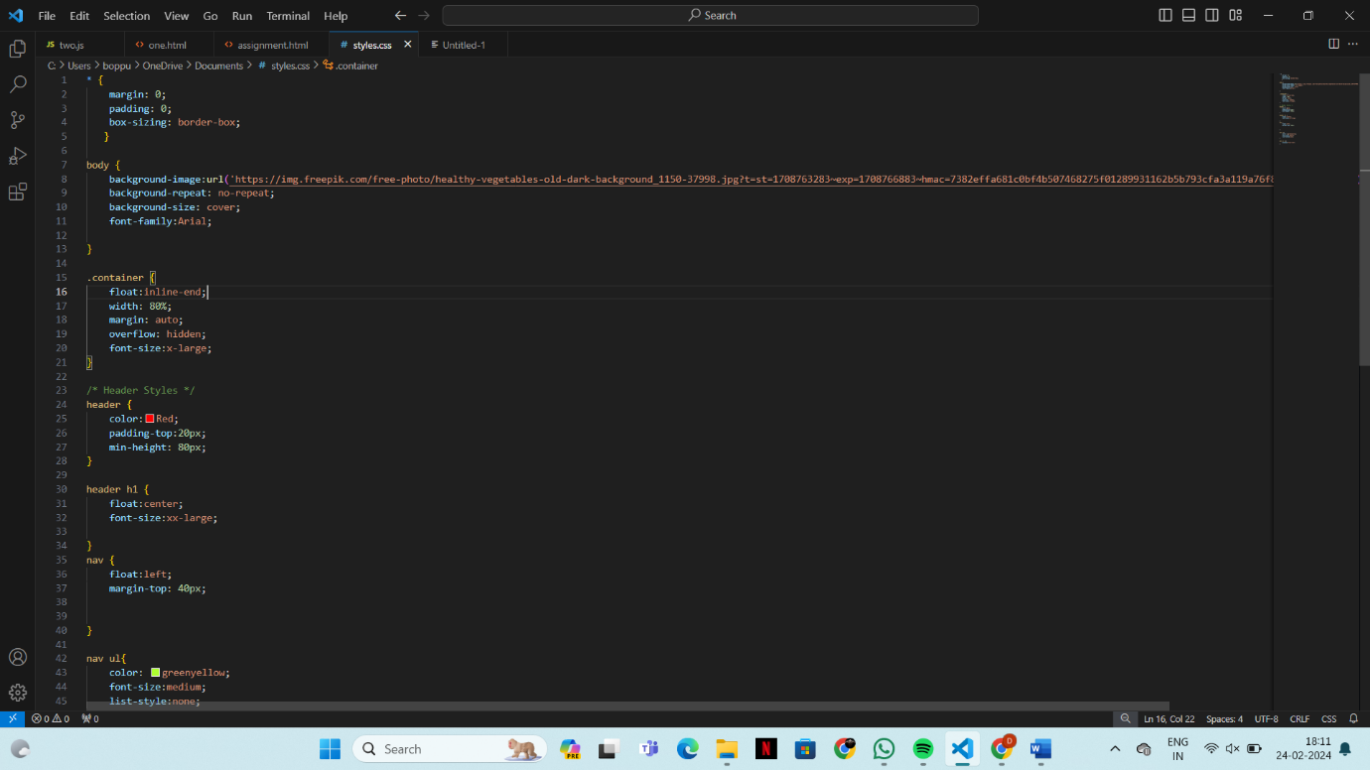

FINAL OUTPUT:

