<!DOCTYPE html>

<html>

<head>

<title>Basic Calculator</title>

</head>

<body>

<div class="calculator">

<input type="text" id="screen" class="calculator-screen" disabled>

<br>

<button class="button" onclick="appendNumber('1')">1</button>

<button class="button" onclick="appendNumber('2')">2</button>

<button class="button" onclick="appendNumber('3')">3</button>

<button class="button" onclick="setOperation('+')">+</button>

<br>

<button class="button" onclick="appendNumber('4')">4</button>

<button class="button" onclick="appendNumber('5')">5</button>

<button class="button" onclick="appendNumber('6')">6</button>

<button class="button" onclick="setOperation('-')">-</button>

<br>

<button class="button" onclick="appendNumber('7')">7</button>

<button class="button" onclick="appendNumber('8')">8</button>

<button class="button" onclick="appendNumber('9')">9</button>

<button class="button" onclick="setOperation('\*')">\*</button>

<br>

<button class="button" onclick="appendNumber('0')">0</button>

<button class="button" onclick="calculate()">=</button>

<button class="button" onclick="setOperation('/')">/</button>

<button class="button" onclick="clearScreen()">C</button>

</div>

<script>

let currentOperation = '';

let currentNumber = '';

let storedNumber = '';

function appendNumber(number) {

currentNumber += number;

document.getElementById('screen').value = currentNumber;

}

function setOperation(operation) {

storedNumber = currentNumber;

currentNumber = '';

currentOperation = operation;

}

function calculate() {

let result;

switch(currentOperation) {

case '+':

result = parseFloat(storedNumber) + parseFloat(currentNumber);

break;

case '-':

result = parseFloat(storedNumber) - parseFloat(currentNumber);

break;

case '\*':

result = parseFloat(storedNumber) \* parseFloat(currentNumber);

break;

case '/':

result = parseFloat(storedNumber) / parseFloat(currentNumber);

break;

default:

result = 'Error';

}

document.getElementById('screen').value = result;

currentNumber = result;

storedNumber = '';

}

function clearScreen() {

currentNumber = '';

storedNumber = '';

currentOperation = '';

document.getElementById('screen').value = '';

}

</script>

</body>

</html>

/\* Basic Calculator Styles \*/

.calculator {

max-width: 400px;

margin: 50px auto;

padding: 20px;

border: 1px solid #ddd;

border-radius: 5px;

box-shadow: 0 0 10px rgba(0, 0, 0, 0.1);

}

.calculator-display {

width: 100%;

height: 50px;

border: none;

background-color: #f2f2f2;

color: #333;

padding: 10px;

font-size: 24px;

border-radius: 5px;

box-shadow: inset 0 -1px 0 rgba(0, 0, 0, 0.1);

text-align: right;

}

.calculator-keys {

display: grid;

grid-template-columns: repeat(4, 1fr);

gap: 10px;

margin-top: 20px;

}

.button {

height: 50px;

background-color: #fff;

border: 1px solid #ddd;

border-radius: 5px;

color: #333;

font-size: 20px;

cursor: pointer;

transition: background-color 0.3s;

}

.button:hover {

background-color: #f9f9f9;

}

.button.operator {

color: #d35400;

}

.button.equal {

grid-column: span 2;

background-color: #16a085;

color: #fff;

}

.button.clear {

background-color: #e74c3c;

color: #fff;

}

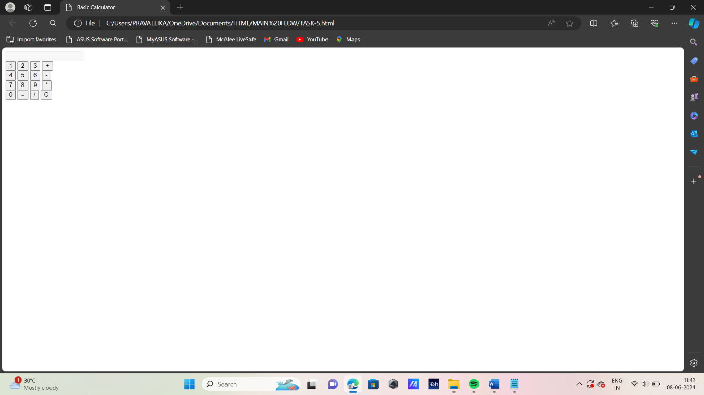

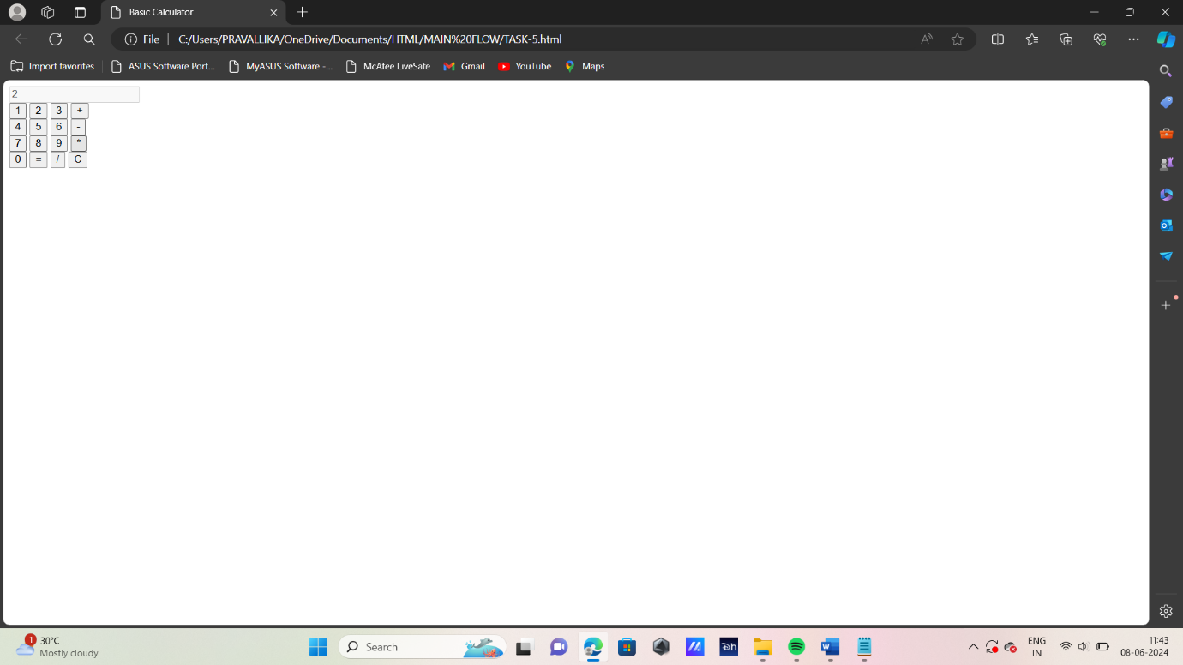

2\*2=4



