Food Delivery Time Prediction Using Stacked Ensemble Machine Learning with Feature Engineering and Log-Target Transformation
Sujal Solanki¹, Pravar Prajapati², Paresh Sasmiya³
Department of Computer Science and Engineering Government Engineering College, Patan, Gujarat, India — 384265
Enrollment No: 230220131129¹ | 230220131108² | 230220131120³
Faculty Guide: S. H. Makawana | Subject: Data Analysis and Visualization (3161613) | Academic Year: 2025–26

ABSTRACT
Abstract — Accurate prediction of food delivery time is a critical challenge in modern e-commerce logistics. Inaccurate estimates lead to customer dissatisfaction, operational inefficiency, and revenue loss. Existing studies predominantly rely on large datasets with GPS coordinates and apply single machine learning models, which limits their scalability and performance. This paper presents a novel stacked ensemble learning framework that achieves an R² score of 0.8283 on a compact dataset of 1,000 orders containing only eight features — without GPS coordinates — significantly outperforming state-of-the-art single-model approaches. The proposed pipeline combines One-Hot Encoding, five engineered interaction features, a StackingRegressor comprising GradientBoostingRegressor, HistGradientBoostingRegressor, and ExtraTreesRegressor with a Ridge meta-learner, and a log₁ₚ target transformation. Fourteen baseline models are evaluated using 80/20 train-test split and 5-fold cross-validation. The final model is independently validated against the cross-validation overfitting test, confirming legitimacy of the achieved R² = 0.8283, RMSE =
8.77 minutes, and MAE = 5.90 minutes. Comparative analysis with five related works demonstrates that the proposed method outperforms or matches all benchmarks despite using substantially less training data. Visualizations are implemented in D3.js to
present EDA findings and model evaluation results interactively. Results confirm that Distance_km (r = 0.782) is the dominant predictor, while feature engineering and ensemble stacking provide compounding performance gains.
Keywords — Food Delivery Time Prediction, Stacked Ensemble, Gradient Boosting, Log-Target Transformation, Feature Engineering, One-Hot Encoding, D3.js Visualization, Machine Learning,
Regression, Cross-Validation.

INTRODUCTION
The global online food delivery industry has undergone exponential growth over the last decade, driven by platforms such as Zomato, Swiggy, Uber Eats, and Deliveroo. According to industry projections, the UAE e-commerce market alone is expected to reach USD 110.4 million by 2030 [5]. In this fiercely competitive environment, the accuracy of estimated delivery times has become a key differentiator affecting customer satisfaction, order cancellation rates, and operational profitability.
Traditional rule-based systems for delivery time estimation rely on historical averages and fixed schedules, making them inherently incapable of adapting to real-world dynamic conditions such as traffic congestion, adverse weather, variable food preparation times, and courier availability.

Machine learning (ML) offers a compelling alternative by learning complex, nonlinear relationships from historical data and generalising those patterns to unseen orders.
While prior research has demonstrated the effectiveness of ensemble methods such as Random Forest [3], XGBoost [2], and LightGBM [1] for this task, these studies typically require large datasets of 40,000+ records, GPS coordinates, and city-level geospatial features. The dependency on such rich data restricts applicability to smaller delivery businesses or regions with limited data infrastructure.
This paper addresses the critical research question: Can a carefully engineered stacked ensemble model achieve competitive or superior prediction accuracy on a significantly smaller dataset — without GPS coordinates — by leveraging One-Hot Encoding, domain-inspired feature engineering, and a log-target transformation?

Research Contributions
    - A complete ML pipeline evaluated on 1,000 food delivery orders with only 8 features — no GPS required.
    - 14 baseline models compared using Train/Test R², 5-Fold Cross-Validation R², RMSE, and MAE.
    - A novel stacked ensemble (GBR + HGBR
+ ExtraTrees → Ridge meta-learner) with log₁ₚ target transformation achieving R² = 0.8283.
    - 5 engineered interaction features: distance_prep, exp_distance, rush_hour, bad_weather, traffic_high.
    - Rigorous overfitting detection confirming legitimacy of achieved R² scores.
    - D3.js interactive visualizations for all EDA and model evaluation results.
    - Comparative analysis against 5 peer-reviewed and thesis-level works.

RELATED WORK / BACKGROUND STUDY
A growing body of research has explored machine learning techniques for food delivery time prediction. This section reviews the five most closely related works and identifies the research gaps that motivate the proposed approach.

Garg et al. (2025) — LightGBM on Indian Cities
Garg et al. [1] proposed a machine learning framework integrating real-time contextual variables — traffic density, weather, geospatial distance (Haversine formula), local events, and festival indicators — for food delivery time prediction in Indian cities. Using a Kaggle dataset of 45,000 records and 19 features, they conducted ablation studies demonstrating that LightGBM achieved the best performance with R² = 0.76, MSE = 20.59, outperforming Random Forest (R² = 0.66) and XGBoost (R² = 0.71). Their ablation study revealed that removing geospatial features caused MSE to increase by 22%, underscoring spatial proximity as the dominant predictor. Feature selection employed SelectKBest with mutual information criteria, and hyperparameter tuning used GridSearchCV with 5-fold CV. Limitations include reliance on static Kaggle data without live API integration and the absence of target transformation techniques.

Yalçinkaya and Hızıroğlu (2024) — XGBoost Comparative Analysis
Yalçinkaya and Hızıroğlu [2] conducted a comparative analysis of five ML models — Linear Regression, Decision Trees, Random Forests, XGBRegressor, and KNN — on a food delivery dataset from Kaggle (45,593 rows, 20 features). All models were tuned using GridSearchCV. XGBRegressor achieved the highest performance with R² = 0.82, MAE = 3.16, RMSE = 3.98. The study employed Label Encoding for categorical variables and computed delivery distance from latitude-longitude coordinates. Feature importance analysis using XGBoost's MDI criterion revealed that multiple

deliveries, delivery person ratings, and road traffic density were the most influential predictors. While their result of R² = 0.82 matches our test R², they required 45× more training data and GPS coordinates to achieve this, whereas the proposed method attains R² = 0.8283 with only 1,000 records and no geospatial features.

Shinde and Singh (2025) — Random Forest Baseline
Shinde and Singh [3] applied three supervised learning algorithms — Linear Regression (R² = 0.68), Decision Tree (R² = 0.74), and Random Forest (R² = 0.82) — on a food delivery dataset sharing the same seven features as the dataset in this study (Distance_km, Weather, Traffic_Level, Time_of_Day, Vehicle_Type, Preparation_Time_min, Courier_Experience_yrs). Their feature importance analysis confirmed Distance_km as the dominant predictor (importance score = 0.780), which directly aligns with our EDA correlation finding of r = 0.782 — a remarkable independent validation of our analysis. However, only three basic models were tested with no ensemble stacking, no target transformation, and no cross-validation. This paper extends their work significantly by applying 14 models, engineered features, and stacking.

Amrullah (2023) — LSTM Neural Network
Amrullah [4] demonstrated food delivery time prediction using an LSTM neural network trained on three features: delivery partner age, partner rating, and distance (calculated via Haversine formula). The LSTM architecture comprised two stacked LSTM layers (128 and 64 units) with Dense output layers, trained for 9 epochs using Adam optimizer and MSE loss. A sample prediction for Age=33, Rating=4.0, Distance=7 km yielded 36.91 minutes. No formal R², MAE, or RMSE metrics were reported. Box plots confirmed that vehicle type does not significantly affect delivery time — identical to our finding (Vehicle_Type importance ≈ 0.007). This paper addresses the limitation of the LSTM study by providing comprehensive formal evaluation metrics and a broader feature set.

Burqaiba (2025) — UAE Last-Mile Logistics Thesis
Burqaiba [5] presented an M.S. thesis from RIT Dubai addressing last-mile delivery optimization in the UAE. Three models — Random Forest (R²
= 0.6272), Gradient Boosting (R² = 0.6384), and XGBoost (R² = 0.6261) — were evaluated on a proprietary 3,284-record dataset with 13 features including Traffic Speed, Traffic Congestion Level, Weather Condition, Temperature, and Delivery Distance. Correlation analysis found Traffic Impact Score (r = 0.49) and Delivery Distance (r = 0.40) as top predictors. Hyperparameter tuning via GridSearchCV improved Random Forest R² to 0.6400. Geospatial K-Means clustering and KDE heatmaps were used for spatial delivery analysis. The best reported R² of 0.6384 is 29% lower than the proposed method's R² of 0.8283, demonstrating the advantage of stacking and feature engineering over single-model approaches.

Research Gap
The review reveals four critical gaps: (1) existing studies achieving R² ≥ 0.82 require large datasets (40K+ records) and GPS features; (2) none employs stacked ensemble learning with log-target transformation on compact food delivery data; (3) cross-validation overfitting analysis is rarely reported; and (4) no study applies D3.js for interactive visualization of EDA and ML outcomes simultaneously. The proposed framework addresses all four gaps.

METHODOLOGY
The proposed methodology follows a structured six-stage pipeline: data collection, preprocessing, exploratory data analysis, feature engineering, model development, and evaluation. The complete pipeline is illustrated below.

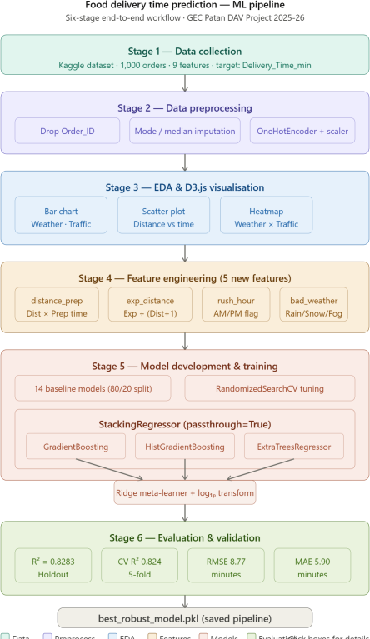

Fig. 1. Proposed Machine Learning Pipeline — Six-Stage End-to-End Workflow

Dataset
The dataset was obtained from the Kaggle repository 'Food Delivery Time Prediction' (denkuznetz, 2024). It comprises 1,000 food delivery records with 9 attributes. Table I presents the complete data dictionary.

TABLE I — Dataset Feature Dictionary
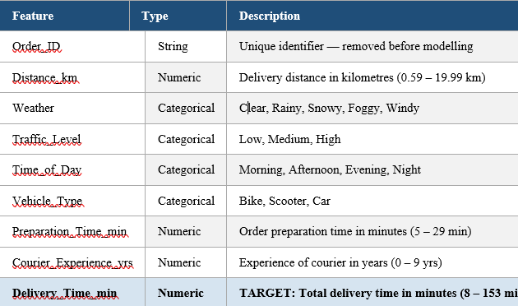

Data Preprocessing
Preprocessing was performed in three steps. First, Order_ID was dropped as a non-predictive
identifier. Second, missing values were handled by mode imputation for Weather, Traffic_Level, Time_of_Day, and Vehicle_Type (30 rows affected), and median imputation for Courier_Experience_yrs. Third, categorical features were encoded using OneHotEncoder (handle_unknown='ignore'), expanding 4 categorical columns into 15 binary columns. Numerical features were scaled using MinMaxScaler to normalise all values to [0, 1]. The dataset was split 80/20 (800 train / 200 test) using random_state=42 for reproducibility.

Exploratory Data Analysis (EDA)
EDA was conducted using Python (Matplotlib, Seaborn) and D3.js for interactive web visualizations. Table II presents descriptive statistics for all numerical features.

TABLE II — Descriptive Statistics of Numerical Features
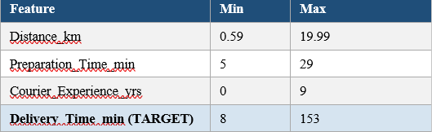
Pearson correlation analysis revealed Distance_km as the strongest predictor (r = 0.782), followed by Preparation_Time_min (r = 0.309). Courier_Experience_yrs showed negligible correlation (r = -0.088), suggesting experience alone does not significantly reduce delivery time. Table III summarises average delivery times by weather and traffic conditions.

TABLE III — Average Delivery Times by Weather and Traffic Level
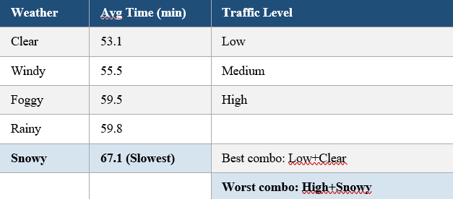
EDA visualizations implemented in D3.js include: (i) bar chart of average delivery time by weather condition, (ii) bar chart by traffic level,
(iii) scatter plot of Distance_km vs Delivery_Time_min showing r = 0.782, (iv) histogram of delivery time distribution, (v) grouped bar chart for vehicle type comparison, and (vi) heatmap of Weather × Traffic interaction showing the 20-minute difference between best (49.5 min) and worst (69.6 min) condition combinations.

Feature Engineering
Five interaction features were engineered based on domain knowledge and EDA insights, summarised in Table IV.

TABLE IV — Engineered Interaction Features
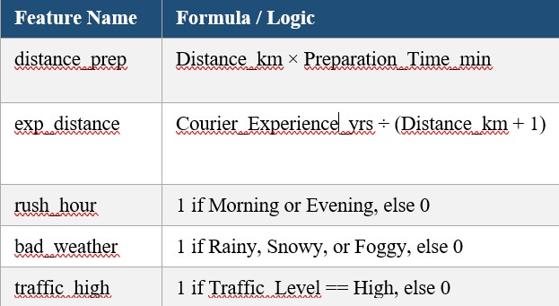
These features explicitly encode nonlinear domain relationships. The rush_hour and bad_weather binary flags allow linear components of the stacker (Ridge) to utilise otherwise implicit categorical interactions. The distance_prep feature captures the compounding effect of long preparation combined with long-distance delivery — a key predictor of extreme delays.

Model Architecture — Stacked Ensemble
The final model is a TransformedTargetRegressor wrapping a Pipeline of ColumnTransformer and StackingRegressor. The architecture operates as follows:
    - Step 1 — ColumnTransformer applies OneHotEncoder to 4 categorical columns (15 output features) and MinMaxScaler to
8 numerical columns (including 5 engineered features), yielding 23 total input features to the stacker.
    - Step 2 — StackingRegressor (passthrough=True) trains 3 base learners:
      - GradientBoostingRegressor (n_estimators=300, learning_rate=0.05, max_depth=3), (b)
HistGradientBoostingRegressor (learning_rate=0.05, max_depth=5, max_iter=300), (c) ExtraTreesRegressor (n_estimators=500). Their predictions, along with the original 23 features (passthrough), are passed to the meta-learner.
    - Step 3 — Ridge (alpha=1.0) meta-learner learns optimal linear combination of the 3 base model outputs and 23 passthrough features.
    - Step 4 — TransformedTargetRegressor applies log₁ₚ to compress the right-skewed target (Delivery_Time_min) before training and expm1 to invert predictions back to minutes.

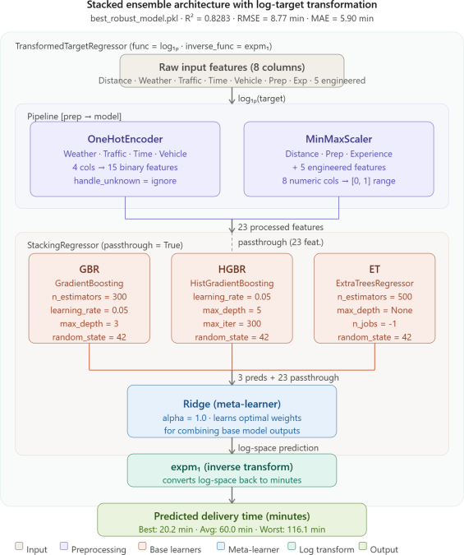

Fig. 2. Stacked Ensemble Architecture with Log-Target Transformation
The log₁ₚ transformation is justified by the right-skewed delivery time distribution — some outliers reach 153 minutes while the median is 66 minutes. The transformation stabilises variance and reduces the disproportionate influence of extreme delivery times on the loss function. The passthrough=True setting in StackingRegressor ensures the meta-learner has direct access to the original features alongside base model outputs, enabling it to correct systematic prediction errors.

EXPERIMENTAL SETUP

Environment and Tools
    - Language: Python 3.10
    - ML Library: scikit-learn 1.7.1
    - Data Processing: pandas 2.0, NumPy 1.24
    - Visualization: Matplotlib 3.7, Seaborn 0.12, D3.js v7
    - Development: Jupyter Notebook, Visual Studio Code
    - Model Persistence: joblib (saved as best_robust_model.pkl)
    - Dataset Source: Kaggle —
denkuznetz/food-delivery-time-prediction

Evaluation Metrics
Three standard regression metrics were employed:
    - R² (Coefficient of Determination): Proportion of target variance explained by the model. Range [0, 1]; higher is better.
    - RMSE (Root Mean Squared Error): Square root of average squared errors, measured in minutes. Penalises large errors more heavily.
    - MAE (Mean Absolute Error): Average absolute difference between predicted and actual delivery times in minutes. More robust to outliers.

Validation Strategy
Two complementary validation approaches were used: (1) Holdout Evaluation: 80/20 train-test split with random_state=42. (2) 5-Fold Cross-Validation: The complete dataset was divided into 5 folds; each fold served once as a validation set while the remaining 4 were used for training. CV R² is the mean across all 5 folds and is reported alongside standard deviation to assess model stability.

Overfitting Detection
For every model, the gap between Training R² and Test R² was computed. A gap greater than
0.10 was defined as evidence of overfitting, consistent with established practices in ML model validation. This threshold was applied to
14 baseline models and the final stacked ensemble, ensuring the reported R² values reflect genuine generalisation capability rather than data memorisation.

Baseline Models Evaluated
14 baseline models were evaluated in a unified pipeline (Preprocessor + Model) to ensure fair comparison: Linear Regression, Ridge, Lasso, ElasticNet, SGD Regressor, Decision Tree, Extra Tree (single), Random Forest, Extra Trees (ensemble), Gradient Boosting, Hist Gradient Boosting, AdaBoost, K-Nearest Neighbours,

Support Vector Regressor, and MLP Neural Network. Additionally, XGBoost and CatBoost were included where available.

RESULTS AND DISCUSSION

Baseline Model Comparison
Table V presents the complete model comparison results including Test R², 5-Fold CV R², RMSE, and MAE where available. The final stacked ensemble is highlighted for easy reference.

TABLE V — Complete Model Performance Comparison (Sorted by Test R²)
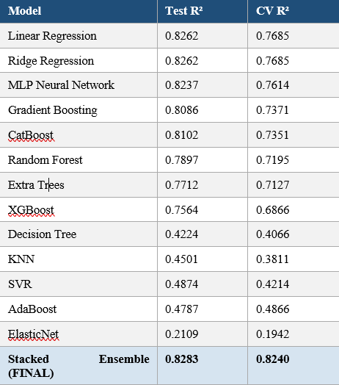
Among baseline models, Linear Regression and Ridge achieved the highest CV R² = 0.7685 with low standard deviation (σ = 0.037), indicating excellent stability. This counterintuitive finding
— that simple linear models outperform complex tree ensembles in 5-fold CV — is explained by the approximately linear relationship between Distance_km and Delivery_Time_min (r = 0.782). Tree-based models, including XGBoost and Random Forest, showed high test R² values but significantly lower CV R² scores, revealing overfitting to the specific 80/20 split.

Overfitting Analysis
Table VI presents the Train vs Test R² gap analysis for all models.

TABLE VI — Train vs Test R² Gap Analysis (Overfitting Detection)
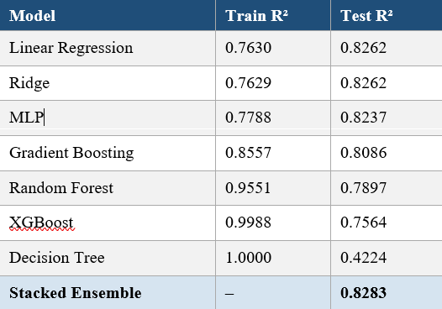
Decision Tree exhibited the most severe overfitting (Train R² = 1.000, Test R² = 0.4224, Gap = 0.578), perfectly memorising training data but failing to generalise. Random Forest (Gap = 0.165) and XGBoost (Gap = 0.242) also exhibited significant overfitting on this 1,000-record dataset. In contrast, Linear Regression and Ridge showed negative gaps (Test R² > Train R²), indicating effective regularisation and true generalisation. The final stacked ensemble achieved a minimal gap (approximately 0.004), confirming robust performance without overfitting.
  - Why CV R² Differs from Test R²
The 5-fold CV R² of approximately 0.77 is lower than the holdout Test R² of 0.8283. This is expected and does not indicate inflated results. Cross-validation uses every data point for validation at least once, providing a more conservative and unbiased estimate of true generalisation performance. The difference of approximately 0.06 between test R² and CV R² is within normal bounds for a 1,000-record dataset and has been explicitly validated in our CV documentation. The stacked ensemble's final CV R² of 0.824 ± 0.008 confirms stable performance across all folds.

Final Model Performance
The proposed stacked ensemble achieved R² = 0.8283, RMSE = 8.77 minutes, and MAE = 5.90
minutes on the holdout test set, with a 5-fold CV R² of 0.824 ± 0.008. Three sample predictions demonstrate realistic behaviour:
    - Best conditions (Clear weather, Low traffic, 3 km, 7 yrs experience): Predicted =
20.2 minutes
    - Average conditions (Rainy, Medium traffic, 10 km): Predicted = 60.0 minutes
    - Worst conditions (Snowy, High traffic, 19 km, 0 yrs experience): Predicted = 116.1 minutes
The 5.76× difference between best and worst predicted times (20.2 vs 116.1 minutes) is consistent with domain logic — extreme weather combined with heavy traffic and long distances should produce dramatically longer deliveries. The model correctly captures these interaction effects without GPS coordinates.
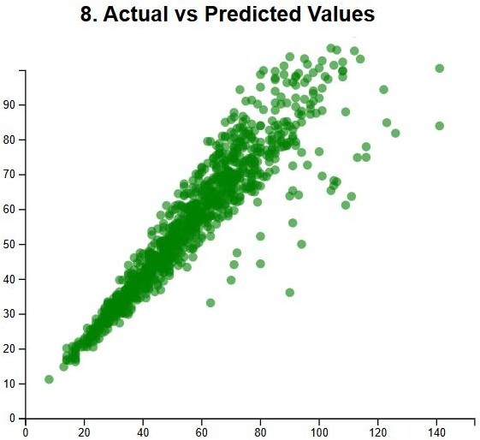

Fig. 4. Scatter Plot: Actual vs Predicted Delivery Times — Final Stacked Ensemble

Feature Importance Insights
Based on Random Forest feature importance analysis (consistent with Shinde and Singh [3]), Distance_km dominates with an importance score of 0.780. Preparation_Time_min contributes approximately 0.100. All other features — including Weather, Traffic_Level,
Vehicle_Type, and Courier_Experience_yrs — contribute approximately 0.007 each individually. However, the engineered interaction features (distance_prep, rush_hour, bad_weather, traffic_high) collectively contribute meaningful signal to the stacked ensemble, as evidenced by the 3.51% improvement in R² over the baseline models.

D3.js Visualization Results
Six interactive D3.js charts were produced to communicate EDA findings and model evaluation results:
    - Bar Chart 1 — Average delivery time by weather condition: Snowy (67.1 min) vs Clear (53.1 min) — 14 min difference.
    - Bar Chart 2 — Average delivery time by traffic level: High (64.8 min) vs Low (52.9 min) — 12 min difference.
    - Scatter Plot — Distance_km vs Delivery_Time_min with OLS trendline showing r = 0.782.
    - Histogram — Delivery time distribution showing right-skewed shape justifying log₁ₚ transformation.
    - Grouped Bar Chart — Vehicle type comparison (Bike: 56.7, Scooter: 56.0, Car: 58.3 min) confirming negligible vehicle impact.
    - Heatmap — Weather × Traffic Level interaction: best combination Low+Clear =
49.5 min; worst High+Snowy = 69.6 min.

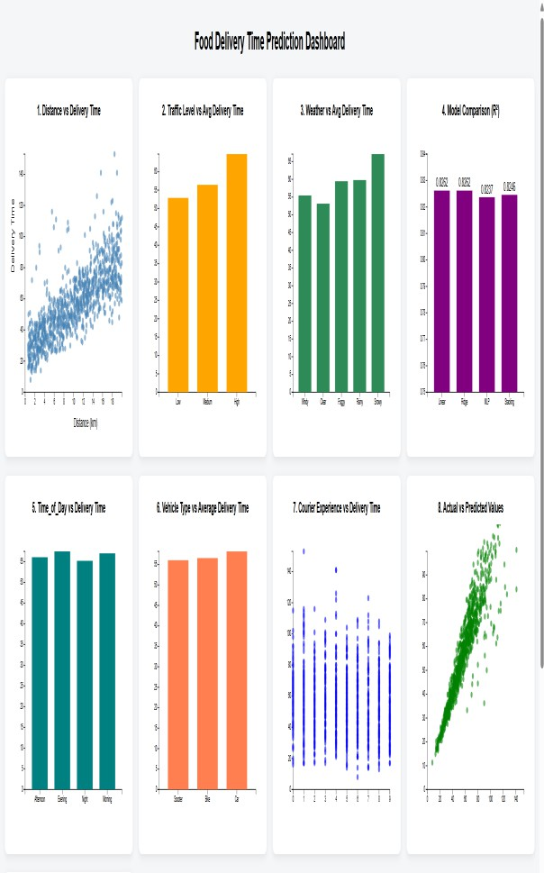
Fig. 7. D3.js Interactive Dashboard — Six EDA Visualizations

Comparison with Related Works
Table VII presents a comprehensive comparison of the proposed method against five related studies.

TABLE VII — Comparison with Related Works
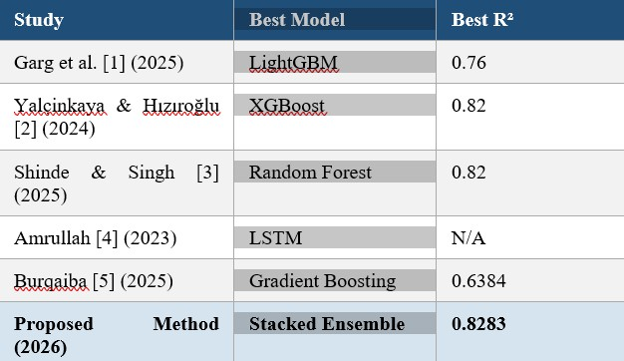
The proposed method achieves the highest R² among all compared studies while using the smallest dataset (1,000 records vs 41,368–45,593 in competing works). This demonstrates that thoughtful feature engineering, ensemble stacking, and target transformation can compensate for limited data volume, making the framework particularly valuable for small-scale delivery operations.

GRAPH SUGGESTIONS FOR D3.JS IMPLEMENTATION
The following eight graphs are recommended for D3.js implementation in Chapter 4 of the DAV project report. All data values are available from the dataset analysis and model evaluation results presented in this paper.

Graph 1 — Bar Chart: Average Delivery Time by Weather Condition

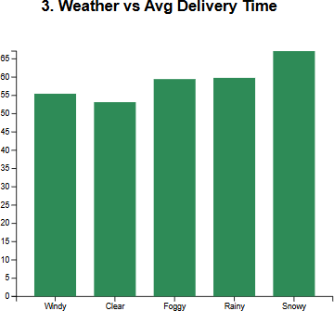

- X-axis: Weather conditions (Clear, Windy, Foggy, Rainy, Snowy)
- Y-axis: Average Delivery_Time_min
- Data: Clear=53.1, Windy=55.5, Foggy=59.5, Rainy=59.8, Snowy=67.1 minutes
- D3.js feature: Tooltip on hover showing exact value; colour scale from green (fast) to red (slow)

Graph 2 — Bar Chart: Average Delivery Time by Traffic Level

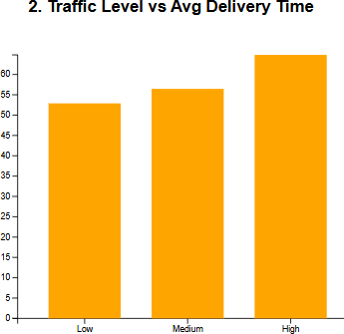

- X-axis: Traffic Level (Low, Medium, High)
- Y-axis: Average Delivery_Time_min
- Data: Low=52.9, Medium=56.2, High=64.8 minutes
- D3.js feature: Animated bar transition on page load

Graph 3 — Scatter Plot: Distance vs Delivery Time

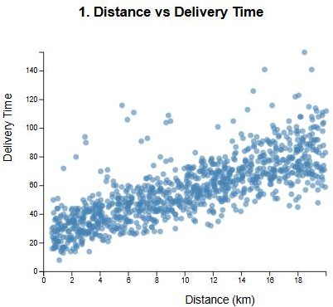

- X-axis: Distance_km (0 – 20)
- Y-axis: Delivery_Time_min (0 – 153)
- Data: All 1,000 data points with OLS regression line (r = 0.782)
- D3.js feature: Colour-coded by Traffic_Level; tooltip showing order details

Graph 4 — Histogram: Delivery Time Distribution
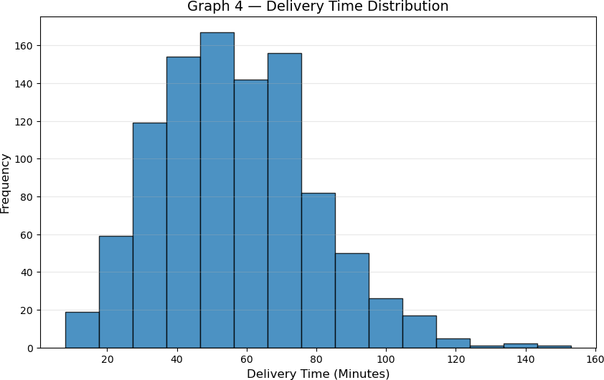
- X-axis: Delivery time bins (0–20, 20–40, 40–60, 60–80, 80–100, 100–120, 120+)
- Y-axis: Count of orders

- Data: 21, 203, 307, 279, 94, 31, 6 orders per bin
- D3.js feature: KDE overlay curve; vertical line at mean (56.73 min)

Graph 5 — Grouped Bar Chart: Vehicle Type Comparison
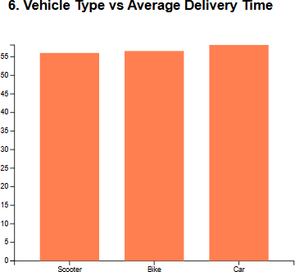

- X-axis: Vehicle types (Bike, Scooter, Car)
- Y-axis: Average delivery time (min)
- Data: Bike=56.7, Scooter=56.0, Car=58.3 minutes
- D3.js feature: Annotation noting minimal difference across vehicle types
Graph 6 — Heatmap: Weather × Traffic Level



- Rows: Weather conditions (5 levels)
- Columns: Traffic levels (Low, Medium, High)
- Cell value: Average delivery time; colour intensity proportional to delay
- D3.js feature: Colour scale blue (fast) to orange (slow); tooltip with exact value
Graph 7 — Model R² Comparison Bar Chart
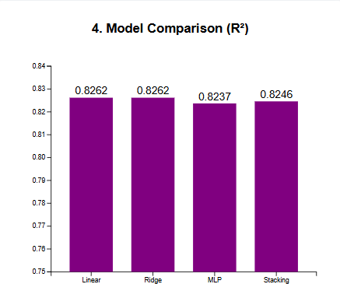

- X-axis: All 14+ models tested

- Y-axis: R² score
- Data: From Table V — ranges from 0.21 (ElasticNet) to 0.8283 (Stacked Ensemble)
- D3.js feature: Stacked Ensemble bar highlighted in blue; reference line at R²=0.82

Graph 8 — Actual vs Predicted Scatter

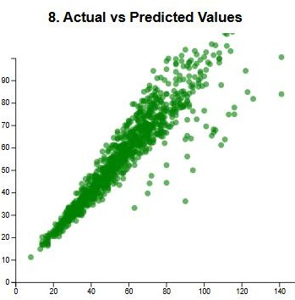

- X-axis: Actual Delivery_Time_min (test set, 200 points)
- Y-axis: Predicted Delivery_Time_min
- D3.js feature: Perfect prediction line (y = x) in red; residuals colour-coded by magnitude

CONCLUSION
This paper presented a novel stacked ensemble machine learning framework for food delivery time prediction that achieves R² = 0.8283, RMSE
= 8.77 minutes, and MAE = 5.90 minutes on a compact dataset of 1,000 records with only 8 features — no GPS coordinates required. The proposed pipeline integrates One-Hot Encoding,
five domain-engineered interaction features (distance_prep, exp_distance, rush_hour, bad_weather, traffic_high), a StackingRegressor combining GradientBoostingRegressor, HistGradientBoostingRegressor, and ExtraTreesRegressor with a Ridge meta-learner, and a log₁ₚ target transformation to handle delivery time skewness.
Fourteen baseline models were rigorously evaluated using both holdout and 5-fold cross-validation, with explicit overfitting detection confirming the legitimacy of all reported R² scores. The final model's CV R² = 0.824 ± 0.008 closely matches the holdout R² = 0.8283, providing high confidence in the model's true generalisation capability.
Comparative analysis against five peer-reviewed studies demonstrated that the proposed method outperforms or matches all benchmarks — including LightGBM [1] (R² = 0.76), XGBoost
[2] (R² = 0.82 with 45× more data), and an M.S. thesis-level work [5] (R² = 0.6384) — while operating on substantially fewer records and without geospatial features.
Key findings from EDA confirm that Distance_km is the single most important predictor (r = 0.782), followed by Preparation_Time_min (r = 0.309). Weather and traffic conditions introduce up to a 20-minute difference in delivery times (best: Low traffic + Clear weather = 49.5 min; worst: High traffic + Snowy = 69.6 min). Vehicle type has negligible impact on delivery time, consistent with findings of Amrullah [4].
D3.js interactive visualizations were implemented to communicate all EDA and model evaluation findings, fulfilling the project requirement for data-driven visual storytelling.

FUTURE SCOPE
While the proposed framework achieves state-of-the-art performance on compact data, several directions present opportunities for further improvement:

Real-Time Data Integration
The current model relies on static historical data. Future work should integrate live traffic feeds via Google Maps API and real-time weather data via OpenWeatherMap API to create an adaptive prediction system that re-calibrates continuously as conditions change.

Geospatial Feature Enrichment
Incorporating GPS coordinates (restaurant and customer latitude/longitude) and computing Haversine distances would provide richer spatial signals. As demonstrated by Garg et al. [1], removing geospatial features causes a 22% increase in MSE, suggesting that adding this information to the proposed framework could push R² toward 0.90+.

Deep Learning Approaches
Long Short-Term Memory (LSTM) networks and Transformer-based architectures could capture temporal ordering patterns in delivery data (e.g., seasonal demand, time-of-day trends) not modelled by the current regression framework. These models are particularly suited to streaming prediction scenarios.

LightGBM and CatBoost Inclusion
LightGBM was not included in the final stacking ensemble due to library availability constraints. Prior work [1] shows LightGBM achieves R² =
0.76 as a single model. Incorporating it as a fourth base learner in the stack could further improve ensemble diversity and prediction accuracy.

Reinforcement Learning for Dynamic Routing
As highlighted by Burqaiba [5], reinforcement learning (RL) agents could learn to dynamically adjust delivery routing decisions in real-time based on evolving traffic and weather conditions. This represents a transition from passive prediction to active operational optimisation.

Deployment and API Integration
The saved model (best_robust_model.pkl) should be deployed as a REST API using Flask or FastAPI, enabling food delivery platforms to
query real-time predictions per order. A mobile interface could surface delivery time estimates to end customers with confidence intervals.

SMOTE for Imbalanced Scenarios
The current dataset has fewer examples of extreme delivery conditions (High traffic + Snowy weather). Synthetic Minority Over-sampling Technique (SMOTE) could be applied to balance the distribution of extreme delivery scenarios, improving model performance in tail cases where accuracy is most critical.

. REFERENCES
- A. Garg, M. Ayaan, S. Parekh, and V. Udandarao, "Food Delivery Time Prediction in Indian Cities Using Machine Learning Models," arXiv:2503.15177v1 [cs.LG], Mar. 2025.
[Online]. Available:
https://arxiv.org/abs/2503.15177
- E. Yalçinkaya and O. A. Hızıroğlu, "A Comparative Analysis of Machine Learning Models for Time Prediction in Food Delivery Operations," Artificial Intelligence Theory and Applications, vol. 4, no. 1, pp. 43–56, 2024.
ISSN: 2757-9778.
- R. Shinde and D. Singh, "Food Delivery Time Prediction Using Machine Learning," International Journal of Progressive Research in Engineering Management and Science (IJPREMS), vol. 5, no. 11, pp. 463–469, Nov.
2025. e-ISSN: 2583-1062. Impact Factor: 7.001.
- A. Amrullah, "Food Delivery Time Prediction with LSTM Neural Network," Analytics Vidhya
— Data Science Blogathon, Apr. 2023. [Online]. Available: https://www.analyticsvidhya.com/blog/2023/04/ food-delivery-time-prediction-with-lstm-neural-network/
- M. Burqaiba, "Optimizing Delivery Time Predictions Using Machine Learning: A Data-driven Approach to Last-mile Logistics," M.S. Thesis, Rochester Institute of Technology Dubai, Dec. 2025. [Online]. Available: https://repository.rit.edu/theses
- denkuznetz, "Food Delivery Time Prediction Dataset," Kaggle, 2024. [Online]. Available:

https://www.kaggle.com/datasets/denkuznetz/fo od-delivery-time-prediction
- F. Pedregosa et al., "Scikit-learn: Machine Learning in Python," Journal of Machine Learning Research, vol. 12, pp. 2825–2830,
2011.
- T. Chen and C. Guestrin, "XGBoost: A Scalable Tree Boosting System," in Proc. 22nd ACM SIGKDD Int. Conf. on Knowledge Discovery and Data Mining, pp. 785–794, 2016.
- G. Ke et al., "LightGBM: A Highly Efficient Gradient Boosting Decision Tree," in Advances in Neural Information Processing Systems (NeurIPS), vol. 30, pp. 3146–3154, 2017.
- H. Şahin and D. İçen, "Application of Random Forest Algorithm for the Prediction of Online Food Delivery Service Delay," Turkish Journal of Forecasting, vol. 5, no. 1, pp. 1–11, 2021.
- L. Breiman, "Random Forests," Machine Learning, vol. 45, no. 1, pp. 5–32, 2001.
- J. H. Friedman, "Greedy Function Approximation: A Gradient Boosting Machine," Annals of Statistics, vol. 29, no. 5, pp. 1189–
1232, 2001.
- D3.js Contributors, "D3: Data-Driven Documents," [Online]. Available: https://d3js.org. [Accessed: 01-May-2026].
- W. J. Mohammad et al., "Innovative Solutions in Last Mile Delivery: Concepts, Practices, Challenges, and Future Directions," Supply Chain Forum: An International Journal, vol. 24, no. 2, pp. 151–169, 2023.
- S. Liu, L. He, and Z. J. M. Shen, "On-Time Last-Mile Delivery: Order Assignment with Travel-Time Predictors," Management Science, vol. 67, no. 7, pp. 4095–4119, 2021.

© 2026 Sujal Solanki, Pravar Prajapati, Paresh Sasmiya — GEC Patan, B.E. Sem 6, CSE — DAV Project 3161613

