**CRUD OPERATIONS:**

This project contains CRUD(Create Read Update Delete) operations.

This is done by using technologies ASP.Net WEBAPI for back end and Angular for front end

Here we have created Web API at backend and then consumed this APIs in project for crud operations

**Web API**

**Get API:**

[**http://localhost:4200/api/shops**](http://localhost:4200/api/shops)

**Getby idAPI:**

[**http://localhost:4200/api/shops/id**](http://localhost:4200/api/shops/id)

**PostAPI:**

[**http://localhost:4200/api/shops**](http://localhost:4200/api/shops)

**PutAPI:**

[**http://localhost:4200/api/shops/id**](http://localhost:4200/api/shops/id)

**DeleteAPI:**

[**http://localhost:4200/api/shops/id**](http://localhost:4200/api/shops/id)

**CRUD**

**List :**Here we can view the list of products and list is properly displayed with paginations

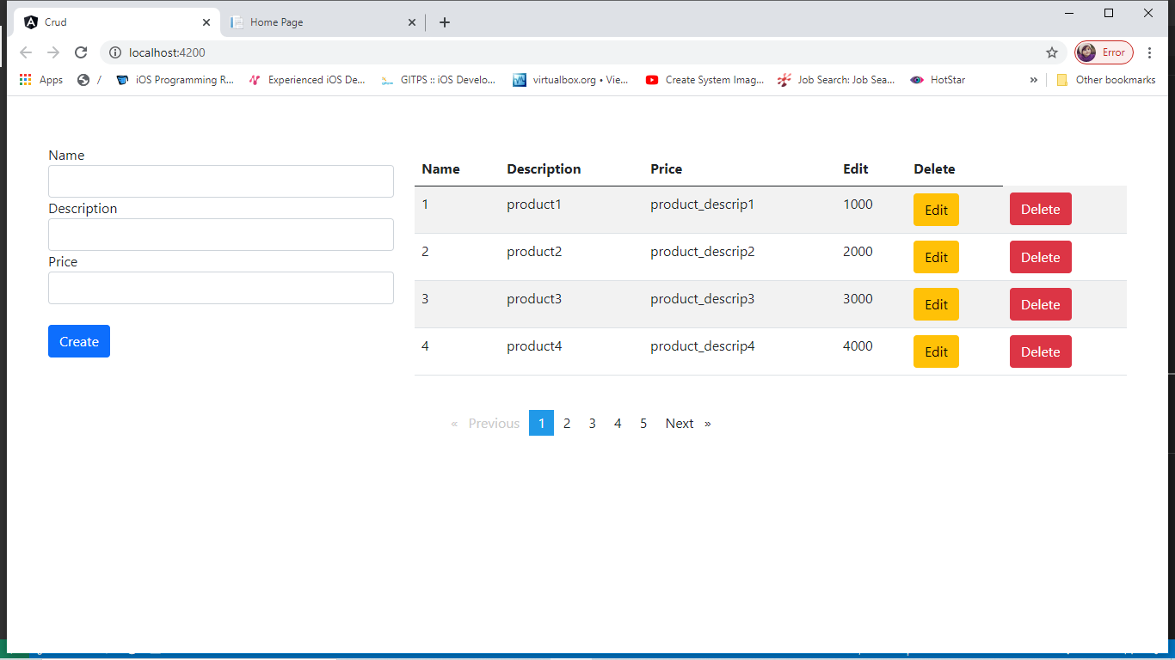

**Create**: Here is the create operation we can send the data and click on button click the data is send in list

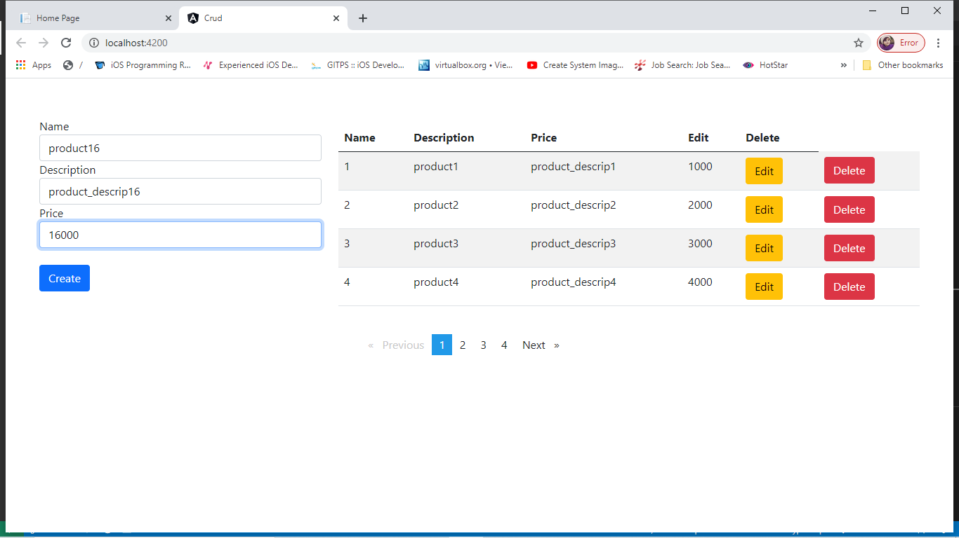

**Delete**: here click on delete button an alert will open saying to delete click OK we can delete the item from the list

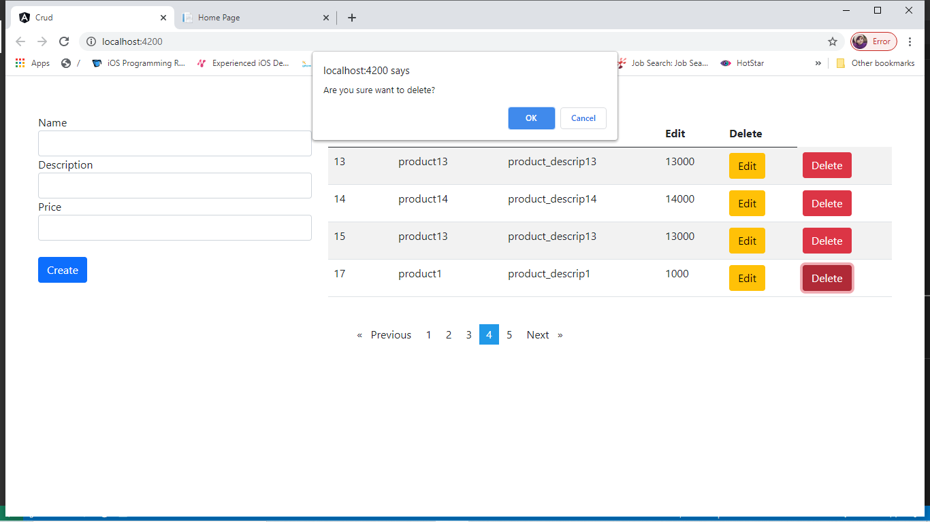

**Update**: Here we can modify any item . on edit button click ,required data is displayed in the form. on updated button click data is updated

