**IOT_Phase1**

**Smart water fountain**

SUBMITTED BY: Praveen.P

PHASE 1: **PROBLEM DEFINITION AND DESIGN**

**THINKING**

**PROBLEM STATEMENT:**

**Design and implement a water fountain system that provides a continuous and aesthetically pleasing water flow while optimizing water usage, energy efficiency, and maintenance requirements.**

**Water Conservation: Implement water-saving measures, such as recycling and filtering systems, to minimize water consumption and reduce environmental impact.**

**Maintenance: Minimize the need for frequent maintenance by using durable materials, self-cleaning mechanisms, and remote monitoring capabilities to detect and address issues promptly.**

**Water Recycling: Design a closed-loop water circulation system that recycles and purifies the fountain's water, reducing the need for constant replenishment and minimizing water waste.**

**Water Quality: Maintain high water quality standards to prevent issues like algae growth, doors, and contamination, utilizing advanced filtration and treatment technologies.**

**PROBLEM SOLUTION:**

**Check Water Supply: Ensure there is enough water in the reservoir or basin. If the water level is too low, it can affect the fountain's performance.**

**Check Water Quality:** **Common water quality measurement factors include temperature, Ph-value, conductance, turbidity and hardness considering the pollution at home can only affect limited factors, we choose temperature, Ph-value and conductance to be the three properties used for calculating water quality in our water fountain.**

**Filter the water: water fountain is also designed to self-filter the water every time when water is pumped through the submersible water pump.**

**Water Smells Bad Solution: Stagnant water can develop doors. Clean the fountain regularly and replace the water with fresh, clean water. Use a water clarifier or purifier if needed.**

**Design a smart water fountain that can monitor the water quality and automatically replace water when polluted (not healthy) or running out. We will use sensors to measure the water quality.**

**Project Definition: The project aims to enhance public water fountains by implementing IOT sensors to control water flow and detect malfunctions. The primary objective is to provide real-time information about water fountain status to residents through a public platform. This project includes defining objectives, designing the IOT sensor system, developing the water fountain status platform, and integrating them using IOT technology and Python.**

**What is smart water fountain?**

**Smart water fountain is a technologically advanced device that provides access to drinking water and incorporates various features to enhance user experience, convenience, and efficiency. These features typically include touch less operation, water filtration, temperature control, customization options, connectivity to mobile apps, and sometimes even water quality monitoring and data collection capabilities. Smart water fountains are designed to offer improved hygiene, accessibility, and user control compared to traditional water fountains.**

**Design Thinking:**

**Project Objectives:**

* **Real-time water fountain monitoring**
* **Efficient water usage**
* **Malfunction detection**
* **Resident awareness.**

**Block Diagram of Smart Water Fountain**

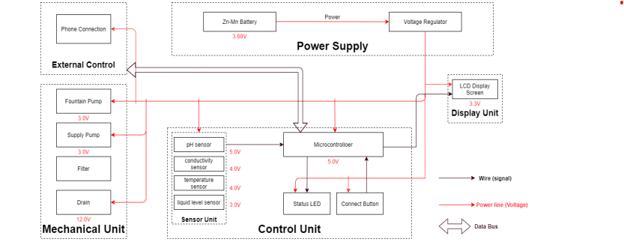

**REAL-TIME WATER FOUNTATION MONITORING:**

**Real-time water fountain monitoring involves continuously tracking and analyzing various aspects of a water fountain's performance to ensure its optimal operation. Here are some key components and objectives of real-time water fountain monitoring are**

**Temperature: Monitoring the temperature of the water to ensure it matches user preferences and safety standards**

**Filter Status: Checking the condition of filters and alerting when they need replacement to maintain water quality**

**Water Quality: Monitoring the quality of the water being dispensed, including pH levels, turbidity, and the presence of contaminants. This helps ensure that the water is safe for consumption.**

**Alerts and Notifications: Sending alerts or notifications to maintenance staff or administrators when anomalies or issues are detected, enabling quick response and troubleshooting**

**Usage Data: Collecting data on when and how frequently the fountain is being used. This information can help in maintenance scheduling and resource allocation.**

**Real-time monitoring can be achieved through sensors, data logging systems, and connectivity options like Wi-Fi or cellular networks. It not only ensures the fountain operates efficiently but also contributes to water conservation and user satisfaction**.

**IOT Sensor Design: Sensor deployment is performed to achieve objectives like increasing coverage, strengthening connectivity, improving robustness, or increasing the lifetime of a given WSN. Therefore, a sensor deployment method must be carefully designed to achieve such objective functions without exceeding the available budget.** **For the PH-value sensor, temperature sensor and conductivity sensor, values will be retrieved and calculated to determine the overall water quality level. When poor water quality is determined, the water replacement procedures will take place. The weight sensor readings will be used to determine the amount of fresh water left in the water tank.**

**Temperature Sensor: A water-proof temperature sensor is going to be used. The measured temperature ranges from -55 to +125 Celsius degrees. Between -10 to + 85 degrees, the accuracy is up to +-0.5 degrees. This sensor can fulfill all requirements needed for this project.**

**PH-sensor: PH value is a valued indicator of water quality. This PH-sensor works with 5V voltage, which is also compatible with the temperature sensor. It can 6measure the PH value from 0 to 14 with an accuracy of +- 0.1 at the temperature of 25 degrees.**

**Conductivity sensor:** **Conductivity sensor is also part of the water quality assessment. The error is small, +-5%F.S. The measurement value ranges from 0 to 20 ms/cm which is enough for water quality monitoring.**

**Liquid Level Sensor**: **This sensor is responsible for reflecting how much freshwater is left in the water tank. When the water level is low, fresh water will be pumped to the water tank to ensure the water fountain keeps running with fresh water. For water level from 0 to 9 inches, the corresponding sensor outputs readings from 0 to 1.6. From that, the quantity of freshwater left can be determined.**

Integration Approach: Determine how IOT sensors will send data to **the water fountain status platform. The data collected by the sensors is then shared via the cloud and integrated with software. The software then analyzes and transmits the data to users via an app or website.**

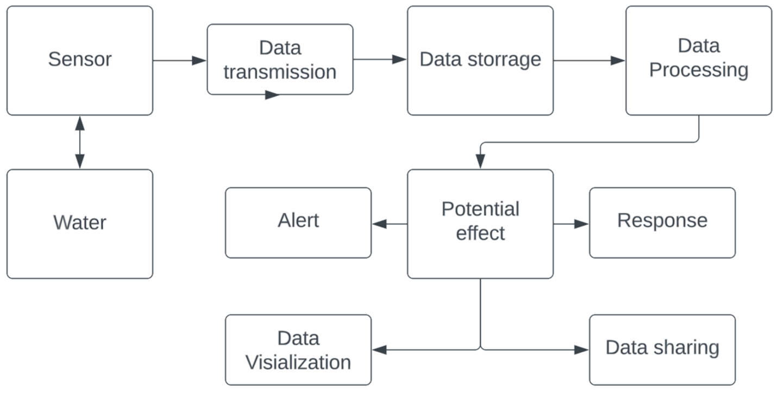

**IOT works like this:**

* **Devices have hardware, like sensors, that collect data.**
* **The data collected by the sensors is then shared via the cloud and integrated with software.**
* **.The software then analyzes and transmits the data to users via an app or website.**

**Smart devices connect to an IOT platform, described by the experts at IOT for all as “the support software that connects everything in an IOT system.” There are hundreds of IOT platforms The Internet of Things is largely made possible by technologies that connect devices and enable them to communicate with one another. Connectivity options have a range of pros and cons with some more suitable for certain use cases like smart homes while others may be more appropriate for IOT applications like industrial automation. These technologies can be divided into two categories**

[**IOT data protocols**](https://www.allaboutcircuits.com/technical-articles/internet-of-things-communication-protocols-iot-data-protocols/)**that allow information to be exchanged between devices even without an internet connection and**[**IOT network protocols**](https://www.allaboutcircuits.com/technical-articles/internet-of-communication-communication-protocols-network-protocols/)**that link devices to one another and to the internet.**

**SOME COMMON IOT COMMUNICATION PROTOCOL**

* **WIFI**
* **ZIG BEE**
* **BLUETOOTH**
* **CELLUAR**

☆-----------------------☆--------------------☆----------------------☆