As per your request we have converted entire application into web which consists of following modules
To implement this project we have designed following modules
- Registration Here: user can sign up with the application
- User Login: user can login to system
- Load & Process ELPV Data: using this model will load and normalize all dataset images and then split into train and test where application using 80% images for training and 20% for testing
- Train Existing & Optimized YOLOv5: 80% training images will be input to existing FRCNN, propose optimized Attention Yolov5 and Extension Yolov6 algorithms to trained a model and this model will be applied on 20% test images to calculate prediction accuracy
- Run Solar Surface Defect Detection: using this module user can upload test image and then extension yolov6 model will classify type of surface defect along with defect probability %.
SCREEN SHOTS
Install python 3.7.2 and then install all packages given in requirements.txt file and then install MYSQL and then copy content from database.txt file and paste in MYSQL console to create database
To run project double click on ‘runWebServer.bat’ file to start python server and then will get below page
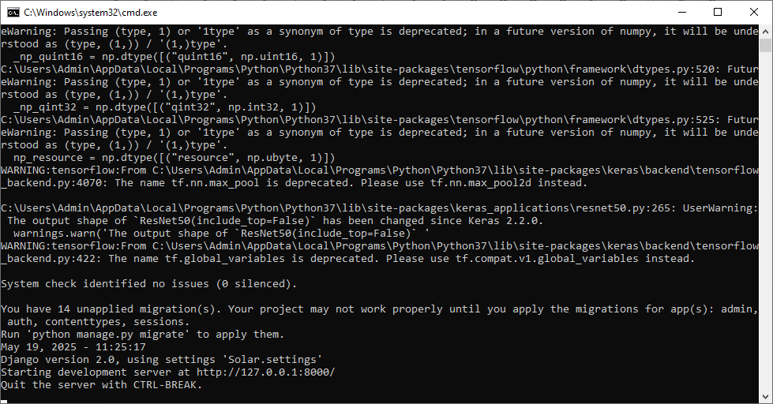
In above screen python server started and now open browser and enter URL as http://127.0.0.1:8000/index.html and then press enter key to get below page
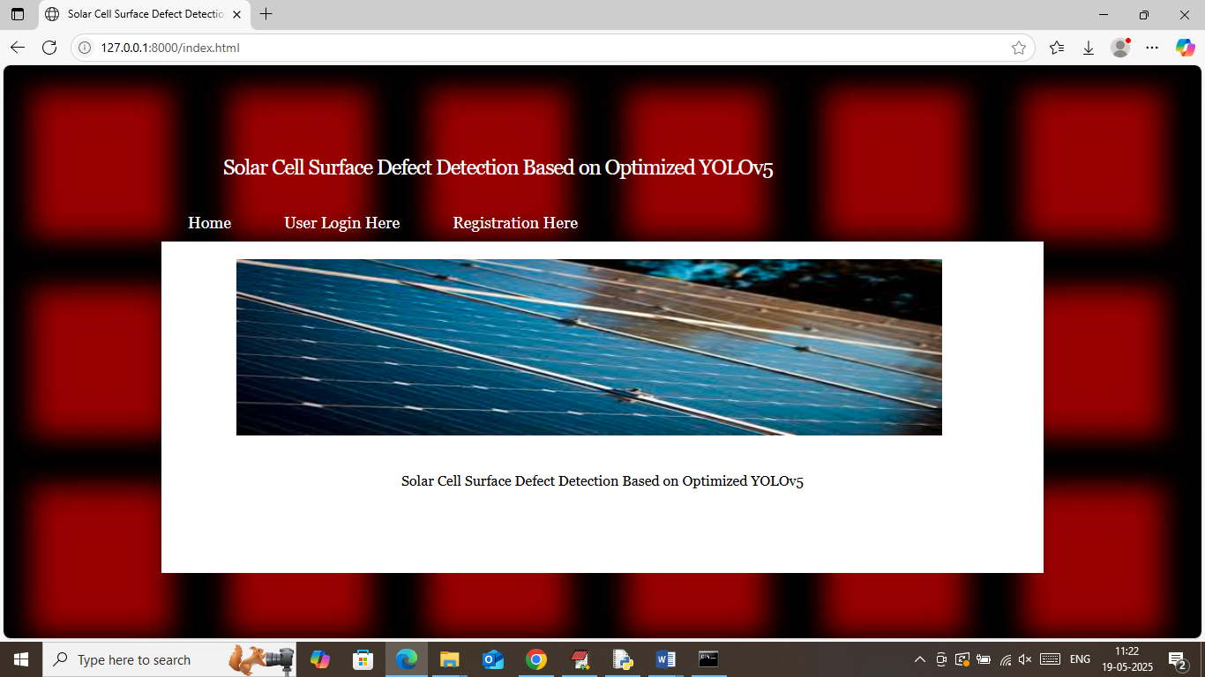
In above screen click on ‘Registration Here’ link to get below page
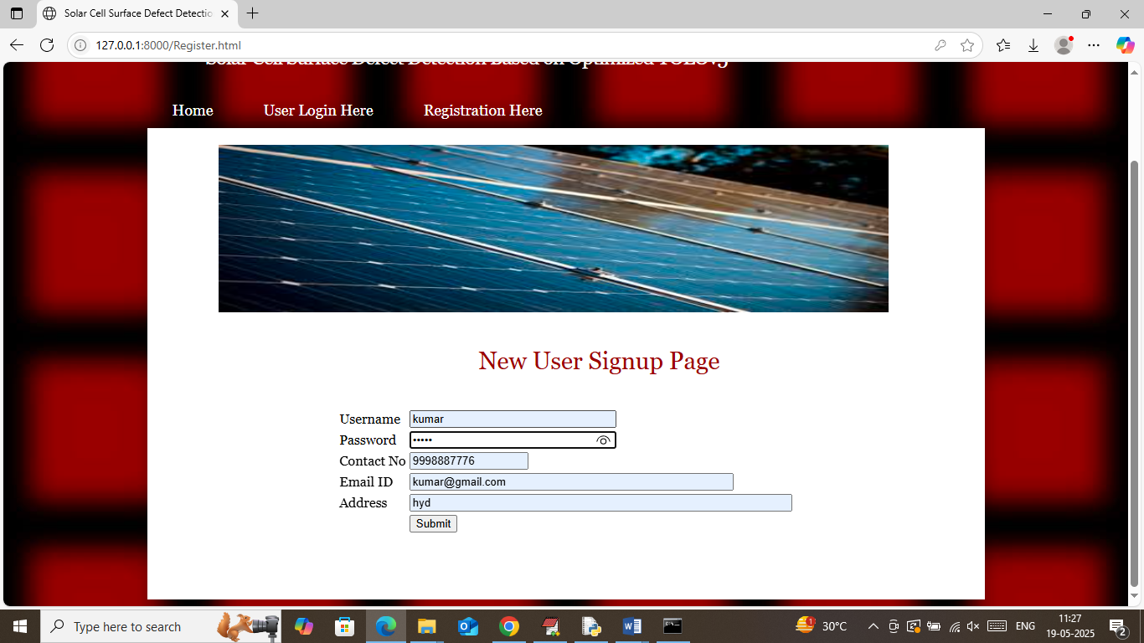
In above screen user is entering sign up details and then press button to get below page
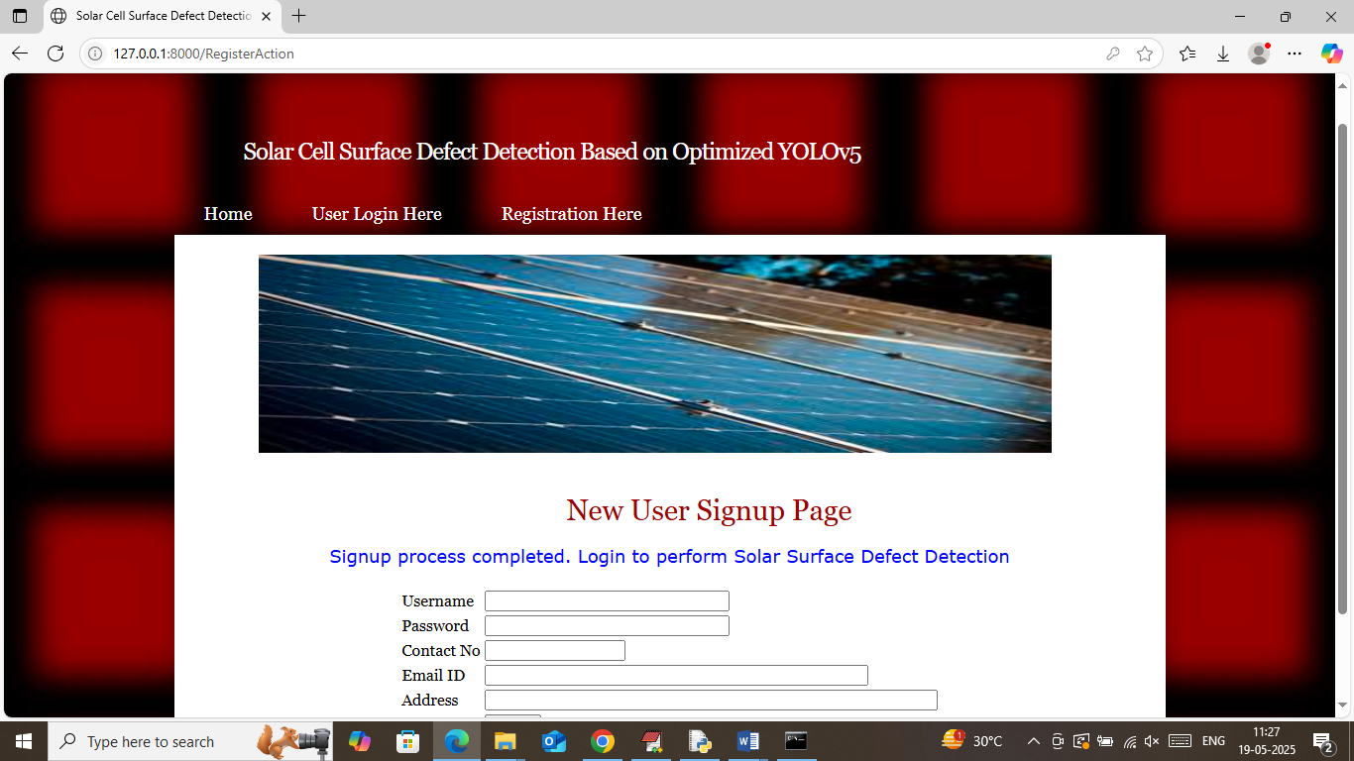
In above screen user sign up process completed and now click on ‘User Login Here’ link to get below page
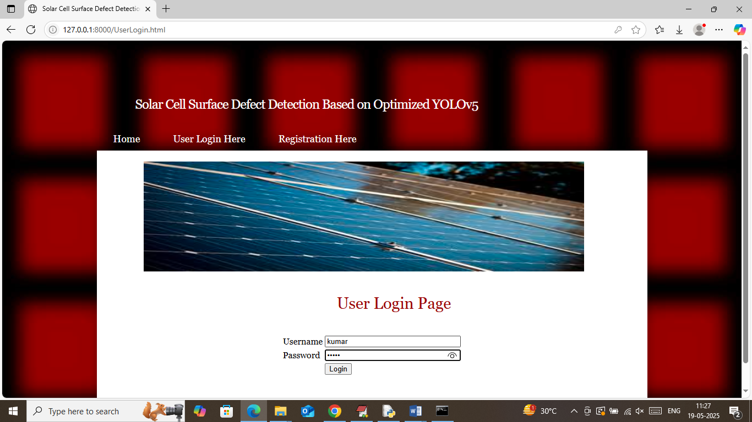
In above screen user is login and after login will get below page
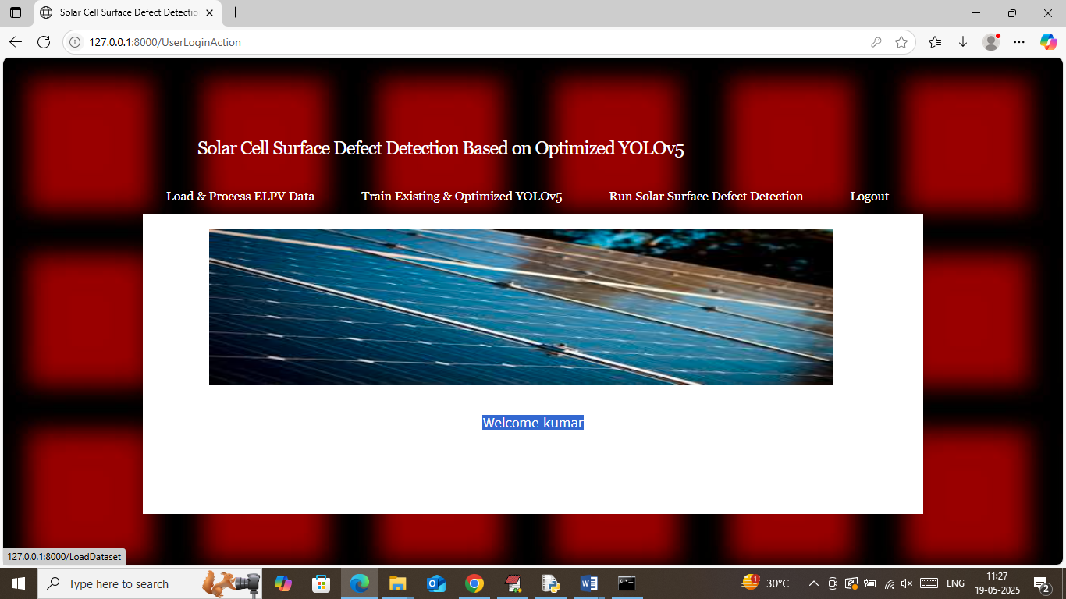
In above screen user can click on ‘Load & Process ELPV Dataset’ link to load dataset and then will get below page
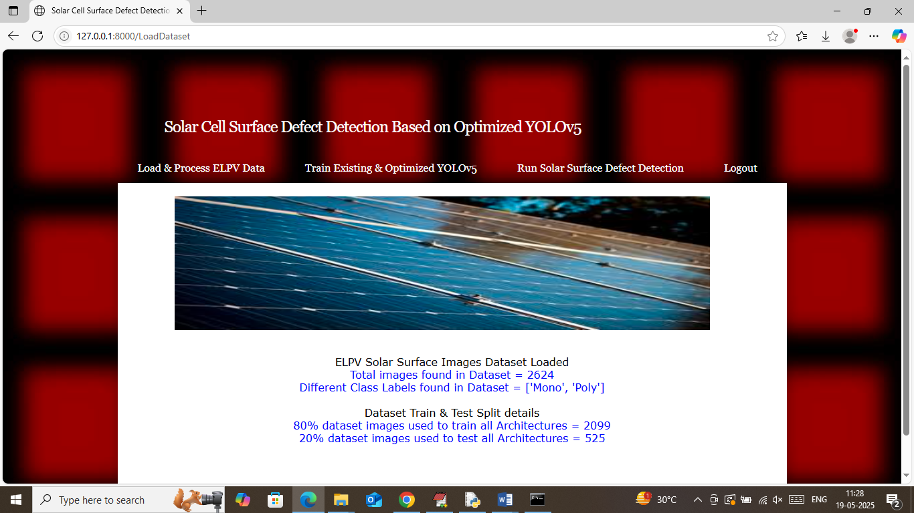
In above screen can see number of images loaded and processed from dataset and then can different class labels found in dataset and then can see train and test size. Now click on ‘Train Existing & Optimized YOLOv5’ link to train propose algorithm and then will get below page
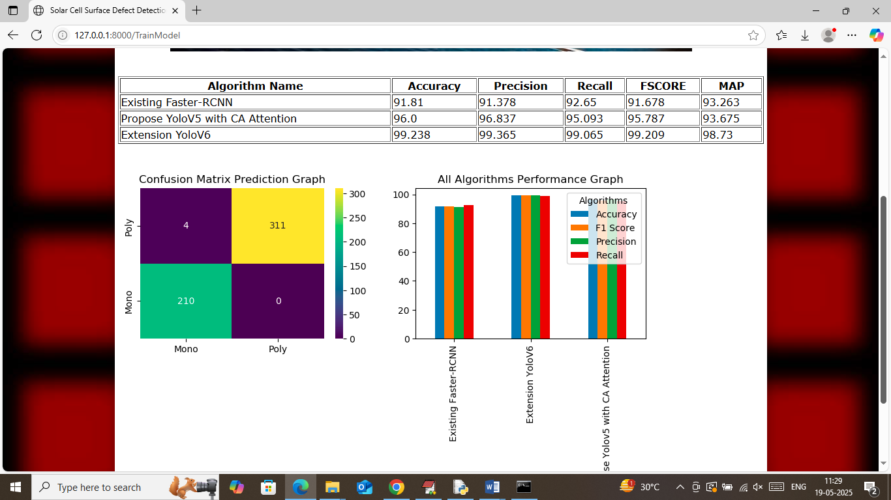
In above screen in table format can see accuracy, precision, recall and FSCORE of existing, propose and extension algorithms where extension Yolov6 got highest accuracy as 99%. In confusion matrix graph x-axis represents Predicted Labels and y-axis represents true labels and then different colour boxes in diagonal represents correct prediction count and remaining blue boxes represents incorrect prediction count which are very few. In second graph showing comparison graph between all algorithms where x-axis represents algorithms names and y-axis represents accuracy, precision and other metrics in different colour bars. Now click on ‘Run Solar Surface Defect Detection’ link to get below page
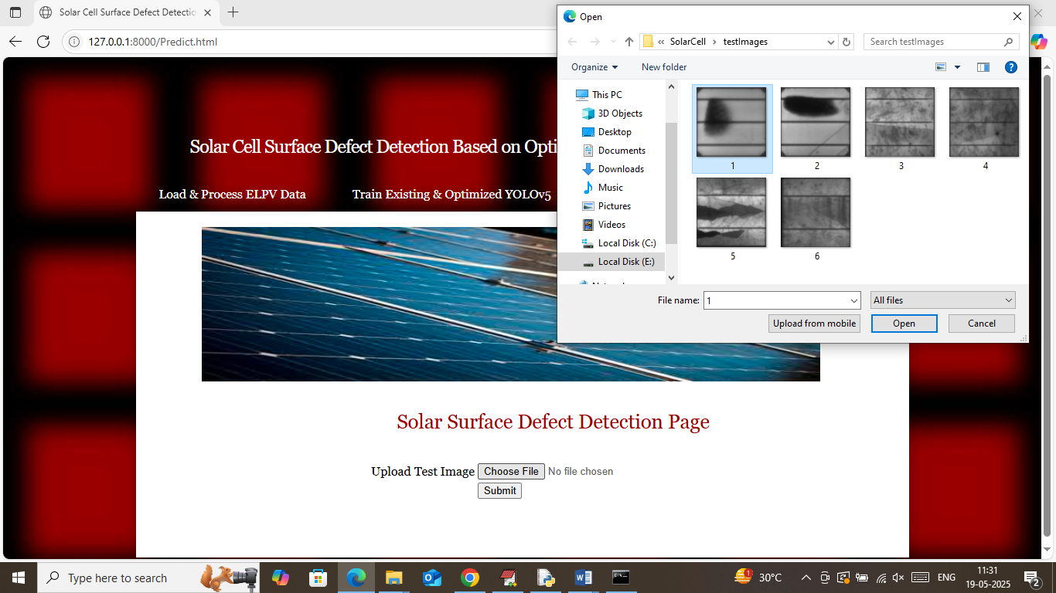
In above screen selecting and uploading test image and then press button to get below page
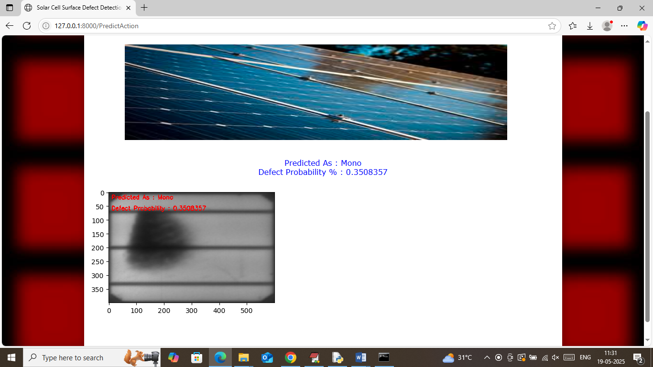
In above screen uploaded image is predicted as Mono Defect and similarly can upload and test other images
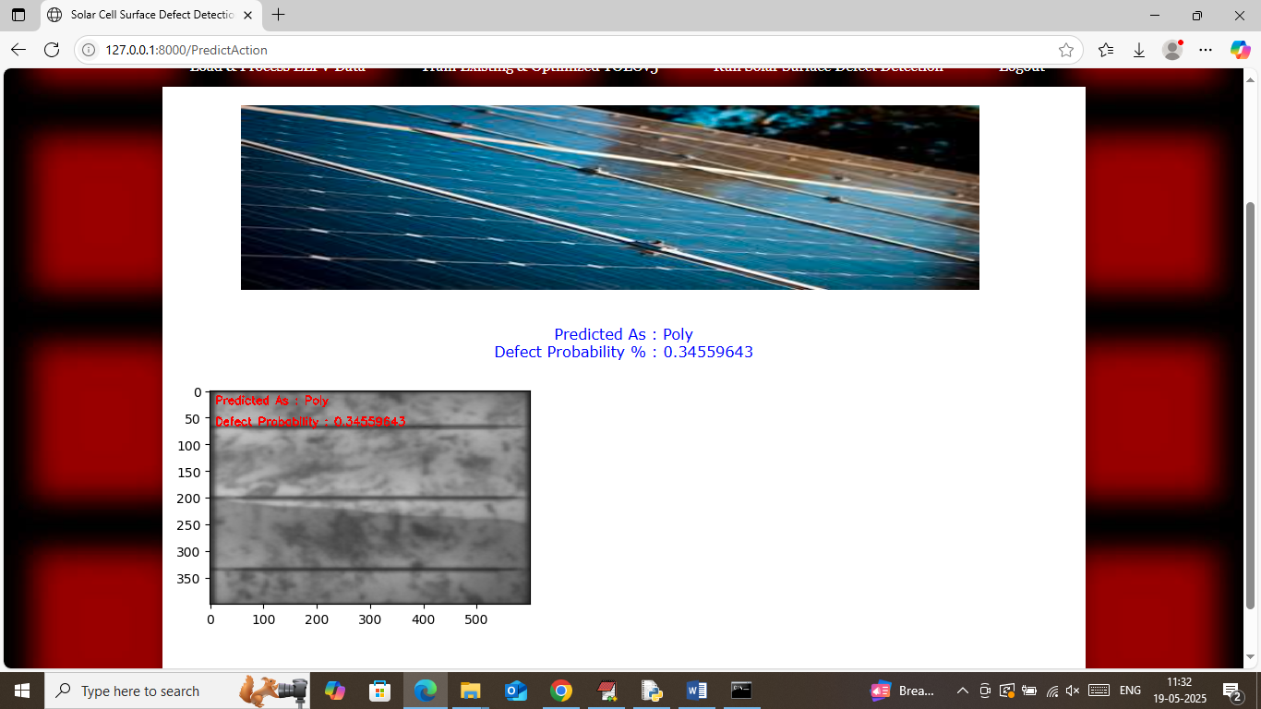
Above image prediction as Poly

