Exercise 7(Financial Forecast)

Code:

public class FinancialForecast {

// Recursive function to calculate future value

public static double predictFutureValue(double currentValue, double growthRate, int years) {

if (years == 0) {

return currentValue;

}

return predictFutureValue(currentValue \* (1 + growthRate), growthRate, years - 1);

}

public static void main(String[] args) {

double currentValue = 100000; // ₹1,00,000

double annualGrowthRate = 0.1; // 10%

int forecastYears = 5;

double futureValue = predictFutureValue(currentValue, annualGrowthRate, forecastYears);

System.out.printf("Future value after %d years: ₹%.2f\n", forecastYears, futureValue);

}

}

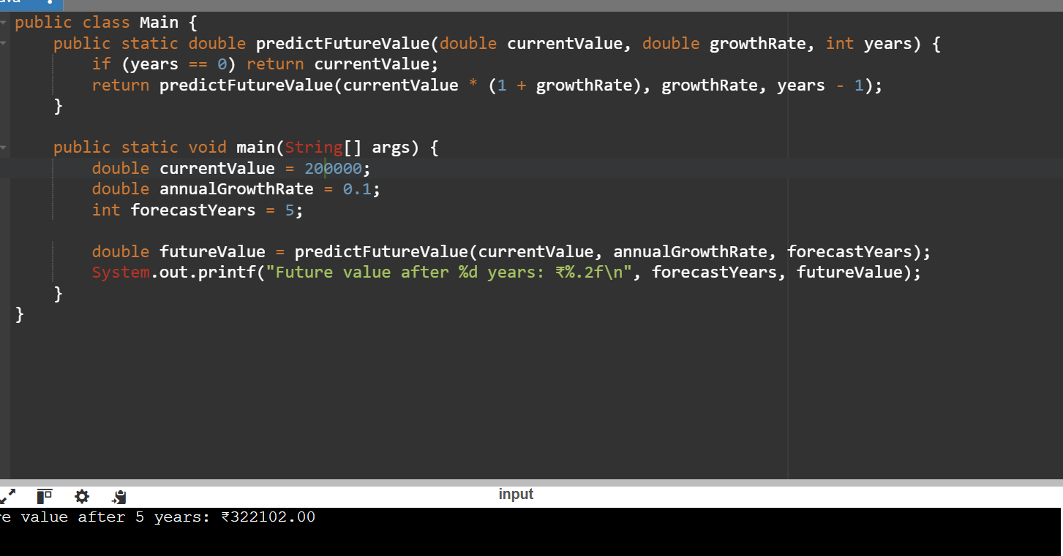Output: