**Task 1: Simple Programs todo for variables**

1. Declare four variables without assigning values and print them in console

var a; var b; var c; var d;

console.log(a); console.log(b); console.log(c); console.log(d);

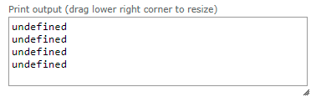

2. How to get value of the variable myvar as output

var myvar= 1;

console.log(myvar);



3. Declare variables to store your first name, last name, marital status, country and age in multiple lines

var details = {firstName:"praveen",lastName:"kumar",maritalStatus:"single",country:"india",age:28};

console.log (details);

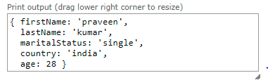

4. Declare variables to store your first name, last name, marital status, country and age in a single line

var firstName="praveen";

var lastName="kumar";

var maritalStatus="single";

var country="india";

var age=28;

console.log (firstName,lastName,maritalStatus,country,age);

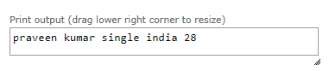

5. Declare variables and assign string, boolean, undefined and null data types

var details = {

firstName:"praveen",

unmarried:true,

};

console.log (typeof(details.firstName));

console.log (typeof(details.unmarried));

console.log (typeof(details.age));

console.log (typeof(null));

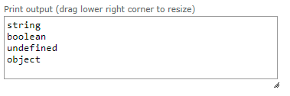

**Task 2: Simple Programs todo for Operators**

**1.Square of a number**

function square(num){

return num * num;

}

console.log(square(2));

console.log(square(5));

console.log(square(8));

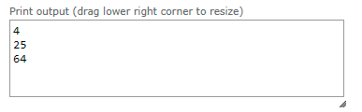

**2. Swapping 2 numbers**

let a = 5, b = 6;

[a, b] = [b, a];

console.log(`${a} ${b}`);



**3. Addition of 3 numbers**

function add(a,b,c){

return a+b+c;

}

console.log(add(2,3,4));

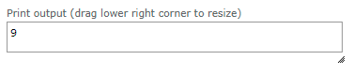

**4. Celsius to Fahrenheit conversion**

const celsius = 100;

const fahrenheit = 1.8 * celsius + 32;

console.log(`${celsius} Celsius = ${fahrenheit} Fahrenheit`);

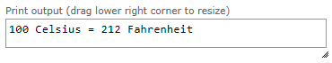

**5. Meter to miles**

function getMiles(meters) {

return meters*0.000621371192;

}

console.log(getMiles(1000));

