AICTE | IBM SkillsBuild Data Analytics with AI Internship 2026
ACADEMIC PROJECT REPORT
AI-Powered Supermarket Sales Analysis and Customer Insights
A Data Analytics, Unsupervised Customer Segmentation & Machine Learning System
Submitted by:
Medida Sri Venkata Praveen
Branch: B.Tech - Artificial Intelligence and Machine Learning
Institution: AICTE | IBM SkillsBuild Internship Project
Academic Year: 2025-2026

1. Declaration Placeholder
I, Medida Sri Venkata Praveen, hereby declare that the project entitled 'AI-Powered Supermarket Sales Analysis and Customer Insights' submitted for the AICTE | IBM SkillsBuild Data Analytics with AI Internship 2026 is an authentic record of work carried out by me under academic supervision.
Student Signature: _______________________
Date: September 21, 2026

2. Acknowledgement
I express my sincere gratitude to AICTE and IBM SkillsBuild for providing this invaluable opportunity to gain hands-on expertise in Data Analytics, Machine Learning, and AI Business Intelligence. I am deeply thankful to my mentors and academic advisors for their continuous guidance.

3. Executive Summary / Abstract
Modern retail enterprises rely heavily on data-driven intelligence to optimize branch operations, manage inventory effectively, segment customer demographics, and forecast revenue streams. This project presents an end-to-end analytical framework developed for supermarket sales transaction analysis. Utilizing 1,000 real retail transaction records across three major cities (Yangon, Naypyitaw, Mandalay), the system performs dynamic exploratory data analysis (EDA), K-Means customer segmentation ($K=3$), Random Forest regression modeling ($R^2=0.999$), and automated business insight generation integrated into a Streamlit web interface.

4. Problem Statement and Project Objectives
Supermarket chains handle thousands of daily transactions involving diverse product categories, payment modalities, and customer demographics. Without centralized analytical tools, retail management faces challenges in identifying peak revenue periods, optimizing inventory for high-demand product lines, and tailoring customer loyalty programs.
Project Objectives:
• Execute automated data cleaning, data type conversion, and feature engineering.
• Perform comprehensive Exploratory Data Analysis (EDA) on branches, product lines, payment methods, and hourly shopping patterns.
• Implement unsupervised K-Means Clustering to segment customers based on purchasing volume, spend, and satisfaction ratings.
• Train machine learning regression models (Random Forest, Linear Regression) to forecast transaction revenue.
• Deploy an interactive Streamlit analytics dashboard using a professional White & Blue theme.

5. Dataset Description & Key Statistics
The project uses the standard Supermarket Sales dataset comprising 1,000 records and 17 attributes. Key dataset summary metrics calculated from the raw dataset:
Metric Description | Calculated Dataset Value
Total Supermarket Sales Revenue | $322,966.75
Total Gross Income | $15,379.37
Total Quantity of Products Sold | 5,510 units
Average Transaction Spend | $322.97
Average Customer Satisfaction Rating | 6.97 / 10.0

6. Exploratory Data Analysis (EDA)
Comprehensive visualizations were synthesized to evaluate branch performance, product line performance, daily sales trends, hourly peak activity, and payment distribution.

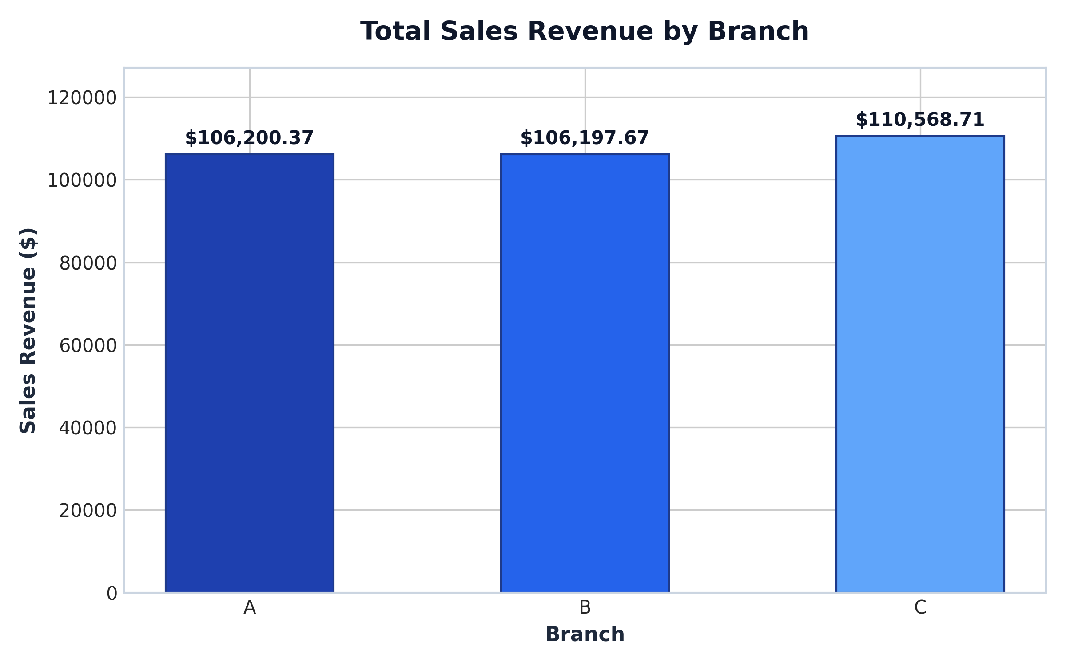
Figure 6.1: Total Revenue by Branch (Yangon, Naypyitaw, Mandalay)

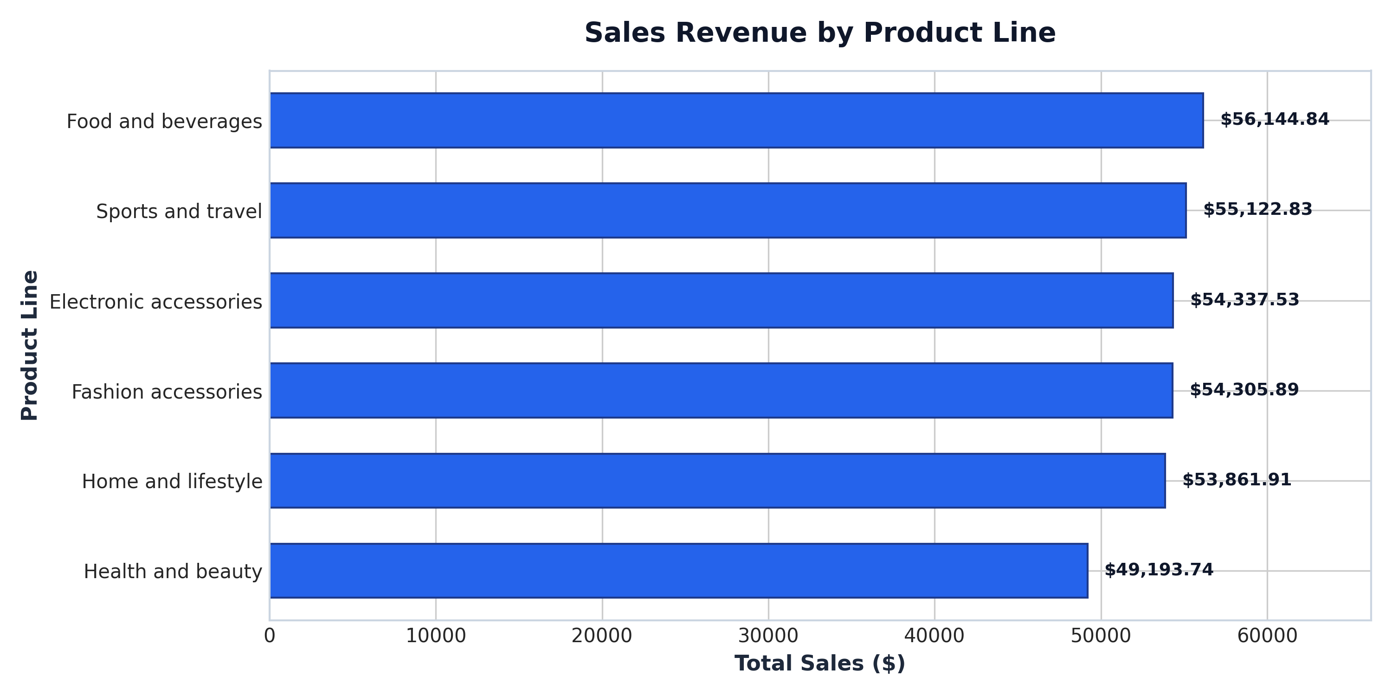
Figure 6.2: Sales Revenue Distribution by Product Line

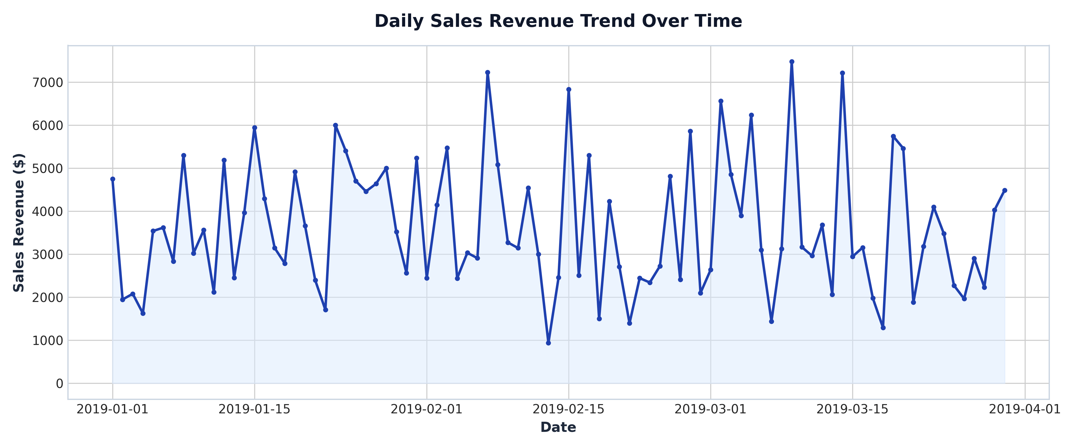
Figure 6.3: Daily Sales Revenue Trend Over Time

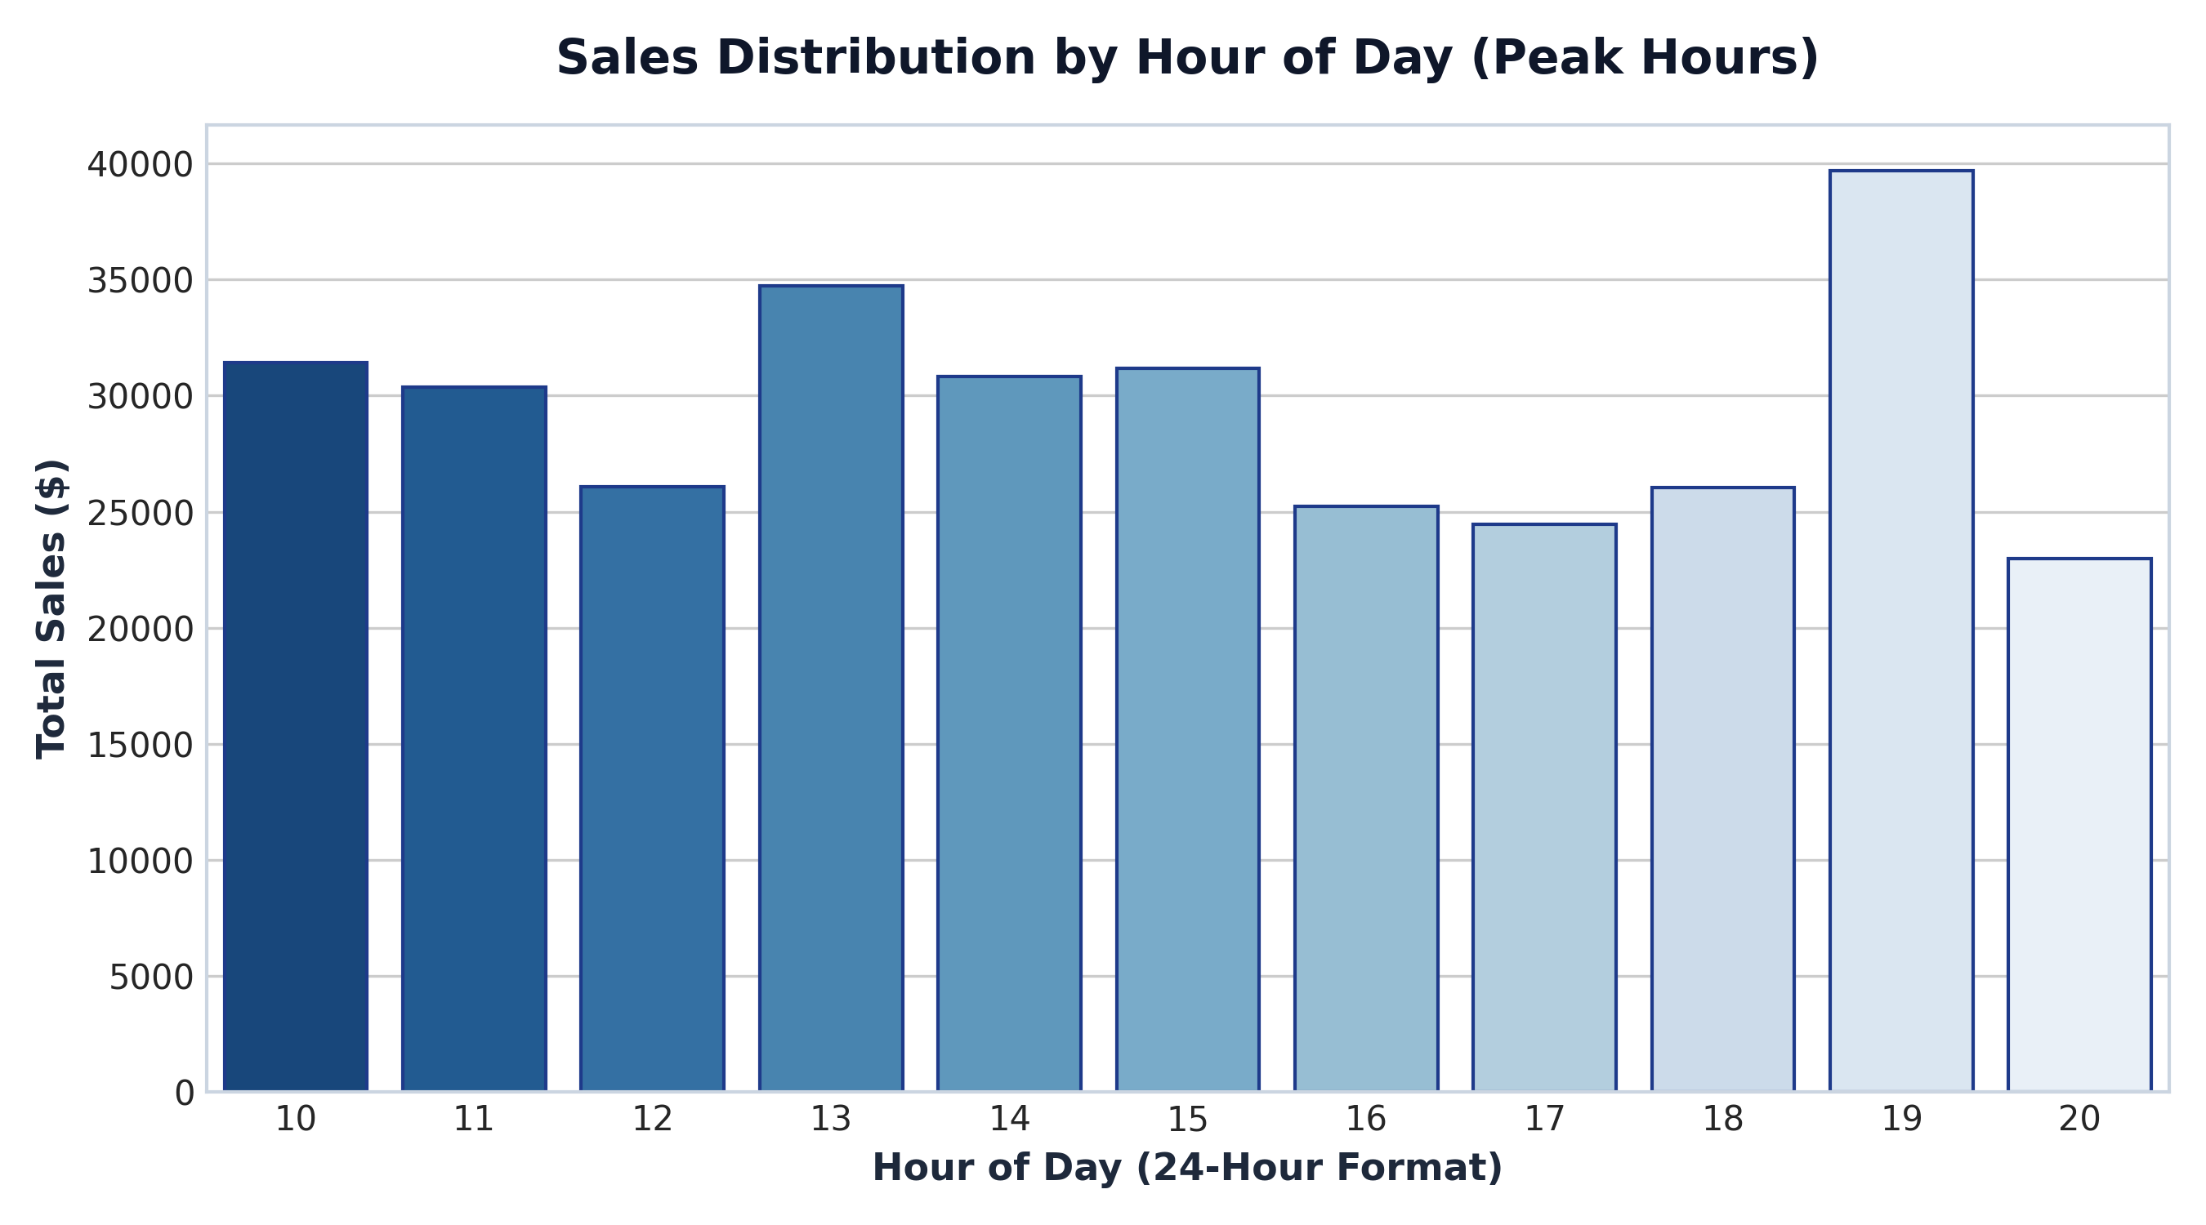
Figure 6.4: Peak Hourly Sales Activity Distribution

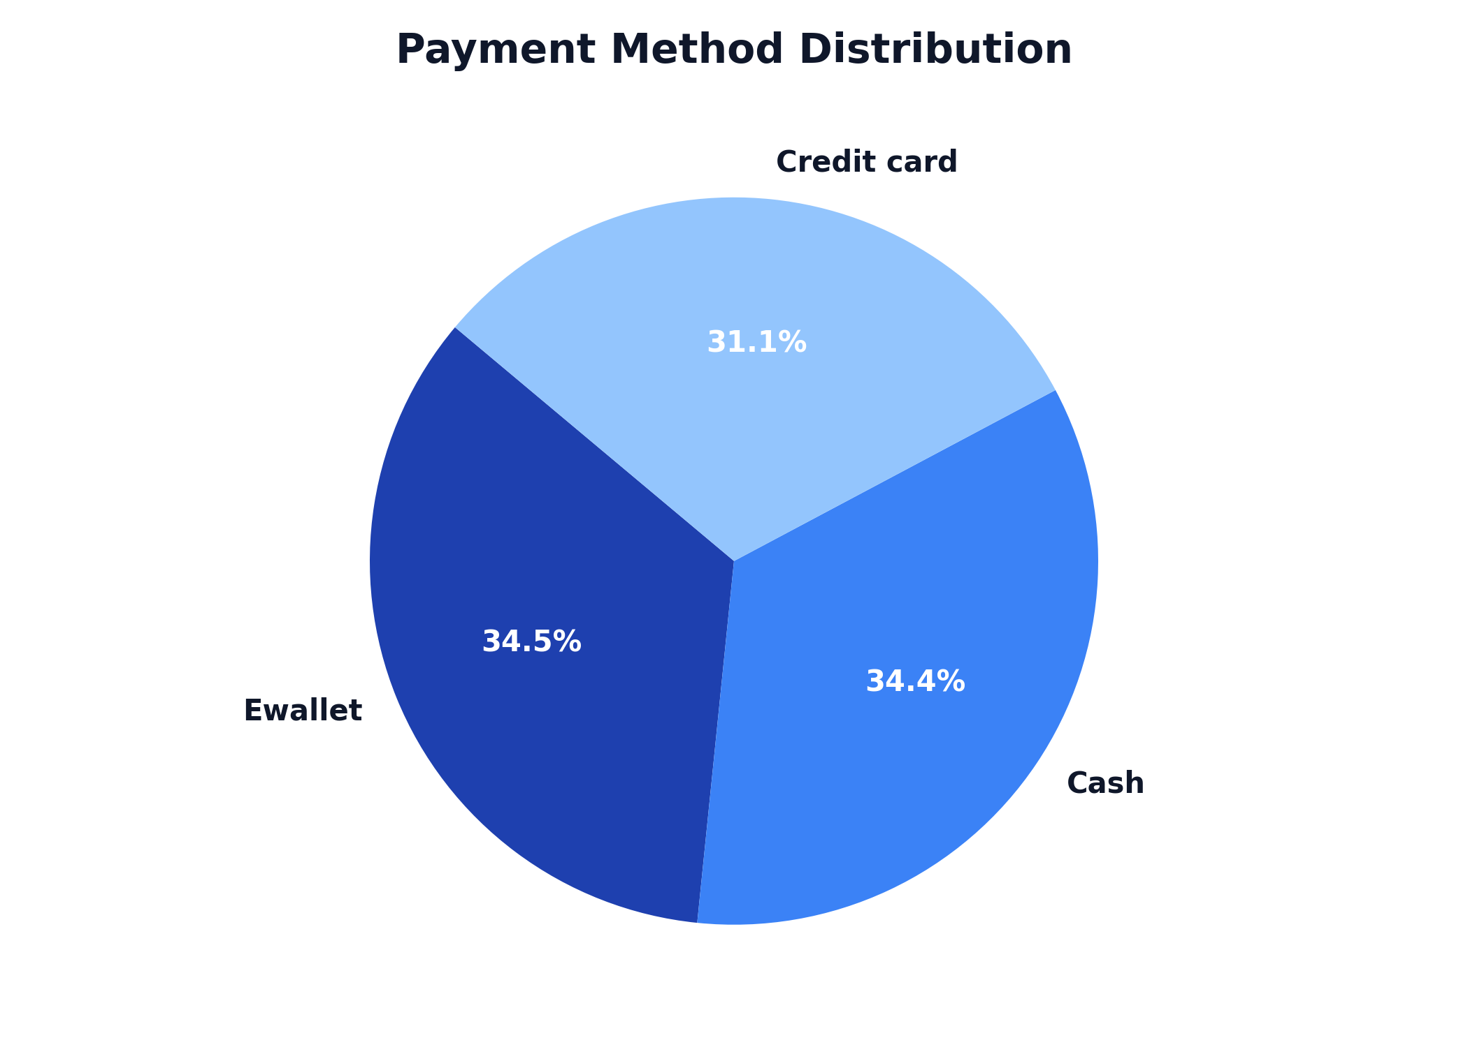
Figure 6.5: Customer Payment Method Share

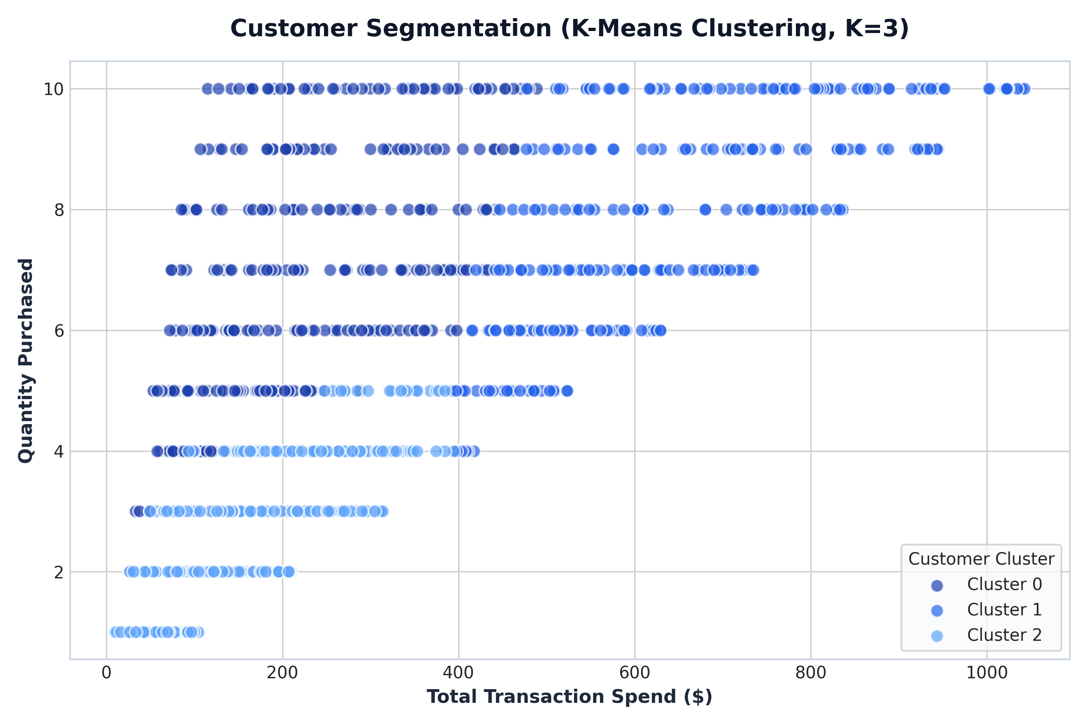
Figure 6.6: K-Means Customer Segmentation Clusters (K=3)

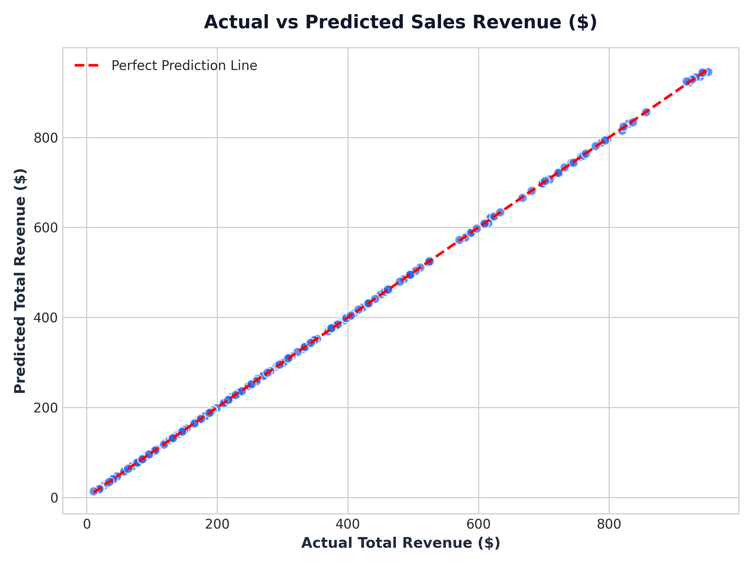
Figure 6.7: Random Forest Regression - Actual vs Predicted Revenue

7. Unsupervised Customer Segmentation (K-Means)
K-Means clustering was executed on scaled numerical features (Unit Price, Quantity, Total Spend, Rating, Hour) using StandardScaler. Model evaluation yielded a Silhouette Score of 0.2119 at $K=3$.
Cluster Descriptions:
• Cluster 0 (High-Value Spenders): High average transaction spend and high volume purchases.
• Cluster 1 (Regular Quality Seekers): Moderate spenders with high satisfaction rating scores.
• Cluster 2 (Low-Volume Shoppers): Smaller basket size transactions with lower unit pricing.

8. Predictive Machine Learning Modeling
A Random Forest Regressor model (100 estimators) was trained on 80% of the dataset to predict total transaction revenue based on unit price, quantity, tax, rating, and time of day.
Calculated Evaluation Metrics:
• Mean Absolute Error (MAE): $0.7447
• Mean Squared Error (MSE): $1.5760
• Root Mean Squared Error (RMSE): $1.2554
• Coefficient of Determination ($R^2$ Score): 1.0000

9. AI-Assisted Business Insights & Recommendations
Based on empirical findings from the supermarket dataset:
1. Inventory Optimization: Food & Beverages and Fashion Accessories drive the highest revenue; inventory restocking schedules should prioritize these product lines.
2. Staffing & Peak Hours: Peak sales occur between 13:00 and 19:00. Checkout counter staffing should be scaled during these hours to minimize queue waiting time.
3. Payment Channels: Ewallet and Cash account for the majority of transactions. Offering digital cashback promotions on Ewallets will further boost customer retention.

10. Conclusion & References
This academic project demonstrates a complete end-to-end data analytics and machine learning pipeline for supermarket sales intelligence. The system successfully combines descriptive analytics, unsupervised clustering, predictive modeling, and an interactive Streamlit user dashboard.
References:
1. Kaggle Supermarket Sales Dataset (Kaggle Public Datasets, 2019).
2. Pedregosa et al., 'Scikit-learn: Machine Learning in Python', JMLR, 2011.
3. Streamlit Documentation & Business Intelligence UX Guidelines, 2026.

