**PITCH PERFECT: A platform, For ideas to reach its true potential**

**List of Personas:**

* **Students / Developers (Founders)**
  + Login / Sign In
  + Domain
  + Idea submission (Create / Save / Delete)
  + Validate idea
  + List ideas with matching
  + Accept / Reject invitation from investor
* **Investors**
  + Login / Sign In
  + Filter / Search ideas
  + Rate / Comment on Ideas
  + Interest (Partial interest for collaboration)
  + Setup meeting
  + Invest

**Database Schema:**

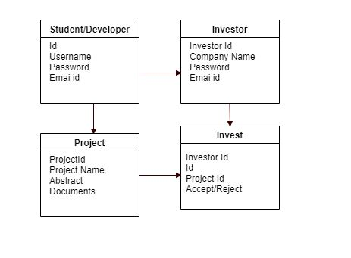

**API’s needed:**

* Login API (v1/pitchperfect/login)
* API for submit(v1/pitchperfect/idea)
* API to retrieve project names and abstracts
* API to retrieve projects based on filters / Search API
* API to save project details
* API to delete project details
* API for investors to show interest in a project
* API for investors to invest on projects

|  |  |  |  |  |
| --- | --- | --- | --- | --- |
| API | Methods | Response code | Input | Response Json/String |
| v1/pitchperfect/login | POST | 200 | User,password | Json with access token |
|  |  | 401 |  | Unauthorized |
|  |  | 403 |  | Forbidden |
| v1/pitchperfect/idea | POST | 201 | {"title":"","abstract":"","scope":"","implementationDetails":""} | Id, timestamp |
| v1/pitchperfect/idea/{id} | PUT | 200 | {"title":"","abstract":"","scope":"","implementationDetails":""} |  |
|  | DELETE | 204 |  |  |
|  | GET | 200 |  | Title,abstract,scope,implementation detail,timestamp(created),timestamp(updated) |
| v1/pitchperfect/idea/{id}/rate | POST | 200 |  |  |
|  | GET | 200 |  | Rating value |
| v1/pitchperfect/idea/{id}/comment | POST,GET,DELETE | 200,200,200 |  | Post-  Get-all the comments |

**Database:**

Data is stored in MongoDB

**Flow diagram:**

