Cyber Security Tasks & Instructions — CodeAlpha
Cyber Security — Internship Overview This internship program offers hands-on experience in cybersecurity principles and practices. CodeAlpha is a leading software development company dedicated to building secure and resilient systems. The internship equips students with skills to identify vulnerabilities, implement security measures, and conduct risk assessments. Interns will learn about network security, ethical hacking, encryption, and threat detection, gaining practical exposure through real-world projects. Expert mentorship and a collaborative environment will prepare interns to contribute effectively to organizational security.

TASK 1: Basic Network Sniffer
● Build a Python program to capture network traffic packets.
● Analyze captured packets to understand their structure and content.
● Learn how data flows through the network and the basics of protocols.
● Use libraries like `scapy` or `socket` for packet capturing.
● Display useful information such as source/destination IPs, protocols and payloads.

I/p:
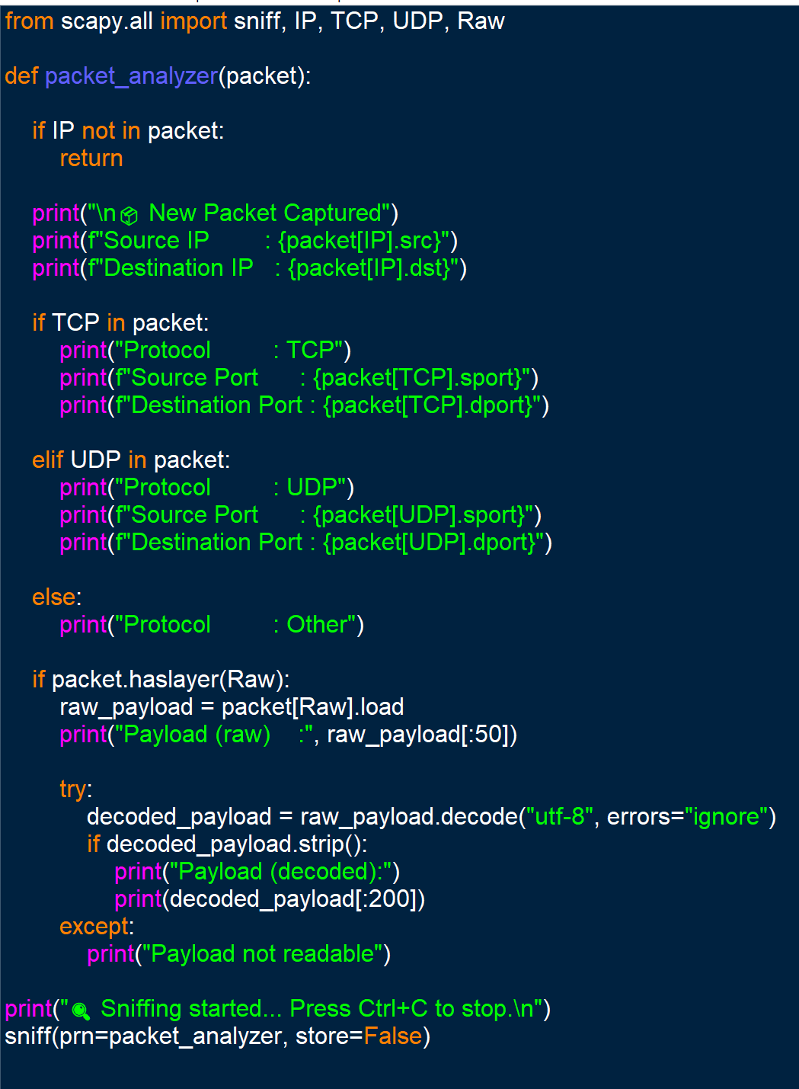
O/p:
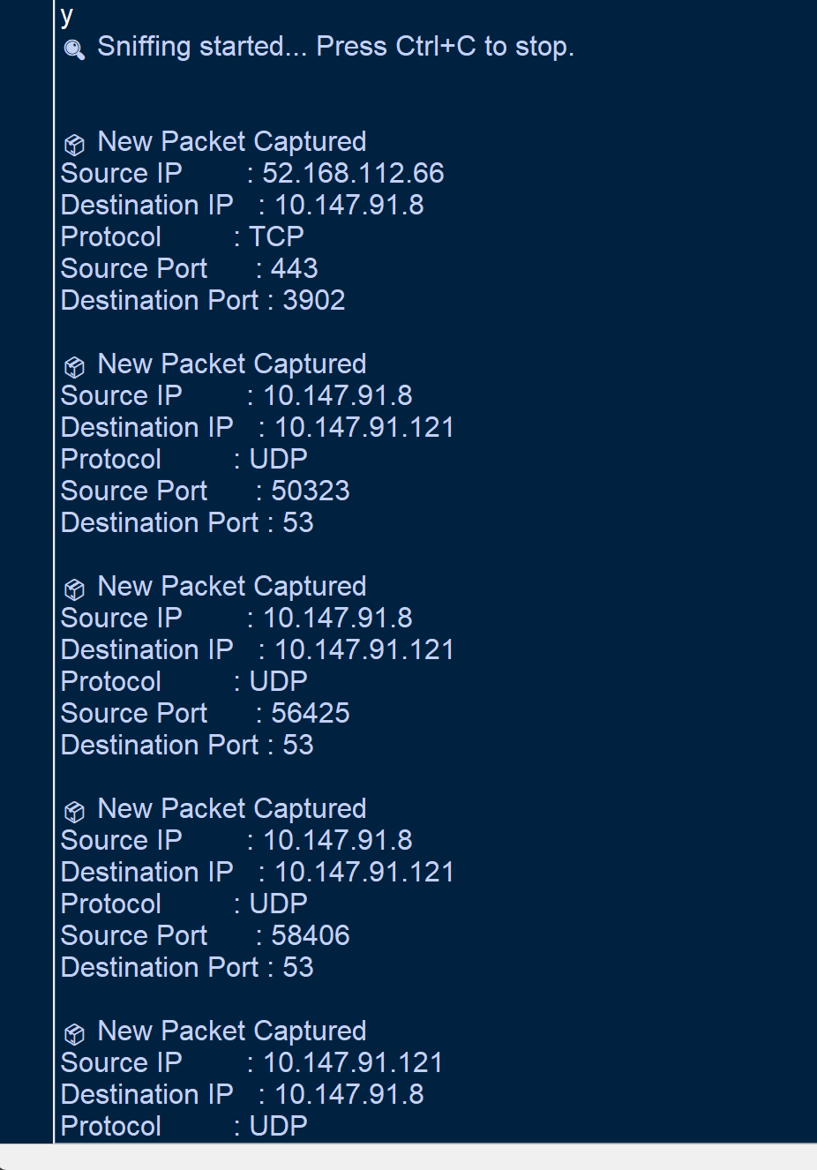

TASK 2: Phishing Awareness Training

● Create a presentation or online module focused on phishing attacks.
● Explain how to recognize phishing emails and fake websites.
● Educate about social engineering tactics used by attackers.
● Provide best practices and tips to avoid falling victim.
● Include real-world examples and interactive quizzes for better engagement.

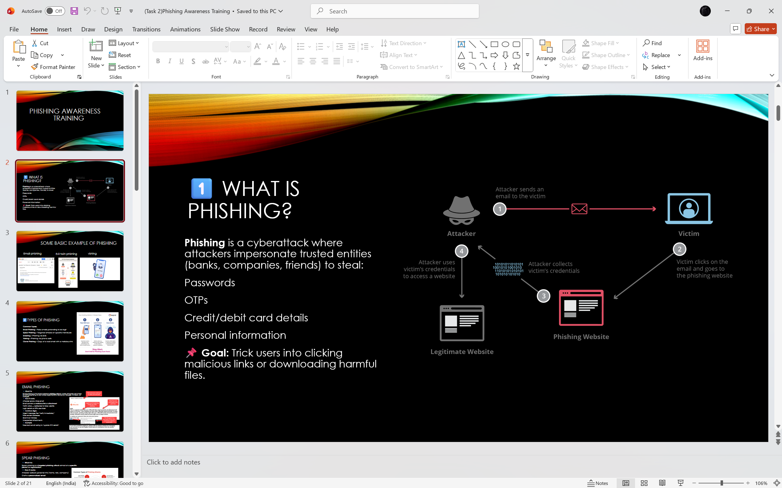

TASK 3: Secure Coding Review

● Select a programming language and application to audit.
● Perform a code review to identify security vulnerabilities.
● Use tools like static analyzers or manual inspection methods.
● Provide recommendations and best practices for secure coding.
● Document findings and suggest remediation steps for safer code.

I/p: language used is python.
#1.vulnerable_login.py
username = input("Enter username: ")
password = input("Enter password: ")

query = "SELECT * FROM users WHERE username='" + username + "' AND password='" + password + "'"

print("Executing Query:")
print(query)
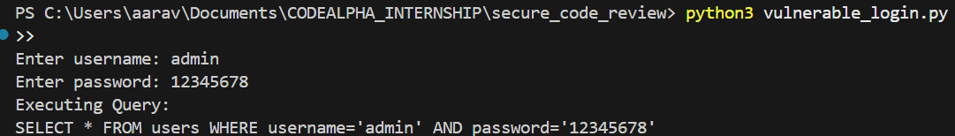

#2.secure_login.py
import hashlib

username = input("Enter username: ")
password = input("Enter password: ")

hashed_password = hashlib.sha256(password.encode()).hexdigest()

print("Hashed Password:")
print(hashed_password)
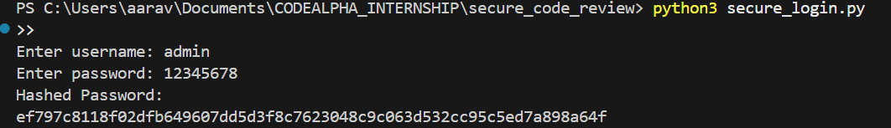
NOTE: install bandit in python library.
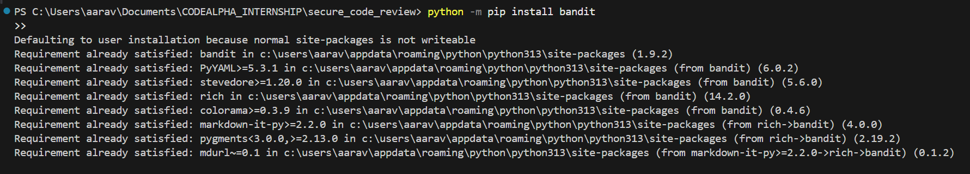
After using bandit static analyzer:
