**Project Plan**

**On**

**Automated Patch Mechanism for MR Software Components**

**SUBMITTED BY**

**PRAVEEN K 1MS12CS075**



**M. S. Ramaiah Institute of Technology**

**(Autonomous Institute, Affiliated to VTU)**

**BANGALORE-560054**

**Department of Computer Science & Engineering**

***Under the guidance of***

|  |  |  |
| --- | --- | --- |
| **Sriranga Natha**  **System Architect, PIC ADI Magnetic Resonance**  **Philips Innovation Campus, Bangalore** | **&** | **Sini Anna Alex**  **Assistant Professor**  **Department of Computer Science & Engineering** |

**Process Model**

***Scrum process of Agile software development methodology:***

Scrum is an iterative and incremental agile software development method for managing software projects and product or application development.

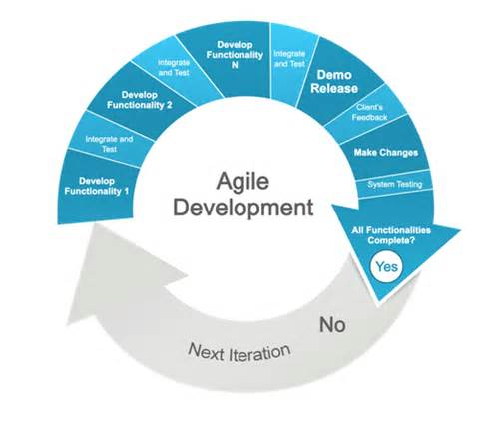

**Project Schedule using Gantt chart**

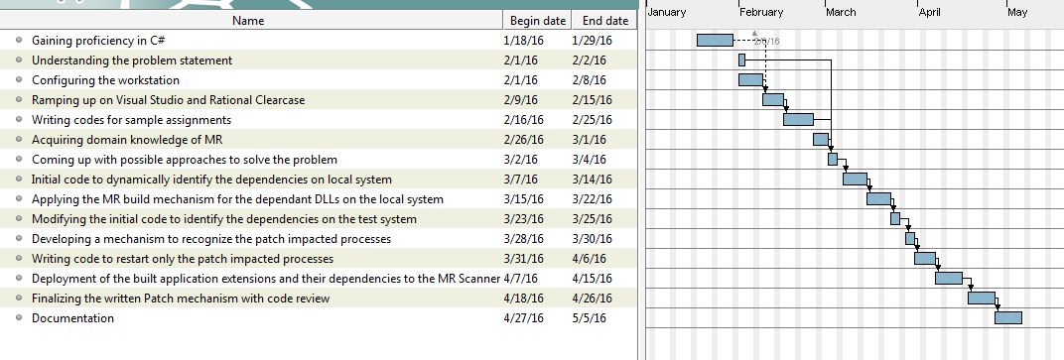

**Risks and the Mitigation steps**

1. Availability of Test System with MR Environment.

Since a test system runs many programs and each program has different priority and use, there is no dedicated test system available for the patching mechanism.

Mitigation: Simulate the MR Application software using VMWare.

Owner: Senior member of the team

1. Requirement for MR patching mechanism is not frozen.

Mitigation: Collect the inputs from architects, developers and research users to have clarity on the need and understand the workflow for current way of patching.

Owner: Senior member of the team

1. Latest Build Metadata is not available.

Interact with SDE team to generate latest Metadata for current development stream and publish the metadata along with benchmarked builds.

Owner: Praveen K

1. The patching mechanism involves parsing of build metadata file which is around 70 MB, which can impact the performance.

Mitigation: Identify different approaches and get the measures for parse. If it takes more than 1 second for parsing, reduce the build metadata by removing unnecessary information.

Owner: Praveen K

1. Performance of patching mechanism is dependent on isolation of processes, which is constrained by current MR software architecture.

Mitigation: Feasibility study needs to be done to identify the isolated processes and list needs to be generated for the processes which are isolated from other processes in MR Environment.

Owner: Praveen K