EXPTNO: 08                                                                           ROLLNO: 220701203

  DEMONSTRATE INTRUSION DETECTION SYSTEM

## AIM:

## The aim of this experiment is to understand the working of Snort as an Intrusion Detection and Prevention System (IDS/IPS) by exploring its various operation modes including Sniffer, Logger, NIDS/NIPS, and PCAP analysis. It involves learning the rule structure used in Snort for traffic filtering and alert generation, investigating traffic logs

## PROCEDURE:

1. Study the theory behind IDS/IPS systems and their types.

2. Launch Snort in different modes using CLI parameters (Sniffer, Logger, IDS).

3. Use sample PCAPs and logs to analyze network traffic.

4. Write detection rules to filter specific traffic based on headers, flags, and content.

5. Investigate alerts generated by Snort and understand their components.

6. Test configuration files and custom rule sets for rule accuracy and performance.

## TASK 1 – INTRODUCTION

- Snort is an open-source NIDS/NIPS maintained by Cisco Talos.

- It detects malicious traffic using rules and generates alerts.

- Offers live traffic inspection, packet logging, and protocol analysis.

- Can operate in Sniffer, Logger, and IPS modes.

- Cross-platform compatibility with modular architecture.

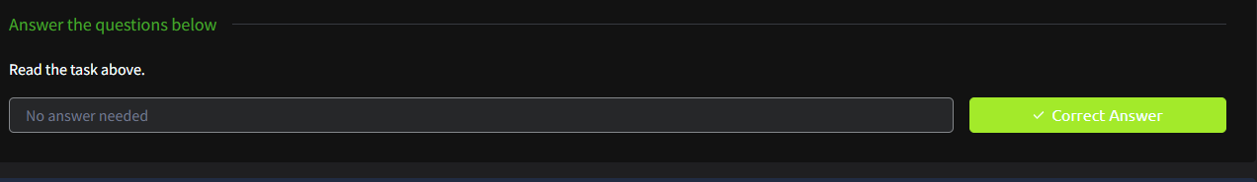- Widely used in blue-team and enterprise defense setups.

## TASK 2 – INTERACTIVE MATERIAL AND VM

- Run the command `./.easy.sh` in Task-Exercises folder.

- Validates VM setup and script execution permissions.

- Output message verifies readiness: "Too Easy!"

- Ensures user environment is configured to start Snort labs.

- No packet analysis in this task — just interaction validation.

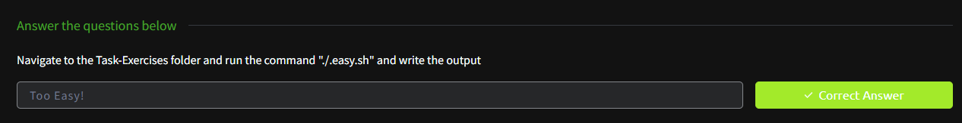- Sets the base for upcoming hands-on tasks.

## TASK 3 – INTRODUCTION TO IDS/IPS

- Covers the distinction between NIDS/HIDS and NIPS/HIPS.

- Behavior-based IPS systems (NBA) require a training period (baselining).

- IPS systems can actively drop or block malicious packets.

- Explains signature-based, behavior-based, and policy-based detection.

- Matches Snort modes to appropriate protection scopes (HIDS, NIDS, HIPS, NIPS).

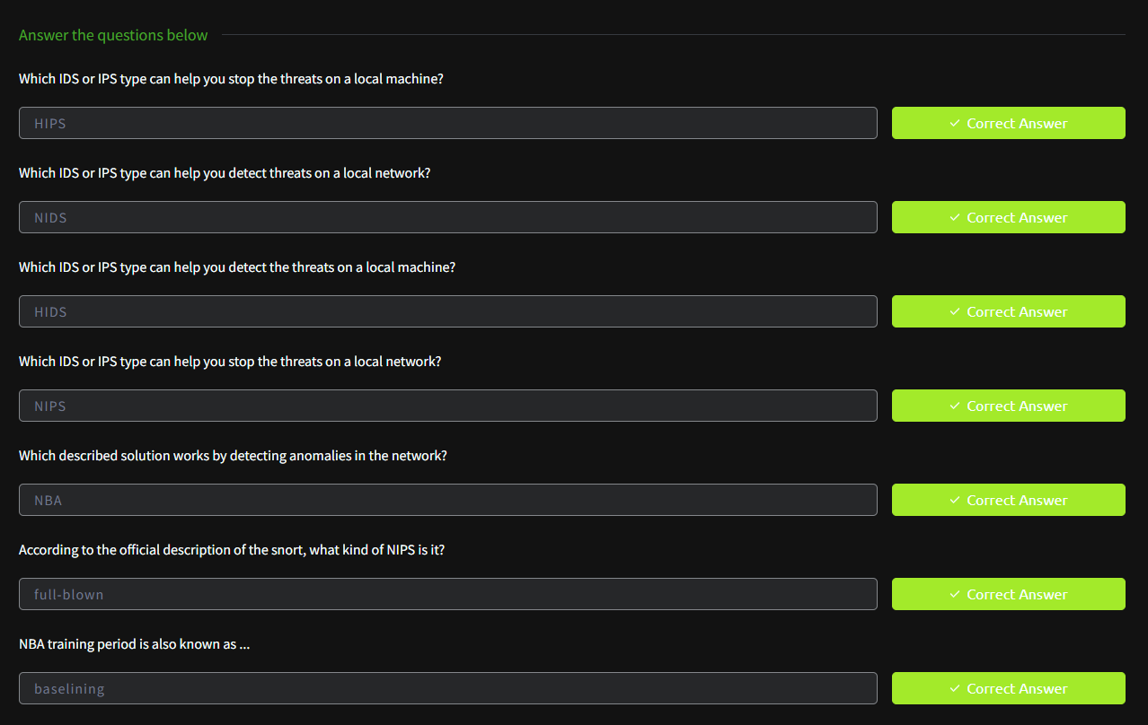- Clarifies that Snort is a full-blown IPS with multi-mode functionality.5yyy

## TASK 4 – FIRST INTERACTION WITH SNORT

- Use `snort -V` to check Snort version and build.

- Run self-test using `snort -T -c <config>` to verify config validity.

- Load default and alternative configs to compare rule counts.

- `-T` tests configuration files for syntax and rule loading.

- Answers: Build number = 149, Rules loaded (default) = 4151, (v2) = 1.

- Validates setup before real traffic analysis begins.

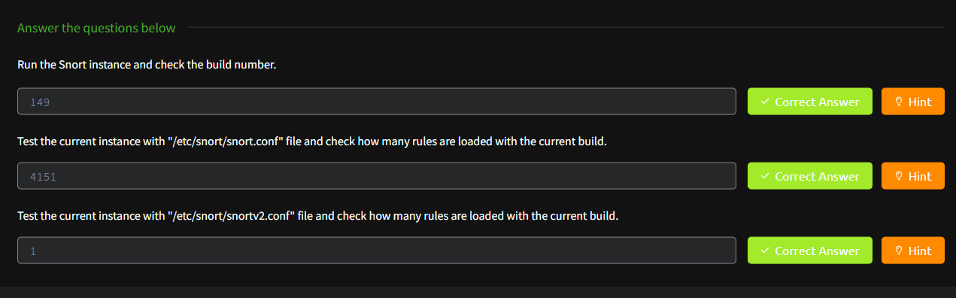

## TASK 5 – OPERATION MODE 1: SNIFFER MODE

- Enables real-time packet inspection (like tcpdump).

- Use flags like `-v`, `-d`, `-e`, and `-X` for verbosity and headers.

- `-i` specifies the interface to sniff.

- Allows combining flags for detailed analysis: `-v -d -e`.

- Useful for viewing live traffic payloads and headers.

- No alerting or logging — just packet visibility.

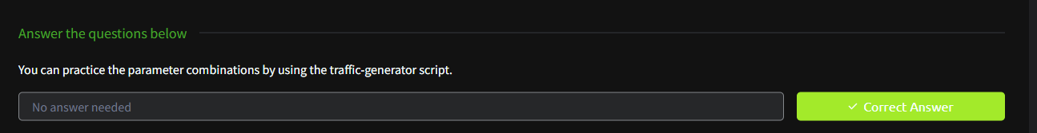

## TASK 6 – OPERATION MODE 2: PACKET LOGGER MODE

- Logs packets in ASCII or tcpdump format to disk.

- `-l` specifies the log directory, default is `/var/log/snort`.

- Use `-r` to read logged files and `-n` to limit packets.

- Analyze logs for source ports, IP IDs, ACK numbers, and referers.

- Use filters like BPF to isolate packets (e.g., `tcp port 80`).

- Enables offline packet analysis from previously captured sessions.

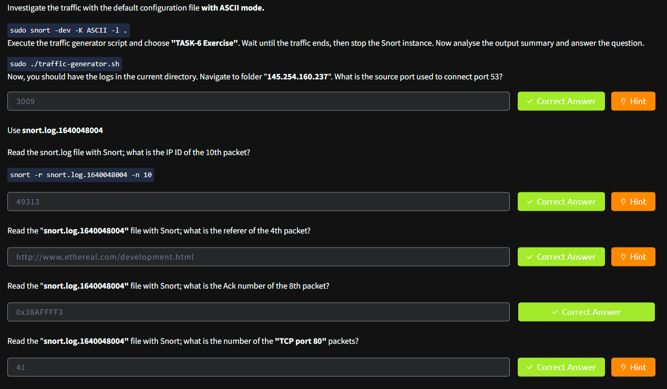

## TASK 7 – OPERATION MODE 3: IDS/IPS

- Requires rule files and configuration (`-c <snort.conf>`).

- Run with modes like `-A full`, `-A console`, `-A fast` for alert types.

- `-D` runs Snort in background, `-X` enables HEX output.

- Example rule: `alert icmp any any <> any any (msg: "ICMP Packet Found"; sid: 100001; rev:1;)`

- IPS mode: `-Q --daq afpacket -i eth0:eth1` enables inline prevention.

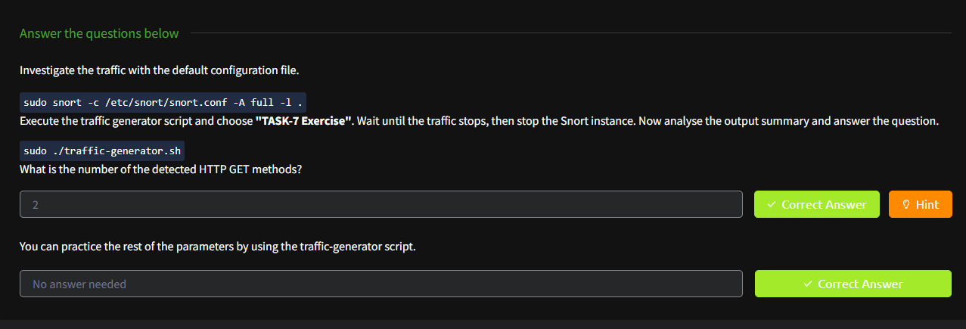- Example: HTTP GET method count = 2 from generated traffic.

## TASK 8 – OPERATION MODE 4: PCAP INVESTIGATION

- Use `-r <file.pcap>` to read PCAP files.

- Supports single and multiple PCAPs using `--pcap-list` and `--pcap-show`.

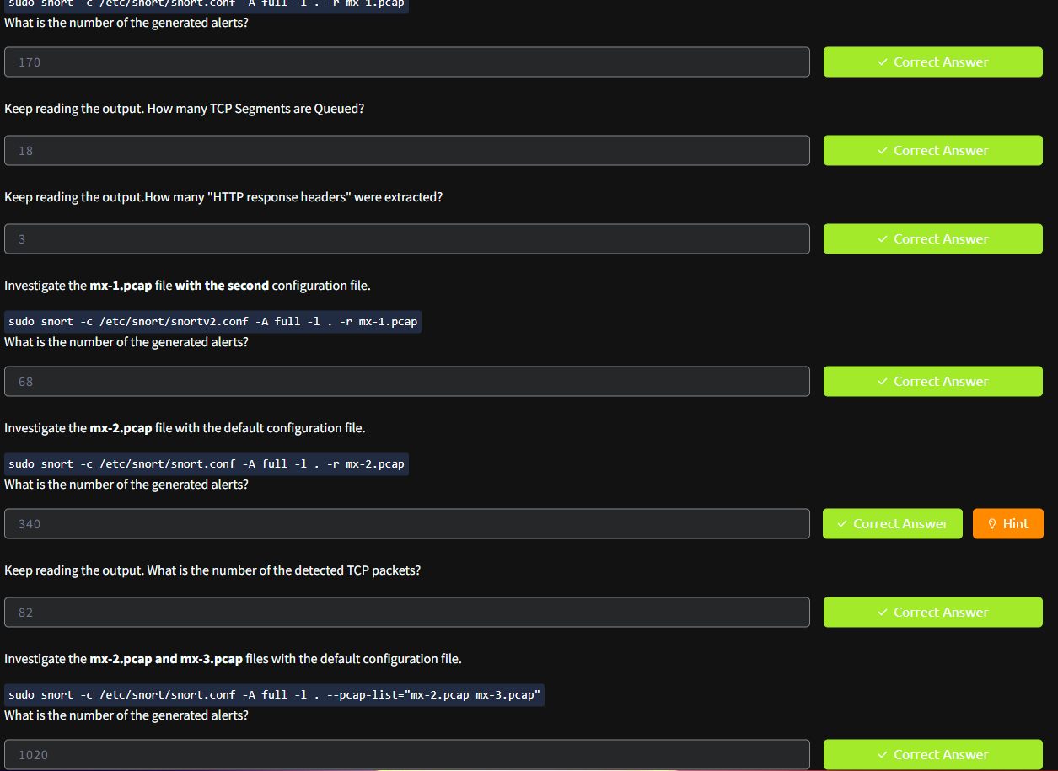- Investigate `mx-1.pcap`, `mx-2.pcap`, and `mx-3.pcap` for alert statistics.

- Analyze TCP segments, HTTP headers, and alert volumes.

- Snort detects alerts based on applied rulesets.

- Enables historical traffic analysis via packet replay.

## TASK 9 – SNORT RULE STRUCTURE

- Rules include: action, protocol, source/destination IP & port, options.

- Use `msg`, `sid`, `rev`, `reference` in general rule options.

- Use `content`, `nocase`, `fast_pattern` in payload rules.

- Use `flags`, `id`, `sameip`, `dsize` in non-payload rules.

- Practice rule writing using `task9.pcap` and `local.rules`.

- Detect TCP flags, identical IPs, and payload patterns via custom rules.

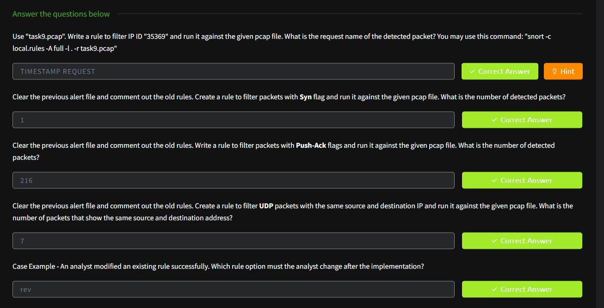

## TASK 10 – SNORT2 OPERATION LOGIC: POINTS TO REMEMBER

- Components: Packet Decoder, Pre-processors, Detection Engine, Logging, Plugins.

- DAQ modules (afpacket, pcap, nfq) control traffic acquisition.

- Configuration file: `snort.conf`, custom rules: `local.rules`.

- Rulesets: Community, Registered, and Subscriber.

- Configuration involves enabling variables, output plugins, and custom rulesets.

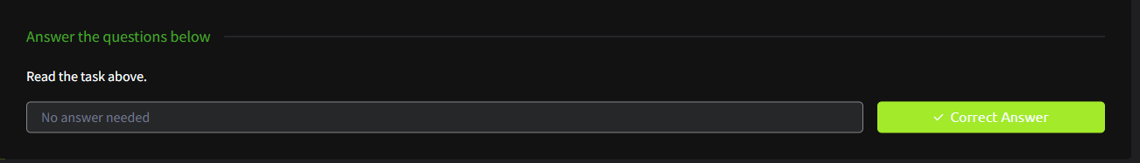- Avoid deleting working rules — comment and test incrementally.

## TASK 11 – CONCLUSION

- Snort provides multi-mode threat detection and prevention capabilities.

- Learning rule syntax is essential for creating custom detections.

- Test rules in lab before deploying in production.

- Incrementally enhance rules to avoid syntax or logic errors.

- Maintain backups of configuration and rule files.

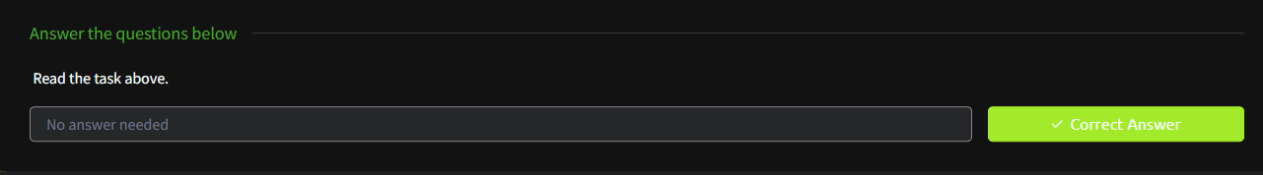- Refer to the Snort Challenge and official cheatsheet for continued practice.

## RESULT:

Successfully understood the working of Snort in Sniffer, Logger, IDS, and PCAP modes. Gained hands-on experience in writing, applying, and testing detection rules using custom traffic and PCAP data. This equips learners with skills necessary for intrusion detection engineering in real-world environments.