Group 4 — 6 members (names redacted for public portfolio)

M Praveen Kumar

Project Title: Application of Statistical Methods in Decision Making within the Financial Services Sector

Introduction

In today's data-centric financial world, statistical tools are vital for guiding strategic and operational decisions across various business domains. This project, developed under the Statistical Methods for Decision Making (SMDM) framework, applies theoretical concepts through practical analysis of Adani Ports and SEZ Ltd. using real-world stock data.
By conducting exploratory data analysis (EDA), we uncover insights from historical stock movements and trading volumes. Statistical techniques such as regression, forecasting, and clustering are employed to inform decision-making processes in finance, marketing, and operations. These methods underscore the value of data-driven strategies in optimizing business performance and minimizing risk.

Application of Statistics in Financial Services
- Risk assessment
Adani Ports can leverage statistical techniques to identify potential financial exposures. For instance, logistic regression models can assess the likelihood of defaults from suppliers or contractors, aiding in credit risk management. Tools such as Value at Risk (VaR) and standard deviation help estimate market risk by evaluating how much the company's stock might decline under adverse conditions (Jorion, 2006). Similarly, actuarial models support the calculation of insurance premiums by assessing cargo risk profiles based on historical trends.

- Forecasting
Predictive modeling supports accurate planning and forecasting for Adani Ports. Using time series analysis methods like ARIMA and exponential smoothing, the company can anticipate future revenues and trading activity. Seasonal trends in cargo movement can also be analyzed to plan resources efficiently. Regression-based interest rate modeling helps assess the cost of borrowing, ensuring better financial planning.

- Fraud detection

Detecting irregular financial patterns is critical to prevent loss and fraud. Adani Ports can use unsupervised learning methods, such as clustering and anomaly detection, to identify abnormal transactions. These models analyze transaction size, frequency, and patterns to detect outliers that may indicate fraudulent activity. Early identification of such anomalies helps maintain operational integrity (Bolton & Hand, 2002).

- Customer Analytics:
Understanding client behavior improves service delivery and customer retention. Statistical clustering can segment customers by trade volume, transaction frequency, and portfolio size. Even though our dataset is based on stock activity, similar segmentation could help identify investor profiles (long-term holders, short-term traders, etc.), enabling tailored communication and product offerings. Retention modeling can also track investor engagement over time, while sentiment analysis tools can gauge investor satisfaction using survey or social media data.

- Portfolio Management:
In portfolio optimization, statistical models ensure a balance between return and risk. Techniques like mean-variance analysis help construct efficient portfolios by minimizing overall risk. Using Adani Ports' historical data, we calculated indicators such as moving averages and standard deviation to analyze stock performance. These measures help determine the appropriate weight of Adani Ports' stock in a diversified investment portfolio.

Functional Area Wise Analysis
A. Marketing
Statistical Applications:
- In the financial sector, the marketing departments use data to make informed decisions. A remarkable example is a customer classification, including dividing customers into different categories such as income level, consumable habits, product preferences and history. This classification system enables high-value customers or subordinate market segments to be detected.
- Another example is the campaign performance review. Variation runs statistical processes such as A/B testing, where two different versions of ads, e-post marketing or destination pages are compared to measure the reaction rate or conversions. Companies use time chain analysis to anticipate future requirements, sales, or customer behavior, allowing them to stay prepared for market changes.
Strategic Role:
- Statistical insights empower marketing teams to shift from guesswork to precision. Instead of promoting products to everyone, marketing strategies can be fine-tuned for specific customer groups, increasing relevance and effectiveness. This results in more personalized experiences, better engagement, and higher conversion rates.
- By accurately predicting market trends and customer needs, marketing teams can allocate budgets more efficiently, reduce unnecessary spending, and improve return on investment (ROI). Over time, this contributes to greater brand loyalty and sustained customer retention, both of which are vital for long-term growth in the financial industry.

B. Human Resources (HR)
Statistical Applications:
- In HR, statistics are used to monitor, understand, and improve employee-related processes. A critical application is predicting employee attrition — identifying employees who are at risk of leaving the organization based on patterns in data such as job role, tenure, performance ratings, or feedback. Statistical models, particularly logistic regression, help make these predictions accurately.
- Workforce planning is another area where forecasting models are used to estimate future hiring needs, based on company growth or project demand. This avoids last-minute staffing gaps. HR teams also use regression and correlation analysis to explore relationships between variables, such as the impact of training programs on employee performance or how job satisfaction affects productivity.
Strategic Role:
- By applying these methods, HR can move from reactive to proactive strategies. For instance, if data shows that new hires in a certain department are more likely to leave within six months, HR can redesign the onboarding or support processes to address that issue early on.
- In addition, performance analysis based on real data helps in making fair and objective decisions about promotions, training, and compensation. These actions not only improve employee morale but also align human capital with organizational goals. Overall, statistical tools help build a more stable, efficient, and motivated workforce, which is key to achieving long-term strategic success.

C. OPERATIONS FUNCTION IN FINANCIAL SERVICES
Operations in the financial sector involve handling millions of transactions (stock trades, fund transfers, loan applications, claims processing, etc.). The goal is to ensure speed, accuracy, cost-efficiency, and regulatory compliance. Let's explore how statistical methods help enhance these outcomes.
Statistical Applications:
1. Process Control Using Control Charts
Process control using control charts plays a crucial role in monitoring the stability and consistency of operations in the financial services sector. These charts help identify whether a process is in a state of control or if there are variations that require corrective action. For example, in a brokerage firm handling equity trades like ADANI PORTS, control charts can be used to track daily metrics such as the percentage of deliverable volumes or trade processing times. When plotted over time with calculated control limits (typically ±3 standard deviations from the mean), any values falling outside these limits signal unusual variations, prompting investigation. Such a system ensures that operational processes such as trade settlement, compliance checks, or back-office clearances are functioning within predictable parameters and that issues are addressed promptly before they impact customer experience or regulatory compliance.
In Financial Services: Used to track metrics such as
- Trade processing time
- Settlement delay time
- Daily delivery volume (e.g., % Deliverable from ADANI PORTS data)
How It Works:
- UCL (Upper Control Limit) and LCL (Lower Control Limit) are calculated using mean ± 3×standard deviation.
- If data points fall outside these limits, it indicates special cause variation that needs investigation.
Benefits:
- Detect delays in real time
- Trigger corrective actions
- Ensure consistency in processing
2. Forecasting Workload (e.g., Loan Application Volumes)
Forecasting workload, such as the number of daily trades, customer support requests, or loan applications, is another vital statistical application. Financial institutions must anticipate incoming volumes to avoid system bottlenecks or understaffing. Using time series models like moving averages or ARIMA, historical data trends can be analysed to forecast future operational loads. For instance, from the ADANI PORTS data, one could observe fluctuations in trading volumes over time and predict high-activity periods, such as those aligned with earnings announcements or policy changes. This forecasting enables firms to allocate resources more efficiently, adjust staffing schedules proactively, and ensure system readiness. It minimises delays and enhances responsiveness, especially during volatile market conditions, contributing to improved service quality and operational control.

Application with ADANI PORTS Data:
You can forecast daily trading volume to help operations teams plan for bandwidth, staffing, or infrastructure needs.
Benefits:
- Minimize wait time and delays
- Improve customer satisfaction
- Avoid over- or underutilization of resources
4. Productivity Analysis with Descriptive Statistics
Productivity analysis using descriptive statistics provides a foundational understanding of operational performance. By calculating measures such as mean, median, standard deviation, variance, skewness, and kurtosis, firms can evaluate how consistent and efficient their operations are over time. In the case of ADANI PORTS data, analyzing the average trading volume, VWAP, and their variability offers insight into the steadiness of market activity. A high standard deviation in these values may indicate volatility, which might necessitate changes in operational readiness or system capacity. Similarly, skewness in delivery volumes might reveal customer behavioral patterns that affect back-end operations. These statistics help operations teams set benchmarks, monitor performance across teams or periods, and identify areas for improvement—whether it's reducing transaction time, optimizing settlement cycles, or refining documentation processes.
In Financial Services:
Operational KPIs such as:
- Average trade processing time
- Mean turnaround time (TAT) for loan approvals
- Standard deviation in call resolution time
Application with ADANI PORTS Data:
Key Measures:
- Mean: Central tendency (e.g., avg. transaction size)
- Standard Deviation: Volatility in operations
- Skewness/Kurtosis: Operational outliers and anomalies
Benefits:
- Understand performance baselines
- Identify inefficiencies
- Benchmark across teams or branches
Strategic Role:
Enhance Operational Efficiency
Enhancing operational efficiency through statistical control ensures that financial firms can identify inefficiencies before they escalate. By consistently monitoring key metrics and using real-time data, organizations can implement corrective actions quickly, reduce error rates, and improve process reliability. For example, consistently high trade settlement times identified through control charts might prompt a review of the back-office workflow or system performance, ultimately leading to more streamlined operations and lower operating costs.
Manage Workload and Staffing Levels
Managing workload and staffing levels becomes significantly more accurate and effective when grounded in statistical forecasting. Anticipating transaction volume peaks allows teams to be staffed appropriately, avoiding both overstaffing during lulls and under-resourcing during surges. This ensures that employee productivity is optimized, and customers receive timely responses, maintaining satisfaction and reducing stress on infrastructure.
Optimize Service Quality
Optimizing service quality is the cumulative result of these practices. By managing variability through control charts, anticipating demand via forecasting models, streamlining customer queues with probabilistic models, and tracking performance through descriptive statistics, firms create a well-oiled operational machine. These efforts lead to faster turnaround times, consistent service standards, and a higher level of reliability—key differentiators in a highly competitive financial environment.

Functional Strategies and Decision Making
Each department uses statistics to support tactical decisions that align with the overall strategy:
- Marketing – Customer Targeting
Using variables like Volume, Turnover, and Deliverable (%), clustering techniques (e.g., K-Means) can segment investors into categories such as short-term traders and long-term holders. This helps in designing targeted marketing strategies, improving engagement, and boosting ROI.
- HR – Attrition Prediction
The dataset does not include HR data (like employee profiles or attrition history), so logistic regression for predicting employee turnover isn’t currently possible. However, such analysis would help HR proactively manage retention if that data is available.
- Operations – Efficiency Monitoring
Operational efficiency can be assessed using control charts on variables like Trading Volume and Turnover. The data shows relative stability, indicating consistent operations. Outliers on these charts could help detect inefficiencies or system anomalies early.
- Risk Management – Forecasting & Exposure
Regression analysis can be applied to forecast stock Close prices based on variables like Open, High, Low, and VWAP. Additionally, Value at Risk (VaR) models could estimate potential losses under extreme market conditions, helping manage financial risk effectively.

Summary Table: Strategic Decision-Making Mapped to Statistical Tools

Function | Strategic Decision | Statistical Tool | Impact
Marketing | Target the right customers | Clustering, A/B Testing | Increased ROI
HR | Reduce attrition | Logistic regression | Stable workforce
Operations | Improve efficiency | Control charts | Higher productivity
Risk | Minimize defaults | Regression, decision trees | Healthier loan book

Descriptive Statistical Analysis of ADANI PORTS Stock.
This analysis explores the descriptive statistics of various trading indicators for ADANI PORTS. Key metrics include previous close, open, high, low, last traded price, VWAP, and several volume and delivery-based parameters. These statistics provide a foundational understanding of the stock’s historical performance, volatility, and trading behavior.
The mean (average) values of each trading metric represent the central tendency over the observed period. For instance, the mean closing price of ADANI PORTS stock was approximately ₹344.11, and the mean opening price was slightly higher at ₹344.76. This suggests that, on average, the stock tends to open slightly higher than the previous day’s close, which may reflect positive overnight sentiment or strong institutional pre-opening orders. The mean high price was ₹351.61 and the mean low price was ₹337.53, indicating an average intraday range of around ₹14–15, which is useful for intraday traders and volatility modeling.
Standard error values indicate the level of precision in the estimated mean. For example, the standard error for the open price is around ₹3.36, which is relatively small compared to the mean, suggesting that the mean is a reliable estimate and the daily prices do not vary widely. The same applies to high and low prices, where standard errors are consistent and small, confirming price stability over time.
Median values, being robust to outliers, provide an alternate view. The median open price (₹325.75) and median low price (₹319.85) are slightly lower than the corresponding means. This suggests that there were some higher price values pulling the mean upwards—possibly due to sharp market rallies or news-driven spikes during the period. The median % deliverable is 44.56%, very close to the mean of 44.59%, indicating consistency in the proportion of shares actually delivered versus traded. A deliverable percentage near 45% typically indicates a healthy mix of speculative and long-term investors.
In terms of volume-related metrics, the average daily volume was about 2.95 million shares, while the median volume was slightly lower at 2 million. This further reflects the skewness in the volume distribution, where a few high-volume days significantly raised the average. The average turnover was a substantial ₹107 trillion (likely reflecting cumulative or incorrectly scaled data), and the average number of trades was around 44,923 per day—demonstrating strong liquidity and market participation in this stock. The mean deliverable volume of approximately 1.2 million shares implies that nearly 40–45% of traded shares were taken for delivery, a sign of investor confidence and lower speculative churning.
From a visual standpoint, this dataset would benefit from histograms to show the distribution of each key variable, especially volume and price. For instance, a histogram of daily volumes might show whether most trading days saw low-to-mid activity with occasional spikes. Similarly, boxplots would reveal the interquartile range and identify any outlier days with extreme price or volume behavior. If plotted over time, line graphs of price and volume would show seasonal trends or volatility clusters, offering strategic insights for portfolio managers or risk officers.
Interpretation of Mean, Median, and Volatility for ADANI Ports Stock

Central Tendency: Mean and Median
- Mean (Average): The average trading price of ADANI Ports stock is around ₹344.
- Median: The midpoint price, where half the observations are above and half below, is around ₹325.
Implication:
These values indicate that the stock most commonly trades in the ₹325–₹344 range. The proximity of the mean and median suggests a relatively balanced distribution of prices, though the mean being slightly higher points to occasional higher price spikes.

Volatility and Dispersion
- Standard Deviation: The standard deviation for price metrics is high (around ₹193), reflecting substantial day-to-day price fluctuations.
- Range: The difference between the minimum and maximum prices is wide, exceeding ₹1,100, which is indicative of significant price swings over the observed period.
Implication:
- The stock experiences significant volatility. This means that while the average price hovers in the mid-300s, it is not uncommon for prices to move sharply in either direction, sometimes exceeding ₹1,300 or dropping near ₹100.
- Such volatility can be attributed to market sentiment, sector news, or broader economic factors influencing the stock.

What This Means for Investors
- Risk and Opportunity: The observed volatility suggests both higher risk and the potential for significant returns. Investors should be prepared for rapid price movements.
- Trading Strategies: The clustering of prices around the mean and median can inform support/resistance levels for technical analysis, while the volatility may present opportunities for short-term trading.
- Portfolio Considerations: Due to the high variability, ADANI Ports stock may be more suitable for investors with a higher risk tolerance or those employing active trading strategies.
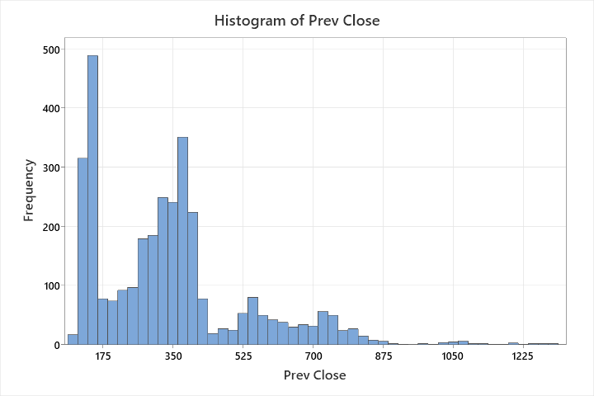

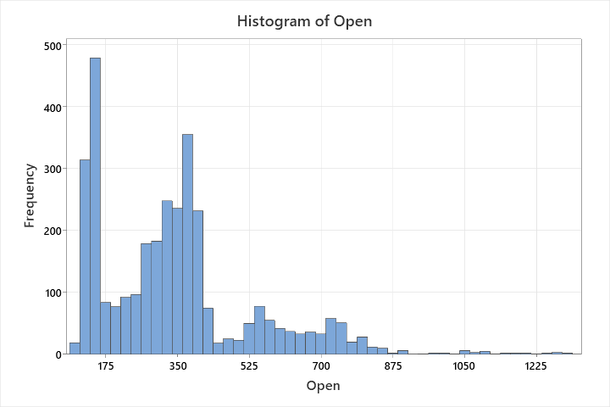

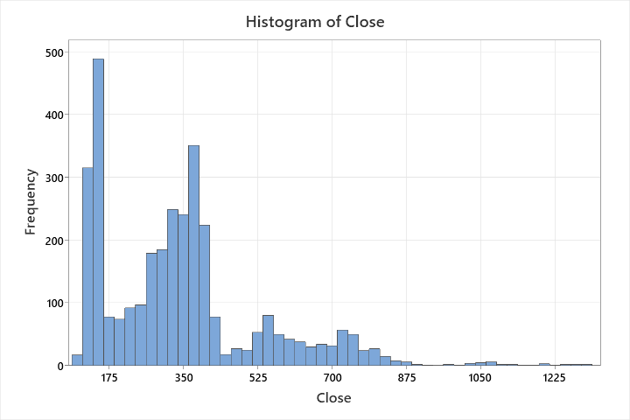
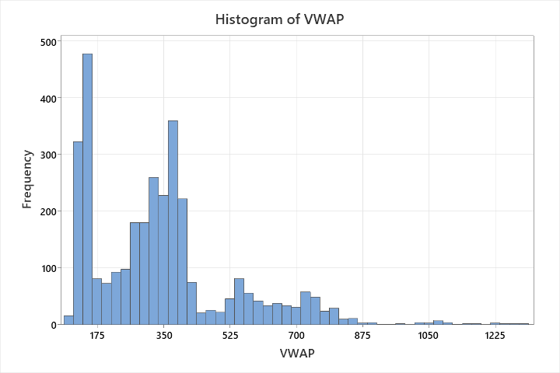
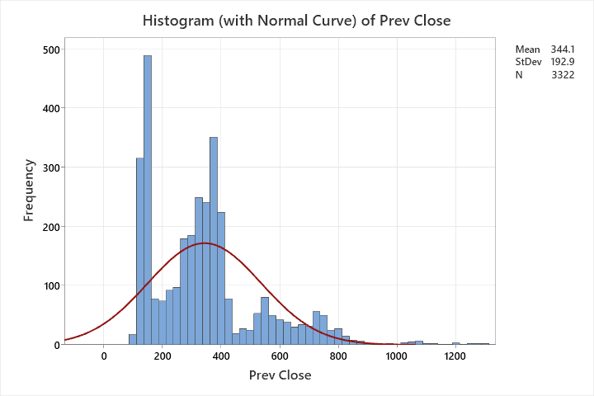

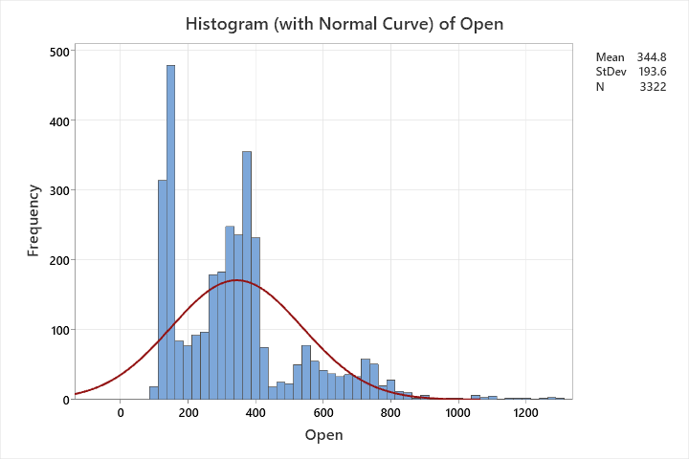
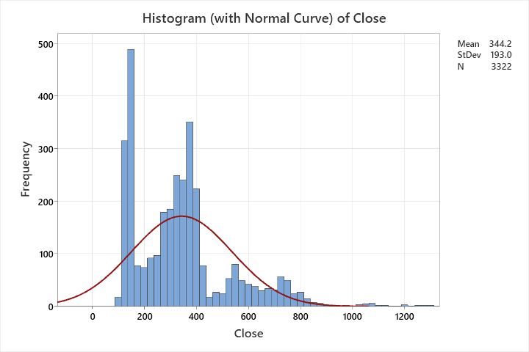
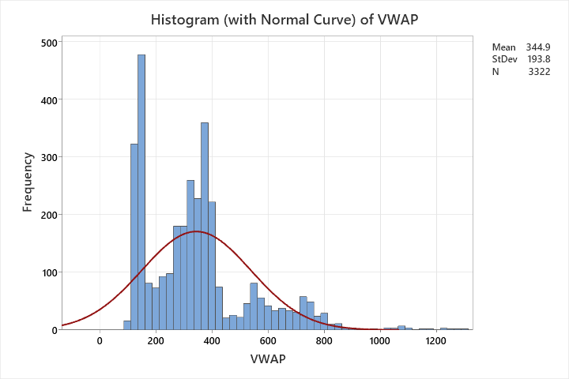

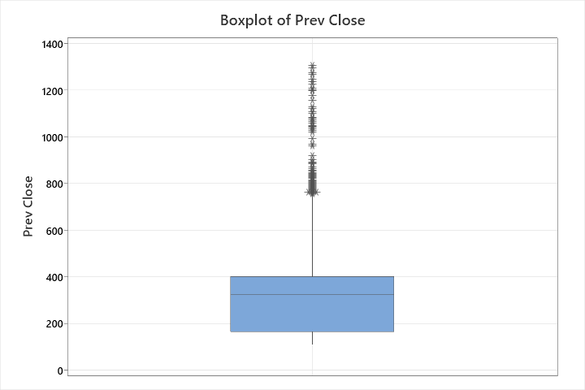
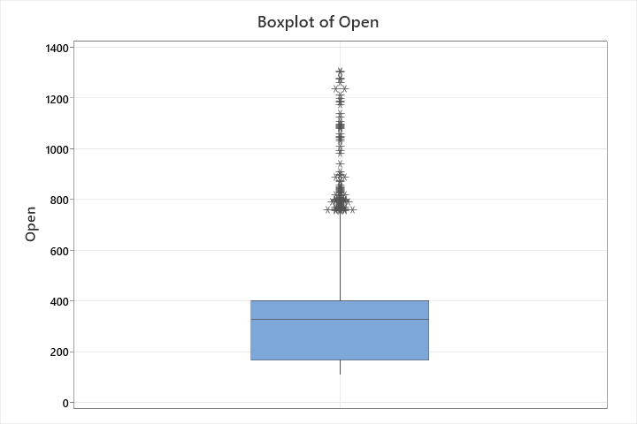

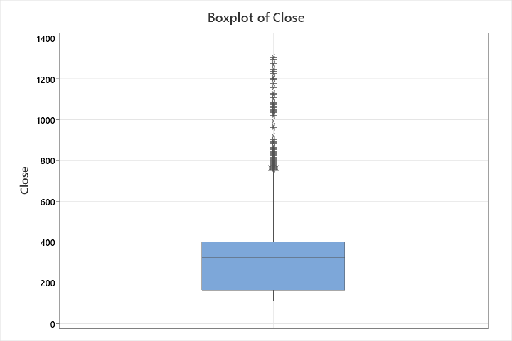

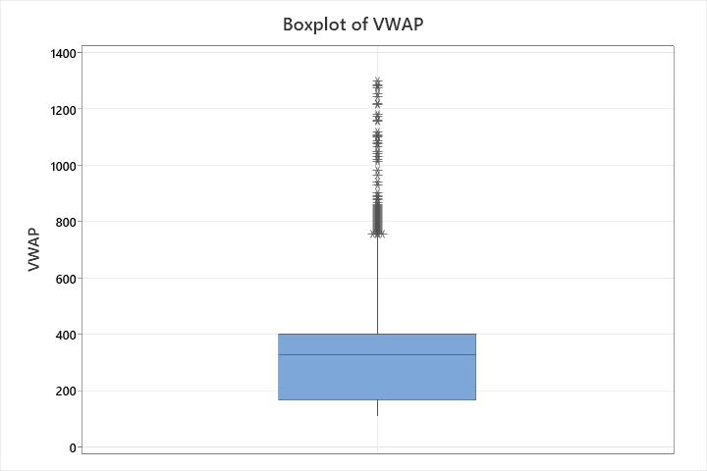
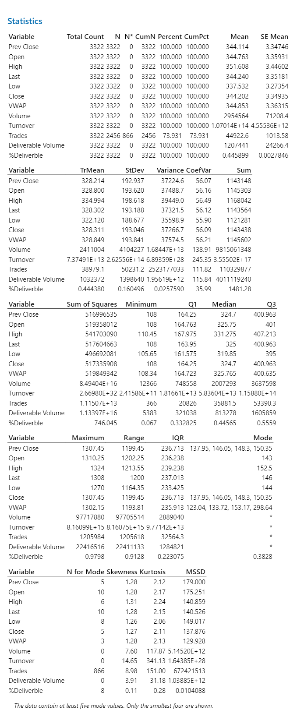
Annova Test
Category | Test | Groups | Dependent Variable | Null Hypothesis (H₀) | Alternate Hypothesis (H₁) | Purpose
Time-Based | Monthly Performance | Months (Jan–Dec) | Closing Price / Returns | No difference in means across months. | At least one month differs significantly. | Detect monthly seasonality.
 | Quarterly Performance | Quarters (Q1–Q4) | Closing Price / Returns | No difference in means across quarters. | At least one quarter differs significantly. | Identify quarterly trends.
 | Yearly Performance | Years (e.g., 2007–2010) | Closing Price / Returns | No difference in means across years. | At least one year differs significantly. | Assess annual performance variations.
Price Movement | Price Range Comparison | Low/Medium/High Price Days | Volume / Turnover | Volume is equal across price ranges. | Volume differs in at least one price range. | Test if trading activity varies with price levels.
 | Trend Direction Comparison | Up/Down/Sideways Days | Deliverable Volume | Deliverable volume is equal across trend directions. | Deliverable volume differs by trend direction. | Analyze delivery behavior during market trends.
Volume-Based | Volume Tier Comparison | Low/Medium/High Volume Days | Price Change / Volatility | Price behavior is equal across volume tiers. | Price behavior differs in at least one tier. | Examine volume’s impact on price dynamics.
 | Deliverable Volume Comparison | Low/Medium/High %Deliverable Days | Next-Day Price Change | No difference in next-day price change. | Next-day price change differs by delivery level. | Test if delivery percentage predicts future price movements.
Day-of-Week Effect | Weekday Comparison | Monday–Friday | Returns / Volume | No difference in means across weekdays. | At least one weekday differs significantly. | Detect day-of-week anomalies (e.g., "Monday Effect").
Event-Based | Pre/Post Event Analysis | Before/After Event Periods | Any Performance Metric | No difference in means before/after the event. | Significant change after the event. | Measure impact of corporate/economic events on stock behavior.
T - Test
Test Description | Null Hypothesis (H₀) | Alternative Hypothesis (Hₐ) | Rejection Criteria | Potential Reasons for Rejection
Mean closing price before vs. after 2008 crisis | μBefore= μAfter | μBefore ≠ μAfter | Reject H₀ if p-value < 0.05 | Market crash led to structural changes in stock behavior; investor sentiment shifted post-crisis.
Mean volume on high vs. low deliverable days | μ High Deliverable= μ Low Deliverable | μ High Deliverable ≠ μ Low Deliverable | Reject H₀ if p-value < 0.05 | High deliverable days may indicate institutional trading, affecting volume differently.
Mean turnover on weekdays vs. weekends | μ Weekday= μ Weekend | Μ Weekday ≠ μ Weekend | Reject H₀ if p-value < 0.05 | Weekend trading (if any) may have lower liquidity or different participant behavior.
Mean % deliverable before vs. after corporate action | μBefore= μAfter | μBefore ≠ μAfter | Reject H₀ if p-value < 0.05 | Corporate actions (e.g., stock splits) may alter investor holding patterns.
Mean daily returns on up vs. down market days | μ Up= μ Down | μ Up ≠ μ Down | Reject H₀ if p-value < 0.05 | Asymmetry in returns (e.g., momentum effects or panic selling on down days).

Conclusion
ADANI Ports stock typically trades between ₹325 and ₹344, but exhibits significant volatility. These characteristic underscores the importance of robust risk management and continuous monitoring for investors and traders considering this stock. Understanding these statistical measures helps in making informed decisions aligned with individual risk profiles and investment objectives.
The descriptive statistics of ADANI PORTS stock indicate a moderately volatile but liquid security, with a healthy mix of delivery-based investing and intraday trading. The price range and trading volumes reflect the stock’s attractiveness for both institutional and retail investors. The consistency between mean and median values across most indicators suggests a relatively stable trading environment, with few outliers. These insights, when visualized through statistical graphs, help investors and analysts understand trading behavior and make informed operational, risk, and investment decisions.

