# Document Info

|  |  |
| --- | --- |
| Document ID | 01_ENLK_ANKR_BI_RFM_001 |
| Document Name | MANIPALANKUR_BI_REFERENCE_MANUAL |
| File Name | 01_ENLK_ANKR_BI_RFM_001.docx |
| Controller | GITHUB |
| Version | 1.0 |
| Release Date | 26/01/2016 |
| Authored By | Bala Gangadhar |
| Reviewed By | Praveen Pillai |
| Approved By |  |

# Revision History

|  |  |  |  |  |  |
| --- | --- | --- | --- | --- | --- |
| Modified By | Reason For Amendment | Reviewed By | Approved By | Date | Version |
| Bala Gangadhar | First Version | Praveen Pillai |  | 01/26/2016 | v1.0 |
|  |  |  |  |  |  |

Manipal Ankur BI Reference Guide

Contents

Document Info 1

Revision History 2

Introduction 5

Login into Tableau Server 5

Search for Specific Dashboards 6

Executive Dashboard 7

Patient Visits 7

Executive Dashboard - Total Patient Visits by Year 8

Executive Dashboard - Total Patient Visits by Month 9

Executive Dashboard - Detailed Analysis 10

Executive Dashboard - Filtering the data 11

Operational Dashboards 15

# Introduction

The scope of this document is limited to a quick reference for accessing the dashboards.

# Login into Tableau Server

Published Dashboards can be accessed through the link below using the credentials provided as shown in Figure1.

<http://wintabs1.cloudapp.net/#/signin?redirect=%2Fsite%2FManipalAnkur>

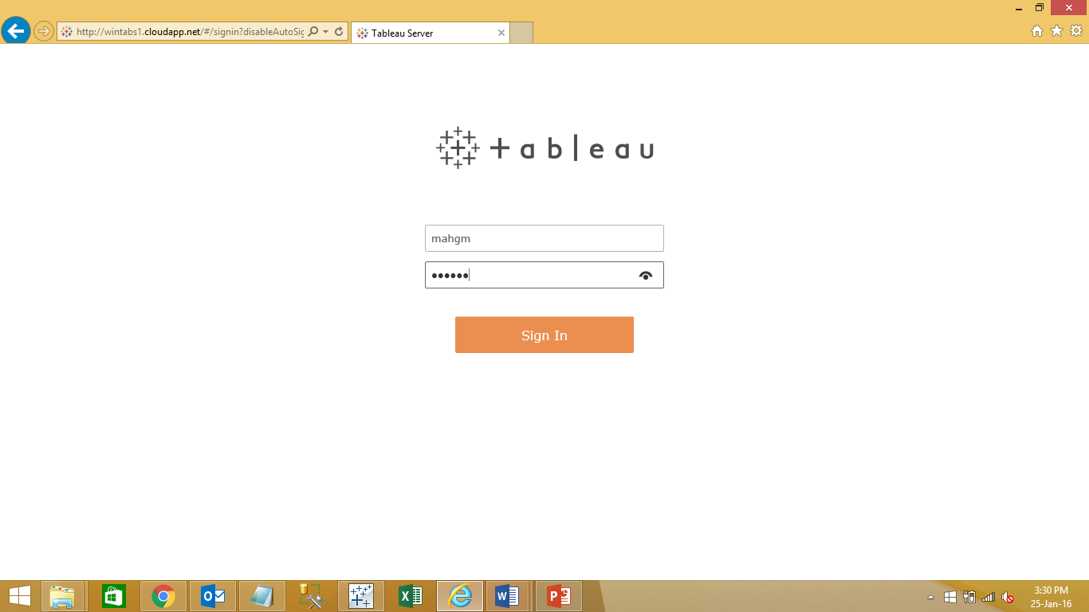

Figure

On successful login to Tableau Server, user will be redirected to the page where all workbooks are published as shown in Figure2

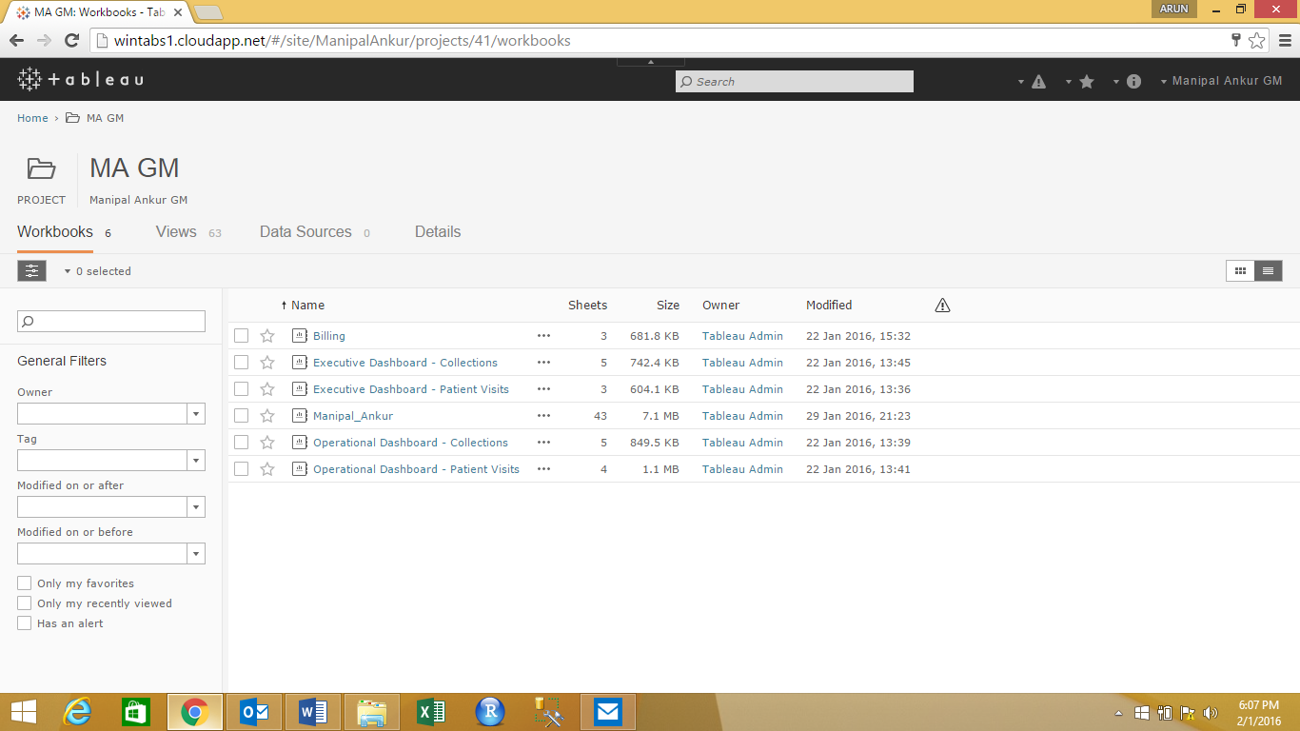

Figure

# Search for Specific Dashboards

User can search for specific list of workbooks by entering the workbook name, full or part, in the search box as shown in Figure 3.

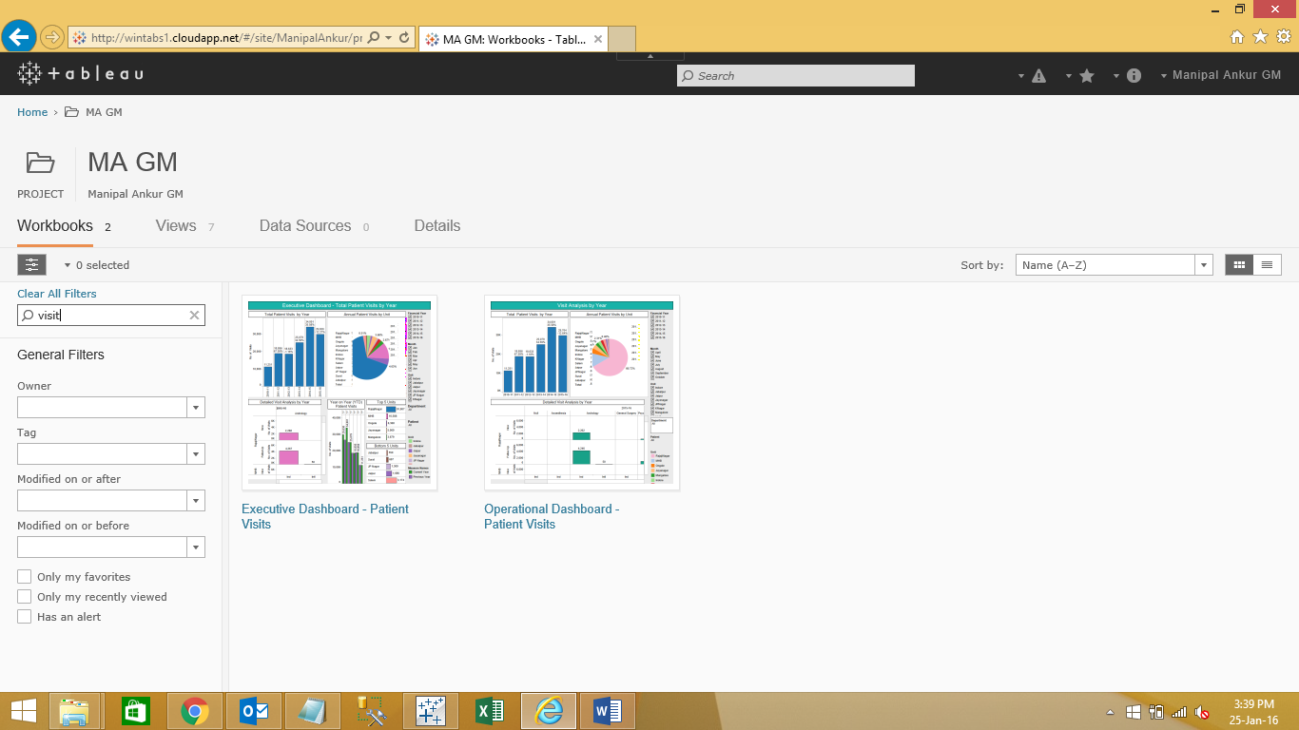

Figure

A list of workbooks will be opened related to visit. User can select the required work book.

# Executive Dashboard

Executive Dashboards are used by the senior management team (CEO, CMO, CFO Etc.) who prefer summarized reports based on financial year and other parameters

## Patient Visits

The **Executive Dashboard – Patient Visits** provides insights to patient visits by Year, Month, Unit, Department, patient type and the status of the patient.

Click on Executive Dashboard – Patient Visits as shown in Figure 4. This will redirect the user to list of Executive Dashboards for Patient Visits as shown in Figure 5.

The List of Executive Dashboards for Patient Visits are

1. Total Patient Visits by Year
2. Total Patient Visits by Month
3. Detailed Analysis

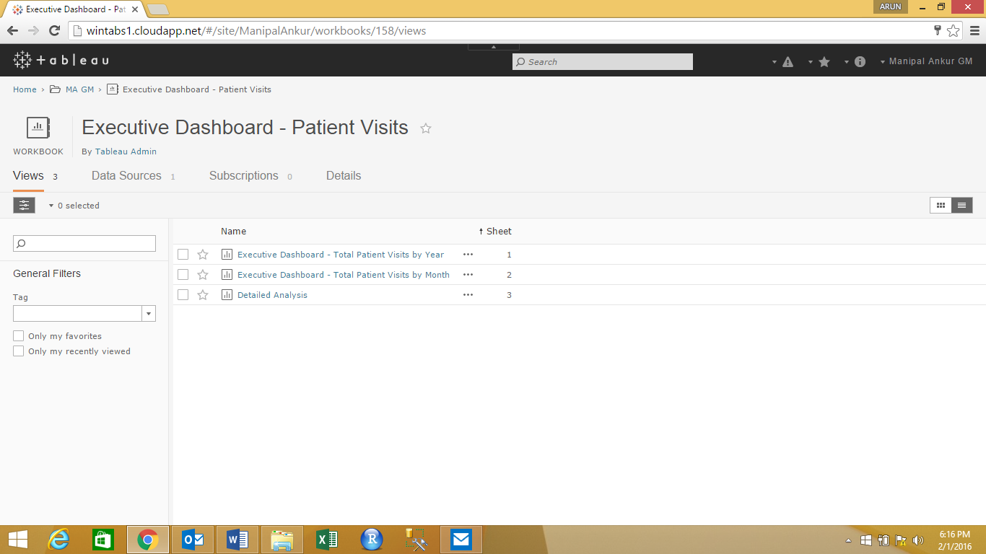

Figure

After selecting the Executive Dashboard – Patient Visits, the list of dashboards available are displayed as shown below in Figure 5

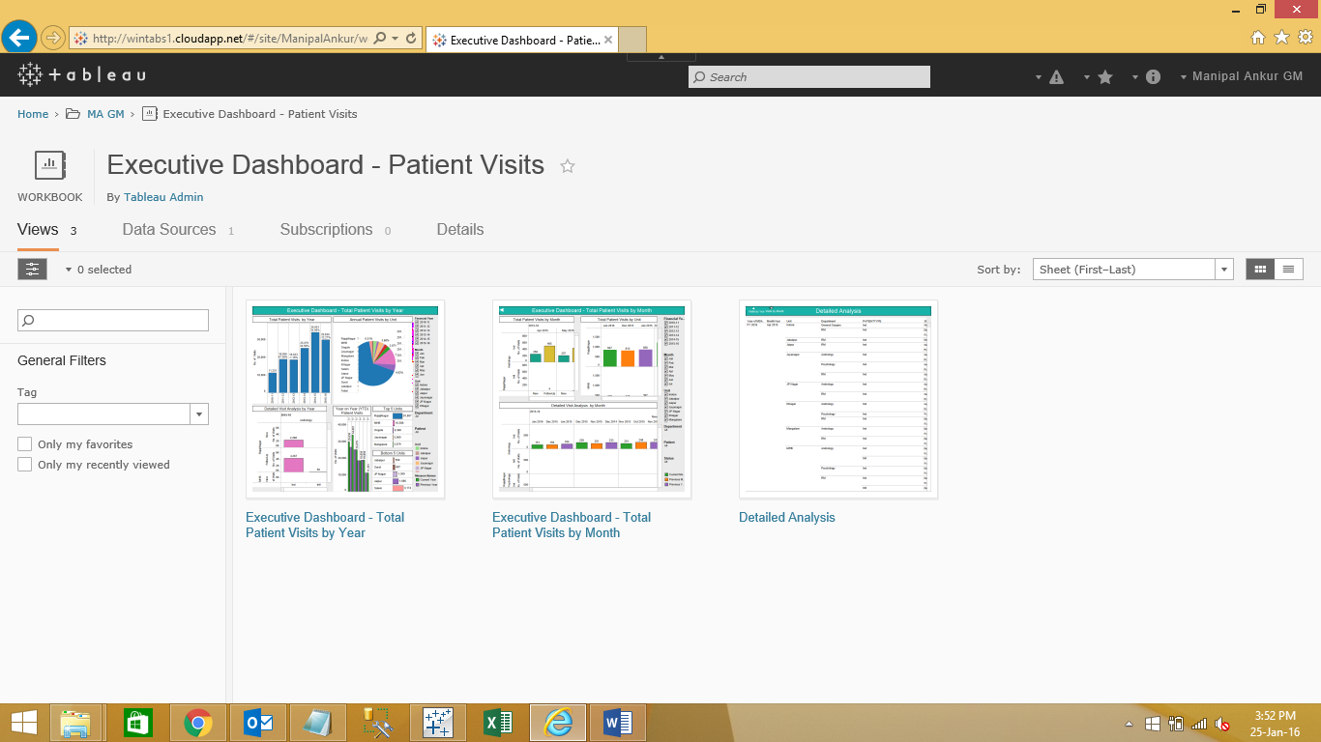

Figure

### Executive Dashboard - Total Patient Visits by Year

This dashboard displays the patient visit details on a financial year basis. There are 6 sections in dashboard as shown in Figure 6.

1. Total Patient Visits by Year

Displays the total patient visit by Year as a total count and percent of difference from current year to previous year.

1. Annual Patient Visits by Unit

Displays the total patient visits per unit and the percent of total visits with respect to each unit.

1. Detailed Visit Analysis by Year

Displays the total visit count with respect to Unit, Department, type of patient and status of the patient for a particular year.

1. Year on Year (YTD) Patient Visits

Displays the comparison between the count of patient visits for the selected year and the same for previous year.

1. Top 5 Units

Displays top 5 units with the highest number of patient visits in descending order.

1. Bottom 5 Units

Displays bottom 5 units with the lowest number of patient visits in ascending order.

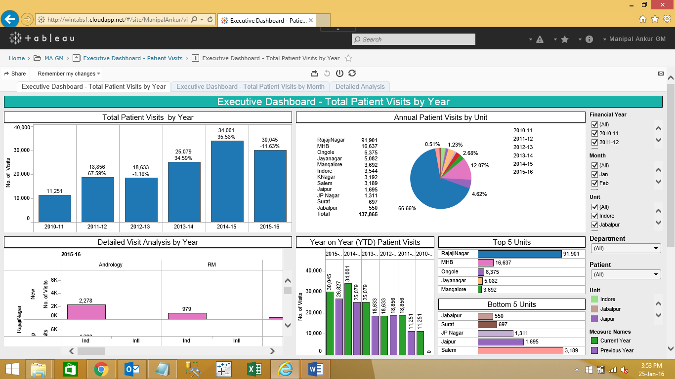

Figure

### Executive Dashboard - Total Patient Visits by Month

This dashboard shows the patient visit details by month for a financial year. There are 3 sections in dashboard as shown in Figure 7.

1. Total Patient Visits by Month

Displays total count of patient visits by Month, Unit and Type of patient and status of patient.

1. Total Patient Visits by Unit

Displays the comparison of patient visits by Current month, previous month of Current year and Current month of previous year with respect to unit/s.

1. Detailed Visit Analysis by Month

Displays month on month patient visit details for the selected Financial Year

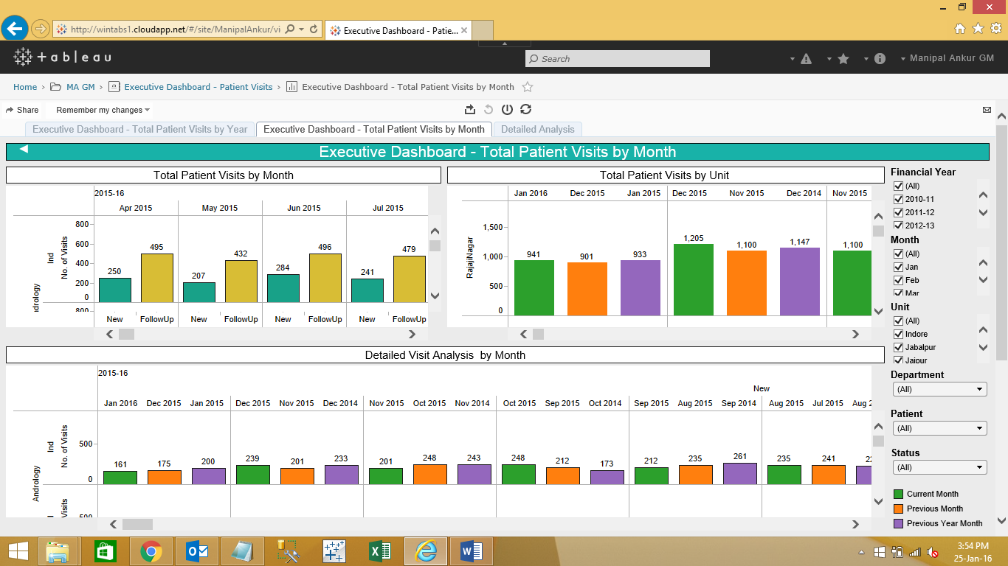

Figure

### Executive Dashboard - Detailed Analysis

The Detailed Analysis Dashboard gives additional details for the patient visits like type of patient, status of patient with respect to unit and department in tabular format as shown in Figure 8

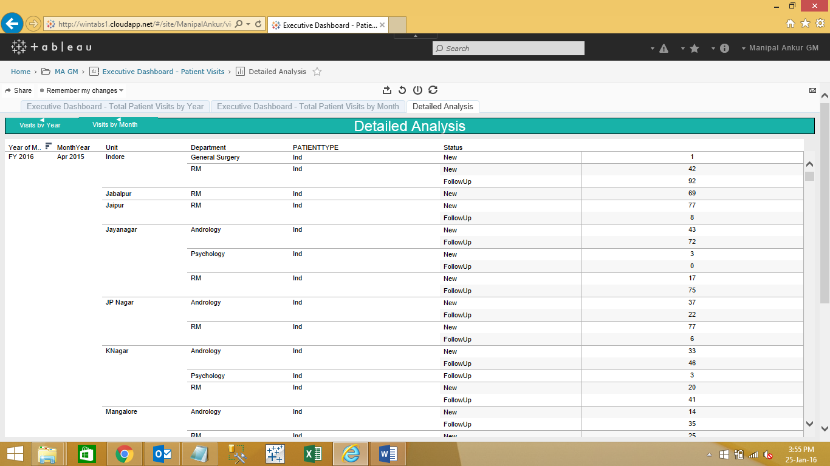

Figure

### Executive Dashboard - Filtering the data

Executive dashboards provides drill down feature to obtain various insights from the data. Users can see the information of patient visits for the particular year across all the units and all the departments by just clicking on a particular year as shown below in Figure 9

In the below screen (Figure 9), highlighted year is 2015-16 and the rest of the sections in the dashboards will be reflected to show the data for the highlighted year.

Tool tip (pop up box) will show the information of selected hyperlink.

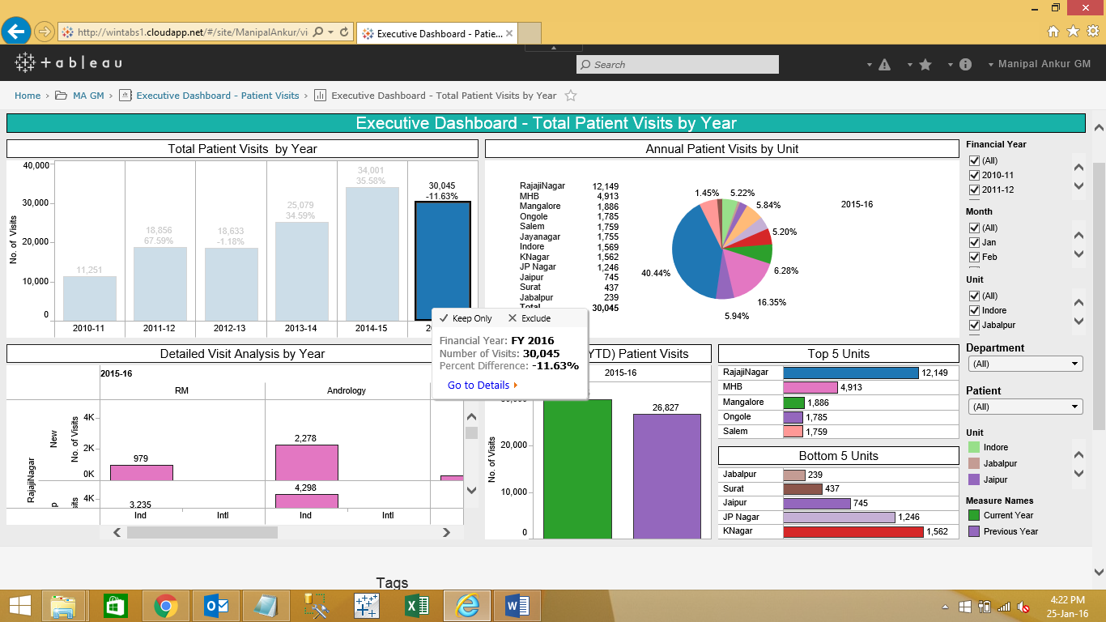

Figure

User can view the data of a particular hospital by clicking on the unit (for eg. Rajajinagar is selected here) in the pie chart shown below in Figure 10. The rest of the sections will reflect the data for the selected Hospital. User can further drill down to the granular level by clicking on the labels.

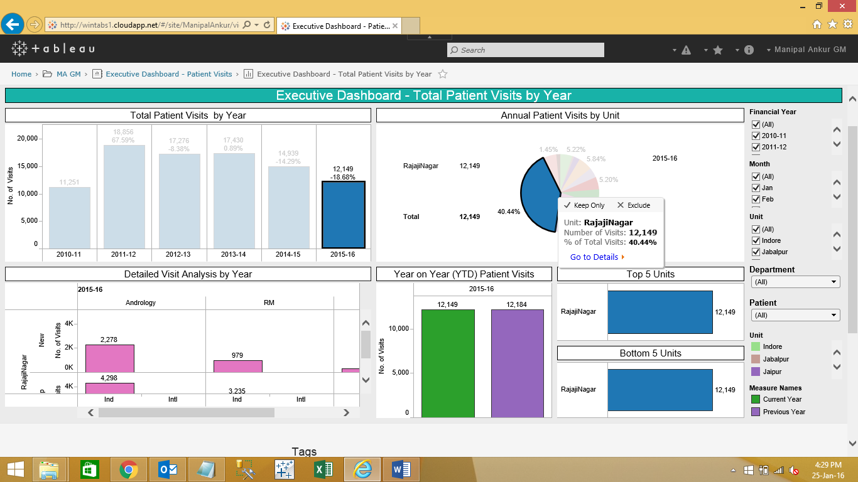

Figure

The user can click on label ‘department’ in the Section ‘Detailed Visit Analysis by Year’ as shown in below Figure 11.

This will further redirect from Detailed Visit Analysis by Year to Total Visits by Month with respect to department Andrology as shown in Figure 12.

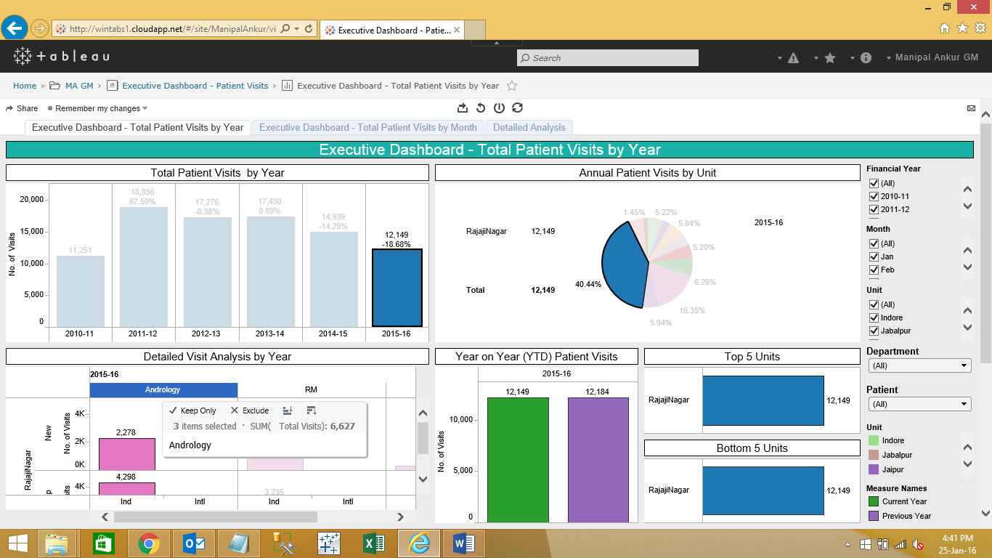

Figure

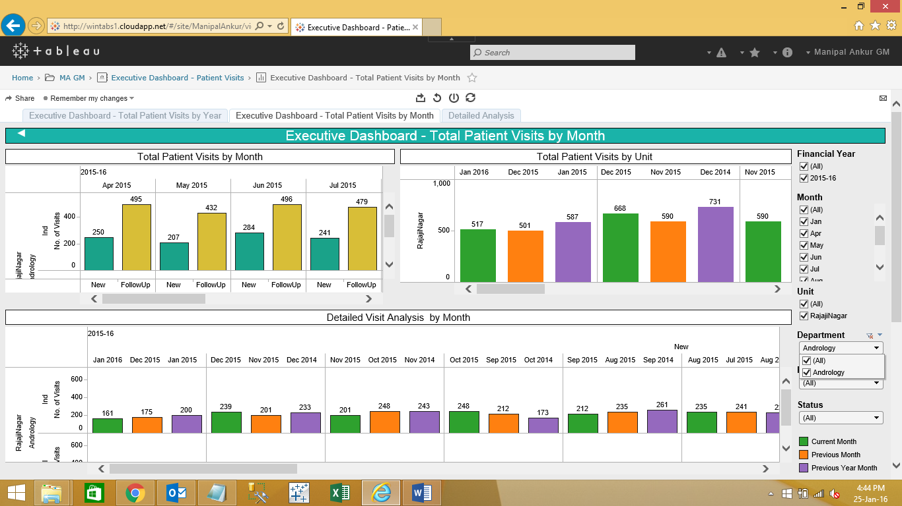

Figure

Explicit filter are available on the right panel. Checking/ unchecking the check boxes corresponding to the parameter will filter the data accordingly

Figure: Displaying data for Particular Month

Executive Dashboards – Links from ToolTip

Users can get detailed report directly from dashboards ‘Total Patient Visits by Year’ or ‘Total Patient Visits by Month’.

The user can click on the Year for which the details report is required. Then select the link ‘Go to Details’ option which appears on the tooltip as shown in Figure 13.

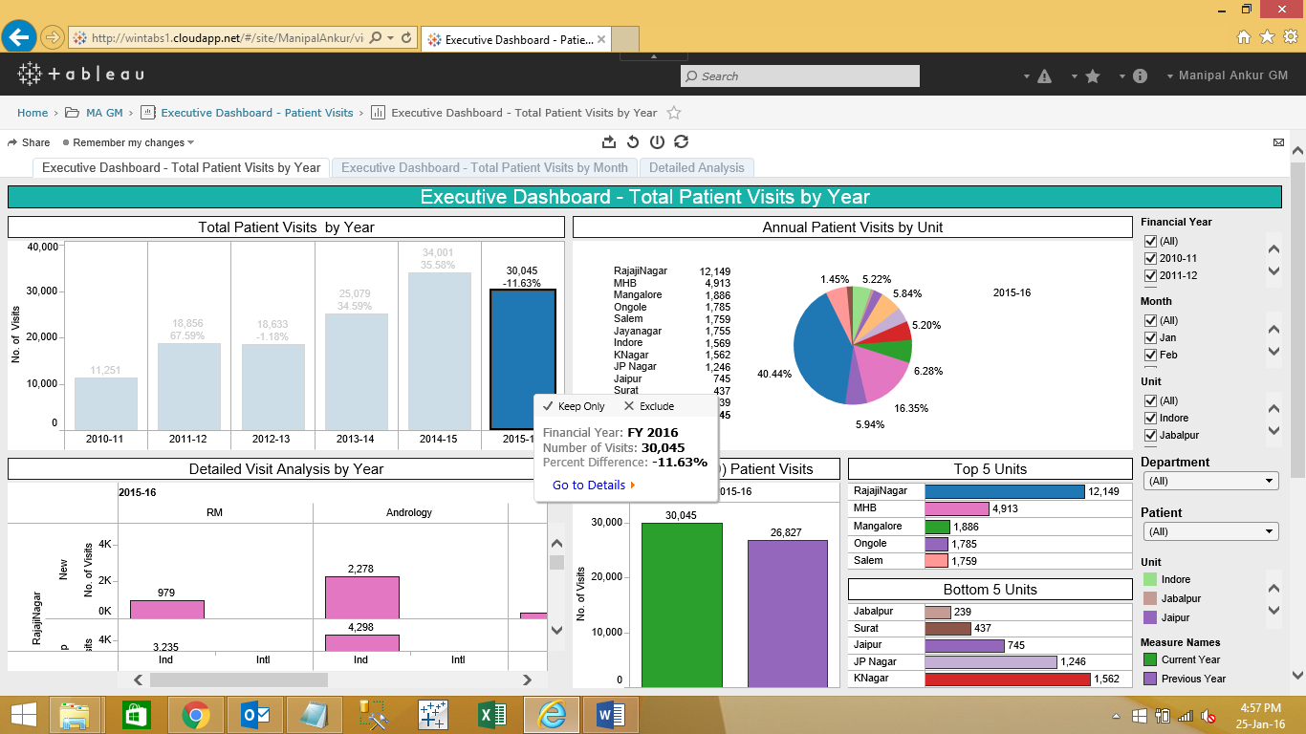

Figure

The user can click on Go to Details option. This will redirect to another dashboard as shown below in Figure 14.

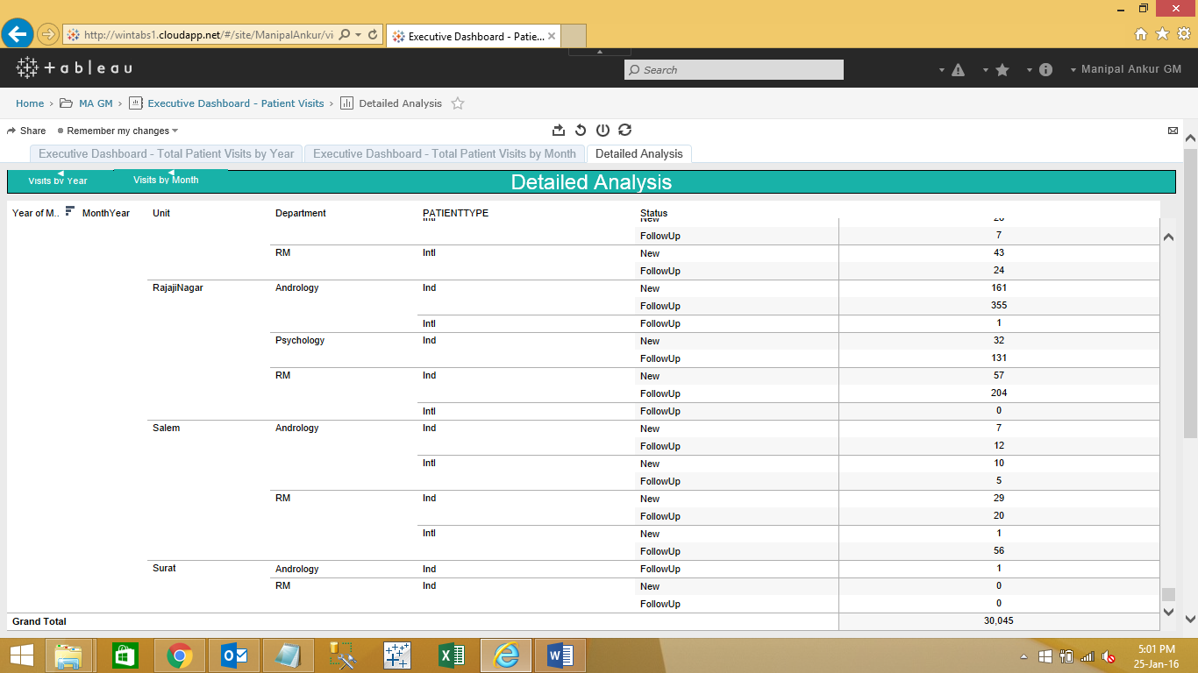

Figure

# Operational Dashboards

The operational dashboards function similar to the Executive dashboard with more granular details.