ED5012 Mid Semester Examination

Location Intelligence Driven Dynamic Geofencing for Autonomous Vehicles
  - Connected and Autonomous Vehicles Problem 6
A safety first multi operator system integrating location intelligence AI ML IoT and cryptographic verification

Name – Praveen Kumar S
Roll Number ED23B038
Course Applications of Human Factors in Design
Submission Mid Semester Examination
Date 25 September 2026

Design position
The geofence is treated as a time bounded safety control over a road graph, not as a static map. Uncertainty can only make the system more conservative; reopening requires stronger evidence than restriction.

Executive Summary
This report proposes a near real time dynamic geofencing service for autonomous vehicles operating in a dense mixed traffic city. The service fuses road geometry, pedestrian density, events, weather, work zones, incidents, fleet observations and source quality into a network aligned risk surface. A graph temporal predictor forecasts short horizon hazards; a monotonic calibrated risk model converts the forecast into a conservative risk score with an explicit uncertainty penalty. A four state policy then publishes green, yellow, orange or red road segment permissions with hysteresis, dwell time, expiry and safe exit behaviour.
The central design choice is that safety constraints are hard and route efficiency is optimised only within the remaining feasible set. Signed short lived updates are checked locally by every vehicle using a city C ITS public key infrastructure. A permissioned ledger records update hashes asynchronously for cross operator audit; vehicles never wait for blockchain consensus before obeying a valid restriction. The architecture is designed for graceful degradation: sparse or stale data increases uncertainty and therefore tightens the geofence instead of silently treating an unobserved area as safe.

Mini Simulation Link - https://praveen-ghostprotocol.github.io/Location-Intelligence-Driven-Dynamic-Geofencing-for-AVs/

Code - https://github.com/Praveen-ghostProtocol/Location-Intelligence-Driven-Dynamic-Geofencing-for-AVs.git

Design Assumptions
The problem is open ended, so the following assumptions define the operating envelope and make the design testable.
Item | Assumption and rationale
City context | A dense Indian metropolitan area with pedestrians, bicycles, motorcycles, buses, human driven vehicles and Level 4 AVs sharing the road.
Road representation | Directed lane or road segment graph; typical segments are 50 to 100 m. A raster risk field may be used internally but is map matched to the graph before enforcement.
Prediction horizon | Risk is estimated at 30 s, 2 min and 5 min. The shorter horizon drives urgent control; longer horizons support smooth rerouting.
Update cadence | Sensors produce 1 to 5 s observations, edge features are fused every 10 s, routine geofence updates are published every 30 s, and emergency restrictions target less than 2 s end to end latency.
Risk states | Four operational states are used: green, yellow, orange and red. They are behavioural permissions, not merely dashboard colours.
Vehicle behaviour | A newly restricted vehicle already inside a zone follows a signed safe exit corridor or reaches a minimum risk condition. It does not stop abruptly in a live traffic lane.
Trust | The city is the policy authority. Real time verification uses public key signatures; a permissioned ledger supplies multi operator auditability.
Failure stance | Uncertainty, missing coverage or stale data never imply safety. They raise the risk bound and can trigger a conservative fallback polygon.

System Objectives and Non Negotiable Constraints
- Safety Prevent entry into road space whose predicted risk or uncertainty exceeds the vehicle's approved operating design domain.
- Predictability Prevent rapid boundary flicker and provide enough approach distance for comfortable deceleration or rerouting.
- Interoperability Give every authorised operator the same signed machine readable rule and version history.
- Availability Continue in degraded mode during sensor, network, cloud or ledger failures.
- Human factors Maintain situation awareness without overloading operators, passengers, pedestrians or human drivers.
- Privacy and accountability Minimise personally identifiable data while preserving provenance, traceability and post incident evidence.

Overall System Architecture
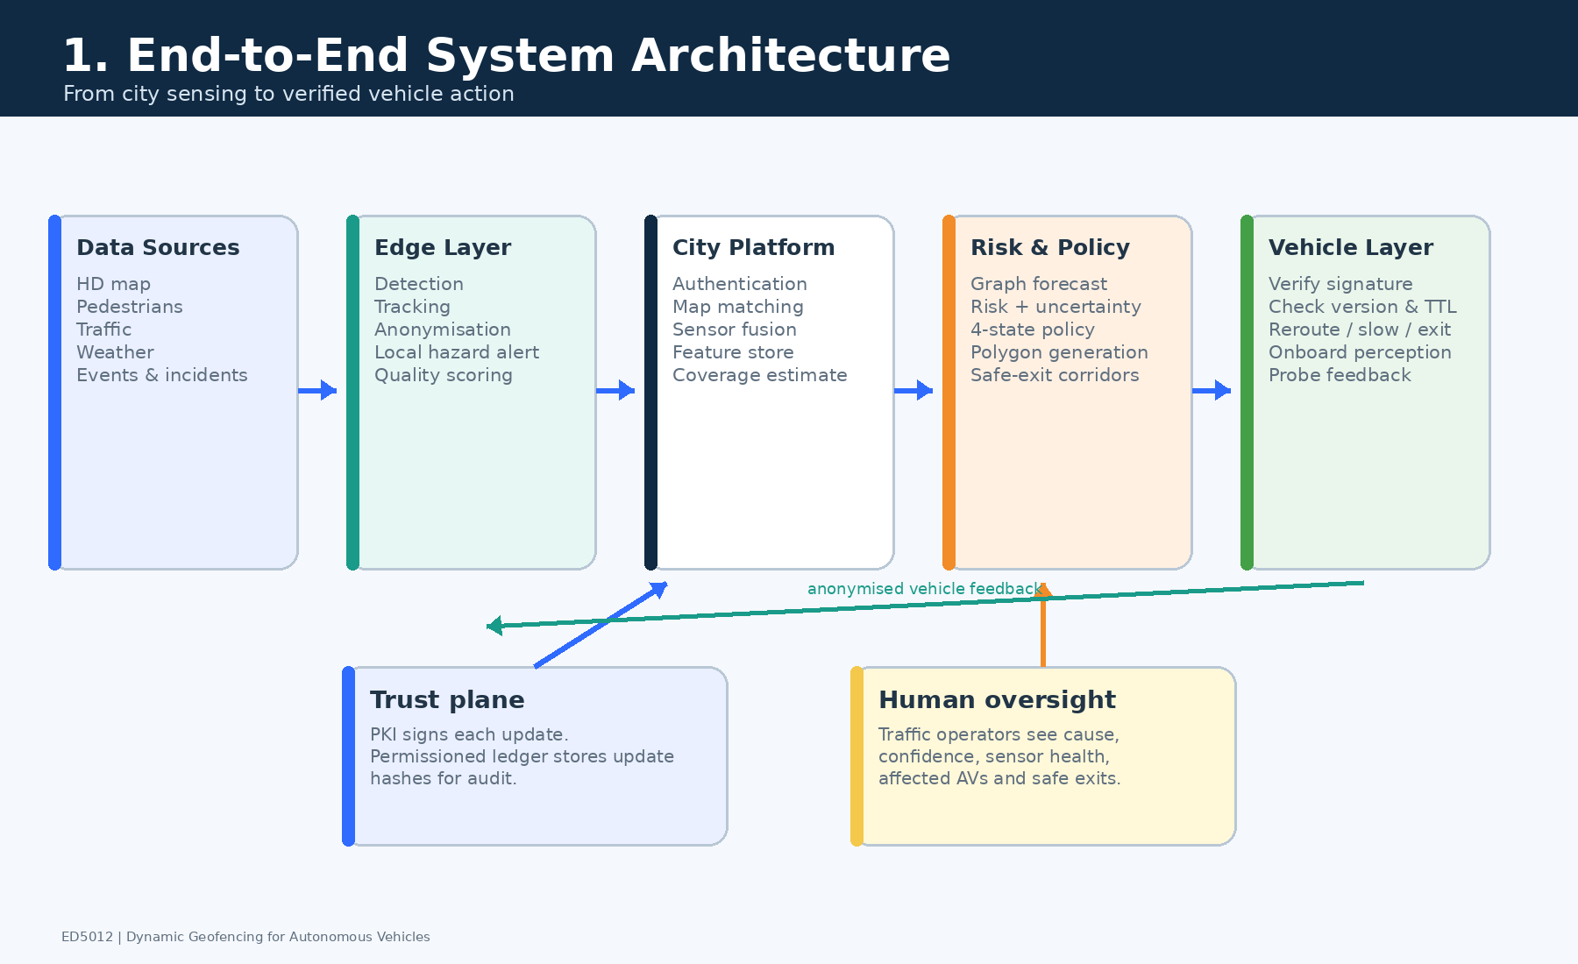
Figure 1 End to end architecture from city sensing to vehicle enforcement and audit
The system is deliberately split into observation, inference, policy and trust. Sensors and authority feeds describe the world; the risk engine estimates what may happen; the policy engine converts risk into a bounded operational rule; the trust layer proves who issued the rule and whether it is current. This separation makes the safety argument inspectable. A model cannot directly command arbitrary vehicle motion, and a cryptographically authentic message is not automatically considered safe unless it also passes semantic and temporal checks.

End to End Decision Loop
1. Collect observations and attach timestamp, location, uncertainty, provenance and health status.
2. Map match and spatially join the observations to road segments and nearby influence areas.
3. Forecast pedestrian, traffic and hazard conditions for 30 s, 2 min and 5 min horizons.
4. Estimate collision or conflict probability, severity and total uncertainty for each segment.
5. Apply hard legal overrides, state thresholds, hysteresis and release dwell time.
6. Build topology preserving polygons and signed safe exit corridors, then publish a short lived versioned update.
7. Vehicles verify, acknowledge and enforce the update locally; audit hashes are committed asynchronously.
8. Telemetry on compliance, false alarms and near misses closes the learning and verification loop.
Evidence from deployed geofencing and cooperative transport programmes supports the individual building blocks: city geofencing trials in Gothenburg, the GeoSence programme, C Roads deployments, WZDx work zone feeds and connected vehicle pilots. However, there is no single proven product that solves the complete problem exactly as stated; the proposed contribution is a coherent safety case that connects those proven pieces. [1 to 4, 12]

1 Data Layers and Live Risk Surface

1.1 Data Layers
Layer | Examples | Why it matters | Typical refresh
Road and lane graph | Lane centre lines, junction topology, turn rules, speed limits, gradients | Defines legal connectivity and allows network rather than Euclidean reasoning | Map release or verified change
Static exposure | Crossings, schools, hospitals, markets, stadiums, bus stops, crash history, flood spots | Represents recurring vulnerability and prior hazard | Monthly to annual
Pedestrian and cyclist state | Counts, density, flow direction, spillover, vulnerable road user tracks | Primary dynamic exposure in mixed traffic | 1 to 5 s
Traffic state | Speed, queue length, occupancy, harsh braking, wrong way motion | Captures congestion and unstable interactions | 1 to 5 s
Events | Stadium schedules, school release, processions, festivals, planned diversions | Provides leading indicators before sensors observe the surge | Minutes to days
Weather and environment | Rain intensity, visibility, surface water, friction proxy, wind | Changes stopping distance and sensor confidence | 1 to 10 min
Incidents and works | Police reports, emergency closures, cones, lane shifts, WZDx or DATEX II feeds | Supports hard closures and topological changes | Immediate
Fleet observations | AV detections, localisation quality, traction control, near misses | Adds mobile coverage and direct operational evidence | 1 to 5 s
Quality and provenance | Timestamp, sensor health, calibration, source trust, missingness | Prevents poor data from appearing certain | With every message
Vehicle capability | ODD, braking envelope, sensor limits, map version | Allows a common geofence to be interpreted conservatively by heterogeneous fleets | Trip start and change

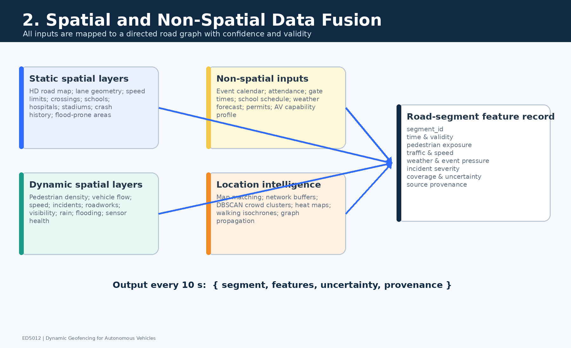
Figure 2 Spatial and non spatial layers fused into a network aligned representation

1.2 Location Intelligence Methods
Method | Role | Why this method
Map matching | Associates observations with the correct lane or segment | A camera point near a flyover must not contaminate the road below it.
Spatial join and network buffer | Adds events, crossings, works and hazards to affected links | Influence follows entrances and road connectivity, not only circular distance.
Heat map and kernel density | Smooths noisy pedestrian counts and near miss locations | Produces a continuous exposure field while preserving hot spots.
DBSCAN clustering | Detects unplanned crowds and incident clusters | Finds irregular spatial groups without assuming their number.
Isochrone and reachability | Estimates how a pedestrian surge or queue can propagate through connected streets | Travel time based influence is more realistic than fixed radius buffers.
Graph propagation | Moves risk through upstream and downstream links | Captures spillback, diversion and network dependencies.

Every segment i at time t is represented by an auditable feature vector xᵢ(t) = [P, V, S, W, E, I, C, H, Q], where P is pedestrian exposure, V traffic dynamics, S static vulnerability, W weather, E event pressure, I incidents and works, C network context, H prediction horizon and Q source quality. The record also carries uncertainty and provenance rather than only a point estimate.
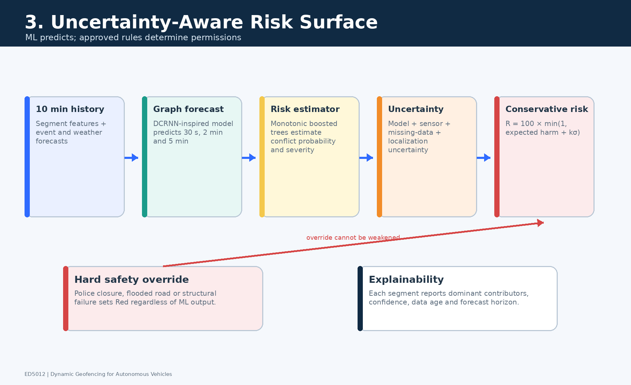
Figure 3 Conversion of fused observations into a conservative live risk surface

1.3 Risk Estimation
A graph temporal network inspired by the Diffusion Convolutional Recurrent Neural Network forecasts traffic, pedestrian and hazard features across connected road segments. This model family is appropriate because urban risk is both temporal and graph structured; upstream queues and exit gate crowds propagate through the network. DCRNN reported materially improved traffic forecasting against earlier baselines and provides a defensible starting point for this module. [5]
The forecast is passed to a calibrated monotonic gradient boosted model that estimates conflict probability p and severity s, producing expected harm μ = p × s. Monotonic constraints encode domain knowledge: all else equal, higher pedestrian density, poorer visibility or lower friction must not reduce risk. This interpretable second stage is preferred to an opaque end to end controller because feature contributions, calibration and threshold behaviour can be audited.
Rᶜ is the conservative risk score on a 0 to 100 scale. The uncertainty term σ combines model residual uncertainty, sensor uncertainty, missing coverage and localisation uncertainty. The multiplier k is 1.5 in normal service and is increased in degraded mode. Thus two segments with the same predicted mean may receive different controls when one is poorly observed.
The maximum across weighted horizons prevents a severe short term hazard from being averaged away while still allowing a developing five minute event to influence routing. Legal closures, verified work zones and emergency declarations bypass the statistical score as hard overrides.

2 AI ML and Dynamic Geofence Policy

2.1 Model Choice and Training
- Predictor A graph temporal model forecasts segment features for multiple horizons and respects road connectivity.
- Risk estimator A monotonic gradient boosted model estimates probability and severity with calibrated uncertainty and interpretable feature attribution.
- Training labels Police validated crashes are supplemented by near miss measures such as time to collision, post encroachment time, emergency braking and pedestrian intrusion.
- Validation split Hold out entire dates, neighbourhoods, weather conditions and event types to test generalisation rather than randomly mixing adjacent samples.
- Calibration Evaluate reliability diagrams, Brier score and expected calibration error. A reported 0.7 risk probability should correspond to approximately 70 percent incidence in the applicable validation bin.
- Governance Monitor drift by zone and road user group; a model update enters shadow mode before it can alter live policy.
End to end reinforcement learning is not selected for the safety critical policy. It may optimise simulated throughput but can learn brittle or hard to explain boundary behaviour. Learning is therefore limited to forecasting and calibrated risk estimation; the final control is a deterministic verified state machine. Risk based ODD research, RSS and control barrier function literature inform the safety envelope and invariant checks. [6 to 8]

2.2 Four State Policy
State | Enter threshold | Release threshold | Vehicle rule | Release dwell
Green | 0 to 29 | Below 20 from yellow | Normal operation within the vehicle ODD | 180 s
Yellow | 30 to 49 | Below 40 from orange | Entry allowed; speed capped at min of legal limit and 30 km h | 120 s
Orange | 50 to 69 | Below 60 from red | No new entry; vehicle already inside follows safe exit at maximum 15 km h | 120 s
Red | 70 to 100 or hard override | Below 60 | Entry prohibited; existing vehicle takes safe exit or minimum risk condition | 120 s

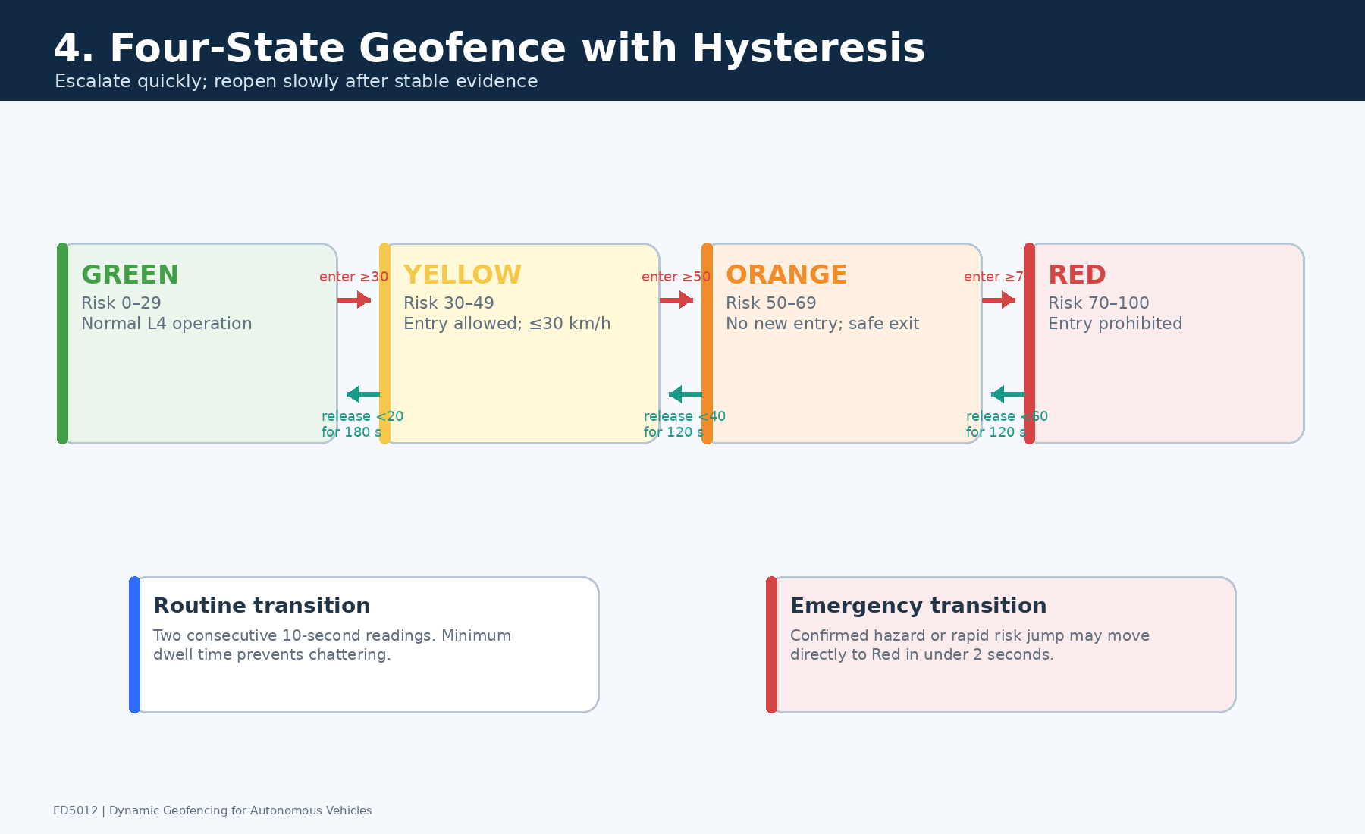
Figure 4 State thresholds, hysteresis and dwell logic used to prevent boundary flicker
Escalation uses two consecutive 10 s risk cycles for ordinary changes, while a verified emergency override escalates immediately. Release requires both a lower threshold and sustained dwell. For example, a red segment does not become orange until risk remains below 60 for 120 s. The asymmetric rule is intentional: restriction should be fast, but reopening should require stronger evidence.

2.3 Polygon Construction and Approach Buffer
The policy engine selects contiguous restricted road segments, dissolves only topologically connected groups, clips the result to roadway boundaries and preserves holes or exceptions required for emergency access. It then adds an upstream approach buffer based on perception and communication latency, braking capability and a geometric margin.
For v = 40 km h = 11.11 m s, total reaction and communication time τ = 2 s, wet road friction μ = 0.35, gravitational acceleration g = 9.81 m s² and margin = 10 m, the buffer is 22.2 + 18.0 + 10 = 50.2 m. A practical map aligned value of 55 m is therefore used. This calculation is repeated for each approach speed and degraded friction estimate.
Each polygon update contains a unique ID, version, creation time, valid from time, expiry time, risk state, affected road IDs, approach buffer, vehicle class or ODD applicability, safe exit corridor, reason codes, confidence, previous update hash and issuer signature. Routine updates are published every 30 s with a 60 s validity; urgent restrictions target under 2 s dissemination.

3 IoT Data Collection and Edge Cloud Processing
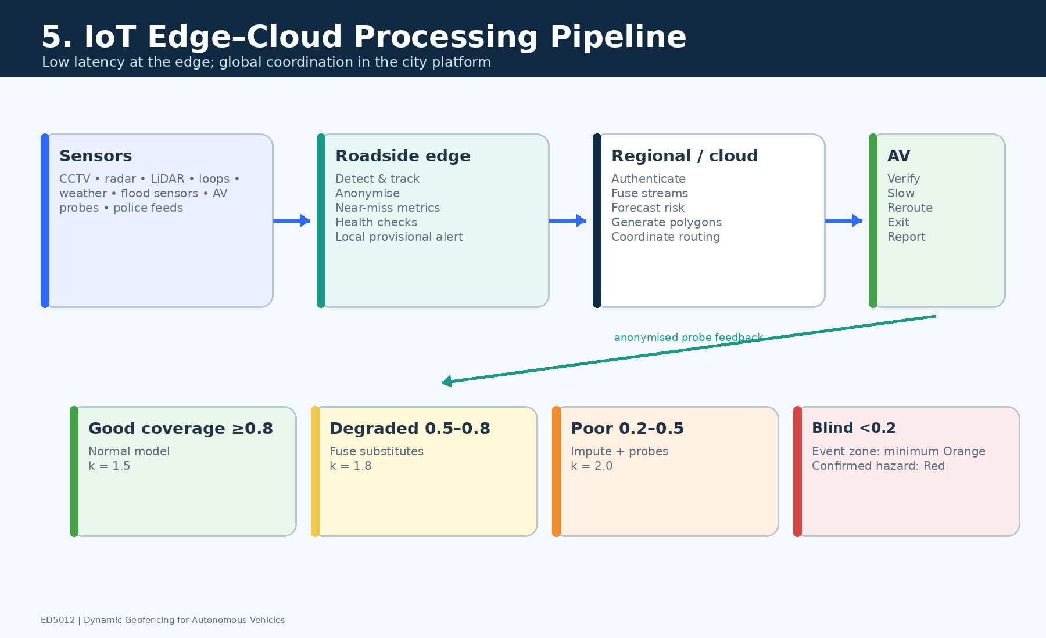
Figure 5 IoT edge cloud pipeline with scoped emergency authority and graceful degradation

3.1 Pipeline
Stage | Main functions | Safety design
Source devices | Cameras, radar, LiDAR, loop detectors, weather stations, signal controllers, road work beacons, smartphones and AV probes | Device identity, secure boot, time synchronisation and health heartbeat
Roadside edge | Object detection, tracking, counts, near miss features, map matching, anonymisation | Raw video normally remains at edge; local sanity checks and redundant paths
Secure broker | Schema validation, deduplication, timestamp checks, topic based distribution | Mutual TLS, rate limits, replay filtering and provenance retention
Cloud fusion | Spatial joins, graph temporal forecast, uncertainty estimation and model monitoring | Active active regions, deterministic fallbacks and signed data lineage
Policy service | State machine, hysteresis, polygon formation and conflict resolution | Hard overrides, invariant checks and two person approval for planned reopening
Distribution | C ITS messages, operator API, roadside broadcast and control room view | Short lived signed updates, acknowledgements and multi channel delivery
Vehicle edge | Signature and semantic checks, local ODD evaluation and trajectory response | Cached root keys, last known safe rule and minimum risk fallback

3.2 Sparse and Missing Coverage
Cᵢ is the effective coverage of segment i. Each contributing source s has a spatial relevance weight wᵢₛ and quality qₛ based on freshness, health, calibration and trust. The multiplicative form rewards independent redundant evidence but prevents a large number of weak sources from being treated as one perfect sensor.
Coverage | Interpretation | Required response
C at least 0.80 | Good | Normal model and k = 1.5
0.50 to 0.79 | Degraded | Increase uncertainty; cross check mobile probes and adjacent sensors
0.20 to 0.49 | Poor | Use conservative imputation and restrict high vulnerability links
Below 0.20 | Blind | Apply precomputed fallback geofence or close entry until trusted evidence returns

The missing data hierarchy is: independent neighbouring fixed sensors, AV mobile probes, graph based short horizon imputation, historical prior conditioned on time and event, uncertainty inflation, and finally restriction. Imputation never restores full confidence. A stale source is progressively down weighted and then removed after its defined time to live.

3.3 Emergency Edge Authority
A trusted roadside edge node may publish a provisional restriction when it independently detects a severe local hazard and the cloud path is unavailable. This authority is deliberately narrow: it may only make the rule more restrictive, must remain within a 500 m radius, expires after 15 to 30 s, is signed by a scoped certificate and must be reconciled by the city service. Edge nodes cannot reopen a road.
Latency component | Target
Sensing and edge feature extraction | 0.45 s
Uplink and broker validation | 0.20 s
Fusion and risk evaluation | 0.35 s
Policy construction and signature | 0.20 s
Broadcast and in vehicle verification | 0.30 s
Total emergency path | 1.50 s nominal; p95 not more than 2.0 s

4 Cryptographic Trust and Cross Operator Verification
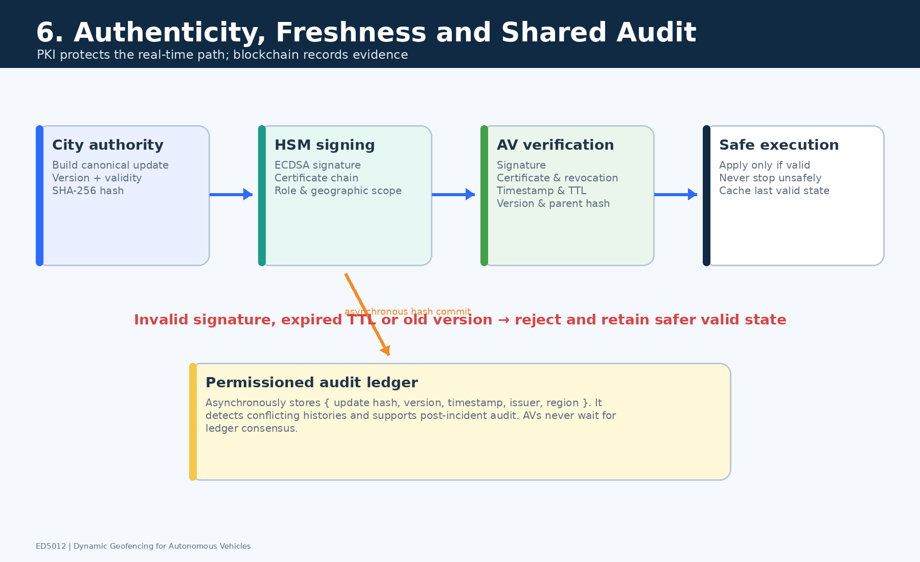
Figure 6 Fast public key verification with an asynchronous permissioned audit ledger

4.1 Real Time Authenticity
The real time trust mechanism follows established cooperative intelligent transport system practice. An offline root certificate authority delegates to city issuing authorities, emergency services and narrowly scoped edge issuers. Each message is hashed with SHA 256 and signed using ECDSA P 256 in a hardware security module. The vehicle stores trusted roots and recent revocation information, allowing verification even when the ledger or cloud is temporarily unreachable. [3, 9]
Hash chaining makes deletion, reordering and substitution visible. Every accepted update must pass all of the following checks; a valid signature alone is insufficient.
1. The schema version and mandatory safety fields are understood.
2. The certificate chain terminates at a trusted root and the issuer scope covers the claimed zone and action.
3. The certificate is valid and not revoked according to current policy.
4. The digital signature matches the message hash.
5. The vehicle clock lies within valid from and expiry bounds, allowing only a small defined skew.
6. The update version is newer than the accepted version and its previous hash matches the local chain.
7. The polygon, road IDs, state and safe exit fields are semantically consistent and physically plausible.
8. The rule applies to the vehicle class and ODD; conflicting updates are resolved by authority and conservatism, never by arrival order alone.

4.2 Permissioned Ledger Role
A permissioned blockchain operated by the city, traffic police, road authority and accredited operator representatives stores only the message hash, update ID, version, issuer, region, state and timestamp. Detailed trajectories and raw sensor data remain off chain. A Byzantine fault tolerant network with n at least 3f + 1 can tolerate f malicious or failed validators; seven validators can therefore tolerate two. [10]
The ledger is not in the vehicle control loop. Vehicles act immediately on a valid short lived signed restriction and audit the ledger asynchronously. This avoids turning consensus delay into braking delay while still providing a common, tamper evident history for disputes, incident investigation and cross operator accountability.

4.3 Threats and Controls
Threat | Potential consequence | Control
Fake geofence broadcast | AV enters a hazardous zone or is maliciously diverted | Certificate chain, scoped issuer, signature and semantic validation
Replay of an old red or green update | Unnecessary closure or unsafe reopening | Short expiry, monotonic version, nonce and previous hash
Compromised edge node | False local restriction | Restricted radius, short TTL, only more restrictive authority and anomaly monitoring
Compromised central issuer | City scale false policy | HSM, role separation, rapid revocation, audit ledger and dual authorisation for planned reopening
GPS spoofing or map mismatch | Wrong zone interpretation | Multi sensor localisation, map version checks and conservative localisation envelope
Denial of service | No fresh update | Multi channel delivery, cached signed rule, static fallback map and minimum risk behaviour

Authenticity matters because a forged permissive update can intentionally route an AV into a pedestrian surge, while a forged restrictive update can immobilise a district or herd traffic toward another target. Currentness is equally important: a genuine but expired message can be unsafe.

5 Explicit Safety and Efficiency Tradeoff
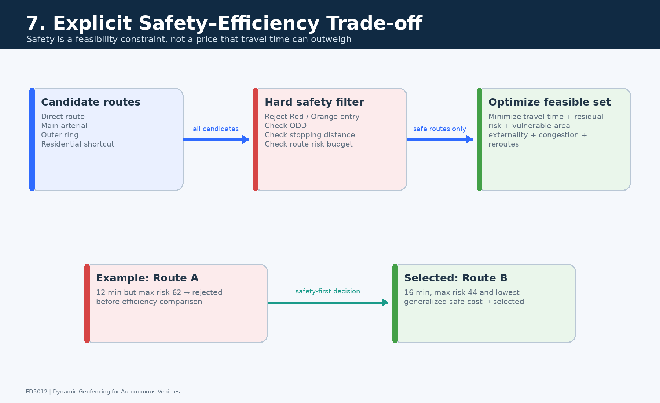
Figure 7 Lexicographic decision rule with safety gates before efficiency optimisation

5.1 Tradeoff Rule
The system does not use a single weighted average that permits enough time saving to compensate for arbitrary safety risk. It applies a lexicographic rule. First, a route is feasible only if every segment is green or yellow, the vehicle ODD is satisfied, stopping sight distance is adequate, maximum segment risk is below 50 and route exposure E is at most 0.35. Second, the least cost route is chosen only from this feasible set.

T is travel time in minutes; E is distance weighted risk exposure; X is vulnerable road user exposure; C is congestion spillover; N is the number of significant route changes. The coefficients are illustrative policy values selected through simulation and stakeholder review, not universal constants. Their units are scaled so the objective is interpretable as generalised minutes.

5.2 Worked Example
Route | Time min | Max risk | E | X | C | Feasible | Objective J
A direct | 12 | 62 | 0.28 | 0.15 | 0.10 | No | Rejected by max risk
B moderate detour | 16 | 44 | 0.32 | 0.10 | 0.05 | Yes | 19.75
C long low risk | 20 | 25 | 0.18 | 0.00 | 0.02 | Yes | 21.86
D unstable shortcut | 14 | 46 | 0.34 | 0.75 | 0.20 | Yes | 21.00 plus reroute penalty

Route A is rejected despite being fastest because it violates the hard risk gate. Among feasible routes, Route B is preferred to Route C because the extra four minutes of Route C does not buy enough additional safety under the stated policy. Route D is disfavoured by vulnerable road user exposure and route instability. If no route passes the safety gates, the AV waits at a signed staging area, uses an approved emergency corridor when applicable or reaches a minimum risk condition.
At network scale, a secondary allocation constraint prevents every operator from selecting the same detour. The city may impose time bounded link quotas or operator neutral route prices, but these cannot relax a red or orange safety rule. Equity is reviewed by measuring whether restrictions repeatedly transfer delay, noise or risk to the same neighbourhoods.

6 Verification and Validation Plan
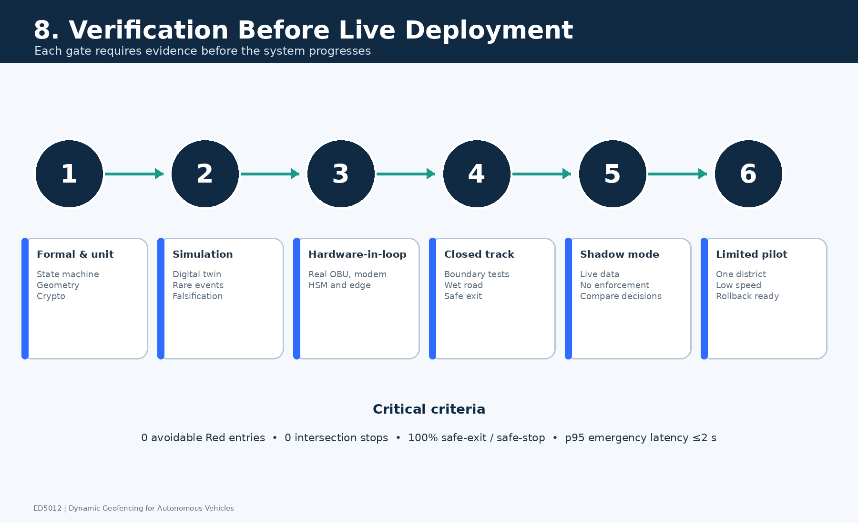
Figure 8 Evidence ladder from offline analysis to supervised public road deployment

6.1 Verification Strategy
Stage | What is tested | Key evidence
Hazard analysis | Unsafe entry, abrupt stop, missed update, conflicting issuer, crowd surge, false reopening | STPA or FMEA with safety requirements and mitigations
Formal policy tests | Allowed state transitions, expiry, version ordering, safe exit invariants | Model checking, property based tests and signed message conformance
Historical replay | Past events, rain, crashes, work zones and outages | Detection lead time, calibration, false closures and missed hazards
Digital twin | Thousands of mixed traffic and adversarial scenarios | Conflict rate, detour, queue spillback, oscillation and equity
Software in loop | Entire decision stack with simulated sensors and communications | Determinism, latency, failover and regression tests
Hardware in loop | Production vehicle gateway, HSM, V2X radio and clock behaviour | Signature time, packet loss, clock skew and stale update handling
Closed track | Real braking, boundary crossings, loss of communications and safe exit | Deceleration, jerk, stopping margin and driver interaction
Shadow deployment | Live data without controlling vehicles | Counterfactual comparison with human approved policy
Phased pilot | Small supervised zone, limited hours and capability classes | Independent safety review and progressive release gates

6.2 Oscillation and Boundary Tests
The central transient hazard is chattering: noisy risk near a threshold repeatedly opens and closes a boundary, causing reroutes, braking and unpredictable interactions. The policy is therefore tested with constant noise, slow ramps, sharp spikes, sawtooth risk, delayed sensors, out of order updates and alternating conflicting sources. Parameter sweeps cover approach speed, friction, latency, localisation error, packet loss, vehicle braking capability and boundary geometry.
Metric | Proposed acceptance criterion
Avoidable entry into active red zone | Zero in the verified scenario set
Unsafe stop in intersection or live lane caused by update | Zero
Safe exit or minimum risk completion after restriction | 100 percent in controllable scenarios
Emergency update latency | p95 not more than 2.0 s; p99 reported
In vehicle signature and semantic verification | p95 not more than 100 ms
Boundary oscillation | No more than one non emergency state reversal per segment in any 5 min window
Routine commanded deceleration | Not more than 2.5 m s²
Routine commanded jerk | Not more than 2.0 m s³
Polygon integrity | No self intersections, disconnected slivers, invalid holes or road ID disagreement
Risk calibration | Brier score and calibration error meet predeclared validation thresholds by zone and event class

Success is not defined only by collision avoidance. The test report must also include false restriction minutes, passenger delay, number of reroutes, operator alert burden, vulnerable road user conflicts, passenger comprehension and distribution of detour externalities across neighbourhoods. This prevents a technically safe system from hiding unusable or inequitable behaviour.

7 Failure Scenario and Fallback Geofencing
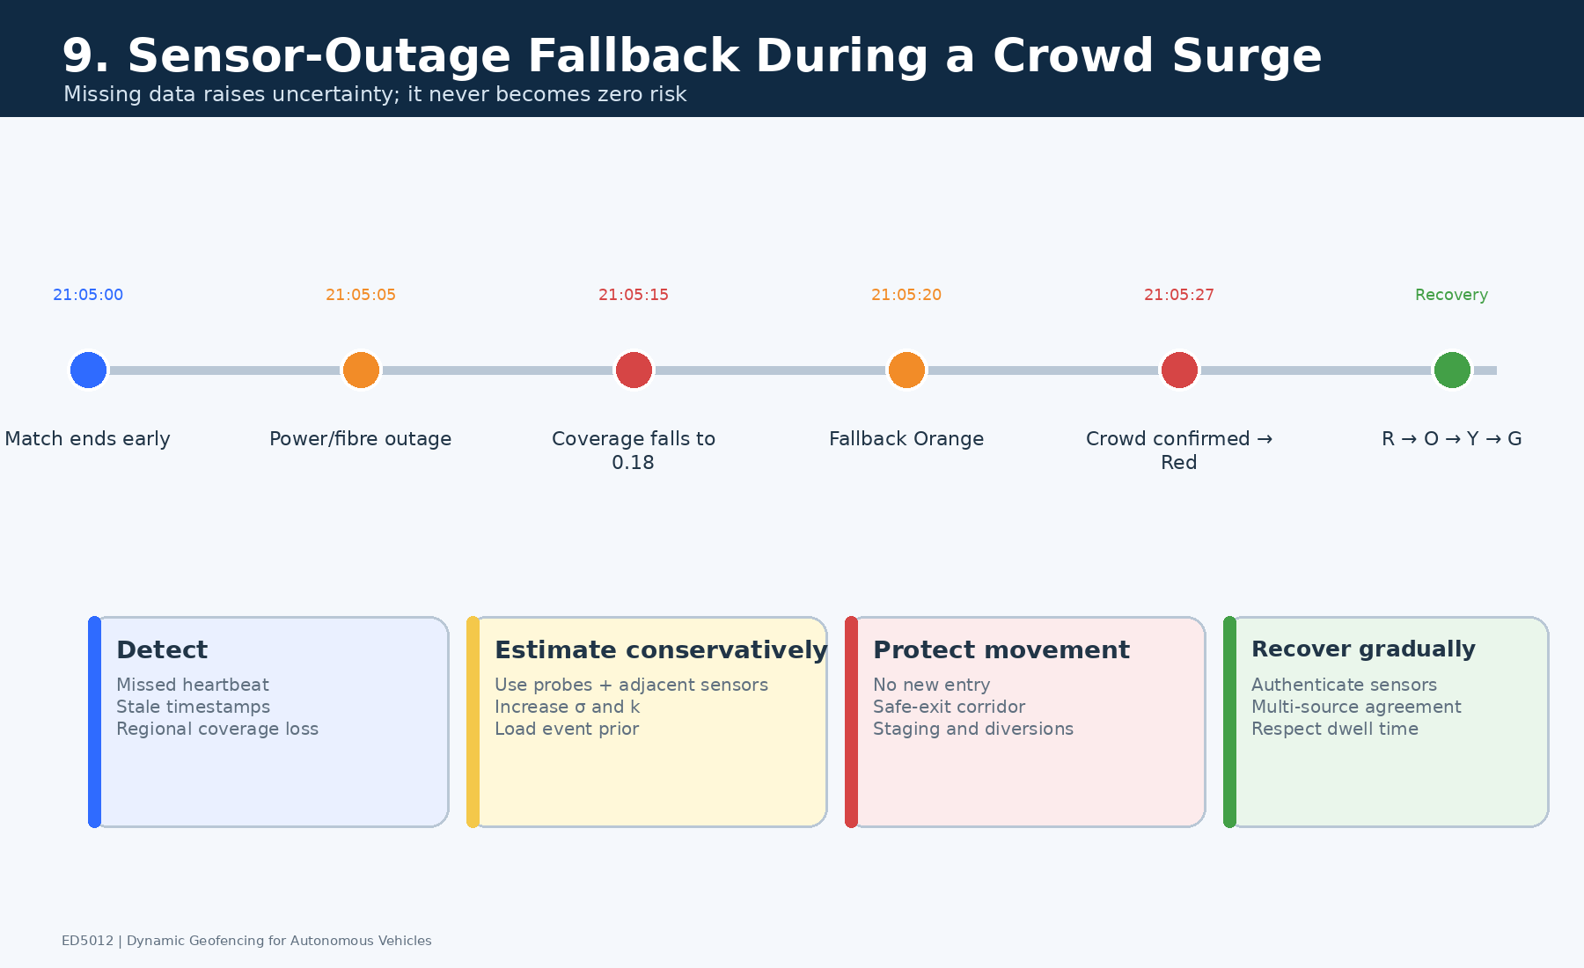
Figure 9 Fail conservative response to a sudden stadium event during a sensor and network outage

7.1 Scenario
A cricket match ends 25 minutes earlier than scheduled during heavy rain. At the same time, a local power and fibre fault disables stadium cameras and roadside links. The true pedestrian surge is therefore not visible to the normal fixed sensing layer. A naive system could retain a green geofence because its last observation was safe.
The proposed system detects missed heartbeats within 10 s. Coverage drops from 0.86 to 0.18 and the area becomes blind. Before failure, μ = 0.23, σ = 0.08 and k = 1.5 give Rᶜ = 100(0.23 + 1.5×0.08) = 35, or yellow. After failure, σ rises to 0.27 and degraded mode uses k = 2.0, giving Rᶜ = 77, or red. The direction of the response is therefore determined by uncertainty, not optimism.

7.2 Fallback Behaviour
1. Declare the fixed sensor zone degraded and attach an explicit reason code and confidence level.
2. Fuse available AV probes, mobile network crowd indicators, adjacent intersections, police reports and the early event termination signal.
3. Activate the precomputed stadium egress fallback polygon and upstream 55 m or speed specific approach buffers.
4. Prohibit new AV entry. Vehicles already inside use signed low speed safe exit corridors; emergency access remains separately controlled.
5. Broadcast through cellular, roadside radio and operator channels. If all communications fail, each AV uses the last valid signed rule until expiry and then its cached static fallback map.
6. Deploy physical traffic control and field confirmation because human driven vehicles and pedestrians cannot be controlled by the digital geofence alone.
7. Log every automatic and human action for later audit and model review.

7.3 Recovery
Restored sensors do not immediately reopen the area. They must authenticate, pass health and calibration checks, agree with at least one independent source and remain stable for the release dwell. The policy steps down red to orange to yellow to green as evidence accumulates. A single recovered camera can make the system more informed but cannot instantly overrule the fail safe state.
This behaviour is deliberately conservative but bounded. The fallback zone is precomputed around plausible egress routes rather than closing the whole city, expiry is explicit, and reopening is evidence based. The design therefore avoids both unsafe permissiveness and indefinite blanket closure.

8 Human Factors and Operational Design
Dynamic geofencing is a joint human automation system. Even when the AV drives itself, traffic operators authorise policy, field staff manage events, passengers interpret reroutes, pedestrians react to vehicle motion and human drivers share the boundary. The human factors objective is accurate situation awareness and predictable behaviour, not maximal information display.

8.1 Control Room
- Perception Show current state, affected roads, source age, coverage, confidence, issuer and number of affected vehicles.
- Comprehension Explain the principal reasons for a change, such as pedestrian surge, low visibility or sensor outage, and distinguish measured risk from uncertainty driven restriction.
- Projection Show 30 s, 2 min and 5 min forecast envelopes plus the expected release condition.
- Alert design Prioritise by consequence and actionability, group correlated alarms, suppress duplicates and use colour plus text, pattern and icon.
- Automation bias control Present alternatives and evidence, record overrides and require stronger authorisation for reopening than for urgent restriction.
- Workload Use progressive disclosure and limit emergency interaction to acknowledge, inspect evidence, approve escalation or deploy field response.

8.2 Passengers Pedestrians and Human Drivers
User | Information need | Design response
AV passenger | Why the route changed, expected delay and what will happen next | Plain language, multilingual audio and visual message; never ask an unqualified Level 4 passenger to take over
Pedestrian | Predictable vehicle yielding and movement intent | Low ambiguity external indication such as Vehicle yielding; never display a message that tells a pedestrian the whole road is safe
Human driver | Stable and recognisable restrictions | Conventional signs, signals, barriers and police direction; digital geofence alone is insufficient
Field responder | Exact boundary, reason, expiry, safe corridor and authority | Map aligned mobile view with offline cache and acknowledgement
Fleet operator | Applicable vehicle class, detour, compliance and service impact | Standard API plus actionable exception queue rather than raw sensor feeds

8.3 Evaluation of Human Performance
Human factors validation measures operator detection time, correct diagnosis, appropriate override rate, alert workload, passenger comprehension, trust calibration and pedestrian conflict behaviour. A useful target is not maximum trust but calibrated trust: users should rely on the system when evidence is strong and recognise degraded mode when evidence is weak. Accessibility testing includes colour vision deficiency, low vision, hearing impairment, language variation and low digital literacy.

Implementation Logic

Policy Pseudocode
for each 10 second cycle
ingest and validate timestamped observations
map match observations and compute coverage C for each segment
forecast features at 30 seconds 2 minutes and 5 minutes
estimate expected harm mu and uncertainty sigma
select k from normal or degraded mode and compute conservative risk
apply verified legal and emergency hard overrides
propose state from green yellow orange red thresholds
apply escalation persistence hysteresis and release dwell
construct topology preserving polygons approach buffers and safe exits
validate invariants sign version and publish short lived update
record hash on permissioned ledger asynchronously
monitor acknowledgements vehicle response and residual risk

Critical Limitations and Mitigations
Limitation | Why it matters | Mitigation and residual risk
Prediction is not proof | Rare crowd and weather combinations may be outside training data | Uncertainty penalty, hard authority overrides, shadow evaluation and conservative ODD. Residual false negatives require field controls.
Digital geofence controls only connected AVs | Human drivers and pedestrians can still enter | Conventional traffic management, signs, barriers and responders remain necessary.
Conservative fallback causes delay | Repeated outages could make the service unusable or inequitable | Bounded local fallback zones, redundancy, restoration SLAs and published false restriction metrics.
PKI proves origin not truth | A valid issuer or its input may still be wrong | Role separation, semantic validation, multi source corroboration, revocation and independent audit.
Ledger adds governance complexity | Poor validator design can centralise control or expose metadata | Permissioned minimal data ledger, explicit governance and no consensus in the braking path.
Fixed thresholds may not suit every road | Speed, geometry and vulnerability differ | Policy classes by road type and vehicle ODD, all validated against common safety invariants.

Conclusion
The proposed solution treats dynamic geofencing as a verifiable safety control over a changing road network. Location intelligence converts heterogeneous observations into a graph aligned risk surface; AI forecasts how that risk will evolve; a deterministic hysteretic policy creates stable road permissions; IoT and edge computing maintain freshness; PKI authenticates each update; and a permissioned ledger supplies cross operator auditability. The explicit tradeoff rule prevents travel time from buying its way through an unsafe zone.
The most important design principle is directional conservatism. Restriction may be fast when evidence is urgent, but reopening requires lower risk, stable coverage and dwell time. If data disappears, uncertainty increases and the geofence tightens locally. Safe exit behaviour, human readable operational interfaces and staged verification prevent a mathematically valid boundary from creating a new physical hazard.

References
1. Volvo Buses. Collaboration takes geofencing to a new level. 2022. https://www.volvobuses.com/
2. Hansen L et al. Geofencing to Accelerate Digital Transitions in Cities Experiences and Findings from GeoSence. Lecture Notes in Mobility. 2026. doi:10.1007/978-3-032-06763-0_13.
3. C Roads Platform. Annual C ITS Deployment Overview Report 2024. https://www.c-roads.eu/
4. United States Department of Transportation. Work Zone Data Exchange WZDx. https://www.transportation.gov/av/data/wzdx
5. Li Y, Yu R, Shahabi C, Liu Y. Diffusion Convolutional Recurrent Neural Network Data Driven Traffic Forecasting. ICLR. 2018.
6. Lee S et al. Risk based Operational Design Domain for Autonomous Driving. IEEE. 2020.
7. Shalev Shwartz S, Shammah S, Shashua A. On a Formal Model of Safe and Scalable Self driving Cars. arXiv:1708.06374. 2017.
8. Ames A, Xu X, Grizzle J, Tabuada P. Control Barrier Function Based Quadratic Programs for Safety Critical Systems. IEEE Transactions on Automatic Control. 2017.
9. European Commission. C ITS Certificate Policy and Certificate Policy for Deployment and Operation of European Cooperative Intelligent Transport Systems. https://transport.ec.europa.eu/
10. Yaga D, Mell P, Roby N, Scarfone K. Blockchain Technology Overview. NISTIR 8202. National Institute of Standards and Technology. 2018. doi:10.6028/NIST.IR.8202.
11. DATEX II. European standard for road traffic and travel information. https://datex2.eu/
12. United States Department of Transportation. Connected Vehicle Pilot Deployment Program. 2024. https://www.its.dot.gov/pilots/

Source Use Note
The sources establish precedent for geofencing, cooperative transport deployment, graph based forecasting, safety envelopes, cryptographic credentialing, blockchain audit and machine readable road events. The numerical thresholds, latency allocation, route weights and worked failure calculation in this report are explicit design assumptions proposed for this examination and would require local calibration and validation before deployment.

