3D PRINTING EXERCISE -1

M Praveen kumar CB.EN.U4CSE20449

AIM: To slice the STL file of a Hiraishin kunai cover using CURA software and generate of G-Code file.

CAD model:

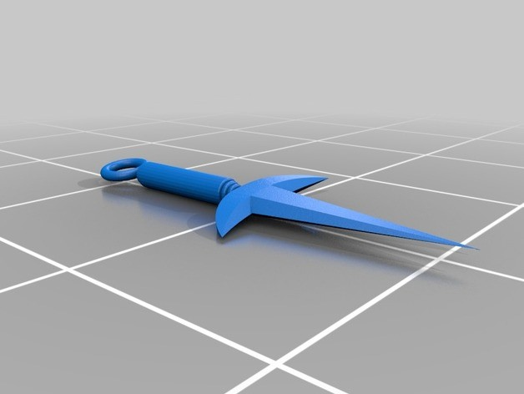

PROCEDURE FOLLOWED:

1. Go to any 3d printing website and search for STL files as per your choice.
2. Download these files as STL type.
3. After downloading these files, create a new folder and post these files.
4. Now open CURA and set the basic settings as per recommended.
5. Then click onto the load option on the left corner of the main screen.
6. Navigate to the folder where the hiraishin kunai STL files are stored and open the file.
7. The STL file now gets opened in the CURA.
8. Wait for few minutes till the readings appear below the load option.
9. Note down the readings including time, length of material used and weight of the product.
10. Now convert the STL model to respective G-code file.

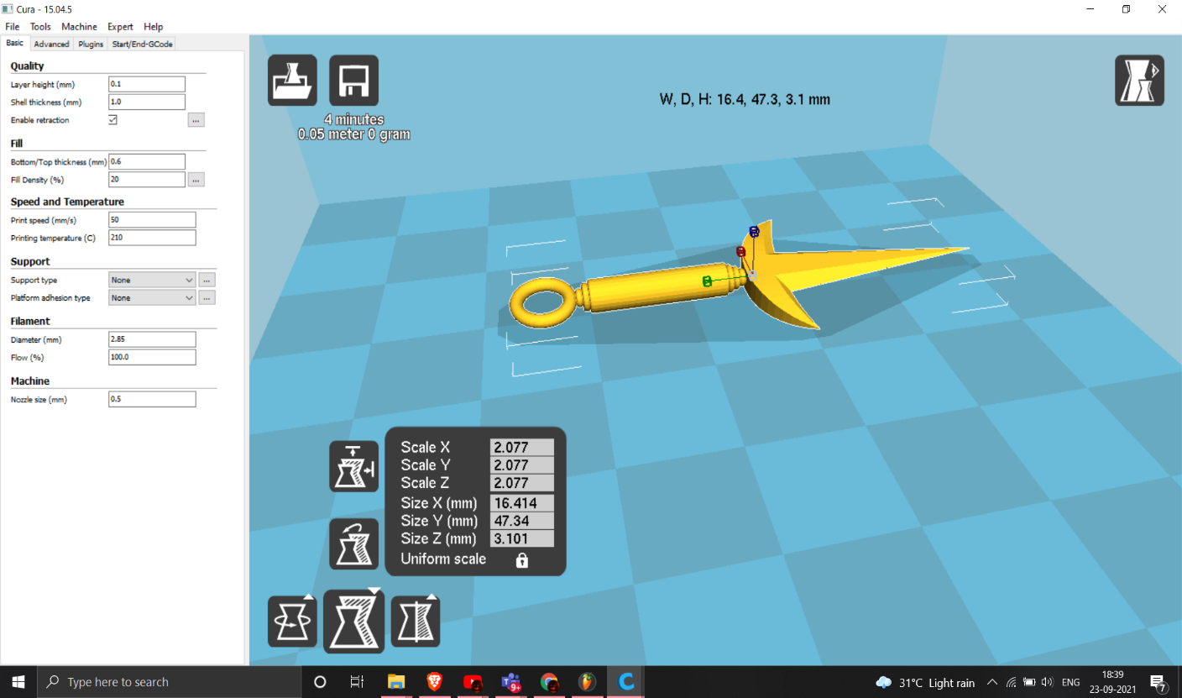

PARAMETERS:

* 1. With the help of scaling option, model was scaled to 2.077 in all the coordinates x, y, Z.
  2. The width of model is 16.414mm, the depth of model is 47.34mm.
  3. The height of model is 3.1mm.
  4. The layer height is set to 0.1mm; the shell thickness is 1.0mm.
  5. The top thickness is 0.6mm and the bottom thickness is 20mm.
  6. The in filled density is 20%, in filled type is grid.
  7. Printing speed is 50mm per second, printing temperature is 210 Degrees; printing bed temperature is 70 degrees.
  8. Support type: EVERYWHERE, Platform Adhesion type: Brim
  9. The total time to print is 6 minutes; the amount of material used is 0.05 meter and

0 grams.

OUTPUT:

The STL file of model is sliced using CURA software and G Code file has been generated. G Code file name: CSE20449_1.gcode

Expected 3D printing time: 4 min. Material consumption: 0.05 m Filament length required: 0 g

3D PRINTING EXERCISE -2

AIM: To slice the STL file of a Sharingan Eye using CURA software and generate of G- Code file.

CAD model:



PROCEDURE FOLLOWED:

1. Go to any 3d printing website and search for STL files as per your choice.
2. Download these files as STL type.
3. After downloading these files, create a new folder and post these files.
4. Now open CURA and set the basic settings as per recommended.
5. Then click onto the load option on the left corner of the main screen.
6. Navigate to the folder where the Sharingan Eye STL files are stored and open the file.
7. The STL file now gets opened in the CURA.
8. Wait for few minutes till the readings appear below the load option.
9. Note down the readings including time, length of material used and weight of the product.
10. Now convert the STL model to respective G-code file.

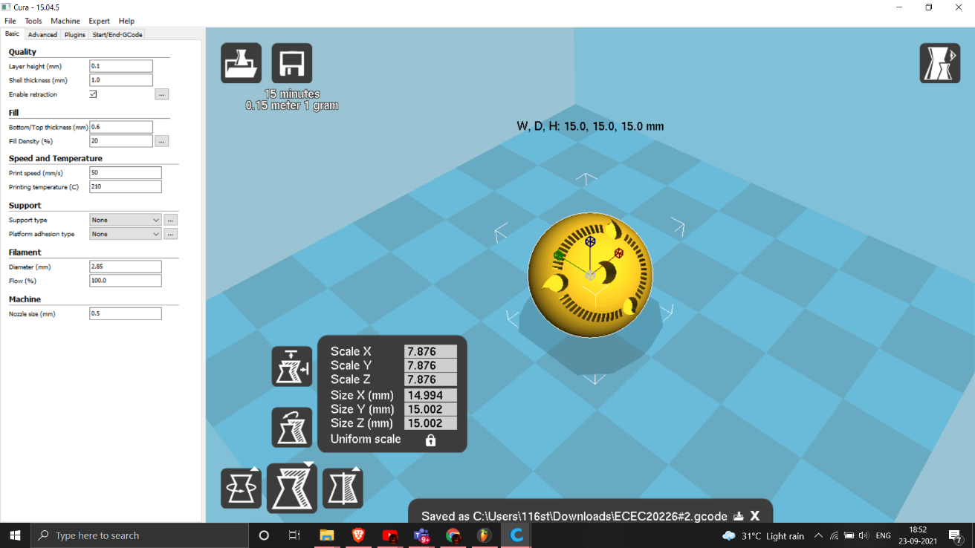

PARAMETERS:

* 1. With the help of Scaling option, model was scaled to 7.876 in all the coordinates x, y, Z.
  2. The width of model is 14.994 mm; the depth of model is 15.002 mm.
  3. The height of model is 15.002 mm.
  4. The layer height is set to 0.1mm; the shell thickness is 1.0mm.
  5. The top thickness is 0.6mm and the bottom thickness is 20mm.
  6. The in filled density is 20%, in filled type is grid.
  7. Printing speed is 50mm per second, printing temperature is 210 Degrees; printing bed temperature is 70 degrees.
  8. Support type: EVERYWHERE, Platform Adhesion type: Brim
  9. The total time to print is 15 minutes; the amount of material used is 0.15 meter and 1.0 grams

OUTPUT:

The STL file of model is sliced using CURA software and G Code file has generated. G Code file name: CSE20449_2.gcode

Expected 3D printing time: 15 minutes

Material consumption: 0.15 m Filament length required: 1.0 g