NAME: M PRAVEEN KUMAR

ROLL NO: CB.EN.U4CSE20449

3D PRINTING EXERCISE - 1

AIM:

To slice the STL file of Thanos Infinity Gauntlet model using CURA software and to generate the G-code file.

CAD MODEL:

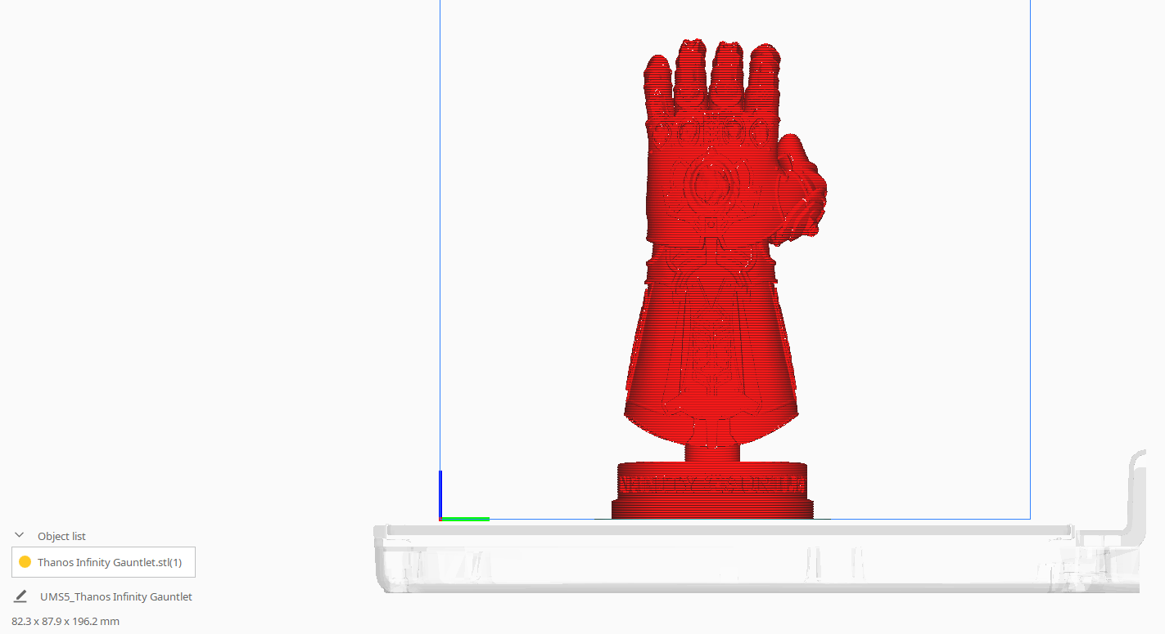

PROCEDURE FOLLOWED:

* Select a required STL file to make it as a good file and open in CURA software.
* Once the file is opened, estimated time to construct the model will be evaluated.
* Place the object vertically or horizontally according to your convenience.
* Adjust the scale of the model to your choice
* Fill the various properties like fill density, quality, thickness
* Change the support type to everywhere and the platform adhesion type to Brim
* Change the printing speed, temperature as per your choice.
* Make a note of estimated time, weight in grams, and the length in meters
* Right click `save to drive` path icon and on G -code file extension to save your file.

PARAMETERS OF MODEL:

* LAYER HEIGHT : 0.06mm
* FILL DENSITY : 20%
* WIDTH : 82.3mm
* HEIGHT : 196.2mm
* DIAMETER : 87.9mm
* TIME : 1day 3 hours 25 minutes

PICTURE OF MODEL IN CURA SOFTWARE:

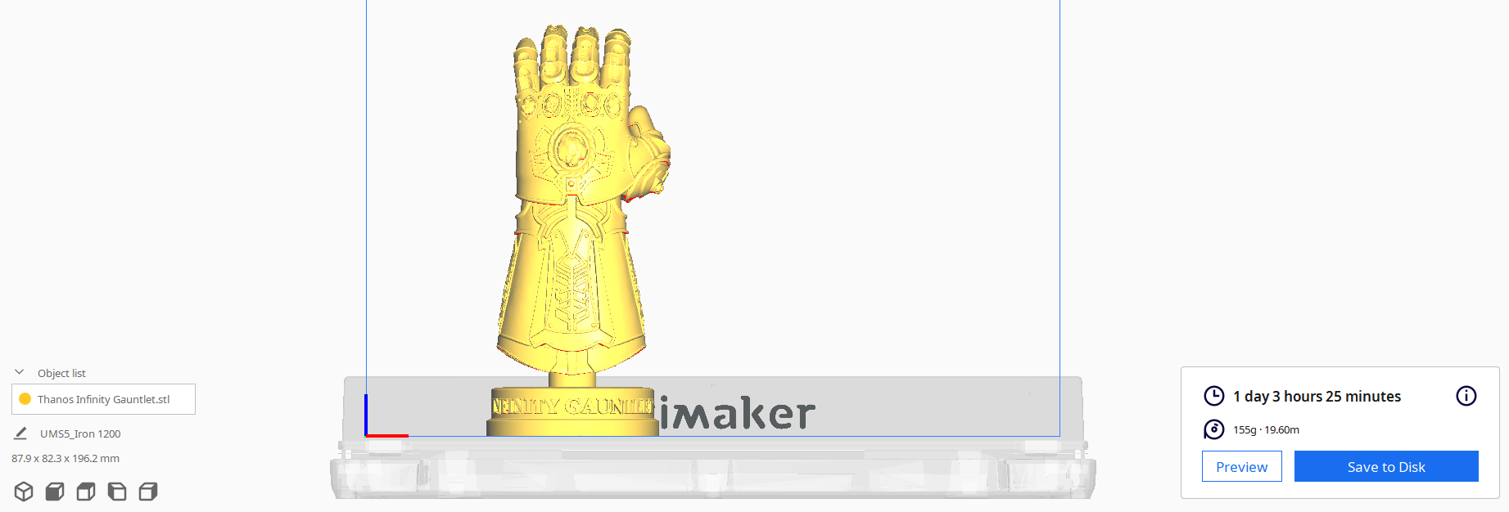

OUTPUT:

The STL fill of Thanos Infinity Gauntlet model is sliced using CURA software and G-code file has been generated.

* G-code file Name : CSE20449_1
* Estimated 3D printing time : 1 Day 3 Hours 25 minutes
* Material consumption : 155 grams
* Filament length required : 19.60m

3D PRINTING EXERCISE - 2

AIM:

To slice the STL file of Harley_davidson_Road_King model using CURA software and to generate the G-code file.

CAD model:

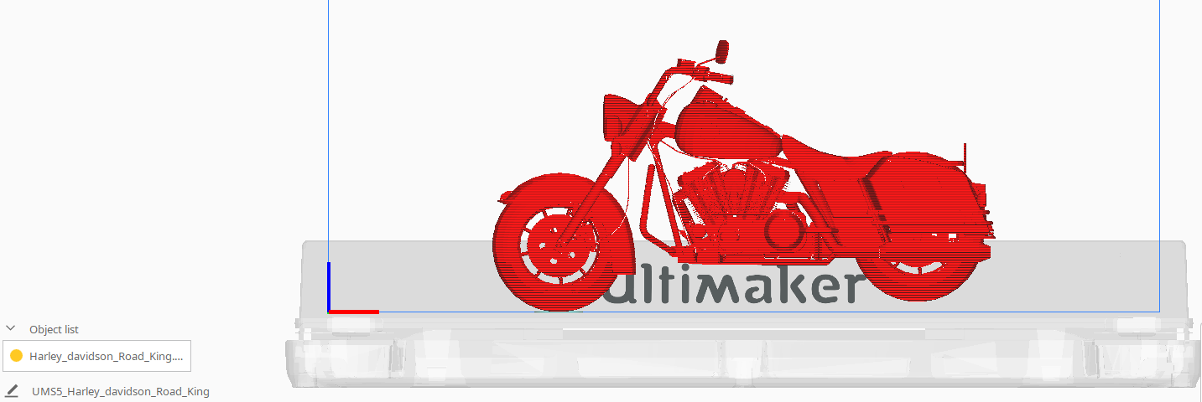

PROCEDURE FOLLOWED:

* Select a required STL file to make it as a good file and open in CURA software.
* Once the file is opened, estimated time to construct the model will be evaluated.
* Place the object vertically or horizontally according to your convenience.
* Adjust the scale of the model to your choice
* Fill the various properties like fill density, quality, thickness
* Change the support type to everywhere and the platform adhesion type to Brim
* Change the printing speed, temperature as per your choice.
* Make a note of estimated time, weight in grams, and the length in meters
* Right click `save to drive` path icon and on G -code file extension to save your file.

PARAMETERS OF MODEL:

* LAYER HEIGHT : 0.06mm
* FILL DENSITY : 20%
* WIDTH : 108.3mm
* HEIGHT : 77.3mm
* DIAMETER : 200.0mm
* TIME : 1 days 4 hours 41 minutes

PICTURE OF MODEL IN CURA SOFTWARE:

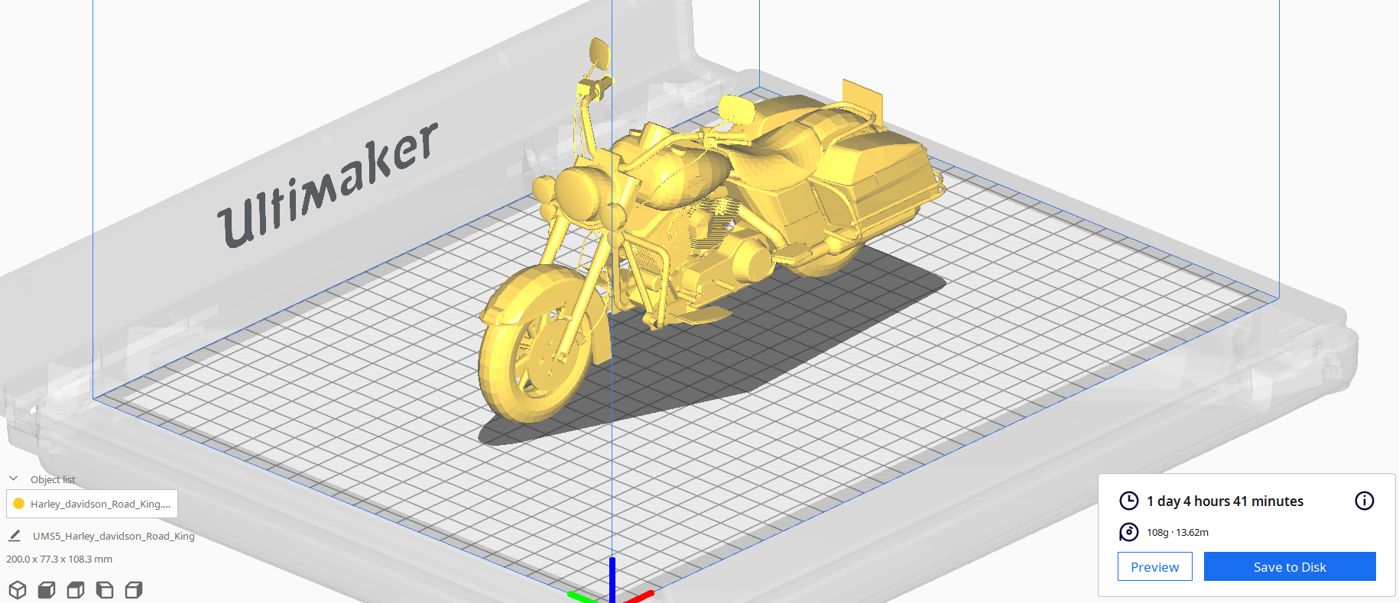

OUTPUT:

The STL fill of Harley_davidson_Road_King model is slice using CURA software and G-code fill has been generated.

* G-code file Name : CSE20449_2
* Estimated 3D printing time : 1day 4 hours 41 minutes
* Material consumption : 108g
* Filament length required : 13.62m