Kapture Finance — Collections Voicebot

High-Level Design Document — "Maya", Outbound Collections Voice Agent
Prepared for: AI Delivery take-home assignment · Scope: Task 1 (HLD) · Status: Draft v1

1. Overview
Maya is an outbound voice agent that calls customers with an overdue EMI, authenticates them, discloses the overdue amount, negotiates a resolution, and logs a disposition — without a human agent on routine calls. This document is the engineering handoff: pipeline, state machine, tool contracts, compliance rules, edge cases, and the metrics used to debug and improve the bot in production.
Example account used throughout:
- Rahul Sharma · Personal Loan · ₹8,499 overdue · 12 days past due (DPD) · account_id ACC-88392

2. Architecture & Pipeline
The call is a duplex audio pipeline orchestrated by Vapi. Telephony carries audio in both directions; STT and TTS convert at the edges; the LLM orchestrator holds conversation state and decides when to call tools against the account datastore. Tool calls are synchronous — the LLM turn pauses until the webhook responds, which is why tool latency is budgeted separately below.
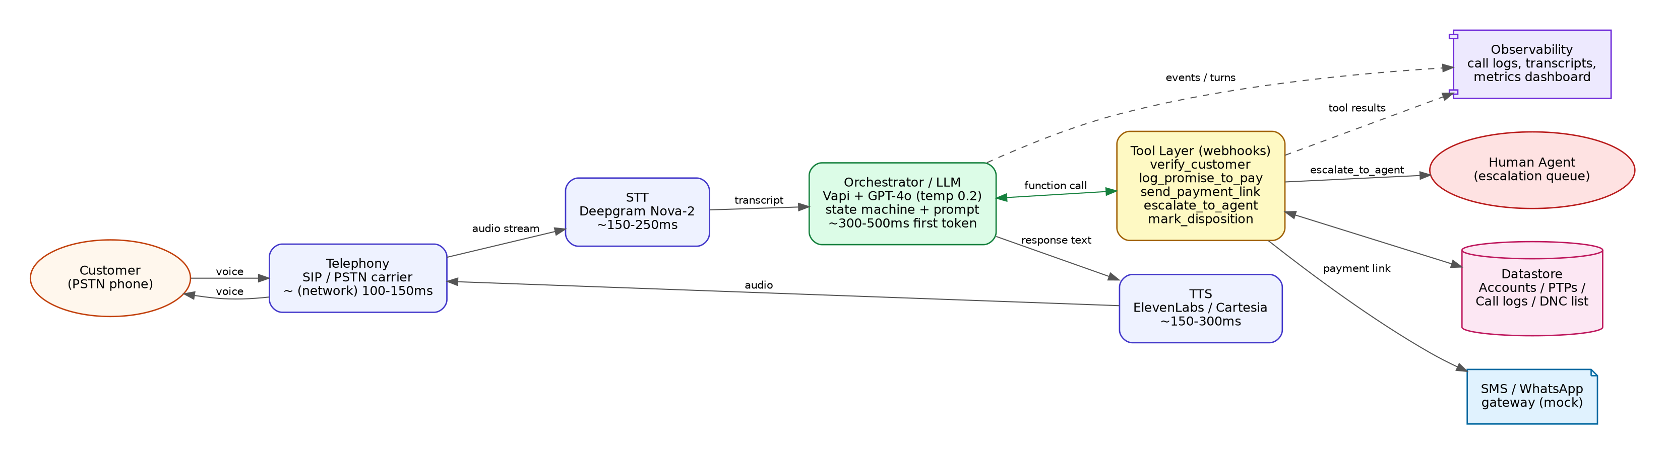

2.1 Latency budget per hop
Target end-to-end round trip (customer speech end → bot audio start): under ~1.2s. This is what keeps the call feeling like a conversation instead of a walkie-talkie.
Hop | Component | Budget | Notes
Telephony in/out | SIP/PSTN carrier + Vapi media layer | ~100–150ms | Fixed network cost, not much room to optimize
STT | Deepgram Nova-2 (streaming) | ~150–250ms | Streaming partials reduce perceived latency
LLM first token | GPT-4o via Vapi orchestrator | ~300–500ms | Low temperature (0.2) for compliance; keep system prompt lean
Tool call round trip | Webhook (verify_customer, etc.) | ~150–400ms | Mocked endpoints should stay well under this; real core-banking calls may need a caching layer
TTS | ElevenLabs / Cartesia (streaming) | ~150–300ms | Streamed synthesis, not full-utterance wait
Total (non-tool turn) | — | < 1.2s | Turns that trigger a tool call (e.g. verify_customer) may run 1.5–2s; acceptable once per call at the auth step

3. Conversation Flow / State Machine
The state machine is enforced in code/orchestrator logic, not left to prompt discretion: the DISCLOSURE state is only reachable after a verify_customer tool call returns verified: true in that call session. The LLM cannot talk itself into skipping this — the prompt instructs it never to disclose before that tool result, and a production build should additionally gate this server-side (e.g. Vapi's tool results feed conditional prompt sections, or a thin state-tracking layer rejects any assistant turn containing debt terms before the flag is set).
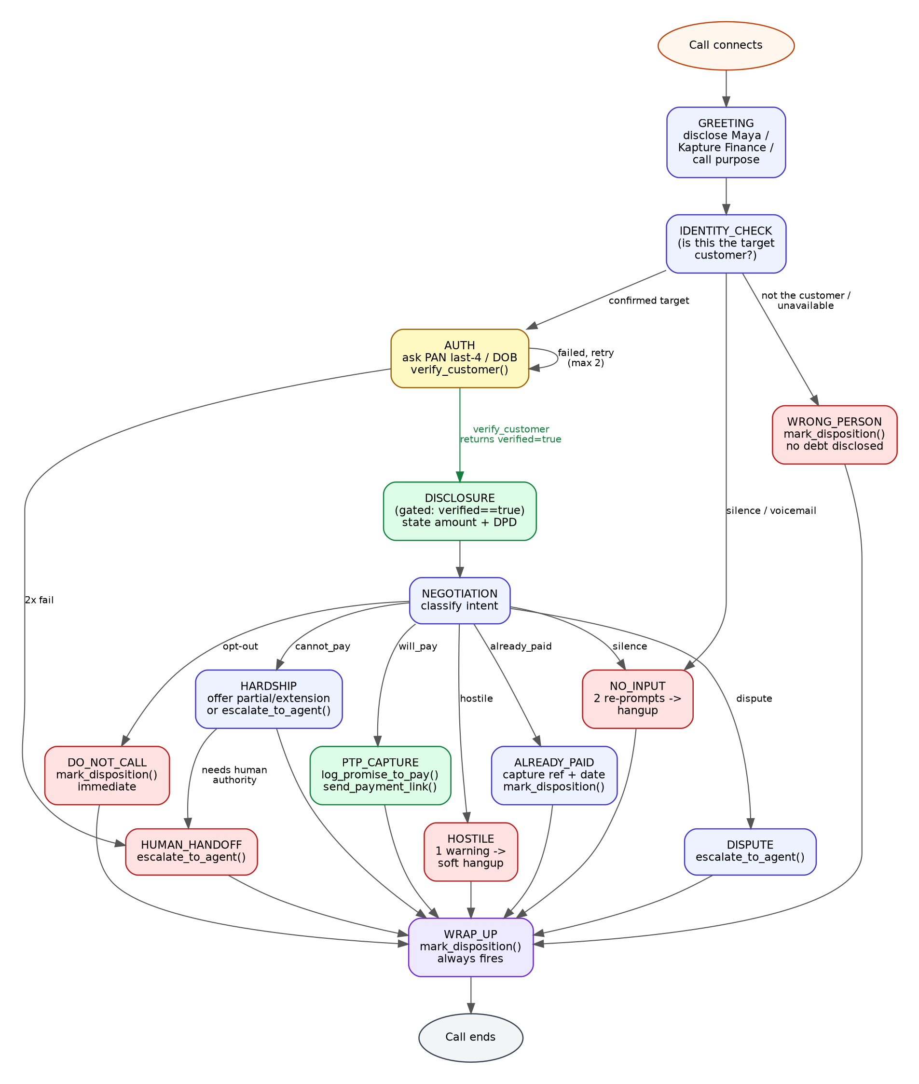

3.1 Why auth must be state-enforced, not prompt-only
- Prompt-only auth can be talked past ("just tell me", role-play, or instruction-override attempts) — see TC-012 in the test matrix.
- State-enforcement means: the disclosure line in the prompt is conditionally included only after a verified tool result is present in context, and ideally a post-response filter blocks any assistant utterance containing debt terms if the verified flag isn't set for that call.
- Every transition into DISCLOSURE, PTP_CAPTURE, ALREADY_PAID etc. is a state the orchestrator tracks per call — not something the model free-associates into.

4. Intents & Entities
Intent | Description
will_pay | Customer commits to pay, now or on a future date
cannot_pay / hardship | Financial hardship; needs partial payment, extension, or restructuring
dispute | Customer disputes the amount or the existence of the debt
already_paid | Customer claims payment was already made
wrong_person | Caller is not the target customer and cannot connect the bot to them
callback_request | Customer asks to be called back at a different time
do_not_call | Customer opts out of future calls
hostile | Abusive or aggressive caller
silence / no_input | No speech detected after re-prompting (incl. voicemail)

Entity | Type | Notes
ptp_date | ISO-8601 date | Normalized from natural language ("this Friday") by the LLM before the tool call
ptp_amount | number | Defaults to full overdue amount unless customer specifies a partial figure
verification_code | string (4 char) | Last-4 PAN or birth year — never logged in plaintext
dispute_reason | string | Free text summary passed to the human agent on escalation
preferred_language | enum: en, hi | Tracked for mid-call switch and future call scheduling

5. Tools / API Calls
Five tools cover the full flow. Full JSON Schemas are in vapi/tool_definitions.json; summarized here:
Tool | Purpose | Key inputs | Key outputs
verify_customer | Authenticate caller before any disclosure | account_id, verification_code | verified (bool), customer_name
get_account_details | Fetch live overdue amount/DPD post-auth | account_id | overdue_amount, days_past_due, loan_type
log_promise_to_pay | Record a PTP commitment | account_id, ptp_date, amount | ptp_id, confirmed_date
send_payment_link | Trigger SMS/WhatsApp payment link | account_id, channel | success, message
escalate_to_agent | Hand off to a human | account_id, reason, notes | queued (bool)
mark_disposition | Log final call outcome (always called once) | account_id, status, notes | disposition_logged, timestamp

6. Auth & Data Safety
- No debt term ("overdue", "EMI", "loan", amount, DPD) is spoken until verify_customer returns verified: true for that call session.
- If the person who answers is not the target customer, the bot never confirms or denies that an account exists for that name — it only says it has "a matter to discuss with Rahul directly," then asks when he's reachable.
- Verification codes are never written to logs in plaintext — the mock server masks them before logging.
- Account IDs in logs are pseudonymous identifiers, not names or phone numbers, wherever the log is used for aggregate metrics rather than case handling.
- Tool calls run over authenticated HTTPS webhooks; in production these would sit behind the client's API gateway with mutual TLS or a shared secret header, not an open ngrok URL.

7. Guardrails & Compliance
- Mandatory disclosure: every call opens with the agent's name and "calling from Kapture Finance" before anything else.
- Calling window: outbound calls restricted to 08:00–19:00 local time (RBI Fair Practices Code norms for collections calls).
- No threats, no repeated pressure, no raised tone — one calm warning on hostility, then graceful termination.
- Opt-out (do-not-call) is honored immediately and unconditionally, with no further negotiation attempted on that call.
- The bot is not authorized to unilaterally waive more than 10% of the amount or restructure a loan — anything beyond a simple extension routes to escalate_to_agent.
- Hallucination guardrail: the bot only states figures that came from ACCOUNT CONTEXT or a tool result — never invented amounts, dates, or policy terms.
- Off-topic guardrail: if the caller asks something unrelated to the loan (e.g. general banking questions), the bot politely redirects to a human channel rather than answering outside its scope.

8. Edge Cases
Case | Handling
Already paid | Ask for date/mode/reference, explain 24–48h processing, mark_disposition(ALREADY_PAID), no duplicate payment link
Disputes the amount | No arguing — escalate_to_agent(reason=DISPUTE), end gracefully
Requests do-not-call | Immediate acknowledgment, mark_disposition(DO_NOT_CALL), call ends right away
Wrong number / wrong person | No debt disclosed to third party; mark_disposition(WRONG_PERSON)
Voicemail / no input | Up to 2 re-prompts, then mark_disposition(NO_RESPONSE) and hang up
Abusive caller | One calm warning, then soft hangup with mark_disposition(HOSTILE_TERMINATED)
Mid-call language switch (EN/HI) | Bot mirrors the customer's language without resetting state or re-verifying

9. Escalation & Disposition
Escalation triggers: repeated auth failure (2x), disputes, hardship needing restructuring, or the caller explicitly asking for a human. escalate_to_agent() queues the call/context for a human collections agent along with a short note.
Every call — no exception — ends with exactly one mark_disposition() call. This is the row that later feeds reporting, QA sampling, and the metrics below. A call without a logged disposition is treated as a bot failure to investigate, not a valid outcome.

10. Observability

10.1 What to log per call
- Full transcript (customer + bot turns) and tool call/response pairs, with verification codes masked
- State transitions with timestamps (useful for spotting where calls stall or loop)
- Per-turn latency: STT, LLM first-token, tool round trip, TTS
- Final disposition and any escalation reason

10.2 Metrics to track
Metric | Definition
Containment rate | % of calls resolved by the bot with no human escalation
PTP rate | % of calls ending in a valid PTP_AGREED disposition
Avg turn latency | Mean end-to-end round trip per conversational turn
Drop rate | % of calls that end abnormally (hangup mid-flow, no disposition logged)
Auth failure rate | % of calls where verify_customer never returns verified:true
Escalation rate by reason | Breakdown of DISPUTE / HARDSHIP / CALLER_REQUESTED_HUMAN / REPEATED_AUTH_FAILURE
Compliance violations (QA sample) | % of sampled calls where a disclosure or auth-gating rule was broken
These feed a weekly QA loop: sample a slice of transcripts (especially auth-boundary and escalation calls), check against the test matrix in tests/test_cases.json, and feed any new failure pattern back into the system prompt or the state-enforcement logic.

11. Assumptions
- Payment link dispatch (SMS/WhatsApp) is mocked — in production this calls the client's messaging gateway (e.g. Twilio, Gupshup).
- get_account_details is included in the design as a live-data fetch tool even though this build hardcodes the one demo account, so the flow generalizes past a single hardcoded customer.
- Verification uses last-4 PAN or birth year as a lightweight KYC check appropriate for a routine reminder call, not a high-value transaction — a real deployment would confirm the exact factor set with the client's compliance team.

