Write a blog on the difference between document and window objects

**Window Object**

* The Window object is a global object in client-side JavaScript, representing the browser window containing a DOM document and acting as the root of the document object model.
* The window object, supported by all browsers, represents the browser’s window and automatically includes global JavaScript objects, functions, and variables as members.
* The Window object is responsible for managing global variables, functions, and objects, providing methods for browser interaction and managing properties related to frames, tabs, or windows, such as alert(), confirm(), setTimeout(), and setInterval()

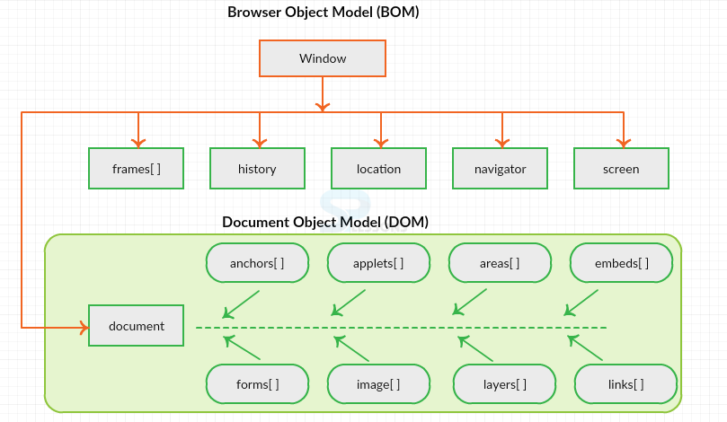

Now lets visualize the difference between window and document.

## Window Vs Document

* **Window object** : It is the top most object and outermost element of the object hierarchy as shown in Figure 1.
* **Document object** : Each HTML document that gets loaded into a window becomes a document object. The document contains the contents of the page. Using document object, JavaScript can modify, add and delete the HTML elements, attributes CSS styles in the page
* The window object represents a window/tab containing a DOM document where as document object is property of window object that points to the DOM document loaded in that window.

You can access a document object either using window.document property or using document object directly as window is global object. In the below example, title is the property of document object.

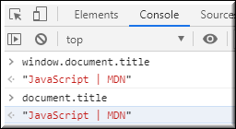

The other major difference is that both window object and document object have properties and methods. Few method names are same in both objects but with different behavior. In the below example window.open() opens a new tab or window and document.open() creates a blank document within the window.

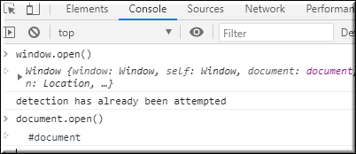

## Screen

Screen is the window property that holds information of browser screen. It refers to screen object associated with that window **object**. Used to display screen width, height, colorDepth, pixelDepth etc

Similar to document screen can be accessed either by window.screen or screen object directly. Screen object doesn't have any methods as in window and document objects

