**Ex : 01**

**Implement programs for visualizing time series data.**

**AIM**

To write a program for visualizing time series data**.**

**PROCEDURE**

• **Prepare the Data**: Load the data into a DataFrame using Pandas. Make sure the columns and values are properly structured.

• **Create Different Visualizations**:

* **Line Plot**: Visualize how Sales and Profit change over time.
* **Scatter Plot**: Explore the relationship between Sales and Profit.
* **Bar Chart**: Compare Sales and Profit per year.
* **Area Plot**: Show the cumulative contribution of Sales and Expenses over time.
* **Seaborn Lineplot**: Use Seaborn to compare Sales, Profit, and Expenses in a more elegant manner.

• **Adjust Plot Settings**: Add labels, titles, and legends to make your plots more informative and readable.

• **Interpret Results**: Analyze trends, relationships, and patterns based on the visualizations.

**PROGRAM**

import pandas as pd

import matplotlib.pyplot as plt

import seaborn as sns

*# Sample time series data (replace with your actual data)*

data = {'Year': [2010, 2011, 2012, 2013, 2014, 2015, 2016, 2017, 2018, 2019],

'Sales': [100, 120, 150, 130, 160, 180, 200, 220, 250, 230],

'Profit': [20, 24, 30, 26, 32, 36, 40, 44, 50, 46],

'Expenses': [80, 96, 120, 104, 128, 144, 160, 176, 200, 184],

'Units_Sold': [500,600,750,650,800,900,1000,1100,1250,1150]}

df = pd.DataFrame(data)

*# 1. Line Plot*

plt.figure(figsize=(10, 6))

plt.plot(df['Year'], df['Sales'], label='Sales')

plt.plot(df['Year'], df['Profit'], label='Profit') *# Example: Adding another line*

plt.xlabel('Year')

plt.ylabel('Value')

plt.title('Sales and Profit Over Time')

plt.legend()

plt.grid(True)

plt.show()

*# 2. Scatter Plot*

plt.figure(figsize=(10, 6))

plt.scatter(df['Sales'], df['Profit'])

plt.xlabel('Sales')

plt.ylabel('Profit')

plt.title('Sales vs. Profit')

plt.grid(True)

plt.show()

*# 3. Bar Chart (grouped)*

df.plot(x='Year', y=['Sales', 'Profit'], kind='bar', figsize=(10,6))

plt.xlabel("Year")

plt.ylabel("Value")

plt.title("Sales and Profit per year")

plt.show()

*# 4. Area Plot*

plt.figure(figsize=(10, 6))

plt.stackplot(df['Year'], df['Sales'], df['Expenses'], labels=['Sales', 'Expenses']) *# Example: Stacked area plot*

plt.xlabel('Year')

plt.ylabel('Value')

plt.title('Sales and Expenses Over Time')

plt.legend()

plt.grid(True)

plt.show()

*# 5. Seaborn Lineplot with multiple variables*

plt.figure(figsize=(10,6))

sns.lineplot(x='Year', y='value', hue='variable', data=pd.melt(df, id_vars=['Year'], value_vars=['Sales', 'Profit', 'Expenses']))

plt.xlabel('Year')

plt.ylabel('Value')

plt.title('Sales, Profit, and Expenses Over Time (Seaborn)')

plt.grid(True)

plt.show()

**OUTPUT**

***Scatter Plot***

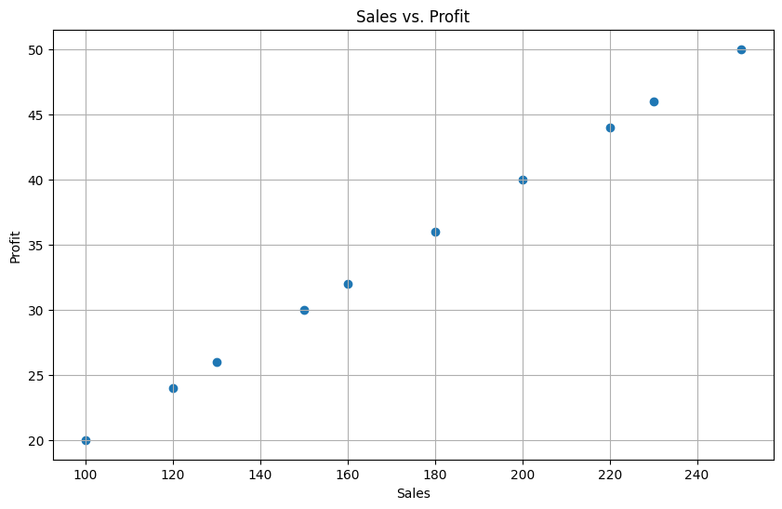

***Line Plot***

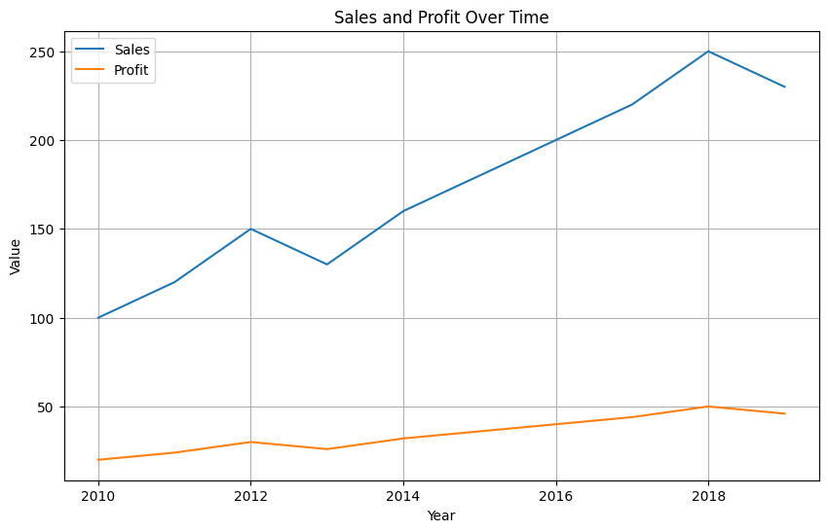

***Bar Chart***

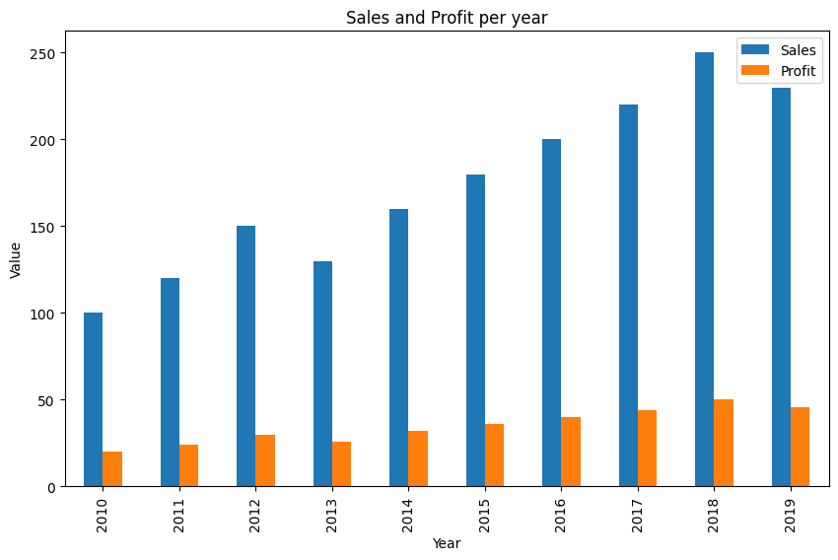

***Area Plot***

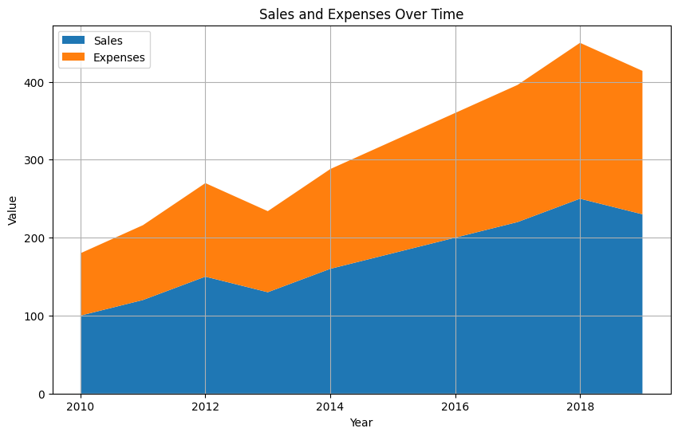

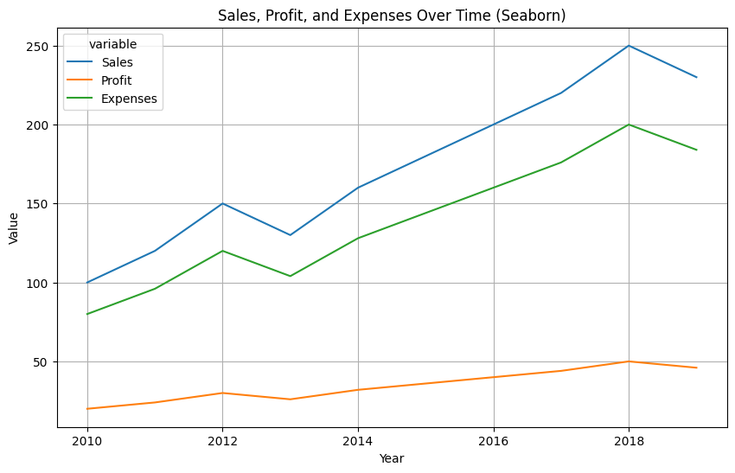

**RESULT**

Thus the program has been implemented successfully.