**Sample Test for GoogleMapsDelete API**

1. Create a request

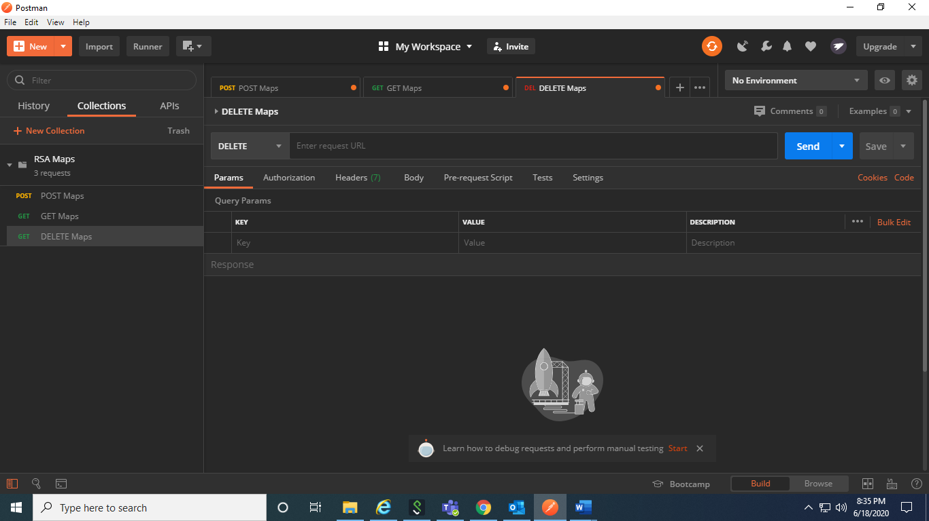

**Complete URL**: https://rahulshettyacademy.com/maps/api/place/delete/json?key=qaclick123

**Base URL**: https://rahulshettyacademy.com

**Resource**: /maps/api/place/delete/json

**Query Parameters:** key

**Http request** : DELETE

**Sample Body** :

{

"place_id":"928b51f64aed18713b0d164d9be8d67f" //(This value comes from Add place response)

}

**Sample Response**

{

"status": "OK"

}

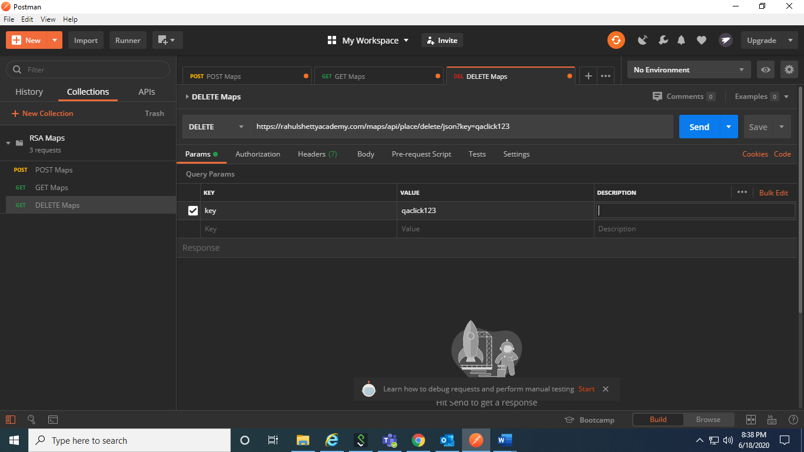

1. We have to enter the body bcos you are making some changes in the data. The placeid is taken from post

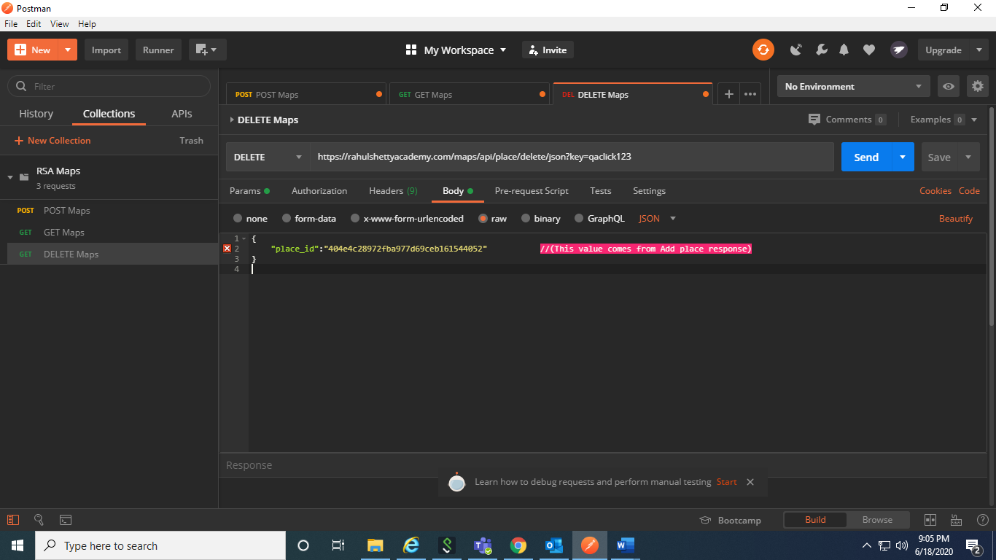

1. After sending the request

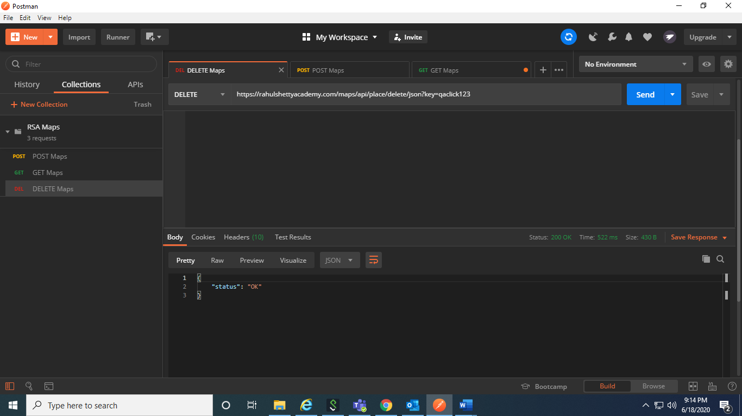

1. To verify delete operation, try to run get again

