**Sample Test for GoogleMapsGet API**

**Complete URL :**

http://rahulshettyacademy.com/maps/api/place/get/json?place_id=xxxx&key=qaclick123

**Base URL**:  [https://rahulshettyacademy.com](https://rahulshettyacademy.com/)

**Resource**: /maps/api/place/get/json

**Parameters**: key, place_id //( place_id value comes from Add place response)

**Http request**: GET

Note: Key value is hardcoded and it is always qaclick123

**Sample Response for the Provided Place_Id**

{

"location":{

"lat" : -38.383494,

"lng" : 33.427362

},

"accuracy":50,

"name":"Frontline house",

"phone_number":"(+91) 983 893 3937",

"address" : "29, side layout, cohen 09",

"types": ["shoe park","shop"],

"website" : "http://google.com",

"language" : "French-IN"

}

* Here, we are retrieving from DB, there’s no Body.
* If its get, then the query parameters should be there in URL.
* With the place ID generated from POST, retrieve the value.
* placeID should be mentioned in the URL to retrieve the value.
* ALWAYS REMEMBER, THERES NO BODY IN GET.

Add a request called GET Maps

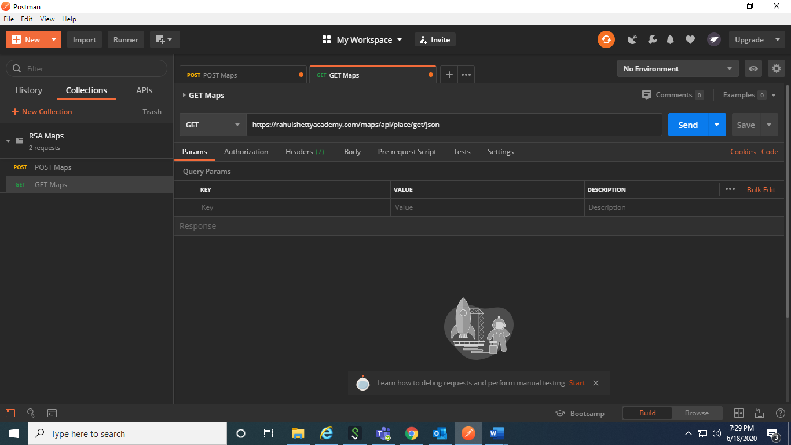

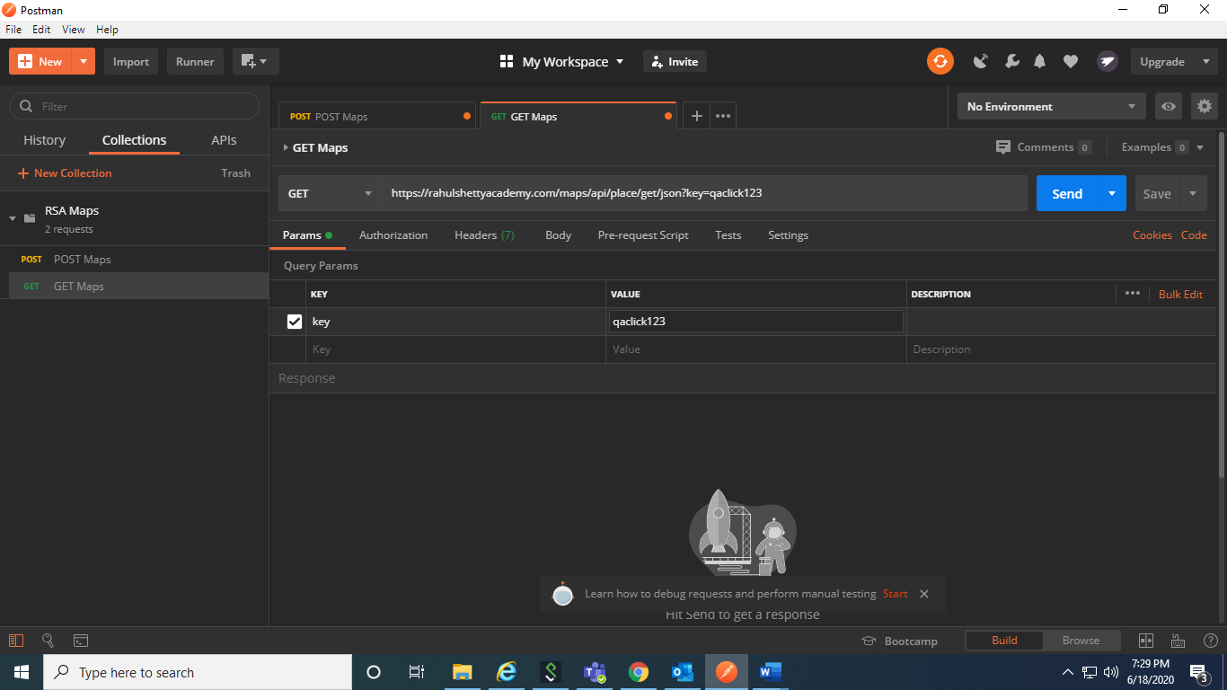

Get the placeID from POST Response and paste it in key and value

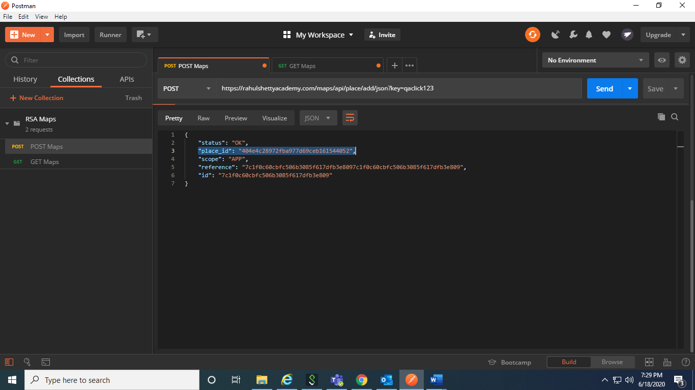

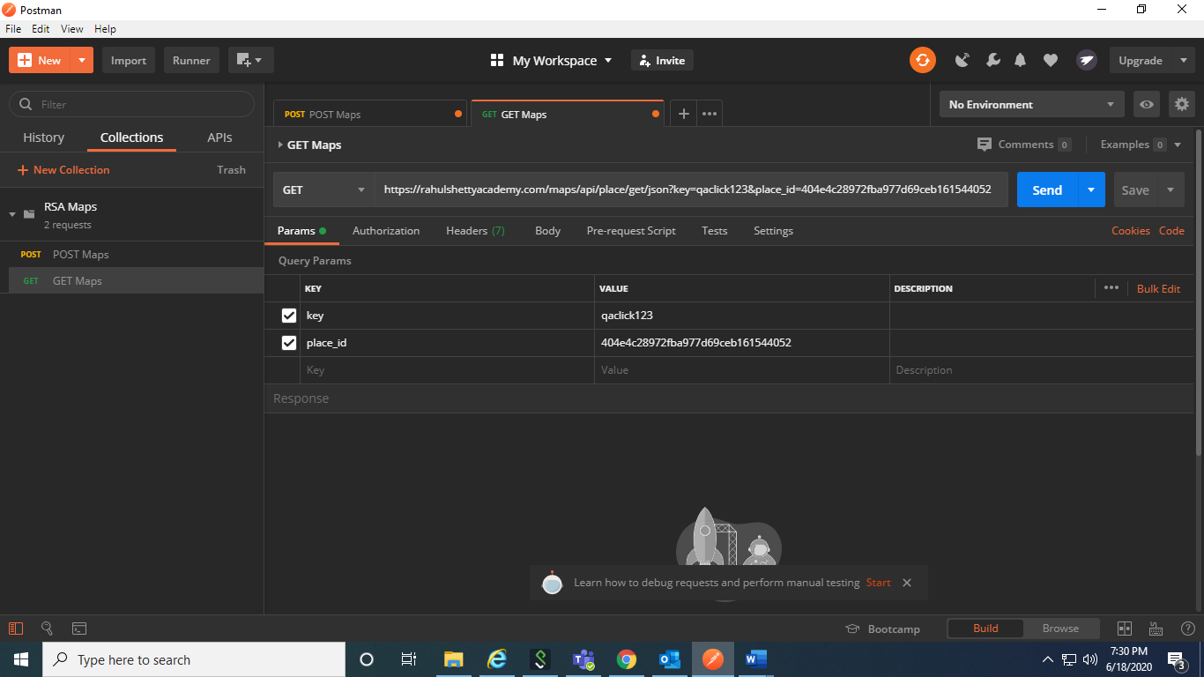

After sending the request, the values get populated. The response has the values that have been given in POST

