**Sample Test for GoogleMapsAdd API**

1. Enter the BaseUrL, resource,Query/Path Parameters

**Base URL:**  [**https://rahulshettyacademy.com**](https://rahulshettyacademy.com/)

**Resource**: /maps/api/place/add/json

**Query Parameters:** key =qaclick123.

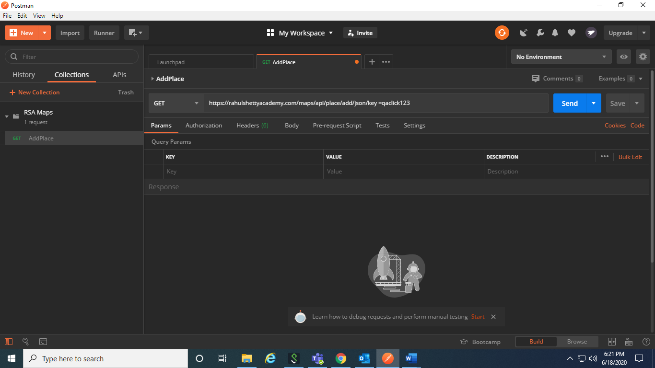

1. Note that we can also give the parameters in key value. It’ll get automatically constructed

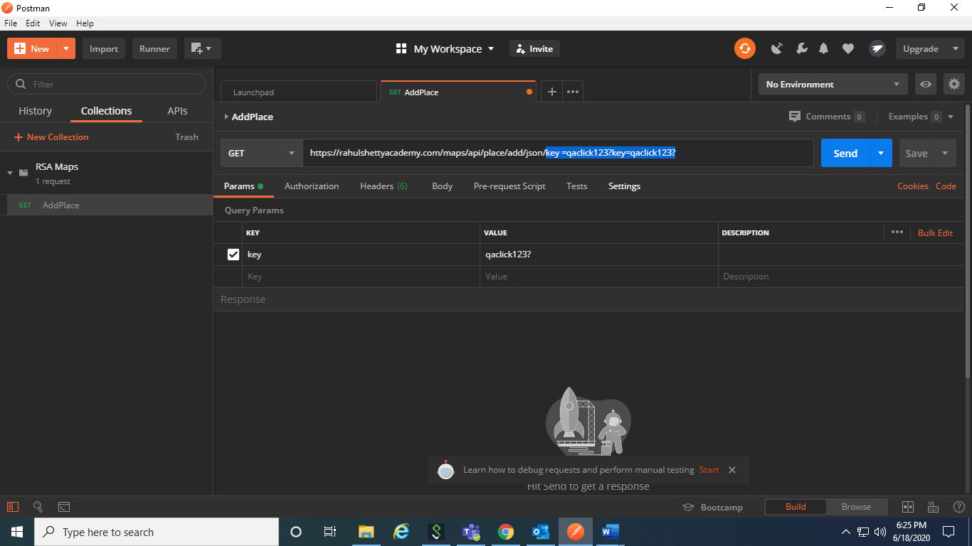

**Http Method**: POST

1. Specify the http method as Post

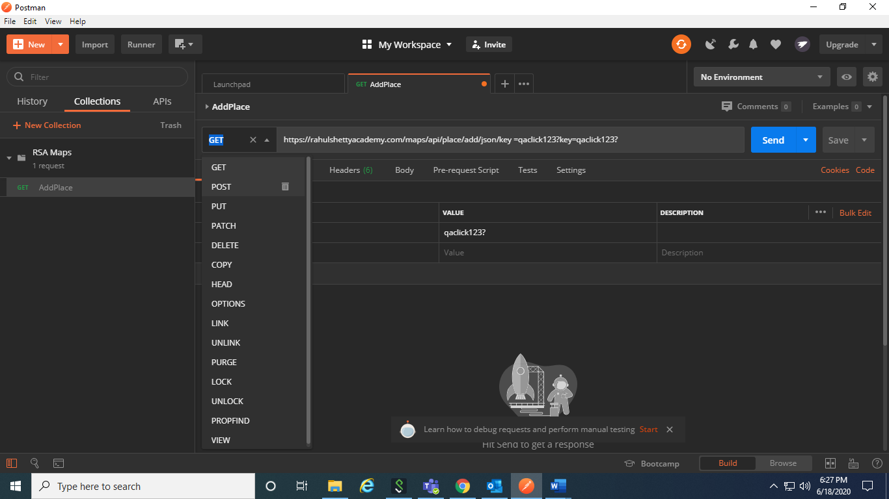

Sample Body :

{

"location": {

"lat": -38.383494,

"lng": 33.427362

},

"accuracy": 50,

"name": "Frontline house",

"phone_number": "(+91) 983 893 3937",

"address": "29, side layout, cohen 09",

"types": [

"shoe park",

"shop"

],

"website": "http://google.com",

"language": "French-IN"

}

1. Add the body. If it is GET method, we can specify the body in URL itself. Since it is PUT method, we must send it securely.

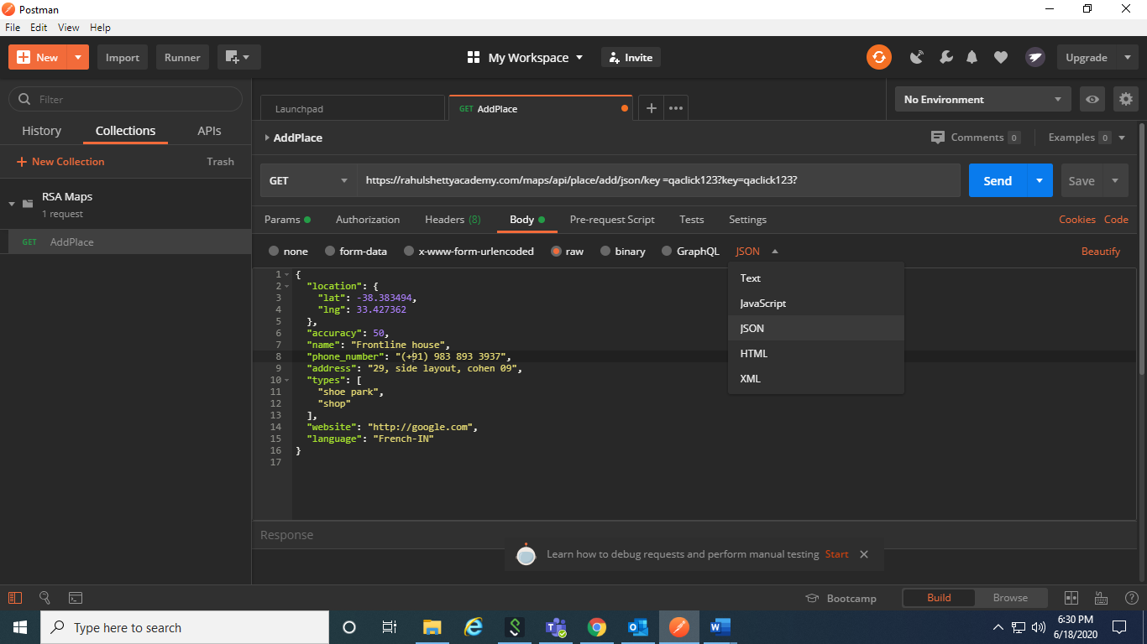

This header content type gets added automatically

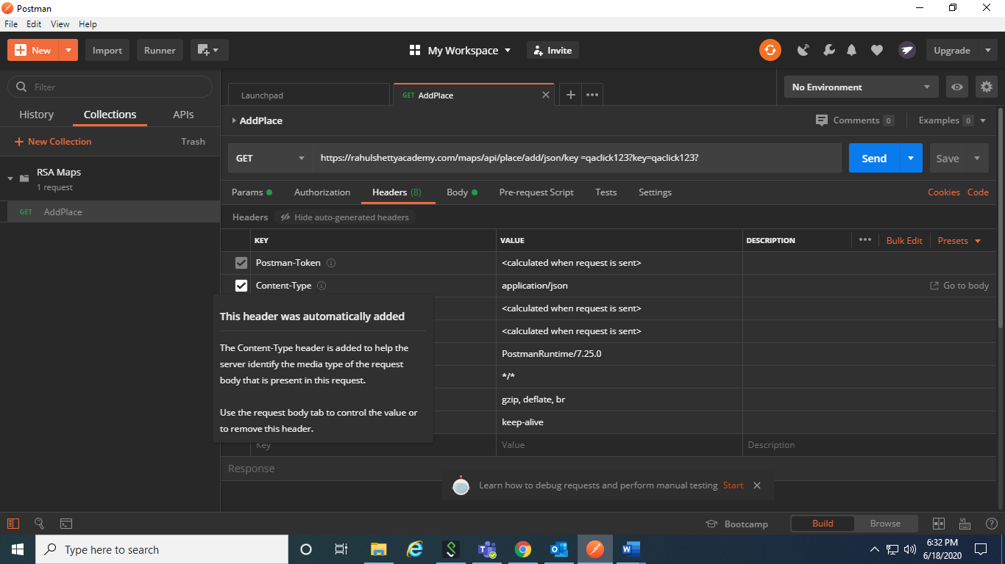

**Sample Response**

{

"status": "OK",

"place_id": "928b51f64aed18713b0d164d9be8d67f",

"scope": "APP",

"reference": "736f3c9bec384af62a184a1936d42bb0736f3c9bec384af62a184a1936d42bb0",

"id": "736f3c9bec384af62a184a1936d42bb0"

}

1. Click on Send. If there’s any issue like server couldn’t send a response, see this. TURN OFF SSL CERTIFICATE VERIFICATION

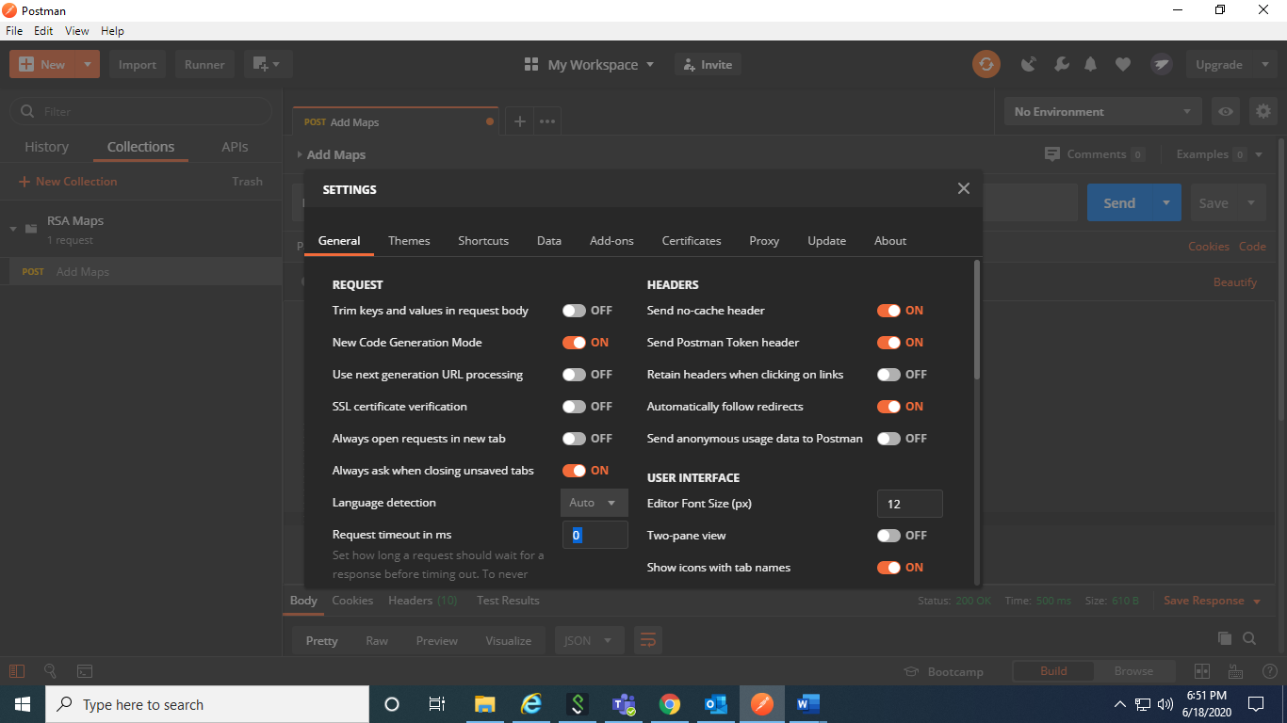

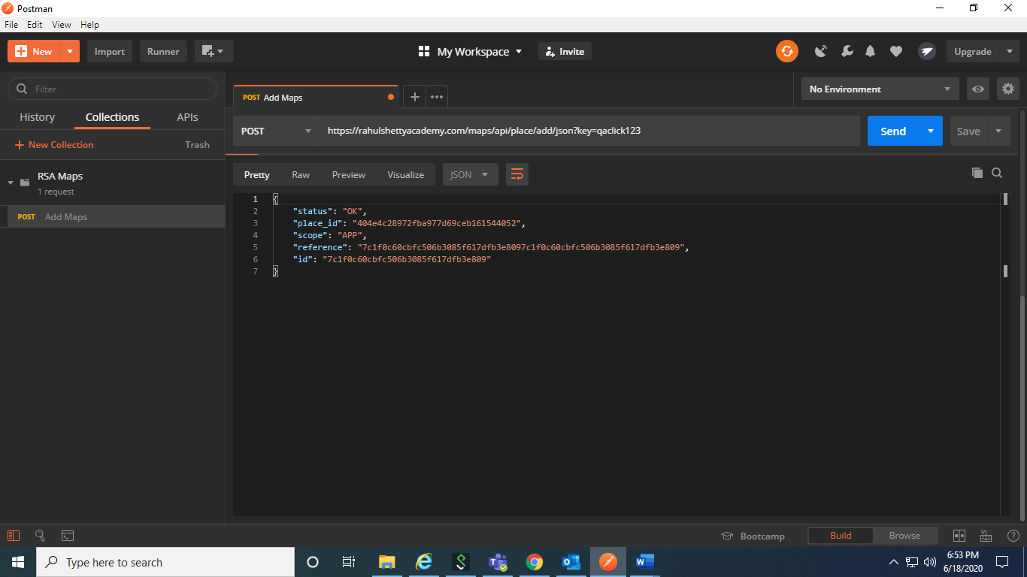

After submitting the request to the API, we get a unique placeID where we can use it in future to retrieve that place.

Thus, this address gets added to the RahulShetty API.